# Administrative panel

1. This is a dashboard page where the sotre’s user can get information about the incoming orders and the online request from restaurant table

TODO: reqwork this page to work properly with desktop and mobile too, manage the incoming order (online too) to get details and close the order, possibility to view all closed order by date.

TIP: The page already work but need some adjust.

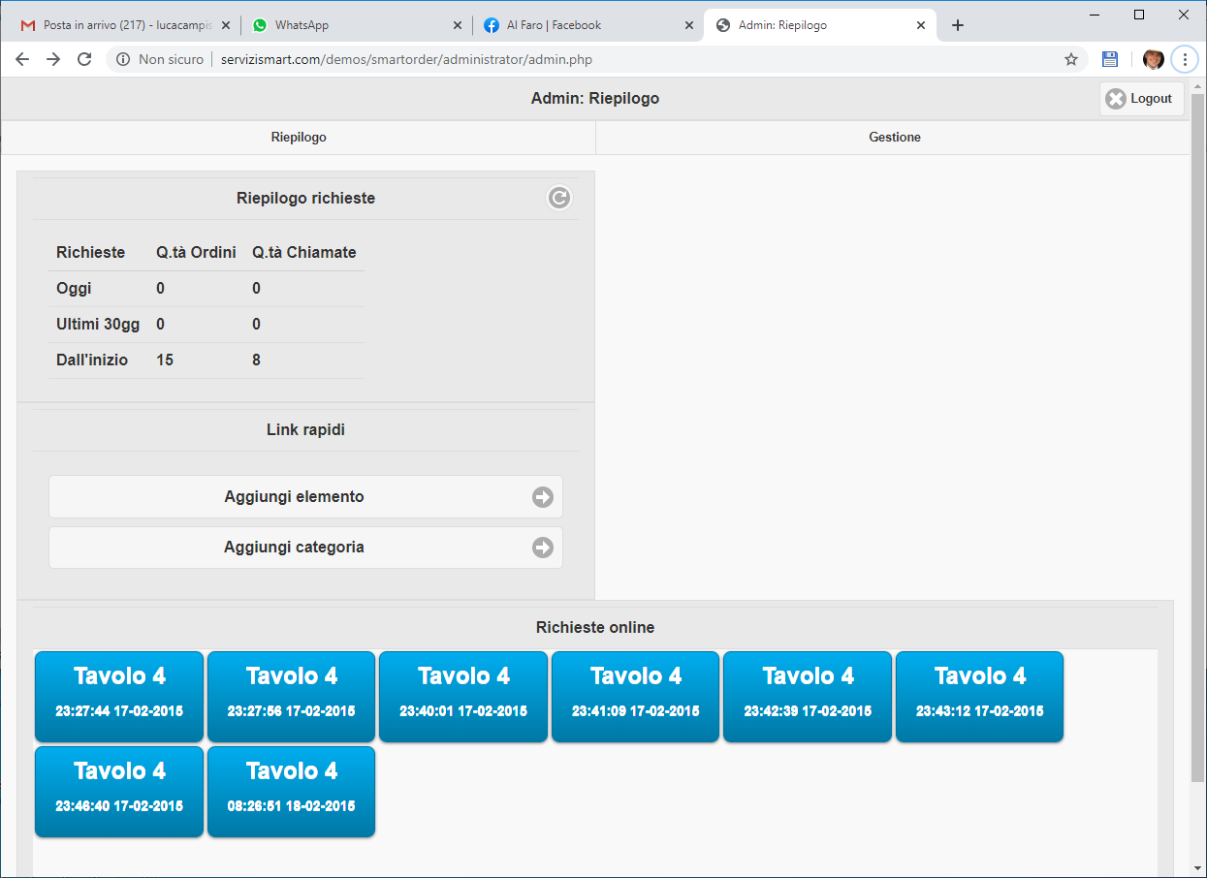

1. Manage cataloge section

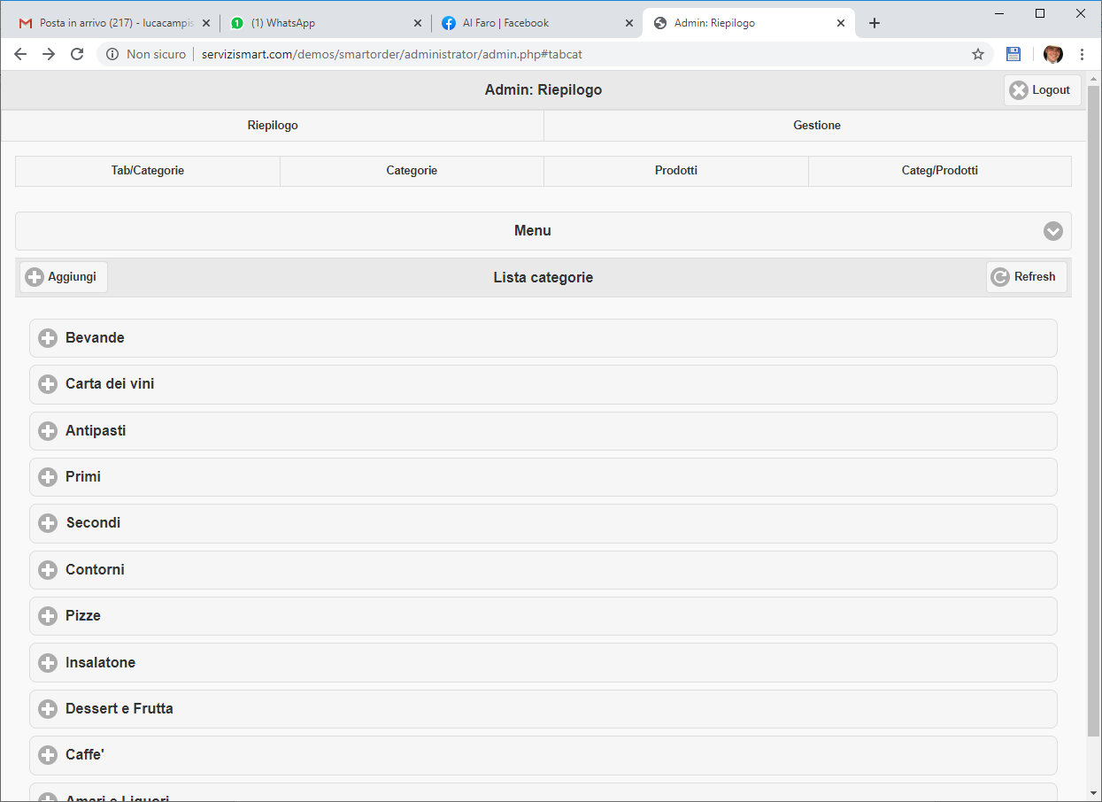

TODO:

1. add tab section to create and manage the “tab” the image below show example of tab

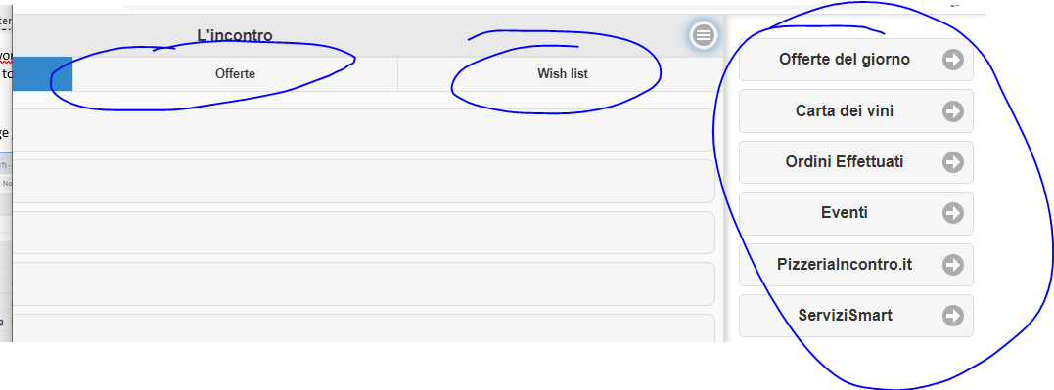

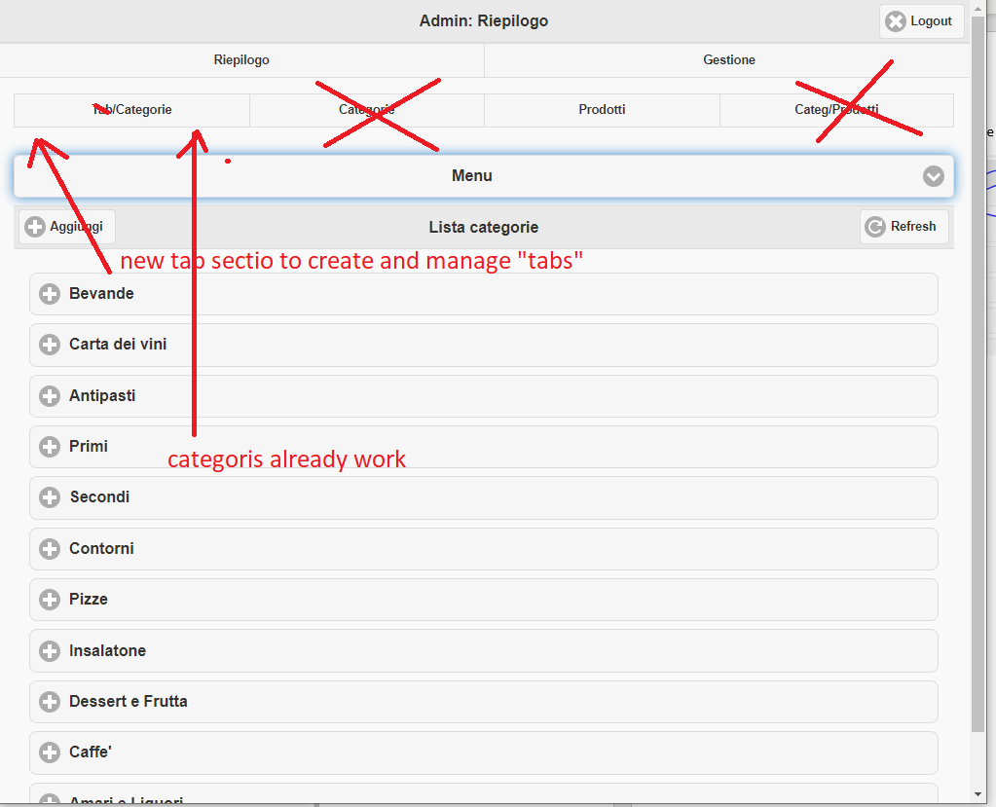

1. finish the products section
   1. add the possilbility to select a category directly from the page below
   2. make the change image button work properly, ate the momento already work, but need to rework to: add a possibility to select images from library (load from certain folder on server) or upload custom image, in this case like already do, need to crop image ande create 2 files, on 100x100px and other 600x600px also these funcionalities need to work good with smartphone.

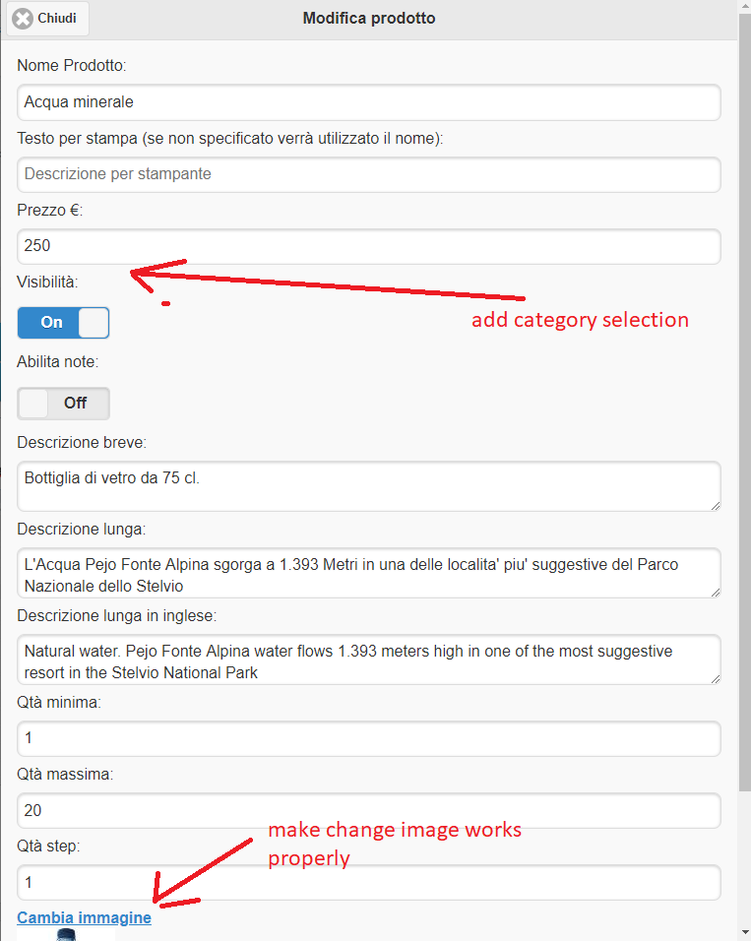

# New features

1. add online chat like freelancer chat to allow store and final customer to text each other

In this case is possible to add this funcionalities only for register users (the registration funtion already work good)

1. add the delivery and take away funcionalities, in this case for the register user is possoble to select a one of this to possibility (if the store allow it by a certain parameters) and add addres fro delivery or choose slots when get the order directly to the store