1. for $book in /bookstore/book/title/text()
return <titulo> {$book} </titulo>

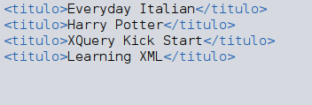

2.

