***Low complexity coherent detection for short reach links using compressed sensing and self-interference in optical OFDM subcarriers.***

Pattern classification using Neural networks using simulated and experimental data. In the process several neural network architectures are tested along with different ranges of SNR values affecting the signals to train and test the models obtained.

The objective in this model training is to reduce noise levels added to the data obtained experimentally and simulated. For this, several models were trained individually starting with a range of SNR from -6 to 50 dB and finishing at 35 to 40 dB range. After the training, a validation process was performed to extract figures of accuracy and bit-error-rate. The data packet size for the validation process on each model had a size of 18x106 symbols to check BER values up to 10-6

1. Experimental Data models.

Models 1,2,3,4 have the same SNR range and only varying the neural network architecture to find the most optimal one. Models 5 to 11 explore the effect in the SNR range when the model is trained using (12,18,36) ANN configuration fixed.

|  |  |
| --- | --- |
| ANN configuration | (6,12,18,36) |
| Data SNR ranges (dB) | (-6,50) |
| Model file name | MLP_1_CV_1.pkl |

|  |  |
| --- | --- |
|  |  |

|  |  |
| --- | --- |
| Model configuration | (6,12,18) |
| Data SNR ranges | (-6,50) |
| Model file name | MLP_1_CV_2.pkl |

|  |  |
| --- | --- |
|  |  |

|  |  |
| --- | --- |
| Model configuration | (12,18,36) |
| Data SNR ranges | (-6,50) |
| Model file name | MLP_1_CV_3.pkl |

|  |  |
| --- | --- |
|  |  |

|  |  |
| --- | --- |
| Model configuration | (6,12,24) |
| Data SNR ranges | (-6,50) |
| Model file name | MLP_1_CV_4.pkl |

|  |  |
| --- | --- |
|  |  |

|  |  |
| --- | --- |
| Model configuration | (12,18,36) |
| Data SNR ranges | (0,50) |
| Model file name | MLP_1_CV_5.pkl |

|  |  |
| --- | --- |
|  |  |

|  |  |
| --- | --- |
| Model configuration | (12,18,36) |
| Data SNR ranges | (10,50) |
| Model file name | MLP_1_CV_6.pkl |

|  |  |
| --- | --- |
|  |  |

|  |  |
| --- | --- |
| Model configuration | (12,18,36) |
| Data SNR ranges | (15,50) |
| Model file name | MLP_1_CV_7.pkl |

|  |  |
| --- | --- |
|  |  |

|  |  |
| --- | --- |
| Model configuration | (12,18,36) |
| Data SNR ranges | (20,50) |
| Model file name | MLP_1_CV_8.pkl |

|  |  |
| --- | --- |
|  |  |

|  |  |
| --- | --- |
| Model configuration | (12,18,36) |
| Data SNR ranges | (25,30) |
| Model file name | MLP_1_CV_9.pkl |

|  |  |
| --- | --- |
|  |  |

|  |  |
| --- | --- |
| Model configuration | (12,18,36) |
| Data SNR ranges | (30,35) |
| Model file name | MLP_1_CV_10.pkl |

|  |  |
| --- | --- |
|  |  |

|  |  |
| --- | --- |
| Model configuration | (12,18,36) |
| Data SNR ranges | (35,40) |
| Model file name | MLP_1_CV_11.pkl |

|  |  |
| --- | --- |
|  |  |

As it can be seen in the previous plots, when the training interval of data gets reduced, the accuracy of classification improves and the BER values decreases significantly. This behaviour can be noticed more clearly in the models 10 and 11 of this section.

1. Simulated Data models.

|  |  |
| --- | --- |
| ANN configuration | (6,12,18,36) |
| Data SNR ranges (dB) | (-6,50) |
| Model file name | MLP_1_CV_1s.pkl |

|  |  |
| --- | --- |
|  |  |

|  |  |
| --- | --- |
| Model configuration | (6,12,18) |
| Data SNR ranges | (-6,50) |
| Model file name | MLP_1_CV_2s.pkl |

|  |  |
| --- | --- |
|  |  |

|  |  |
| --- | --- |
| Model configuration | (12,18,36) |
| Data SNR ranges | (-6,50) |
| Model file name | MLP_1_CV_3s.pkl |

|  |  |
| --- | --- |
|  |  |

|  |  |
| --- | --- |
| Model configuration | (6,12,24) |
| Data SNR ranges | (-6,50) |
| Model file name | MLP_1_CV_4s.pkl |

|  |  |
| --- | --- |
|  |  |

|  |  |
| --- | --- |
| Model configuration | (12,18,36) |
| Data SNR ranges | (0,50) |
| Model file name | MLP_1_CV_5s.pkl |

|  |  |
| --- | --- |
|  |  |

|  |  |
| --- | --- |
| Model configuration | (12,18,36) |
| Data SNR ranges | (10,50) |
| Model file name | MLP_1_CV_6s.pkl |

|  |  |
| --- | --- |
|  |  |

|  |  |
| --- | --- |
| Model configuration | (12,18,36) |
| Data SNR ranges | (15,50) |
| Model file name | MLP_1_CV_7s.pkl |

|  |  |
| --- | --- |
|  |  |

|  |  |
| --- | --- |
| Model configuration | (12,18,36) |
| Data SNR ranges | (20,50) |
| Model file name | MLP_1_CV_8s.pkl |

|  |  |
| --- | --- |
|  |  |

|  |  |
| --- | --- |
| Model configuration | (12,18,36) |
| Data SNR ranges | (25,30) |
| Model file name | MLP_1_CV_9s.pkl |

|  |  |
| --- | --- |
|  |  |

|  |  |
| --- | --- |
| Model configuration | (12,18,36) |
| Data SNR ranges | (30,35) |
| Model file name | MLP_1_CV_10s.pkl |

|  |  |
| --- | --- |
|  |  |

|  |  |
| --- | --- |
| Model configuration | (12,18,36) |
| Data SNR ranges | (40,45) |
| Model file name | MLP_1_CV_12s.pkl |

|  |  |
| --- | --- |
|  |  |

As it can be seen for both experimental and practical trained models, the influence in the range of training and SNR values influences the performance of classification of symbols. The higher the SNR values of the symbol to be classified, the better the accuracy of classification is.

Simulated data models perform better than the experimental ones. This difference can be observed in the range of data of the last models where in the 40 to 45 dB of SNR the simulated models are 100% accurate while the experimental one still has some inaccuracies of prediction and the BER does not reach to zero.

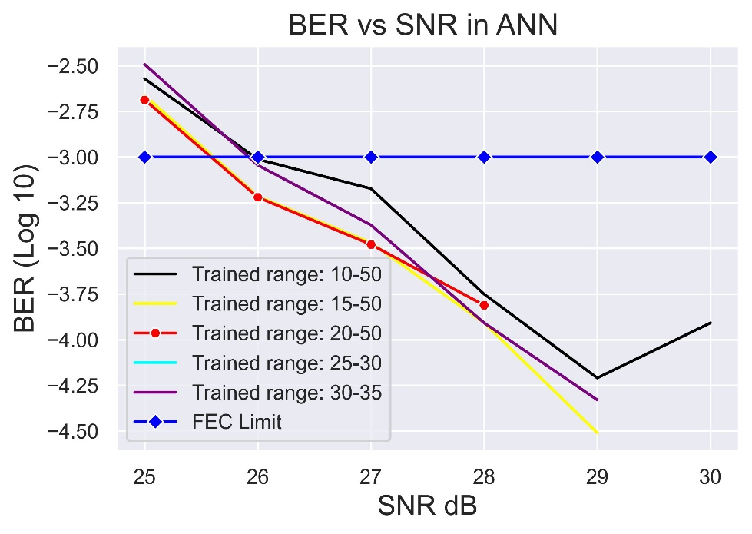

The comparison in the former plot shows that regardless of the training data range of the models in 26 dB the FEC limit is overcome. This explains the flexibility of the system and allows to have train the models in different data ranges if they go above 10 dB. As seen in former plots, when the range is below 10dB the BER increases and FEC methods need to be applied.

For the simulations performed the best model is under the data training set from 20 to 50 dB which with and SNR of 26 dB a 0.000609568 BER is achieved.

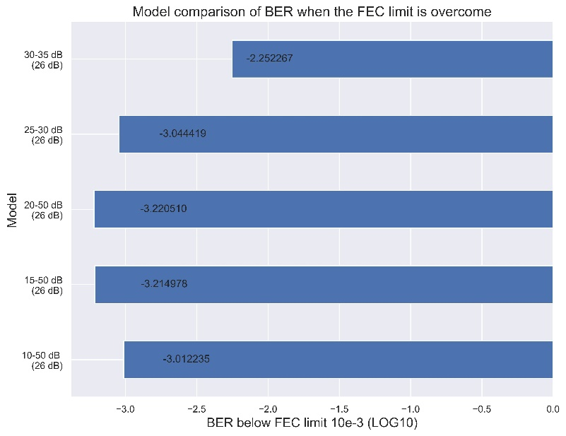

The former plot shows that there is a similarity in the BER values, to avoid FEC, when the SNR is 26 dB. The only significant difference is on the model with the data range of 30 to 35dB but still is better than the FEC limit.