Nest

# Information

Nest Developer Website: <https://developers.nest.com>

Android SDK: <https://github.com/nestlabs/android-sdk>

Android SDK documentation: <https://nestlabs.github.io/android-sdk>

Sample App: <https://github.com/nestlabs/android-sdk-sample>

Nest developer account

Email: [thermostat.project.nest@gmail.com](mailto:thermostat.project.nest@gmail.com)

Password: Project123!

# Instruction

To modify the Reward-base Thermostat Interface application:

1. Go to Nest developer website and sign-in with the Nest developer account.
2. Click “PRODUCTS” under the “Nest Developers” title will bring you to the product page.
3. Here you can find the “Reward-base Thermostat Interface” product, click it.
4. You can modify the product details here.

To modify contact and company information:

1. Go to Nest developer website and sign-in with the Nest developer account.
2. Click the email at top right corner of the website, then click “profile”.
3. Contact and company information can be found and edited here.

To use Nest Home Simulator:

1. Follow the instruction here: <https://developers.nest.com/documentation/cloud/home-simulator>
2. Use the Nest developer account to log-in.

Firebase

# Information

Firebase Website: <https://firebase.google.com>

Firebase Android API Reference: <https://firebase.google.com/docs/reference/android/packages>

Firebase Console: <https://console.firebase.google.com/?pli=1>

Firebase account

Email: [thermostat.project.firebase@gmail.com](mailto:thermostat.project.firebase@gmail.com)

Password: Project123!

# Instruction

To access the Firebase features:

1. Go to Firebase Console.
2. Log-in with the Firebase account.
3. Click the “Thermostat Interface” project

To manage users: Click the “Auth” tab on the left

To Access the real time database: Click the “Database” tab on the left

To export the database as JSON file: Click the button on top right corner, then select “Export JSON”

To use Remote Config feature: Click the “Remote Config” tab on the left

To change UI of the application remotely for all users:

1. Click “ui_mode” and change its default value to the UI mode you want.

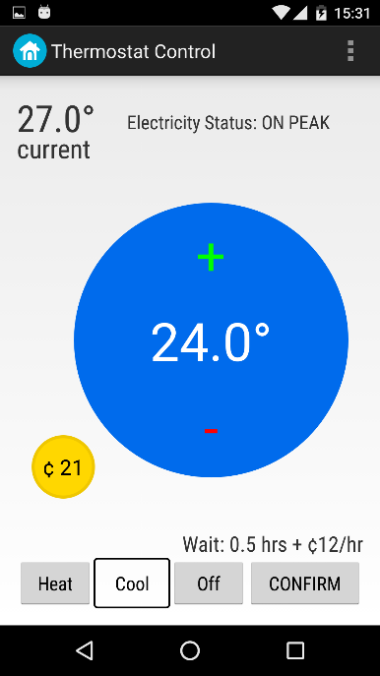 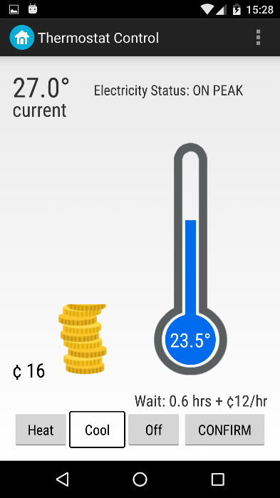 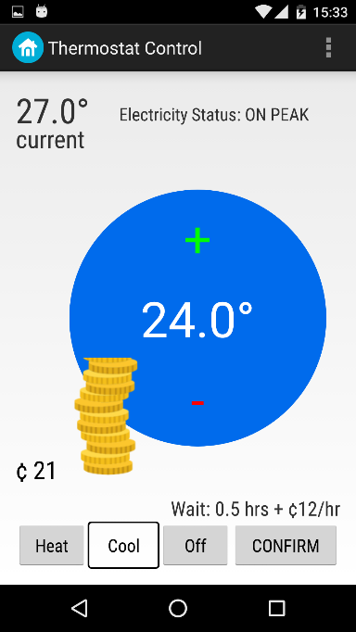

UI Mode 0 UI Mode 1 UI Mode 2

1. Click UPDATE then click PUBLISH CHANGES.
2. The users should be able to see the UI changes after they restart the application.

To change UI of the application remotely for a specific group of users:

1. Click “ui_mode”, then click “Add value for condition”, “Define new condition”
2. Select App ID as com.project.uoft.thermostat_interface
3. Select the user group you want to apply.

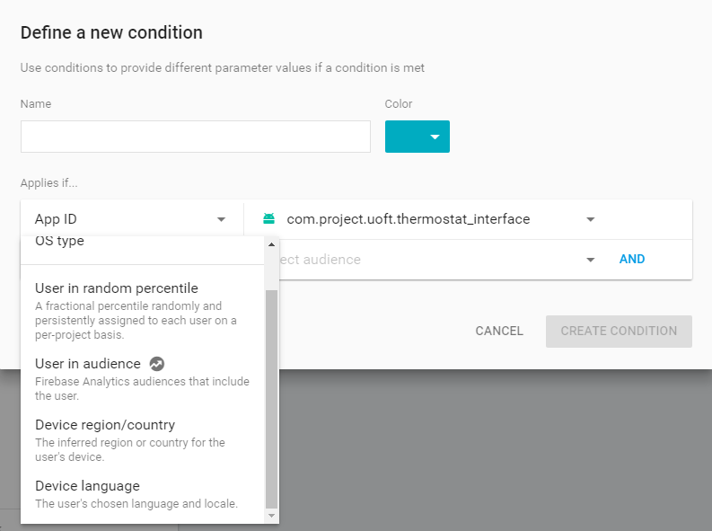

1. Give the condition a name and click “CREATE CONDITION”
2. Then you can define a new ui_mode value for the condition.
3. Click “UPDATE” and “PUBLISH CHANGES”

To use Firebase Analytics: Click the “Analytics” tab on the left

Password for Emails

[Thermostat.project.nest@gmail.com](mailto:Thermostat.project.nest@gmail.com)

[Thermostat.project.firebase@gmail.com](mailto:Thermostat.project.firebase@gmail.com)

Their pass word are the same: Project123!