***** Flashloader for ATMEAGA 644 microcontroller *****

(c) 2021 Cristian Zaslo, cristianzaslo@gmail.com

Development toolchain:
-> Compiler/Assembler: IAR Atmel AVR v2.28A/WIN
-> Code editor: X32 v3.0

Programming toolchain:
-> target with ATmega 644 ucontroller
-> serial programmer to write the flashloader
-> RS232-TTL converter (e.g. http://picprojects.org.uk/projects/simpleSIO/ssio.htm)
-> Windows 7/10 environment
-> FlashTool_AT644 or an equivalent tool to write the main application
-> link to FlashTool_AT644: https://github.com/cristianzaslo/FlashTool_ATmega644

Installation:
-> program the flashloader (flat644.hex) using a JATG interface or serial programmer (e.g. Atmel-ICE)
-> connect PD2 to GND; this step activates the flashloader upon reset
-> connect PDO (RXD0), PD1 (TXD0) and GND pins to RS232-TTL converter
-> connect RS232-TTL converter to host PC
-> run FlashTool_AT644 application and select the *.hex file application to download
-> reset the target; an 0x55 char will be sent by target and upon reception the download sequence is automatically started

Data exchange sequence between target and host:
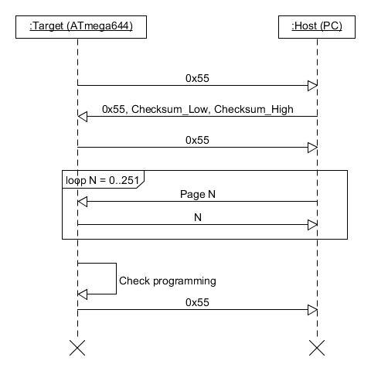

Remarks:

-> in case of communication error or incorrect checksum an 0xAA char is sent to host and download sequence is aborted
-> communication speed is 9600kb
-> flashloader size is 1kb, leaving 63kb free for main application
-> recommended lock bit and fuses protection modes after flashing the bootloader:
LB2 = 0, LB1 = 0 -> further programming and verification disabled
BOOTRST = 0 -> jump to flash loader after RESET
BOOTSZ1 = 1, BOOTSZ0 = 1 -> bootsize = 512 words (1024 bytes)

