***** Serial FlashTool for ATMEAGA 644 microcontroller *****

(c) 2021 Cristian Zaslo, cristianzaslo@gmail.com

Development toolchain:
-> Compiler/Assembler: Dev-C++ v5.11
-> Code editor: X32 v3.0

Programming toolchain:
-> target with ATmega 644 ucontroller and flat644.hex pre-programmed
-> link to flat644.hex: https://github.com/cristianzaslo/FlashLoader_ATmega644
-> RS232-TTL converter (e.g. http://picprojects.org.uk/projects/simpleSIO/ssio.htm)
-> Windows 7/10 environment

Installation:
-> connect RS232-TTL converter to host PC
-> switch target into flashloader mode (connect PD2 to GND)
-> copy FlashTool_AT644.bat, FlashTool_AT644.exe and the *.hex file to program into a common folder
-> run FlashTool_AT644.bat, select the COM number and select the *.hex file application to download
-> reset the target; an 0x55 char will be sent by the target and upon reception the download sequence is automatically started

Data exchange sequence between target and host:
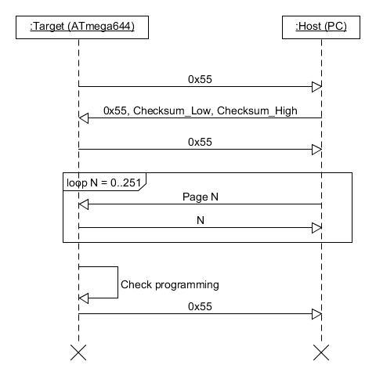
Remarks:

-> in case of communication error or incorrect checksum an 0xAA char is sent to host and download sequence is aborted
-> communication speed is 9600kb

