## Lab 7

We kept training the model up to 10000 iterations.

## 

It’s performance has improved quite significantly.

## Lab 6

We tried calculating the weights for the cross-entropy loss based on the prevalence of the classes in the data. We computed the weights of each class $c$ using the formula: $\frac{totalPixelsNo}{pixelsInClassNo(c)}$.

Applying this calculation on the dataset, we ended up with the following weights:

| **class** | **w** |
| --- | --- |
| background | 3.4872 |
| normal tissue | 1.4666 |
| benign lesion | 48.5861 |
| cancerous lesion | 92.7031 |

We started with the [base U2Net model](https://drive.google.com/uc?id=1ao1ovG1Qtx4b7EoskHXmi2E9rp5CHLcZ).

The model was trained for 1400 iterations, after which we evaluated its performance characteristics:

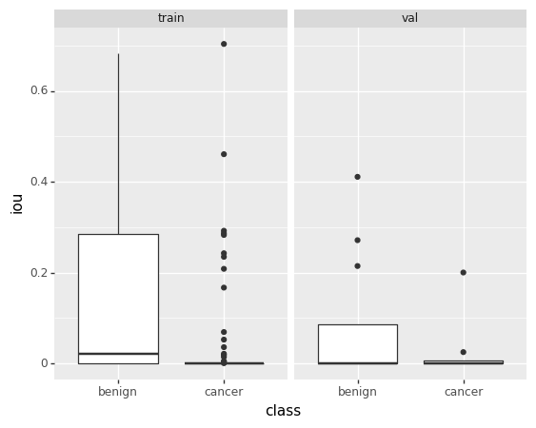

We kept training the model another 1200 iterations (for a total of 2600), after which we evaluated it once more:

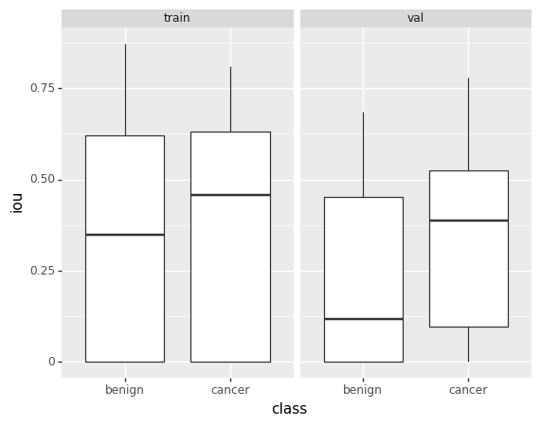

Its performance had improved, but was still not up to the level of the previous iteration.

## Lab 5

We noticed that the distribution of the classes in our dataset was quite uneven – the background and regular tissue classes were significantly more common than benign/cancerous lesions.

To combat this, in the calculation of the cross-entropy loss, we assigned a weight to each one of the classes. The higher the weight of a particular class is, the more importance is assigned to that class in the loss.

We manually picked weights for all the classes:

| **class** | **w** |
| --- | --- |
| background | 0.5 |
| normal tissue | 1 |
| benign lesion | 5 |
| cancerous lesion | 5 |

TODO: What was the starting point? Did the model start from scratch?

We trained the model for 1000 iterations, and obtained the following results:

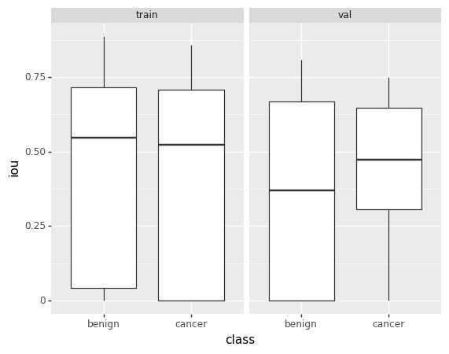

## Lab 4

## 

# Old

## Lab 4

Antrenam pe breast

## Lab 3

* (5) algoritm inteligent + small data
* (5) descriere algoritm inteligent

### Descriere algoritm inteligent

Clasificam toti pixelii din poza in 4 categorii:

* background
* normal
* benign
* cancer

Algoritm:

* Incarcam pozele de antrenare
* Incarcam categoriile
  + Categoria de “background” o obtinem facand flood fill pe fundalul negru al pozei
  + Crop
  + Restul pozei intra in categoria “normal”
  + Apoi, daca exista label-e pentru tumori (“benign” sau “cancer”) in poza respectiva, se pun dreptunghiuri peste categoria “normal”
* Augmentare de date
  + Posibil sa folosim displacement vectors
* Modelul de baza este U2Net, varianta “mare”
  + 3 canale de intrare, 4 canale de iesire
  + Plecam de la [modelul preantrenat pentru salient object detection](https://drive.google.com/uc?id=1ao1ovG1Qtx4b7EoskHXmi2E9rp5CHLcZ)
* Training loop
  + Trecem poza prin U2Net, calculam gradientii
  + Loss-ul este dat de cross-entropy intre saliency map-urile returnate de model, si label-urile asignate pixelilor

## Lab 2

* (10) flow-ul de baza
* (5) descriere functionalitati ale aplicatiei, descriere (plastica si formala) a problemei rezolvate cu ajutorul AI related work & useful tools and technologies

### functionalitati ale aplicatiei

* in aplicatie se incarca un fisier care reprezinta o felie a unei mamografii digitale cu tomosinteza
* aplicatia detecteaza portiuni ale mamografiei care pot fi tumori (sau lipsa acestora)
* fiecarei portiuni aplicatia ii atribuie o eticheta (tumoare benigna, canceroasa, etc.)

### descriere a problemei rezolvate:

* se usureaza detectarea tumorilor mamare
* se faciliteaza prevenirea cancerului de san (prin luarea regulata de mamografie, si testarea acesteia cu ajutorul aplicatiei)

### related work & useful tools and technologies

* [Development of an Artificial Intelligence-Based Breast Cancer Detection Model by Combining Mammograms and Medical Health Records](https://www.ncbi.nlm.nih.gov/pmc/articles/PMC9913958/)
  + Takes into account mammogram and health records
  + Transfer learning followed by classification
* [Breast Cancer Classification using Deep Learned Features Boosted with Handcrafted Features](https://arxiv.org/pdf/2206.12815.pdf) 
  + Proposes using handcrafted features (in conjunction with features obtained with transfer learning)
  + Handcrafted features, meaning: HOG (Histogram of Oriented Gradients), LBP (Local Binary Pattern)
* [U2Net](https://arxiv.org/pdf/2005.09007.pdf)
* PyTorch