File System & Cloud Simulator

- File System
The File System is a tree where the Directories are intermediate nodes or leaves and the Files are just leaves.
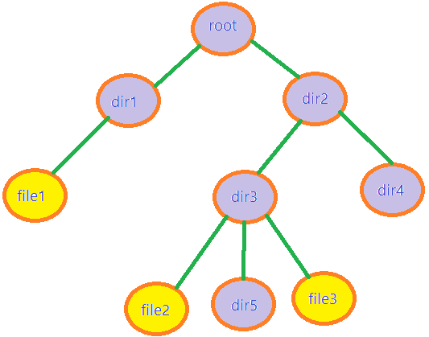
The TreeFileSystem class represents the tree itself. It contains a HashMap where is stored as key a Director and as value a Node.
A Node is an object where is stored his key from HashMap as current director, his parent and all his children.
Let’s presume that I am currently at Node dir3 from above. His parent is dir2, and his children are file2, dir5 and file3.
Class File extends Director.

- Users & Permissions
The users from the system are stored in a Management class called UserManagement. It’s a TreeSet adding users alphabetically and respects the Singleton Pattern. User class is an inner class.
Each user has particular permissions over each file and director from the system.
Each director/file has an array of permissions. A Permission is unique for each user and has 2 bool member to decide user’s rights.

- Restoring the System
Restoring the system after shutdown is possible because of SystemConfiguration class. Before beginning the system, the data is read from 3 configuration files stored at “src\cloud\Configurations”. After each shutdown the current configuration of system is written in these 3 files: directors.txt, files.txt, users.txt.

- Commands
Commands respect the Command Pattern. Command Interface has the execute method.
There are 4 kind of commands: read, write, independent of system, those for the cloud.
The abstract classes ReadCommand and WriteCommand verify the current user’s permission over a director/file.
For implementing the commands, also is used the Factory Pattern.
CommandsFactory class decides what command to execute.
CommandsConfiguration contains the methods of commands. Here is where the magic happens.
In CommandRunnable is read the command and sent forward for executing.

- Observator & Logger
Is respected Observer Pattern.
There are used 2 observers and a subject. Each time is thrown an Exception is notified ExceptionObserver. Each time a user logs in or logs out is notified UsersObserver. Each observer contains a Logger and writes in a file its log.

- Cloud
The cloud is divided in 3 store units which simulates 3 external real hard-drives.
In CloudService class are the methods for upload, sync and listcloud.
When a user wants to upload a director on cloud, first is checked if it is enough space for that director. Then is built a mini tree system for that director. If the director hasn’t got enough space for the first station, its files are divided to the rest of 2 stations.
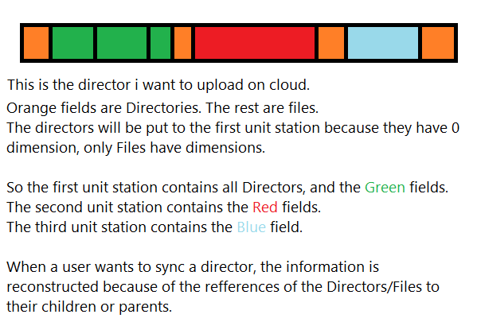

- Utilities
AutoComplete can be used when a user begins to write a command in terminal. When pressing TAB the text will be auto completed with the nearest possibility.
The History Helper can be used if a user presses Up Arrow or Down Arrow. It completes the text in terminal with the last executed command. With the arrows the user can navigate through last executed commands.

