

**Table of Contents**

**1. Purpose** **3**

**2. Pain Points and Limitations** **3**

**3. User Persona Assessment** **3**

**4. Assessment of Current vs Proposed Purchasing Process Flow** **4**

**5. Data Architecture** **4**

5.1 MAIN FARMER’S MARKET Google Sheet 4

5.1.1 Invoice Information 5

5.1.2 Products Sold 8

5.1.3 Inventory **10**

5.2 DASHBOARD Google Sheet 13

5.2.1 Descriptive Dashboard - “Statistics DB” tab 13

5.2.2 Optimizer - “Forecasting DB” tab 13

5.3 How Each Tab is Connected 13

5.4 Architecture of the Forecasting Framework 14

**6. Grocery List Tool** **14**

6.1 Forecast Demand models used 14

6.2 Optimizer 16

6.3 Front-End Dashboard Tool 18

**7. Step-by-step process/checklist on what a typical forecast cycle would look like** **19**

**8. How to Operationalize the Model Using Real Data** **20**

**Appendix A** **22**

**Appendix B** **23**

# **1. Purpose**

The purpose of this document is to guide members of Innovation Assistance (IA) around the proof-of-concept (POC) farmer’s market tool and provide recommendations on improving the ordering process.

# **2. Pain Points and Limitations**

* Moved to a new location that has limited fridge space as opposed to the prior location. This would mean that the tool, once in production, should be accurate in reducing the number of leftovers that IA may have after a market
* Sometimes there are a lot of leftovers after a market. To try and reduce waste, this food is donated to members or transformed into meals for resale, or else they go to waste
* IA only uses the Google suite (sheets, drive, docs, etc), as it is free of cost. They can’t afford to spend money on tools, making it a limitation to the development of the POC
* Currently, not enough real data is collected on what and how much was sold at the markets, making it difficult to build forecasting models with the goal of accuracy at this phase in the POC

# **3. User Persona Assessment**

There are two full-time workers at Innovation Assistance who are in charge of running the bi-weekly farmer’s markets. They are Micah Angell (floor manager) and Erin Wen (operations manager). Since IA’s creation in April 2020, the two have noticed an increased need for food assistance. They are looking to help increase access to fresh produce at a cheaper cost to those in the Peter McGill community with the solidarity farmer’s market.

To do this, they have shifted the model from monthly markets to twice-a-month markets during the summer, and if successful, are looking to shift the model to weekly in the fall. To keep up with this demand, having a forecasting tool to help them better manage their budget and reduce leftovers would be essential in helping them achieve their mission.

As both are not technical people and cannot afford to spend money on tools, the final solution must incorporate the Google suite, as this is what they currently use, are comfortable with, and is free of cost.

# **4. Assessment of Current vs Proposed Purchasing Process Flow**

The current purchasing process starts with members of IA making an educated guess on how much produce they should order for their farmer’s market. This gets written down on a Google Sheet that is then shared with their key supplier, who tries their best to fulfill the grocery list given their budget and what is in stock with the farmers. This order then gets shipped to IA with an approximate 2-week lead time, in time for their bi-weekly market. Any leftovers from the market are then transformed and resold or donated to members of IA.

For our POC tool to work, we need to make modifications to the current purchasing process for it to be deemed usable in the future. The process should start with IA requesting a quote from the supplier that contains information on what products are available for sale, their quantities, and their cost. 1 master Google Sheet is used for data collection and must be consistently updated after every market with the latest information. This file is then automatically loaded into a Google Colab file that only requires IA to click the “Run” button to generate the forecasted demand of products and the optimizer that will provide them with an optimized grocery list. With this optimized list, they can place their order with the supplier.

The benefit of including a step for a quote allows IA to have more certainty as to which products are available for sale, as well as what the expected cost is without putting the control in the hands of the supplier to sell them other products that may not be in-line with their budget. It essentially shifts their operating approach from one that is passive to one that is proactive. The forecast and optimizer tool will be able to generate a proposed grocery list within minutes, allowing IA to make more educated decisions with the data they have, which should help reduce spending and potential waste. Please refer to Appendix A for the process flow maps of the current vs proposed ordering process.

# **5. Data Architecture**

## **5.1 MAIN FARMER’S MARKET Google Sheet**

When you open the master google sheet (called “main farmer’s market”), the first tab that opens is the “Summary”, which lists all the tabs within the file, a link to that specific tab for easy navigation, and a brief description on what that tab contains:

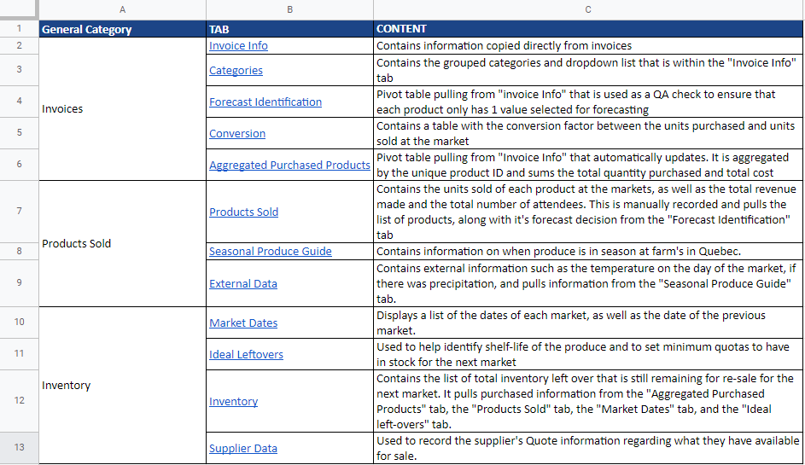

*1. Summary Tab*

Within the master Google sheet, there are 3 key sections/categories that are important to keep updated, and that which are used within the tool:

* Invoice Information
* Products Sold
* Inventory

### **5.1.1 Invoice Information**

**5.1.1.1 Invoice Info:**

This Google sheet contains information from invoices. Columns A to H have information that is copied directly from the invoices. Total Cost (Column H), is calculated as the quantity (Column D) x Unit Invoice Price (Column G). All of this information has to be manually entered (if the original invoice is only provided as a PDF) or can be copy-pasted from an excel invoice.

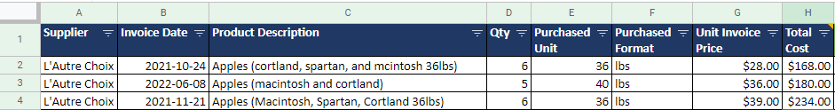

*2. Sample of Columns A to H in the Invoice Info Tab*

Columns I to Q are additional information that is manually recorded.

* Column I is a general product description based on the Product Description in column C.
* Column J is a product category that is based on the value written in Column I. This is already predefined in a list within the tab called “Categories” and uses a Vlookup based on the value in column I. If there is a new product in column I, you must add it to the list in the “Categories” tab and assign it an appropriate category. For example, if you never purchased apples before, you need to record this and assign a group to it, such as “fruits”.
* Column K is the unit price calculated as the division of the Unit Invoice Price (Column G) over the Purchased Unit (Column E).
* Column L is the total quantities within the purchased format and calculated as the Purchased Unit (Column E) multiplied by the Quantity (Column D).
* Column M references the Purchased Format in Column F for readability.
* Column N is for any comments or assumptions as required.
* Column O is a drop-down selection that allows you to determine whether or not you want to forecast this product. The data within the dropdown reference values within the “Categories” tab.
* Column P is the market date on which that purchased product was for.
* Column Q is a unique identifier that is to be used to link with other tabs within the master google sheet. It is the concatenation of the Market Date (Column P) and the Product description (Column I). Within the “Invoice Info” tab, the same Unique ID may exist in more than one row if the product was purchased more than once for the same market. This will not be an issue for linking between other tabs, as these values would be aggregated within a pivot table (“Aggregated Purchased Products”) for referencing between tabs.



*3. Sample of Columns C to Q in the Invoice Info Tab*

For the values in Columns J and O, here is a sample of the options used within the drop-downs that come from the “Categories” tab:

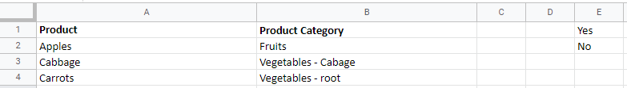

*4. Sample of the Categories Tab*

**5.1.1.2 Forecast Identification**

This tab contains a pivot table from the “Invoice Info” tab, in which the Product (column A) and the “To Forecast?” (column B) columns are used as rows to display the decision for each product on whether to forecast or not. This is used as a quality assurance (QA) check to ensure that all values of “To Forecast?” are the same for each product. If a product has both “Yes” and “No” written, you need to go back into the “Invoice Info” tab and make the correction. This pivot table will automatically update and requires no manual intervention. Columns D to I are additional columns used for QA to ensure that if there is a new product that is purchased and has “Yes” for the “To Forecast?”, its information in these tabs must be added to ensure that the forecast can run without error. Information that is missing for new products uses a red highlight with conditional formatting, advising that the product is missing in the tab. These columns use various formulas that can simply be copy-pasted for new products and require no additional modifications.

* Column D uses a vlookup with the “Conversion” tab
* Column E uses a vlookup with the “Products Sold” tab
* Column F uses an hlookup with the “Seasonal Produce Guide” tab
* Column G uses a vlookup with the “Ideal leftovers” tab
* Column H uses a vlookup with the “ Inventory” tab
* Column I uses a vlookup with the “ Supplier data” tab

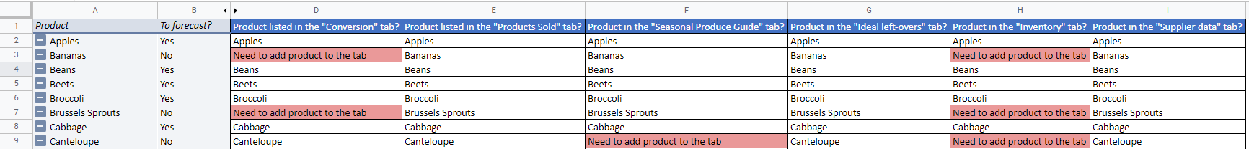

*5. Sample of the Categories Tab*

**5.1.1.3 Conversion**

This tab contains information on assumptions made for converting the purchased unit to the sold unit. For example, apples are purchased in pounds. However, when they are sold at the market, they are sold on a “per unit” (i.e. 1 apple) basis.

* Column A contains the product description (which needs to be written the same way as the product descriptions in column I of the “Invoice Info” tab).
* Column B is the unit in which the product is purchased and uses a vlookup to pull this information from column M in the “Invoice Info” tab.
* Column C is the unit the product is sold in (needs to match as a consistent unit across all markets).
* Column E contains the conversion value between the “Sold in” unit vs. the “Purchased as” unit.
* Column F clarifies what the value in Column F means. Wherever there is an “X”, this means the value corresponds to what is in Column F.
* Column G is the reference used to make the conversion assumptions. It is important to note that if there is a product you want to forecast and it is not currently included in this tab, you must add it to this table, along with its appropriate conversion value.



*6. Sample of the Conversion Tab*

**5.1.1.4 Aggregated Purchased Products**

This tab contains a pivot table using information from the “Invoice Info” tab, along with the “Conversion” tab. The pivot table uses the “Unique ID” (column A) and the “Product” description (column B) as rows, along with the “Total Quantities in Purchased Format” (column C) and “Total Cost” (column D) as aggregated sums. Column E references the value in column C, as making calculations using direct references from the pivot does not work. Column F uses a vlookup to bring in the conversion factor value of the product from the “Conversion” tab. Lastly, Column G converts the value in Column E using the conversion value in Column F. It is ok to have values in this column as blank, so long as it is not a product to be forecasted. If it is a product to be forecasted, it is important to record the necessary information within the “Conversion” tab.

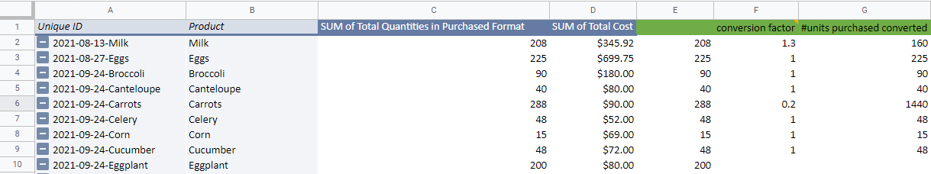

*7. Sample of the Aggregated Purchased Products Tab*

### **5.1.2 Products Sold**

**5.1.2.1 Products Sold**

This tab displays how much of each type of product was sold at the markets, along with the revenue generated, and how many people attended the market.

* Row 2 contains the total revenue information that requires to be manually entered.
* Row 3 contains the total attendee information and requires to be manually entered.
* Column A contains the product description. These values are directly pulled from the Forecast Identification tab
* Column B contains the “To Forecast?” values directly from the “Forecast Identification” tab.
* Columns C to Q contains information on how much of each product was sold at the market. The values pull from the “Solidarity Market Inventory” file will automatically be populated by copying the formula for the previous market and just changing the name of the tab to the respective market’s tab. **Important - the “Solidarity Market Inventory” must be the same file structure each time. Therefore, in the second row, it is important to include the total sum of the products sold so that these values can get pulled correctly into the Products Sold tab.**

For demonstration purposes, we created synthetic data within the sheet that comes from 3 sources:

* Market dates in green = real market data provided by IA
* Market dates in orange = uses synthetic data from the Synthetic Data google sheet
* Market dates in yellow = uses a random function that pulls from the green and orange market dates

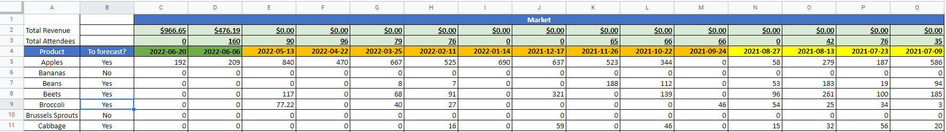

*8. Sample of the Products Sold Tab*

**5.1.2.2 Seasonal Produce Guide**

This tab contains information from équiterre on when products are in season in Quebec. This information was manually entered, along with additional products (highlighted in orange) that were added from online research. Where it is written “1” means that the product is in season during that month, otherwise, it is not in season. It is important to note that products that were purchased and that are not currently on the list must be added if they are to be forecasted. This is because some forecasting models incorporate this information, which would otherwise result in an error when running the code.

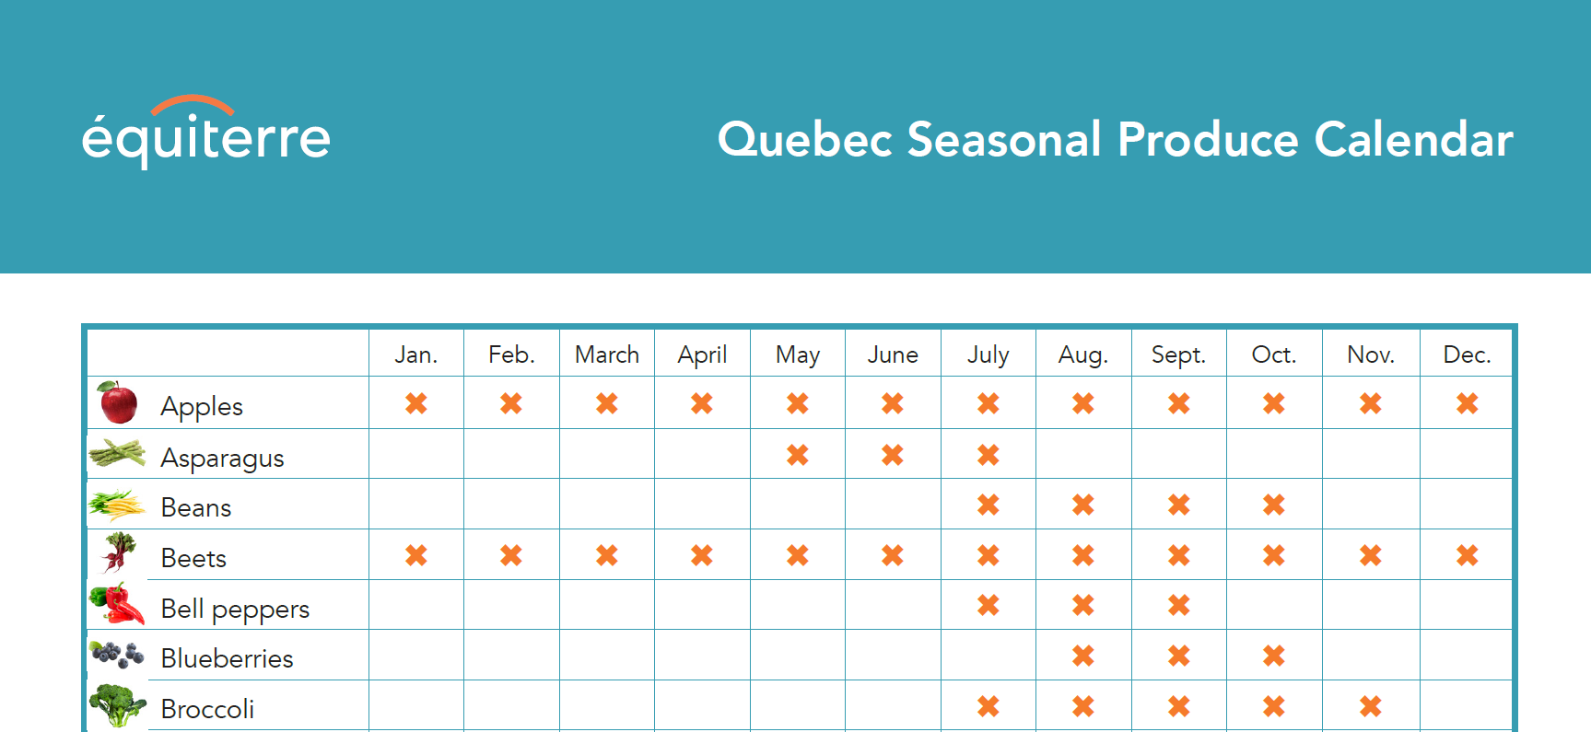

*9. Sample of the Quebec Seasonal Produce Calendar from équiterre*

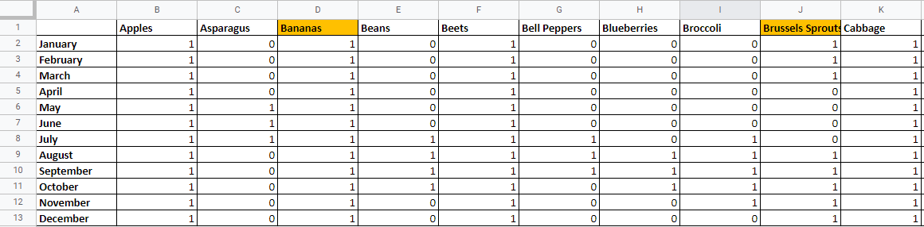

*10. Sample of the Seasonal Produce Guide Tab*

**5.1.2.3 External Data**

This tab contains various sources of external information that are used within the forecasting models. Columns A-C need to be manually entered, where column A contains the date of the market, column B the temperature in celsius on the day of the market, and column C a binary value that indicates if there was precipitation (i.e. rain, snow). Columns B and C can utilize any weather forecast website to get this information. Columns D onward use an hlookup formula, along with an “if” statement to pull in the seasonal produce guide information that would display whether or not each product is in season during the specified date of the market. The list of products in row 1 starting in column D are automatically updated and linked to the “Seasonal Produce Guide” tab.



*11. Example “If” Statement for Apples*

It is important to note that when you are planning on generating a forecast for your next market, **you must add the necessary information about that upcoming market to the file**. You would essentially have to add a new row, input the date of the market, what the weather and precipitation forecast is, and drag the formulas from column D onward to your new row. Once the market happens, it is important to update the weather and precipitation information to what was recorded on that day. It was designed this way to minimize any contact with the Google Colab code file, considering the users of the tool do not understand the code. The following sample shows how the values for the upcoming market are highlighted in yellow.

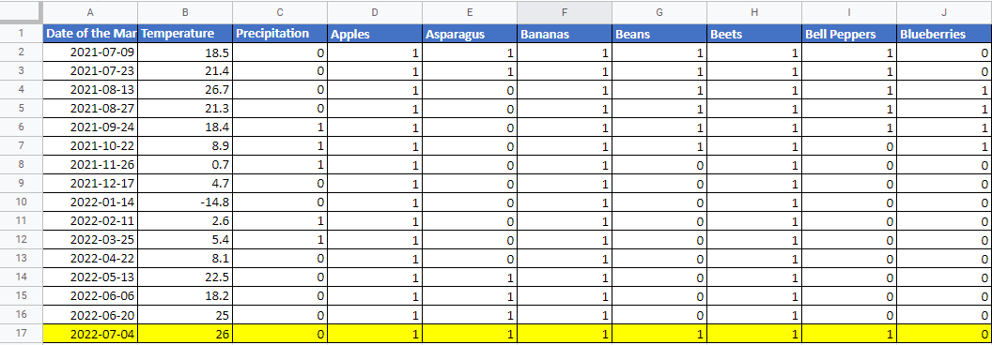

*12. Sample of the External Data Tab*

### **5.1.3 Inventory**

**5.1.3.1 Market Dates**

This tab contains the list of market dates (column A) and the date of the previous market (column B). Dates in column A must be manually entered for each market date. Dates in column B reference the previous date in column A. To add a new date, always insert from row 2 and copy the formula in B.

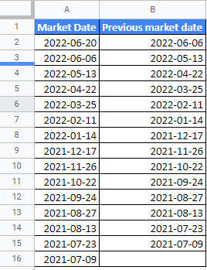

*13. Sample of the Market Dates Tab*

**5.1.3.2 Ideal left-overs**

This tab contains information on the shelf-life of each product and whether it can be resold at the next market. Column A contains the list of products. Column B contains a “yes” or “no” value on whether the product can be resold at the market. This is an assumption made from the information in column C. Column C contains comments and web links to back up the assumptions written in column B. If there is a new product, it is important to add the information for it in this tab, even if it is not being forecasted, because these values are tracked within the Inventory tab.

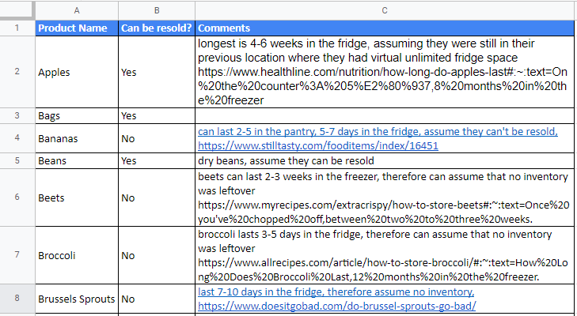

*14. Sample of the Ideal Leftovers Tab*

**5.1.3.3 Inventory**

This tab contains information regarding what is in stock/leftover inventory that can be resold at the next market. Columns A, B, and G require manual entry, and Columns C-F and H-L are automatically updated using various formulas.

* Column A contains the date of the market.
* Column B contains the product name.
* Column C is the unique ID that concatenates the values of the market date with the product name.
* Column D contains the total amount purchased of the product that vlookup’s the value from the “Aggregated Purchased Products” tab.
* Column E contains the total cost of the product that vlookup’s the value from the “Aggregated Purchased Products” tab.
* Column F contains the amount of inventory that was leftover from the previous market that is good for resale at the next market. This pulls the value from Column K based on the previous market date from the “Market Dates” tab.
* Column G contains how much of the product is available from the IA garden.
* Column H is the summation of columns D, F, and G to get the total amount of the product available for sale.
* Column I uses an index match function to pull information on how much was sold at the market from the “Products Sold” tab.
* Column J displays how much inventory there is leftover from the market by subtracting values from columns I to H.
* Column K uses a vlookup and if statement to determine whether the value listed in column J can be resold at the next market.
* Column L calculates the difference between columns J and K in order to get the total lost inventory (i.e., products that could not be resold at the market and therefore are considered “wasted”).

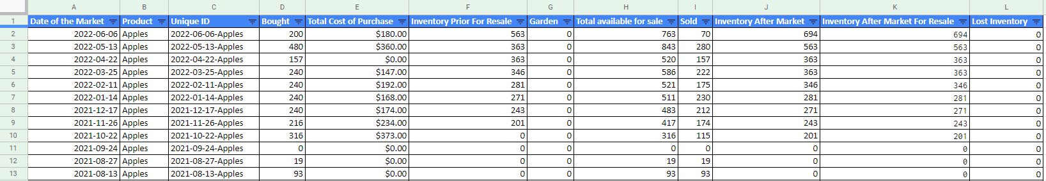

*15. Sample of the Inventory Tab*

It is important to record this information after each market, as this will help determine how much of each product may need to be purchased for the next market. To do this, copy the list of products in column A in the “Products sold” tab, paste them into column B. Then input the market date in column A. For columns C to L, copy-paste a previous market’s records and paste them. These columns contain formulas that will automatically update. Lastly, ensure that you adjust the “Garden” inventory accordingly.

**5.1.3.4 Supplier Data**

This tab contains information that is manually entered from supplier quotes, along with the available budget for the market. Row 1 allows you to select a market date from a dropdown selection. Row 2 requires input on the budget constraint. Column A contains the list of products. If there is a new product, it needs to be added to the list. Column B contains information on how much is available for sale at the farmer’s market. Column C displays the unit price of the product for sale. Column D contains the format in which the product is purchased.

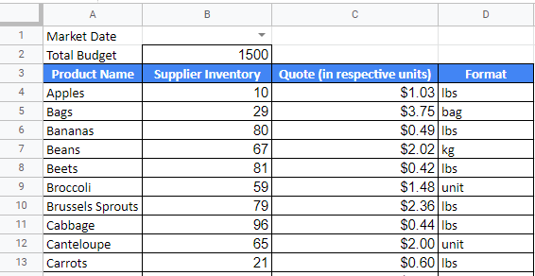

*16. Sample of the Supplier Data Tab*

## **5.2 DASHBOARD Google Sheet**

### **5.2.1 Descriptive Dashboard - “Statistics DB” tab**

## 

To build the plots displayed in the descriptive dashboard, we first had to import the necessary data into the sheet. In particular, we had to import the following tabs from the MAIN FARMER’S MARKET sheet:

* Invoice Info: All columns were imported.
* Inventory: All columns were imported.
* Conversion: Only the “Product” and “Purchased as” columns were imported.
* Products Sold: Only the “Date of Market”, “Total Revenue” and “Total Attendees” columns were imported.

Additionally, a new tab called “Drop-Down Formatting” was created using the Inventory and Conversion tabs and includes unique values of fruits with their associated units and market dates. This tab is used in the formatting of the filters.

### **5.2.2 Optimizer - “Forecasting DB” tab**

To run, the optimizer needs the following information: Supplier’s quotes, inventory levels and IA’s total budget, inventory from their garden and reusable leftovers. This data can be found in the data architecture (Inventory and Supplier data tabs). The Google Colab code file (“Code.ipynb) that contains the model, queries this data directly from the master Google sheet (MAIN FARMER’S MARKET). After solving the model, the results are directly displayed on the Forecasting DB tab of the DASHBOARD Google sheet.

## **5.3 How Each Tab is Connected**

To help visually see what information is connected with each of the tabs, we’ve put together an entity-relationship diagram. Those tabs containing information (i.e. tabs used for drop-down selection lists were not included) are represented in 2 colours. Those in blue represent the tabs in the master Google sheet, and those in green are the tabs in the Dashboard Google sheet. Please refer to Appendix B for the diagram.

## **5.4 Architecture of the Forecasting Framework**

The following is an architecture diagram that showcases high-level how the tools used throughout the framework are connected, allowing for the flow of information. There are five major components: data sources, input, analysis, output, and storage. 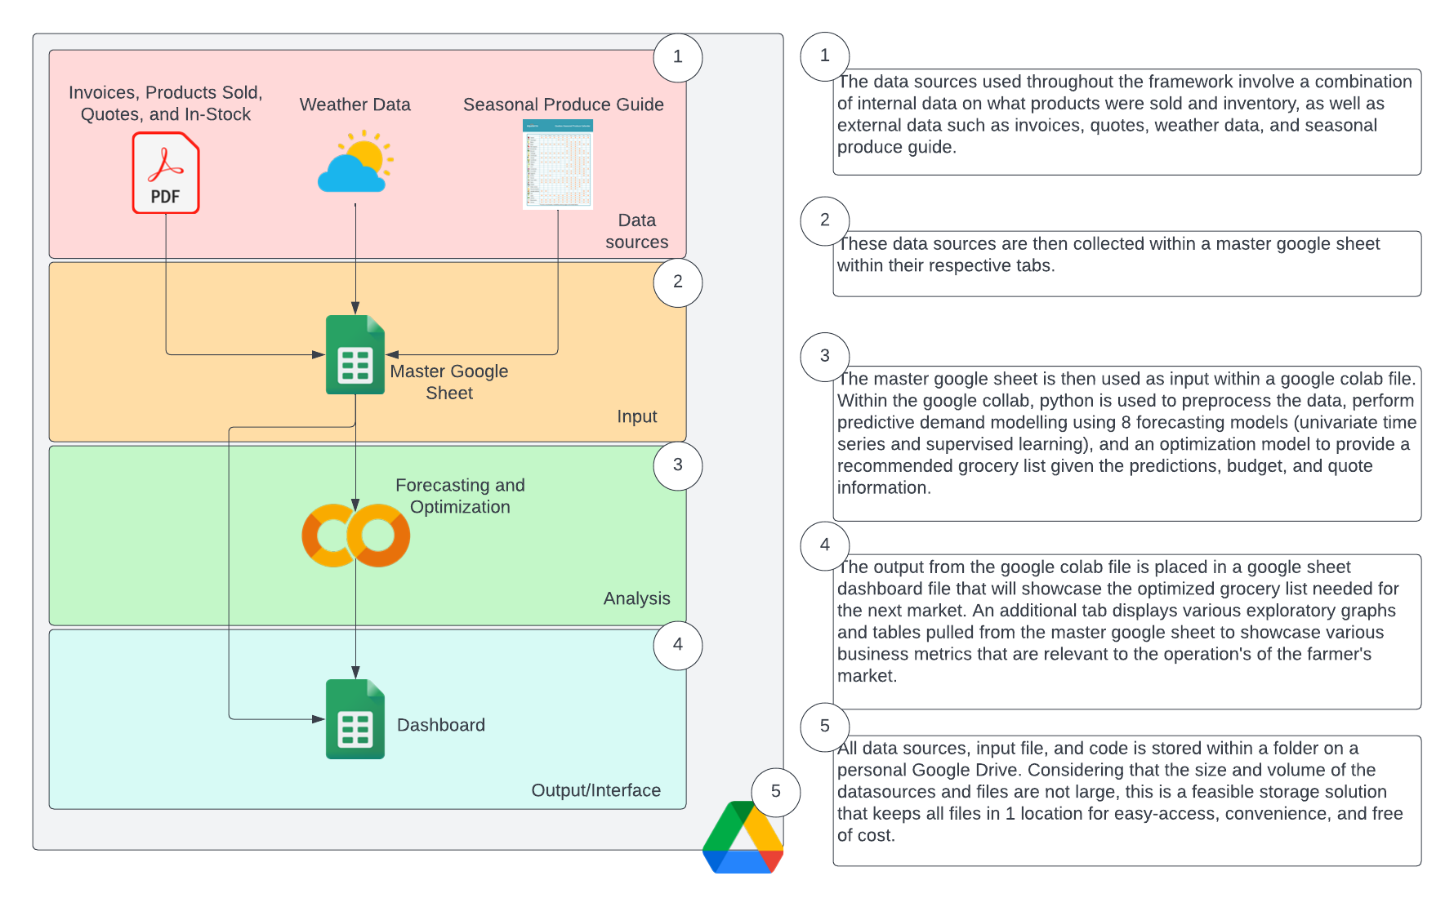

*17. Architecture Diagram*

# **6. Grocery List Tool**

The grocery list tool that we have developed as a proof of concept contains forecasting and optimization models coded using the python language in Google Colab, that outputs the results on what to purchase into a grocery list dashboard created in Google Sheets. We’ll take a closer look at each component of this tool and how it is set up.

## **6.1 Forecast Demand models used**

The data source used within the forecasting model pulls from 3 tabs within the master google sheet: Products Sold (used to predict demand and understand the amount to purchase), External Data (used within the supervised learning models), and Conversion (used to convert the forecasted value into the purchase unit of the supplier). The pandas package was used to convert these data into data frames and apply data cleaning and formatting to be used within the forecasting models.

Since we are working with synthetic data, the focus of the forecasting models at this phase in the POC is not to produce accurate results, but rather to put together a framework that uses multiple forecasting models within a competition using the mean absolute percentage error as the accuracy measure to choose the best model for each product (using the sklearn metrics package). This measure of accuracy was chosen, due to it being easy to comprehend for IA users.

With the architecture we have set up within the excel files, as IA gathers real data, they would not be required to make any modifications within the code, rather just clicking the run button to produce the results as follows: click on “Runtime”, then “Run all”. You will be asked to authorize your Gmail account, make sure you click agree.



*18. Where to Run the Code*

As a future extension of this POC, we recommend that once a sufficient amount of real data is collected, revisit the models produced and focus on building models that produce accurate results.

Within the forecasting model competition, we created eight different models, using a combination of univariate time series (using the stats models package) and supervised learning models (using the sklearn package) to predict 1 period ahead:

* Moving average
* Auto arima
* Seasonal auto arima
* Simple exponential smoothing
* Holt winter’s exponential smoothing
* Naive forecasting
* Random forest
* Multiple linear regression

Considering that prices being charged at the market are low, as well as offering a pay-what-you-can system for members, price, in the end, we have made the assumption that it would not be a significant factor in determining demand. However, in an effort to identify other factors that may impact demand, we’ve identified weather, precipitation, and a seasonal produce guide as potentially beneficial sources of information that can help boost model performance in our supervised models. Logically, we can make the assumption that when the weather is not nice/has precipitation in the forecast, this may potentially impact the total number of attendees to the market. The seasonal guide is also a good source in determining demand because all the produce that is purchased comes from Quebec farms and therefore would help signal in the model that demand for such a product may decrease if it is no longer in season. Of course, there could be potential to have multicollinearity between the seasonal guide, weather, and precipitation. However, once more real data has been gathered, a multicollinearity analysis should be done to not only identify which variables should be kept within the models, but to also see how effective these sources of data really are at predicting demand. For now at this stage in the POC, we have created the framework to allow for the collection and usage within the models to demonstrate how they can be incorporated within the framework.

The train/test split used to test the models is set to 90/10, as the only output we need from the model is for 1 period in the future. Therefore, we can use more data for training and capturing any seasonal patterns that may occur within the demand.

## **6.2 Optimizer**

The optimization model is a key part of our tool, as it allows us to know how much to order from suppliers to minimize leftovers while being constrained to a budget all while fulfilling, as much as possible, the demand forecasted by the forecasting models we have built.

The optimization model is a linear mixed integer problem (MIP), as it includes continuous and binary decision variables. The package that was used in Google Colab to solve the model is [pulp](https://coin-or.github.io/pulp/).

The formulation of the MIP is as follows:

1. Decision Variables:

* : Quantity of product i to order from suppliers
* : Expected Sales for product i
* : First binary variable to control for demand fulfillment constraint
* : Second binary variable to control for demand fulfillment constraint

1. Data Required:

* : Total suppliers’ inventory for product i
* : Forecasted demand for product i
* : Total inventory produced in garden for product i
* : Total leftovers from previous market for product i
* : Supplier quote (in $ per respective unit) for product i
* B : Total budget
* M: Very big number

1. Objective Function:
2. Constraints

* Data type constraints:
* is continuous and greater than 0
* is continuous and greater than 0
* is binary and can only take on the values 0 and 1
* is binary and can only take on the values 0 and 1
* Budget constraints: The total cost should not exceed budget
* Supplier constraints: We cannot order more than what suppliers have in their inventory
* for all i
* Sales constraints: Sales is the minimum between demand and total pre-market inventory
* for all i
* for all i
* Demand fulfillment constraint:

→ If the sum of suppliers’ total inventory, leftovers and garden produce is enough to cover the forecasted demand then only order what is needed to exactly match the demand.

→ If the sum of suppliers’ total inventory, leftovers and garden produce is not enough to cover the forecasted demand then order all of suppliers’ inventory.

This more complex constraint can be modeled as follows:

All units should be specific to each product (e.g. Apples are in lbs). Please refer to the Conversion tab in the MAIN FARMER’S MARKET file for the full list of products and respective units.

The output of the optimizer is then directly displayed on the dashboard as a table. The table has 4 sections:

1. Product:

* **Unit**: Unit clarification for each produce.
* **Product Name**: Produce name.

1. Total Available Supply

* **Total Suppliers Inventory**: Total quantity available to order.
* **From Garden**: : Total quantity of produce grown in IY’s garden.
* **From Previous Market**: Total Quantity of leftovers from previous market.

1. Market Inventory Planning

* **Forecasted Demand**: Predicted demand from our forecasting models.
* **Quantity to Order from Suppliers**: Grocery list to be sent to suppliers.
* **Quantity from Garden/Previous Market**: Quantity to sell from garden and previous leftovers.
* **Forecasted Sales:** Expected sales when taking into account demand and supply.
* **Forecasted Leftovers**: Expected leftovers when taking into account inventory and sales.

1. KPI

* **% Fulfilled Demand**: This represents how much of the demand was fulfilled.
* **Leftover reduction from previous market**: This represents how much IY was able to reduce leftovers

## **6.3 Front-End Dashboard Tool**

The Front-End Dashboard was built on Google Sheets, as Google provides cross-platform integration. The main components of the dashboard are the first two tabs:

* **Statistics DB:** This tab provides summary statistics in the form of plots on the overall health of the market. It also provides other information (leftover, sales, cost) on products. The dashboard includes two types of filter; Date and Product. Users of the dashboard can filter all plots on the dashboard by date. The product filter however, only governs the four last plots (in the Inventory Management section)
* **Forecasting DB**: This tab outlays the table outputted by the optimizer model described in the previous section.

The other tabs in the dashboard are data imports. More specifically, we first had to import the relevant data before querying it in the “Statistics DB” tab to build the plots. The dashboard was built to automatically integrate new data added to the data architecture.

To add new plots, the dashboard operator will first have to import the data in a new sheet using the [IMPORTRANGE()](https://support.google.com/docs/answer/3093340?hl=en) function and then query the data in the “Statistics DB” tab using the [QUERY()](https://support.google.com/docs/answer/3093343?hl=en) function in a similar fashion as what was done.

# **7. Step-by-step process/checklist on what a typical forecast cycle would look like**

When you are preparing for the new market, we recommend you use the following step-by-step process to ensure that no steps are missed along the way:

* Choose which products to forecast for the next market by updating the “To forecast?” column in the “Invoice Info” tab in the master google sheet. Make sure that all the latest invoice information is added as well
* In the “Forecast Identification” tab:
  + Double-check that each product listed within the “Forecast Identification” tab in the master google sheet has 1 choice in the “To forecast?” column. If any of the products have both “Yes” and “No” values, go back into the “Invoice Info” tab and make the correction.
  + If there are any products highlighted in red advising that they need to be added to a specific tab, please do so if the product is selected for the forecast. Otherwise, no need to add the information
    - Add products to the “Conversion” tab
    - Add products to the “Products Sold” tab
    - Add products to the “Seasonal Produce Guide” tab
    - Add products to the “Ideal-leftovers” tab
    - Add products to the “Inventory” tab
    - Add products to the “Supplier data” tab
* In the “Aggregated Purchased Products”, ensure formulas for columns E-G are copied for any additional data in the pivot table
* In the “Products Sold” tab, ensure that all the latest market information was added
* In the “External Data” tab,
  + Ensure a line is added for the market you are forecasting:
    - Add the market date
    - Add the forecasted temperature
    - Add the forecasted precipitation
    - Copy-paste the formula from column D onward
  + Ensure that the temperature and precipitation data of the previous market are updated with the actuals
* In the “Market Data” tab, ensure that the latest market date and its previous date are in the table
* In the “Inventory” tab, ensure that all the latest inventory information is up to date from the previous market
* Received a quote from the supplier
  + Input quote information, along with the available budget for the next market in the “Supplier data” tab in the master google sheet
* Run the forecast-optimization code in Google Collab
* Observe the suggested grocery list in the Dashboard
* Place an order with the supplier
* Receive order and invoice
* Add invoice information in the “Invoice Info” tab
* Go to market
* Update units sold in the “Product Sold” tab
* Update units left-over in the “Inventory” tab
  + If any inventory is leftover that cannot be resold, donate it to members/transform it into food

# **8. How to Operationalize the Models Using Real Data**

As mentioned previously in section 5.1.2.1 Products Sold, the majority of the data used throughout the POC is synthetic. We recommend that IA collect information on **1 year’s worth of markets** (assuming a minimum of 24 data points if IA decides to maintain only a bi-weekly market), to have enough data that captures all seasons.

Once this data is collected, for the framework to be operationalized, IA must delete the data in the following tabs of the master google sheet:

* **Products Sold tab**: delete all columns with dates in row 4 highlighted in orange and yellow

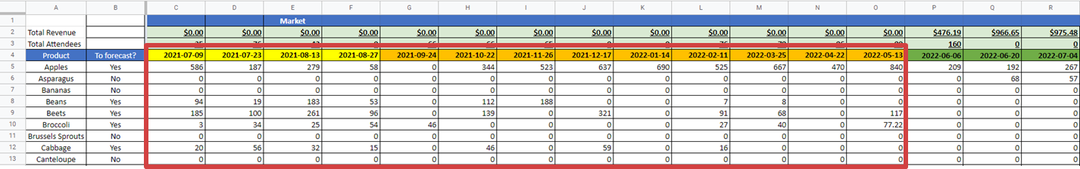

* **Inventory tab**: delete all rows where the “Date of the Market” column has dates corresponding to the orange and yellow dates in the above screenshot.
  + For column K “Inventory After Market for Resale”, double check that the values listed here are correct in terms of inventory leftover. As previously explained, this column uses an if and vlookup statement to determine whether or not the amount left over listed in column J “Inventory After Market” can be resold based on the “Ideal leftovers” tab. Here, we had assumed that if the product can be resold based on the “Idea leftovers” tab, then it will take the full value listed in column J “Inventory After Market”, otherwise, the inventory leftover would be 0. It may be that if the product can be resold, not all of the inventory values listed in column J will end up being resold (i.e. may decide to still donate some of the food or convert it to food anyways). If this is the case, you can manually override the formula in column K to adjust the final value available for resale at the next market.

# **Appendix A**

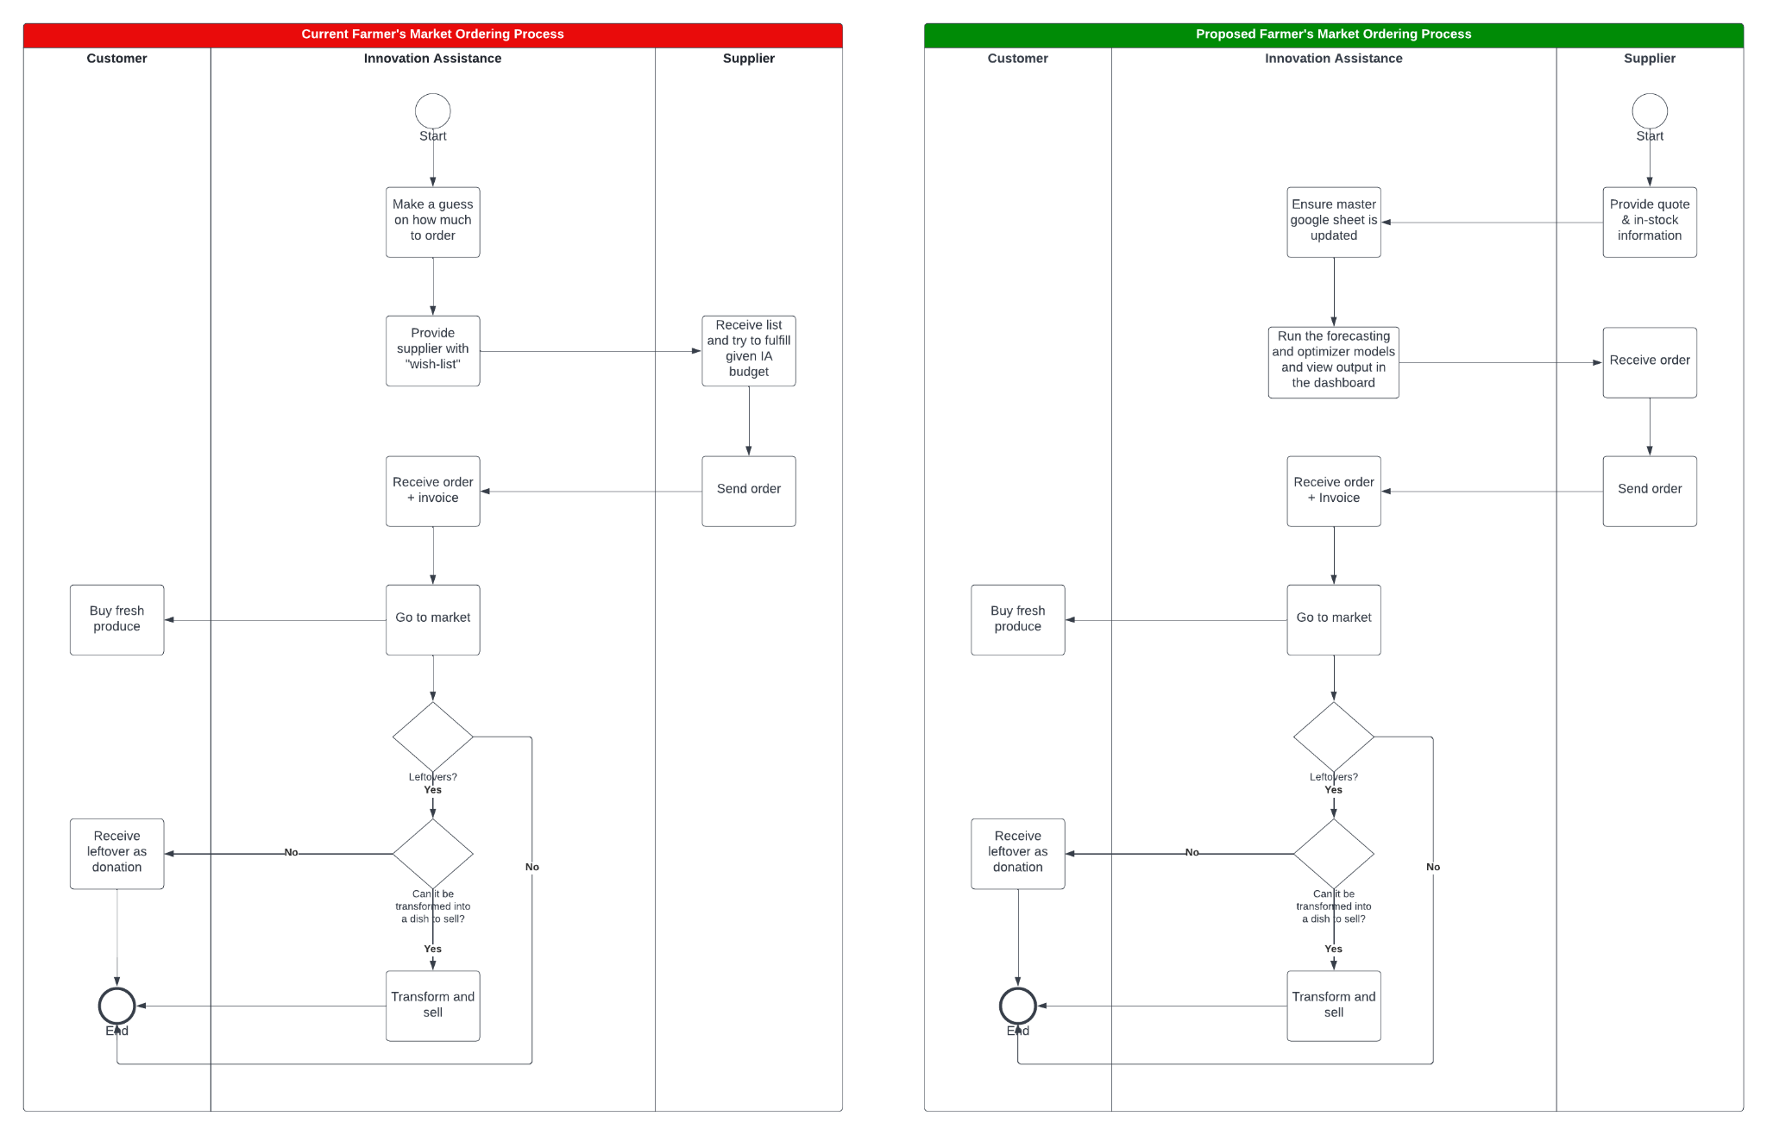

# **Appendix B**

The arrows in red represent information that is used within the forecasting and optimization models.