DOCUMENTATION

PROJECT 1

STUDENT NAME: FĂȚAN CRISTINA
GROUP: 30224

CONTENTS

1. Assignment Objective 3
2. Problem Analysis, Modeling, Scenarios, Use Cases 3
3. Design 3
4. Implementation 3
5. Results 3
6. Conclusions 3
7. Bibliography 3

Assignment Objective
The main objective of this project is to design and implement a polynomial calculator with a dedicated graphical interface. This polynomial calculator allows users to perform various mathematical operations on polynomials, including addition, subtraction, multiplication, division, derivative, and integration.
Sub-objectives:
- Analyze the problem and identify requirements
- Design the polynomial calculator
- Use Map for modelling the Polynomial
- Implement a graphical user interface using Java Swing or JavaFX
- Testing the calculator using Junit

Problem Analysis, Modeling, Scenarios, Use Cases
Problem Analysis
A polynomial is an algebraic expression composed of one or more monomials. A monomial, on the other hand, is a single term consisting of a coefficient multiplied by one or more variables raised to non-negative integer exponents.
For example, consider the polynomial 3x^2-5x+2. In this expression, each part 3x^2 ( 3 is the coefficient, 2 is the power and x is the variable), -5x and 2 is a monomial.
This is how the polynomial calculator looks like:
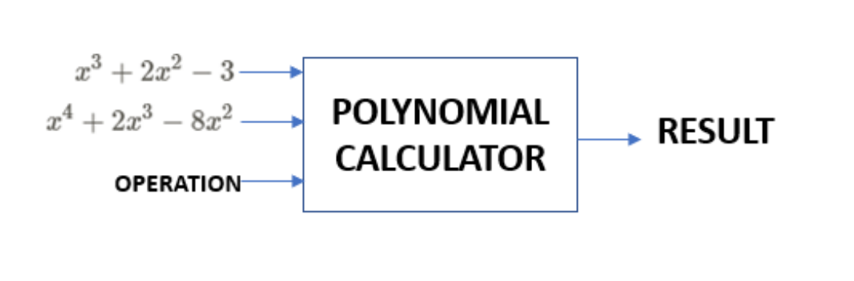
Functional requirements:
- Users can input polynomials from the keyboard in an appropriate format ( 3x^2-5x+2)
- Users can select the mathematical operation they want to perform by pressing buttons (addition, subtraction, multiplication, division, derivative, integration)
- Users can view the result of the mathematical operation performed on the input polynomials

Non-functional requirements:
- RELIABILITY - The code correctly handles unexpected situations or errors that may arise during polynomial operations (e.g. input of invalid characters )
- FLEXIBILITY AND EXTENSIBILITY – The code allows for future expansion and addition of new functionalities.
- PERFORMANCE EFFICIENCY – The code is performance- efficient, allowing for quick manipulation of polynomials without significant delays.

USE-CASE MAIN SCENERIO:
- The user inputs 2 polynomials into the graphical user interface
- The user selects the wanted operation (e.g. addition)
- The polynomial calculator performs the operation and displays the result

Design
Polynomial Calculator’s Interface:
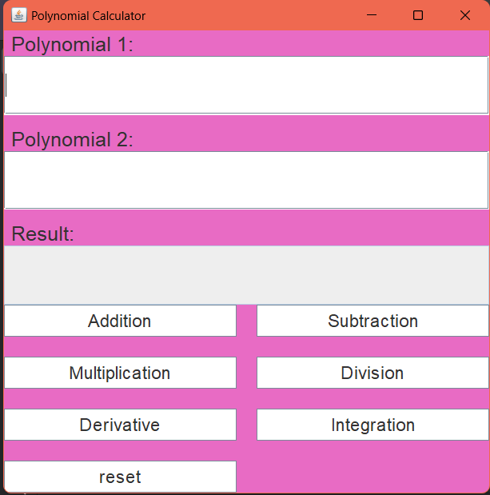

UML DIAGRAM:
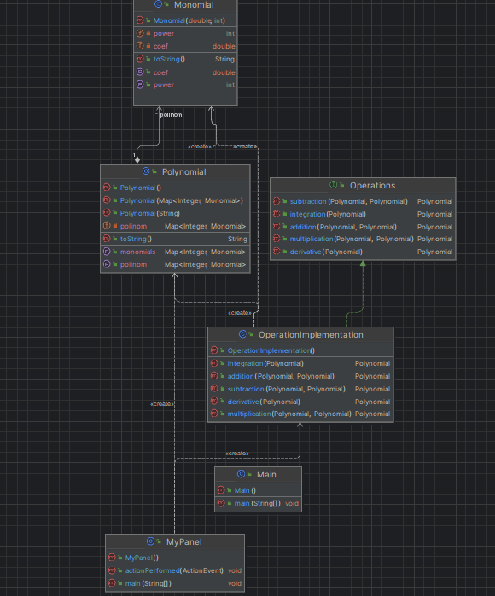

Implementation
Polynomial class
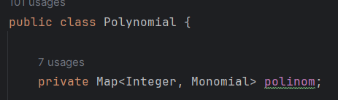
We declare a Map of monomials to create the polynomial.

The Polynomial(String input) constructor parses a string representing a polynomial and extracts the monomials. It uses regular expressions to match and extract coefficients and exponents from the input string.
public Polynomial(String input) {
// Map to store the parsed monomials
Map<Integer, Monomial> result = new HashMap<>();
// Regular expression pattern to match monomials in the input string
Pattern pattern = Pattern.compile("((-?\\d+(?=x))?(-?[x])(\\^(-?\\d+))?)|((-?)[x])|(-?\\d+)");
// Remove whitespace and asterisks from the input string
input = input.replaceAll("\\s", "");
input = input.replaceAll("\\*", "");
// Matcher to find matches of monomials in the input string
Matcher matcher = pattern.matcher(input);
double coefficient = 0;
int exponent = 0;
// Loop through matches and extract coefficients and exponents
while (matcher.find()) {
if (matcher.group(3) != null && matcher.group(2) != null) {
exponent = (matcher.group(5) != null ? Integer.parseInt(matcher.group(5)) : 1);
coefficient = Integer.parseInt(matcher.group(2));
} else if (matcher.group(3) != null && matcher.group(2) == null) {
if (matcher.group(3).equals("-x")) {
coefficient = -1;
} else {
coefficient = 1;
}
exponent = (matcher.group(5) != null ? Integer.parseInt(matcher.group(5)) : 1);
} else if (matcher.group(3) == null && matcher.group(2) == null) {
coefficient = Integer.parseInt(matcher.group());
}
// Add the extracted monomial to the result map
result.put(exponent, new Monomial(coefficient, exponent));
coefficient = 0;
exponent = 0;
}
// Assign the result map to the polynomial map
this.polinom = result;
}
// Getter method for the polynomial map
public Map<Integer, Monomial> getPolinom() {
return this.polinom;
}
// Setter method for the polynomial map
public void setPolinom(Map<Integer, Monomial> polinom) {
this.polinom = polinom;
}

Monomial class:
public class Monomial {
private double coef;
private int power;

where we save the coefficient and the power.
Operations class:
package Logic;
import Model.Polynomial;
import java.util.Map;
public interface Operations {
public Polynomial addition(Polynomial P, Polynomial Q);
public Polynomial subtraction(Polynomial P, Polynomial Q);
public Polynomial multiplication(Polynomial P, Polynomial Q);
// public Polynomial division(Polynomial P, Polynomial Q);
public Polynomial derivative(Polynomial P);
public Polynomial integration(Polynomial P);
}

where we declare all operations
OperationImplementation class where we implement all the operations that we want the polynomial calculator to execute.
First operation for example, the addition:
We use a basic algorithm where we have 2 polynomials (P,Q) and a third one (as a map) where we will save the result of the operation. And at the end we transform the string into a polynomial.
@Override
public Polynomial addition(Polynomial P, Polynomial Q) {
Map<Integer, Monomial> addResult = new HashMap<>();
// Adding monomials from Polynomial P
for (Monomial monom : P.getMonomials().values()) {
addResult.put(monom.getPower(), new Monomial(monom.getCoef(), monom.getPower()));
}
// Adding monomials from Polynomial Q
for (Monomial monom : Q.getMonomials().values()) {
int searchingPower = monom.getPower();
if (addResult.containsKey(searchingPower)) {
double sum = addResult.get(searchingPower).getCoef() + monom.getCoef();
addResult.get(searchingPower).setCoef(sum);
} else {
addResult.put(monom.getPower(), new Monomial(monom.getCoef(), monom.getPower()));
}
}
// Creating the result Polynomial
Polynomial result = new Polynomial(addResult);
return result;
}
Similarly are implemented the rest of the operations.
MyPanel Class
Where we implement the interface of the Polynomial Calculator. It allows users to perform various mathematical operations on polynomials, such as addition, subtraction, multiplication, derivative, and integration.The class extends JFrame to create a window for the GUI.It implements the ActionListener interface to handle button clicks.The GUI contains text fields for inputting two polynomials and displaying the result, along with buttons for different operations.Each operation button has an associated action listener that triggers the corresponding operation when clicked.The actionPerformed method checks which button is clicked and performs the corresponding operation using the OperationImplementation class.The main method creates an instance of MyPanel, displaying the GUI to the user.

Results

We performed some tests using Juni both correct and incorrect ones.
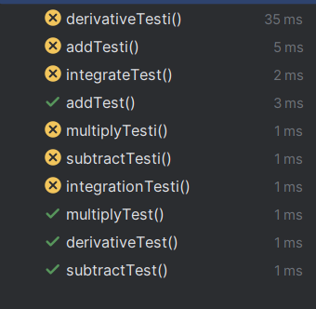

Conclusions
In conclusion, I have acquired a better understanding of the Model-View-Controller (MVC) architecture and gained more knowledge about modeling problems using data structures and classes. This project was undertaken to deepen my understanding of Object-Oriented Programming (OOP) concepts and to become familiar with GUI functionalities.
Acquired Skills:
- Utilizing graphical interfaces using Java Swing
- Employing regular expressions to transform and validate polynomials represented as strings of characters.
- Utilizing the Java Map interface.
Potential Future Project Extensions:
- Adding new functionalities
- Implementing the option to choose variables

Bibliography
- https://algs4.cs.princeton.edu/code/edu/princeton/cs/algs4/Polynomial.java.html
- Java Swing Tutorial - javatpoint
- https://www.baeldung.com/java-tutorial

