About LGU

* History
* Vision
* Mission
* LGU Organizational Chart
* Socio Economic Profile

Registration

* New

1. Citizen
2. Business

* Update

1. Citizen
2. Business

Certification

* Residency
* Clearance
* Indigency
* Business
* Others

Report

* Table
* Graphs

Security

* Groups
* User
* Permission
* Role

Setup

* PSGC
* Citizen Characteristics
* Business Characteristics
* Taxes, Fees and Charges

|  |  |  |  |
| --- | --- | --- | --- |
| **tanay_logo.jpgLocal Government Information Management Systems** | **User** | | |
| Search  Go | images.jpg  Citizen's Registration | map.png | |
| **Main Navigation** |
| About LGU |
| Registration |
| Certification | document.png  Certification |
| Report |
| Security |
| Setup |
|  |
|  | school.jpg  Daycare Services | **Quick Facts** | |
|  | people.pngPeople | |
|  | Population Count (LGIMS Encoded 12/07/2017) | 10 |
|  | Population, MPO MIC December 2015 | 119,541 |
|  | Population, PSA August 2015 | 117,830 |
|  | report.png  Reports | geography.jpgGeography | |
|  | Population per Square Kilometer | 257.2 |
|  | Land Area in Square Kilometers | 150.00 |
|  | LGU Classification | Urban |
|  | LGU Classification | Lowland |
|  | | | |

|  |  |  |
| --- | --- | --- |
| **tanay_logo.jpgLocal Government Information Management Systems** | **User** | |
| Search  Go | Profile: | |
| **Main Navigation** |  |  |
| **LGU Profile** |  |  |
| Registration |  |  |
| Certification |  |  |
| Report |  |  |
| Utility |  |  |
|  |  |  |
|  |  |  |
|  |  |  |
|  |  |  |
|  |  |  |
|  |  |  |
|  |  |  |
|  |  |  |
|  |  |  |
|  |  |  |
|  |  |  |
|  |  |  |
|  | | |

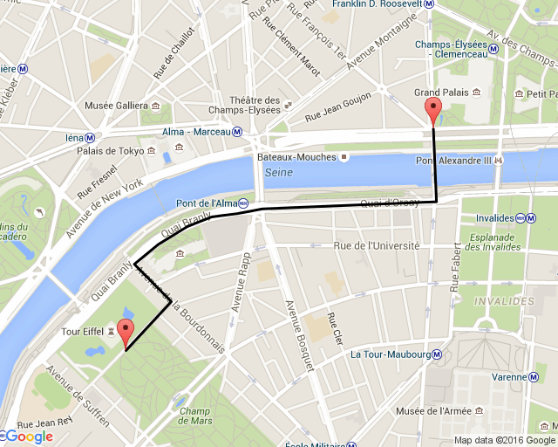

|  |  |  |  |
| --- | --- | --- | --- |
| **tanay_logo.jpgLocal Government Information Management Systems** | **User** | | |
| Search  Go | images.jpg  Citizen's Registration | map.png | |
| **Main Navigation** |
| LGU Profile |
| Registration |
| * New | document.png  Certification |
| * Update |
| Certification |
| Report |
| * Demographic |
| * RBI | school.jpg  Daycare Services | **Quick Facts** | |
|  | people.pngPeople | |
|  | Population Count (LGIMS Encoded 12/07/2017) | 10 |
|  | Population, MPO MIC December 2015 | 119,541 |
|  | Population, PSA August 2015 | 117,830 |
|  | report.png  Reports | geography.jpgGeography | |
|  | Population per Square Kilometer | 257.2 |
|  | Land Area in Square Kilometers | 150.00 |
|  | LGU Classification | Urban |
|  | LGU Classification | Lowland |
|  | | | |