Ivara12c SOA Composite – Rebuild Guide (JDeveloper 12.2.1.4)
Date: December 23, 2025
Author: Cristin Lau

Goal
Recreate the IvaraToSewerAI SOA composite in Oracle JDeveloper 12.2.1.4 under project Ivara12c: DB inbound → BPEL 2.0 → File adapter (opaque payload). This guide provides step-by-step instructions with screenshot placeholders and embedded database connection screenshot.

0) Prerequisites
• JDeveloper 12.2.1.4 installed and SOA Suite extensions enabled
• Access to a SOA Domain (Integrated WebLogic or external)
• JDBC connectivity to the schema containing EPSEWERAI_WOT_STG1
• File system directory accessible by the SOA server for File Adapter writes
• WebLogic JNDI resources configured: eis/DB/SOA and eis/FileAdapter

1) Create the SOA Application and Project
1. File → New → Applications → SOA Application
2. Application Name: Ivara12c
3. Project Name: IvaraToSewerAI; Project Type: SOA Composite with BPEL; Finish.

[ Screenshot ] New Application wizard – SOA Application
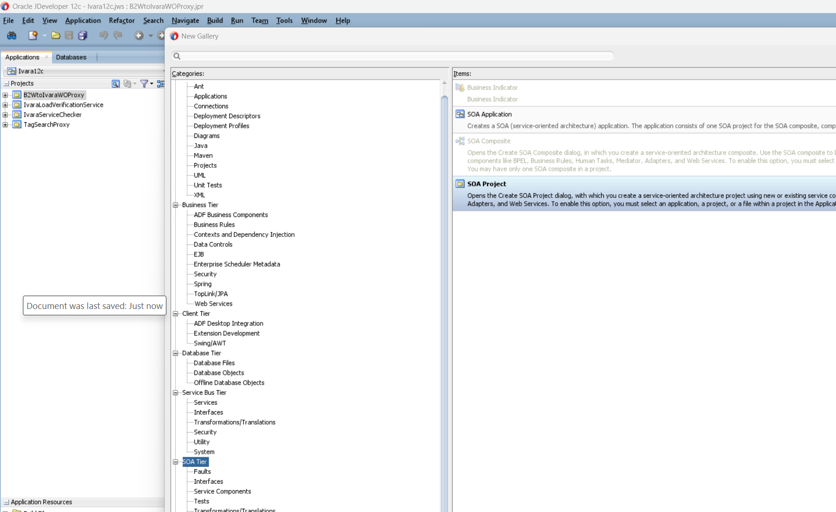

[ Screenshot ] New SOA Project wizard – Project Name and Type
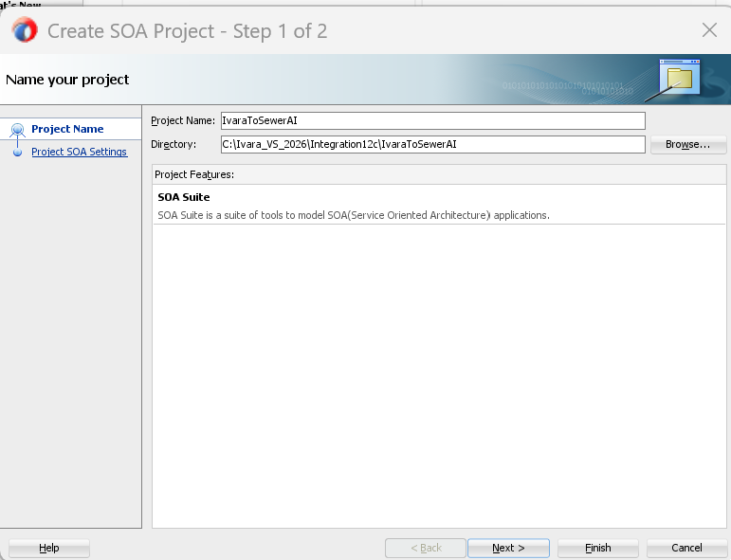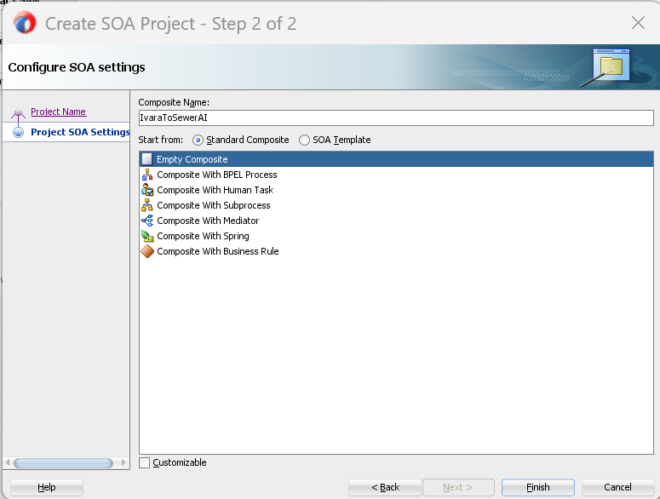

2) Create the Inbound DB Adapter (ReadWOTSewerAIData)
1. In Composite Editor, drag Database Adapter to Exposed Services (left).
2. Service Name: ReadWOTSewerAIData
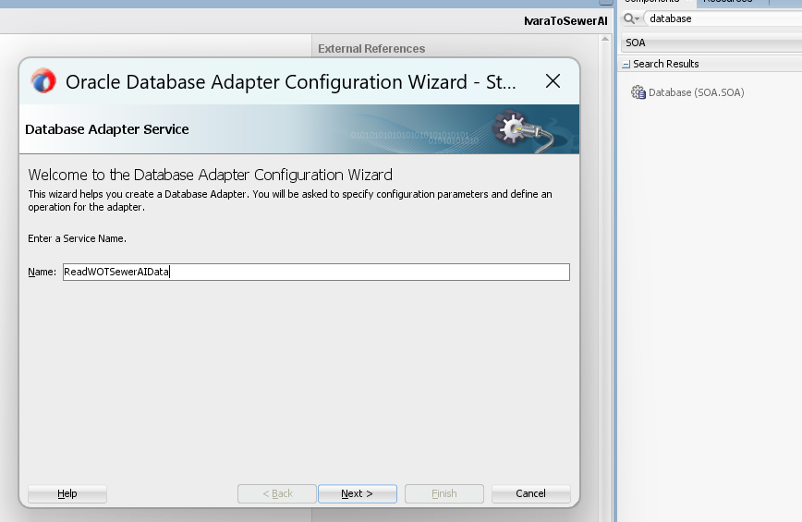

3. JNDI Name: eis/DB/jdbc/Ivara/NonXA; pick your DB connection.
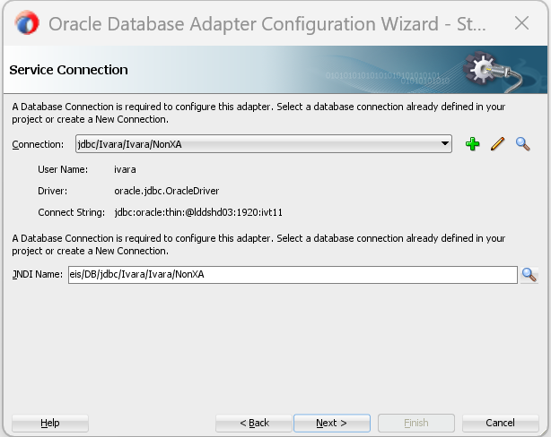

4. Operation Type: Poll for New/Changed Records.
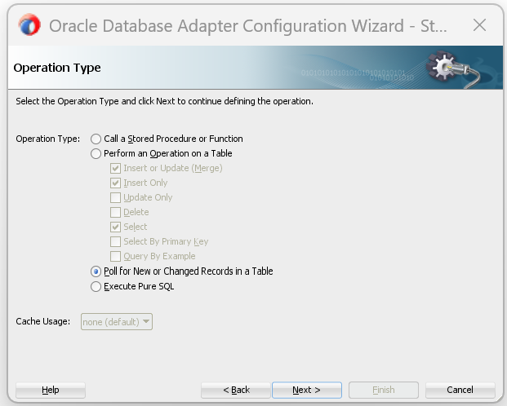
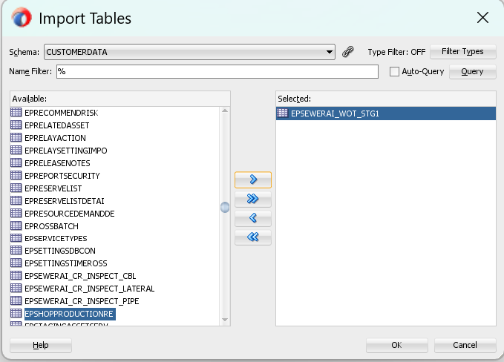

5. Select table/view or custom SQL returning: WORKORDER_NO, DESCRIPTION, STATUS, FEED_STATUS, LAST_UPDATED.
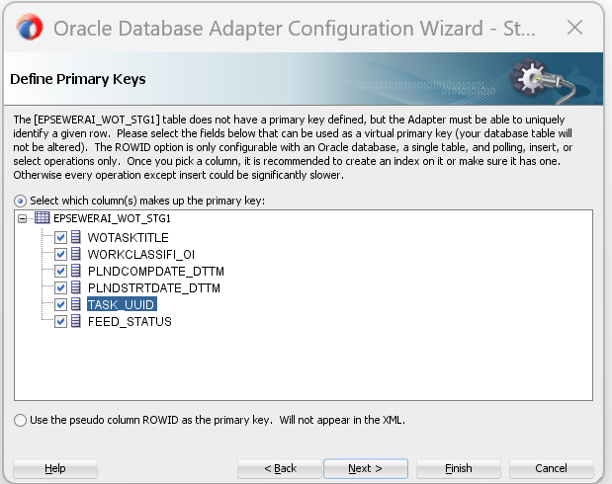

6. Define polling criteria (e.g., FEED_STATUS = "READ"), primary key, and mark processed.
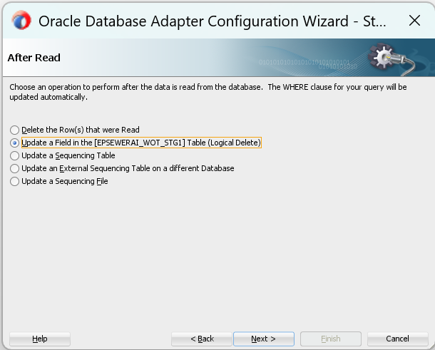
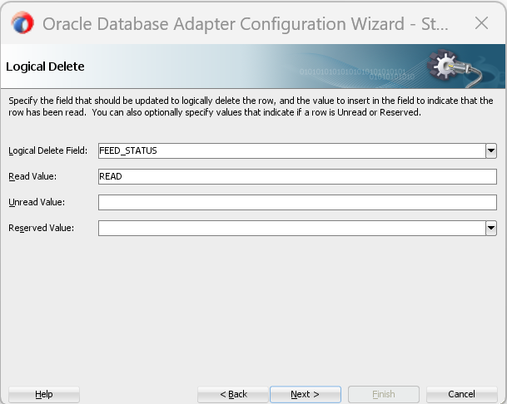

7. Finish — WSDLs/ReadWOTSewerAIData.wsdl and Adapters/ReadWOTSewerAIData_db.jca are created.
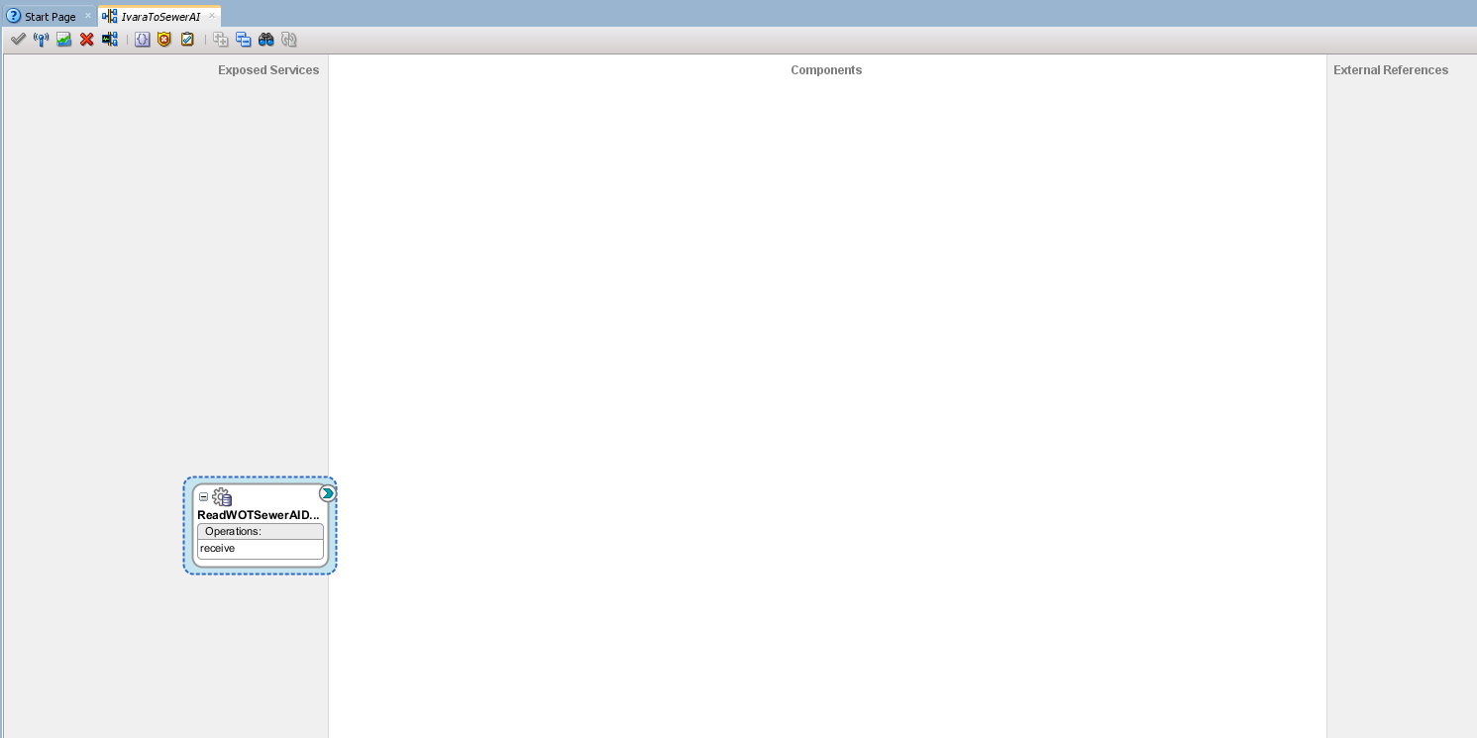

3) Create the Outbound File Adapter (ExportWOTUpdate_sp)
1. Drag File Adapter to External References (right).
2. Service Name: ExportWOTUpdate_sp
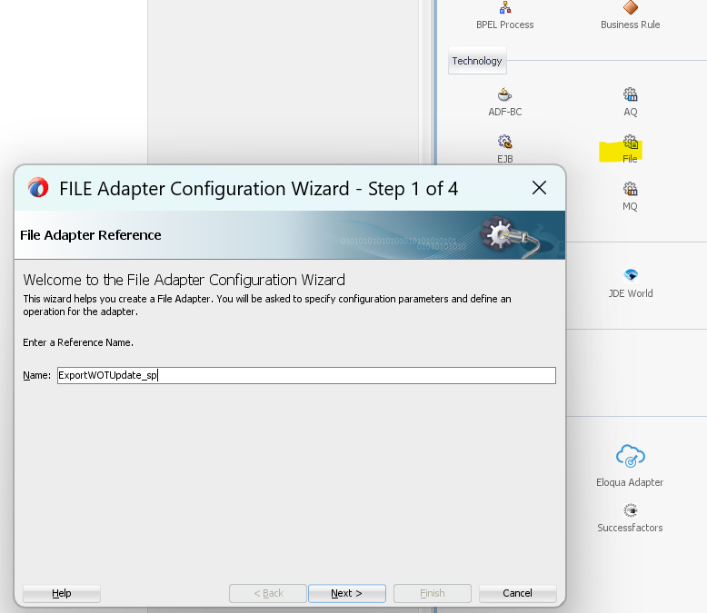
3. Operation: Write File; JNDI: eis/FileAdapter
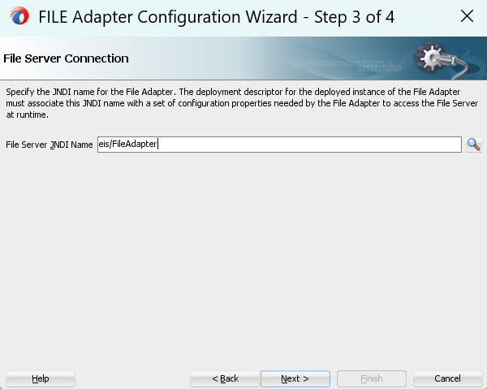
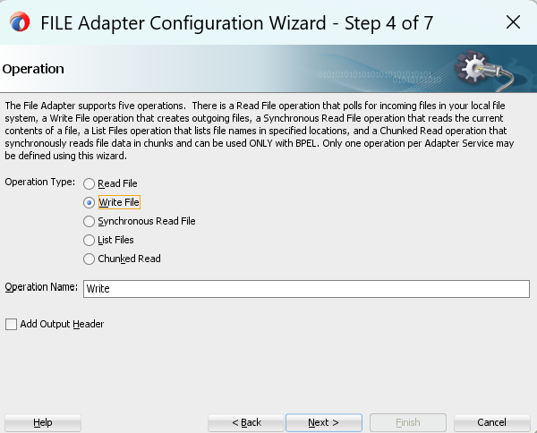
4. Directory: \\epcor.ca\AppData\ivaraimport\SewerAI_Export (UNC path). Ensure SOA server account has access.
5. Filename: WOT_Update_%yy%mm%dd_%hh%mi%ss_%seq%.json
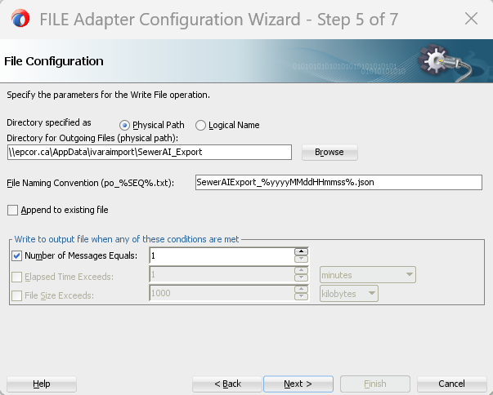
6. Format: Opaque (binary payload with base64Binary).
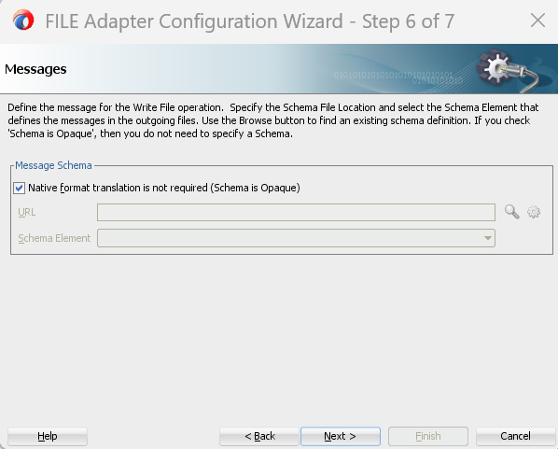

7. Finish — WSDLs/ExportWOTUpdate_sp.wsdl and Adapters/ExportWOTUpdate_sp_file.jca are created.
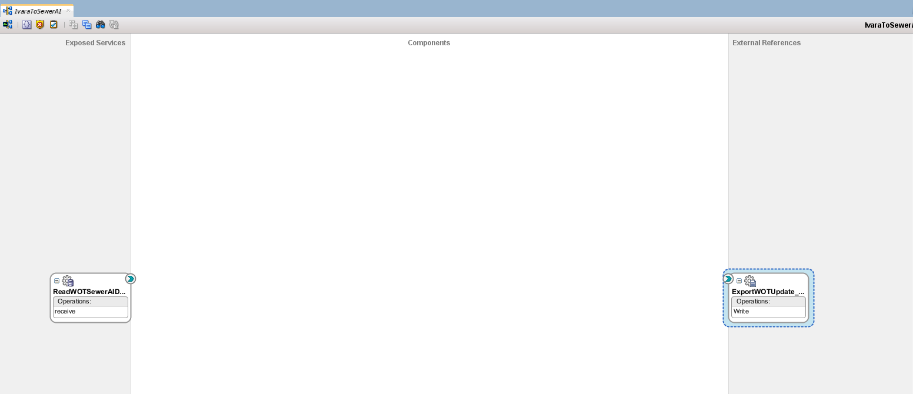
Tip: For UNC paths, configure WebLogic File Adapter with proper permissions. If on Linux, mount the share or use NFS. If on Windows, ensure WebLogic service account can access the share.

4) Create the BPEL Process (SendWOTChanges_sp)

1. Drag BPEL Process into the Components swimlane.
2. Name: SendWOTChanges
3. Template: No Service
4. Namespace: http://xmlns.oracle.com/Ivara12c/IvaraToSewerAI/SendWOTChanges
5. Finish.

[ Screenshot ] BPEL Process wizard – Name, Template, Namespace
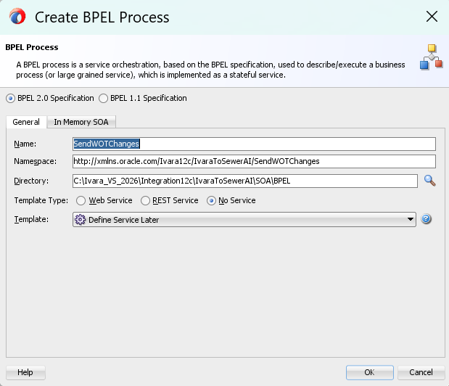

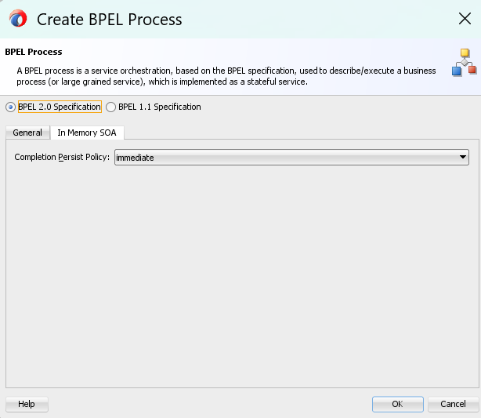

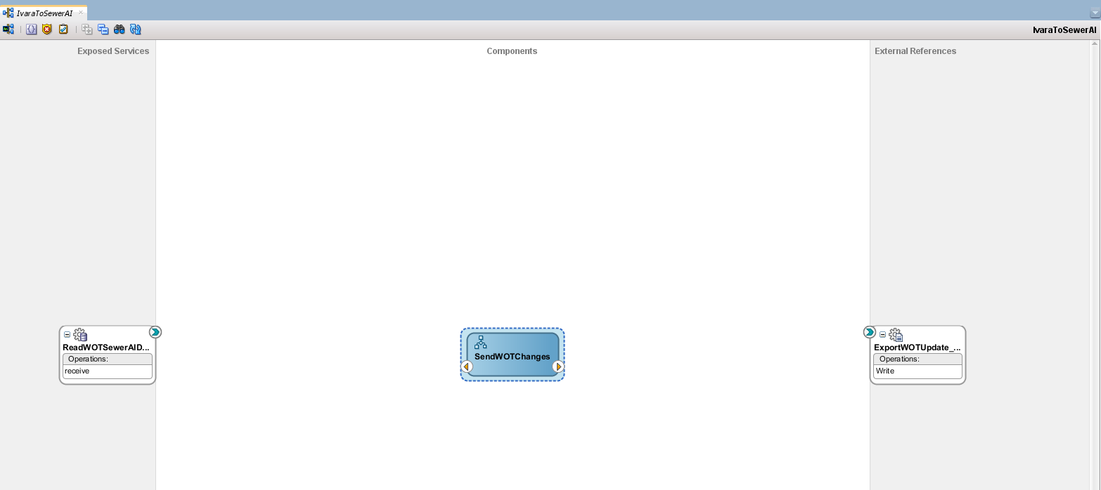
Wire DB Adapter → BPEL:
- In the Composite Editor, click the green arrow on ReadWOTSewerAIData (left).
- Drag it to the left port of SendWOTChanges (middle).
- This creates the inbound partnerLink and the receive activity in BPEL.

Wire BPEL → File Adapter:
- Click the right arrow on SendWOTChanges.
- Drag it to ExportWOTUpdate_sp (right).
- This creates the outbound partnerLink and the invoke activity in BPEL.

Save the composite.
- After wiring, open SendWOTChanges.bpel and confirm:
  - receive activity is present.
  - Add assign and invoke as per the guide.

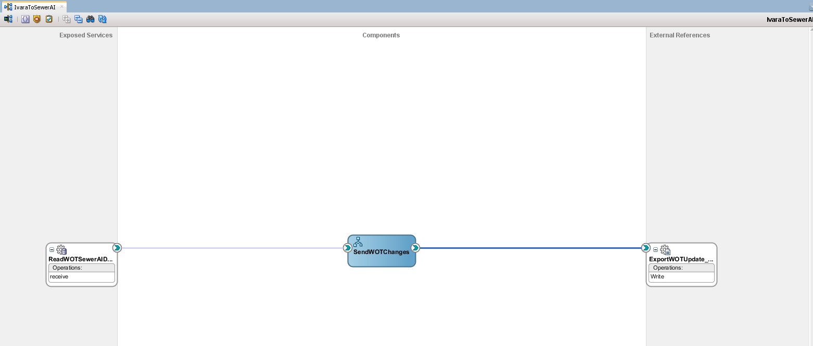

1. Add the Receive Activity
- Drag Receive from the Component Palette into the sequence.
- Configure:
  - Name: receiveFromDB
  - Partner Link: ReadWOTSewerAIData
  - Operation: receive (or whatever your DB adapter WSDL defines)
  - Variable: inputVariable (create if not exists)
  - Create Instance: Yes (this starts the process)

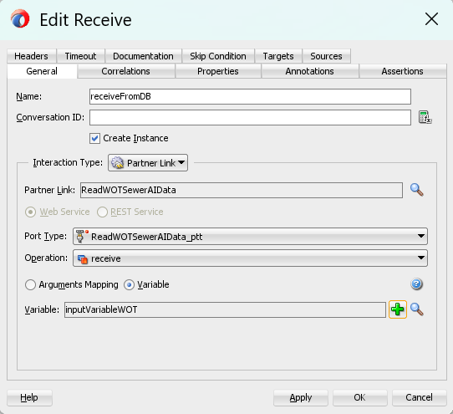

2. Add the Assign Activity
- Drag Assign below the Receive.
- Name: BuildOpaquePayload
- Add a Copy Rule:
  - From: Expression
    - Paste the Base64 + JSON expression:
Plain Text
xpath isn’t fully supported. Syntax highlighting is based on Plain Text.

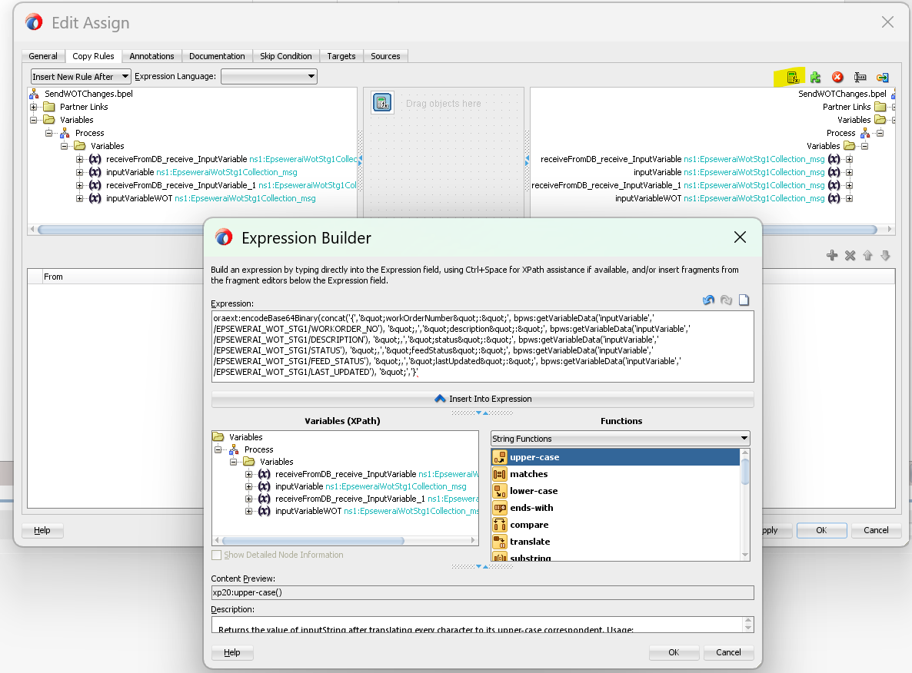

addAuditTrailEntry("EncodeAndSetOpaquePayloadScope started.");

try {
// Fetch ELEMENTS and read their text with getTextContent()
org.w3c.dom.Element wotasktitleEl = (org.w3c.dom.Element) getVariableData(
"inputVariableWOT","EpseweraiWotStg1Collection",
"/top:EpseweraiWotStg1Collection/top:EpseweraiWotStg1[1]/top:wotasktitle");
String wotasktitle = (wotasktitleEl == null) ? "" : wotasktitleEl.getTextContent();

org.w3c.dom.Element workclassifiOiEl = (org.w3c.dom.Element) getVariableData(
"inputVariableWOT","EpseweraiWotStg1Collection",
"/top:EpseweraiWotStg1Collection/top:EpseweraiWotStg1[1]/top:workclassifiOi");
String workclassifiOiStr = (workclassifiOiEl == null) ? "" : workclassifiOiEl.getTextContent();

org.w3c.dom.Element plndstrtdateDttmEl = (org.w3c.dom.Element) getVariableData(
"inputVariableWOT","EpseweraiWotStg1Collection",
"/top:EpseweraiWotStg1Collection/top:EpseweraiWotStg1[1]/top:plndstrtdateDttm");
String plndstrtdateDttm = (plndstrtdateDttmEl == null) ? "" : plndstrtdateDttmEl.getTextContent();

org.w3c.dom.Element plndcompdateDttmEl = (org.w3c.dom.Element) getVariableData(
"inputVariableWOT","EpseweraiWotStg1Collection",
"/top:EpseweraiWotStg1Collection/top:EpseweraiWotStg1[1]/top:plndcompdateDttm");
String plndcompdateDttm = (plndcompdateDttmEl == null) ? "" : plndcompdateDttmEl.getTextContent();

org.w3c.dom.Element taskUuidEl = (org.w3c.dom.Element) getVariableData(
"inputVariableWOT","EpseweraiWotStg1Collection",
"/top:EpseweraiWotStg1Collection/top:EpseweraiWotStg1[1]/top:taskUuid");
String taskUuidB64 = (taskUuidEl == null) ? "" : taskUuidEl.getTextContent();

org.w3c.dom.Element feedStatusEl = (org.w3c.dom.Element) getVariableData(
"inputVariableWOT","EpseweraiWotStg1Collection",
"/top:EpseweraiWotStg1Collection/top:EpseweraiWotStg1[1]/top:feedStatus");
String feedStatus = (feedStatusEl == null) ? "" : feedStatusEl.getTextContent();

// xs:long -> String (safe stringify)
String workclassifiOi = "";
if (workclassifiOiStr != null && workclassifiOiStr.length() > 0) {
try { workclassifiOi = String.valueOf(Long.valueOf(workclassifiOiStr)); }
catch (Throwable t) { workclassifiOi = ""; }
}

// Minimal JSON escaping
String esc_wotasktitle = (wotasktitle == null) ? "" : wotasktitle.replace("\\", "\\\\").replace("\"", "\\\"");
String esc_plndstrtdateDttm = (plndstrtdateDttm == null) ? "" : plndstrtdateDttm.replace("\\", "\\\\").replace("\"", "\\\"");
String esc_plndcompdateDttm = (plndcompdateDttm == null) ? "" : plndcompdateDttm.replace("\\", "\\\\").replace("\"", "\\\"");
String esc_feedStatus = (feedStatus == null) ? "" : feedStatus.replace("\\", "\\\\").replace("\"", "\\\"");
String esc_taskUuidB64 = (taskUuidB64 == null) ? "" : taskUuidB64.replace("\\", "\\\\").replace("\"", "\\\"");

// Build JSON
String json = "{"
+ "\"taskUuid\":\"" + esc_taskUuidB64 + "\","
+ "\"wotasktitle\":\"" + esc_wotasktitle + "\","
+ "\"workclassifiOi\":\"" + workclassifiOi + "\","
+ "\"plndstrtdateDttm\":\""+ esc_plndstrtdateDttm + "\","
+ "\"plndcompdateDttm\":\""+ esc_plndcompdateDttm + "\","
+ "\"feedStatus\":\"" + esc_feedStatus + "\""
+ "}";

// Base64 encode JSON
String base64 = java.util.Base64.getEncoder().encodeToString(json.getBytes("UTF-8"));

// Write to element-based part: target the global element
setVariableData("fileWriteRequest", "opaque", "/opaque:opaqueElement", base64);

addAuditTrailEntry("Prepared opaque payload and set Base64 JSON into fileWriteRequest");
} catch (com.oracle.bpel.client.BPELFault bf) {
addAuditTrailEntry("Selection error: " + bf.getMessage());
throw bf;
} catch (Throwable t) {
addAuditTrailEntry("Error preparing opaque payload: " + t.getMessage());
throw new RuntimeException(t);
}
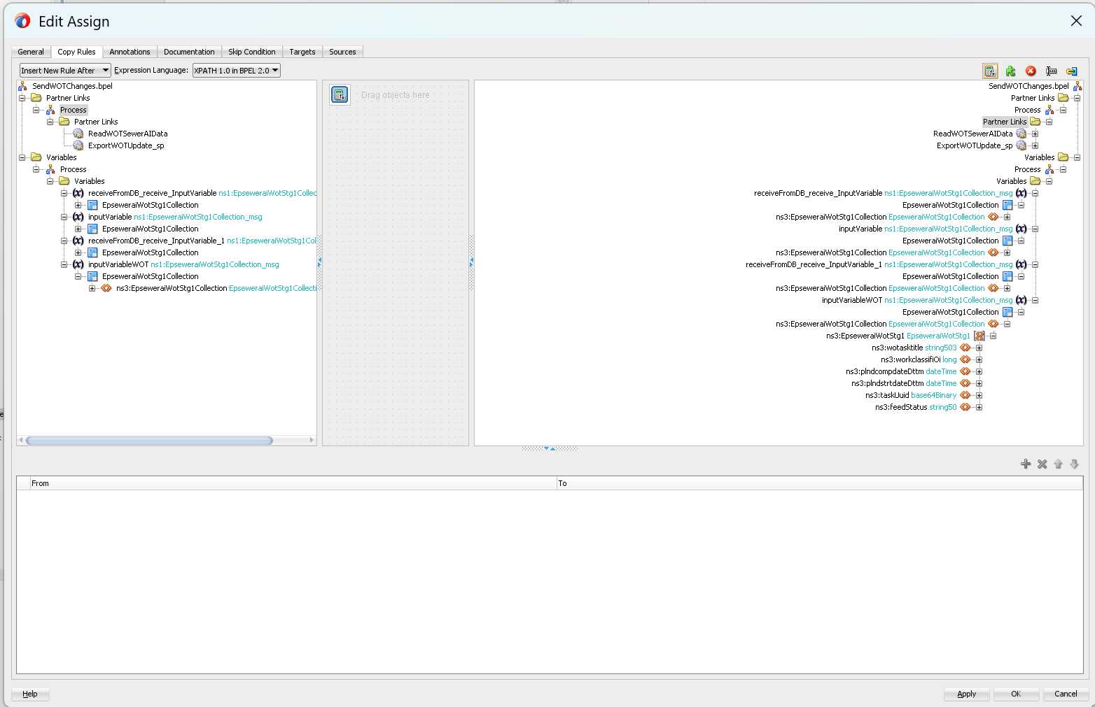
Show more lines
  - To: $fileWriteRequest.opaque

3. Add the Invoke Activity
- Drag Invoke below Assign.
- Configure:
  - Name: invokeExportFile
  - Partner Link: ExportWOTUpdate_sp
  - Operation: Write
  - Input Variable: fileWriteRequest
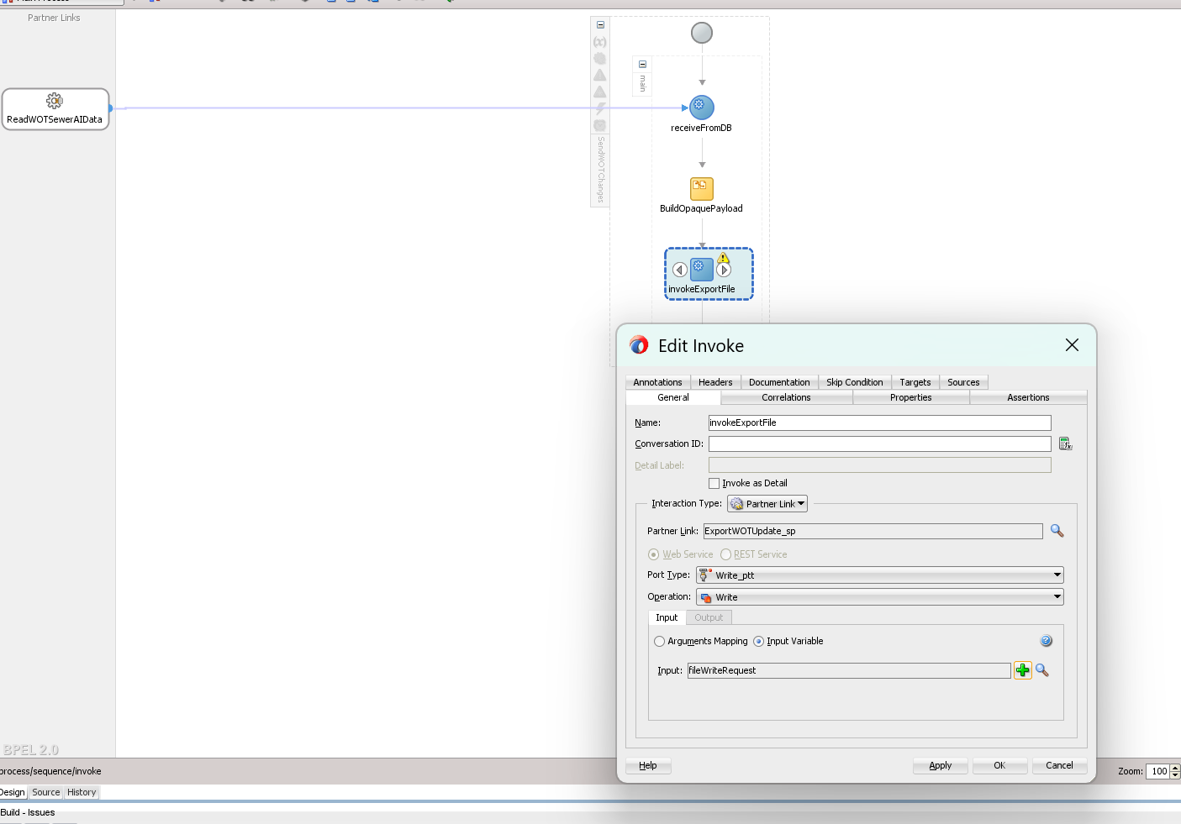

4. Create Variables
- In the Variables section:
  - inputVariable → messageType = DB adapter WSDL message
  - fileWriteRequest → messageType = File adapter WSDL message

5. Validate
- The error “Element not completed: 'sequence'” will disappear once you add these activities.
- Save and compile.

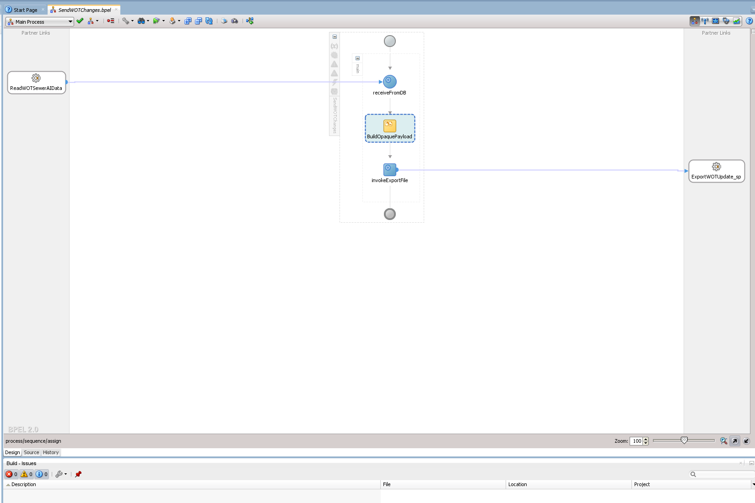

5) Create Update Adapter
Step 1: Open the Composite and Start the Adapter Wizard

- In JDeveloper, open your SOA project and go to the Composite.xml diagram.
- In the Components Palette (usually on the right), under Service Adapters, find Database Adapter.
- Drag the Database Adapter into the External References swimlane of your composite diagram.
- The Adapter Configuration Wizard will open automatically.
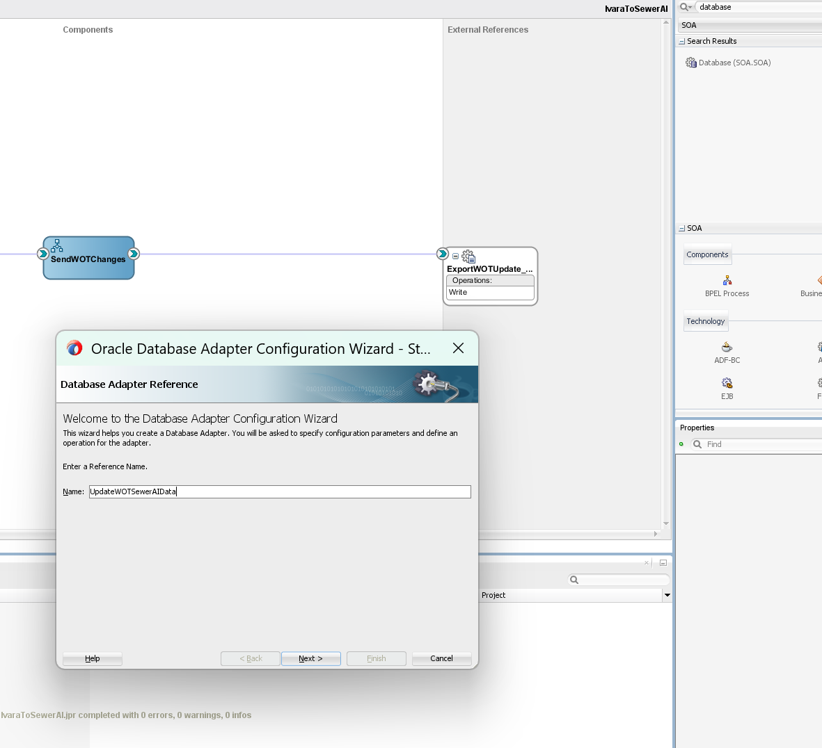
Step 2: Configure the Adapter Connection
- In the Adapter Configuration Wizard, the first screen is Welcome. Click Next.
- On the Service Name screen:
  - Enter a name for the adapter service, e.g., UpdateWOTSewerAIData.
  - Click Next.
- On the Connection screen:
  - Select the Application Server Connection that points to your SOA domain (the same one used for your existing DB adapter).
  - Under JNDI Name, choose the same JNDI as your inbound adapter (likely eis/DB/IVARA/ivara).
  - Click Next.
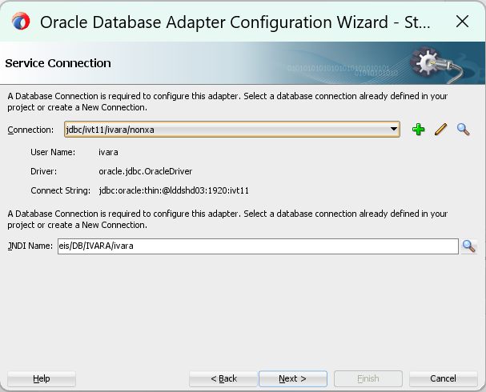

Step 3: Choose the Operation Type (Update)
- In the Adapter Configuration Wizard, you should now be on the Operation screen.
- Select Perform an Operation on a Table (not “Call a Stored Procedure”).
- Click Next.
- On the Operation Type screen:
  - Choose Update from the list of operations (Insert, Update, Delete, Select).
  - Click Next.
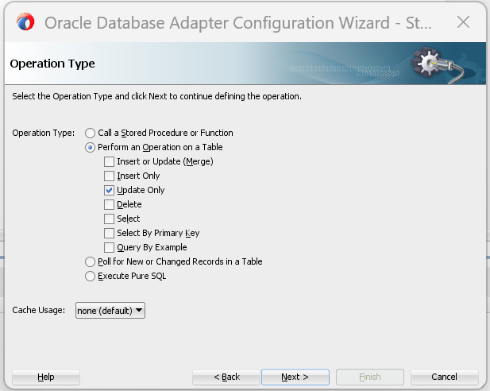

Step 4: Select the Table and Columns for Update
- On the Table Selection screen:
  - From the list of available tables, select EPSEWERAI_WOT_STG1 (or the exact table name you use for staging).
  - Click Next.
- On the Update Columns screen:
  - Check the columns you want to update:
    - FEED_STATUS (set to READ).
    - Optionally, UPDATED_AT or any audit column if you want to stamp a timestamp.
  - Click Next.
- On the Where Clause Columns screen:
  - Select the column that uniquely identifies the row (usually TASK_UUID).
  - This will be used in the WHERE clause for the update.
  - Click Next.
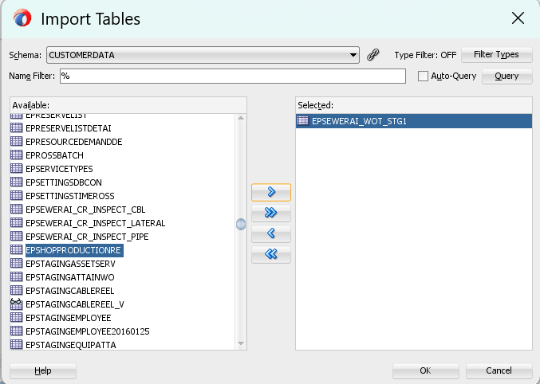

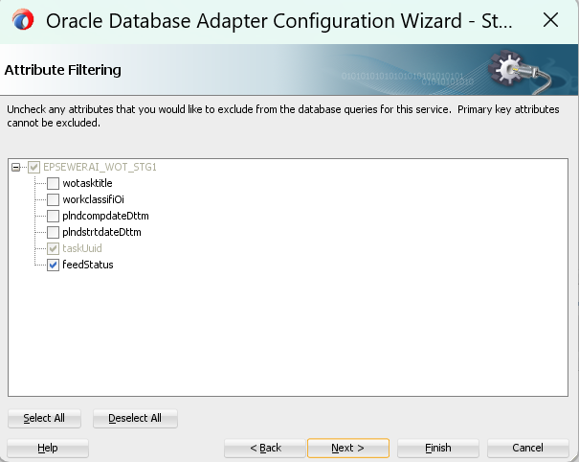
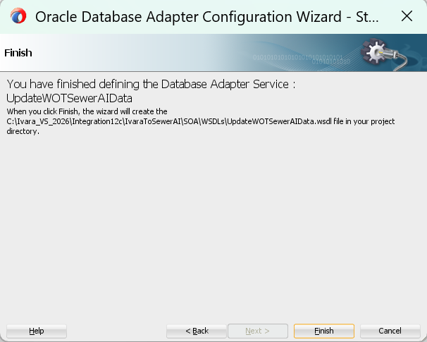

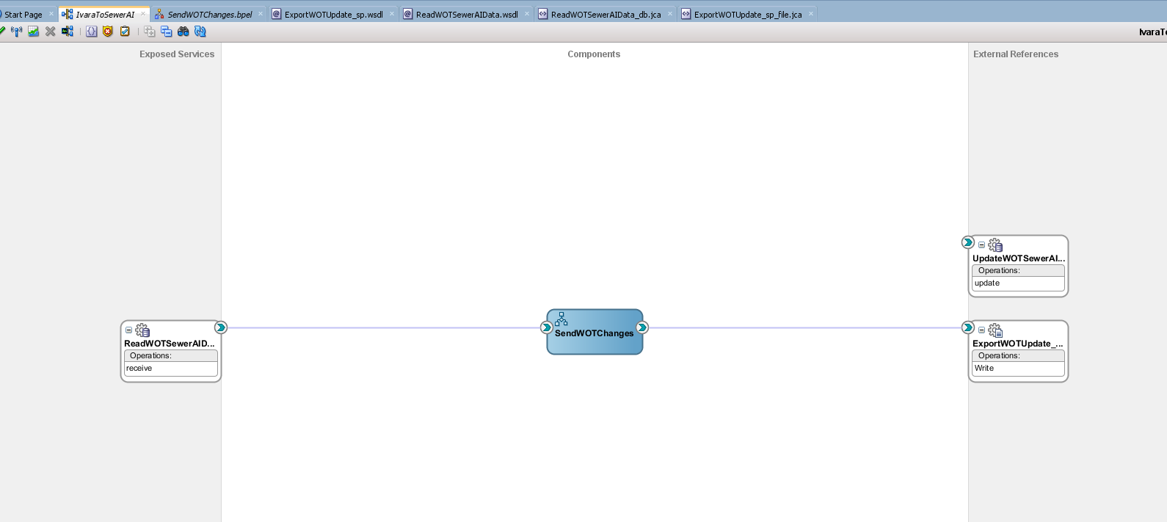

Step 5: Wire the Update Adapter into the BPEL Process
- Open your BPEL process (SendWOTChanges.bpel) in the design view.
- In the Components Palette, under Partner Links, you should now see UpdateWOTSewerAIData.
- Drag the Invoke activity from the palette into your sequence after the File Adapter invoke (writeOpaque).
- In the Invoke Properties:
  - Partner Link: UpdateWOTSewerAIData
  - Operation: update (the one generated by the wizard)
  - Input Variable: Create a new variable (e.g., updateRequest) of the type defined in the adapter WSDL.
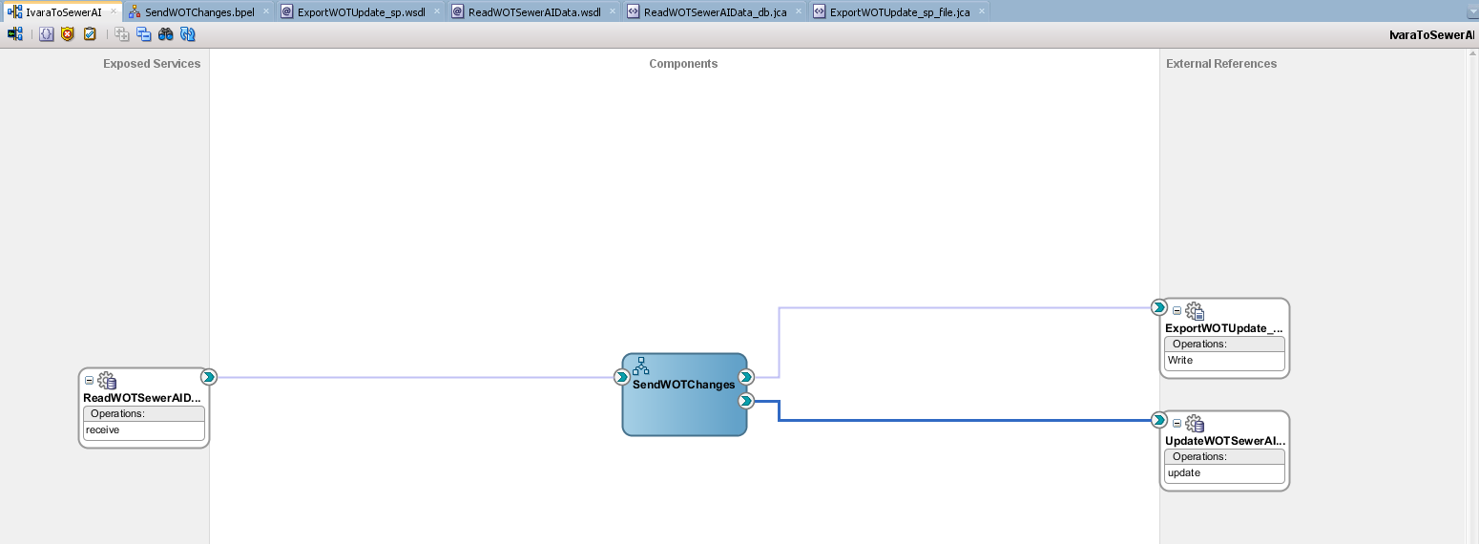
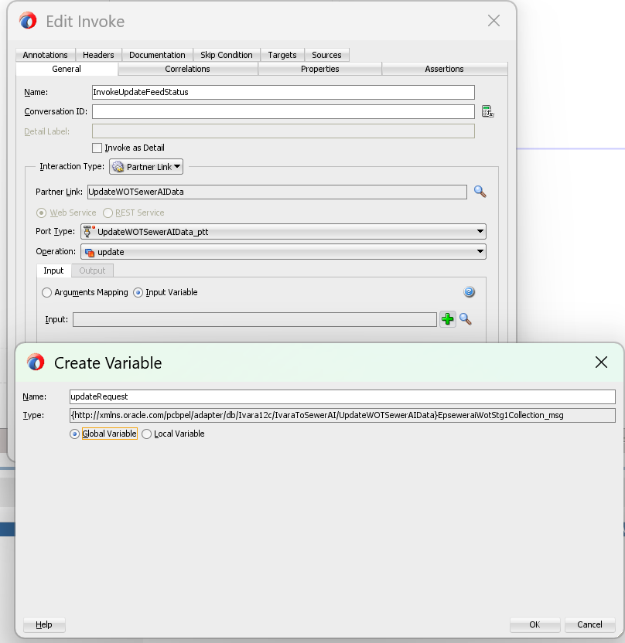

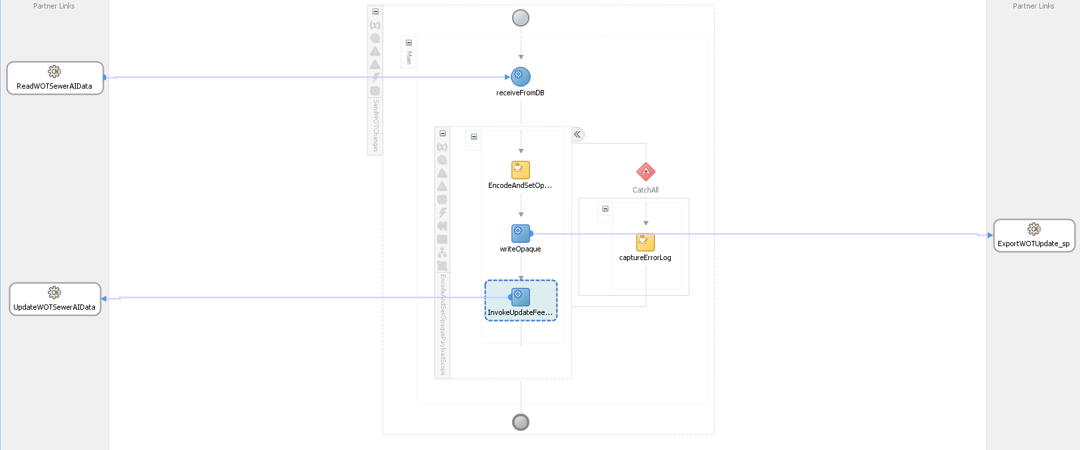

Step 6: Create an Assign before the invoke to populate updateRequest
- Add an Assign activity immediately before InvokeUpdateFeedStatus.
- In the Assign:
  - Copy 1 (TASK_UUID):
From: the UUID coming from your inbound payload (decode if your DB stores plain text; otherwise pass as-is).
XPath you already use in your embedding:
"/top:EpseweraiWotStg1Collection/top:EpseweraiWotStg1[1]/top:taskUuid" (source)
To: updateRequest → part EpseweraiWotStg1Collection → path to the table row’s taskUuid element in the update message.
  - Copy 2 (FEED_STATUS):
From: a literal 'READ'.
To: updateRequest → part EpseweraiWotStg1Collection → path to feedStatus element.

Next step (Copy Rule 2): Set feedStatus = 'READ'
- In the Assign activity, add a new copy rule:
  - From: click Expression (or Literal) and enter:
  - READ
  - To: select
  - $updateRequest/EpseweraiWotStg1Collection/EpseweraiWotStg1/feedStatus
- Ensure xsi:nil is not checked (i.e., false) for both taskUuid and feedStatus in the target.
- Save the BPEL.

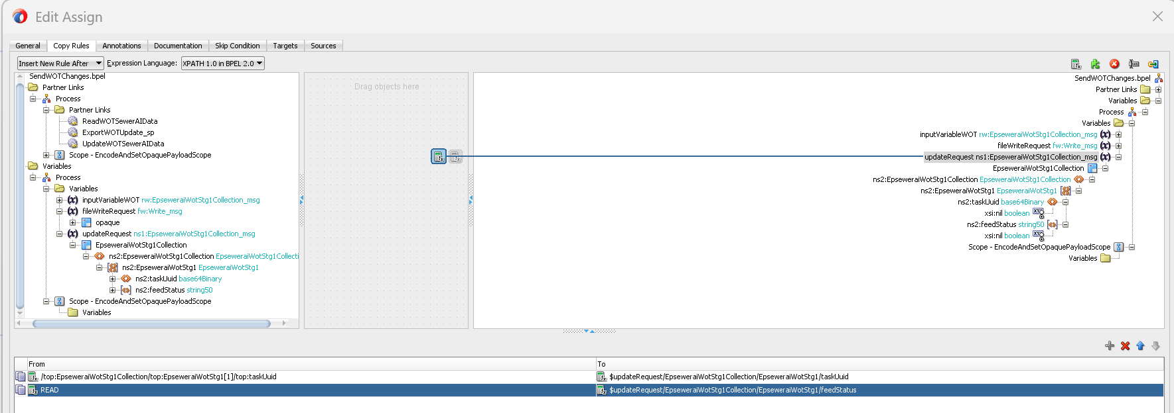

Next step: Place the Invoke and validate
- Place the invoke after the file write
In your sequence, ensure InvokeUpdateFeedStatus is immediately after writeOpaque (the File Adapter). That guarantees you only update the DB to READ after the JSON is written.
- Set the Invoke’s variables
  - Input Variable: updateRequest (already created).
  - Output Variable: optional (you can skip it or create updateResponse if you want to inspect the adapter’s return).
- (Recommended) Strengthen fault handling
  - Wrap the file write + update invoke in the same scope and add a catchAll that rethrows on any fault.
This prevents updating FEED_STATUS=READ if the outbound write fails.
  - Example:
XML
<faultHandlers>
<catchAll>
<sequence>
<extensionActivity>
<bpelx:exec name="logFault"><![CDATA[
addAuditTrailEntry("Fault in outbound flow; rethrowing to avoid marking READ.");
]]></bpelx:exec>
</extensionActivity>
<rethrow/>
</sequence>
</catchAll>
</faultHandlers>

