IvaraToSewerAI – Rebuild and Deployment Master Guide
Combined Implementation Guide (DEV / UAT / PROD)
February 12, 2026
Table of Contents (Right‑click → Update Field → Update entire table).

Part A – Full End‑to‑End Build Guide (Primary Reference)

IvaraToSewerAI – JDeveloper Build & Deployment Guide
Purpose: step-by-step instructions to recreate the IvaraToSewerAI SOA composite in a new environment (DEV/UAT/PROD) using JDeveloper GUI, including all database scripts and key configuration values.

Table of Contents

Right-click the TOC in Word → Update Field → Update entire table.

1. What this composite does
IvaraToSewerAI reads Work Order Tasks (WOT) that have been staged for SewerAI integration. For each WOT task marked NEW/UPDATE, it builds a Projects JSON payload, writes an export file, calls the SewerAI Projects API, then marks the WOT row as SENT. It then finds related CR inspection records for the same project/task, builds Videos JSON payloads (LACP/MACP/PACP), writes export files, calls the SewerAI Videos API, and marks those inspection rows as SENT.

1.1 High-level flow

Figure 1. End-to-end flow (DB → JSON → file exports → REST APIs → status updates).

1.2 Composite wiring

Figure 2. Composite diagram as packaged in the source project.

2. Prerequisites
Software / access:
• JDeveloper 12c (12.2.1.4) with SOA extension installed
• Access to SOA Suite 12c domain (soa_server1) and partition (e.g., Ivara12c)
• Database access to CUSTOMERDATA schema (or target schema in new environment)
• Network access to SewerAI API endpoints (Projects and Videos)
• A shared file path for outbound exports (used by ExportWOTUpdate_sp and ExportInspectUpdate_sp)
Artifacts included in the source package:
• Full JDeveloper project folder (IvaraToSewerAI)
• Deployment archive: deploy/sca_IvaraToSewerAI.jar
• Database DDL/DML scripts: 1–9_SewerAI_*.sql
• Composite resources: BPEL, WSDLs, XSD/NXSD schemas, XSL transform

3. Environment configuration checklist

4. Database setup (run first)
Run the following scripts in order in the target environment. These create the staging tables, views, and triggers used by the composite.
Appendix A contains the full text of each script.

5. Recreate the SOA application in JDeveloper (GUI)
This section assumes you are building from scratch in a clean JDeveloper workspace. If you are allowed to import the existing project folder, see Section 6 for the faster path.

5.1 Create a new SOA Application
1) File → New → Applications → SOA Application.
2) Application Name: IvaraToSewerAI
3) Project Name: IvaraToSewerAI
4) Template: SOA Application (Composite)
5) Finish.

5.2 Create the BPEL component
1) In the composite editor, drag “BPEL Process” into the composite.
2) Name: SendWOTChanges
3) Template: Asynchronous BPEL Process (recommended for polling)
4) Generate WSDL (default)
5) Finish.
Then open SendWOTChanges.bpel to add the scope/logic, variables, and invokes as described in Section 5.6.

5.3 Create the DB Adapter service: ReadWOTSewerAIData (poll)
1) Drag “Database Adapter” to the left (Services) swim-lane.
2) Name: ReadWOTSewerAIData
3) Wizard: Polling operation.
4) Select the DB connection (create it if needed) and schema.
5) Use the view/table used for WOT staging (see Script #1 and #3).
6) Polling frequency: set per environment.
7) WHERE clause should restrict to feed_status in (NEW, UPDATE) or equivalent.
8) Finish and wire the service to SendWOTChanges input.

5.4 Create DB Adapter references
Create the following DB adapters as References (right swim-lane). Use “Insert/Update” for update adapters and “Select” for read adapters.

5.5 Create File Adapter references (exports)
Create these as File Adapters under References. They write JSON payloads (or text) to a shared outbound folder for auditing/replay.

5.6 Create REST references (SewerAI APIs)
Create two REST references using the REST Adapter wizard (or HTTP binding) and generate WSDL/XSD:
• SewerAIProjects – Projects endpoint
• SewerAIVideos – Videos endpoint
Set the base URL and auth headers via composite.properties or SOA configuration plan during deployment (recommended).

5.7 Add schemas and XSL resources
Add these files into the project (drag/drop into the SOA project):
• xsl/StripNilElements.xsl
• Schemas/VideosLACPRequest.xsd, VideosMACPRequest.xsd, VideosPACPRequest.xsd (NXSD root elements must match)
• Any *_table.xsd generated by adapter wizards
Tip: Keep paths identical to the source project so existing XPath/XSLT references work.

5.8 Implement the BPEL logic (high-level map)
In SendWOTChanges.bpel, the key blocks are:
1) ReadWOTSewerAIData poll result → identify task_uuid/project identifiers.
2) BuildInspectJson_Init / BuildInspectJson: construct JSON strings for Projects and Videos.
3) ExportWOTUpdate_sp: write Projects JSON file.
4) SewerAIProjects invoke: call Projects endpoint.
5) UpdateWOTSewerAIData: mark WOT row SENT.
6) ReadCRInspect: fetch inspections tied to the task_uuid.
7) For-each inspection row: build Videos payload and invoke SewerAIVideos.
8) ExportInspectUpdate_sp: write Videos JSON file.
9) UpdateCRInspectStatus: mark inspection row(s) SENT.
If you are importing the provided .bpel file, verify all partner links, variables, and schema imports resolve without red X errors.

6. Faster option: import the provided project folder
If your process allows importing the delivered source project instead of rebuilding each adapter manually:
1) Unzip the package.
2) In JDeveloper: File → Open → select IvaraToSewerAI.jpr.
3) Resolve any missing connections (DB, file, REST) in Application Resources.
4) Open composite.xml to confirm all wires and endpoints.
5) Deploy as in Section 7.
This is the recommended approach for consistency across environments.

7. Deployment

7.1 Create deployment profile
1) Right-click SOA project → Deploy → New Deployment Profile.
2) Type: SOA Composite.
3) Name: sca_IvaraToSewerAI
4) Finish.
The build should generate deploy/sca_IvaraToSewerAI.jar (already included in the package).

7.2 Deploy to SOA Suite
1) Right-click SOA project → Deploy → sca_IvaraToSewerAI.
2) Choose Application Server (soa_server1) and SOA partition.
3) Set revision (e.g., 1.0 / 1.1) and deployment configuration plan (recommended).
4) Deploy.
After deployment, validate in Enterprise Manager: check composites → IvaraToSewerAI → instances.

8. Post-deploy verification
Run a controlled test:
1) Insert or update a WOT staging row to feed_status=NEW.
2) Confirm the poll picks it up and an instance starts.
3) Confirm export files are written (Projects + Videos).
4) Confirm REST calls are received by SewerAI.
5) Confirm DB status updates: EPSEWERAI_WOT_STG1.feed_status and EPSEWERAI_CR_INSPECT.feed_status become SENT.
6) Review EM audit trail for any selectionFailure or NXSD translation errors (root element mismatch).

Appendix A – Database scripts (full text)

1_SewerAI_Create_Table_EPSEWERAI_WOT_STG1.sql
------------------------------------------------------------
-- Step 1: Drop staging table if exists (CUSTOMERDATA)
------------------------------------------------------------
BEGIN
EXECUTE IMMEDIATE 'DROP TABLE CUSTOMERDATA.EPSEWERAI_WOT_STG1';
EXCEPTION
WHEN OTHERS THEN
NULL; -- expected if first run
END;
/
------------------------------------------------------------
-- Step 2: Create staging table
------------------------------------------------------------
DROP TABLE CUSTOMERDATA.EPSEWERAI_WOT_STG1
CREATE TABLE CUSTOMERDATA.EPSEWERAI_WOT_STG1 (
TASK_UUID RAW(16) NOT NULL,
WOTASKTITLE VARCHAR2(503),
PLNDCOMPDATE_DTTM DATE,
PLNDSTRTDATE_DTTM DATE,
WORKCLASSIFI_OI NUMBER,
FEED_STATUS VARCHAR2(50)
);

2_SewerAI_TRG_WOT_TO_STG1.sql
create or replace TRIGGER TRG_WOT_TO_STG1
AFTER INSERT OR UPDATE OF
wotasktitle,
plndcompdate_dttm,
plndstrtdate_dttm,
workclassifi_oi
ON MNT.WORKORDERTASK
FOR EACH ROW
BEGIN
MERGE INTO CUSTOMERDATA.EPSEWERAI_WOT_STG1 s
USING (
SELECT
/* TASK_UUID is RAW(16) and NOT NULL in target table */
:NEW.uuid AS task_uuid,
:NEW.wotasktitle AS wotasktitle,
:NEW.plndcompdate_dttm AS plndcompdate_dttm,
:NEW.plndstrtdate_dttm AS plndstrtdate_dttm,
:NEW.workclassifi_oi AS workclassifi_oi
FROM MNT.workorders wo
WHERE wo.workordersoi = :NEW.workorder_oi
AND wo.site_oi = 58
AND :NEW.workclassifi_oi IN (209, 211, 215, 266)
) src
ON (s.task_uuid = src.task_uuid)
WHEN MATCHED THEN
UPDATE SET
s.wotasktitle = src.wotasktitle,
s.plndcompdate_dttm = src.plndcompdate_dttm,
s.plndstrtdate_dttm = src.plndstrtdate_dttm,
s.workclassifi_oi = src.workclassifi_oi,
s.feed_status = 'UPDATED'
WHERE
NVL(s.wotasktitle, '~') <> NVL(src.wotasktitle, '~')
OR NVL(s.plndcompdate_dttm, DATE '1900-01-01')
<> NVL(src.plndcompdate_dttm, DATE '1900-01-01')
OR NVL(s.plndstrtdate_dttm, DATE '1900-01-01')
<> NVL(src.plndstrtdate_dttm, DATE '1900-01-01')
OR NVL(s.workclassifi_oi, -1)
<> NVL(src.workclassifi_oi, -1)
WHEN NOT MATCHED THEN
INSERT (
task_uuid,
wotasktitle,
plndcompdate_dttm,
plndstrtdate_dttm,
workclassifi_oi,
feed_status
)
VALUES (
src.task_uuid,
src.wotasktitle,
src.plndcompdate_dttm,
src.plndstrtdate_dttm,
src.workclassifi_oi,
'NEW'
);
END;

3_SewerAI_Create_View_SEWERAI_INSPECTIONS_V.sql
CREATE OR REPLACE FORCE EDITIONABLE VIEW "CUSTOMERDATA"."SEWERAI_INSPECTIONS_V" (
"WORK_ORDERS_NUMBER",
"WORK_ORDER_TASK_TITLE",
"ASSET_NUMBER",
"ADDITIONAL_INFORMATION",
"FACILITYOI",
"FACILITY_ID",
"FACILITY_TYPE",
"EPDRFACILITY_OI",
"EPDRFACILITYWORKHISTORYOI",
"CREATEDATE_DTTM",
"LASTUPDATE_DTTM",
"INSPECTION_TYPE",
"PIP_TYPE",
"PIPE_USE",
"MATERIAL",
"SHAPE",
"ACCESS_TYPE",
"MANHOLE_NUMBER",
"MH_USE",
"COVER_SHAPE",
"WALL_MATERIAL",
"BENCH_MATERIAL",
"CHANNEL_MATERIAL",
"WALL_BYSIZE",
"WALL_DEPTH",
"ELEVATION",
"FRAME_MATERIAL",
"PIPE_SEGMENT_REFERENCE",
"LATERAL_SEGMENT_REFERENCE",
"UPSTREAM_MH",
"DOWNSTREAM_MH",
"WORK_ORDER_TASK_UUID",
"DR_UUID",
"UNKNOWN_TYPE",
"HEIGHT",
"UP_ELEVATION",
"UP_GRADE_TO_INVERT",
"DOWN_ELEVATION",
"DOWN_GRADE_TO_INVERT",
"STREET",
"TOTAL_LENGTH",
"YEAR_CONSTRUCTED",
"SIZE",
"DRAINAGE_AREA"
) AS
WITH
/* ---------- Lookups used by MACP ---------- */ mh_use_map AS (
SELECT
'COMBINED' AS ivara_mh_use,
'CB' AS pioneers_code
FROM
dual
UNION ALL
SELECT
'FOUNDATION DRAIN',
'ZZ'
FROM
dual
UNION ALL
SELECT
'NOT APPLICABLE',
'ZZ'
FROM
dual
UNION ALL
SELECT
'SANITARY',
'SS'
FROM
dual
UNION ALL
SELECT
'STORM',
'SW'
FROM
dual
),
/* ---------- Shared CLOB-safe HTML cleaner (materialize once) ---------- */ clean_longdesc AS (
SELECT /*+ MATERIALIZE */
a.workordertaskoi,
replace(
regexp_replace(
regexp_replace(
regexp_replace(
regexp_replace(
regexp_replace(
regexp_replace(
regexp_replace(
replace(
replace(
replace(
replace(
replace(
replace(
to_clob(
a.longdescript
), CHR(38)
|| 'amp;lt;', CHR(38)
|| 'lt;'
), CHR(38)
|| 'amp;gt;', CHR(38)
|| 'gt;'
), CHR(38)
|| 'amp;nbsp;', CHR(38)
|| 'nbsp;'
), CHR(38)
|| 'amp;quot;', CHR(38)
|| 'quot;'
), CHR(38)
|| 'amp;#39;', CHR(38)
|| '#39;'
), CHR(38)
|| 'amp;amp;', CHR(38)
|| 'amp;'
), '&lt;!DOCTYPE[^&gt;]*&gt;', '', 1, 0, 'in'
), '&lt;head[^&gt;]*&gt;.*?&lt;
/head&gt;', '', 1, 0, 'in'
), '&lt;style[^&gt;]*&gt;.*?&lt;
/style&gt;', '', 1, 0, 'in'
), '&lt;script[^&gt;]*&gt;.*?&lt;
/script&gt;', '', 1, 0, 'in'
), '&lt;[^&gt;]+&gt;', '', 1, 0, 'n'
), '\s+', ' '
), '^\s+|\s+$', ''
), CHR(38)
|| 'amp;', CHR(38)
) AS additional_information_clob
FROM
mnt.workordertask a
),
/* ============================ MACP (Manhole & Catch Basin) ============================ */ macp_base AS (
SELECT
wo.wonumber
|| '.'
|| a.tasknumber AS work_orders_number,
a.wotasktitle AS work_order_task_title,
s.assetnumber AS asset_number,
cli.additional_information_clob AS additional_information,
e1.epdrdrainagefacilityoi AS facilityoi,
e1.facilityid AS facility_id,
e1.facilitytype AS facility_type,
e.epdrfacility_oi,
e.epdrfacilityworkhistoryoi,
e.createdate_dttm,
e.lastupdate_dttm,
CASE
WHEN e1.facilitytype = 10
AND ep2.unknfactype = 3 THEN
'AMH'
WHEN e1.facilitytype = 10
AND ep2.unknfactype = 2 THEN
'ACB'
WHEN e1.facilitytype = 1 THEN
'AMH'
WHEN e1.facilitytype = 2 THEN
'ACB'
ELSE
NULL
END AS access_type,
CASE
WHEN e1.facilitytype = 1 THEN
regexp_replace(
e1.facilityid, '^MH', ''
)
WHEN e1.facilitytype = 2 THEN
regexp_replace(
e1.facilityid, '^CB', ''
)
WHEN e1.facilitytype = 10
AND ep2.unknfactype = 3 THEN
regexp_replace(
e1.facilityid, '^MH', ''
)
WHEN e1.facilitytype = 10
AND ep2.unknfactype = 2 THEN
regexp_replace(
e1.facilityid, '^CB', ''
)
ELSE
NULL
END AS manhole_number,
a.uuid AS work_order_task_uuid,
e.uuid AS dr_uuid,
ep2.unknfactype AS unknown_type,
CASE
WHEN e1.facilitytype IN ( 1, 2 ) THEN
'MACP'
WHEN e1.facilitytype = 10
AND ep2.unknfactype IN ( 2, 3 ) THEN
'MACP'
ELSE
NULL
END AS inspection_type,
/* Manhole attributes */
mh.wwtype AS mh_wwtype,
mh.neighbourhd AS mh_neighbourhd,
mh.location AS mh_location,
mh.cone AS mh_cone,
mh.bench AS mh_bench,
mh.channel AS mh_channel,
mh.shape AS mh_shape,
mh.diameter_fl AS mh_diameter_fl,
mh.depth_fl AS mh_depth_fl,
mh.groundelevat_fl AS mh_groundelevat_fl,
/* Catch basin attributes */
cb.wwtype AS cb_wwtype,
cb.neighbourhd AS cb_neighbourhd,
cb.location AS cb_location,
cb.shape AS cb_shape,
cb.diameter_fl AS cb_diameter_fl,
cb.depth_fl AS cb_depth_fl,
cb.framecover AS cb_framecover,
/* MACP-only reference (for CB / Unknown 2/3) */
CASE
WHEN ( e1.facilitytype = 2
OR ( e1.facilitytype = 10
AND ep2.unknfactype IN ( 2, 3 ) ) ) THEN
e1.facilityid
ELSE
NULL
END AS macp_pipe_segment_reference
FROM
mnt.workordertask a
LEFT JOIN mnt.workorders wo ON a.workorder_oi = wo.workordersoi
LEFT JOIN mnt.asset s ON a.asset_oi = s.assetoi
JOIN customerdata.epdrfacworkhistory e ON e.wotask_oi = a.workordertaskoi
LEFT JOIN customerdata.epdrdrainfacility e1 ON e.epdrfacility_oi = e1.epdrdrainagefacilityoi
LEFT JOIN customerdata.epdrunknfac ep2 ON e1.epdrunknownf_oi = ep2.epdrunknownfacilityoi
LEFT JOIN customerdata.epdrmanhole mh ON mh.manholeid = e1.facilityid
LEFT JOIN customerdata.epdrcatchbasin cb ON cb.catchbasinid = e1.facilityid
LEFT JOIN clean_longdesc cli ON cli.workordertaskoi = a.workordertaskoi
WHERE
( e1.facilitytype IN ( 1, 2 )
OR ( e1.facilitytype = 10
AND ep2.unknfactype IN ( 2, 3 ) ) )
),
/* ============================ PACP (Pipes) ============================ */ pacp_base AS (
SELECT
wo.wonumber
|| '.'
|| a.tasknumber AS work_orders_number,
a.wotasktitle AS work_order_task_title,
s.assetnumber AS asset_number,
cli.additional_information_clob AS additional_information,
e1.epdrdrainagefacilityoi AS facilityoi,
e1.facilityid AS facility_id,
e1.facilitytype AS facility_type,
e.epdrfacility_oi,
e.epdrfacilityworkhistoryoi,
e.createdate_dttm,
e.lastupdate_dttm,
ep1.material AS raw_material,
ep1.shape AS raw_shape,
ep1.wwtype AS raw_wwtype,
ep1.pipeid AS raw_pipeid,
ep1.usfacilityid AS upstream_mh,
ep1.dsfacilityid AS downstream_mh,
ep1.diameter_fl AS raw_diameter_fl,
ep1.usgroundelev_fl AS raw_usgroundelev_fl,
ep1.usinvertelev_fl AS raw_usinvertelev_fl,
ep1.dsgroundelev_fl AS raw_dsgroundelev_fl,
ep1.dsinvertelev_fl AS raw_dsinvertelev_fl,
ep1.location AS raw_location,
ep1.length_fl AS raw_length_fl,
ep1.yearconst AS raw_yearconst,
ep1.usneighbour AS raw_usneighbour,
CASE
WHEN e1.facilitytype = 8 THEN
'PACP'
WHEN e1.facilitytype = 10
AND ep2.unknfactype IN ( 4, 5, 6, 7, 8 ) THEN
'PACP'
ELSE
NULL
END AS inspection_type,
'Pipe' AS pip_type,
CASE
WHEN ep1.pipeid IS NULL THEN
NULL
WHEN upper(
ep1.pipeid
) LIKE 'PIP%' THEN
substr(
ep1.pipeid, 4
)
WHEN upper(
ep1.pipeid
) LIKE 'CBL%' THEN
substr(
ep1.pipeid, 4
)
ELSE
ep1.pipeid
END AS base_pipe_ref,
ep2.unknfactype AS unknown_type,
a.uuid AS work_order_task_uuid,
e.uuid AS dr_uuid
FROM
mnt.workordertask a
LEFT JOIN mnt.workorders wo ON a.workorder_oi = wo.workordersoi
LEFT JOIN mnt.asset s ON a.asset_oi = s.assetoi
JOIN customerdata.epdrfacworkhistory e ON e.wotask_oi = a.workordertaskoi
LEFT JOIN customerdata.epdrdrainfacility e1 ON e.epdrfacility_oi = e1.epdrdrainagefacilityoi
LEFT JOIN customerdata.epdrpipe ep1 ON e1.epdrpipe_oi = ep1.epdrpipeoi
LEFT JOIN customerdata.epdrunknfac ep2 ON e1.epdrunknownf_oi = ep2.epdrunknownfacilityoi
LEFT JOIN clean_longdesc cli ON cli.workordertaskoi = a.workordertaskoi
WHERE
e1.facilitytype = 8
OR ( e1.facilitytype = 10
AND ep2.unknfactype IN ( 4, 5, 6, 7, 8 ) )
),
/* ============================ LACP (Service Connections) ============================ */ lacp_base AS (
SELECT
wo.wonumber
|| '.'
|| a.tasknumber AS work_orders_number,
a.wotasktitle AS work_order_task_title,
s.assetnumber AS asset_number,
cli.additional_information_clob AS additional_information,
e1.epdrdrainagefacilityoi AS facilityoi,
e1.facilityid AS facility_id,
e1.facilitytype AS facility_type,
e.epdrfacility_oi,
e.epdrfacilityworkhistoryoi,
e.createdate_dttm,
e.lastupdate_dttm,
esc.pipelength AS lacp_pipelength,
esc.pipesize AS lacp_pipesize,
esc.recordtype AS lacp_recordtype,
esc.location AS lacp_location,
esc.neighbourhd AS lacp_neighbourhd,
esc.pipetype AS lacp_pipetype,
esc.wass_appid AS lacp_wass_appid,
'LACP' AS inspection_type,
'Service Connection' AS pip_type,
CASE
WHEN instr(
esc.wass_appid, '-', - 1
) > 1 THEN
substr(
esc.wass_appid, 1, instr(
esc.wass_appid, '-', - 1
) - 1
)
ELSE
esc.wass_appid
END AS base_pipe_ref,
ep2.unknfactype AS unknown_type,
a.uuid AS work_order_task_uuid,
e.uuid AS dr_uuid
FROM
mnt.workordertask a
LEFT JOIN mnt.workorders wo ON a.workorder_oi = wo.workordersoi
LEFT JOIN mnt.asset s ON a.asset_oi = s.assetoi
JOIN customerdata.epdrfacworkhistory e ON e.wotask_oi = a.workordertaskoi
LEFT JOIN customerdata.epdrdrainfacility e1 ON e.epdrfacility_oi = e1.epdrdrainagefacilityoi
LEFT JOIN customerdata."EPDRSERVICECONNECT" esc ON esc.wass_appid = e1.facilityid
LEFT JOIN customerdata.epdrunknfac ep2 ON e1.epdrunknownf_oi = ep2.epdrunknownfacilityoi
LEFT JOIN clean_longdesc cli ON cli.workordertaskoi = a.workordertaskoi
WHERE
e1.facilitytype = 4
OR ( e1.facilitytype = 10
AND ep2.unknfactype IN ( 6, 7 ) )
),
/* ============================ Normalize each branch (typed) ============================ */ macp_out AS (
SELECT
CAST(b.work_orders_number AS VARCHAR2(100)) AS work_orders_number,
CAST(b.work_order_task_title AS VARCHAR2(400)) AS work_order_task_title,
CAST(b.asset_number AS VARCHAR2(200)) AS asset_number,
to_nclob(
b.additional_information
) AS additional_information,
CAST(b.facilityoi AS NUMBER) AS facilityoi,
CAST(b.facility_id AS VARCHAR2(200)) AS facility_id,
CAST(b.facility_type AS NUMBER) AS facility_type,
CAST(b.epdrfacility_oi AS NUMBER) AS epdrfacility_oi,
CAST(b.epdrfacilityworkhistoryoi AS NUMBER) AS epdrfacilityworkhistoryoi,
CAST(b.createdate_dttm AS DATE) AS createdate_dttm,
CAST(b.lastupdate_dttm AS DATE) AS lastupdate_dttm,
CAST(b.inspection_type AS VARCHAR2(20)) AS inspection_type,
CAST(NULL AS VARCHAR2(200)) AS pip_type,
CAST(NULL AS VARCHAR2(50)) AS pipe_use,
CAST(NULL AS VARCHAR2(200)) AS material,
CAST(NULL AS VARCHAR2(20)) AS shape,
CAST(b.access_type AS VARCHAR2(50)) AS access_type,
CAST(b.manhole_number AS VARCHAR2(200)) AS manhole_number,
CAST(mhuse_map.pioneers_code AS VARCHAR2(50)) AS mh_use,
CAST(
CASE
WHEN(b.facility_type = 2
OR(b.facility_type = 10
AND b.unknown_type = 2)) THEN
sc_cb.pioneers_code
ELSE
sc_mh.pioneers_code
END
AS VARCHAR2(20)) AS cover_shape,
CAST(
CASE
WHEN b.facility_type = 2
OR(b.facility_type = 10
AND b.unknown_type IN(2, 3)) THEN
NULL
ELSE
mat_wall.pioneers_code
END
AS VARCHAR2(20)) AS wall_material,
CAST(
CASE
WHEN b.facility_type = 2
OR(b.facility_type = 10
AND b.unknown_type IN(2, 3)) THEN
NULL
ELSE
mat_bench.pioneers_code
END
AS VARCHAR2(20)) AS bench_material,
CAST(
CASE
WHEN b.facility_type = 2
OR(b.facility_type = 10
AND b.unknown_type IN(2, 3)) THEN
NULL
ELSE
mat_chan.pioneers_code
END
AS VARCHAR2(20)) AS channel_material,
CAST(
CASE
WHEN(b.facility_type = 2
OR(b.facility_type = 10
AND b.unknown_type = 2)) THEN
b.cb_diameter_fl
ELSE
b.mh_diameter_fl
END
AS NUMBER) AS wall_bysize,
CAST(
CASE
WHEN(b.facility_type = 2
OR(b.facility_type = 10
AND b.unknown_type = 2)) THEN
b.cb_depth_fl
ELSE
b.mh_depth_fl
END
AS NUMBER) AS wall_depth,
CAST(
CASE
WHEN(b.facility_type = 2
OR(b.facility_type = 10
AND b.unknown_type = 2)) THEN
NULL
ELSE
b.mh_groundelevat_fl
END
AS NUMBER) AS elevation,
CAST(
CASE
WHEN(b.facility_type = 2
OR(b.facility_type = 10
AND b.unknown_type = 2)) THEN
b.cb_framecover
ELSE
NULL
END
AS VARCHAR2(100)) AS frame_material,
CAST(b.macp_pipe_segment_reference AS VARCHAR2(200)) AS pipe_segment_reference,
CAST(NULL AS VARCHAR2(200)) AS lateral_segment_reference,
CAST(NULL AS VARCHAR2(200)) AS upstream_mh,
CAST(NULL AS VARCHAR2(200)) AS downstream_mh,
CAST(b.work_order_task_uuid AS VARCHAR2(100)) AS work_order_task_uuid,
CAST(b.dr_uuid AS VARCHAR2(100)) AS dr_uuid,
CAST(b.unknown_type AS NUMBER) AS unknown_type,
CAST(NULL AS NUMBER) AS height,
CAST(NULL AS NUMBER) AS up_elevation,
CAST(NULL AS NUMBER) AS up_grade_to_invert,
CAST(NULL AS NUMBER) AS down_elevation,
CAST(NULL AS NUMBER) AS down_grade_to_invert,
CAST(
CASE
WHEN(b.facility_type = 2
OR(b.facility_type = 10
AND b.unknown_type = 2)) THEN
b.cb_location
ELSE
b.mh_location
END
AS VARCHAR2(400)) AS street,
CAST(NULL AS NUMBER) AS total_length,
CAST(NULL AS NUMBER) AS year_constructed,
CAST(NULL AS VARCHAR2(100)) AS "SIZE",
CAST(
CASE
WHEN(b.facility_type = 2
OR(b.facility_type = 10
AND b.unknown_type = 2)) THEN
b.cb_neighbourhd
ELSE
b.mh_neighbourhd
END
AS VARCHAR2(200)) AS drainage_area
FROM
macp_base b
LEFT JOIN customerdata.epsewerai_shape_code sc_mh ON upper(
TRIM(sc_mh.ivara_shape)
) = upper(
TRIM(b.mh_shape)
)
LEFT JOIN customerdata.epsewerai_shape_code sc_cb ON upper(
TRIM(sc_cb.ivara_shape)
) = upper(
TRIM(b.cb_shape)
)
LEFT JOIN (
SELECT
upper(
TRIM(ivara_mh_use)
) AS ivara_mh_use,
pioneers_code
FROM
mh_use_map
) mhuse_map ON upper(
TRIM(
CASE
WHEN(b.facility_type = 2
OR(b.facility_type = 10
AND b.unknown_type = 2)) THEN
b.cb_wwtype
ELSE
b.mh_wwtype
END
)
) = mhuse_map.ivara_mh_use
LEFT JOIN customerdata.epsewerai_wall_bench_channel_code mat_wall ON upper(
TRIM(mat_wall.ivara_material)
) = upper(
TRIM(
CASE
WHEN(b.facility_type = 2
OR(b.facility_type = 10
AND b.unknown_type IN(2, 3))) THEN
NULL
ELSE
b.mh_cone
END
)
)
LEFT JOIN customerdata.epsewerai_wall_bench_channel_code mat_bench ON upper(
TRIM(mat_bench.ivara_material)
) = upper(
TRIM(
CASE
WHEN(b.facility_type = 2
OR(b.facility_type = 10
AND b.unknown_type IN(2, 3))) THEN
NULL
ELSE
b.mh_bench
END
)
)
LEFT JOIN customerdata.epsewerai_wall_bench_channel_code mat_chan ON upper(
TRIM(mat_chan.ivara_material)
) = upper(
TRIM(
CASE
WHEN(b.facility_type = 2
OR(b.facility_type = 10
AND b.unknown_type IN(2, 3))) THEN
NULL
ELSE
b.mh_channel
END
)
)
), pacp_out AS (
SELECT
CAST(b.work_orders_number AS VARCHAR2(100)) AS work_orders_number,
CAST(b.work_order_task_title AS VARCHAR2(400)) AS work_order_task_title,
CAST(b.asset_number AS VARCHAR2(200)) AS asset_number,
to_nclob(
b.additional_information
) AS additional_information,
CAST(b.facilityoi AS NUMBER) AS facilityoi,
CAST(b.facility_id AS VARCHAR2(200)) AS facility_id,
CAST(b.facility_type AS NUMBER) AS facility_type,
CAST(b.epdrfacility_oi AS NUMBER) AS epdrfacility_oi,
CAST(b.epdrfacilityworkhistoryoi AS NUMBER) AS epdrfacilityworkhistoryoi,
CAST(b.createdate_dttm AS DATE) AS createdate_dttm,
CAST(b.lastupdate_dttm AS DATE) AS lastupdate_dttm,
CAST(b.inspection_type AS VARCHAR2(20)) AS inspection_type,
CAST(b.pip_type AS VARCHAR2(200)) AS pip_type,
CAST(
CASE
WHEN upper(
TRIM(b.raw_wwtype)
) = 'FOUNDATION' THEN
'PN'
WHEN upper(
TRIM(b.raw_wwtype)
) = 'SANITARY' THEN
'SS'
WHEN upper(
TRIM(b.raw_wwtype)
) = 'STORM' THEN
'SW'
WHEN upper(
TRIM(b.raw_wwtype)
) = 'WATER' THEN
'XX'
WHEN upper(
TRIM(b.raw_wwtype)
) = 'COMBINED' THEN
'CB'
WHEN upper(
TRIM(b.raw_wwtype)
) IN('NOT APPLICABLE', 'N/A', 'NA') THEN
'XX'
ELSE
NULL
END
AS VARCHAR2(50)) AS pipe_use,
CAST(coalesce(
mc.pioneers_code, b.raw_material
) AS VARCHAR2(200)) AS material,
CAST(sc.pioneers_code AS VARCHAR2(20)) AS shape,
CAST(NULL AS VARCHAR2(50)) AS access_type,
CAST(NULL AS VARCHAR2(200)) AS manhole_number,
CAST(NULL AS VARCHAR2(50)) AS mh_use,
CAST(NULL AS VARCHAR2(20)) AS cover_shape,
CAST(NULL AS VARCHAR2(20)) AS wall_material,
CAST(NULL AS VARCHAR2(20)) AS bench_material,
CAST(NULL AS VARCHAR2(20)) AS channel_material,
CAST(NULL AS NUMBER) AS wall_bysize,
CAST(NULL AS NUMBER) AS wall_depth,
CAST(NULL AS NUMBER) AS elevation,
CAST(NULL AS VARCHAR2(100)) AS frame_material,
CAST(
CASE
WHEN b.facility_type = 10
AND b.unknown_type IN(4, 5) THEN
b.facility_id
ELSE
b.base_pipe_ref
END
AS VARCHAR2(200)) AS pipe_segment_reference,
CAST(NULL AS VARCHAR2(200)) AS lateral_segment_reference,
CAST(b.upstream_mh AS VARCHAR2(200)) AS upstream_mh,
CAST(b.downstream_mh AS VARCHAR2(200)) AS downstream_mh,
CAST(b.work_order_task_uuid AS VARCHAR2(100)) AS work_order_task_uuid,
CAST(b.dr_uuid AS VARCHAR2(100)) AS dr_uuid,
CAST(b.unknown_type AS NUMBER) AS unknown_type,
CAST(b.raw_diameter_fl AS NUMBER) AS height,
CAST(b.raw_usgroundelev_fl AS NUMBER) AS up_elevation,
CAST(b.raw_usinvertelev_fl AS NUMBER) AS up_grade_to_invert,
CAST(b.raw_dsgroundelev_fl AS NUMBER) AS down_elevation,
CAST(b.raw_dsinvertelev_fl AS NUMBER) AS down_grade_to_invert,
CAST(b.raw_location AS VARCHAR2(400)) AS street,
CAST(b.raw_length_fl AS NUMBER) AS total_length,
CAST(b.raw_yearconst AS NUMBER) AS year_constructed,
CAST(NULL AS VARCHAR2(100)) AS "SIZE",
CAST(b.raw_usneighbour AS VARCHAR2(200)) AS drainage_area
FROM
pacp_base b
LEFT JOIN customerdata.epsewerai_material_code mc ON upper(
TRIM(mc.ivara_material)
) = upper(
TRIM(b.raw_material)
)
LEFT JOIN customerdata.epsewerai_shape_code sc ON upper(
TRIM(sc.ivara_shape)
) = upper(
TRIM(b.raw_shape)
)
), lacp_out AS (
SELECT
CAST(b.work_orders_number AS VARCHAR2(100)) AS work_orders_number,
CAST(b.work_order_task_title AS VARCHAR2(400)) AS work_order_task_title,
CAST(b.asset_number AS VARCHAR2(200)) AS asset_number,
to_nclob(
b.additional_information
) AS additional_information,
CAST(b.facilityoi AS NUMBER) AS facilityoi,
CAST(b.facility_id AS VARCHAR2(200)) AS facility_id,
CAST(b.facility_type AS NUMBER) AS facility_type,
CAST(b.epdrfacility_oi AS NUMBER) AS epdrfacility_oi,
CAST(b.epdrfacilityworkhistoryoi AS NUMBER) AS epdrfacilityworkhistoryoi,
CAST(b.createdate_dttm AS DATE) AS createdate_dttm,
CAST(b.lastupdate_dttm AS DATE) AS lastupdate_dttm,
CAST(b.inspection_type AS VARCHAR2(20)) AS inspection_type,
CAST(b.pip_type AS VARCHAR2(200)) AS pip_type,
CAST(
CASE
WHEN upper(
TRIM(b.lacp_recordtype)
) = 'FOUNDATION' THEN
'PN'
WHEN upper(
TRIM(b.lacp_recordtype)
) = 'SANITARY' THEN
'SS'
WHEN upper(
TRIM(b.lacp_recordtype)
) = 'STORM' THEN
'SW'
WHEN upper(
TRIM(b.lacp_recordtype)
) = 'WATER' THEN
'XX'
WHEN upper(
TRIM(b.lacp_recordtype)
) IN('NOT APPLICABLE', 'N/A', 'NA') THEN
'XX'
ELSE
NULL
END
AS VARCHAR2(50)) AS pipe_use,
CAST(coalesce(
mc_sc.pioneers_code, b.lacp_pipetype
) AS VARCHAR2(200)) AS material,
CAST(NULL AS VARCHAR2(20)) AS shape,
CAST(NULL AS VARCHAR2(50)) AS access_type,
CAST(NULL AS VARCHAR2(200)) AS manhole_number,
CAST(NULL AS VARCHAR2(50)) AS mh_use,
CAST(NULL AS VARCHAR2(20)) AS cover_shape,
CAST(NULL AS VARCHAR2(20)) AS wall_material,
CAST(NULL AS VARCHAR2(20)) AS bench_material,
CAST(NULL AS VARCHAR2(20)) AS channel_material,
CAST(NULL AS NUMBER) AS wall_bysize,
CAST(NULL AS NUMBER) AS wall_depth,
CAST(NULL AS NUMBER) AS elevation,
CAST(NULL AS VARCHAR2(100)) AS frame_material,
CAST(NULL AS VARCHAR2(200)) AS pipe_segment_reference,
CAST(
CASE
WHEN b.facility_type = 10
AND b.unknown_type IN(6, 7) THEN
b.facility_id
ELSE
b.base_pipe_ref
END
AS VARCHAR2(200)) AS lateral_segment_reference,
CAST(NULL AS VARCHAR2(200)) AS upstream_mh,
CAST(NULL AS VARCHAR2(200)) AS downstream_mh,
CAST(b.work_order_task_uuid AS VARCHAR2(100)) AS work_order_task_uuid,
CAST(b.dr_uuid AS VARCHAR2(100)) AS dr_uuid,
CAST(b.unknown_type AS NUMBER) AS unknown_type,
CAST(NULL AS NUMBER) AS height,
CAST(NULL AS NUMBER) AS up_elevation,
CAST(NULL AS NUMBER) AS up_grade_to_invert,
CAST(NULL AS NUMBER) AS down_elevation,
CAST(NULL AS NUMBER) AS down_grade_to_invert,
CAST(b.lacp_location AS VARCHAR2(400)) AS street,
CAST(b.lacp_pipelength AS NUMBER) AS total_length,
CAST(NULL AS NUMBER) AS year_constructed,
CAST(b.lacp_pipesize AS VARCHAR2(100)) AS "SIZE",
CAST(b.lacp_neighbourhd AS VARCHAR2(200)) AS drainage_area
FROM
lacp_base b
LEFT JOIN customerdata.epsewerai_material_code mc_sc ON upper(
TRIM(mc_sc.ivara_material)
) = upper(
TRIM(b.lacp_pipetype)
)
)
SELECT
"WORK_ORDERS_NUMBER",
"WORK_ORDER_TASK_TITLE",
"ASSET_NUMBER",
"ADDITIONAL_INFORMATION",
"FACILITYOI",
"FACILITY_ID",
"FACILITY_TYPE",
"EPDRFACILITY_OI",
"EPDRFACILITYWORKHISTORYOI",
"CREATEDATE_DTTM",
"LASTUPDATE_DTTM",
"INSPECTION_TYPE",
"PIP_TYPE",
"PIPE_USE",
"MATERIAL",
"SHAPE",
"ACCESS_TYPE",
"MANHOLE_NUMBER",
"MH_USE",
"COVER_SHAPE",
"WALL_MATERIAL",
"BENCH_MATERIAL",
"CHANNEL_MATERIAL",
"WALL_BYSIZE",
"WALL_DEPTH",
"ELEVATION",
"FRAME_MATERIAL",
"PIPE_SEGMENT_REFERENCE",
"LATERAL_SEGMENT_REFERENCE",
"UPSTREAM_MH",
"DOWNSTREAM_MH",
"WORK_ORDER_TASK_UUID",
"DR_UUID",
"UNKNOWN_TYPE",
"HEIGHT",
"UP_ELEVATION",
"UP_GRADE_TO_INVERT",
"DOWN_ELEVATION",
"DOWN_GRADE_TO_INVERT",
"STREET",
"TOTAL_LENGTH",
"YEAR_CONSTRUCTED",
"SIZE",
"DRAINAGE_AREA"
FROM
(
SELECT
*
FROM
macp_out
UNION ALL
SELECT
*
FROM
pacp_out
UNION ALL
SELECT
*
FROM
lacp_out
);

4_SewerAI_Create_Table_EPSEWERAI_CR_INSPECT.sql
CREATE TABLE "CUSTOMERDATA"."EPSEWERAI_CR_INSPECT"
( "PROJECT_SID" VARCHAR2(36 BYTE),
"INSPECTION_TYPE" VARCHAR2(5 BYTE),
"INSPECTIONID" VARCHAR2(36 BYTE),
"WORKORDER" VARCHAR2(15 BYTE),
"PROJECT" VARCHAR2(503 BYTE),
"PO_NUMBER" VARCHAR2(50 BYTE),
"ADDITIONAL_INFORMATION" CLOB,
"PIPE_SEGMENT_REFERENCE" VARCHAR2(15 BYTE),
"LATERAL_SEGMENT_REFERENCE" VARCHAR2(15 BYTE),
"MANHOLE_NUMBER" VARCHAR2(15 BYTE),
"MATERIAL" VARCHAR2(200 BYTE),
"PIPE_USE" VARCHAR2(50 BYTE),
"COVER_SHAPE" VARCHAR2(20 BYTE),
"UPSTREAM_MH" VARCHAR2(15 BYTE),
"DOWNSTREAM_MH" VARCHAR2(15 BYTE),
"FACILITY_TYPE" NUMBER,
"FACILITY_ID" VARCHAR2(200 BYTE),
"FACILITYOI" NUMBER,
"PIP_TYPE" VARCHAR2(200 BYTE),
"SHAPE" VARCHAR2(20 BYTE),
"ACCESS_TYPE" VARCHAR2(50 BYTE),
"MH_USE" VARCHAR2(50 BYTE),
"WALL_MATERIAL" VARCHAR2(20 BYTE),
"BENCH_MATERIAL" VARCHAR2(20 BYTE),
"CHANNEL_MATERIAL" VARCHAR2(20 BYTE),
"WALL_BYSIZE" NUMBER,
"WALL_DEPTH" NUMBER,
"ELEVATION" NUMBER,
"FRAME_MATERIAL" VARCHAR2(100 BYTE),
"HEIGHT" NUMBER,
"UP_ELEVATION" NUMBER,
"UP_GRADE_TO_INVERT" NUMBER,
"DOWN_ELEVATION" NUMBER,
"DOWN_GRADE_TO_INVERT" NUMBER,
"STREET" VARCHAR2(400 BYTE),
"TOTAL_LENGTH" NUMBER,
"YEAR_CONSTRUCTED" NUMBER,
"SIZE" VARCHAR2(100 BYTE),
"DRAINAGE_AREA" VARCHAR2(200 BYTE),
"UNKNOWN_TYPE" NUMBER,
"CREATEDATE_DTTM" DATE,
"LASTUPDATE_DTTM" DATE,
"FEED_STATUS" VARCHAR2(50 BYTE)
) SEGMENT CREATION IMMEDIATE
PCTFREE 10 PCTUSED 40 INITRANS 1 MAXTRANS 255
NOCOMPRESS LOGGING
STORAGE(INITIAL 65536 NEXT 1048576 MINEXTENTS 1 MAXEXTENTS 2147483645
PCTINCREASE 0 FREELISTS 1 FREELIST GROUPS 1
BUFFER_POOL DEFAULT FLASH_CACHE DEFAULT CELL_FLASH_CACHE DEFAULT)
TABLESPACE "IVARA_DATA"
LOB ("ADDITIONAL_INFORMATION") STORE AS BASICFILE (
TABLESPACE "IVARA_DATA" ENABLE STORAGE IN ROW CHUNK 8192 RETENTION
NOCACHE LOGGING
STORAGE(INITIAL 65536 NEXT 1048576 MINEXTENTS 1 MAXEXTENTS 2147483645
PCTINCREASE 0 FREELISTS 1 FREELIST GROUPS 1
BUFFER_POOL DEFAULT FLASH_CACHE DEFAULT CELL_FLASH_CACHE DEFAULT)) ;
CREATE UNIQUE INDEX "CUSTOMERDATA"."UX_CR_INSPECT_INSPID" ON "CUSTOMERDATA"."EPSEWERAI_CR_INSPECT" ("INSPECTIONID")
PCTFREE 10 INITRANS 2 MAXTRANS 255 COMPUTE STATISTICS
STORAGE(INITIAL 65536 NEXT 1048576 MINEXTENTS 1 MAXEXTENTS 2147483645
PCTINCREASE 0 FREELISTS 1 FREELIST GROUPS 1
BUFFER_POOL DEFAULT FLASH_CACHE DEFAULT CELL_FLASH_CACHE DEFAULT)
TABLESPACE "IVARA_DATA" ;
CREATE UNIQUE INDEX "CUSTOMERDATA"."UX_CR_INSPECT_PROJ_INSP" ON "CUSTOMERDATA"."EPSEWERAI_CR_INSPECT" ("PROJECT_SID", "INSPECTIONID")
PCTFREE 10 INITRANS 2 MAXTRANS 255 COMPUTE STATISTICS
STORAGE(INITIAL 65536 NEXT 1048576 MINEXTENTS 1 MAXEXTENTS 2147483645
PCTINCREASE 0 FREELISTS 1 FREELIST GROUPS 1
BUFFER_POOL DEFAULT FLASH_CACHE DEFAULT CELL_FLASH_CACHE DEFAULT)
TABLESPACE "IVARA_DATA" ;
CREATE OR REPLACE EDITIONABLE TRIGGER "IVARA"."TRG_CR_INSPECT_UPD_WOT_STG1"
AFTER INSERT ON CUSTOMERDATA.EPSEWERAI_CR_INSPECT
FOR EACH ROW
BEGIN
UPDATE CUSTOMERDATA.EPSEWERAI_WOT_STG1 w
SET w.feed_status = 'UPDATED'
WHERE w.task_uuid = REPLACE(:NEW.project_sid, '-', '')
AND NVL(w.feed_status, '~') <> 'UPDATED';
END;
/
ALTER TRIGGER "IVARA"."TRG_CR_INSPECT_UPD_WOT_STG1" ENABLE;
CREATE OR REPLACE EDITIONABLE TRIGGER "CUSTOMERDATA"."TRG_CR_INSPECT_UPD_WOT_STG1"
AFTER INSERT ON CUSTOMERDATA.EPSEWERAI_CR_INSPECT
FOR EACH ROW
BEGIN
UPDATE CUSTOMERDATA.EPSEWERAI_WOT_STG1 w
SET w.feed_status = 'UPDATED'
WHERE UPPER(w.task_uuid) = REPLACE(UPPER(:NEW.project_sid), '-', '')
AND NVL(w.feed_status, '~') <> 'UPDATED';
END;
/
ALTER TRIGGER "CUSTOMERDATA"."TRG_CR_INSPECT_UPD_WOT_STG1" ENABLE;
GRANT INSERT ON "CUSTOMERDATA"."EPSEWERAI_CR_INSPECT" TO "MNT";

5_SewerAI_Test_Create_Shape_Code.sql
-- Create the lookup table (2 columns + virtual normalization)
CREATE TABLE CUSTOMERDATA.EPSEWERAI_SHAPE_CODE (
ivara_shape VARCHAR2(100 CHAR) NOT NULL,
pioneers_code VARCHAR2(5 CHAR) NOT NULL
);
INSERT INTO CUSTOMERDATA.EPSEWERAI_SHAPE_CODE (ivara_shape, pioneers_code) VALUES ('ARCH TYPE "A"', 'A');
INSERT INTO CUSTOMERDATA.EPSEWERAI_SHAPE_CODE (ivara_shape, pioneers_code) VALUES ('ARCH TYPE "B"', 'A');
INSERT INTO CUSTOMERDATA.EPSEWERAI_SHAPE_CODE (ivara_shape, pioneers_code) VALUES ('ARCH TYPE "C"', 'A');
INSERT INTO CUSTOMERDATA.EPSEWERAI_SHAPE_CODE (ivara_shape, pioneers_code) VALUES ('BASKET HANDLE', 'Z');
INSERT INTO CUSTOMERDATA.EPSEWERAI_SHAPE_CODE (ivara_shape, pioneers_code) VALUES ('BOX SECTION', 'S');
INSERT INTO CUSTOMERDATA.EPSEWERAI_SHAPE_CODE (ivara_shape, pioneers_code) VALUES ('CIRCULAR', 'C');
INSERT INTO CUSTOMERDATA.EPSEWERAI_SHAPE_CODE (ivara_shape, pioneers_code) VALUES ('DOUBLE BARREL PIPE', 'Z');
INSERT INTO CUSTOMERDATA.EPSEWERAI_SHAPE_CODE (ivara_shape, pioneers_code) VALUES ('EGG', 'E');
INSERT INTO CUSTOMERDATA.EPSEWERAI_SHAPE_CODE (ivara_shape, pioneers_code) VALUES ('ELIPTICAL', 'O');
INSERT INTO CUSTOMERDATA.EPSEWERAI_SHAPE_CODE (ivara_shape, pioneers_code) VALUES ('EYE', 'E');
INSERT INTO CUSTOMERDATA.EPSEWERAI_SHAPE_CODE (ivara_shape, pioneers_code) VALUES ('HIGH HEAD', 'Z');
INSERT INTO CUSTOMERDATA.EPSEWERAI_SHAPE_CODE (ivara_shape, pioneers_code) VALUES ('INNER CIRCULAR', 'C');
INSERT INTO CUSTOMERDATA.EPSEWERAI_SHAPE_CODE (ivara_shape, pioneers_code) VALUES ('MONOLITHIC', 'A');
INSERT INTO CUSTOMERDATA.EPSEWERAI_SHAPE_CODE (ivara_shape, pioneers_code) VALUES ('OVAL', 'O');
INSERT INTO CUSTOMERDATA.EPSEWERAI_SHAPE_CODE (ivara_shape, pioneers_code) VALUES ('RECTANGULAR', 'R');
INSERT INTO CUSTOMERDATA.EPSEWERAI_SHAPE_CODE (ivara_shape, pioneers_code) VALUES ('UNKNOWN', 'Z');
-- Second block mappings
INSERT INTO CUSTOMERDATA.EPSEWERAI_SHAPE_CODE (ivara_shape, pioneers_code) VALUES ('BOX', 'S');
INSERT INTO CUSTOMERDATA.EPSEWERAI_SHAPE_CODE (ivara_shape, pioneers_code) VALUES ('NOT CODED', 'Z');
COMMIT;
SELECT * FROM CUSTOMERDATA.EPSEWERAI_SHAPE_CODE;

6_SewerAI_Test_Create_Material_Code.sql
CREATE TABLE CUSTOMERDATA.EPSEWERAI_MATERIAL_CODE (
ivara_material VARCHAR2(200) CONSTRAINT material_code_xref_uk UNIQUE,
pioneers_code VARCHAR2(20) NOT NULL
);
-- Bulk insert all mappings (keys are normalized to UPPERCASE)
-- Optional: start clean
--TRUNCATE TABLE CUSTOMERDATA.EPSEWERAI_MATERIAL_CODE;
-- Bulk insert all mappings (keys are normalized to UPPERCASE)
INSERT ALL
-- Original full set
INTO CUSTOMERDATA.EPSEWERAI_MATERIAL_CODE (ivara_material, pioneers_code) VALUES ('ASBESTOS CEMENT PIPE', 'AC')
INTO CUSTOMERDATA.EPSEWERAI_MATERIAL_CODE (ivara_material, pioneers_code) VALUES ('BRICK', 'BR')
INTO CUSTOMERDATA.EPSEWERAI_MATERIAL_CODE (ivara_material, pioneers_code) VALUES ('CAST IRON PIPE', 'CAS')
INTO CUSTOMERDATA.EPSEWERAI_MATERIAL_CODE (ivara_material, pioneers_code) VALUES ('CLAY TILE PIPE', 'CT')
INTO CUSTOMERDATA.EPSEWERAI_MATERIAL_CODE (ivara_material, pioneers_code) VALUES ('CMP', 'CMP')
INTO CUSTOMERDATA.EPSEWERAI_MATERIAL_CODE (ivara_material, pioneers_code) VALUES ('CON', 'CP')
INTO CUSTOMERDATA.EPSEWERAI_MATERIAL_CODE (ivara_material, pioneers_code) VALUES ('CONCRETE BLOCK PIPE', 'CP')
INTO CUSTOMERDATA.EPSEWERAI_MATERIAL_CODE (ivara_material, pioneers_code) VALUES ('CONCRETE SEGMENTED TUNNEL', 'CSU')
INTO CUSTOMERDATA.EPSEWERAI_MATERIAL_CODE (ivara_material, pioneers_code) VALUES ('CORRUGATED METAL PIPE', 'CP')
INTO CUSTOMERDATA.EPSEWERAI_MATERIAL_CODE (ivara_material, pioneers_code) VALUES ('CORRUGATED STEEL PIPE', 'SP')
INTO CUSTOMERDATA.EPSEWERAI_MATERIAL_CODE (ivara_material, pioneers_code) VALUES ('CURED IN PLACE PIPE', 'CP')
INTO CUSTOMERDATA.EPSEWERAI_MATERIAL_CODE (ivara_material, pioneers_code) VALUES ('EYE PIPE', 'ZZZ')
INTO CUSTOMERDATA.EPSEWERAI_MATERIAL_CODE (ivara_material, pioneers_code) VALUES ('FIBERGLASS REINFORCED PIPE', 'FRP')
INTO CUSTOMERDATA.EPSEWERAI_MATERIAL_CODE (ivara_material, pioneers_code) VALUES ('GLASS FIBRE REINFORCED PLASTIC', 'FRP')
INTO CUSTOMERDATA.EPSEWERAI_MATERIAL_CODE (ivara_material, pioneers_code) VALUES ('HIGH DENSITY POLYETHYLENE', 'PE')
INTO CUSTOMERDATA.EPSEWERAI_MATERIAL_CODE (ivara_material, pioneers_code) VALUES ('KOR FLO PVC PIPE', 'PVC')
INTO CUSTOMERDATA.EPSEWERAI_MATERIAL_CODE (ivara_material, pioneers_code) VALUES ('MICRO TUNNELLING CONCRETE', 'CP')
INTO CUSTOMERDATA.EPSEWERAI_MATERIAL_CODE (ivara_material, pioneers_code) VALUES ('NON-CORRODE PIPE', 'OB')
INTO CUSTOMERDATA.EPSEWERAI_MATERIAL_CODE (ivara_material, pioneers_code) VALUES ('NON-REINFORCED CONCRETE', 'CP')
INTO CUSTOMERDATA.EPSEWERAI_MATERIAL_CODE (ivara_material, pioneers_code) VALUES ('NPD', 'ZZZ')
INTO CUSTOMERDATA.EPSEWERAI_MATERIAL_CODE (ivara_material, pioneers_code) VALUES ('OPEN PROFILE PVC - ULTRA RIB', 'PVC')
INTO CUSTOMERDATA.EPSEWERAI_MATERIAL_CODE (ivara_material, pioneers_code) VALUES ('PERFORATED HDPE', 'PE')
INTO CUSTOMERDATA.EPSEWERAI_MATERIAL_CODE (ivara_material, pioneers_code) VALUES ('PERFORATED METAL PIPE', 'SP')
INTO CUSTOMERDATA.EPSEWERAI_MATERIAL_CODE (ivara_material, pioneers_code) VALUES ('PERFORATED SUB DRAIN', 'PE')
INTO CUSTOMERDATA.EPSEWERAI_MATERIAL_CODE (ivara_material, pioneers_code) VALUES ('PERFORATED UNDERDRAIN', 'PE')
INTO CUSTOMERDATA.EPSEWERAI_MATERIAL_CODE (ivara_material, pioneers_code) VALUES ('PLASTIC LINED PIPE', 'PSC')
INTO CUSTOMERDATA.EPSEWERAI_MATERIAL_CODE (ivara_material, pioneers_code) VALUES ('POLYETHYLENE PIPE', 'PE')
INTO CUSTOMERDATA.EPSEWERAI_MATERIAL_CODE (ivara_material, pioneers_code) VALUES ('POLYVINYL CHLORIDE', 'PVC')
INTO CUSTOMERDATA.EPSEWERAI_MATERIAL_CODE (ivara_material, pioneers_code) VALUES ('POURED IN PLACE CONCRETE', 'CP')
INTO CUSTOMERDATA.EPSEWERAI_MATERIAL_CODE (ivara_material, pioneers_code) VALUES ('PUD', 'ZZZ')
INTO CUSTOMERDATA.EPSEWERAI_MATERIAL_CODE (ivara_material, pioneers_code) VALUES ('PVC', 'PVC')
INTO CUSTOMERDATA.EPSEWERAI_MATERIAL_CODE (ivara_material, pioneers_code) VALUES ('PVC SEWER SLEEVE', 'PVC')
INTO CUSTOMERDATA.EPSEWERAI_MATERIAL_CODE (ivara_material, pioneers_code) VALUES ('REINFORCED CONCRETE', 'RCP')
INTO CUSTOMERDATA.EPSEWERAI_MATERIAL_CODE (ivara_material, pioneers_code) VALUES ('REINFORCED CONCRETE PIPE', 'RCP')
INTO CUSTOMERDATA.EPSEWERAI_MATERIAL_CODE (ivara_material, pioneers_code) VALUES ('RUB', 'ZZZ')
INTO CUSTOMERDATA.EPSEWERAI_MATERIAL_CODE (ivara_material, pioneers_code) VALUES ('SANITITE POLYPROPYLENE PIPE', 'PP')
INTO CUSTOMERDATA.EPSEWERAI_MATERIAL_CODE (ivara_material, pioneers_code) VALUES ('STEEL PIPE', 'SP')
INTO CUSTOMERDATA.EPSEWERAI_MATERIAL_CODE (ivara_material, pioneers_code) VALUES ('SULPHATE RESISTANT CONCRETE', 'CP')
INTO CUSTOMERDATA.EPSEWERAI_MATERIAL_CODE (ivara_material, pioneers_code) VALUES ('TIL', 'ZZZ')
INTO CUSTOMERDATA.EPSEWERAI_MATERIAL_CODE (ivara_material, pioneers_code) VALUES ('UNK', 'XXX')
INTO CUSTOMERDATA.EPSEWERAI_MATERIAL_CODE (ivara_material, pioneers_code) VALUES ('UNKNOWN', 'XXX')
INTO CUSTOMERDATA.EPSEWERAI_MATERIAL_CODE (ivara_material, pioneers_code) VALUES ('URB', 'ZZZ')
INTO CUSTOMERDATA.EPSEWERAI_MATERIAL_CODE (ivara_material, pioneers_code) VALUES ('VCT - VITRIFIED CLAY TILE PIPE', 'VCP')
-- NOTE: WEEPING TILE was previously 'PSC' in the old list; newer mapping sets it to 'PVC'. We will apply the newer one below.
INTO CUSTOMERDATA.EPSEWERAI_MATERIAL_CODE (ivara_material, pioneers_code) VALUES ('WOOD STAVE', 'WZ')
INTO CUSTOMERDATA.EPSEWERAI_MATERIAL_CODE (ivara_material, pioneers_code) VALUES ('VITRIFIED CLAY PIPE', 'VCP')
-- New rows and helpful variants
INTO CUSTOMERDATA.EPSEWERAI_MATERIAL_CODE (ivara_material, pioneers_code) VALUES ('AC', 'AC')
INTO CUSTOMERDATA.EPSEWERAI_MATERIAL_CODE (ivara_material, pioneers_code) VALUES ('CAMALLOY', 'ZZZ')
INTO CUSTOMERDATA.EPSEWERAI_MATERIAL_CODE (ivara_material, pioneers_code) VALUES ('CAST IRON', 'CAS')
INTO CUSTOMERDATA.EPSEWERAI_MATERIAL_CODE (ivara_material, pioneers_code) VALUES ('CONCRETE', 'CP')
INTO CUSTOMERDATA.EPSEWERAI_MATERIAL_CODE (ivara_material, pioneers_code) VALUES ('COPPER', 'ZZZ')
INTO CUSTOMERDATA.EPSEWERAI_MATERIAL_CODE (ivara_material, pioneers_code) VALUES ('GALVINIZED', 'ZZZ')
INTO CUSTOMERDATA.EPSEWERAI_MATERIAL_CODE (ivara_material, pioneers_code) VALUES ('GALVANIZED', 'ZZZ')
INTO CUSTOMERDATA.EPSEWERAI_MATERIAL_CODE (ivara_material, pioneers_code) VALUES ('GI', 'XXX')
INTO CUSTOMERDATA.EPSEWERAI_MATERIAL_CODE (ivara_material, pioneers_code) VALUES ('HPLCP', 'ZZZ')
INTO CUSTOMERDATA.EPSEWERAI_MATERIAL_CODE (ivara_material, pioneers_code) VALUES ('HPLC P', 'ZZZ')
INTO CUSTOMERDATA.EPSEWERAI_MATERIAL_CODE (ivara_material, pioneers_code) VALUES ('KITEC', 'PE')
INTO CUSTOMERDATA.EPSEWERAI_MATERIAL_CODE (ivara_material, pioneers_code) VALUES ('LEAD', 'ZZZ')
INTO CUSTOMERDATA.EPSEWERAI_MATERIAL_CODE (ivara_material, pioneers_code) VALUES ('MAN HOLE #', 'XXX')
INTO CUSTOMERDATA.EPSEWERAI_MATERIAL_CODE (ivara_material, pioneers_code) VALUES ('NO CORRODE', 'OB')
INTO CUSTOMERDATA.EPSEWERAI_MATERIAL_CODE (ivara_material, pioneers_code) VALUES ('PEX', 'PE')
INTO CUSTOMERDATA.EPSEWERAI_MATERIAL_CODE (ivara_material, pioneers_code) VALUES ('POLYETHYLENE', 'PE')
INTO CUSTOMERDATA.EPSEWERAI_MATERIAL_CODE (ivara_material, pioneers_code) VALUES ('STEEL', 'SP')
INTO CUSTOMERDATA.EPSEWERAI_MATERIAL_CODE (ivara_material, pioneers_code) VALUES ('STL', 'ZZZ')
INTO CUSTOMERDATA.EPSEWERAI_MATERIAL_CODE (ivara_material, pioneers_code) VALUES ('TILE', 'VCP')
INTO CUSTOMERDATA.EPSEWERAI_MATERIAL_CODE (ivara_material, pioneers_code) VALUES ('TR', 'ZZZ')
INTO CUSTOMERDATA.EPSEWERAI_MATERIAL_CODE (ivara_material, pioneers_code) VALUES ('TRANSITE', 'ZZZ')
-- Apply newer mapping for WEEPING TILE
INTO CUSTOMERDATA.EPSEWERAI_MATERIAL_CODE (ivara_material, pioneers_code) VALUES ('WEEPING TILE', 'PVC')
SELECT 1 FROM DUAL;
COMMIT;
Select * from CUSTOMERDATA.EPSEWERAI_MATERIAL_CODE
order by 2,1;

7_SewerAI_Create_View_V_CR_INSPECT_TO_SEND.sql
CREATE OR REPLACE FORCE EDITIONABLE VIEW "CUSTOMERDATA"."V_CR_INSPECT_TO_SEND" (
"INSPECTION_TYPE",
"PIP_TYPE",
"PROJECT_SID",
"INSPECTIONID",
"WORKORDER",
"PROJECT",
"PO_NUMBER",
"ADDITIONAL_INFO",
"PIPE_SEGMENT_REFERENCE",
"LATERAL_SEGMENT_REFERENCE",
"MANHOLE_NUMBER",
"MATERIAL",
"PIPE_USE",
"COVER_SHAPE",
"UPSTREAM_MH",
"DOWNSTREAM_MH",
"FACILITY_TYPE",
"FACILITY_ID",
"FACILITYOI",
"SHAPE",
"ACCESS_TYPE",
"MH_USE",
"WALL_MATERIAL",
"BENCH_MATERIAL",
"CHANNEL_MATERIAL",
"WALL_BYSIZE",
"WALL_DEPTH",
"ELEVATION",
"FRAME_MATERIAL",
"HEIGHT",
"UP_ELEVATION",
"UP_GRADE_TO_INVERT",
"DOWN_ELEVATION",
"DOWN_GRADE_TO_INVERT",
"STREET",
"CITY",
"TOTAL_LENGTH",
"YEAR_CONSTRUCTED",
"SIZE",
"DRAINAGE_AREA",
"FEED_STATUS"
) AS
SELECT
c.inspection_type,
c.pip_type,
c.project_sid,
c.inspectionid,
c.workorder,
c.project,
c.po_number,
/* No cleanup/transformation; passthrough */
c.additional_information,
c.pipe_segment_reference,
c.lateral_segment_reference,
c.manhole_number,
c.material,
c.pipe_use,
c.cover_shape,
c.upstream_mh,
c.downstream_mh,
/* Extended set */
c.facility_type,
c.facility_id,
c.facilityoi,
c.shape,
c.access_type,
c.mh_use,
c.wall_material,
c.bench_material,
c.channel_material,
c.wall_bysize,
c.wall_depth,
c.elevation,
c.frame_material,
c.height,
c.up_elevation,
c.up_grade_to_invert,
c.down_elevation,
c.down_grade_to_invert,
c.street,
'Edmonton' AS city,
c.total_length,
c.year_constructed,
c."SIZE",
c.drainage_area,
c.feed_status
FROM
customerdata.epsewerai_cr_inspect c
WHERE
upper(
TRIM(c.feed_status)
) = 'NEW'
AND c.inspection_type IS NOT NULL
AND EXISTS (
SELECT
1
FROM
customerdata.epsewerai_wot_stg1 w
WHERE
upper(
TRIM(w.feed_status)
) = 'SENT'
/* normalized UUID compare (strings with hyphens in table; strip for match) */
AND replace(
upper(
TRIM(w.task_uuid)
), '-', ''
) = replace(
upper(
TRIM(c.project_sid)
), '-', ''
)
);

8_SewerAI_TRG_CR_INSPECT.sql
create or replace TRIGGER IVARA.TRG_CR_INSPECT
FOR INSERT ON CUSTOMERDATA.EPDRFACWORKHISTORY
COMPOUND TRIGGER
TYPE t_key IS RECORD ( dr_uuid VARCHAR2(50) );
TYPE t_tab IS TABLE OF t_key;
g_rows t_tab;
BEFORE STATEMENT IS
BEGIN
g_rows := t_tab();
END BEFORE STATEMENT;
BEFORE EACH ROW IS
BEGIN
g_rows.EXTEND;
g_rows(g_rows.COUNT).dr_uuid := :NEW.uuid;
END BEFORE EACH ROW;
AFTER STATEMENT IS
BEGIN
FOR i IN 1 .. g_rows.COUNT LOOP
MERGE INTO CUSTOMERDATA.EPSEWERAI_CR_INSPECT t
USING (
SELECT
/* === Canonicalize UUIDs to lowercase 8-4-4-4-12 strings === */
LOWER(
REGEXP_REPLACE(
REGEXP_REPLACE(v2.WORK_ORDER_TASK_UUID, '-', ''),
'^(........)(....)(....)(....)(............)$',
'\1-\2-\3-\4-\5'
)
) AS PROJECT_SID,
LOWER(
REGEXP_REPLACE(
REGEXP_REPLACE(v2.DR_UUID, '-', ''),
'^(........)(....)(....)(....)(............)$',
'\1-\2-\3-\4-\5'
)
) AS INSPECTIONID,
/* === Core columns (apply truncations here) === */
SUBSTR(v2.WORK_ORDERS_NUMBER, 1, 15) AS WORKORDER,
SUBSTR(v2.WORK_ORDER_TASK_TITLE, 1, 503) AS PROJECT,
SUBSTR(v2.ASSET_NUMBER, 1, 50) AS PO_NUMBER,
/* Already sanitized plain text */
v2.CLEAN_INFO_STEP AS CLEAN_INFO,
/* Segment refs with truncations */
SUBSTR(v2.PIPE_SEGMENT_REFERENCE, 1, 15) AS PIPE_SEGMENT_REFERENCE,
SUBSTR(v2.LATERAL_SEGMENT_REFERENCE, 1, 15) AS LATERAL_SEGMENT_REFERENCE,
SUBSTR(v2.MANHOLE_NUMBER, 1, 15) AS MANHOLE_NUMBER,
/* Codes/lookups */
v2.MATERIAL,
v2.PIPE_USE,
NVL(v2.COVER_SHAPE, 'Z') AS COVER_SHAPE,
/* MH ends (truncate here for consistency) */
SUBSTR(v2.UPSTREAM_MH, 1, 15) AS UPSTREAM_MH,
SUBSTR(v2.DOWNSTREAM_MH, 1, 15) AS DOWNSTREAM_MH,
/* Extended set */
v2.INSPECTION_TYPE,
v2.FACILITY_TYPE,
v2.FACILITY_ID,
v2.FACILITYOI,
v2.PIP_TYPE,
v2.SHAPE,
v2.ACCESS_TYPE,
v2.MH_USE,
v2.WALL_MATERIAL,
v2.BENCH_MATERIAL,
v2.CHANNEL_MATERIAL,
v2.WALL_BYSIZE,
v2.WALL_DEPTH,
v2.ELEVATION,
v2.FRAME_MATERIAL,
v2.HEIGHT,
v2.UP_ELEVATION,
v2.UP_GRADE_TO_INVERT,
v2.DOWN_ELEVATION,
v2.DOWN_GRADE_TO_INVERT,
v2.STREET,
v2.TOTAL_LENGTH,
v2.YEAR_CONSTRUCTED,
v2."SIZE" AS SIZE_COL,
v2.DRAINAGE_AREA,
v2.UNKNOWN_TYPE,
v2.CREATEDATE_DTTM,
v2.LASTUPDATE_DTTM
FROM (
/* === Inner SELECT computes CLEAN_INFO_STEP (fully de-HTML'd) === */
SELECT
v.WORK_ORDER_TASK_UUID,
v.DR_UUID,
v.WORK_ORDERS_NUMBER,
v.WORK_ORDER_TASK_TITLE,
v.ASSET_NUMBER,
v.PIPE_SEGMENT_REFERENCE,
v.LATERAL_SEGMENT_REFERENCE,
v.MANHOLE_NUMBER,
v.MATERIAL,
v.PIPE_USE,
v.COVER_SHAPE,
v.UPSTREAM_MH,
v.DOWNSTREAM_MH,
v.INSPECTION_TYPE,
v.FACILITY_TYPE,
v.FACILITY_ID,
v.FACILITYOI,
v.PIP_TYPE,
v.SHAPE,
v.ACCESS_TYPE,
v.MH_USE,
v.WALL_MATERIAL,
v.BENCH_MATERIAL,
v.CHANNEL_MATERIAL,
v.WALL_BYSIZE,
v.WALL_DEPTH,
v.ELEVATION,
v.FRAME_MATERIAL,
v.HEIGHT,
v.UP_ELEVATION,
v.UP_GRADE_TO_INVERT,
v.DOWN_ELEVATION,
v.DOWN_GRADE_TO_INVERT,
v.STREET,
v.TOTAL_LENGTH,
v.YEAR_CONSTRUCTED,
v."SIZE",
v.DRAINAGE_AREA,
v.UNKNOWN_TYPE,
v.CREATEDATE_DTTM,
v.LASTUPDATE_DTTM,
/* ===== Sanitizer (decode entities ? strip tags/blocks ? normalize) =====
1) Decode &lt;, &gt;, &quot;, &#39;, &nbsp;, &amp;
2) Remove DOCTYPE, HEAD, STYLE, SCRIPT
3) Remove all remaining tags
4) Collapse whitespace and trim
*/
REGEXP_REPLACE(
REGEXP_REPLACE(
REGEXP_REPLACE(
REGEXP_REPLACE(
REGEXP_REPLACE(
REGEXP_REPLACE(
REGEXP_REPLACE(
-- (1) Decode common entities
REPLACE(
REPLACE(
REPLACE(
REPLACE(
REPLACE(
REPLACE(
v.ADDITIONAL_INFORMATION,
CHR(38)||'lt;', '<'
),
CHR(38)||'gt;', '>'
),
CHR(38)||'quot;', '"'
),
CHR(38)||'#39;', ''''
),
CHR(38)||'nbsp;',' '
),
CHR(38)||'amp;', CHR(38) -- &amp; ? &
),
-- (2a) Strip DOCTYPE
'<!DOCTYPE[^>]*>', '', 1, 0, 'in'
),
-- (2b) Strip <head>...</head>
'<head[^>]*>.*?</head>', '', 1, 0, 'in'
),
-- (2c) Strip <style>...</style>
'<style[^>]*>.*?</style>', '', 1, 0, 'in'
),
-- (2d) Strip <script>...</script>
'<script[^>]*>.*?</script>', '', 1, 0, 'in'
),
-- (3) Remove any remaining tags
'<[^>]+>', '', 1, 0, 'n'
),
-- (4a) Collapse whitespace
'\s+', ' '
),
-- (4b) Trim start/end
'^\s+|\s+$', ''
) AS CLEAN_INFO_STEP
FROM CUSTOMERDATA.SEWERAI_INSPECTIONS_V v
JOIN MNT.WORKORDERTASK a
ON a.UUID = v.WORK_ORDER_TASK_UUID
JOIN MNT.WORKORDERS wo
ON wo.WORKORDERSOI = a.WORKORDER_OI
WHERE v.DR_UUID = g_rows(i).dr_uuid
AND wo.SITE_OI = 58
) v2
) s
ON (t.PROJECT_SID = s.PROJECT_SID AND t.INSPECTIONID = s.INSPECTIONID)
WHEN MATCHED THEN UPDATE SET
t.WORKORDER = s.WORKORDER,
t.PROJECT = s.PROJECT,
t.PO_NUMBER = s.PO_NUMBER,
t.ADDITIONAL_INFORMATION = s.CLEAN_INFO,
t.PIPE_SEGMENT_REFERENCE = s.PIPE_SEGMENT_REFERENCE,
t.LATERAL_SEGMENT_REFERENCE = s.LATERAL_SEGMENT_REFERENCE,
t.MANHOLE_NUMBER = s.MANHOLE_NUMBER,
t.MATERIAL = s.MATERIAL,
t.PIPE_USE = s.PIPE_USE,
t.COVER_SHAPE = s.COVER_SHAPE,
t.UPSTREAM_MH = s.UPSTREAM_MH,
t.DOWNSTREAM_MH = s.DOWNSTREAM_MH,
t.FEED_STATUS = 'NEW',
t.FACILITY_TYPE = s.FACILITY_TYPE,
t.FACILITY_ID = s.FACILITY_ID,
t.FACILITYOI = s.FACILITYOI,
t.PIP_TYPE = s.PIP_TYPE,
t.SHAPE = s.SHAPE,
t.ACCESS_TYPE = s.ACCESS_TYPE,
t.MH_USE = s.MH_USE,
t.WALL_MATERIAL = s.WALL_MATERIAL,
t.BENCH_MATERIAL = s.BENCH_MATERIAL,
t.CHANNEL_MATERIAL = s.CHANNEL_MATERIAL,
t.WALL_BYSIZE = s.WALL_BYSIZE,
t.WALL_DEPTH = s.WALL_DEPTH,
t.ELEVATION = s.ELEVATION,
t.FRAME_MATERIAL = s.FRAME_MATERIAL,
t.HEIGHT = s.HEIGHT,
t.UP_ELEVATION = s.UP_ELEVATION,
t.UP_GRADE_TO_INVERT = s.UP_GRADE_TO_INVERT,
t.DOWN_ELEVATION = s.DOWN_ELEVATION,
t.DOWN_GRADE_TO_INVERT = s.DOWN_GRADE_TO_INVERT,
t.STREET = s.STREET,
t.TOTAL_LENGTH = s.TOTAL_LENGTH,
t.YEAR_CONSTRUCTED = s.YEAR_CONSTRUCTED,
t."SIZE" = s.SIZE_COL,
t.DRAINAGE_AREA = s.DRAINAGE_AREA,
t.UNKNOWN_TYPE = s.UNKNOWN_TYPE,
t.CREATEDATE_DTTM = s.CREATEDATE_DTTM,
t.LASTUPDATE_DTTM = s.LASTUPDATE_DTTM
WHEN NOT MATCHED THEN INSERT (
PROJECT_SID, INSPECTION_TYPE, INSPECTIONID, WORKORDER, PROJECT, PO_NUMBER,
ADDITIONAL_INFORMATION, PIPE_SEGMENT_REFERENCE, LATERAL_SEGMENT_REFERENCE,
MANHOLE_NUMBER, MATERIAL, PIPE_USE, COVER_SHAPE, UPSTREAM_MH, DOWNSTREAM_MH,
FEED_STATUS,
FACILITY_TYPE, FACILITY_ID, FACILITYOI, PIP_TYPE, SHAPE, ACCESS_TYPE, MH_USE,
WALL_MATERIAL, BENCH_MATERIAL, CHANNEL_MATERIAL, WALL_BYSIZE, WALL_DEPTH,
ELEVATION, FRAME_MATERIAL,
HEIGHT, UP_ELEVATION, UP_GRADE_TO_INVERT, DOWN_ELEVATION, DOWN_GRADE_TO_INVERT,
STREET, TOTAL_LENGTH, YEAR_CONSTRUCTED, "SIZE", DRAINAGE_AREA,
UNKNOWN_TYPE, CREATEDATE_DTTM, LASTUPDATE_DTTM
) VALUES (
s.PROJECT_SID, s.INSPECTION_TYPE, s.INSPECTIONID, s.WORKORDER, s.PROJECT, s.PO_NUMBER,
s.CLEAN_INFO, s.PIPE_SEGMENT_REFERENCE, s.LATERAL_SEGMENT_REFERENCE,
s.MANHOLE_NUMBER, s.MATERIAL, s.PIPE_USE, s.COVER_SHAPE, s.UPSTREAM_MH, s.DOWNSTREAM_MH,
'NEW',
s.FACILITY_TYPE, s.FACILITY_ID, s.FACILITYOI, s.PIP_TYPE, s.SHAPE, s.ACCESS_TYPE, s.MH_USE,
s.WALL_MATERIAL, s.BENCH_MATERIAL, s.CHANNEL_MATERIAL, s.WALL_BYSIZE, s.WALL_DEPTH,
s.ELEVATION, s.FRAME_MATERIAL,
s.HEIGHT, s.UP_ELEVATION, s.UP_GRADE_TO_INVERT, s.DOWN_ELEVATION, s.DOWN_GRADE_TO_INVERT,
s.STREET, s.TOTAL_LENGTH, s.YEAR_CONSTRUCTED, s.SIZE_COL, s.DRAINAGE_AREA,
s.UNKNOWN_TYPE, s.CREATEDATE_DTTM, s.LASTUPDATE_DTTM
);
END LOOP;
END AFTER STATEMENT;
END TRG_CR_INSPECT;

9_SewerAI_TRG_CR_INSPECT_UPD_WOT_STG1.sql
create or replace TRIGGER TRG_CR_INSPECT_UPD_WOT_STG1
AFTER INSERT ON CUSTOMERDATA.EPSEWERAI_CR_INSPECT
FOR EACH ROW
BEGIN
UPDATE CUSTOMERDATA.EPSEWERAI_WOT_STG1 w
SET w.feed_status = 'UPDATED'
WHERE w.task_uuid = REPLACE(:NEW.project_sid, '-', '')
AND NVL(w.feed_status, '~') <> 'UPDATED';
END;

Appendix B – Key project artifacts
Item | DEV/UAT value | PROD value
SOA server URL
SOA partition | Ivara12c
Composite revision | 1.0
DB connection JNDI
DB schema (owner) | CUSTOMERDATA
Outbound file directory
SewerAI base URL
SewerAI auth (token/user)

Step | Script | Creates/Updates
1 | 1_SewerAI_Create_Table_EPSEWERAI_WOT_STG1.sql | EPSEWERAI_WOT_STG1 staging table
2 | 2_SewerAI_TRG_WOT_TO_STG1.sql | Trigger to populate STG1 from WOT changes
3 | 3_SewerAI_Create_View_SEWERAI_INSPECTIONS_V.sql | SEWERAI_INSPECTIONS_V view
4 | 4_SewerAI_Create_Table_EPSEWERAI_CR_INSPECT.sql | EPSEWERAI_CR_INSPECT table
5 | 5_SewerAI_Test_Create_Shape_Code.sql | Test/reference data (shape codes)
6 | 6_SewerAI_Test_Create_Material_Code.sql | Test/reference data (material codes)
7 | 7_SewerAI_Create_View_V_CR_INSPECT_TO_SEND.sql | V_CR_INSPECT_TO_SEND view (records to send)
8 | 8_SewerAI_TRG_CR_INSPECT.sql | Trigger for CR inspection insert/update logic
9 | 9_SewerAI_TRG_CR_INSPECT_UPD_WOT_STG1.sql | Trigger to update STG1 based on CR changes

Reference | Type | Operation | Notes
UpdateWOTSewerAIData | DB Adapter | Update | Updates EPSEWERAI_WOT_STG1.feed_status → SENT and sets any audit columns
ReadCRInspect | DB Adapter | Select | Reads V_CR_INSPECT_TO_SEND records for the current task_uuid/project_sid
UpdateCRInspectStatus | DB Adapter | Update | Sets EPSEWERAI_CR_INSPECT.feed_status → SENT for sent inspections

Reference | Type | Direction | Output
ExportWOTUpdate_sp | File Adapter | Write | Project JSON payload file
ExportInspectUpdate_sp | File Adapter | Write | Videos JSON payload file(s)

Artifact | Path in project | Purpose
BPEL | SOA/BPEL/SendWOTChanges.bpel | Main orchestration
Composite descriptor | SOA/composite.xml | Wiring of services/references
XSL | SOA/xsl/StripNilElements.xsl | Removes nil/empty nodes before NXSD translation
NXSD schemas | SOA/Schemas/VideosLACPRequest.xsd etc. | XML→JSON translation roots
WSDLs | SOA/WSDLs/*.wsdl | Adapter/REST interface contracts
Deployment jar | deploy/sca_IvaraToSewerAI.jar | Deployable archive

Part B – Original Rebuild Manual (Legacy Reference)
Ivara12c SOA Composite – Rebuild Guide (JDeveloper 12.2.1.4)
Date: December 23, 2025
Author: Cristin Lau

Goal
Recreate the IvaraToSewerAI SOA composite in Oracle JDeveloper 12.2.1.4 under project Ivara12c: DB inbound → BPEL 2.0 → File adapter (opaque payload). This guide provides step-by-step instructions with screenshot placeholders and embedded database connection screenshot.

0) Prerequisites
• JDeveloper 12.2.1.4 installed and SOA Suite extensions enabled
• Access to a SOA Domain (Integrated WebLogic or external)
• JDBC connectivity to the schema containing EPSEWERAI_WOT_STG1
• File system directory accessible by the SOA server for File Adapter writes
• WebLogic JNDI resources configured: eis/DB/SOA and eis/FileAdapter

1) Create the SOA Application and Project
1. File → New → Applications → SOA Application
2. Application Name: Ivara12c
3. Project Name: IvaraToSewerAI; Project Type: SOA Composite with BPEL; Finish.

[ Screenshot ] New Application wizard – SOA Application

[ Screenshot ] New SOA Project wizard – Project Name and Type

2) Create the Inbound DB Adapter (ReadWOTSewerAIData)
1. In Composite Editor, drag Database Adapter to Exposed Services (left).
2. Service Name: ReadWOTSewerAIData

3. JNDI Name: eis/DB/jdbc/Ivara/NonXA; pick your DB connection.

4. Operation Type: Poll for New/Changed Records.

5. Select table/view or custom SQL returning: WORKORDER_NO, DESCRIPTION, STATUS, FEED_STATUS, LAST_UPDATED.

6. Define polling criteria (e.g., FEED_STATUS = "READ"), primary key, and mark processed.

7. Finish — WSDLs/ReadWOTSewerAIData.wsdl and Adapters/ReadWOTSewerAIData_db.jca are created.

3) Create the Outbound File Adapter (ExportWOTUpdate_sp)
1. Drag File Adapter to External References (right).
2. Service Name: ExportWOTUpdate_sp

3. Operation: Write File; JNDI: eis/FileAdapter

4. Directory: \\epcor.ca\AppData\ivaraimport\SewerAI_Export (UNC path). Ensure SOA server account has access.
5. Filename: WOT_Update_%yy%mm%dd_%hh%mi%ss_%seq%.json

6. Format: Opaque (binary payload with base64Binary).

7. Finish — WSDLs/ExportWOTUpdate_sp.wsdl and Adapters/ExportWOTUpdate_sp_file.jca are created.

Tip: For UNC paths, configure WebLogic File Adapter with proper permissions. If on Linux, mount the share or use NFS. If on Windows, ensure WebLogic service account can access the share.

4) Create the BPEL Process (SendWOTChanges_sp)

1. Drag BPEL Process into the Components swimlane.
2. Name: SendWOTChanges
3. Template: No Service
4. Namespace: http://xmlns.oracle.com/Ivara12c/IvaraToSewerAI/SendWOTChanges
5. Finish.

[ Screenshot ] BPEL Process wizard – Name, Template, Namespace

Wire DB Adapter → BPEL:
In the Composite Editor, click the green arrow on ReadWOTSewerAIData (left).
Drag it to the left port of SendWOTChanges (middle).
This creates the inbound partnerLink and the receive activity in BPEL.

Wire BPEL → File Adapter:
Click the right arrow on SendWOTChanges.
Drag it to ExportWOTUpdate_sp (right).
This creates the outbound partnerLink and the invoke activity in BPEL.

Save the composite.
After wiring, open SendWOTChanges.bpel and confirm:
receive activity is present.
Add assign and invoke as per the guide.

1. Add the Receive Activity
Drag Receive from the Component Palette into the sequence.
Configure:
Name: receiveFromDB
Partner Link: ReadWOTSewerAIData
Operation: receive (or whatever your DB adapter WSDL defines)
Variable: inputVariable (create if not exists)
Create Instance: Yes (this starts the process)

2. Add the Assign Activity
Drag Assign below the Receive.
Name: BuildOpaquePayload
Add a Copy Rule:
From: Expression
Paste the Base64 + JSON expression:
Plain Text
xpath isn’t fully supported. Syntax highlighting is based on Plain Text.

addAuditTrailEntry("EncodeAndSetOpaquePayloadScope started.");

try {
// Fetch ELEMENTS and read their text with getTextContent()
org.w3c.dom.Element wotasktitleEl = (org.w3c.dom.Element) getVariableData(
"inputVariableWOT","EpseweraiWotStg1Collection",
"/top:EpseweraiWotStg1Collection/top:EpseweraiWotStg1[1]/top:wotasktitle");
String wotasktitle = (wotasktitleEl == null) ? "" : wotasktitleEl.getTextContent();

org.w3c.dom.Element workclassifiOiEl = (org.w3c.dom.Element) getVariableData(
"inputVariableWOT","EpseweraiWotStg1Collection",
"/top:EpseweraiWotStg1Collection/top:EpseweraiWotStg1[1]/top:workclassifiOi");
String workclassifiOiStr = (workclassifiOiEl == null) ? "" : workclassifiOiEl.getTextContent();

org.w3c.dom.Element plndstrtdateDttmEl = (org.w3c.dom.Element) getVariableData(
"inputVariableWOT","EpseweraiWotStg1Collection",
"/top:EpseweraiWotStg1Collection/top:EpseweraiWotStg1[1]/top:plndstrtdateDttm");
String plndstrtdateDttm = (plndstrtdateDttmEl == null) ? "" : plndstrtdateDttmEl.getTextContent();

org.w3c.dom.Element plndcompdateDttmEl = (org.w3c.dom.Element) getVariableData(
"inputVariableWOT","EpseweraiWotStg1Collection",
"/top:EpseweraiWotStg1Collection/top:EpseweraiWotStg1[1]/top:plndcompdateDttm");
String plndcompdateDttm = (plndcompdateDttmEl == null) ? "" : plndcompdateDttmEl.getTextContent();

org.w3c.dom.Element taskUuidEl = (org.w3c.dom.Element) getVariableData(
"inputVariableWOT","EpseweraiWotStg1Collection",
"/top:EpseweraiWotStg1Collection/top:EpseweraiWotStg1[1]/top:taskUuid");
String taskUuidB64 = (taskUuidEl == null) ? "" : taskUuidEl.getTextContent();

org.w3c.dom.Element feedStatusEl = (org.w3c.dom.Element) getVariableData(
"inputVariableWOT","EpseweraiWotStg1Collection",
"/top:EpseweraiWotStg1Collection/top:EpseweraiWotStg1[1]/top:feedStatus");
String feedStatus = (feedStatusEl == null) ? "" : feedStatusEl.getTextContent();

// xs:long -> String (safe stringify)
String workclassifiOi = "";
if (workclassifiOiStr != null && workclassifiOiStr.length() > 0) {
try { workclassifiOi = String.valueOf(Long.valueOf(workclassifiOiStr)); }
catch (Throwable t) { workclassifiOi = ""; }
}

// Minimal JSON escaping
String esc_wotasktitle = (wotasktitle == null) ? "" : wotasktitle.replace("\\", "\\\\").replace("\"", "\\\"");
String esc_plndstrtdateDttm = (plndstrtdateDttm == null) ? "" : plndstrtdateDttm.replace("\\", "\\\\").replace("\"", "\\\"");
String esc_plndcompdateDttm = (plndcompdateDttm == null) ? "" : plndcompdateDttm.replace("\\", "\\\\").replace("\"", "\\\"");
String esc_feedStatus = (feedStatus == null) ? "" : feedStatus.replace("\\", "\\\\").replace("\"", "\\\"");
String esc_taskUuidB64 = (taskUuidB64 == null) ? "" : taskUuidB64.replace("\\", "\\\\").replace("\"", "\\\"");

// Build JSON
String json = "{"
+ "\"taskUuid\":\"" + esc_taskUuidB64 + "\","
+ "\"wotasktitle\":\"" + esc_wotasktitle + "\","
+ "\"workclassifiOi\":\"" + workclassifiOi + "\","
+ "\"plndstrtdateDttm\":\""+ esc_plndstrtdateDttm + "\","
+ "\"plndcompdateDttm\":\""+ esc_plndcompdateDttm + "\","
+ "\"feedStatus\":\"" + esc_feedStatus + "\""
+ "}";

// Base64 encode JSON
String base64 = java.util.Base64.getEncoder().encodeToString(json.getBytes("UTF-8"));

// Write to element-based part: target the global element
setVariableData("fileWriteRequest", "opaque", "/opaque:opaqueElement", base64);

addAuditTrailEntry("Prepared opaque payload and set Base64 JSON into fileWriteRequest");
} catch (com.oracle.bpel.client.BPELFault bf) {
addAuditTrailEntry("Selection error: " + bf.getMessage());
throw bf;
} catch (Throwable t) {
addAuditTrailEntry("Error preparing opaque payload: " + t.getMessage());
throw new RuntimeException(t);
}

Show more lines
To: $fileWriteRequest.opaque

3. Add the Invoke Activity
Drag Invoke below Assign.
Configure:
Name: invokeExportFile
Partner Link: ExportWOTUpdate_sp
Operation: Write
Input Variable: fileWriteRequest

4. Create Variables
In the Variables section:
inputVariable → messageType = DB adapter WSDL message
fileWriteRequest → messageType = File adapter WSDL message

5. Validate
The error “Element not completed: 'sequence'” will disappear once you add these activities.
Save and compile.

5) Create Update Adapter
Step 1: Open the Composite and Start the Adapter Wizard

In JDeveloper, open your SOA project and go to the Composite.xml diagram.
In the Components Palette (usually on the right), under Service Adapters, find Database Adapter.
Drag the Database Adapter into the External References swimlane of your composite diagram.
The Adapter Configuration Wizard will open automatically.

Step 2: Configure the Adapter Connection
In the Adapter Configuration Wizard, the first screen is Welcome. Click Next.
On the Service Name screen:
Enter a name for the adapter service, e.g., UpdateWOTSewerAIData.
Click Next.
On the Connection screen:
Select the Application Server Connection that points to your SOA domain (the same one used for your existing DB adapter).
Under JNDI Name, choose the same JNDI as your inbound adapter (likely eis/DB/IVARA/ivara).
Click Next.

Step 3: Choose the Operation Type (Update)
In the Adapter Configuration Wizard, you should now be on the Operation screen.
Select Perform an Operation on a Table (not “Call a Stored Procedure”).
Click Next.
On the Operation Type screen:
Choose Update from the list of operations (Insert, Update, Delete, Select).
Click Next.

Step 4: Select the Table and Columns for Update
On the Table Selection screen:
From the list of available tables, select EPSEWERAI_WOT_STG1 (or the exact table name you use for staging).
Click Next.
On the Update Columns screen:
Check the columns you want to update:
FEED_STATUS (set to READ).
Optionally, UPDATED_AT or any audit column if you want to stamp a timestamp.
Click Next.
On the Where Clause Columns screen:
Select the column that uniquely identifies the row (usually TASK_UUID).
This will be used in the WHERE clause for the update.
Click Next.

Step 5: Wire the Update Adapter into the BPEL Process
Open your BPEL process (SendWOTChanges.bpel) in the design view.
In the Components Palette, under Partner Links, you should now see UpdateWOTSewerAIData.
Drag the Invoke activity from the palette into your sequence after the File Adapter invoke (writeOpaque).
In the Invoke Properties:
Partner Link: UpdateWOTSewerAIData
Operation: update (the one generated by the wizard)
Input Variable: Create a new variable (e.g., updateRequest) of the type defined in the adapter WSDL.

Step 6: Create an Assign before the invoke to populate updateRequest
Add an Assign activity immediately before InvokeUpdateFeedStatus.
In the Assign:
Copy 1 (TASK_UUID):
From: the UUID coming from your inbound payload (decode if your DB stores plain text; otherwise pass as-is).
XPath you already use in your embedding:
"/top:EpseweraiWotStg1Collection/top:EpseweraiWotStg1[1]/top:taskUuid" (source)
To: updateRequest → part EpseweraiWotStg1Collection → path to the table row’s taskUuid element in the update message.
Copy 2 (FEED_STATUS):
From: a literal 'READ'.
To: updateRequest → part EpseweraiWotStg1Collection → path to feedStatus element.

Next step (Copy Rule 2): Set feedStatus = 'READ'
In the Assign activity, add a new copy rule:
From: click Expression (or Literal) and enter:
READ
To: select
$updateRequest/EpseweraiWotStg1Collection/EpseweraiWotStg1/feedStatus
Ensure xsi:nil is not checked (i.e., false) for both taskUuid and feedStatus in the target.
Save the BPEL.

Next step: Place the Invoke and validate
Place the invoke after the file write
In your sequence, ensure InvokeUpdateFeedStatus is immediately after writeOpaque (the File Adapter). That guarantees you only update the DB to READ after the JSON is written.
Set the Invoke’s variables
Input Variable: updateRequest (already created).
Output Variable: optional (you can skip it or create updateResponse if you want to inspect the adapter’s return).
(Recommended) Strengthen fault handling
Wrap the file write + update invoke in the same scope and add a catchAll that rethrows on any fault.
This prevents updating FEED_STATUS=READ if the outbound write fails.
Example:
XML
<faultHandlers>
<catchAll>
<sequence>
<extensionActivity>
<bpelx:exec name="logFault"><![CDATA[
addAuditTrailEntry("Fault in outbound flow; rethrowing to avoid marking READ.");
]]></bpelx:exec>
</extensionActivity>
<rethrow/>
</sequence>
</catchAll>
</faultHandlers>

Appendix – Figures (Embedded)
Figure 1. Ivara12c_SewAIImplementation_image1.png
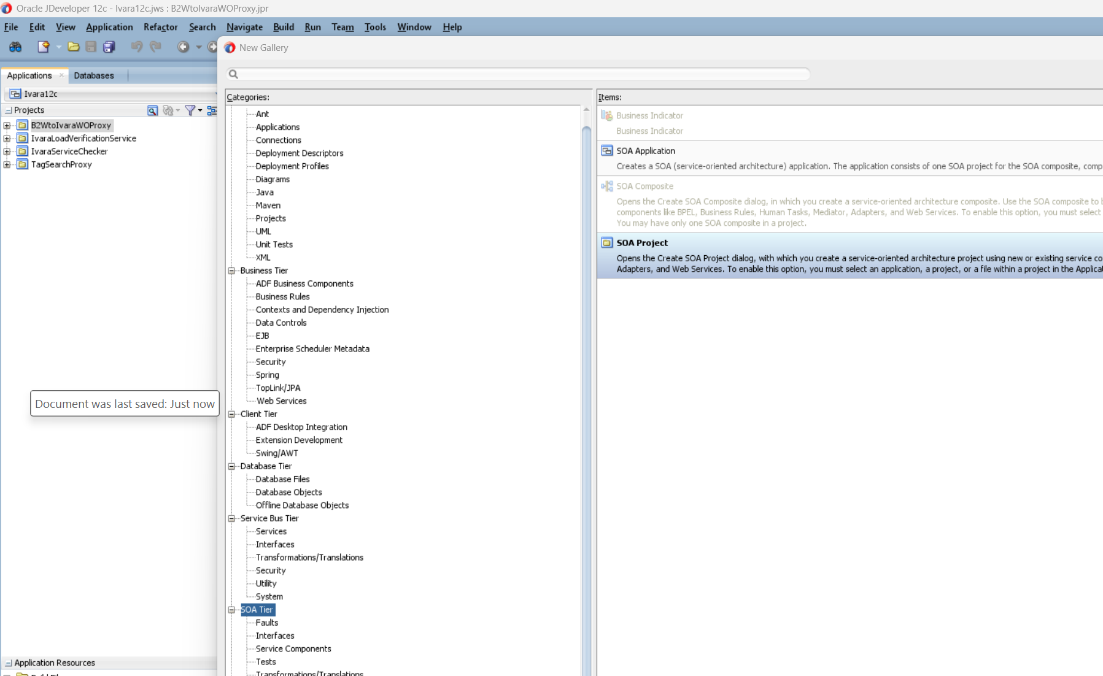

Figure 2. Ivara12c_SewAIImplementation_image10.png
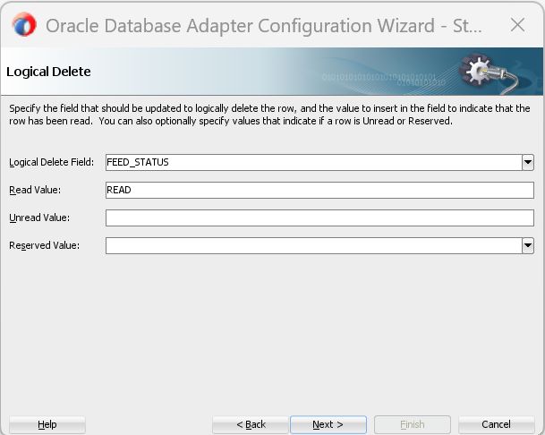

Figure 3. Ivara12c_SewAIImplementation_image11.png
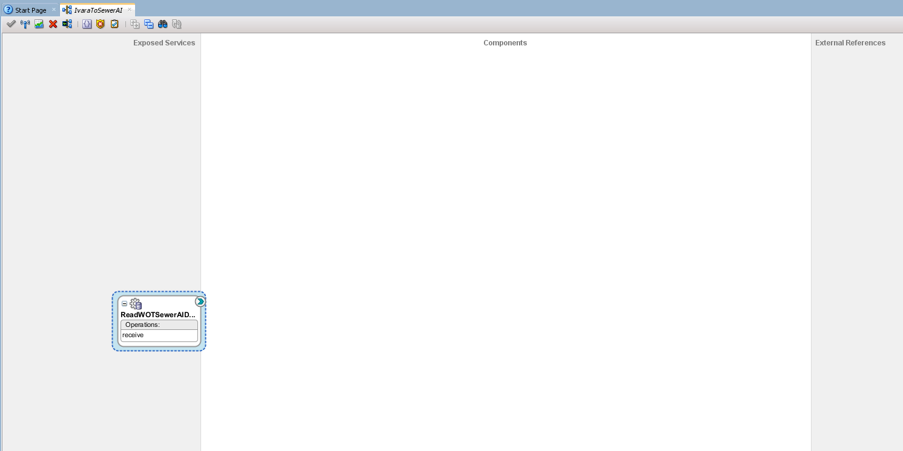

Figure 4. Ivara12c_SewAIImplementation_image12.png
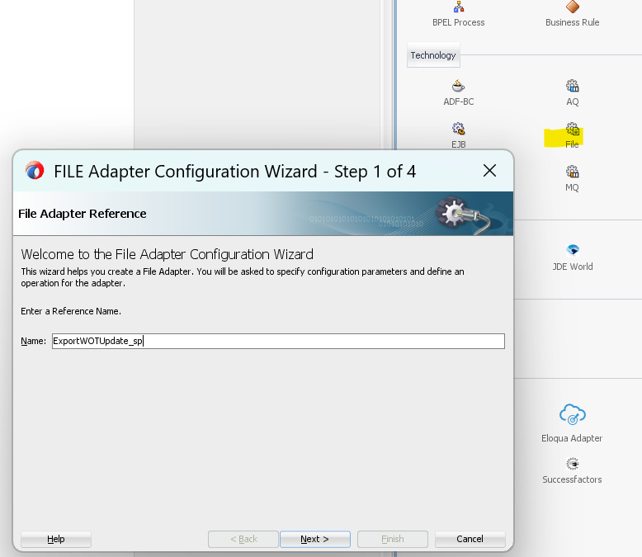

Figure 5. Ivara12c_SewAIImplementation_image13.png
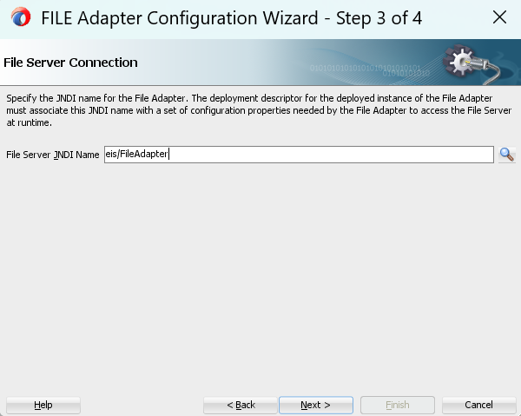

Figure 6. Ivara12c_SewAIImplementation_image14.png
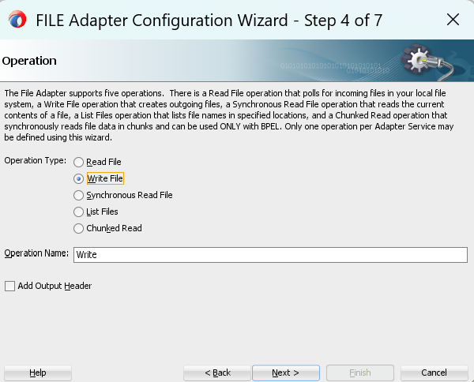

Figure 7. Ivara12c_SewAIImplementation_image15.png
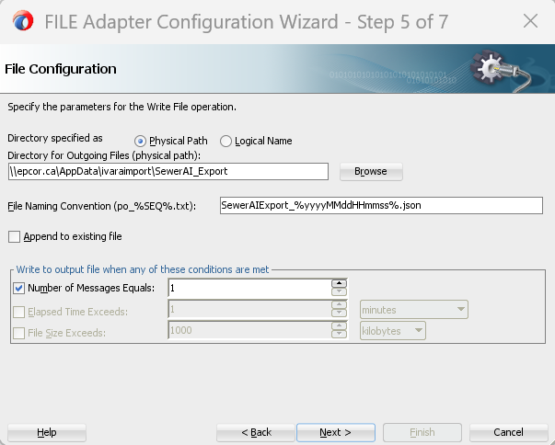

Figure 8. Ivara12c_SewAIImplementation_image16.png
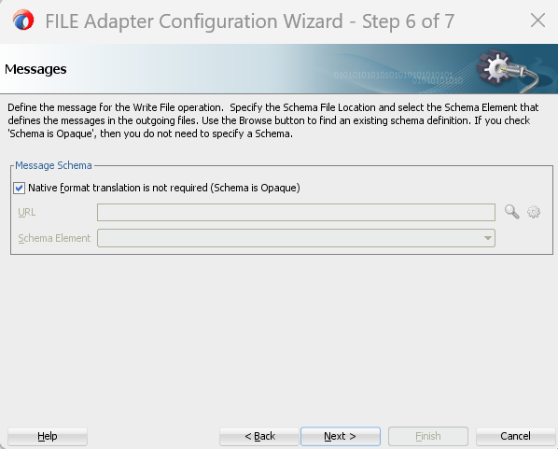

Figure 9. Ivara12c_SewAIImplementation_image17.png
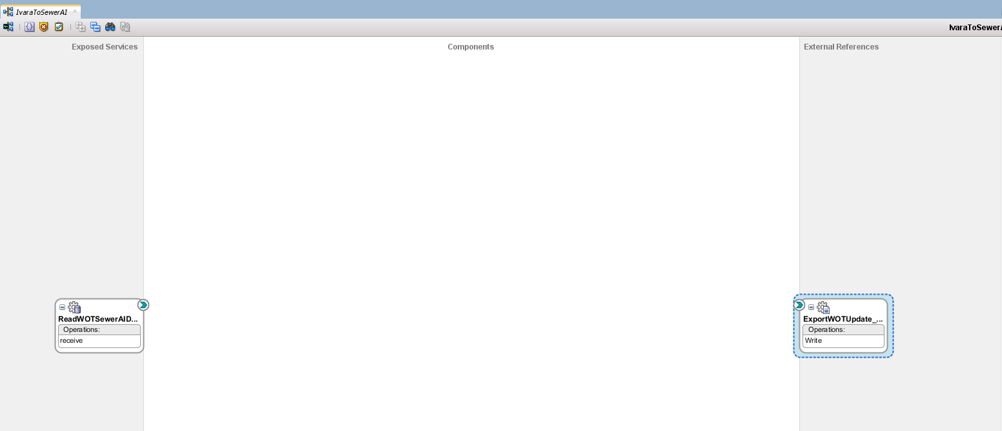

Figure 10. Ivara12c_SewAIImplementation_image18.png
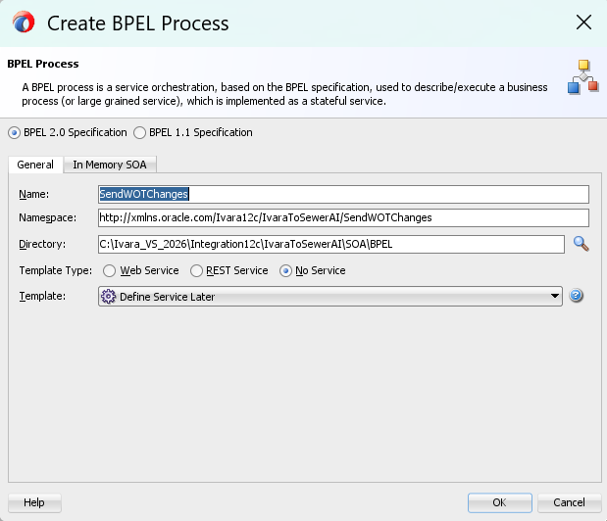

Figure 11. Ivara12c_SewAIImplementation_image19.png
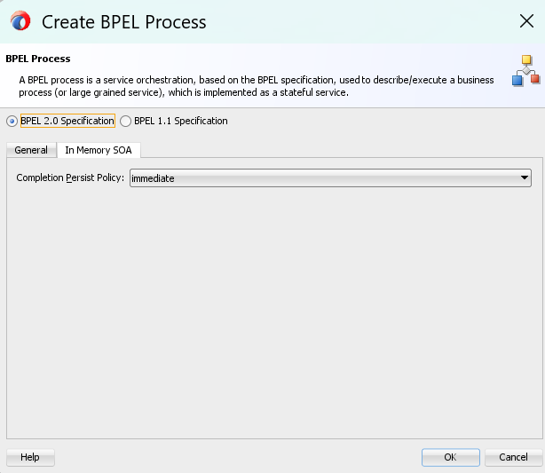

Figure 12. Ivara12c_SewAIImplementation_image2.png
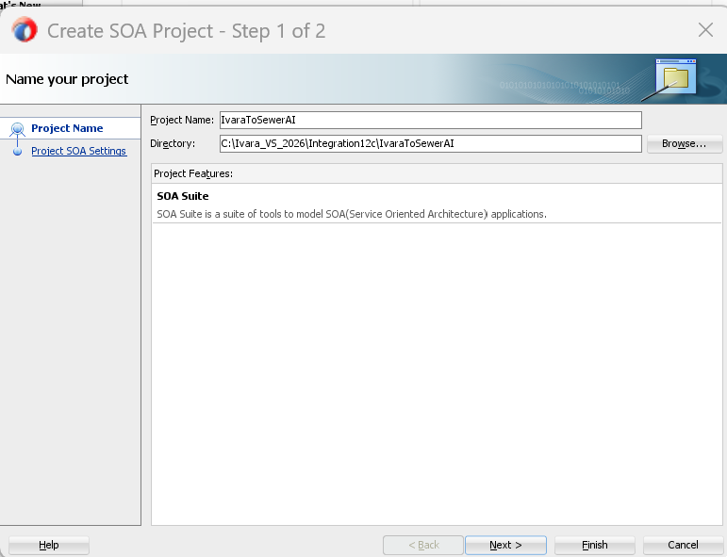

Figure 13. Ivara12c_SewAIImplementation_image20.png
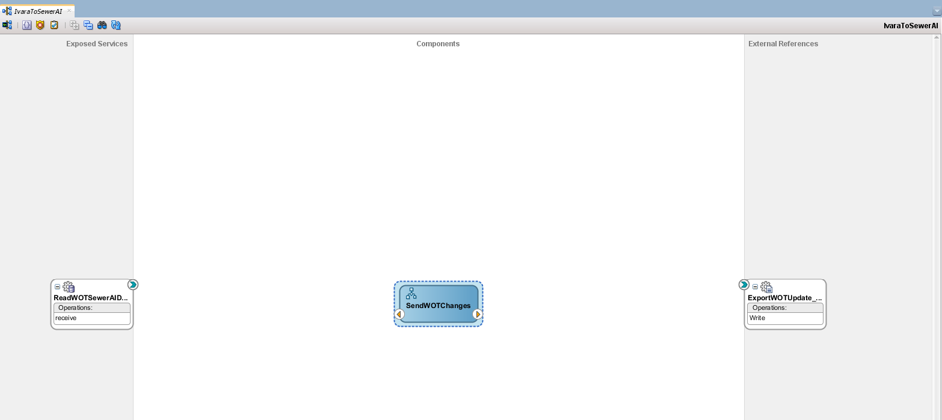

Figure 14. Ivara12c_SewAIImplementation_image21.png
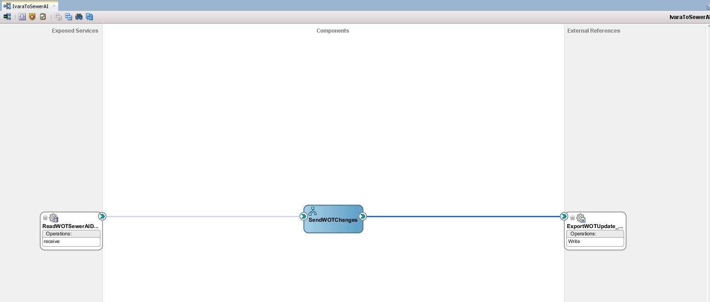

Figure 15. Ivara12c_SewAIImplementation_image22.png
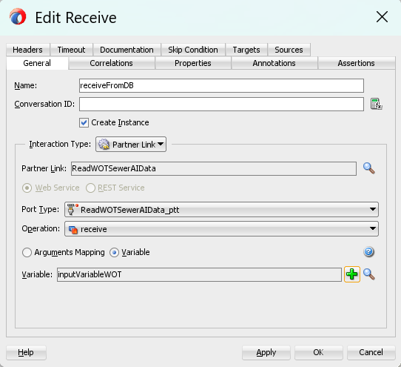

Figure 16. Ivara12c_SewAIImplementation_image23.png
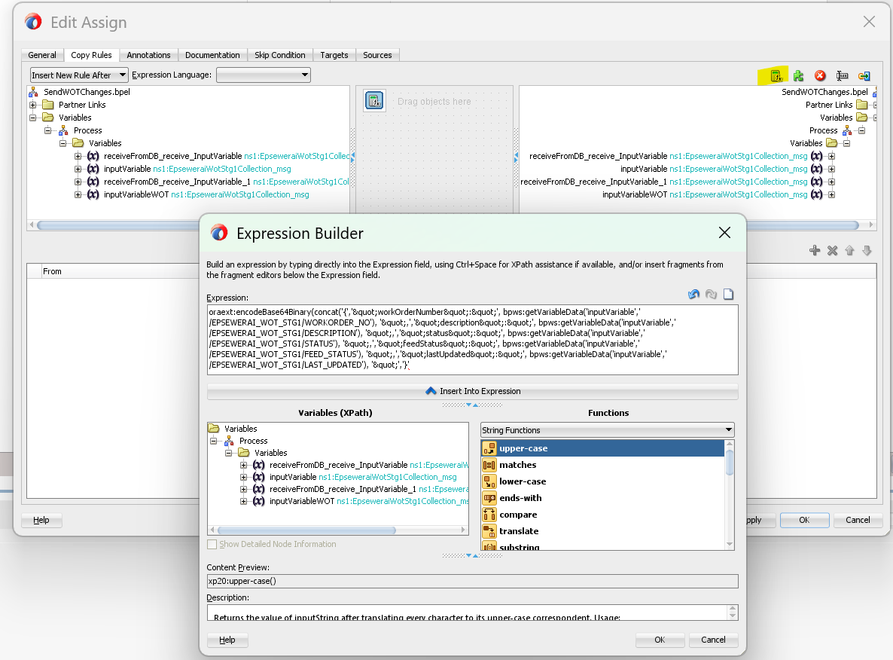

Figure 17. Ivara12c_SewAIImplementation_image24.png
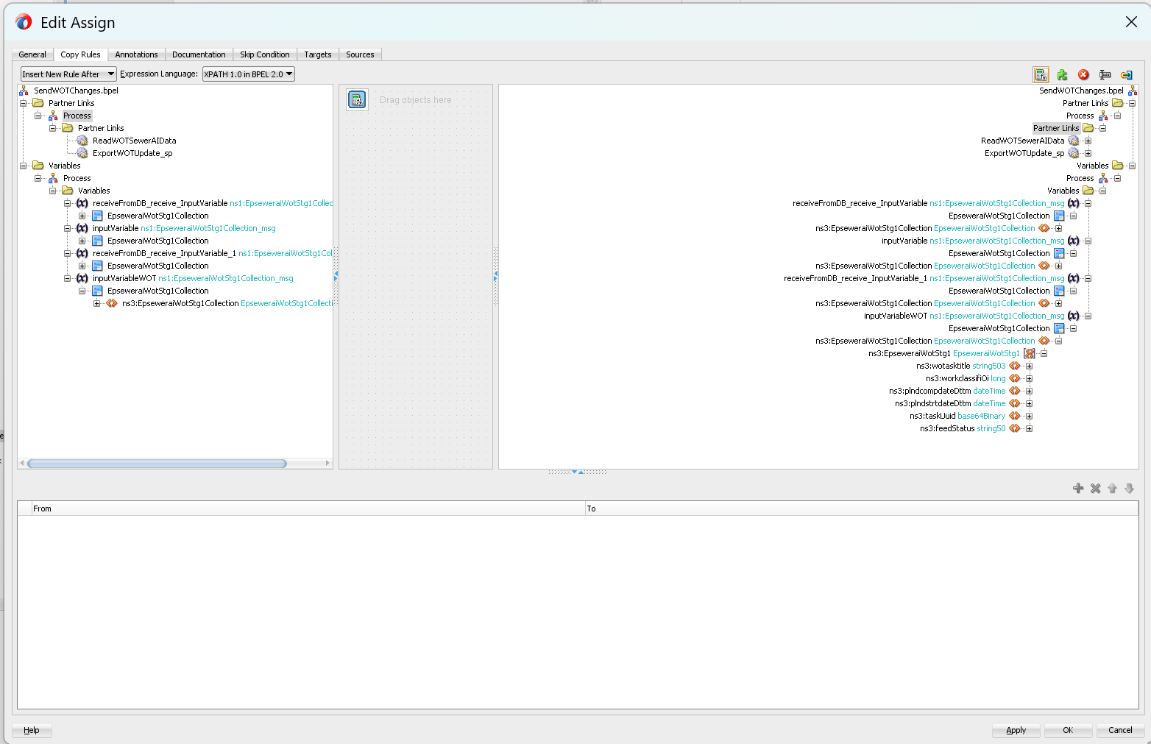

Figure 18. Ivara12c_SewAIImplementation_image25.png
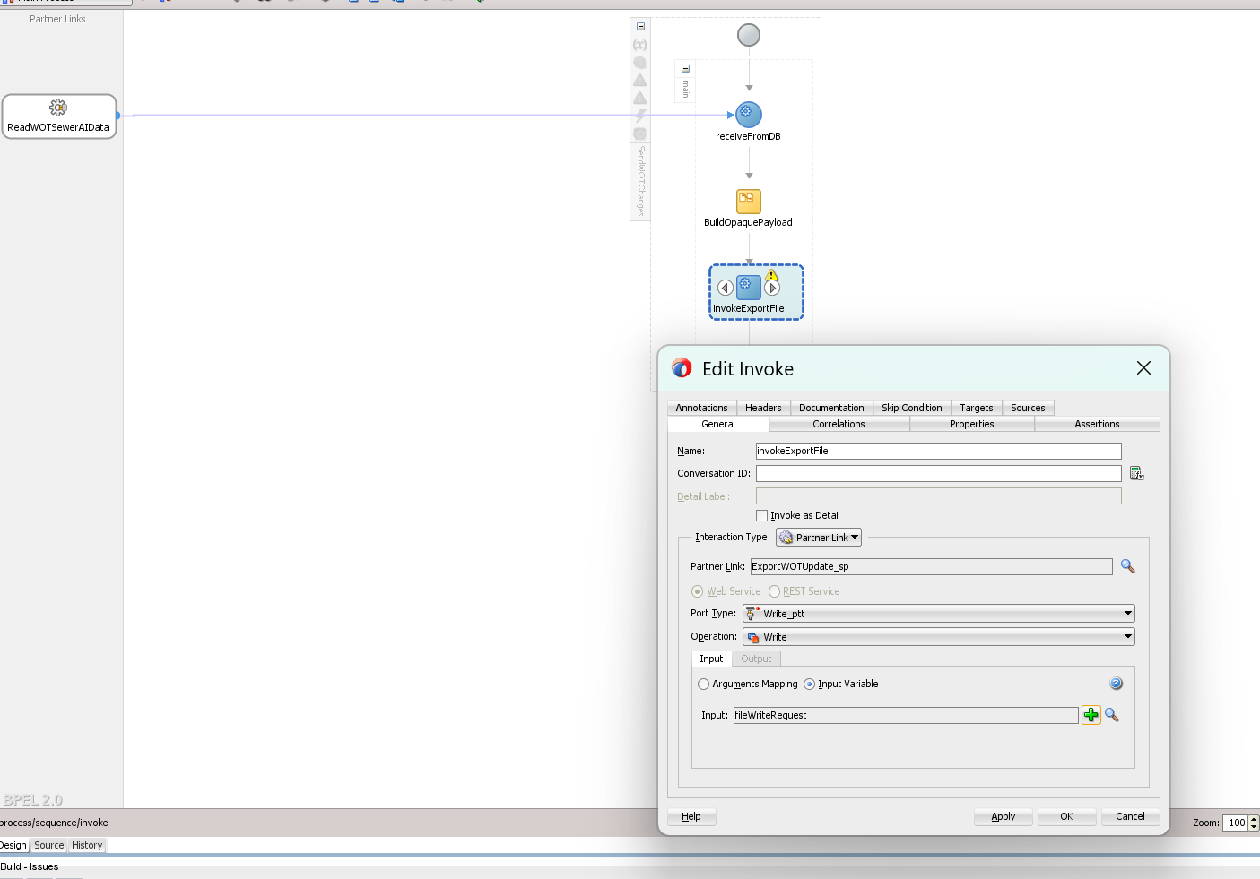

Figure 19. Ivara12c_SewAIImplementation_image26.png
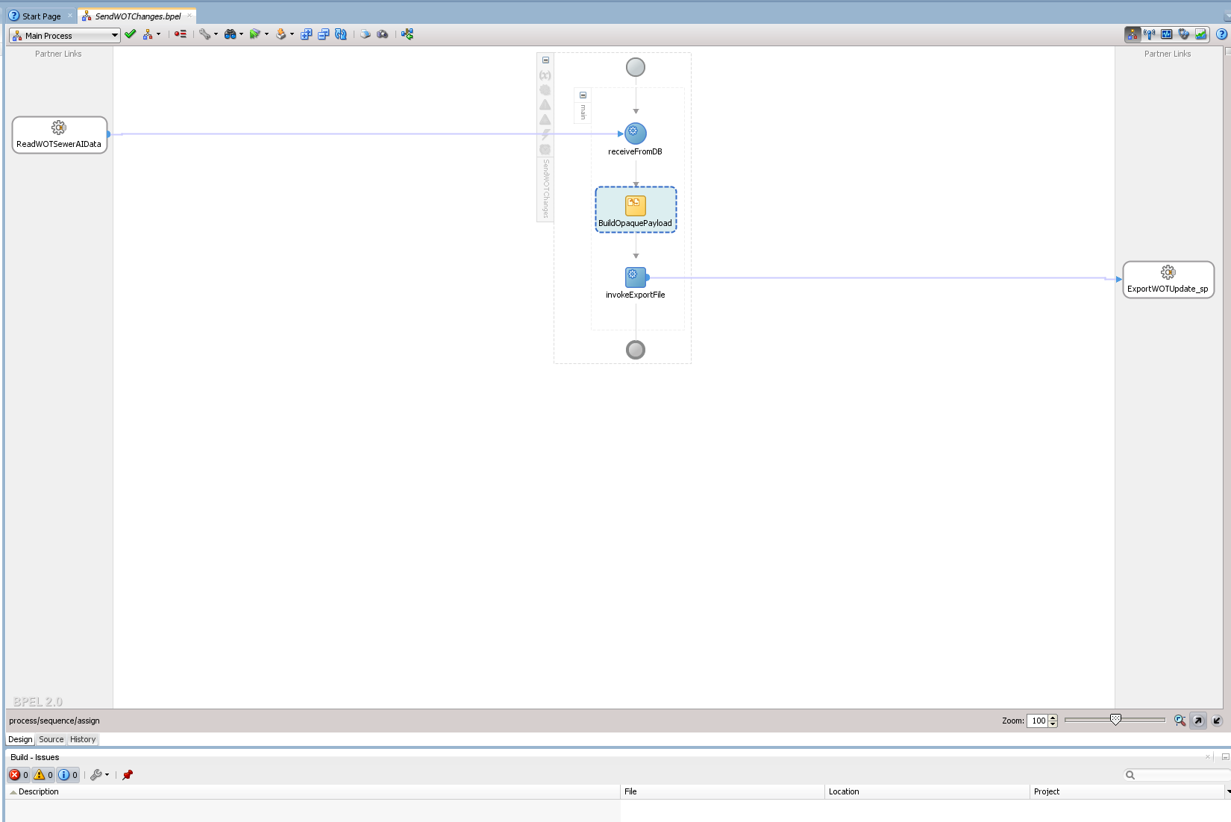

Figure 20. Ivara12c_SewAIImplementation_image27.png
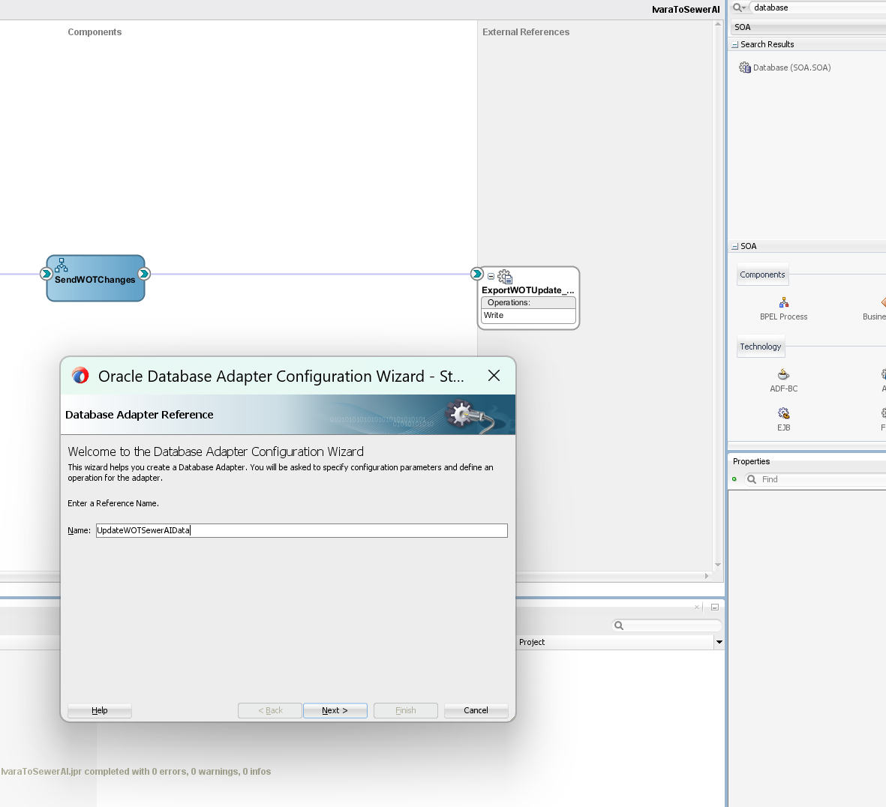

Figure 21. Ivara12c_SewAIImplementation_image28.png
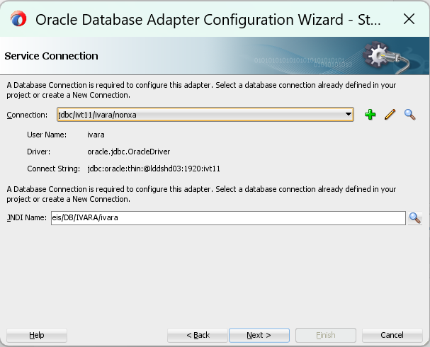

Figure 22. Ivara12c_SewAIImplementation_image29.png
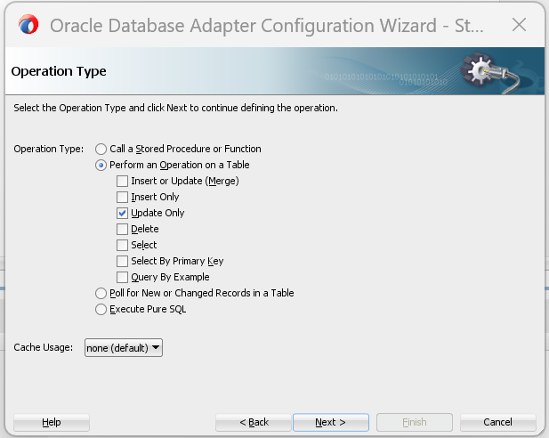

Figure 23. Ivara12c_SewAIImplementation_image3.png
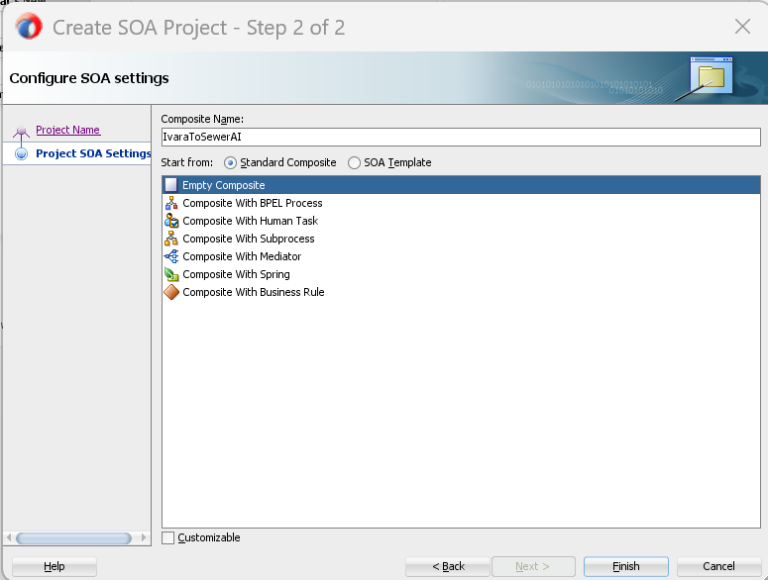

Figure 24. Ivara12c_SewAIImplementation_image30.png
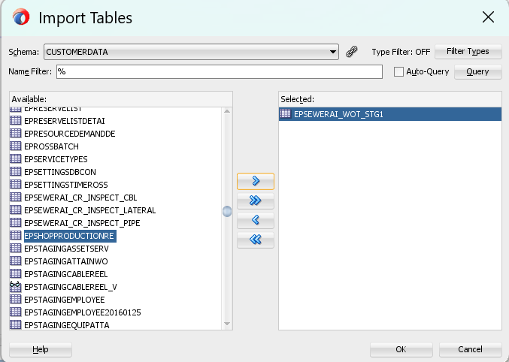

Figure 25. Ivara12c_SewAIImplementation_image31.png
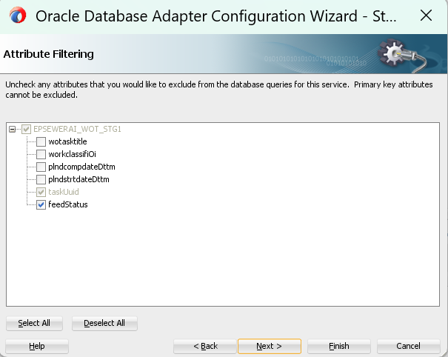

Figure 26. Ivara12c_SewAIImplementation_image32.png
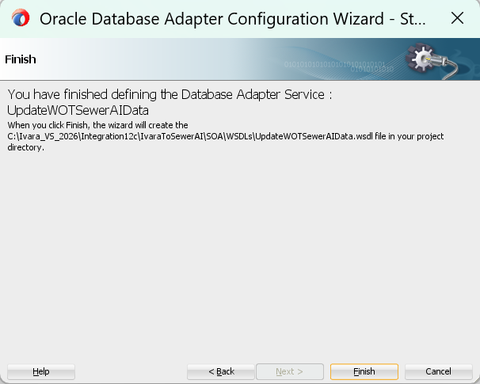

Figure 27. Ivara12c_SewAIImplementation_image33.png
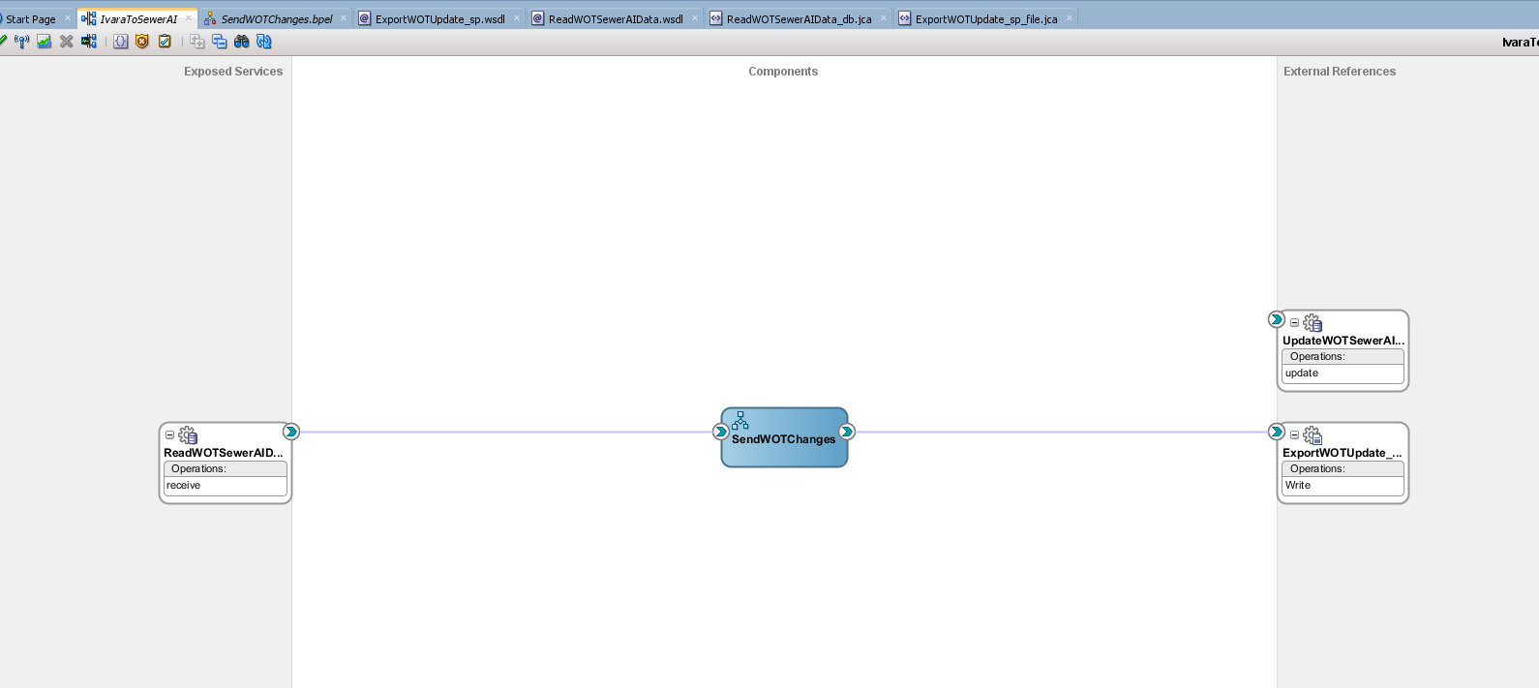

Figure 28. Ivara12c_SewAIImplementation_image34.png
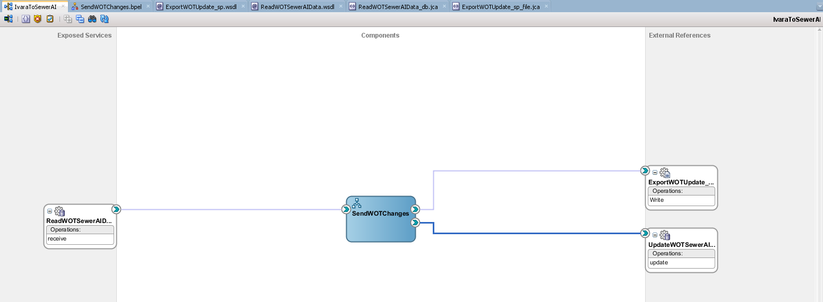

Figure 29. Ivara12c_SewAIImplementation_image35.png
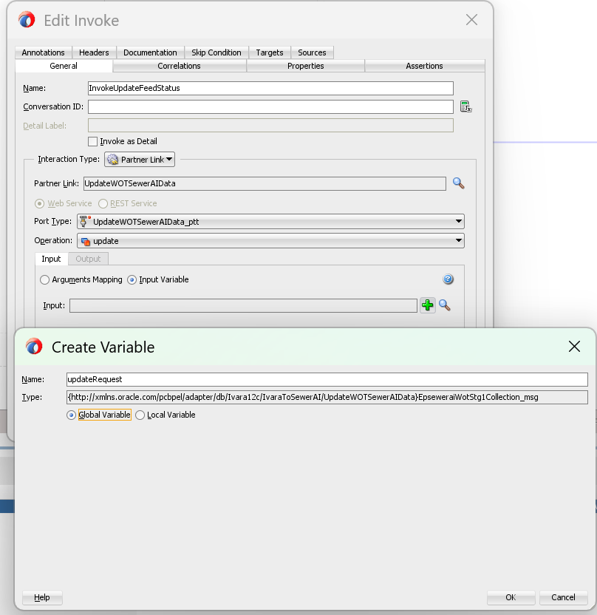

Figure 30. Ivara12c_SewAIImplementation_image36.png
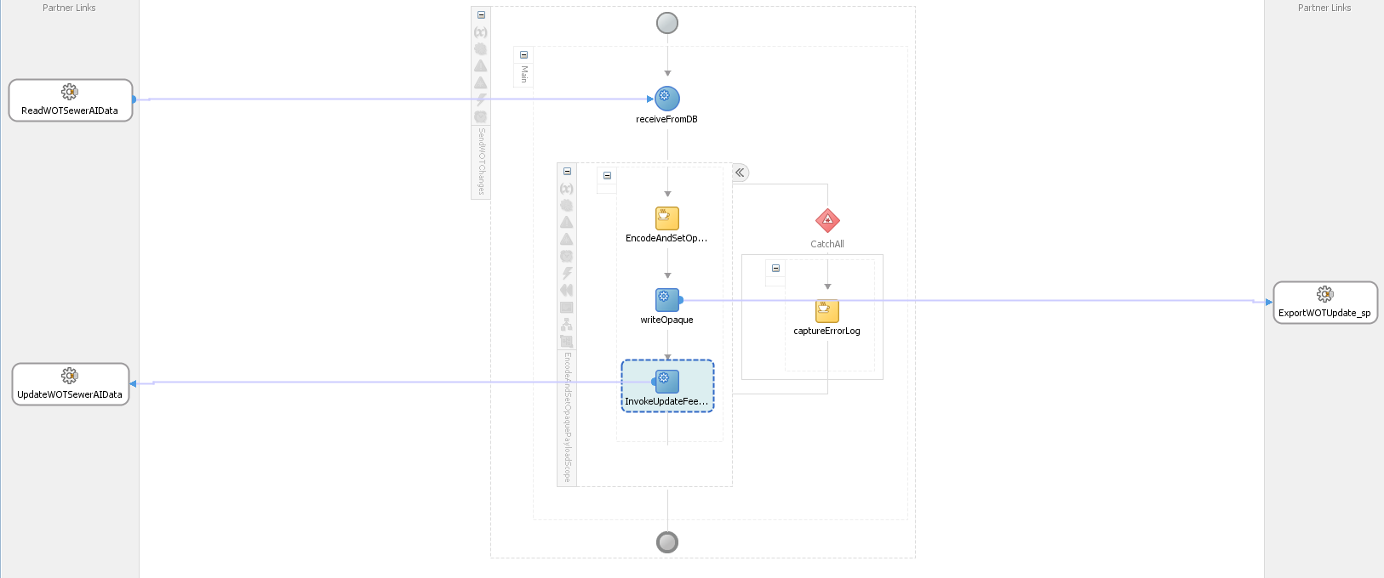

Figure 31. Ivara12c_SewAIImplementation_image37.png
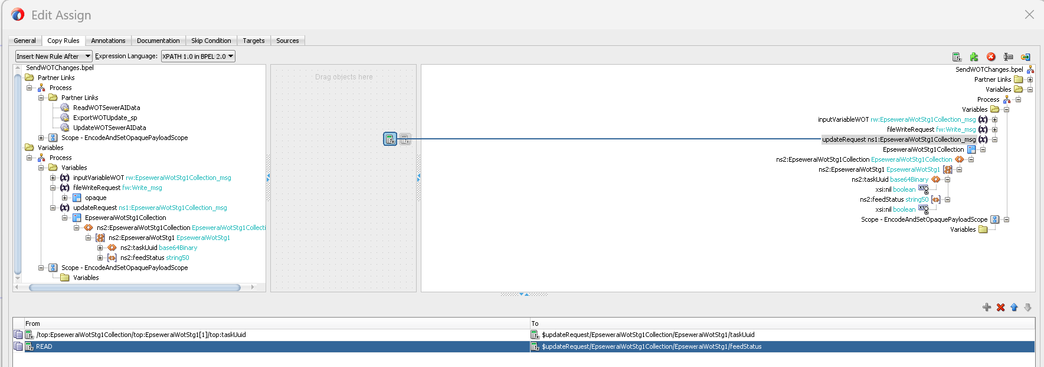

Figure 32. Ivara12c_SewAIImplementation_image4.png
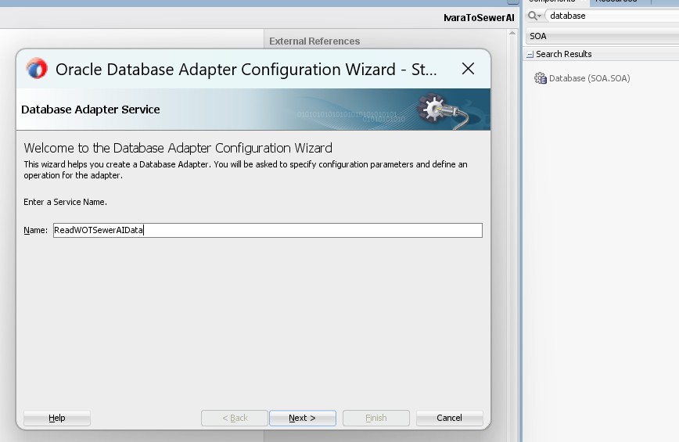

Figure 33. Ivara12c_SewAIImplementation_image5.png
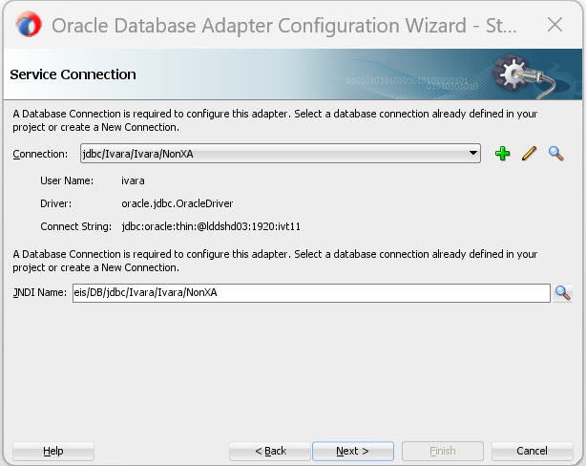

Figure 34. Ivara12c_SewAIImplementation_image6.png
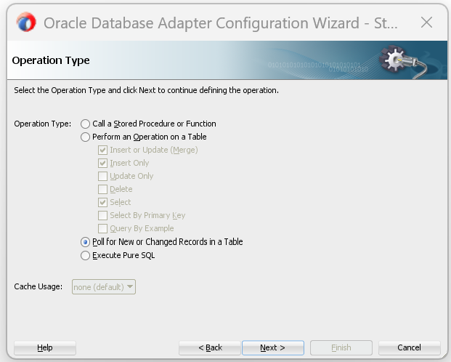

Figure 35. Ivara12c_SewAIImplementation_image7.png
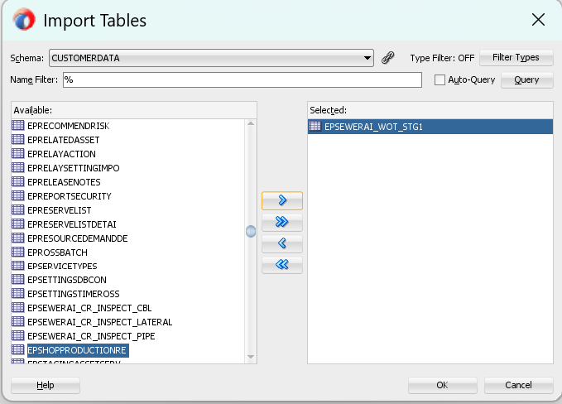

Figure 36. Ivara12c_SewAIImplementation_image8.png
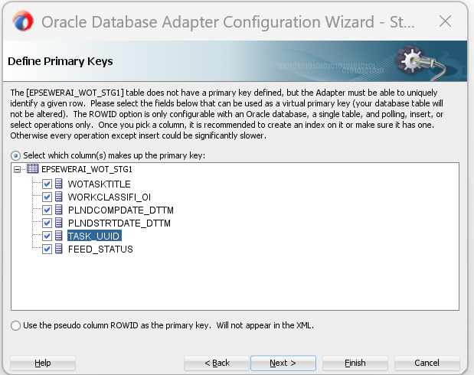

Figure 37. Ivara12c_SewAIImplementation_image9.png
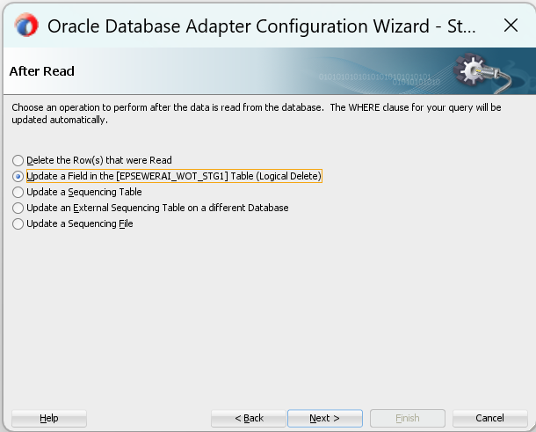

Figure 38. IvaraToSewerAI_JDeveloper_Build_Guide_image1.png
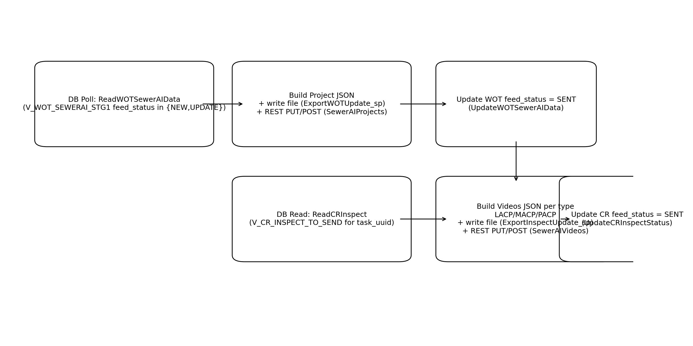

Figure 39. IvaraToSewerAI_JDeveloper_Build_Guide_image2.jpg
