Conclusões for Regression taken with all the feactures

Accuracy 79.6%

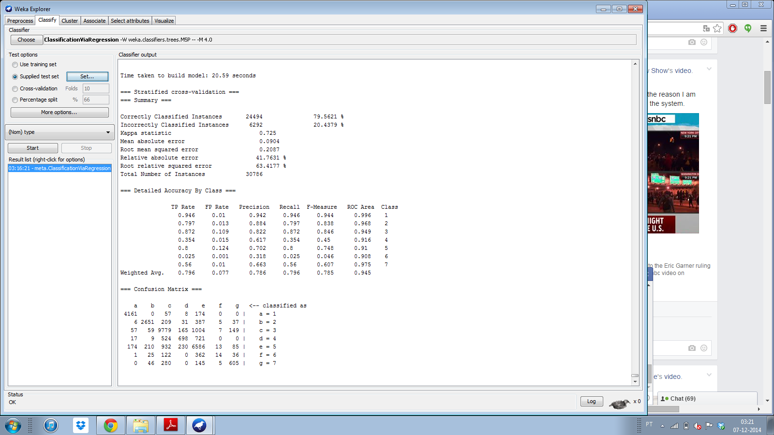Curiosities: Sky is the best classified – More true positives and more true negatives

C is the one with more false positives

Conclusões for Regression taken with all the feactures

This time first trained and then tested

