I’d like to show you two images with Times Square:
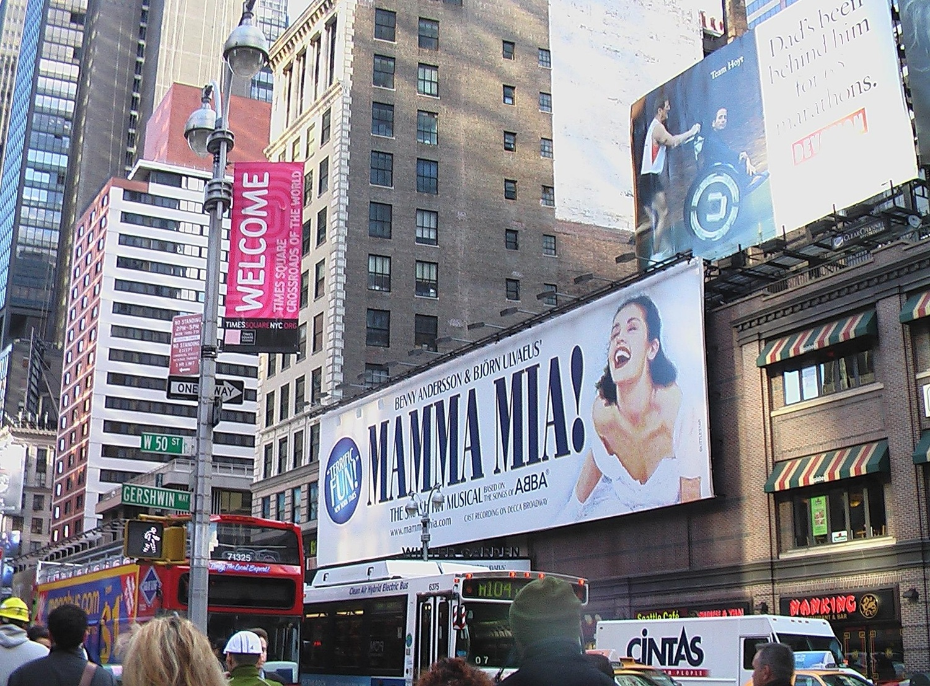 | 

I’ll show this text on purpose rendered on two columns. I talk here about travelling to New York.
Textul acesta il arat special pe doua coloane. Vorbesc aici despre a vizita New York-ul.

And this will be another table, but with text:
One | First | 1
Two | Second | 2
Three | Third | 3
Four | Fourth | 4


