https://wiki.fogproject.org/wiki/index.php?title=Migrate_FOG
No vamos a seguir por completo la guía, al menos en lo que se refiere al traspaso de archivos de un lado al otro, porque ya lo hemos visto en los otros lados.
En nuestro caso, hemos usado el backup de la base de datos que hemos conseguido con el script “oficial”. Y lo hemos añadido al del servidor 10.2.7.6
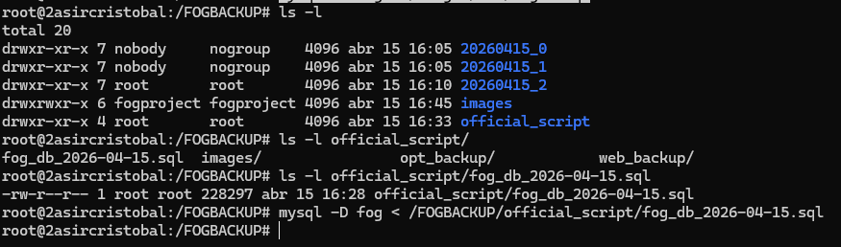
Tanto los hosts como las imágenes de sistemas se han añadido perfectamente:
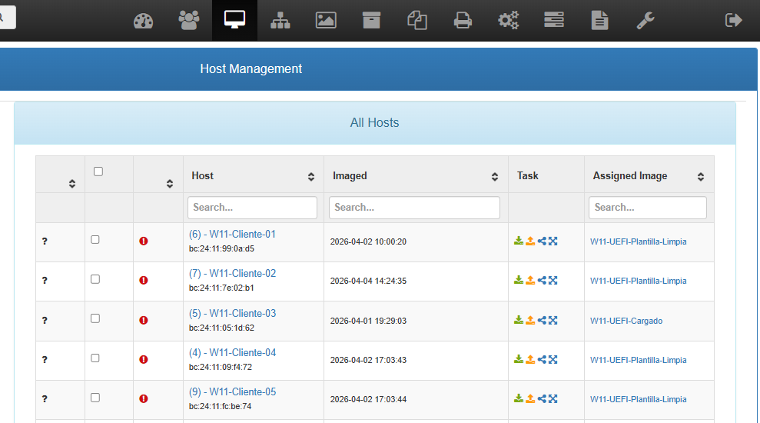
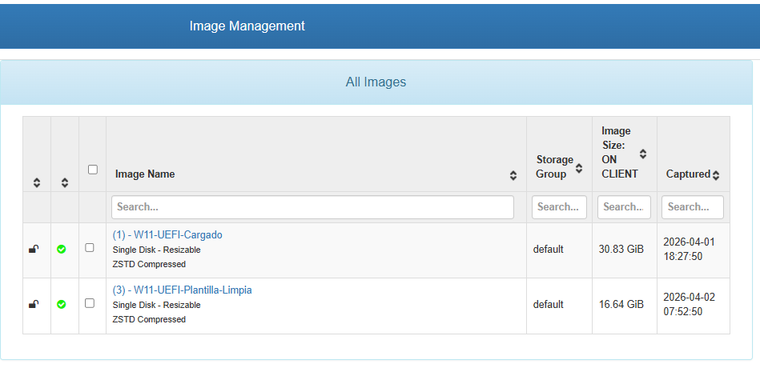

Fix IP Addresses, Passwords, and Interface on new server
Because we have imported the old database into the new server in order to preserve all of the host data, image definitions, group definitions, image assignments, and so on, we also imported all of the old server's IP Addresses and passwords along with it. This can't be helped using the approach we took - which is the approach to take if your web interface on the old server was just completely not working. Because of this, we need to change just a few places in the FOG Web GUI, and change the old FOG Server's IP address to the new FOG Server's IP Address, and update a few passwords.
First, we must find out what the new FOG Password and new interface is. On the new FOG Server, run this command and note the outputted lines that begin with password= and interface=
cat /opt/fog/.fogsettings
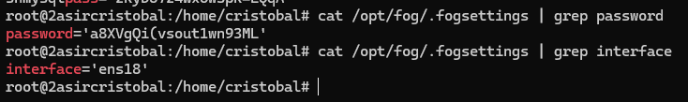
cat /opt/fog/.fogsettings | grep password
password='a8XVgQi(vsout1wn93ML'
cat /opt/fog/.fogsettings | grep interface
interface='ens18'

You'll want to copy/paste the password because of it's length.
Paste the password into the below fields in the new FOG Server's web interface:
- Web Interface -> Storage Management -> [click node name] -> Password and update the Interface field with the new interface name also.


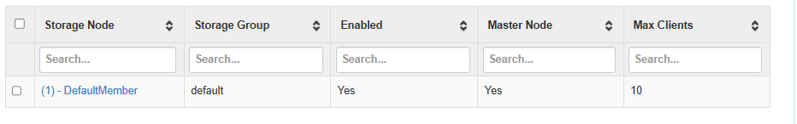
Se le ha copiado la contraseña del FOG en 10.2.7.5. Debemos cambiársela por la suya. La interfaz ha coincidido que es la misma: ens18

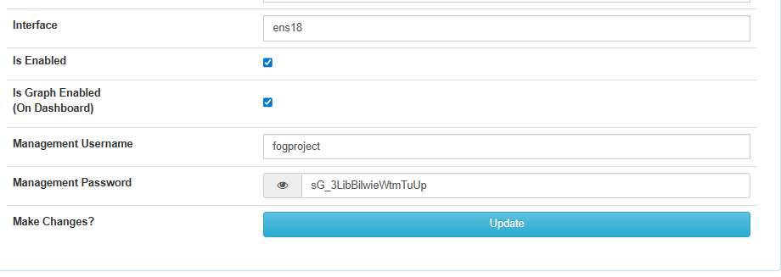
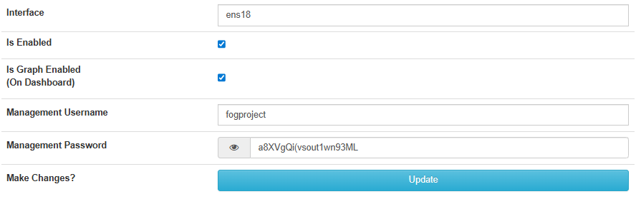

Si no terminamos de confgiurar lo de las IPS nos pedirá servidor de TFTP:
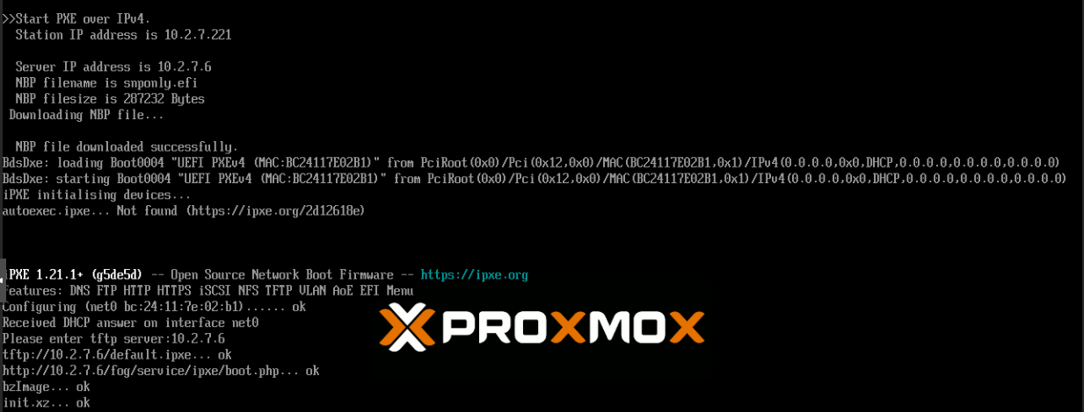
Y habrá error:
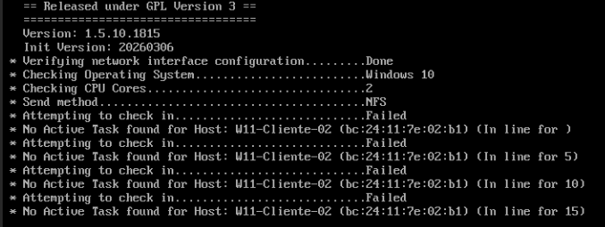
- Web Interface -> FOG Configuration -> FOG Settings -> TFTP Server -> FOG_TFTP_FTP_PASSWORD

Debemos cambiar la IP y la Password:
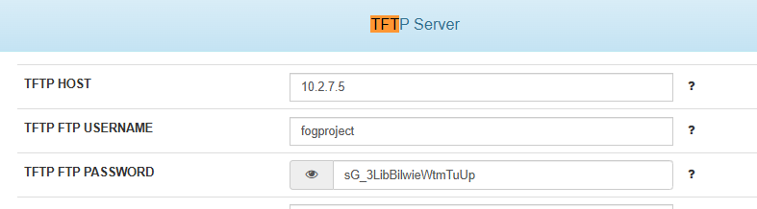
Arreglado:
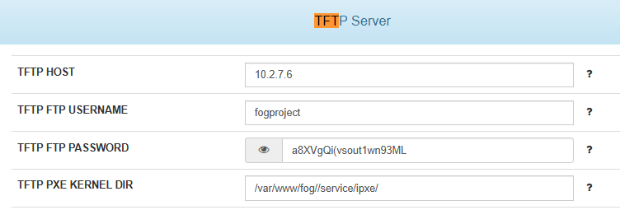

Update the IP Address in the below fields in the new FOG Server's web interface:
- Web Interface -> Storage Management -> [click node name] -> IP Address
También hay que cambiarle aquí la IP:
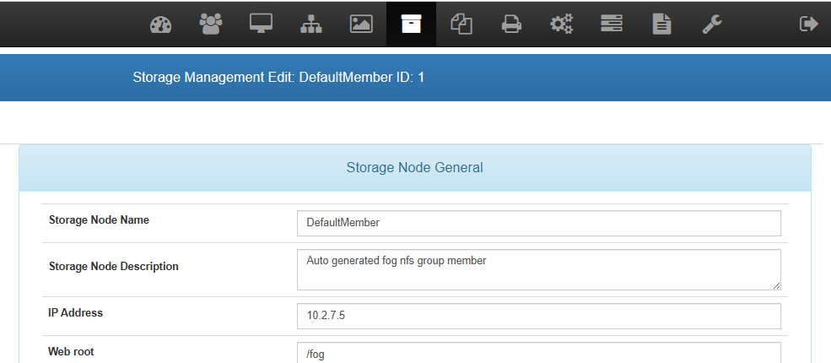
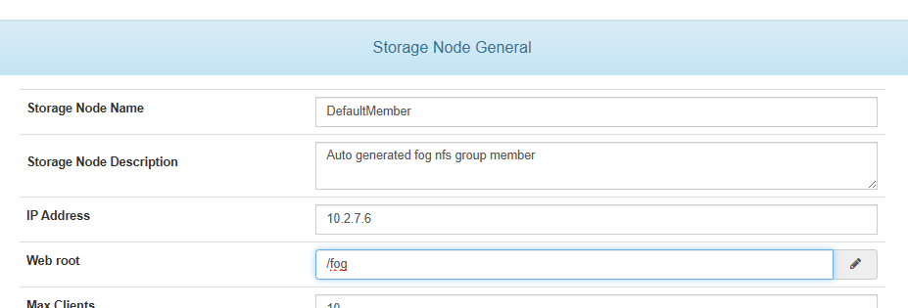

- Web Interface -> FOG Configuration -> FOG Settings -> Web Server -> FOG_WEB_HOST
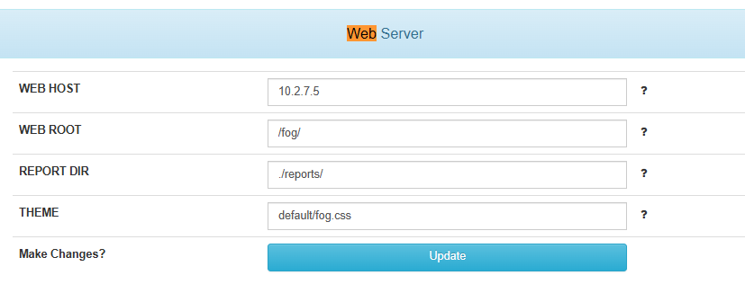
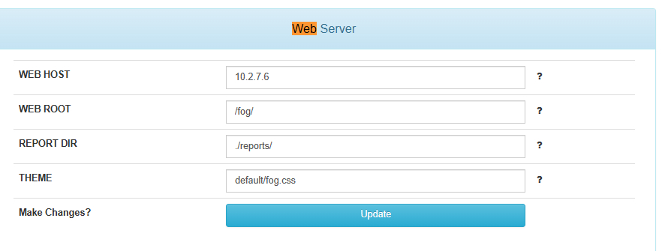

- Web Interface -> FOG Configuration -> FOG Settings -> TFTP Server -> FOG_TFTP_HOST
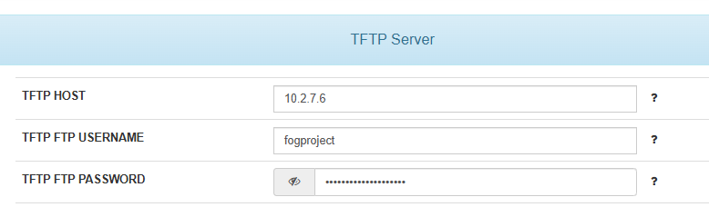

Tras eso se realizó el despliegue en un equipo y no hubo ningún problema.
