**Shoppable App Release Note**

**ONLY BROWSE THE PRODUCT TYPE YOU WANT**

You can find the products you love organized by type right on your home screen.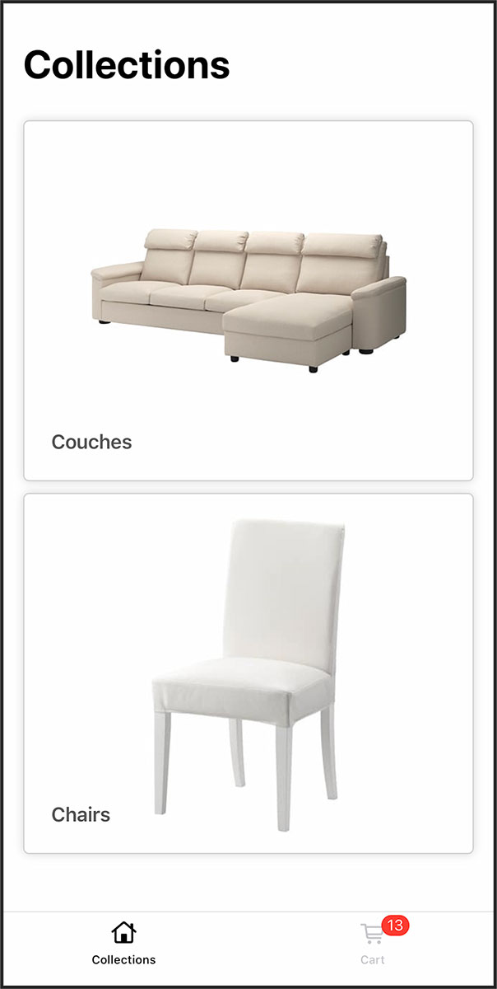

Browse through the collection of products you are the most interested in.

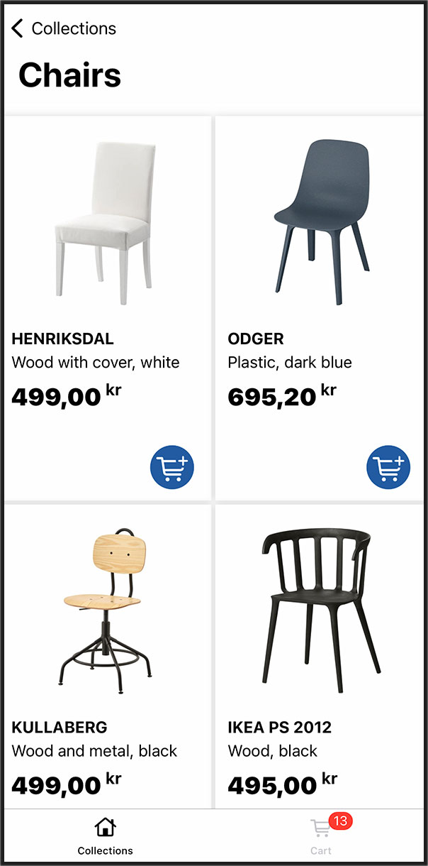

And you can also browse in Spanish amigo!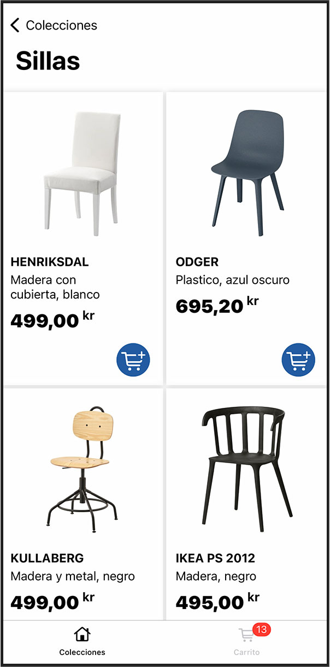

When you find something you love, just tap on the Shopping Cart button and voilà! The product will be automatically added to your Shopping Cart and ready to be buy.

**TAKE A BETTER LOOK AT THE PRODUCT WITH A BIGGER PHOTO**

Do you want to see more physical details of the product but the thumbnail is too small? Just tap on the product and take a peak at the large photo.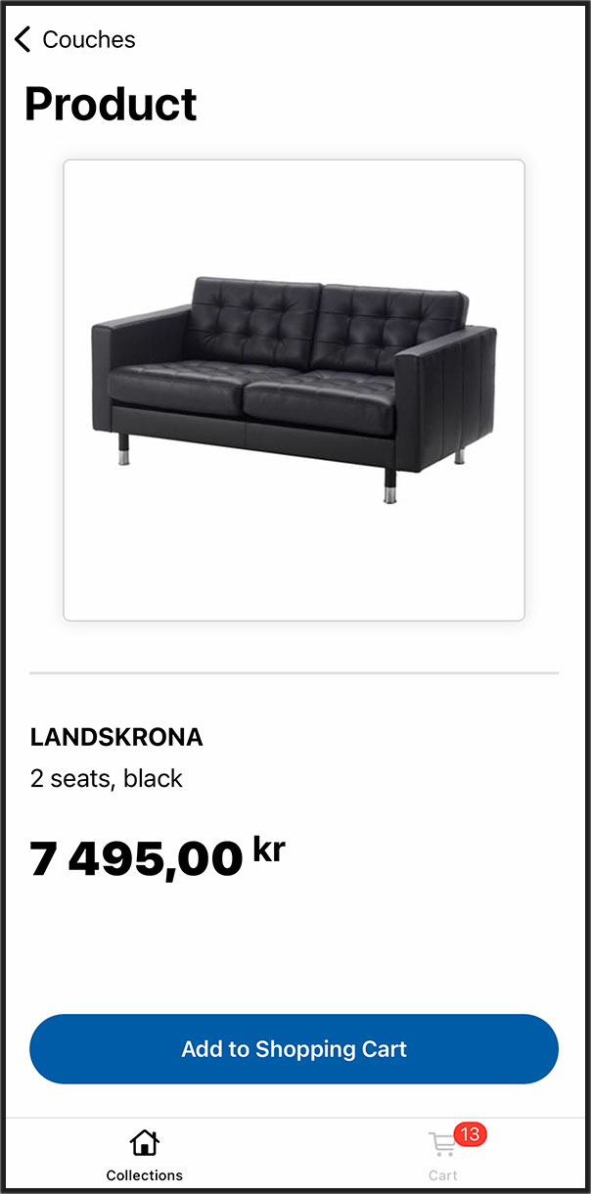

Now that you fell in love with your product, you can add it to your Shopping Cart directly from here.

**ARE YOU READY TO BUY? HEAD TO THE SHOPPING CART**

Once you’re ready to take your beauties home, just head to the Shopping Cart and buy them.

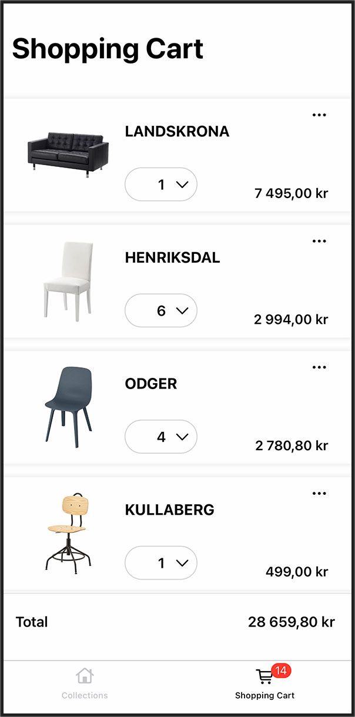

But you need more than 1 chair, right? Then add more to your Shopping Cart by tapping on the product’s quantity button.

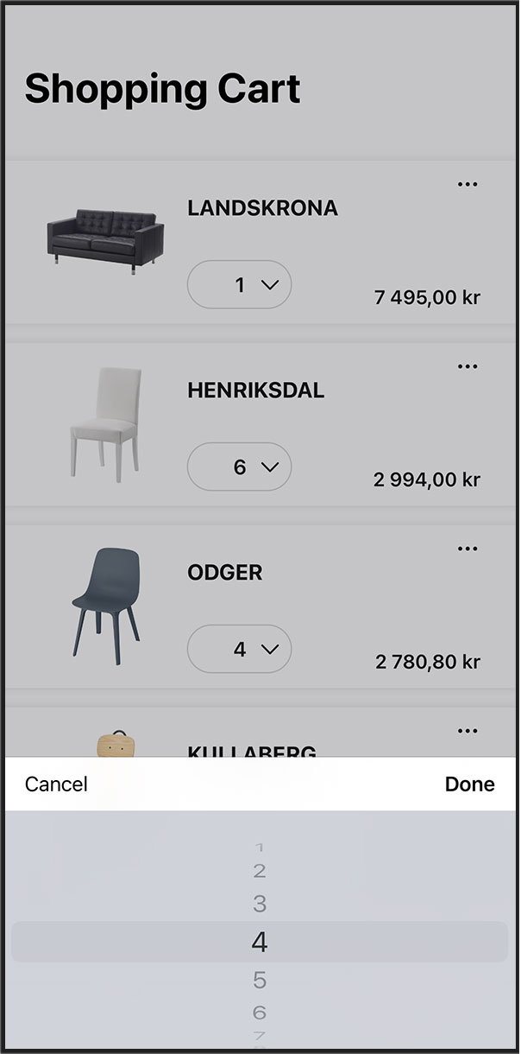

And if you changed your mind about a product and want to remove it from your Shopping Cart, you can do it in two ways:

1. Swipe left on the product and tap on the red button.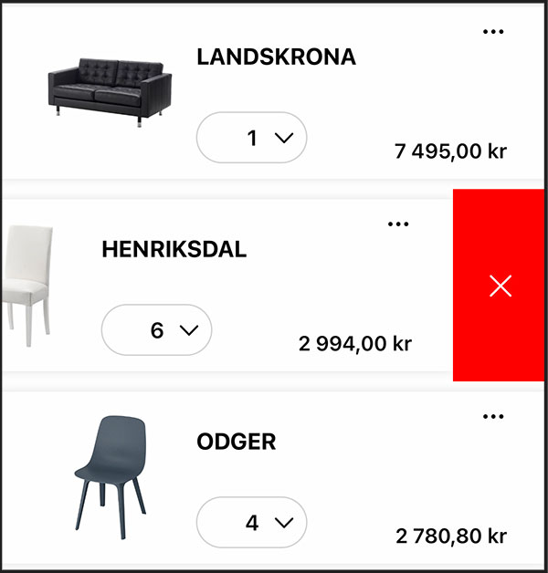

2. Tap on the “Options” button and choose “Remove Item” from the menu.