Table of Contents

Unified Client Agent Test Document 1
Installation Instructions 1
Minimum Requirements 1
Windows Installation 2
Linux Installation 2
Increasing debugging 2
Procedures For Tests 4
Testing reboot 4
Testing Domain Join 5
Testing Domain Unjoin 6
Testing PID-file Cleanup 6

Unified Client Agent Test Document

Installation Instructions
The Unified Client Agent (UCA) has a single, unified installer. Its intent is to provide a singular installation experience across the platforms it supports. However, the execution of this installer and the prerequisites are unique on each platform.
The installer can only be found in ENV01 at http://10.4.0.66/ucaPhase2/. All test machines for the UCA must obtain the UCA from ENV01.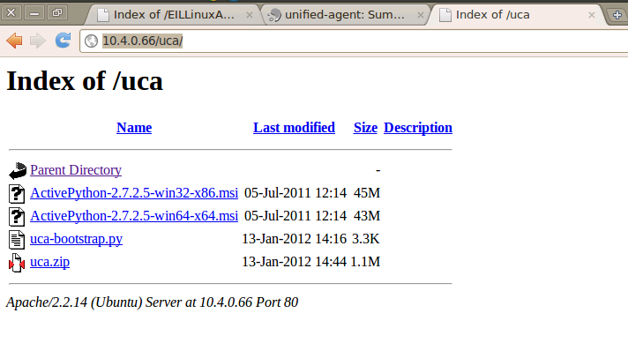

Minimum Requirements
The UCA has the following as general, minimum requirements:
- General
  - Minimum Python Version 2.5
  - (UCA should run on Python 3.0, however as it is not yet available on any of the Linux distributions we support, nor is it available as an ActivePython bundle, it has not been tested yet.)
  - Windows
  - ActivePython bundle which includes the Win32 APIs
  - (The ActivePython bundle included in the above URL will suffice).
  - Linux
  - POSIX compliant shell environment
  - LSB compliant Python interpretor

Windows Installation
All of the following must be done as the Administrator on the Windows system.
Start by downloading and installing the ActivePython installer from the URL above for whatever Windows platform you are running (x86 or x64).
Next, download the “uca-bootstrap.py” file and save it somewhere you can find it.
Start up a shell environment (such as PowerShell) and navigate to where you downloaded the “uca-bootstrap.py” file.
Execute the bootstrap with:
python.exe uca-bootstrap.py
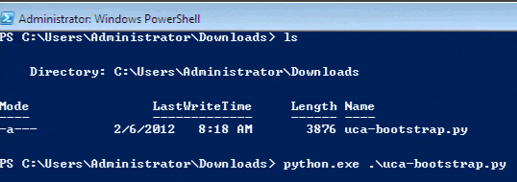
Installation logging will display, if you encounter any errors during installation please collect the error and report it.

Linux Installation
All of the following must be done as the root user on the Linux system.
Start by downloading the “uca-bootstrap.py” file from the above URL:
# wget http://10.4.0.66/ucaPhase2/uca-bootstrap.py
Make the bootstrap file executable, then run it:
# chmod +x uca-bootstrap.py
# ./uca-bootstrap.py
Installation logging will display, if you encounter any errors during installation please collect the error and report it.

Increasing debugging
If you encounter a problem, and can reproduce it, please increase the logging on the UCA and provide us with the full log including the problem.
The log file for the UCA is called “clieant-agent-base.log” and it can be found in “C:\EIL” under Windows and “/opt/intel/eil/clientagent/home” under Linux.
Increasing the debugging level can be done in the “clientagent.cfg” file (also found in the above directories). Specifically, increase the logging level to 3, 4 or 5.
Once you have modified the logging level it is generally a good idea to ensure the UCA has accepted the changes. Typically, the UCA will automatically discover configuration changes every 60 seconds. You can watch the logs and verify it has changed by looking for an entry similar to the following:
2012-03-13 14:56:52,118 - root - INFO - Log level set to 3
However, if it doesn't update (or doesn't update quick enough for you) you can always force a restart to reload the config. Under Windows, this can be done in the Services screen, and under Linux this can be done by executing the following init script:
# /etc/init.d/eil_steward.py restart
If this restart at all fails, you can also force a restart by rebooting the system (though you should consider this a “last resort” option, as it will mean something has gone wrong with the UCA and should be reported).

Procedures For Tests
The tests for the UCA should be performed using the staging Portal release which is accessible in the lab at http://eilportal.eil-infra.com/PortalStaging/LabResources.aspx.
PLEASE NOTE: Changes made in the staging environment will affect the production environment. Take care while testing.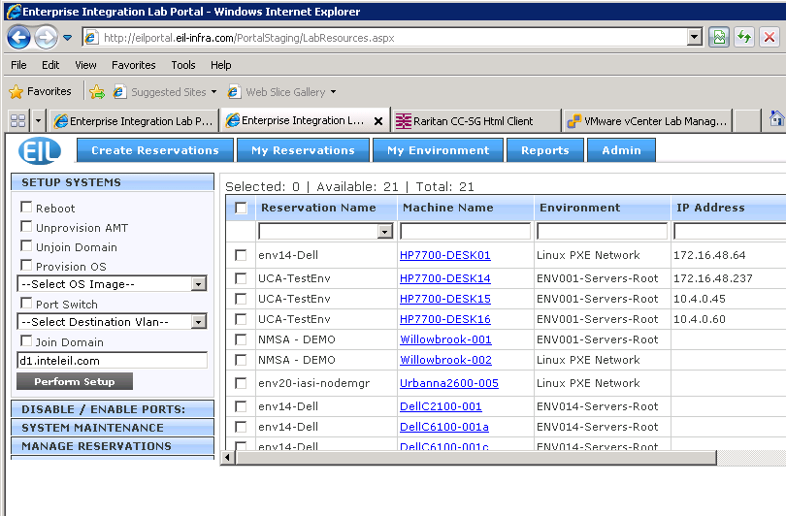
If you are testing under Linux, it might be advisable to watch the log file (detailed above) with something like “tail -f” .

Testing reboot
- On the staging Portal, select the system you are testing on (which has the UCA installed on it) and select the “Reboot” option:
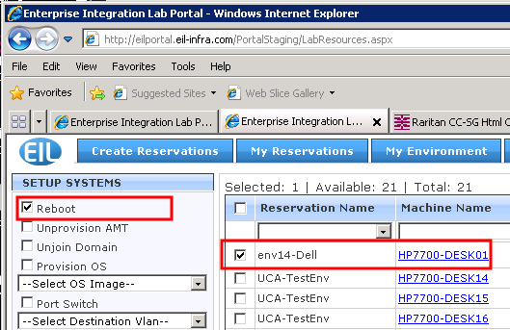
- Click “Perform Setup”.
- Watch the “Operation Status” field to verify that the Reboot command was sent and consumed.
- Watch the system you are testing to verify that it is rebooted.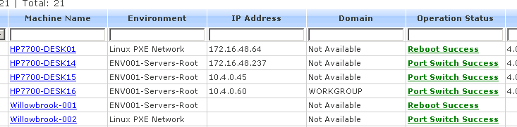

Testing Domain Join
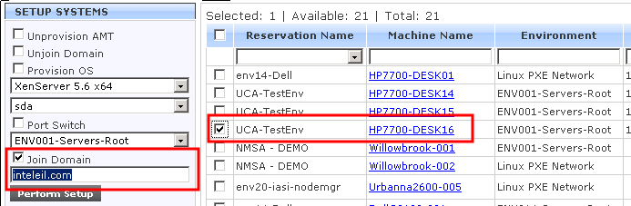
- On the staging Portal, select the system you are testing on (which has the UCA installed on it) and select the “Join Domain” option:
- Click “Perform Setup”.
- Watch the “Operation Status” field to verify that the Join command was sent and consumed.
- Verify that the system you are testing has joined the domain by right-clicking on “My Computer” or “Computer” (depending on the version of Windows you are using), and selecting “Properties”.
NOTE: On Linux, the “Join Domain” command is currently unsupported and not-applicable.

Testing Domain Unjoin
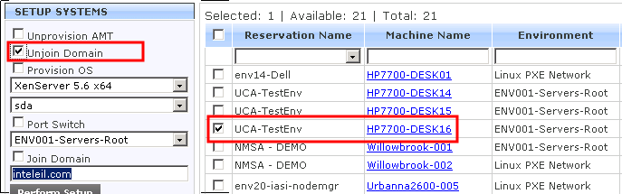
- On the staging Portal, select the system you are testing on (which has the UCA installed on it) and select the “Unjoin Domain” option:
- Click “Perform Setup”
- Watch the “Operation Status” field to verify that the Unjoin command was sent and consumed.
- Verify that the system you are testing has unjoined the domain by right-clicking on “My Computer” or “Computer” (depending on the version of Windows you are using), and selecting “Properties”.
- NOTE: On Linux, the “Unjoin Domain” command is currently unsupported and not-applicable.

Testing PID-file Cleanup
- This test is Linux-only. It should be run as root.
- On a Linux system with the UCA installed, find the process ID file (PID) at /opt/intel/eil/clientagent/home/clientagent.pid
- Stop the UCA by issuing the command:
# /etc/init.d/eil_steward.py stop
- Verify that the PID file has been destroyed.
- Start the UCA by issuing the command:
# /etc/init.d/eil_steward.py start
- Verify that the PID file exists and view it to obtain the process ID.
# cat /opt/intel/eil/clientagent/home/clientagent.pid
- Verify that the PID is the “eil_steward.py” script by using this command (and replacing “PID” with the process ID obtained in the last step).
# ps -p PID -f

Testing Asset Discovery and Update
The UCA performs an asset discovery when the agent first starts, and every hour thereafter. It then updates the Portal with its system's asset information. Thus, in order to test the asset discovery and update, a bit of manual intervention on the user's part is required.
- Restart the agent. Under Windows, this can be accomplished by selecting the “EIL Unified Agent” in the Services window and clicking “Restart”. Under Linux, this can be accomplished by issuing restart to the init script as root, “/etc/init.d/eil_steward.py restart”.
- Verify that the agent has sent the asset data and received no error. Check the logs for the following entries indicating a successful asset interaction:
2012-03-13 14:56:52,436 - clientagent.steward.ccmsupdate - INFO - Sending updated asset information to CCMS
2012-03-13 14:56:52,687 - clientagent.steward.ccmsupdate - INFO - CCMS updated with asset information
- Verify that the Portal now reflects the updated data. Inside the portal, click on the system's link and verify that it has updated asset information (one of the best ways to verify it is current is to look for “ClientAgentVersion” which will be XX.XX-ucaPhase2, where XX.XX are version numbers):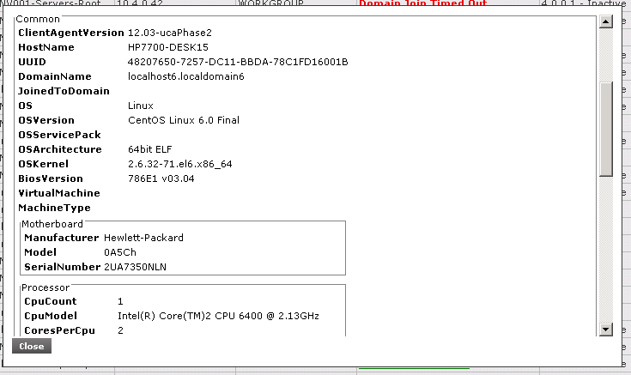
- (Optional) Verify that the asset XML is correctly generated. This is completely optional, and more important for Linux than Windows, but you can also verify that the assets discovered are being generated into proper XML. If you run the steward with the option “asset”, it will output the asset XML being generated.
Under Windows:
C:\eil\bin\> python eil_steward.py asset
Under Linux:
# /opt/intel/eil/clientagent/bin/eil_steward.py asset
Under Linux, it can also be piped through xmllint to make it readable:
# /opt/intel/eil/clientagent/bin/eil_steward.py asset | xmllint –format -
This is completely optional, but is helpful in knowing that the NMSA/LAF tests (to come later) will succeed under Linux.

Test Auto-Upgrade Feature
The UCA has an auto-upgrade feature. When it receives a command from the Portal to upgrade, or when it detects a new version, it will upgrade itself. The problem is, during testing, we cannot do either. So, we have a way to force the auto-upgrade process by passing “upgrade” to the steward.
- Start the upgrade.
Under Windows:
Execute the following as administrator in the C:\eil\bin directory:
C:\eil\bin> python eil_steward.py upgrade
Under Linux:
Execute the following as root:
# /opt/intel/eil/clientagent/bin/eil_steward.py upgrade
- Watch the upgrade to verify that no error occurs.
- Verify the UCA is running by either checking the logs or checking the services in Windows or the init script in Linux.

