Table of Contents
Architecture Overview for the Unified Client Agent 1
Introduction: 1
Original Goal of the Unified Client Agent 1
Review: 1
Original high-level overview 1
Note on the repository on UbuntuDev 2
Unified Client Agent Architecture 3
Design diagram for the UCA 3
Overview of the repository-layout 4
Platform-identification code 5
Various Undecided Design Choices 6
Atoms 6

Architecture Overview for the Unified Client Agent

Introduction:
The following architecture overview is assembled from previous emails and presentations concerning the design and direction of the Unified Client Agent. If it looks familiar, this is because there is nothing new here. However, it probably will help to have it all in one location at any rate.

Original Goal of the Unified Client Agent
To refresh our memories, the original stated goal (from a presentation given October 5th, 2011) of the UCA was:
- Reduce maintenance difficulties
- Re-use much of the existing (working) code
- Make it easier to synchronize the two agents
- Have a single code-base which runs on all platforms we support

Review:

Original high-level overview
The original high-level overview for the UCA design was in a presentation given on or around October 5th, 2011. Specifically, it was in the fourth slide, and was with reference to the existing Proof of Concept code:
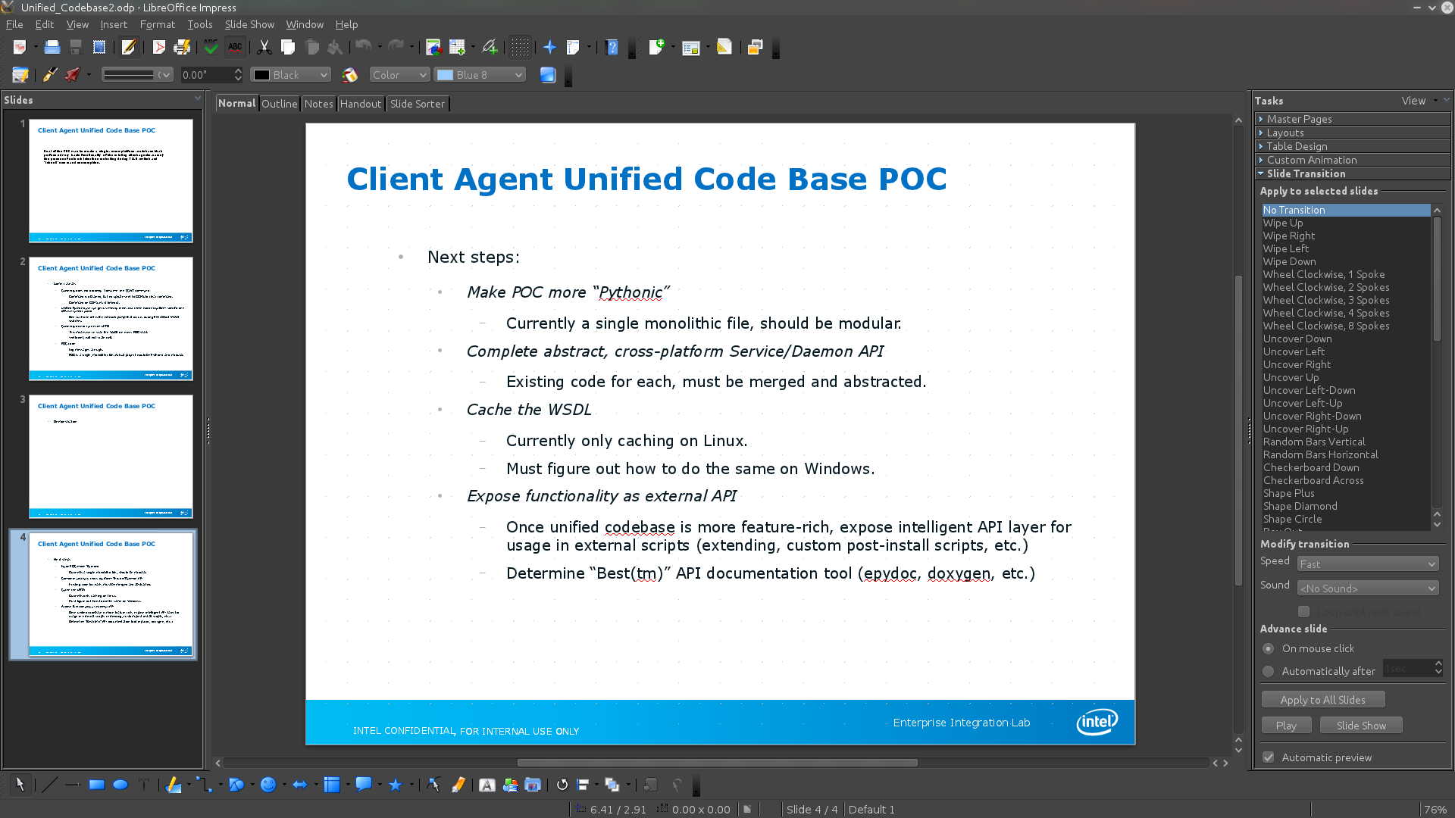
So, our original, high-level architecture goals were as follows:
- Make POC more “Pythonic”
  - Currently a single monolithic file, should be modular.
- Complete abstract, cross-platform Service/Daemon API
  - Existing code for each, must be merged and abstracted.
- Cache the WSDL
  - Currently only caching on Linux.
  - Must figure out how to do the same on Windows.
- Expose functionality as external API
  - Once unified codebase is more feature-rich, expose intelligent API layer for usage in external scripts (extending, custom post-install scripts, etc.)
  - Determine “Best(tm)” API documentation tool (epydoc, doxygen, etc.)

With these goals in mind, the UCA repo was created on UbuntuDev in ENV01 and the framework was started.

Note on the repository on UbuntuDev
Because we needed a source-code management solution that would work equally well under both Windows and Linux, adding a secondary Mercurial repository on UbuntuDev seemed like the logical decision. Mercurial is a cross-platform, distributed, version control system which runs equally well under both Windows and Linux. It is mature, and stable, and in use in many projects (including our previous Linux Client Agent). Additionally, the distributed nature would help due to the fact that we have engineers which are working in a distributed fashion. Plus, adding it alongside the Linux CA repo would automatically include it in our incremental backups.
For more information on Mercurial, see the Mercurial guide online here: http://mercurial.selenic.com/guide/
See also, the TFS_Notes.txt file in the Linux CA repository for more information on why TFS was abandoned for the LCA in favor of Mercurial for Linux integration.

Unified Client Agent Architecture

Design diagram for the UCA
This is actually from the original presentation given on the subject from around September 12th, 2011. As you can see from a slide from this presentation,
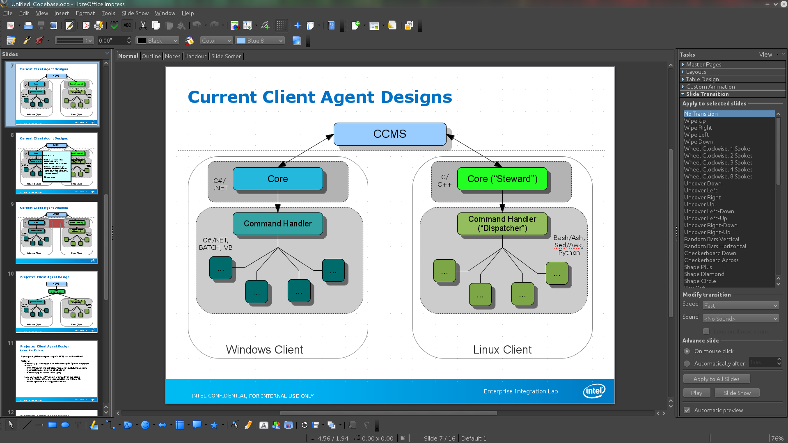
we wanted to mimic the existing client agent designs to maximize code-reuse. This is especially true on the Linux-side where our command-handling has a large number of dispatcher-scriptlets which support a very wide array of distributions.
Thus, after some discussion in the meetings, the following organization was decided on:
Core (“Steward”)
Command Handler
(“Dispatcher”)
...
...
...
...

Here, the names are taken from the Linux CA, as the Windows CA did not have specific names (nor, even as distinct a division).
- The “steward” would be a core, cross-platform, single-codebase, service on Windows, daemon on Linux, which interacted with CCMS (or other servers in the future, such as NMSA, etc.)
- Once a command was given from CCMS, the “steward” would hand it down to an underlying “dispatcher” which issues platform-specific code to execute the command.
By having this distinction, we can segregate the bulk of the platform-specific code into the “dispatcher”, and leave the logic in the “steward” largely platform-agnostic.

Overview of the repository-layout
(This is from an email to Richard on December 13th, 2011. It's copied verbatim, so there are instructions in here which may not make sense taken out of context.)
If you pull the repository from UbuntuDev for the UCA, inside the top-level you will see four directories and a file:
drwxrwxr-x 4 sam sam 4096 Dec 13 16:57 .hg
-rw-rw-r-- 1 sam sam 62 Nov 29 14:42 .hgignore
drwxrwxr-x 3 sam sam 26 Sep 19 16:19 docs
drwxrwxr-x 2 sam sam 51 Dec 12 17:34 poc
drwxrwxr-x 5 sam sam 91 Dec 1 22:56 src
'.hg' is where Mercurial stores configuration as well as revisions. You wont want to touch anything in there unless you know what you're doing.
'.hgignore' is a place to list files and file patterns that Mercurial should ignore. Currently it just has temporary file stuff for the editors I use in Linux, but we may want to modify it to include anything similar in Windows (like, if Visual Studio leaves file droppings around that we don't want in version control).
'docs' is where I was planning on putting documentation in the future. Currently it doesn't have much in it- just the previous presentations from various meetings and the timeline from October 28th, 2011.
'poc' is where I previously had the proof-of-concept code. I'd suggest adding your current code there so we can have it backed up. If you want to make a sub-directory under poc, feel free.
'src' is where the source code for the unified agent lives. If you look in there, you should see the following file/directory tree
(excluding suds):
$ tree -I suds src/
src/
|-- clientagent
| |-- __init__.py
| |-- common
| | |-- __init__.py
| | |-- config.py
| | |-- platform_id.py
| | `-- utility.py
| `-- steward
| |-- __init__.py
| |-- atom.py
| |-- ccmsupdate.py
| `-- libdaemon
| |-- __init__.py
| |-- unix_daemon.py
| `-- windows_service.py
|-- eil_steward.py
`-- tests
`-- test_platform_id.py
You can see that we have a top-level module called “clientagent”, under which everything else lives. Inside the “common” directory you will see some utility code (currently a configuration utility, a utility for platform-identification, and a generic utility module which will contain miscellaneous utilities which do not fit elsewhere).
There is also a directory, called “libdaemon”, which is housing the daemon code for Linux and the service code for Windows.
Finally, we have the top-level eil_steward.py (which was so-named because that's what we called it in the Linux CA) which ties it all together as well as a tests directory where unit-tests will go (currently it just has a test for the platform-identification code).

Platform-identification code
The one thing worth mentioning here is the platform-identification module, clientagent.common.platform_id. This is summarized from an email to Richard sent on October 26th, 2011. The original email has more information.
Under Linux we have a hard-requirement that we completely identify the platform we are running on. We must identify the base-distribution for a given platform, as well as any variant we may be running on.
So, for example, let's say we are running on CentOS. CentOS is derived from Red Hat Enterprise Linux, so we identify the base-distribution as “RHEL” and the variant as “CentOS”.
Another, more significant example are the Xen distributions, XenServer and XenClient. XenServer is derived from Red Hat Enterprise Linux, but XenClient is derived from an embedded distribution called “Angstrom”. Thus,
- XenServer: “RHEL”, variant “xen”
- XenClient: “Ansgtrom”, variant “xenclient”
This platform-identification is necessary for the dispatcher to run properly. However, on the Windows-side, we don't seem to need such a precise definition of the platform. Something as simple as “win32” or “Windows” will suffice.
In the platform-identification code in the repository, there currently are “FIXME”s where the Windows definition takes place. On October 26th, in the email mentioned above, I mentioned it may be a good idea for someone more familiar with Windows to review it and make sure these assumptions are correct. It still is probably a good idea.

Various Undecided Design Choices

Atoms
(The following is taken and reworded a bit from an email to Richard dated November 29th, 2011. I will try to go into a bit more detail here, however, in an effort to make it as clear as possible.)
Previously, both the Windows CA and the Linux CA combined their CCMS-handling logic with the logic for any other functions they were managing, such as the 60-minute asset update in Windows, or the NMSA integration under Linux. This is because we have, essentially, had continuous feature creep in both client agents.
The two big problems we have encountered with this approach are:
- New features tend to require re-working of core client agent code, as well as knowledge of the internals of said agent.
- Any processes that take a while to complete can potentially block the client agent from executing additional commands.
For #2, this has especially been a big complaint from the Node Manager team as they have tests which, by design, run for hours at a time. When the Node Manager team learned of our plans to re-write the client agent in a unified code-base, they specifically requested that we try to solve this concurrency problem and come up with a way to allow them to run multiple Node Manager requests at once. This was brought up in a presentation on, or around, November 15th 2011 (this presentation can be found in the Unified Client Agent repository).
Currently, we have a suggestion as how we can handle this. However, it is not set in stone, and, in fact, Richard was asked in an email on November 29th what he thought of this suggestion. The idea is as follows:
- Define any activity that the UCA has to do as something called an “atom”. This could be interacting with CCMS, polling the NMSA, or eventuality even doing TAF2.0 stuff. We call it an “atom” because we want there to be a certain atomicity with the activity, e.g., we deal with discrete elements of the activity (poll CCMS for commands, look for UCA updates, etc.)
- Once we have the activities defined as atoms, the UCA can simply run through a queue of atoms having each execute their code during the main loop.
  - One big advantage here is that we can split out all of the activity code from the main loop code, which currently resides in the daemon/service modules. The daemon/service module does not need to know, or even care, about CCMS, NMSA, or whatever.
- Each atom has an “update” method which is called with time delta information. This update is where all of the atom's activities take place (interact with CCMS, etc.)
- Down the road, if we need to thread NMSA interactions (or anything else) we can easily do so because adding these new features will be completely self-contained in their own atom modules. Thus, if we need to execute commands in a non-blocking way, yet still have atomicity, we can handle it inside these modules.
Now, this was my (Sam Hart) suggestion. However, I was and still am open to alternatives. One big advantage is that it doesn't add much additional complexity. In fact, all it really does it off-load the logic which previously was jumbled together with the service/daemon code into its own module.
Initially, all we would add in is an atom for CCMS interactions. However, this framework would allow us to very easily add additional atoms down the road.
Again, we don't have to do it this way, this was simply a suggestion. However, as we have no other suggested alternatives for solving the above problems, I have gone ahead and started an atom for CCMS interactions.
If you look in the clientagent/libdaemon directory, you will see an “atom.py”, which defines the base-class for all future atoms. It is very tiny, simply specifying:
- ACTIVE: A flag to determine if this atom is currently active or not
- update(timeDelta): The update method called once every main loop iteration.
- shutdown(): A shutdown method which is called when the daemon/service shuts down.
One other added benefit of this is that it gives us a way to control UCA shutdown without having it shutdown in the middle of a executing command. The main-loop simply checks the ACTIVE flag for each atom every iteration. If no atoms are ACTIVE, we know the UCA is safe to shutdown.

This was from the file “Unified_Codebase2.odp” which has been in the Unified Client Agent repo.
Unified_codebase.odp, which can be found in the UCA repository.

