Table of Contents

Unified Client Agent Test Document 1

Installation Instructions 1

Windows Installation 1

Linux Installation 3

Procedures For Tests 3

# Unified Client Agent Test Document

## **Installation Instructions**

**The Unified Client Agent (UCA) has a single, unified installer. Its intent is to provide a singular installation experience across the platforms it supports. However, the execution of this installer and the prerequisites are unique on each platform.**

**The installer can only be found in ENV01 at** [**http://10.4.0.66/uca/**](http://10.4.0.66/uca/)**. All test machines for the UCA must obtain the UCA from ENV01.**

### Windows InstallationA description...

All of the following must be done as the Administrator on the Windows system.

Start by downloading and installing the ActivePython installer from the URL above for whatever Windows platform you are running (x86 or x64).

Next, download the “uca-bootstrap.py” file and save it somewhere you can find it.

Start up a shell environment (such as PowerShell) and navigate to where you downloaded the “uca-bootstrap.py” file.

Execute the bootstrap with:

python.exe uca-bootstrap.py

Installation logging will display, if you encounter any errors during installation please collect the error and report it.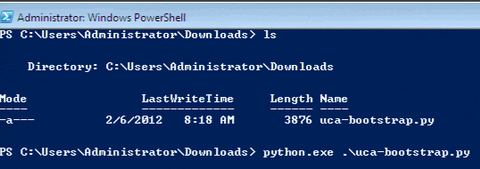

### Linux Installation

All of the following must be done as the root user on the Linux system.

Start by downloading the “uca-bootstrap.py” file from the above URL:

# wget <http://10.4.0.66/uca/uca-bootstrap.py>

Make the bootstrap file executable, then run it:

# chmod +x uca-bootstrap.py

# ./uca-bootstrap.py

Installation logging will display, if you encounter any errors during installation please collect the error and report it.

### Increasing debugging

If you encounter a problem, and can reproduce it, please increase the logging on the UCA and provide us with the full log including the problem.

The log file for the UCA is called “clieant-agent-base.log” and it can be found in “C:\EIL” under Windows and “/opt/intel/eil/clientagent/home” under Linux.

Increasing the debugging level can be done in the “clientagent.cfg” file (also found in the above directories). Specifically, increase the logging level to 3, 4 or 5.

Once you have modified the logging level it is generally a good idea to ensure the UCA has restarted. Under Windows, this can be done in the Services screen, and under Linux this can be done by executing the following init script:

# /etc/init.d/eil_steward.py restart

If this restart at all fails, you can also force a restart by rebooting the system (though you should consider this a “last resort” option, as it will mean something has gone wrong with the UCA and should be reported).

## Procedures For Tests

**The tests for the UCA should be performed using the staging Portal release which is accessible in the lab at** [**http://eilportal.eil-infra.com/PortalStaging/LabResources.aspx**](http://eilportal.eil-infra.com/PortalStaging/LabResources.aspx)**.**

**PLEASE NOTE: Changes made in the staging environment will affect the production environment. Take care while testing.**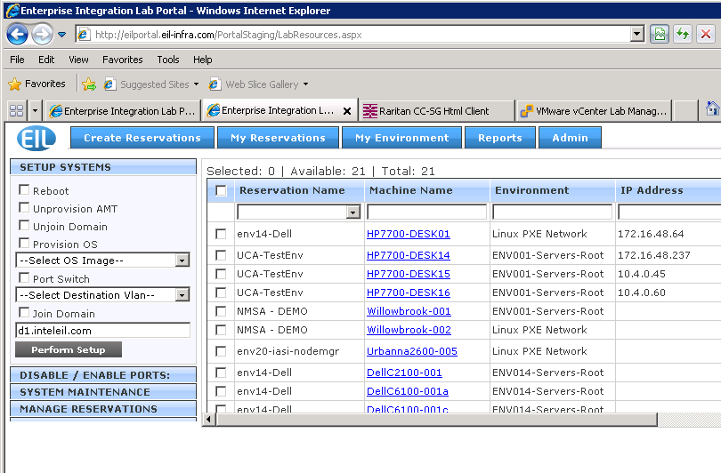

**If you are testing under Linux, it might be advisable to watch the log file (detailed above) with something like “tail -f” .**

### **Testing reboot**

1. **On the staging Portal, select the system you are testing on (which has the UCA installed on it) and select the “Reboot” option:**
2. **Click “Perform Setup”.**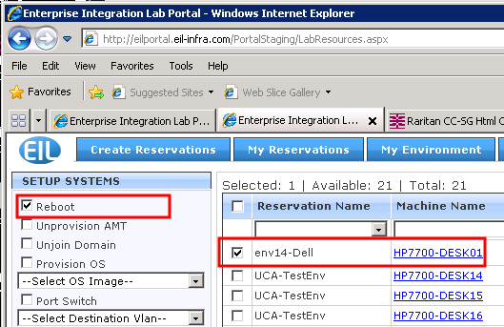
3. **Watch the “Operation Status” field to verify that the Reboot command was sent and consumed.**
4. **Watch the system you are testing to verify that it is rebooted.**