**GHANA TECHNOLOGY UNIVERSITY COLLEGE (GTUC)**



**FACULTY OF INFORMATICS**

# TITLE:

**DESIGN AND IMPLEMENTATION OF** **E-NOTICE AND FILE SHARING PLATFORM: A case study of GTUC Graduate school**

A Project Work Submitted in Partial Fulfilment of the Requirements For

BSc. in Information Technology

**BY:**

SEMENHYIA ESTHER

HAGAN GABRIEL NANA ADJIN

**SUPERVISOR:**

Mr. KELVIN PRINCE OWUSU

**AUGUST 2018**

## **DECLARATION**

This project is presented as part of the requirements for a BSc. in Information Technology awarded by Ghana Technology University College. I hereby declare that this project is entirely the result of hard work, research, and inquiries. I am confident that this project work is not copied from any other person. All sources of information have however been acknowledged with due respect.

**AUTHORS**

SEMENHYIA ESTHER SIGNATURE: ……………………………….

ID: 040115298 DATE: ……………………………………….

HAGAN GABRIEL NANA ADJIN SIGNATURE: ………………………………

ID: 040115220 DATE: ………………………………………

**SUPERVISOR:**

MR. KELVIN PRINCE OWUSU SIGNATURE: ……………………………….

DATE: ………………………….

**HEAD OF DEPARTMENT:**

MR. EZER OSEI YEBOAH-BOATENG SIGNATURE: ……………………………….

DATE: ……………………………………….

# **ACKNOWLEDGEMENT**

First, we thank the Almighty God for granting us the strength and wisdom to complete this documentation. A lot of time and effort was spent to ensure that this project meets the objectives that were stated. We wish to express sincere gratitude to Mr. Kelvin Prince Owusu for his guidance and patience in supervising the writing of this documentation. His advice and valuable suggestions were the sources of encouragement throughout the completion of our project.

Last, but not least, we wish to thank all our friends and family who had been supportive during the writing of this documentation. I am grateful for their encouragement and moral support during the progress of the project.

Table of Contents

TITLE: I

**DECLARATION** II

**ACKNOWLEDGEMENT** III

**LIST OF FIGURES** VI

**ABSTRACT** 1

**CHAPTER ONE** 2

**1.0 Introduction** 2

**1.1 Background of Study** 2

**1.2 Problem Statement** 3

**1.3 Aim** 3

**1.4 Objectives** 3

**1.5 Project Scope** 4

**1.6 Significance of Study** 4

**CHAPTER TWO** 6

**LITERATURE REVIEW** 6

**2.0 INTRODUCTION** 6

**2.1 Information Dispensation through Electronic Notifications** 6

**2.2 Classification of Notification Systems** 8

**2.3 Electronic Notification and Interactive System** 8

**2.4 Management Information System** 9

**2.5 Security** 10

**2.6 Smartphones** 10

**2.7 Notification Systems** 11

**2.7.1 Analysis on Existing Paper-Based Notification Systems** 11

**2.7.2 Analysis of Electronic Based Notification Systems** 12

**2.7.3 Analysis of Existing Electronic Notification Systems in Institutions** 12

**CHAPTER 3** 15

**SYSTEM SPECIFICATION AND DESIGN** 15

**3.0 Introduction** 15

**3.1 Feasibility Studies** 15

**3.1.1 Technical Feasibility** 15

**3.1.2 Economical Feasibility** 16

**3.1.3 Operational Feasibility** 16

**3.1.4** **System Scope** 16

**3.1.8 Agile Vs. Traditional SDLC Models** 20

**3.1.9 Agile Model - Pros and Cons** 20

**3.2 Requirement Specification** 21

**3.2.1** **Functional Requirement** 21

**3.2.2 Non-Functional Requirements** 22

**3.3 System Functional Design** 23

**3.3.1 System Architecture** 23

**3.4.1 Structural Design** 24

**3.4.2 Use case diagram** 25

**3.4.3 Sequence Diagram** 27

**3.5 Database Design** 28

**3.5.1 Data Dictionary** 28

**3.6 Tools and Methodology used** 31

**3.6.1 Software Package Used** 31

**3.6.2 Tools Used** 31

**3.6.2.1 Software Requirement** 32

**3.6.2.2 User-Interface Design** 32

**3.6.2.3 Database Management** 32

**3.6.2.4 Notifications Management** 32

**3.6.2.5 Operating System** 32

**3.7 Hardware, Software and Human Computer Interaction (HCI) Requirements** 33

**3.7.1 Requirement for System Development** 33

**3.8**  **Android Application Design Principles** 34

**CHAPTER 4** 35

**SYSTEM IMPLEMENTATION AND TESTING** 35

**4.0** **Introduction** 35

**4.1 Guidelines on how the E-notice and Information System can be implemented** 35

**4.2** **Features and Components of the Prototype** 36

**4.3 Interface Design** 36

**4.4 Source Codes** 36

**4.5 Testing** 36

**4.6 Types of Tests** 36

**4.6.1 Unit Testing** 37

**4.6.2 Validation Testing** 37

**4.6.3 System Testing** 37

**4.6.4 Acceptance Testing** 38

**CHAPTER 5** 44

**CONCLUSION AND RECOMMENDATION** 44

**5.0 Introduction** 44

**5.1** **Outcomes of the Project** 44

**5.2** **Limitations of the project** 44

**5.3** **Future of the Project** 45

**5.4** **Conclusion** 45

**5.5 Recommendation** 46

**References** 47

**APPENDIX A** 50

# **LIST OF FIGURES**

**Figure 3.1 – Agile Method…………………………………………………………………….26**

**Figure 3.2 - System Architecture…………………………………………………………….31**

**Figure 3.3 - Structural Design of E-Notice and Information System………………32**

**Figure 3.4 - Use Case Diagram for E-Notice and Information System……………….33**

**Figure 3.5 - Sequence Diagram for E-Notice and Information System………………34**

**Figure 3.5.1.1 – Student Table……………………………………………………………….35**

**Figure 3.5.1.2 – Lecture Notes Table…………………………………………………………36**

**Figure 3.5.1.3 – Notification Table……………………………………………………………36**

**Figure 3.6 - Entity Relationship Diagram for E-Notice and Information System…….37**

**Figure 4.1 – Interface Design (Admin)……………………………………………………….46**

**Figure 4.2 – Interface Design (Student/Lecturer) ………………………………….47**

**Figure 4.3 – Student Homepage………………………………………………………………48**

**Figure 4.4 – Student Lecture Notes Page…………………………………………………….49**

**Figure 4.5 – Student Chat (One to One) …………………………………………….50**

**Figure 4.6 – Student Chat (One to Many) ………………………………………….51**

## **ABSTRACT**

The dispensation of information is certainly important in educational institutions especially the masters level. But currently the paper-based style of information dispensation is poised with many difficulties such as not receiving it in time, having to wait in long queues to simply find out about fees information, etc. For this reason, an efficient system is to be proposed and developed in this paper to ease the issue of offline dispensation of information amongst indigenes within educational institutions. The system is an android mobile application that sends notifications directly to a user’s android mobile phone in case of any happenings on campus and adequately provide an interactive platform between students and lecturers. In this paper, the proposed system was developed using Java, Extensible Mark-up Language (XML) and Firebase, a cloud service provided by Google to handle database queries.

# **CHAPTER ONE**

## **1.0 Introduction**

This chapter seeks to shed more light on how the idea was drafted, the problems it seeks to solve and includes information, which was derived from those directly involved, that is the master students and how that information would help them.

## **1.1 Background of Study**

Information system plays a vital role in all our daily activities in today’s world. These activities range from government, business, organization, education etc. The availability and advancement of technology has become a necessity, which drives the human revolution forward with efficiency and effectiveness.

Technology has many applications with limitless boundaries. This project will focus on an electronic notification and interactive system between students and lecturers for educational institutions.

Systems Design and application of systems theory is the product development that defines the architecture, component, modules, interfaces, functionality and data for a system to satisfy specified requirements.

The performance and functionality of the electronic notification system can either be enhanced or limited by the way information dispensation is conceptualized. The internet is thus clearly an effective medium for educational institutions to gain recognition across the world with distinct advantages. The system allows individuals or institutions to reach a wide range for small fractions of traditional market strategies, which provide outcomes for quick evaluation and continual adjustment to improve results.

Technological advancements are contributing widely to the redefinition of the ubiquitous nature of information.

The electronic dispensation of information within educational institutions would vastly reduce the paper work involved in sharing information. In addition, communicating easily with lecturers when matters arise would curb certain educational problems. That leads to maximized control, monitoring, serviceability and revenues.

## **1.2 Problem Statement**

Dispensation of information in the university during the offline era posed various difficulties to the masters’ students as well as lecturers. Offline dispensation of information reduced the scope of how the masters students choose when and how they access that information based on their locations. The graduate school of Ghana Technology University College does not have its own e-notice and interaction system, which could make things easier for them. This results in the lack of flow of information.

The solution to this problem is to create a notification and information system, where students can view personal and fees information, access their modules, check examination/module results, download course notes from lectures and receive notifications on events and of course a platform to interact between each other, or even lecturers directly.

## **1.3 Aim**

The aim of this project is to help with the current paper-based system and replace it with the state of the art technology to deliver educational notifications in case of any happenings on campus, provide students with the means to engage with the lecturers and students in times of educational related difficulty.

## **1.4 Objectives**

The following are objectives of this project:

* To develop and implement a school notification system where students and lecturers can easily receive notifications about their institutions regardless of their location.
* To design a database for receiving student and lecturer data with respect to school related activities.
* To allow instantaneous communication, where students and lecturers can communicate with each other on the spot.

## **1.5 Project Scope**

The system is an easy-to-use self-service, which enables students to receive notifications about certain events in their institutions directly on their smartphones without having to be on campus to have a look at the noticeboard. In addition, they can easily get in contact with their lecturers in case of any educational difficulty right within the mobile application. Students would simply have to log in to the system to receive notifications from the administration or the lecturers. They would receive a ping regardless of whichever location they may find themselves. There would be no need to be in school to have a look at the noticeboard anymore. Secondly, the lecturers can adequately contact students or vice versa in case, some information must be dispensed. There would be no need to go and stand at the lecturer’s door to see him/her. Everything would be done online which is going to reduce stress. Lecturers can also upload lecture notes and materials to the platform, so students can download with the click of a button. The electronic notification system coupled with the interactive platform will be developed using the System Development Life Cycle (SDLC).

## **1.6 Significance of Study**

This platform will give institutions and individuals a large avenue for recognition, advancement in technology and even advertise products. Other crucial benefits are as follows:

**STUDENTS**

* + Detailed information about events that might be happening on campus would be readily available to students 24 hours a day, 7 days a week.
  + Students can communicate with lecturers easily at their own convenience.
  + Download lecture notes at own convenience

**LECTURERS**

* + Receive detailed school related information about events that might be happening on campus.
  + Easily communicate with students in case of information dispensation.
  + Upload lecture notes easily.

**ACADEMIA**

The system is expected to subsequently serve as a basis for further research by academia leading to more improvement in this area. The documentation of the project will help in further referencing, understanding and benefits of technology.

**GOVERNMENT**

Implementation of this system would vastly reduce paper-based methods of dispensing information; the school will benefit from saving money for paper-based operations. Since the government has a share in the school, both the government and other shareholders of the school will save money on paper based operational work. Since there would be less rampant dispensation of paper-based work, the environment will be neat, and it will attract global recognition hence more revenue.

# **CHAPTER TWO**

# **LITERATURE REVIEW**

## **2.0 INTRODUCTION**

This chapter defines facts and findings based on student information systems and e-notice systems as well as reviews of the development of such systems in many countries. This chapter will analyse issues concerning the development of an electronic notification system and an interactive system integrated in an android application in general.

## **2.1 Information Dispensation through Electronic Notifications**

Information is a key necessity for specialization – allowing production and improvements to occur at different locations. Information has throughout the years been a spur to expansion; quality information allows more developments, a greater speed to innovation, high utilization and less impact regarding new infrastructure.

The increasing use of SMS messages (text messages), voice mail and email has made it possible to continuously be in touch -- no matter the location. Many businesses are relying on these technology tools to reach customers. For example, banks notify customers of unusual activity on their account, airlines alert passengers to delays or gate changes, and retail stores send sale reminders to frequent shoppers. These communications are called **electronic notifications**.

Upon going through some articles, books, websites or journals that are related to the system, a notification system is a combination of software and hardware that provides a means of delivering a message to a set of recipients. It commonly shows activity related to an account. Such systems constitute an important aspect of modern Web applications. (WiseGeek.com, 2016).

An electronic notification is any automated communication received by e-mail, phone, text message or fax. Electronic notifications have thousands of applications for businesses, governments, schools and individuals. Some of the simplest and most common electronic notifications include:

* News and weather alerts received as text messages on your cell phone
* Travel offers received as e-mail as part of a frequent flyer program
* Automated political surveys conducted by phone
* Targeted marketing campaigns sent via fax

Many companies and organizations such as emergency management agencies and universities are signing on with third-party electronic notification services for their mass communications needs. With these subscription services, organizations can instantly and securely communicate with thousands of employees, customers, clients and constituents across all communication platforms.

Third-party electronic notifications services save organizations time and money because they automate nearly all the communication process without requiring companies to invest in costly personnel, hardware or software. Organizations simply subscribe to the off-site service and manage all contacts and communications through a desktop Web interface.

Automated electronic notification also provides a way to easily analyse responses. For example, a CEO can send a voice message inviting all international managers to an online training session. The automated system will collect all the responses and present the CEO with an instant list of attendees.

This automated data analysis is particularly useful for marketing purposes. A company can announce a promotion or new product over a variety of platforms and easily track which messages and platforms generate the most purchases.

In Ghana, it is rare to see institutions use any kind of notification system to dispense information to their members. Information is regularly sent across campuses through the noticeboards or if a student takes a picture and spreads it through his email or WhatsApp contacts. That comes with so many difficulties, which would be further explained in this chapter. New technologies can boost the implementation of information dispensation structure and interaction feature with ease.

## **2.2 Classification of Notification Systems**

Electronic notification systems are classified according to the way they are generated and displayed to the user. The education given to people on the system, the easier it would be to understand the system. Therefore, the long-term objective is for the institution to discard the paper-based method of spreading information to its members. The summarized classification of all notification systems is;

* *User-generated notifications*: - These notifications contain content created by a human using the app to other humans. Generally, these are the most engaging but especially so when the content they contain is private and directed to specific people. Mobile messaging is the highest volume example of this type of notification, but other examples include comments/likes/favourites on posted content or @mentions.
* *Content-generated notifications*: - These notifications are generated by an application based on the permission of its users. This is the fastest growing category of notifications because the amount of machine-readable data mobile devices creates location, contacts, calendars, and much more. The norms around context-generated notifications are still be worked out between developers and users. Location-based notifications currently dominate this category, but other examples include information about your next meeting (time relevance) or updates about your favourite sports teams (interest relevance).
* *System-generated notifications*: - These notifications are generated by an app based on the needs of the app. This type of notification can usually be called re-engagement at best or spam at worst. Sometimes these can create value for the end user like letting you know a friend has started using the app or that there is a sale of in app purchases.

## **2.3 Electronic Notification and Interactive System**

Widespread of internet usage has led to the emergence of a variety of electronic services with electronic dispensation of information (e-notices) as an example. E-notices creates an avenue for simplicity, mobility and comfort. Users can simply receive information instantaneously on their smartphone without having to be present on campus to access it.

Also, another service of widespread internet is the ease of interaction. With just a simple text, information can be conveyed to even the farthest of destinations.

A user first must register, log in for server validation for the server to either accept or reject before accessing the full functionality of the system. This is intended to prevent duplication, which avoids multiple use of user accounts to ensure authenticity, and integrity that user accounts are from authorized sources.

Certain setbacks with these kinds of systems is that servers cannot be trusted due to the probability of it crashing.

## **2.4 Management Information System**

A Management Information System (MIS), is a computer-based system that optimizes the collection, transfer, and presentation of information throughout an organization by using an integrated structure of databases and information flow (Long & Long, 2004). MIS combines the theoretical work of computer science, management science, and operations research with a practical orientation toward developing system solutions to real-world problems and managing information technology resources (Kenneth C. Laudon *et al*., 2004).

MIS is also seen as a system collecting and analysing data and producing reports. Its purpose is to help managers to solve structured problems. However, it should also fulfil several other purposes (Adriana Harizanova, 2003):

* It should provide a basis to analyse warning signals that can originate both externally and internally; this is the main function of data base;
* It should automate routine operations thus avoiding human work in the processing tasks;
* It should assist management in making routine decisions;
* It should provide the information necessary to make non-routine decisions;
* It should serve as a strategic weapon to gain competitive advantages.

There are numerous definitions of MIS, for this research, MIS can be defined as a system providing bus operator management with accurate and timely information necessary to facilitate the decision-making process and enable the bus operator’s planning, control, and operational functions to be carried out effectively. By doing so, MIS will increase competitiveness between bus operators, reducing cost and improving processing speed.

## **2.5 Security**

G.J. Udo (2001) defined Security as the protection of data against accidental or intentional disclosure to unauthorized persons, or unauthorized modifications or destruction. Security concern has become one of the main reasons for not transacting online because as soon as a user accesses the Internet, anyone from anywhere around the world has access to the information being sent. The risk of data theft, theft of service, and corruption of data, and viruses becomes a reality. The lack of security, reliability and accountability make the Internet online transaction too risky for many users (T. Ramayah *et al*., 2003).

Devising the Internet security policy can be complex because a rational policy requires an organization to access the value of information. The policy must apply to information stored in computers as well as to information traveling through a network.

Nowadays, the society consisting of either the businesses or the government these internet security issues concern areas. These people are very dependent on the data communication networks for their daily performance especially in the businesses areas. The rise of the internet with opportunities to connect computers anywhere in the world has significantly increased the potential vulnerability of the organizational assets (Fitzgerald and Dennis, 2002). Emphasis on internet security also has increased because of well-publicized security.

For this project, the Internet security that should be taken into consideration is the unauthorized access. Unauthorized access can have defined as the use and access of information without getting the permission from the administrator. This problem is often viewed as the hacker or the employee gaining access to the information and resources from the organization through the internet.

## **2.6 Smartphones**

A smartphone is a handheld personal computer with a mobile operating system and an integrated mobile broadband cellular network connection for voice, SMS and internet data communication; most if not all smartphones also support Wi-Fi (PC World, 2016). Smartphones are typically pocket-sized as opposed to tablets. Which are much larger. They can run a variety of software known as apps. Most basic apps come pre-installed with the system while others are available for download from places like the Google PlayStore.

Today, smartphones largely fulfil most people’s needs for a telephone, digital camera and video camera, GPS navigation, a media player, clock, news, calculator, web browser, handheld video game player, flashlight, compass, an address book, note-taking, digital messaging, an event calendar, etc.

There are various types of smartphones on the market today, namely;

* Samsung Phones
* Xiaomi
* Techno

These smartphones all have some kind of Operating System pre-installed on them. Typical types are the Google OS called Android and the IOS from Apple. As far as this project is concerned, we would be using the Android OS to achieve its goals.

## **2.7** **Notification Systems**

According to Oxford Dictionary (2010), a notification is defined as “the action of notifying someone or something”. Generally, a notification system is a combination of software and hardware that provides a means of delivering a message to a set of recipients. It commonly shows activity related to an account. Such systems constitute an important aspect of modern Web applications (WiseGeek.com, 2016). Notification systems can be categorized into two types, paper-based and electronic based.

### **2.7.1 Analysis on Existing Paper-Based Notification Systems**

In the university today, most of the information is spread using posters, sheets or stickers. Before students, members, or any institutions receive this information, the information would have to be printed as hardcopy and pasted on the noticeboard or distributed by hand to every member of the institution.

This comes with quite a few difficulties such as some student not receiving it due to his/her absence in school, the paper after being read turns into rubbish, etc. In addition, the management of that institution cannot tell if every member got that piece of information so in case of blame towards a certain issue, it would be unfair to judge. The ambiguities let the management face operation and accounting problems.

### **2.7.2 Analysis of Electronic Based Notification Systems**

In the graduate school of Ghana Technology University College, it has been quite difficult to dispense information by electronic means. For this reason, other countries were considered to have successfully integrated technology into their dispensation of information. Even in these countries, only top universities have achieved this feat. These include Harvard University Mobile App, Zarqa University Notification System and the KNUST Aim Mobile App. The management of each institution composes the kind of message to spread from a computer or administrative point. As soon as it is ready to be sent, it is reviewed and sent. The message is sent through the server across the internet to the users within seconds. Even if the users do not have internet connection at that moment, it will remain on the server until internet is available and the message sent to the user. At the end of the day, the management can print out summary reports of users who received the information and those who did not.

### **2.7.3** **Analysis of Existing Electronic Notification Systems in Institutions**

This section will make an analysis of some already existing electronic notification systems as well as interaction systems.

#### **2.7.3.1 KNUST Aim Student Mobile App**

Academic Information Manager (AIM) is the official mobile app for students of Kwame Nkrumah University of Science and Technology. It was first developed by four students and taken over by the University Information Technology Services (UITS). It is mobile companion of the student online portal, which is also a part of KNUST Academic Record Management Information System (ARMIS). Its main objective is to bring functions of the online student portal to mobile devices. The key functions of AIM are listed below.

* Course Registration
* Results Checking
* Editing Personal Records
* Access to news
* Notifications
* Instant Messaging
* Fees checking and download bills
* Google Maps Integration

The feature we would be analysing is the notification aspect of this mobile application. Students receive alerts of happenings on campus as promptly as ever making life somewhat easier for them.

**Advantages of KNUST AIM app**

* User friendly because the steps involved are simple and direct
* The users can check for notifications toward a specific event
* Reliable and convenient
* News availability is listed clearly in the notification section. Users can find out what to know just by clicking on that notification option.

**Disadvantages of using the KNUST AIM mobile app**

* In case of unavailability of internet connection, the student has no access to information.
* Notification filtering is not available
* Help and FAQS feature not available.

#### **2.7.3.2 Harvard Mobile**

The Harvard Mobile app is a University-wide initiative to improve the mobile experience of students, faculty, staff, visitors, and neighbours who interact with Harvard’s campus and community. Released in January 2013, Harvard Mobile 2.0 is the latest version of the application with many functional, design, and content enhancements. Harvard Mobile 2.0 now has native applications for Android and iOS operating systems, as well as a mobile web application accessible to any web-enabled smartphone.

Once again, we would be analysing the notification feature and interactive platform of this application.

**Advantages of using the Harvard Mobile**

* Chats and interaction is instantaneous
* Notifications is available in the notification section
* In case of unavailable connection, notifications stay in the server until the user establishes connection and the message is sent.
* User friendly and direct

**Disadvantages of using the Harvard Mobile**

* Notification filtering is unavailable
* Static data
* Unable to clear data

#### **2.7.3.3 Zaqra University Notification System**

The Zaqra University Notification System is a notification system that helps students connect to the educational website of the university. It achieves high and quick organization between instructor and students, save time, effort by connecting android application to the educational database using latest technologies. The main feature is sending notifications and interacting with lecturers and students. GCM is a service, which allows developers to send push messages to Android devices from the server. GCM handles the queuing of the messages as well as delivering those messages to the target applications on the devices. GCM is a free service by Google, and it has no quotas. It is the default push messaging solution for the Android platform.

**Advantages of using Zaqra University Notification System**

* Notifications and interaction between lecturers and students is instantaneous
* User friendly and direct
* Notification is available in the notification section
* Works without internet.

**Disadvantages of using Zaqra University Notification System**

* Information is static
* Unable to clear messages section causing phone to be slow
* Notification filtering is unavailable

# **CHAPTER 3**

# **SYSTEM SPECIFICATION AND DESIGN**

## **3.0 Introduction**

System Specification and Design are essential elements that need to be discussed to come up with a successful system. In developing such a system, one cannot help but bring out the essential features that form the building blocks for its effective development and subsequent deployment. Therefore, coming up with the system design in the 1st phase of this chapter talks about the feasibility studies, the System Specification, Analysis & Methodologies, as well as Methods, tools and techniques used in eliciting information for the development of the system. Other elements that could be captured in the next phase of this chapter is the requirement specification of the system, the system design and the Data Modelling tools (ARP) that will be significant in the system development.

## **3.1 Feasibility Studies**

A careful study has been made to capture the reality of the new system design. The outcome and recommendations of this feasibility study helped us as a sound basis for deciding how to proceed with the project. We undertook three types of feasibility studies; technical, economical and operational, which were used to elicit ideas for the system design.

### **3.1.1 Technical Feasibility**

Technical feasibility was conducted to find out current existing tools, techniques and technologies that would aid the design of the new system. Technical feasibility is concerned with specifying equipment and software that will satisfy the user requirement. From the outcome of this study, it was found out that the proposed system can run on any mobile phone supporting Android OS and Internet services and works on the best software and hardware that had been used while designing the system.

### **3.1.2 Economical Feasibility**

Some cost-benefit analyses are considered to find the management’s position to undertake this project. Throughout the Economic feasibility, we were able to determine whether there were sufficient benefits in creating to make the cost acceptable. As this signifies the cost-benefit analysis and savings. On the behalf of the cost-benefit analysis, the proposed system is feasible and is economical regarding its pre-assumed cost for making a system, we classified the costs of online notification systems according to the phase in which they occur.

### **3.1.3 Operational Feasibility**

The operational feasibility criteria measure the urgency of the problem or the acceptability of a solution. The purpose of this operational feasibility was to find out how the new system will operate upon completion in terms of how information would be dispensed to the master students without the constraints of time.

### **System Scope**

The outcome of the feasibility studies enlightens us to define the scope of the system. The system therefore is designed in such a way that it will help the administrators, attendants and other supplementary workers to perform the following tasks:

* Keeps any information uploaded by either the lecturer, student or the administrator and appropriately display it to any when it is requested.
* The system accepts and keeps records of every user and the task or activity performed at any time using the system to establish an audit trail of every action thus, whoever is responsible for any problem or loss to the company.
* The system allows the administrator to add or delete any user accounts from the system.
* Only the administrator can cause modifications to any account on the system and a user can navigate records on the system without making any changes to it.

**3.1.5 Methodology**

It is important to fulfil the planning for the implementation phase. This can only be done if proper methodology is selected. Methodology is important to make sure all project life cycle activities are being carried out without any shortcuts. Methodology helps the system developers to take one-step at a time towards accomplishing the full system.

**Research Methodology**

The main purpose of research methodology is to find the benefits and problems concerning the E-Notice system. The following will further explore on research methodology that is used to complete the research. Various methods can be adopted to gather information from a variety of sources such as sampling, research and site visits, observation of the work environment, questionnaires, interviews, prototyping and joint requirements planning (Whitten J.L *et al*., 2002). Not all the fact-finding methods are suitable to adopt. The methods are selected based on the research purpose. The procedure that had been followed to accomplish the project’s objective is by first identifying the purpose of the dissertation and further moving into depth where the purpose, obstacles, benefits, suggestion and recommendation on E-Notice system implementation.

**3.1.6 Fact Finding**

The fact-finding methods that has been selected for this research project consists of

Observation, interview and questionnaires. Once information is gathered, a prototype is

Developed as to support the findings. Development of the prototype of E-Notice information System is developed to support the objectives of the research. The following

Will be the research methodologies discussed in detail.

**3.1.7 Choice of Methodology**

The methodology that might be useful is the project life cycle and prototype. The project life cycle methodology and prototyping is a methodology that allows users to review all phases until the users are satisfied with E-Notice Application System.

Agile SDLC model is a combination of iterative and incremental process models with focus on Individuals and iterations over processes and tools, working software over comprehensive documentation, customer collaboration over contract negotiation and responding to change over following a plan **(Beck, Kent, et al.2001. “Manifesto for Agile** **software Development”. http://agailemanifesto.org/.Retrieved 2010-06-14)**. Agile Methods breaks the tasks into small increments with minimal planning. Iterations are short time frames (time boxes) that typically last from one to four weeks. Each iteration involves a cross functional teams working simultaneously through a full software development cycle including;

* **Planning:** Once an idea is deemed viable and feasible, the project team comes together and works to identify features. The goal of this phase is to break down the idea into smaller pieces of work (the features) then to prioritize each feature and assign it to an iteration.
* **Requirement** **Analysis:** is an important phase where many meetings with project supervisors, Lecturers, Ghana Technology University Masters Students and Common staff members to discuss and identify the requirements of the proposed c information system. The team needs to gather information like who will use the proposed E-Notice and information system and how they will use it. These requirements must be quantifiable, relevant and detailed.
* **Design:** The system and software design are prepared from the requirements identified in the previous phase. The team then thinks about what the proposed E-Notice and information system will look like. A test strategy or plan to proceed is then drafted.
* **Coding:** This phase is all about creating and testing features, and scheduling iterations for deployment (following the iteration and incremental development approach). The development phase starts with iteration 0, because there are no features being delivered. This iteration lays down the foundation for development, with tasks like finalizing contracts, preparing the environments and funding.
* **Testing:** Once the code has been developed, it is tested against the requirements to make sure the product is solving the user’s needs and matching user stories. During this phase, unit testing, integration testing, system testing, and acceptance testing are done.
* **Deployment:** After testing, the product is delivered to customers for them to use. However, deployment is not the end of the project. Once customers start using the products, they may run into new problems that the project team will need to address.

Agile model believes that every project needs to be handled differently and the existing methods need to be tailored to best suit the project requirements. In Agile, the tasks are divided to time boxes (small periods) to deliver specific features for a release. Each build is incremental in terms of features; the final build holds all the features required by the customer.

**Here is a graphical illustration of the Agile Model**

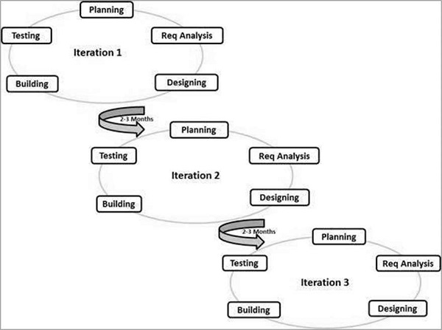

**Figure 3.1 Agile Model Source: www.slidegeeks.com/agilemethods**

The Agile thought process had started early in the software development and started becoming popular with time due to its flexibility and adaptability.

The most popular agile methods include Rational Unified Process (1994), Scrum (1995), Crystal Clear, Extreme Programming (1996), Adaptive Software Development, Feature Driven Development, and Dynamic Systems Development Method (DSDM) (1995). These are now collectively referred to as **Agile Methodologies**, after the Agile Manifesto was published in 2001.

Following are the Agile Manifesto principles –

* **Individuals and interactions** − In Agile development, self-organization and motivation are important, as are interactions like co-location and pair programming.
* **Working software** − Demo working software is considered the best means of communication with the customers to understand their requirements, instead of just depending on documentation.
* **Customer collaboration** − As the requirements cannot be gathered completely in the beginning of the project due to various factors, continuous customer interaction is very important to get proper product requirements.
* **Responding to change** − Agile Development is focused on quick responses to change and continuous development.

### **3.1.8 Agile Vs. Traditional SDLC Models**

According to Boehm, B; R (2004). Guide for the Perplexed. Boston, MA: Addison-Wesley. ISBN O-321-18612-5. Appendix A, PAGES 165-194, agile method lie on the **adaptive software development methods**, whereas the traditional SDLC models like the waterfall model is based on a predictive approach. Predictive teams in the traditional SDLC models usually work with detailed planning and have a complete forecast of the exact tasks and features to be delivered in the next few months or during the product life cycle.

Predictive methods entirely depend on the **requirement analysis and planning** done in the beginning of cycle. Any changes to be incorporated go through a strict change control management and prioritization.

Agile uses an **adaptive approach** where there is no detailed planning and there is clarity on future tasks only in respect of what features need to be developed. There is feature driven development and the team adapts to the changing product requirements dynamically. The product is tested very frequently, through the release iterations, minimizing the risk of any major failures in future.

**Customer Interaction** is the backbone of this agile methodology, and open communication with minimum documentation are the typical features of agile development environment. The agile teams work in close collaboration with each other and are most often located in the same geographical location.

### **3.1.9 Agile Model - Pros and Cons**

Agile methods are being widely accepted in the software world recently. However, this method may not always be suitable for all products. Here are some pros and cons of the agile model.

#### **3.1.9.1 Advantages of the Agile Model**

* Agile methodology allows for changes to be made after the initial planning. Re-writes to the program, as the users decides to make changes, are expected.
* Because the Agile methodology allows users to make changes, it is easier to add features that will help the project team to keep up to date with the latest developments.
* At the end of each sprint, project priorities are evaluated. This allows users to add their feedbacks so that they ultimately get the product they desire.
* The testing at the end of each sprint ensures that the bugs are caught and taken care of in the development cycle. They will not be found at the end.
* Promotes teamwork and collaboration. Agile highlight on the importance of frequent communication and face-to-face interactions. Teams working together, and users can take responsibility and own part of the project.

#### **3.1.9.2 Disadvantages of the Agile Model**

* While the level of flexibility in Agile is usually an acknowledged positive, it also comes with some trade-offs. It can be hard to establish a solid delivery date, documentation can be neglected, or final product can be very different than originally intended.

## **3.2 Requirement Specification**

Performance is measured in terms of the output provided by the application. Requirement specification plays an important part in the analysis of a system. Only when the requirement specifications are properly given, it is possible to design a system, which will fit into the required environment. The requirements gathered from the **Harvard Mobile** and the **Zaqra University Notification System** were useful in developing the necessary requirement specification.

### **Functional Requirement**

Functional requirements capture the intended behaviour of the system. This behaviour may be expressed as services, tasks or functions the system is required to perform. In product development, it is useful to distinguish between the baseline functionality necessary for any system to be compete in that product domain, and features that differentiate the system from competitors’ products. Features may be additional functionality or differ from the basic functionality along some quality attribute (such as performance or memory utilization). The Functional requirements that serve as the basis for the new system include the following:

* The system should allow the addition of new users and their associated information.
* The system should allow the modification and deletion of existing user information.
* The system should be able to authenticate and restrict user’s access to system resources.
* The system shall present an error message if the user enters invalid login information and allow the user to attempt a login again.
* The system should allow users to change their password
* The system should allow users to receive electronic notifications about events.
* The system should be able to validate information entered into the system.
* The system should be able to store data entered into the system. Students and lecturers should be able to view information about campus events or lectures.
* The system should provide a form interface to capture information from masters’ students and lecturers.
* The system should be able to serve as a communication platform between the masters’ students and lecturers.

### **3.2.2 Non-Functional Requirements**

The non-functional requirements are not the functions of the system rather they are Standards that the system must comply with instead of its specific behaviours. They are the systems qualities;

* Reliability: The system shall be accessible at any time, except for technology infrastructure failure. This requirement shall be provided for by the Ghana Technology University College who is the primary beneficiary of this system.
* Usability: The system will be designed to promote clarity and interface consistency that will ensure ease of use. The system will be intuitive and self-explanatory since it will be mainly used by people who may have little knowledge in computers.
* Interoperability: The system shall allow for easy integration with other diverse systems.
* User friendliness: The system should be user friendly. The user interface should be easy to navigate, and the colour schemes should be moderate.
* Flexibility: While insufficient flexibility of an information system to support a business process precludes the use of the system in certain cases, excessive flexibility of an information system can limit the usability of the system (Silver 1991), in addition to presenting an unnecessary investment. The system will be flexible so that it can respond to potential internal or external changes affecting its value delivery, in a timely and cost-effective manner.
* Extensibility: The system shall be extensible using Android Studio IDE. Code may be modified, styles may be changed, and content may be added all using the Android Studio IDE interface.
* Resource Utilization: The system shall be accessible from any Android mobile smart device with an active Internet connection. The system’s database can be accessed from any internet enabled device since it’s primarily online.

## **3.3 System Functional Design**

### **3.3.1 System Architecture**

System architecture is a response to the conceptual and practical difficulties of the description and design of complex systems. It is a visual model of a system, its components and their interactions. The drive of a model is to reduce the ambiguities that occur in the descriptions and to visualize its design. The system architecture for this project is shown below.

The system architecture has a smart phone with android OS, a web service, a database server and the user as its components. The android smart phone or tablet must use network for internet connectivity to ensure better performance however 2G should also satisfy the user request with added disadvantage of time lag. The user will login to the application through an android smart phone. The user-type is verified with the database server and access is given to the appropriate user. The android application accesses data from the firebase cloud server through the internet.

1. **User Module:** In this module, users will be authenticated by providing username and password. If username and password is valid then they will be taken to their screens. To identify the user, the unique device ID of the android device with the number would be stored automatically on the server. When they get matched with each other system checks the status of that device and transfer the control to respective user-interface.
2. **Database Module:** The proposed system used Firebase Database as its database because of their simplicity and flexibility. This module stores every single information about students, faculty and model their data on specified operations.
3. **Admin Module:** This module is also designed for staff, who will use the mobile phone to transmit college event notifications. The entered admin details are encrypted and sent to server for verification. Only after successful authentication are the operations performed.
4. **Communicate Module:** In which the student or staff can convey a message or communicate with each other. In this, the ordinary text can be sent as well as the various files like in format of Word (.doc, .docx), Pdf(.pdf), text(.txt) are can be sent.

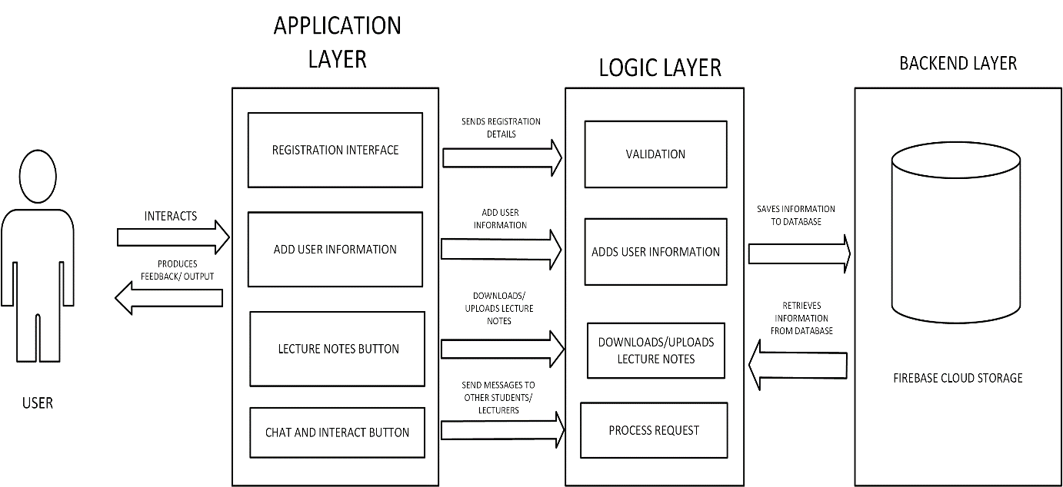

**Figure 3.2 System Architecture Source: Author’s Design (2018)**

### **3.4.1 Structural Design**

The Structural Design of the e-notice and information system for the masters’ students android application shows a bird’s eye view of the entire system. Generally, it allows easy accessibility to obtain information. Students can browse the android application to obtain various types of information such as university events information, find lecture notes, latest news in the world of education and a feedback platform. On the other hand, the Administrator would be able to assess the system to update the portal on campus events information, promotions, latest news, school and general information and feedback.

A structure diagram has been created for the e-notice and information system for masters’ students android application. The main system is divided into 2 major sections, Administrator section and Customer section as shown in Figure 3.3.

Authority

Students Accounts/Information Administration

Student Section

Admin Section

E-Notice and Information System

**Figure 3.3 Structural Design of E-Notice and Information System**

**Source; Authors’ Design**

### **3.4.2 Use case diagram**

A use case diagram is a dynamic or behaviour diagram in UML. Use case diagrams model the functionality of a system using the actors and use cases. Use cases are a set of actions, services, ad functions that the system needs to perform. In this context, a system is something being developed or operated, such as a website. The actors are people or entities operating under defined roles within the system. Use case diagrams are valuable for visualizing the functional requirements of a system that will translate into design choices and development priorities. Figure 3.4 clearly depicts the use-case diagram of the E-Notice and Information System.

LOGIN

STUDENT

ADD, EDIT, DELETE

AVAILABLE INFORMATION

ADD, EDIT, DELTE

VIEW INFORMATION/RECEIVE NOTIFICATIONS

CHAT/COMMUNICATE

USER

REGISTER

CANCEL INFORMATION

LOG OUT

ADMIN

**Figure 3.4** **Use Case Diagram for E-Notice and Information System**

**Source: Author’s Design (2018)**

### **3.4.3 Sequence Diagram**

A sequence diagram shows object interactions arranged in time sequence. It depicts the objects and classes involved in the scenario and the sequence of messages exchanged between the objects needed to carry out the functionality of the scenario. Sequence diagrams are typically associated with use case realizations in the Logical View of the system under development. Sequence Diagrams are sometimes called event diagrams or event scenarios.

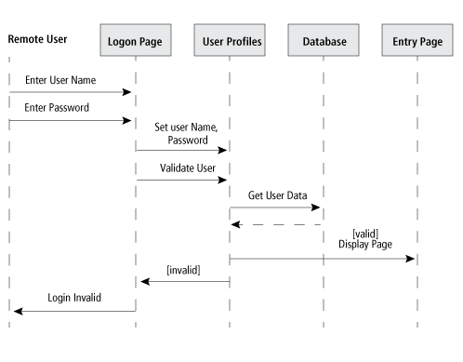

**FIGURE 3.5**

**Sequence Diagram for E-Notice and Information System Source: Author’s Design (2018)**

## **3.5 Database Design**

### **3.5.1 Data Dictionary**

In Firebase, key-value pairs are used to represent tables as shown in the images below:

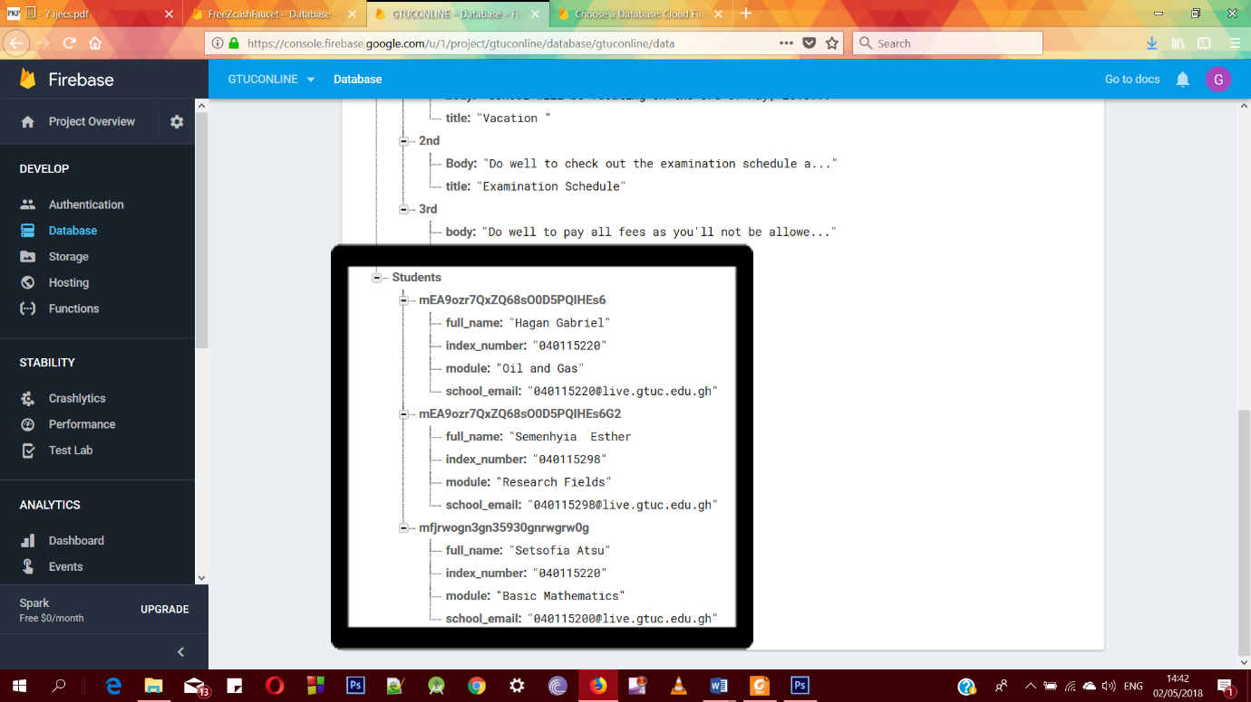

**Figure 3.5.1.1 – Student Details**

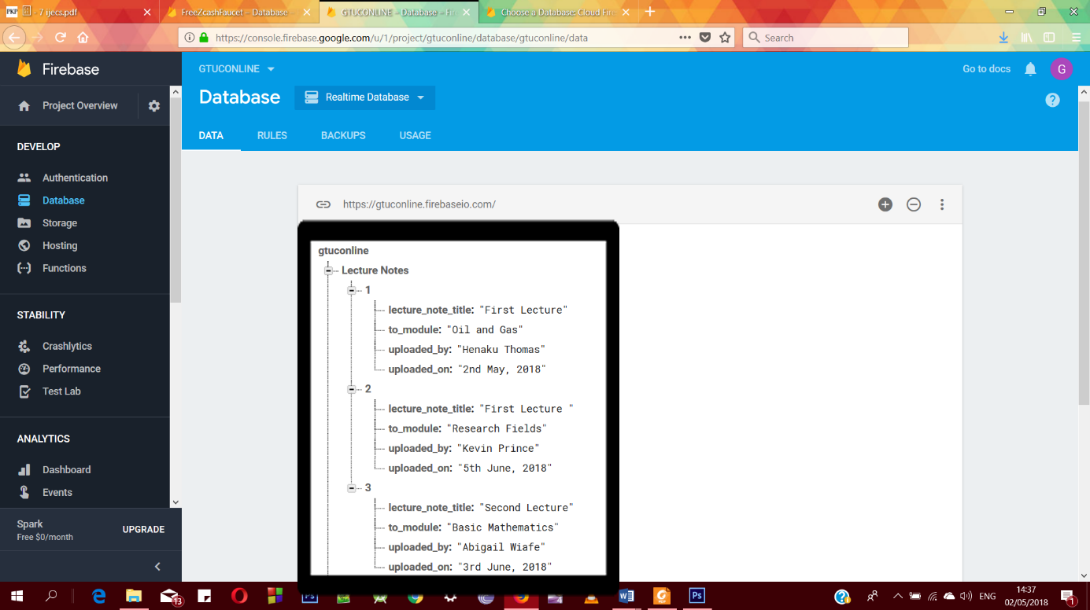

**Figure 3.5.1.2 – Lecture Note Details**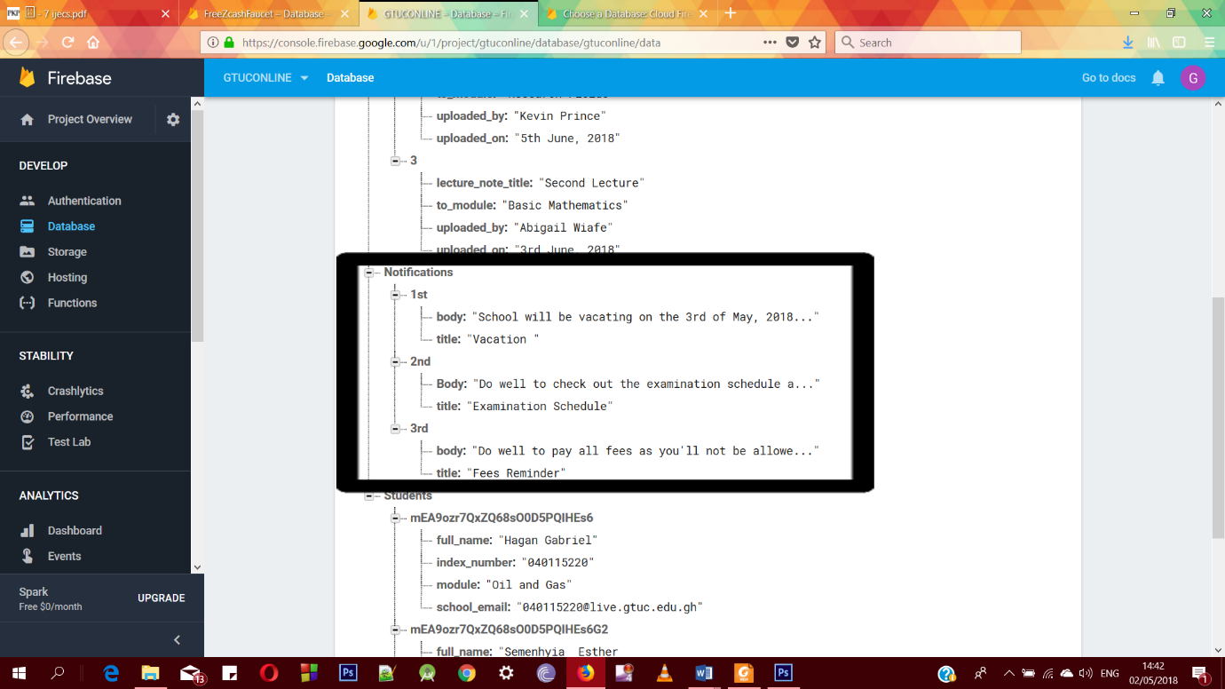

**Figure 3.5.1.3 – Notification Details**

**3.5.2 Entity Relationship Model**

The Entity Relationship diagram (ERD) is a kind of diagram for presenting visually the entity set, attributes and relationship between entities in a database. The ERD is a top down approach to the database design that begins by identifying the important data, called entities and the relationship between the data must be represented in the model. We designed the ERD of this system by using the technique of normalization. Normalization is a formal technique of analysing based on their primary key. At the end of the ERD design, we will validate and check the model to ensure that it is able to support all requirements necessary.

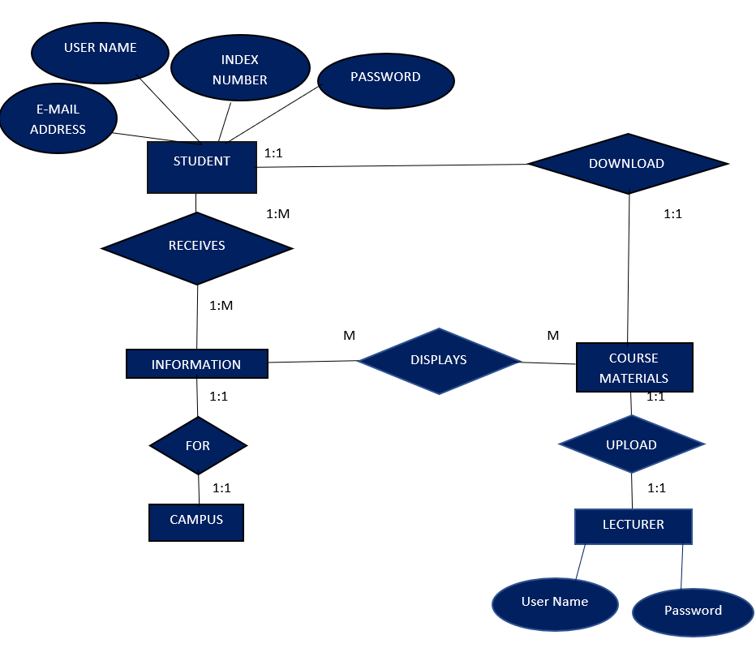

**Figure 3.6** **Entity Relationship Diagram for E-Notice and Information System**

**Source: Author’s Design (2018)**

## **3.6 Tools and Methodology used**

In this section the Tools and Methodology used in the development of the prototype system is introduced.

### **3.6.1 Software Package Used**

To develop the prototype of the proposed system an appropriate software package needs to be selected. To determine suitable software, it can be identified by addressing several questions:

1. **Familiarity: Is it familiar and easy to learn?**

This aspect concerns the Administrator and the Customer. It is best to choose a software that is familiar to the Administrator and Customer so that both parties are more comfortable using the system and find it easy to learn.

1. **Flexibility: Can the system be changed or is it easy to modify the program?**

The system needs to be changed or enhanced from time to time, as the Administrator may want to alter or modify some functions. This can be achieved depending on the type of software package and the degree of flexibility allowed.

1. **Maintainability: Can the system be maintained easily?**

The system should be able to be maintained easily by the Administrator. Maintainability will also reduce time and cost if the software package allows maintainability and this would mean that the software is more reliable and efficient to us.

Thus, in choosing the tools to develop the prototype system, the above criteria are checked to ensure it is met.

### **3.6.2 Tools Used**

The tools used for the development of the prototype system are important, as it would affect the effectiveness and efficiency of the system. Thus, careful consideration has been taken in choosing the appropriate tool.

### **3.6.2.1 Software Requirement**

Java is an open source language that is widely used to build android applications. And it will be used as the primary language alongside Extensible Markup Language in Android Studio to build the android application.

### **3.6.2.2 User-Interface Design**

To build a beautiful UI to be appealing yet efficient to the student, Extensible Markup Language will be used. XML is an open source language that anyone can use without purchasing a license.

### **3.6.2.3 Database Management**

Firebase is a mobile and web application development platform developed by firebase, Inc. in 2011, then acquired by Google in 2014. Firebase provides a real-time database and backend service. The service provides application developers an API that allows application data to be synchronized across clients and stored on Firebase’s cloud. The company provides client libraries that enable integration with Android applications. This real-time database will be used to secure data by using server-side enforced security rules.

### **3.6.2.4 Notifications Management**

Firebase also comes with a notification feature to be able to send messages to the users instantly. This is very easy as Firebase provides an easy to use UI to achieve this feat. It involves two components for sending and receiving: a trusted environment such Cloud Functions for Firebase or an app server on which to build, target and send messages and finally an Android app that receives messages.

### **3.6.2.5 Operating System**

For this project, the latest version of Windows 10 is used as the development platform since it has easy to use interface and more improved user management compared to other Windows platforms.

## **3.7 Hardware, Software and Human Computer Interaction (HCI) Requirements**

The choosing of Hardware and Software is very important for developing a system as it has a profound impact on the quality and productivity of the system.

### **3.7.1 Requirement for System Development**

The basic software and hardware used to develop the system are as follows:

1. Intel(R) Core (TM) i5-6200 CPU @2.30GHz
2. 6GB of RAM
3. Hard disk space – 1TB
4. Windows 10 (Creators Build)
5. Google Chrome
6. Android Studio
7. XML
8. Java
9. Firebase Cloud Service

**3.7.2 Human Computer Interaction (HCI) Factors**

The design is created based on Human Computer Interaction factors such as user, productivity factors, organizational factors, and user interface factors. They include:

1. **The user**

In designing the site, the experience and educational background of the users have been taken into consideration.

1. **Productivity factors**

The design must have good quality and at the same time have increased output and minimal error.

1. **Organizational factors**

There is no need to provide training for the system, as the design is easy to use.

1. **User Interface**

The use of colours, icons and command buttons, graphic and output display is important when designing the interface. All these have been included when designing the android application.

## **3.8 Android Application Design Principles**

The principles of Android Application Design focus mainly on the interface design of the android application. This is where all requirements of the users are translated into a detailed design. Here are the major principles (Schneiderman, 1998) that have been adopted in designing the user interface of the e-notice and information system.

* 1. **Focus on user needs**

By integrating the requirement statements and user preference, an E-notice and information system is designed according to the user needs.

* 1. **Maintain competitiveness**

The e-notice and information system will cause minimal time cost to the user. Cost means time taken to download a material such as going to the other modules applications and time taken to retrieve information. This is important, as it will indirectly affect the user’s impression on the effectiveness of the functions.

1. **Standardization**

The interface of the E-notice and Information System has common user-interface features across other pages. This is to reduce the need for users to relearn the new design of the system.

1. **Good graphical design**

Good graphical design means to create a consistent, pleasing and efficient look and feel for the system. With a consistent layout, users will feel eased and pleased to use the system.

# **CHAPTER 4**

# **SYSTEM IMPLEMENTATION AND TESTING**

## **Introduction**

After the system design phase that discusses on how the system should be functioning, the next process will be System Implementation and Testing. System Implementation is a process that converts the system requirements and design into program codes. This phase at times involves some modification to the previous design and describes how the initial and revised process design is put into a real working system. Testing on the other had also involves operation of a system or application under a controlled condition and evaluating the results. The controlled conditions should include both normal and abnormal conditions. Testing should intentionally attempt to make things go wrong to determine if things happen when they should not, or things do not happen when they should. Therefore, huge effort will be spent in this phase to determine the success of the system and ease the process of modification, debugging, testing, verification, system integration and for future enhancement.

## **4.1 Guidelines on how the E-notice and Information System can be implemented**

* Plan to include all lecturers and to maintain a uniform standard relationship for all lecturers.
* Make information accessible and available via the e-notice android application for the graduate students.
* Analysis of business requirements and benefits by applying ICT.
* Evaluate existing information flow and communication between students and lecturers and the school.

## **4.2 Features and Components of the Prototype**

In Chapter 3, the system is divided into smaller modules or components so that the system is easily manageable and could be developed into a working system faster and easily. It would be easy to develop the appropriate interface for the system based on the system components. The E-Notice and Information System has two sections, namely the Administrator section and the Customer section. Both these sections have been discussed in Chapter 3.

## **4.3 Interface Design**

The further explanation of the interface design for the E-Notice and Information System is attached in the Appendix section of this document.

## **4.4 Source Codes**

The source codes for the E-Notice and Information System is attached to the Appendix section.

## **4.5 Testing**

Testing is the process that is carried out to ensure that the system conforms to the specification and meets the requirements of the users, namely lecturers and graduate students. Testing had been conducted not only in the end but also during the development of the prototype system. Functional and interface testing were carried out for the module or for the whole system. Each link had been checked to make sure all the links are working correctly. Interface testing is carried out to identify that the interface works correctly, and faults are not created because of interface errors.

## **4.6 Types of Tests**

The major tests conducted are unit testing, validation testing, system testing and acceptance testing. All are thoroughly explained below.

### **4.6.1 Unit Testing**

This is the testing process which we can do manually because in this testing program tests individually using dummy record to see whether that program produce satisfied output as the company and validation also.

### **4.6.2 Validation Testing**

In this, requirements established as part of software requirements analysis are validated against the software that has been constructed. Validation testing provides final Assurance that software meets all functional, behavioural and performance requirements. Validation can be defined in many ways, but a simple definition is that validation succeeds when software functions in a manner that can be understood reasonably by the customer.

1. Validation Test Criteria
2. Configuration Review
3. Alpha and Beta Testing (conducted by end users)

### **4.6.3 System Testing**

System testing is a series different test whose primary purpose is to fully exercise the computer-based system. Where the software and other system elements are tested as whole. To test computer software, we spiral out along streamlines that broadens the scope of testing with each turn. The last higher-order testing step falls outside the boundary of software Engineering and in to the broader context of computer system engineering. Software, once validated, must be combining with other system elements (e.g. hardware, people, databases). System testing verifies that all the elements Mesh properly, and that overall system function/performance is achieved.

1. Recovery Testing
2. Security Testing
3. Stress Testing

### **4.6.4 Acceptance Testing**

Acceptance testing will give both students and administrators the opportunity to verify the system functionality and usability prior to the system deployment. The users will test the system interaction with database, using network communications, or interacting with other hardware or other applications. The system is testes with data supplied by the end users rather than simulated test data. Acceptance testing reveals errors and omissions in the system requirement definition because real data exercises the system in different ways from the test data. It also reveals requirements problem where the system’s facilities do not really meet the user’s needs or the system’s performance is unacceptable. The testing process continues until the system developer and client agrees that the E-Notice and Information System is an acceptable implementation of system requirement.

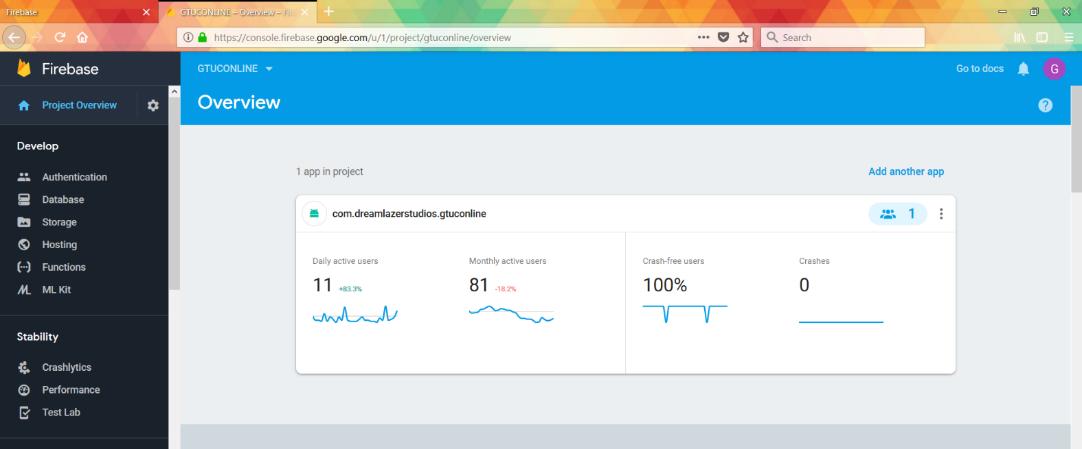

**FIGURE 4.1 - INTERFACE DESIGN (ADMINISTRATOR)**

Figure A – 1 shows the main interface that the administrator uses to manipulate the whole system. An administrator can create, delete, disable and block users from the interface right here. He/she also has the statistics of how the students are using the system that was built.

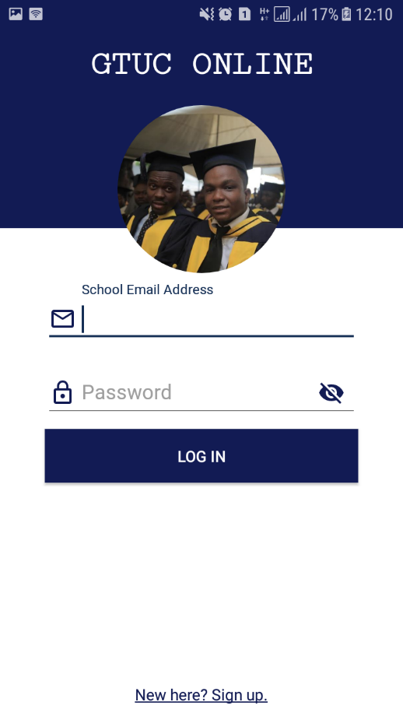

**FIGURE 4.2 INTERFACE DESIGN (STUDENT/LECTURER)**

Figure 4.2 shows the main page of the student where there is a login feature for the security purpose. A student can register and login by inserting his/her email address and inserting the password. In case of a wrong password, the system displays “Details entered isn’t correct” error message. The student must then enter their details again.

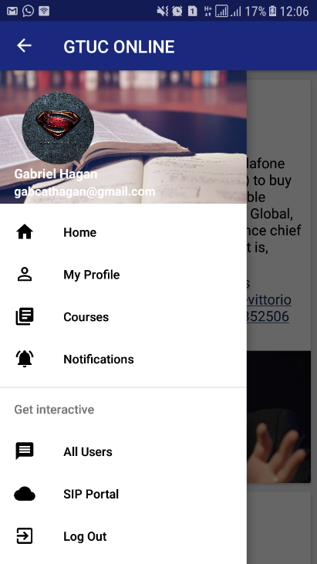

**Figure 4.3 Student Home Page**

Figure 4.3 shows the home page of the E-Notice and Interactive System for the student. This page will be shown when the student successfully logs in to the application. The home page contains buttons to navigate to the home page, the profile, courses, notifications, all users, student school portal and final to log out of the system.

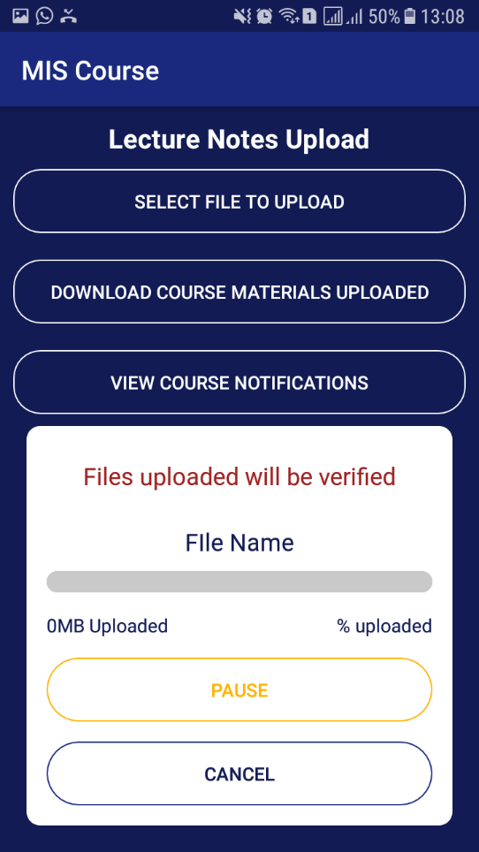

**Figure 4.4 Student Lecture Notes Page**

Figure 4.4 shows the lecture notes page where the student can download lecture notes, view course notifications and chat with the students also taking his/her course. To be able to chat with the students or lecturer, the student would have to log in to the secret portal of that course with a specific password. This is for security purposes.

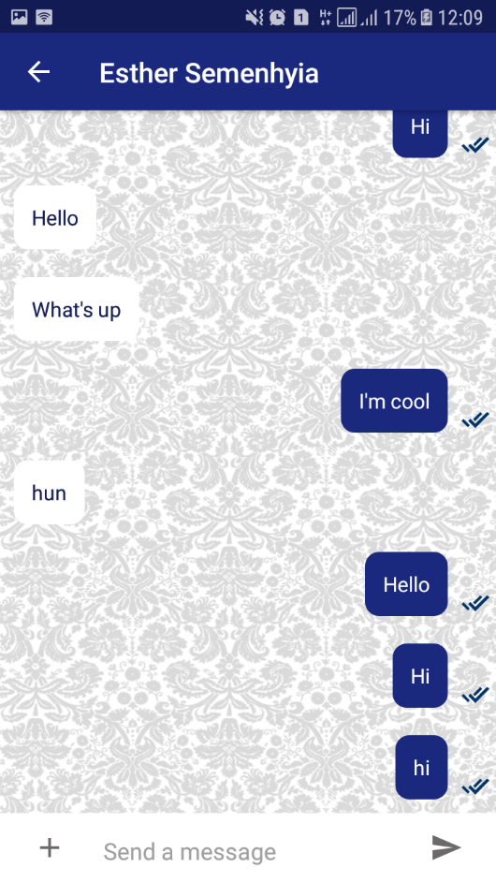

**Figure 4.5 Student Chat Page (One to One)**

Figure 4.5 shows the chatting page. As said in chapter one, the students can easily chat with their colleagues and their lectures in real time. One advantage of our system is that is real-time.

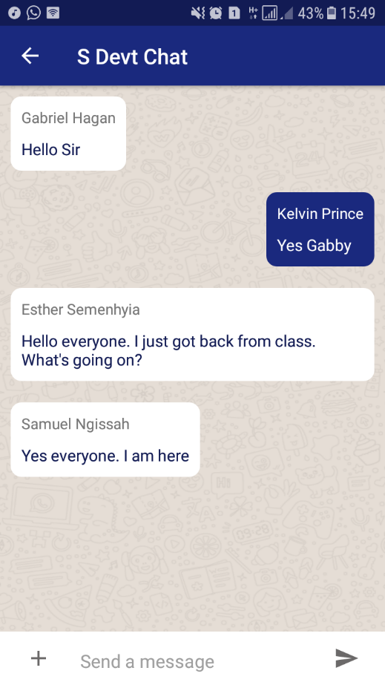

**Figure 4.6 Student Chat Page (One to Many)**

Figure 4.6 clearly shows a group chat between a user, “Kelvin Prince” chatting with users, “Gabriel Hagan”, “Samuel Ngissah” and “Esther Semenhyia”. Our system allows users to engage in group chats with other students. All in real time.

# **CHAPTER 5**

# **CONCLUSION AND RECOMMENDATION**

# **5.0 Introduction**

This Chapter discusses the outcomes of this project, its limitations and the future outcome of this project altogether.

Finally, this chapter concludes the various issues that has been highlighted in the previous chapters. Knowledge in terms of concept, theory, technical and practical aspects on an E-Notice information System has been gained.

## **5.1 Outcomes of the Project**

Based on the objectives that have been stated in the earlier chapters, the achievements are as follows:

* The first objective has been successfully completed, which is to investigate and analyse the problems on the existing information systems provided by the Graduate School of Ghana Technology University College to its masters’ students. The problems of existing information system are clearly stated in Chapter 2 where a thorough study had been conducted by investigating existing information system systems overseas specifically.
* We also created an android application where users can easily get access to important information, download lecture notes and communicate effectively with each other using their mobile phones.

## **5.2 Limitations of the project**

Few constraints encountered during the process of completing the project document are:

The first constraint was the inability to find any research document obtaining information on how the lecturers identify if students have seen the emails sent to them. This is paramount to the success of our system because the information is needed by the students to achieve success in their respective fields.

## **5.3 Future of the Project**

Some of the future works of the research for the E-Notice information system that were taken into consideration are:

**(a) Enhanced User Interface**

The user interface of the system can be enhanced to be more attractive, impressive and interactive when this Android app is converted to a real-time system.

1. **Increase Administrators Task**

Administrator’s task can be further enhanced to include more features to ease maintenance process. For example, analytical tools, data mining, other relevant reports and database backup are recommended to be included in this E-Notice information system to provide more analytical function to the school and its students.

1. **Incorporation of all Foreign University Alliance of the Graduate School of Ghana Technology University College**

This system can also accommodate all the foreign universities who are in alliance with Ghana Technology University College. For instance, Coventry University, UK Aalborg University, Denmark University of the West of Scotland, Anhalt University, Germany CASS Europe Business School, Luxembourg and Kwame Nkrumah University of Science and Technology too have a common platform to share educational materials. This future platform is very important to create a rapport between Ghanaian students and its foreign students.

## **5.4 Conclusion**

The E-Notice information system is a system with its own strengths and limitations. A thorough study and implementation of an E-Notice information System has been conducted.

There is room for improvement on the suggested guidelines, study and implementation of the E-Notice Android application. An important challenge would be to connect the master students with the foreign students in the foreign universities that they’re in alliance with. If those students could also get on board, there will be a huge impact on the performance of the student life.

## **5.5 Recommendation**

The following recommendations will be suitable to the betterment of the project.

* This system must be managed by experienced I.T. management to enhance the information sharing within the university.
* The system can be further built to run on IOS platforms to accommodate universalism.
* More universities can be added to encourage more competition.

# **References**

**Adriana Harizanova, (2003)**, “Management Information System in tailoring industry” in*Academic Open Internet Journal*, Volume 9, 2003, [Online] [www.acadjournal.com](http://www.acadjournal.com)

**Beck, Kent, et al.2001.** “Manifesto for Agile software Development”. http://agailemanifesto.org/.Retrieved 2018-06-14.

**Boehm, B; R (2004).** Guide for the Perplexed. Boston, MA: Addison-Wesley. ISBN O-321-18612-5. Appendix A, PAGES 165-194.

**Balazs Beny’o, Balint Sodor, Tibor Doktor and Gergely Fordos**, "Student attendance monitoring at the university using NFC", International Conference on Advanced Computer Science Applications and Technologies 978-1-4577-05809/12/ 2012 IEEE.

**Cia Zhongxi**,"Campus Employment Information Network Development based on Android Platform " International Conference on Intelligent Transportation, Big Data Smart City 2016 IEEE.

**Fei Shao, Zinan Chang, Yi Zhang**, " AES Encryption Algorithm Based on the High-Performance Computing of GPU", Second International Conference on Communication Software and Networks,978-0-7695-39614/10 2010 IEEE.

**Hsuan-Che Yang,Wen-Ying Wang** “Facilitating Academic Service-Learning with Android-based Applications and Ubiquitous Computing Environment ”,Published in 978-0- 7695-4493-9/11 2011 IEEE.

**JinMei-shan,QiuChang-li,LiJing**, "The Designment of Student Information Management System Based on B/S Architecture", IEEE Computer Society ,978-1-4799-3134-7/14/ 2014 IEEE.

**Kenneth C. Laudon et al., (2004)**, “Management Information Systems – Managing theDigital Firm”, Eight Edition, 2004.

**Keretapi Tanah Malayu, (2006)**, i*ntroduction*, <http://www.ktmb.com.my/section.cfm?id=143 14/3/2006.

Retrieved 06/07/2018.  
**K. B. Lee**, “Developing Mobile Collaborative Learning Application for Mobile Users.” International Journal of Interactive Mobile Technologies, Vol 5, No 4, 2011, pp. 42-48.

**Ng Cheng Yee, (2006)**, The Star, 21/1/ 2018

**Oxford English Dictionary, (2005)**, Oxford University Press, 2005.

**Park May Berhad, (2006)**, [Online] <http://www.parkmayberhad.com/>, 2018/03/06.

**Pfleeger S.L., (2001)**, Software Engineering Theory and Practice, (2nded.). Upper SaddlerRiver, New Jersey: Prentice-Hall.

**Ramesh Shrestha,Yao Aihong**,"Design of Secure Location and Message Sharing System for Android Platform", International Conference on Advanced Computer Science Applications and Technologies 978-1-4673-0089-6/12/ 2012 IEEE.

**S.R.Bharamagoudar, Geeta R.B., S.G.Totad** “Web Based Student Information Management System”, International Journal of Advanced Research in Computer and Communication Engineering -June 2013, ISSN: 2319-5940.  
**Suchita Tayde, Asst. Prof. Seema Siledar** “File Encryption, Decryption Using AES Algorithm in Android Phone”, International Journal of Advanced Research in Computer Science and Software Engineering, May-2015, ISSN: 2277 128X.

**Suriyani Ariffin,Ramlan Mahmod,Ratini Rahmat, Nuzul Annisa Idris**,"SMS Encryption using 3D-AES Block Cipher on Android Message Application ", International Conference on Advanced Computer Science Applications and Technologies 978-1-4799-2758-6/13 2013 IEEE.

**Siti Aisah Mohd Noor, Norliza Zaini, Mohd Fuad Abdul Latip, Nabilah Hamzah**, " Android-based Attendance Management System" , IEEE Conference on Systems, Process and Control (ICSPC 2015), 18 - 20 December 2015, Bandar Sunway, Malaysia.

**Yang Shulin,Hu Jieping**, " Research and Implementation of Web Services in Android Network Communication Framework Volley" , IEEE Computer Society ,978-1-4799-3134-7/14/ 2014 IEEE.

**Yang Shulin, Hu jipieng** “Research and Implementation of Web Services in Android Network Communication Framework Volley” IEEE- ICCSN.2014.20.

**Zhi-gang YUE ,You-wei JIN**," The development and design of the student management system based on the network environment", International Conference on Multimedia Communications,978-0-7695-4136-5/10 2010 IEEE.

# **APPENDIX A**

<?xml version="1.0" encoding="utf-8"?>

<manifest xmlns:android="http://schemas.android.com/apk/res/android"

package="com.dreamlazerstudios.gtuconline">

<uses-permission android:name="android.permission.ACCESS_NETWORK_STATE" />

<uses-permission android:name="android.permission.ACCESS_WIFI_STATE" />

<uses-permission android:name="android.permission.INTERNET" />

<uses-permission android:name="android.permission.WRITE_EXTERNAL_STORAGE" />

<uses-permission android:name="android.permission.READ_EXTERNAL_STORAGE" />

<uses-permission android:name="com.google.android.c2dm.permission.RECEIVE" />

<uses-permission android:name="android.permission.WAKE_LOCK" />

<application

android:name=".GTUCONLINE"

android:allowBackup="true"

android:icon="@mipmap/ic_launcher"

android:label="@string/app_name"

android:roundIcon="@mipmap/ic_launcher_round"

android:supportsRtl="true"

android:theme="@style/AppTheme">

<activity

android:name=".LoginActivity"

android:screenOrientation="portrait"

android:theme="@style/MyTheme">

<intent-filter>

<action android:name="LoginActivity" />

<category android:name="android.intent.category.DEFAULT" />

</intent-filter>

</activity>

<activity android:name=".MainActivity">

<intent-filter>

<action android:name="MainActivity" />

<category android:name="android.intent.category.DEFAULT" />

</intent-filter>

</activity>

<activity

android:name=".ChoiceActivity"

android:screenOrientation="portrait"

android:theme="@style/MyTheme" />

<activity

android:name=".WelcomeActivity"

android:screenOrientation="portrait"

android:theme="@style/MyTheme">

<intent-filter>

<action android:name="android.intent.action.MAIN" />

<category android:name="android.intent.category.LAUNCHER" />

</intent-filter>

</activity>

<activity

android:name="com.theartofdev.edmodo.cropper.CropImageActivity"

android:theme="@style/Base.Theme.AppCompat" />

<activity

android:name=".StudentSignUp"

android:screenOrientation="portrait"

android:theme="@style/MyTheme" />

<activity

android:name=".LecturerSignUp"

android:screenOrientation="portrait" />

<activity android:name=".ProgrammeActivity" />

<service android:name=".MyFirebaseInstanceIDService">

<intent-filter>

<action android:name="com.google.firebase.INSTANCE_ID_EVENT" />

</intent-filter>

</service>

<service

android:name=".MyFirebaseMessagingService"

android:enabled="true"

android:exported="true">

<intent-filter>

<action android:name="com.google.firebase.MESSAGING_EVENT" />

</intent-filter>

</service>

<activity

android:name=".TopicActivity"

android:theme="@style/MyTheme" />

<activity android:name=".MIS" />

<activity android:name=".GB" />

<activity android:name=".FIN" />

<activity android:name=".ENGINEERINGM" />

<activity android:name=".BDM" />

<activity android:name=".SCM" />

<activity android:name=".TE" />

<activity android:name=".TM" />

<activity android:name=".BET" />

<activity android:name=".ICT" />

<activity android:name=".T" />

<activity android:name=".IT" />

<activity android:name=".AM" />

<activity android:name=".OGM" />

<activity android:name=".I" />

<activity android:name=".PEF" />

<activity android:name=".QM" />

<activity android:name=".EPM" />

<activity android:name=".PM" />

<activity android:name=".HM" />

<activity android:name=".StudentsList">

<intent-filter>

<action android:name="StudentsList" />

<category android:name="android.intent.category.DEFAULT" />

</intent-filter>

</activity>

<activity android:name=".LecturersList" />

<activity android:name=".AdminActivity" />

<activity

android:name=".ChatActivity"

android:parentActivityName=".StudentsList">

<intent-filter>

<action android:name="Chats" />

<category android:name="android.intent.category.DEFAULT" />

</intent-filter>

</activity>

<activity android:name=".LecturerMainActivity" />

<activity

android:name=".Download"

android:parentActivityName=".MIS">

<intent-filter>

<action android:name="Download" />

<category android:name="android.intent.category.DEFAULT" />

</intent-filter>

</activity>

<activity

android:name=".MIS_Information"

android:parentActivityName=".MIS">

<intent-filter>

<action android:name="InfoSys" />

<category android:name="android.intent.category.DEFAULT" />

</intent-filter>

</activity>

<activity android:name=".Terms" />

<activity

android:name=".Admin_Login"

android:parentActivityName=".LoginActivity" />

<activity

android:name=".Manipulation"

android:parentActivityName=".Admin_Login" />

<activity android:name=".Admins" />

<activity

android:name=".SystemsDevt"

android:parentActivityName=".MIS" />

<activity

android:name=".SysGroupChat"

android:parentActivityName=".SystemsDevt" />

<activity

android:name=".EntSystems"

android:parentActivityName=".MIS" />

<activity android:name=".DownloadEnt">

<intent-filter>

<action android:name="DownloadEnt" />

<category android:name="android.intent.category.DEFAULT" />

</intent-filter>

</activity>

<activity android:name=".student_mis" />

<activity

android:name=".Student_SystemsDevt"

android:parentActivityName=".student_mis">

<intent-filter>

<action android:name="Student_SystemsDevt" />

<category android:name="android.intent.category.DEFAULT" />

</intent-filter>

</activity>

<activity

android:name=".Student_EntSys"

android:parentActivityName=".student_mis" />

<activity

android:name=".SystemsDevt_Add"

android:parentActivityName=".SystemsDevt" />

<activity android:name=".EntSystemsAdd" />

<activity android:name=".EntSystemsInfo" />

<activity

android:name=".DatabaseSystems"

android:parentActivityName=".MIS" />

<activity android:name=".DownloadDatabaseSys" />

<activity

android:name=".Student_DatabaseSystems"

android:parentActivityName=".student_mis" />

<activity android:name=".DatabaseInfo" />

<activity

android:name=".DatabaseAdd"

android:parentActivityName=".DatabaseSystems" />

<activity

android:name=".IntroToOil"

android:parentActivityName=".GB" />

<activity

android:name=".DownloadIntro"

android:parentActivityName=".IntroToOil" />

<activity

android:name=".IntroToOilInfo"

android:parentActivityName=".IntroToOil" />

<activity

android:name=".IntroToOilAdd"

android:parentActivityName=".IntroToOil" />

<activity android:name=".student_gb" />

<activity android:name=".StudentIntro" />

<activity

android:name=".MIS_students_new"

android:parentActivityName=".SystemsDevt">

</activity>

<activity android:name=".AdminMainPage">

</activity>

<activity android:name=".AdminAdd"

android:parentActivityName=".AdminMainPage">

</activity>

</application>

</manifest>