LAURETA ePORTFOLIO
Project Documentation

Prepared by:
Criszle T. Laureta
Bachelor of Science in Information Technology
Data Center College of the Philippines — Bangued Campus

September 2026

1. Project Overview
Laureta ePortfolio is a personal portfolio website for Criszle T. Laureta, a graduating Bachelor of Science in Information Technology student at Data Center College of the Philippines (Bangued Campus). The website serves as a digital showcase of Criszle's skills, projects, certifications, education, and professional experience.
The portfolio is built as a single-page application using the Laravel PHP framework with Blade templating. It features a modern, responsive design with a distinctive "matcha green" dark theme, interactive canvas-based hero animations, and a clean component-based architecture. All content is statically hardcoded in PHP arrays within the controller — no database is required.

1.1 Purpose
- Showcase academic and professional achievements to potential employers and collaborators
- Demonstrate web development skills through the portfolio's own implementation
- Provide easy access to certificates, project details, and contact information
- Serve as a living document that evolves alongside the owner's career

1.2 Key Highlights
- Owner: Criszle T. Laureta
- Role: BS Information Technology Student (4th Year)
- Institution: Data Center College of the Philippines — Bangued Campus
- Location: Bangbangar, Bangued, Abra, Philippines
- Projects Showcased: 4 completed projects
- Certifications: 5 professional certifications (CHED, TESDA, DICT, CSC)

2. Features

2.1 Page Sections
- Home / Hero Section: Animated canvas background with morphing blobs, mouse-trail syntax-highlighting fragments, name, role, tagline, CTA buttons, and social links.
- About Section: Biography, photo gallery, location, resume download button, and skills/tools panels.
- Projects Section: Timeline-style project cards with 'See More / See Less' toggle, detail modals with screenshot carousels, and tech tags.
- Education & Experience: Two-column timeline showing tertiary/secondary education and work experience (SSS Intern, LGU Bangued Student Aide).
- Certifications Section: Cards for 5 certifications with full-screen image viewer, prev/next navigation, and PDF document links.
- Contact Section: Email, phone, and social links (GitHub, Facebook, Instagram) with a contact form that triggers a mailto handler.

2.2 Interactive Elements
- Animated hero background with 3 morphing matcha-green blobs and mouse-trail code fragments
- Sticky navigation with mobile hamburger menu and off-canvas slide-down
- Scroll-spy active-section highlighting using IntersectionObserver
- Smooth scrolling between sections with scroll-padding offset
- Reveal-on-scroll animations for section content
- Project detail modals with browser-frame mockup and screenshot carousel
- Full-screen certificate image viewer with keyboard navigation (arrows + Esc)
- Back-to-top button appearing after 300px scroll
- Profile gallery carousel in the About section

2.3 Design & Theme
- Dark "matcha green" pastel theme with CSS custom properties
- Fully responsive across mobile, tablet, and desktop breakpoints
- Google Fonts: Inter (body) + Sora (headings)
- Inline SVG icons via Blade components for social links and tool logos
- Cache-busting query strings on static assets for reliable updates

3. Technology Stack
The following table summarizes the technologies and tools used in this project:

Layer | Technology
Backend Framework | Laravel 12 (^12.0)
Language | PHP ^8.2
Templating | Laravel Blade (.blade.php) with anonymous components
Styling | Tailwind CSS 4 + Custom CSS (1,552 lines, matcha green theme)
Frontend Scripting | Vanilla JavaScript (511 lines, no framework)
Build Tooling | Vite 7 + laravel-vite-plugin + @tailwindcss/vite
Database | None — all content is hardcoded PHP arrays
Fonts | Google Fonts: Inter + Sora
Icons | Inline SVG via Blade components
Dev Server | XAMPP (Apache + PHP)
Version Control | Git + GitHub

3.1 Architecture
The application follows a minimal but clean architecture:
- Single route (GET /) maps to PortfolioController@index
- PortfolioController defines private methods returning plain PHP arrays for all content
- One main Blade template (portfolio/index.blade.php) composes the entire page
- Reusable Blade components: layout, nav, footer, project-card, project-modal, gallery-modal, stat-card, section-heading, tool-logo, icon, social
- Static CSS and JS files served from public/ with cache-busting
- No database, no migrations, no Eloquent models — purely static content delivery

3.2 Project File Structure
Key directories and files:
- app/Http/Controllers/PortfolioController.php — All content data (hardcoded PHP arrays)
- resources/views/portfolio/index.blade.php — Main single-page Blade template
- resources/views/components/ — Blade components (layout, nav, footer, icons, etc.)
- public/css/app.css — Custom themed stylesheet (1,552 lines)
- public/js/app.js — Vanilla JavaScript for all interactions (511 lines)
- public/img/ — Project screenshots, profile photos, logos
- public/pdf_cert/ — Certificate images and PDF documents
- public/files/ — Resume PDF
- routes/web.php — Single route definition
- PROMPT_LOG.md — AI collaboration prompt history

4. AI Collaboration Summary
This portfolio was built entirely through AI-assisted development using a Large Language Model (LLM) coding assistant. A total of 11 structured prompts were used chronologically to design, build, and customize the website. The complete prompt history is documented in PROMPT_LOG.md.

4.1 Collaboration Approach
The development process followed a prompt-driven workflow where natural-language instructions were given to the AI assistant, which then generated feature-sized code changes. Each prompt included specific technical constraints and content requirements, and the AI produced complete, working implementations for each feature.

4.2 Development Timeline
The 11 prompts covered the full development lifecycle:
- Prompt 1 — Initial Setup: Established the Laravel project with single-page layout, responsive design, sticky navigation, and component architecture.
- Prompt 2 — Personal Info: Customized name, role, tagline, and social media links (GitHub, Facebook, Instagram).
- Prompt 3 — Animated Hero: Created the interactive canvas background with morphing blobs and mouse-trail syntax-highlighting fragments.
- Prompt 4 — Bio Section: Updated the 'Glimpse Into Me' biography with personal and academic content.
- Prompt 5 — Resume Button: Added the Download Resume button linking to the PDF file.
- Prompt 6 — Skills & Tools: Populated skills categories (Programming, Tools, Soft Skills, Technical & Creative).
- Prompt 7 — Projects: Added project details for Holy Ghost School Online Information System.
- Prompt 8 — Education: Updated education history (Data Center College, Abra High School).
- Prompt 9 — Experience: Added work experience (SSS Intern, LGU Bangued Student Aide).
- Prompt 10 — Certificates: Added certification details and images (Cyber Awareness, NCII, Netiquette, Data Analytics).
- Prompt 11 — Contact: Updated email and phone number.

4.3 Key Outcomes
- Rapid prototyping: The entire portfolio was built in a single development session
- Consistent code quality: The AI maintained Laravel conventions and Blade component patterns throughout
- Constraint adherence: All technical constraints (no database, hardcoded content, responsive design) were strictly followed
- Full documentation: Every prompt and its result are logged in PROMPT_LOG.md for reproducibility
- Git integration: Each prompt corresponded to a clean, feature-sized git commit

4.4 AI Tools & SDKs
No AI SDKs, APIs, or runtime AI packages are included in the codebase. The AI was used purely as a development-time coding assistant to generate source code, not as a runtime feature of the application itself.

5. Setup & Deployment Steps

5.1 Prerequisites
- PHP 8.2 or higher
- Composer (PHP package manager)
- Node.js 18+ and npm (for asset building, optional)
- XAMPP or equivalent local server stack
- Git (for version control)

5.2 Local Development Setup
Follow these steps to set up the project locally:
Step 1: Clone the repository
git clone https://github.com/criszlelaureta/LAURETA_EPORTFOLIO.git
Step 2: Install PHP dependencies
composer install
Step 3: Configure environment
cp .env.example .env
php artisan key:generate
Step 4: Install frontend dependencies (optional)
npm install
Step 5: Build assets (optional — pre-built files exist)
npm run build
Step 6: Start the development server
php artisan serve
Alternatively, with XAMPP, place the project in htdocs and access it at:
http://localhost/LAURETA_EPORTFOLIO/public

5.3 Deployment Notes
- No database migrations are needed — the app is 100% static content
- CSS and JS files are pre-compiled in public/css/ and public/js/
- Images and certificates must be placed in public/img/ and public/pdf_cert/ respectively
- The .htaccess file in public/ handles Apache URL rewriting
- For production, set APP_ENV=production and APP_DEBUG=false in .env
- Cache-busting query strings (?v=N) should be incremented when assets change

5.4 Updating Content
To update any portfolio content, edit the arrays in app/Http/Controllers/PortfolioController.php:
- Personal Info: Edit the profile() method
- Skills & Tools: Edit the skills() method
- Projects: Edit the projects() method and place images in public/img/
- Education: Edit the education() method
- Experience: Edit the experience() method
- Certifications: Edit the certifications() method and place images in public/pdf_cert/
- Contact Info: Edit the contacts() method

6. Screenshots & Visual Assets
The following section documents the visual assets included in the portfolio. Due to the nature of this document, screenshots are represented as placeholders. In a live deployment, these would be replaced with actual screen captures.

6.1 Hero Section
The hero section features an animated canvas background with morphing matcha-green blobs and interactive mouse-trail code fragments. The main content includes the owner's name, role, tagline, and CTA buttons.

Hero Section — Logo and Branding

6.2 About Section
The About section displays the 'Glimpse Into Me' biography, a photo gallery grid, location information, resume download button, and skill/tool panels.
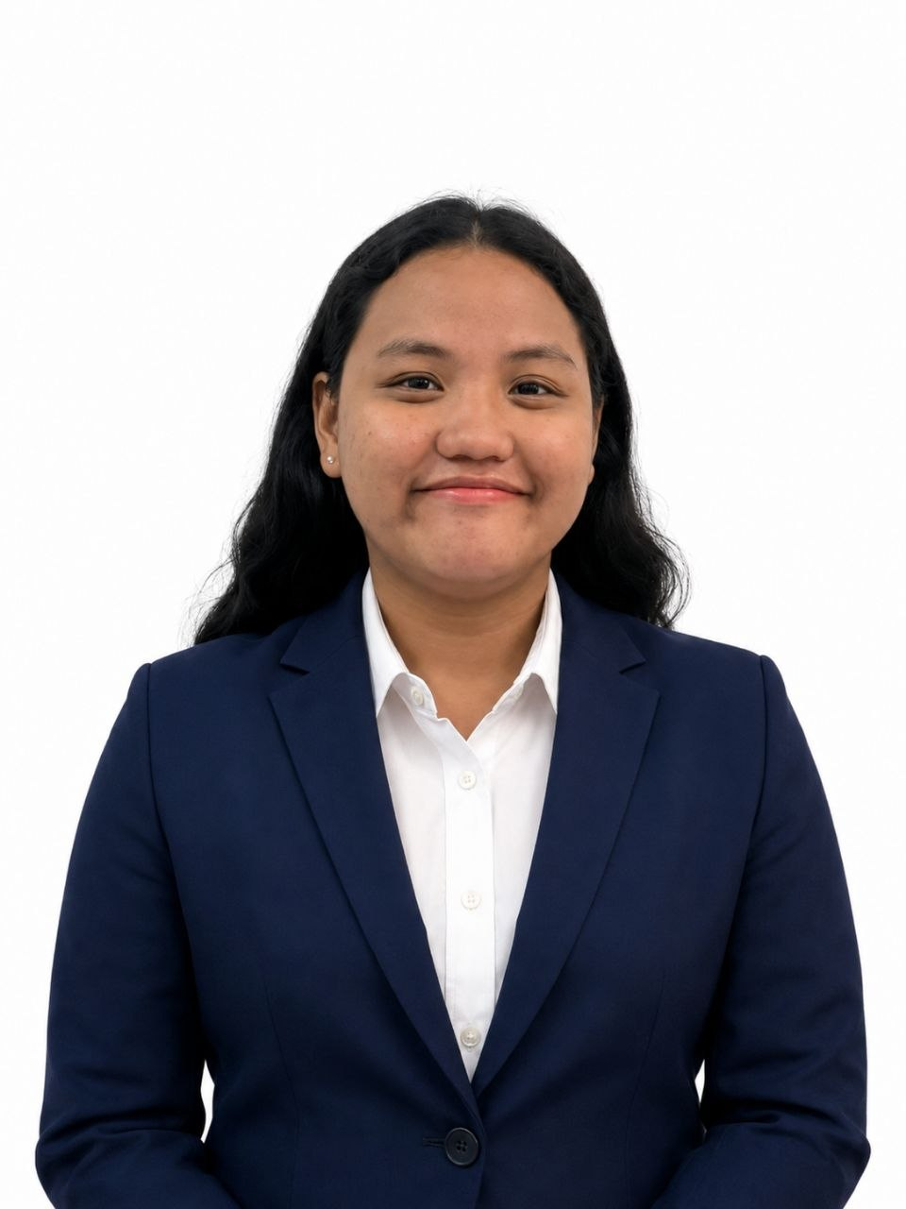
About Section — Profile and Bio

6.3 Projects Section
Four projects are showcased in a timeline layout with expandable details and screenshot carousels:

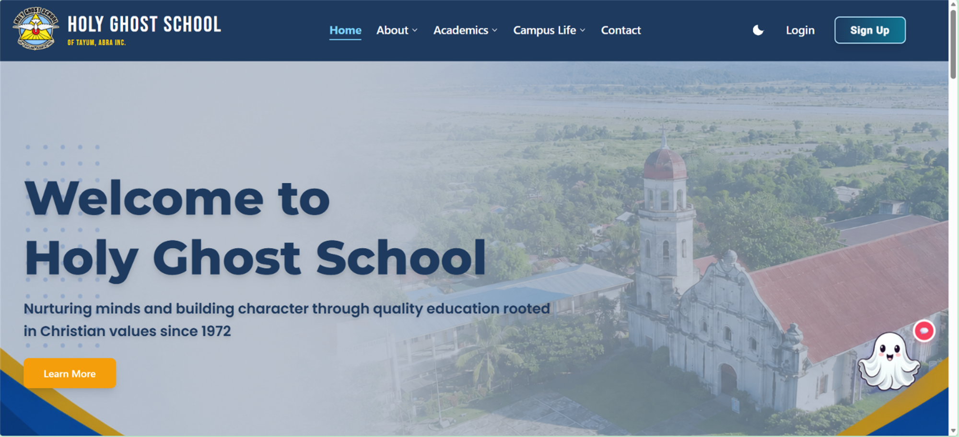
Project 1: Holy Ghost School Online Information System
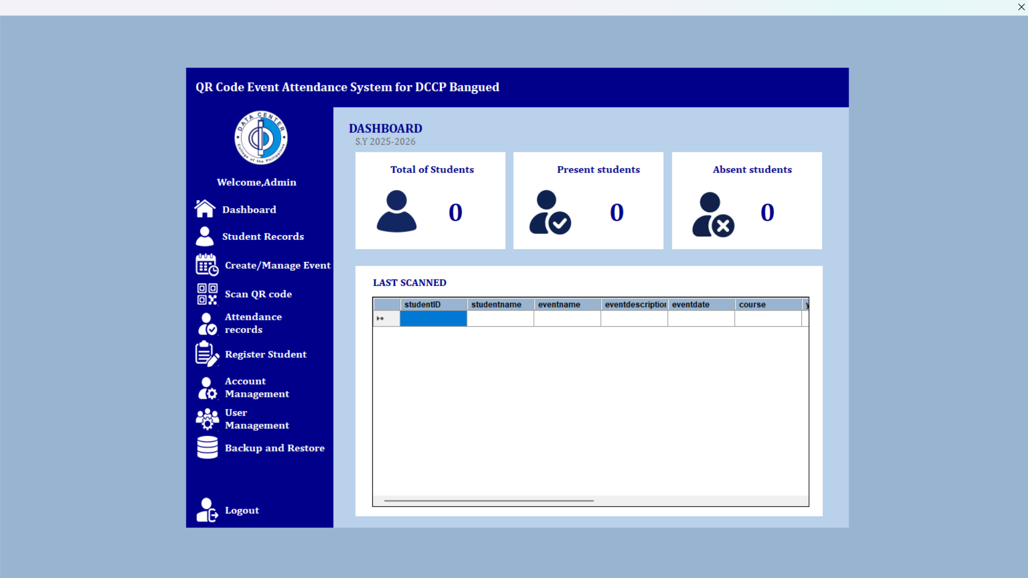
Project 2: QR Code Based Event Attendance System
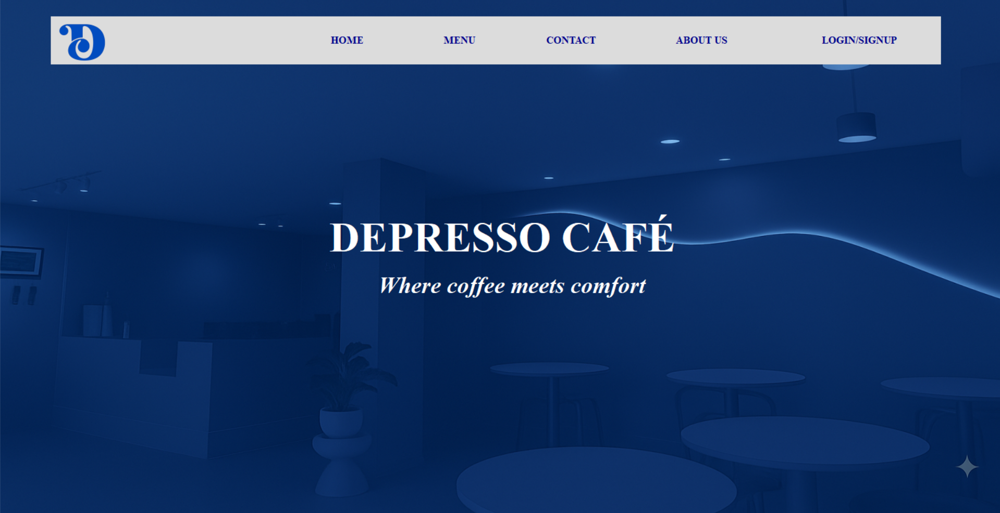
Project 3: Online Ordering and Reservation for Depresso
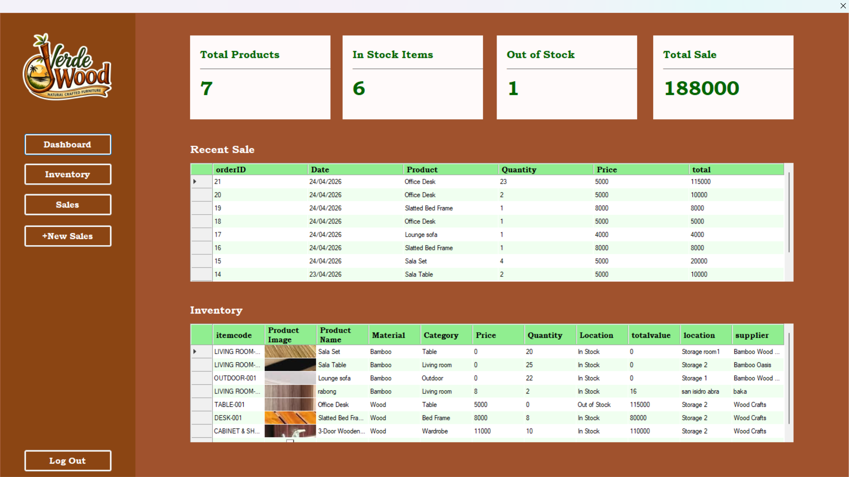
Project 4: Inventory System for Verde Wood Furniture

6.4 Certifications
Five professional certifications are displayed as cards with viewable images and PDF documents:

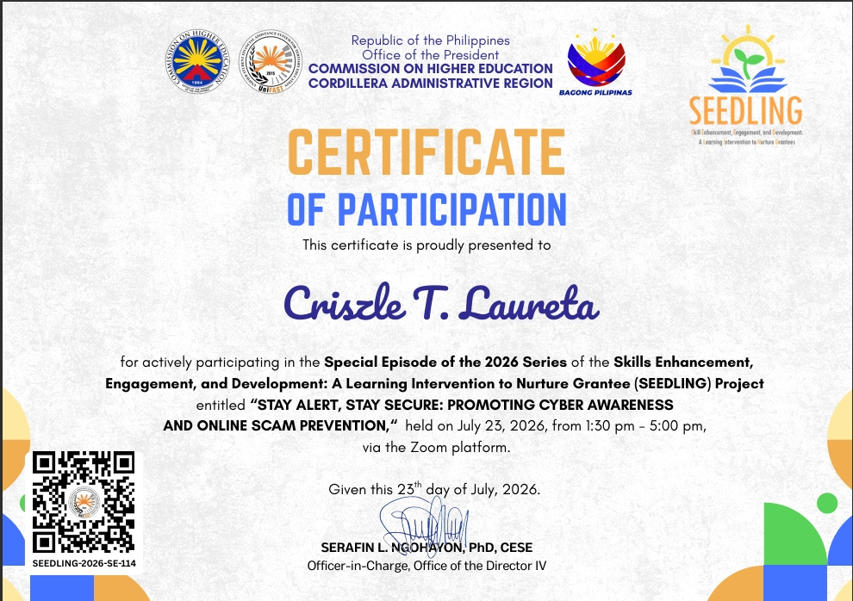
Certificate: Stay Alert, Stay Secure — Cyber Awareness (CHED)
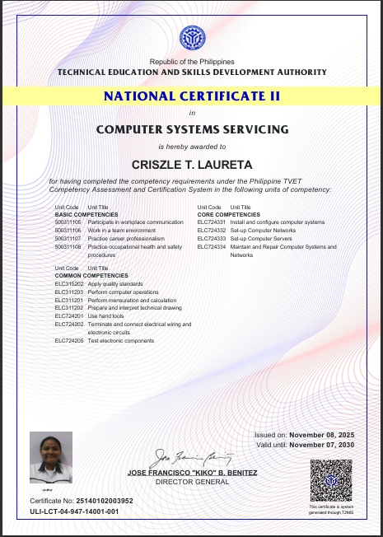
Certificate: Computer Systems Servicing NCII (TESDA)
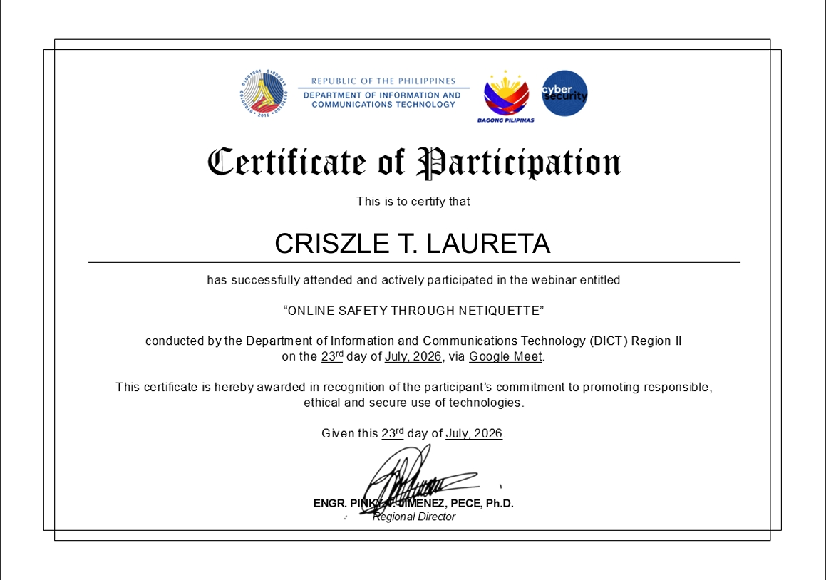
Certificate: Online Safety Through Netiquette (DICT)
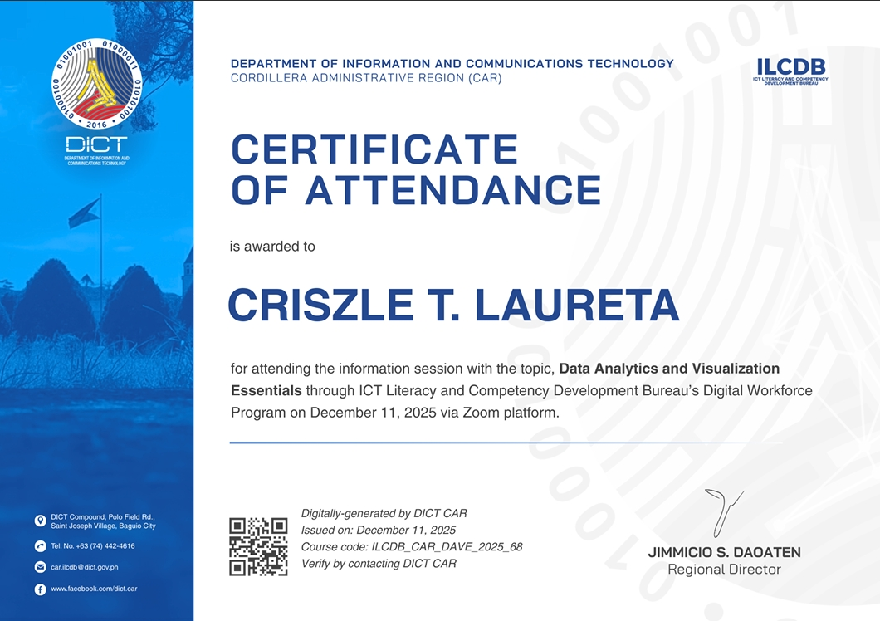
Certificate: Data Analytics and Visualization Essentials (DICT)

6.5 Additional Visual Assets
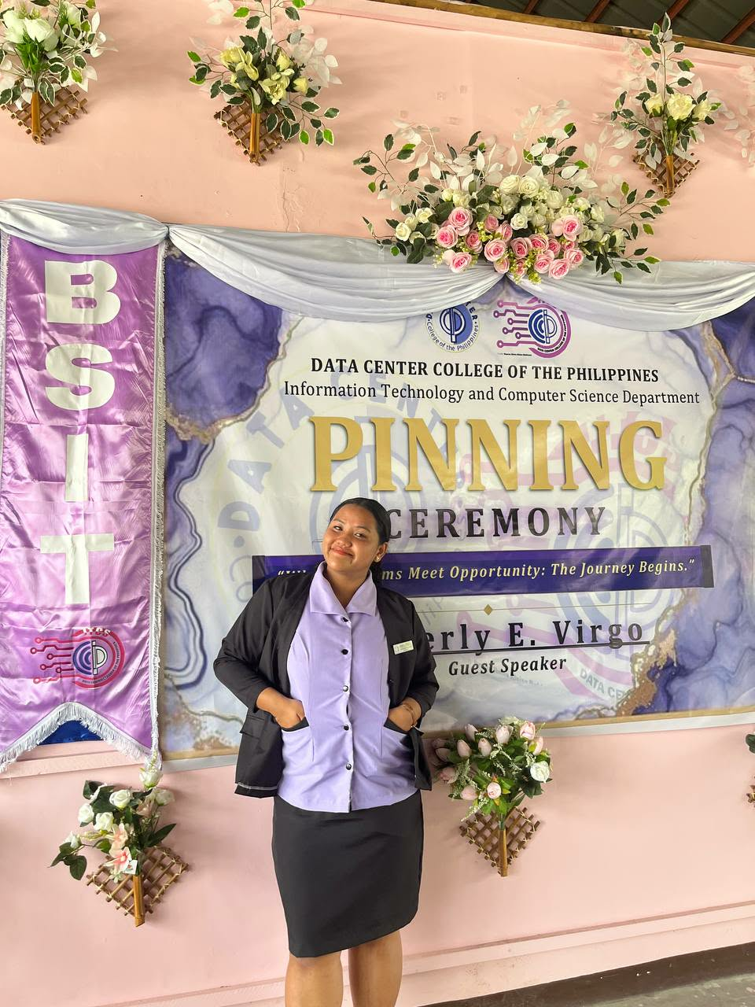
Academic Pinning Ceremony
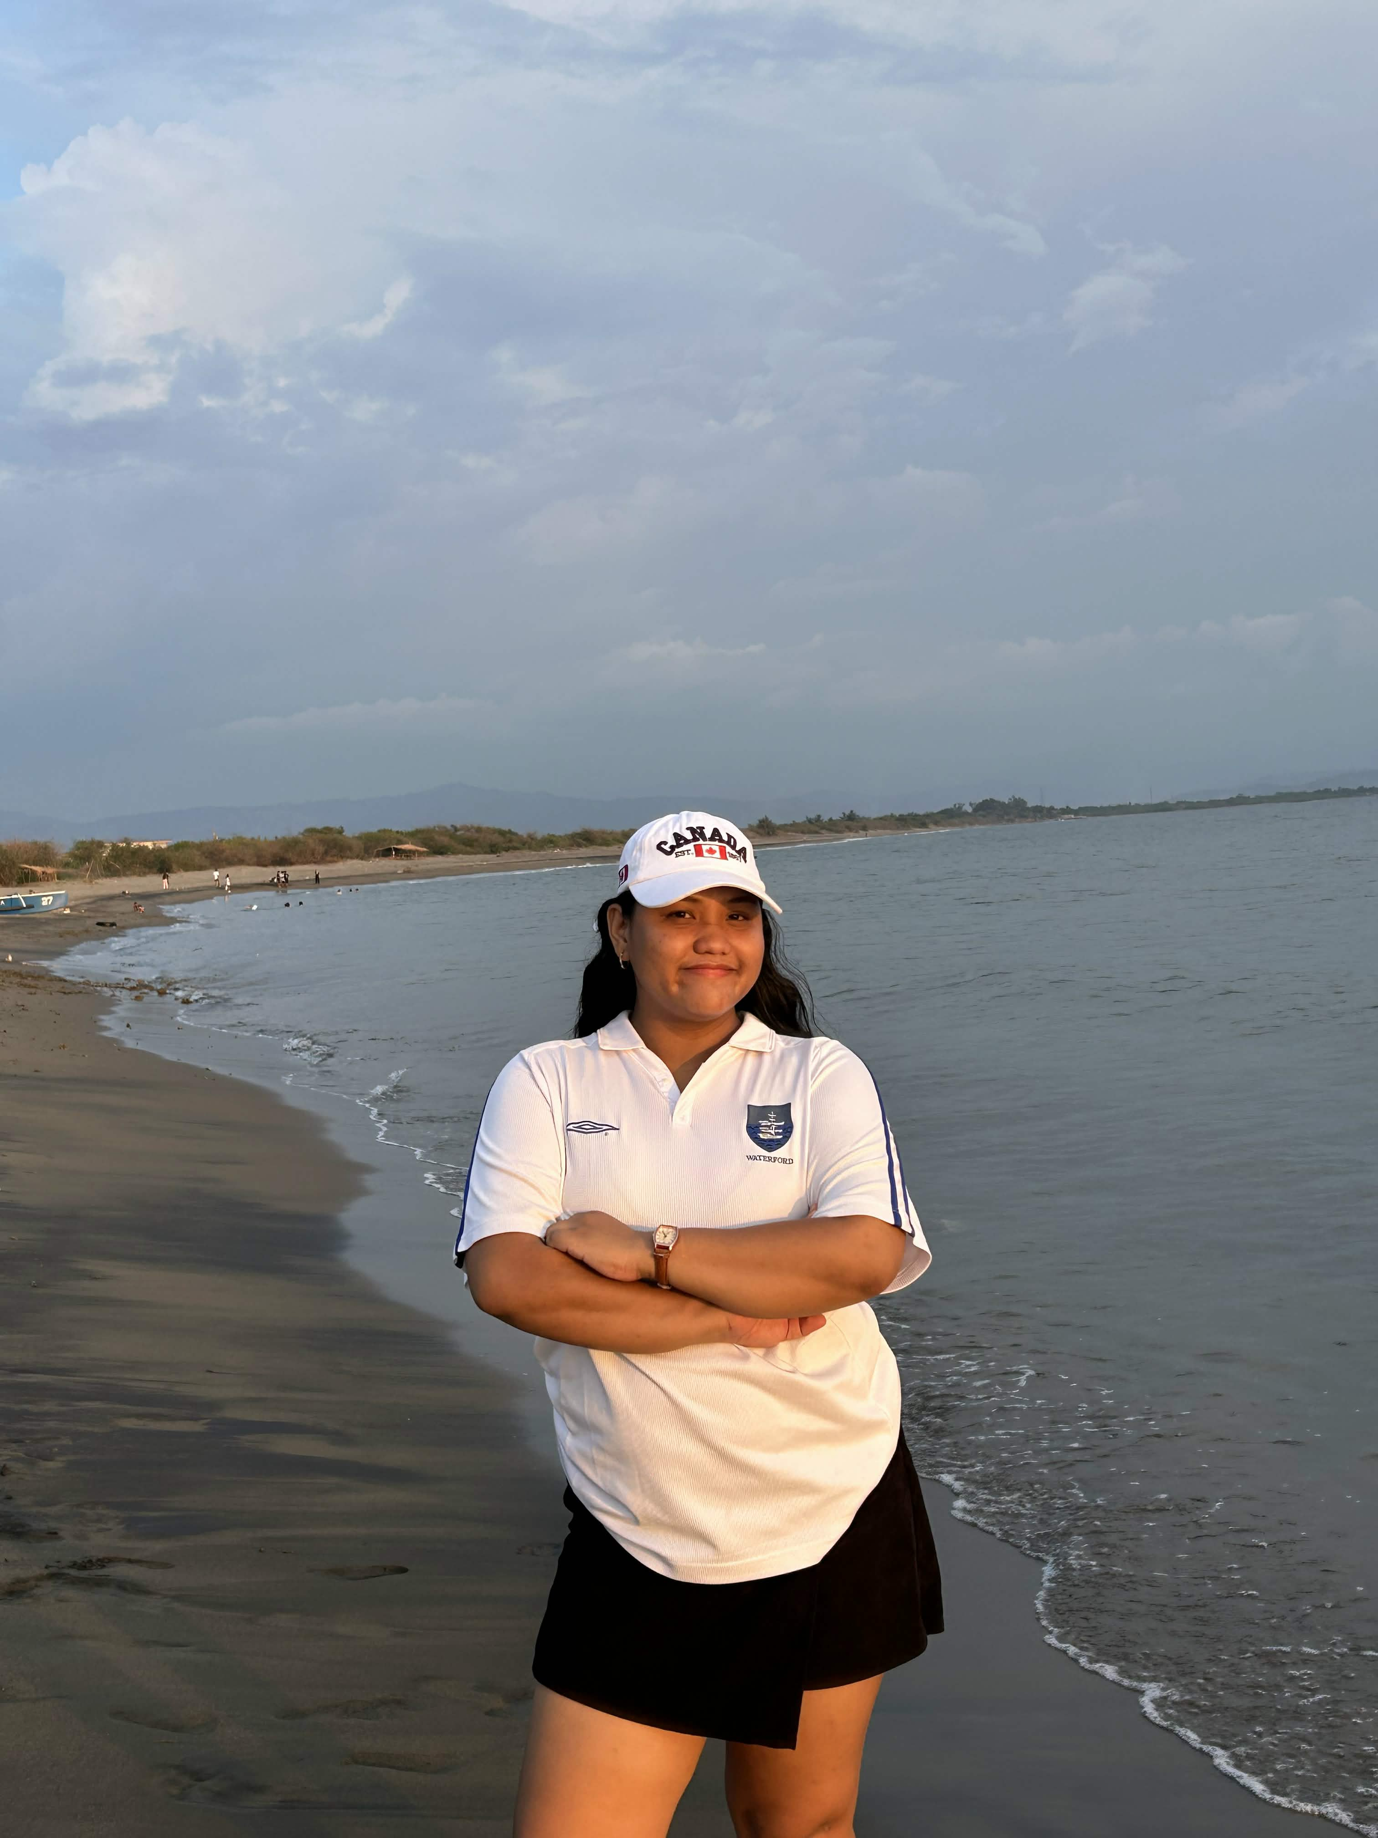
Personal Photo

7. Conclusion
The Laureta ePortfolio demonstrates how AI-assisted development can rapidly produce a polished, professional web application. By leveraging an LLM coding assistant with structured, constraint-driven prompts, the entire portfolio — from initial setup to final customization — was completed efficiently while maintaining clean code architecture and Laravel best practices.
The project showcases not only technical web development skills but also the ability to effectively collaborate with AI tools to accelerate the development workflow. The resulting portfolio serves as a comprehensive digital presence for Criszle T. Laureta, highlighting academic achievements, professional experience, certifications, and project work in an engaging, interactive format.

— End of Document —

