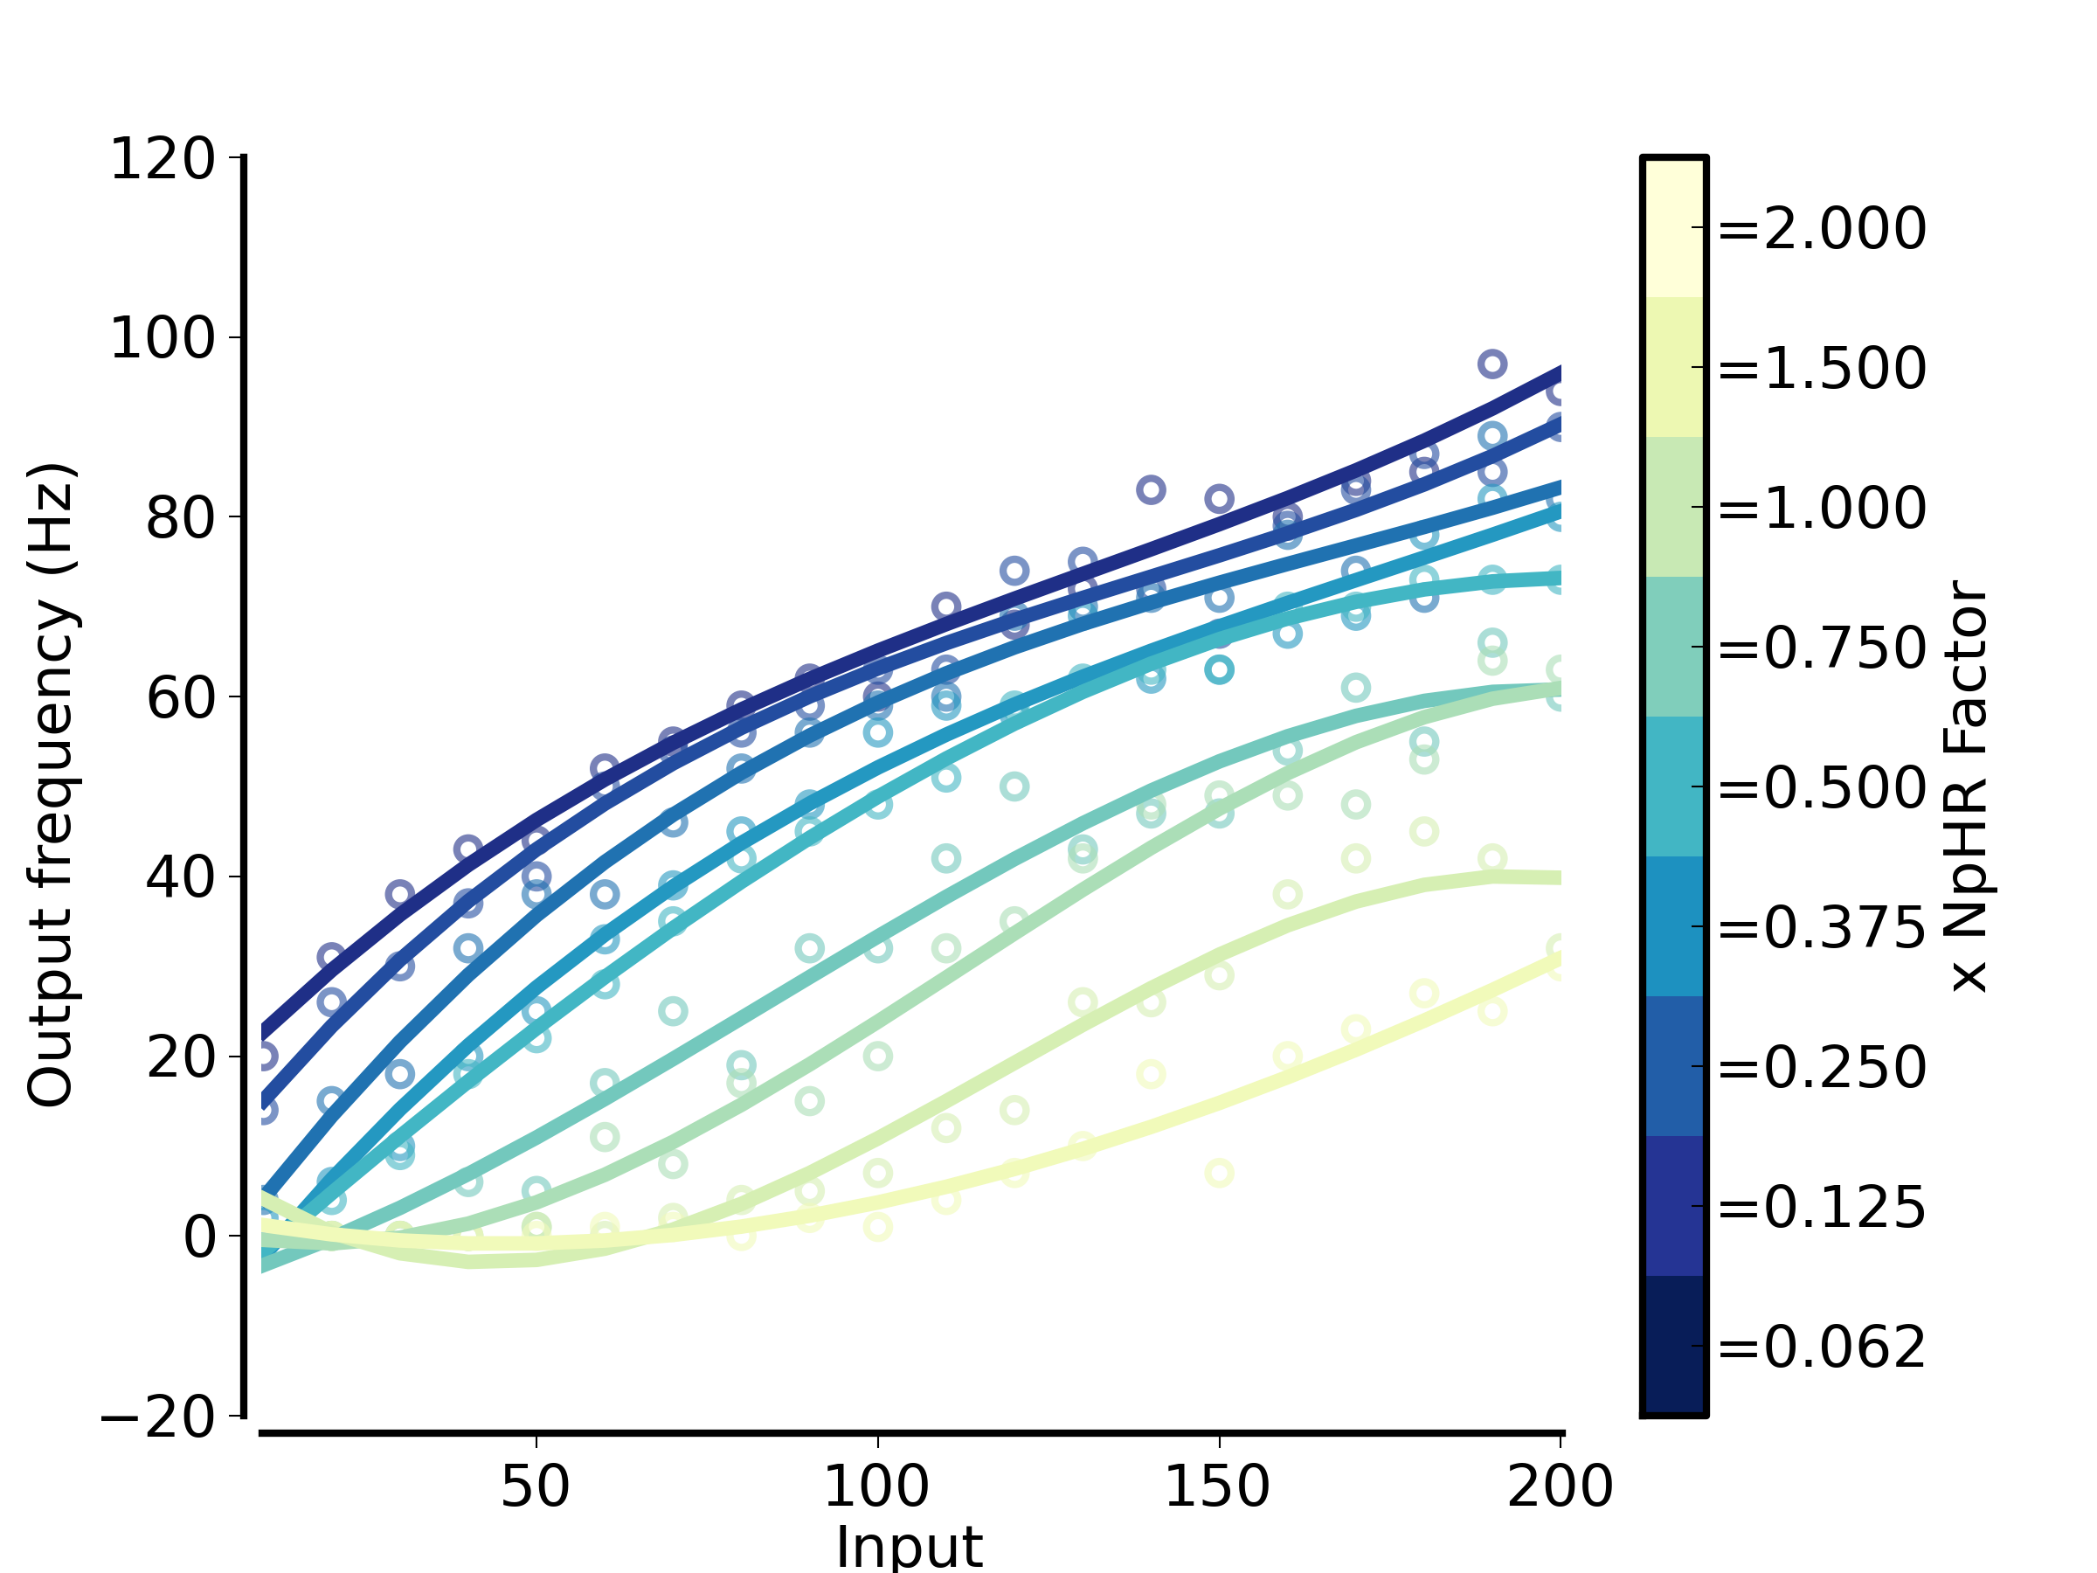
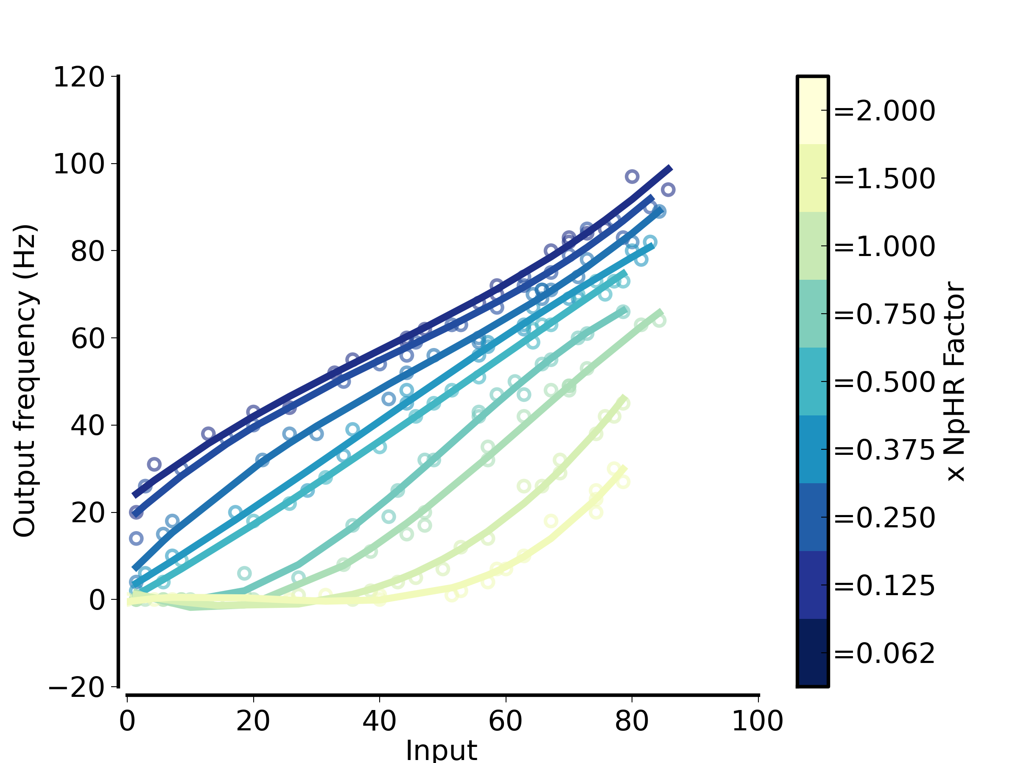
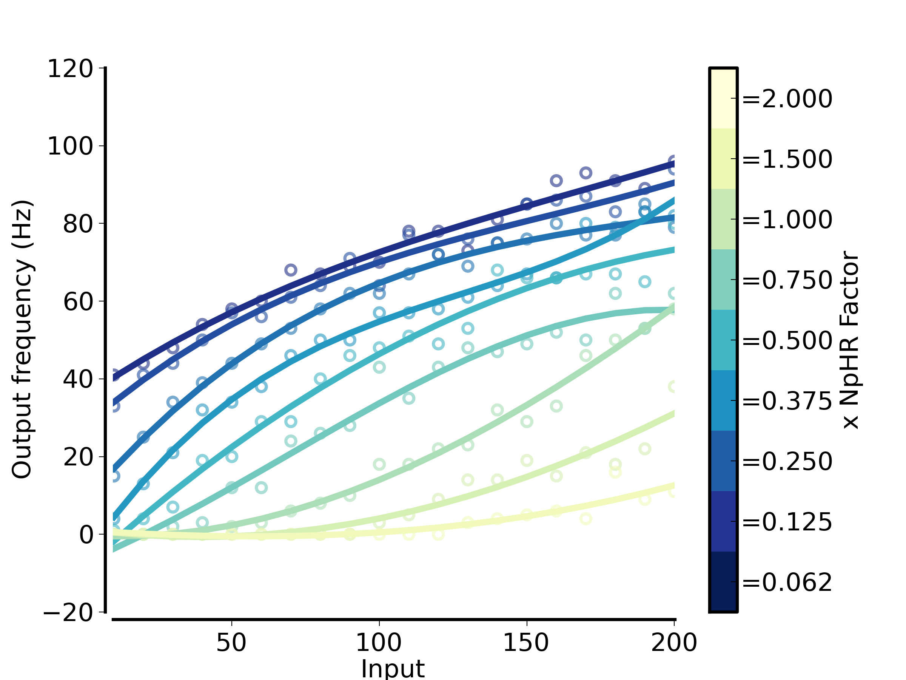
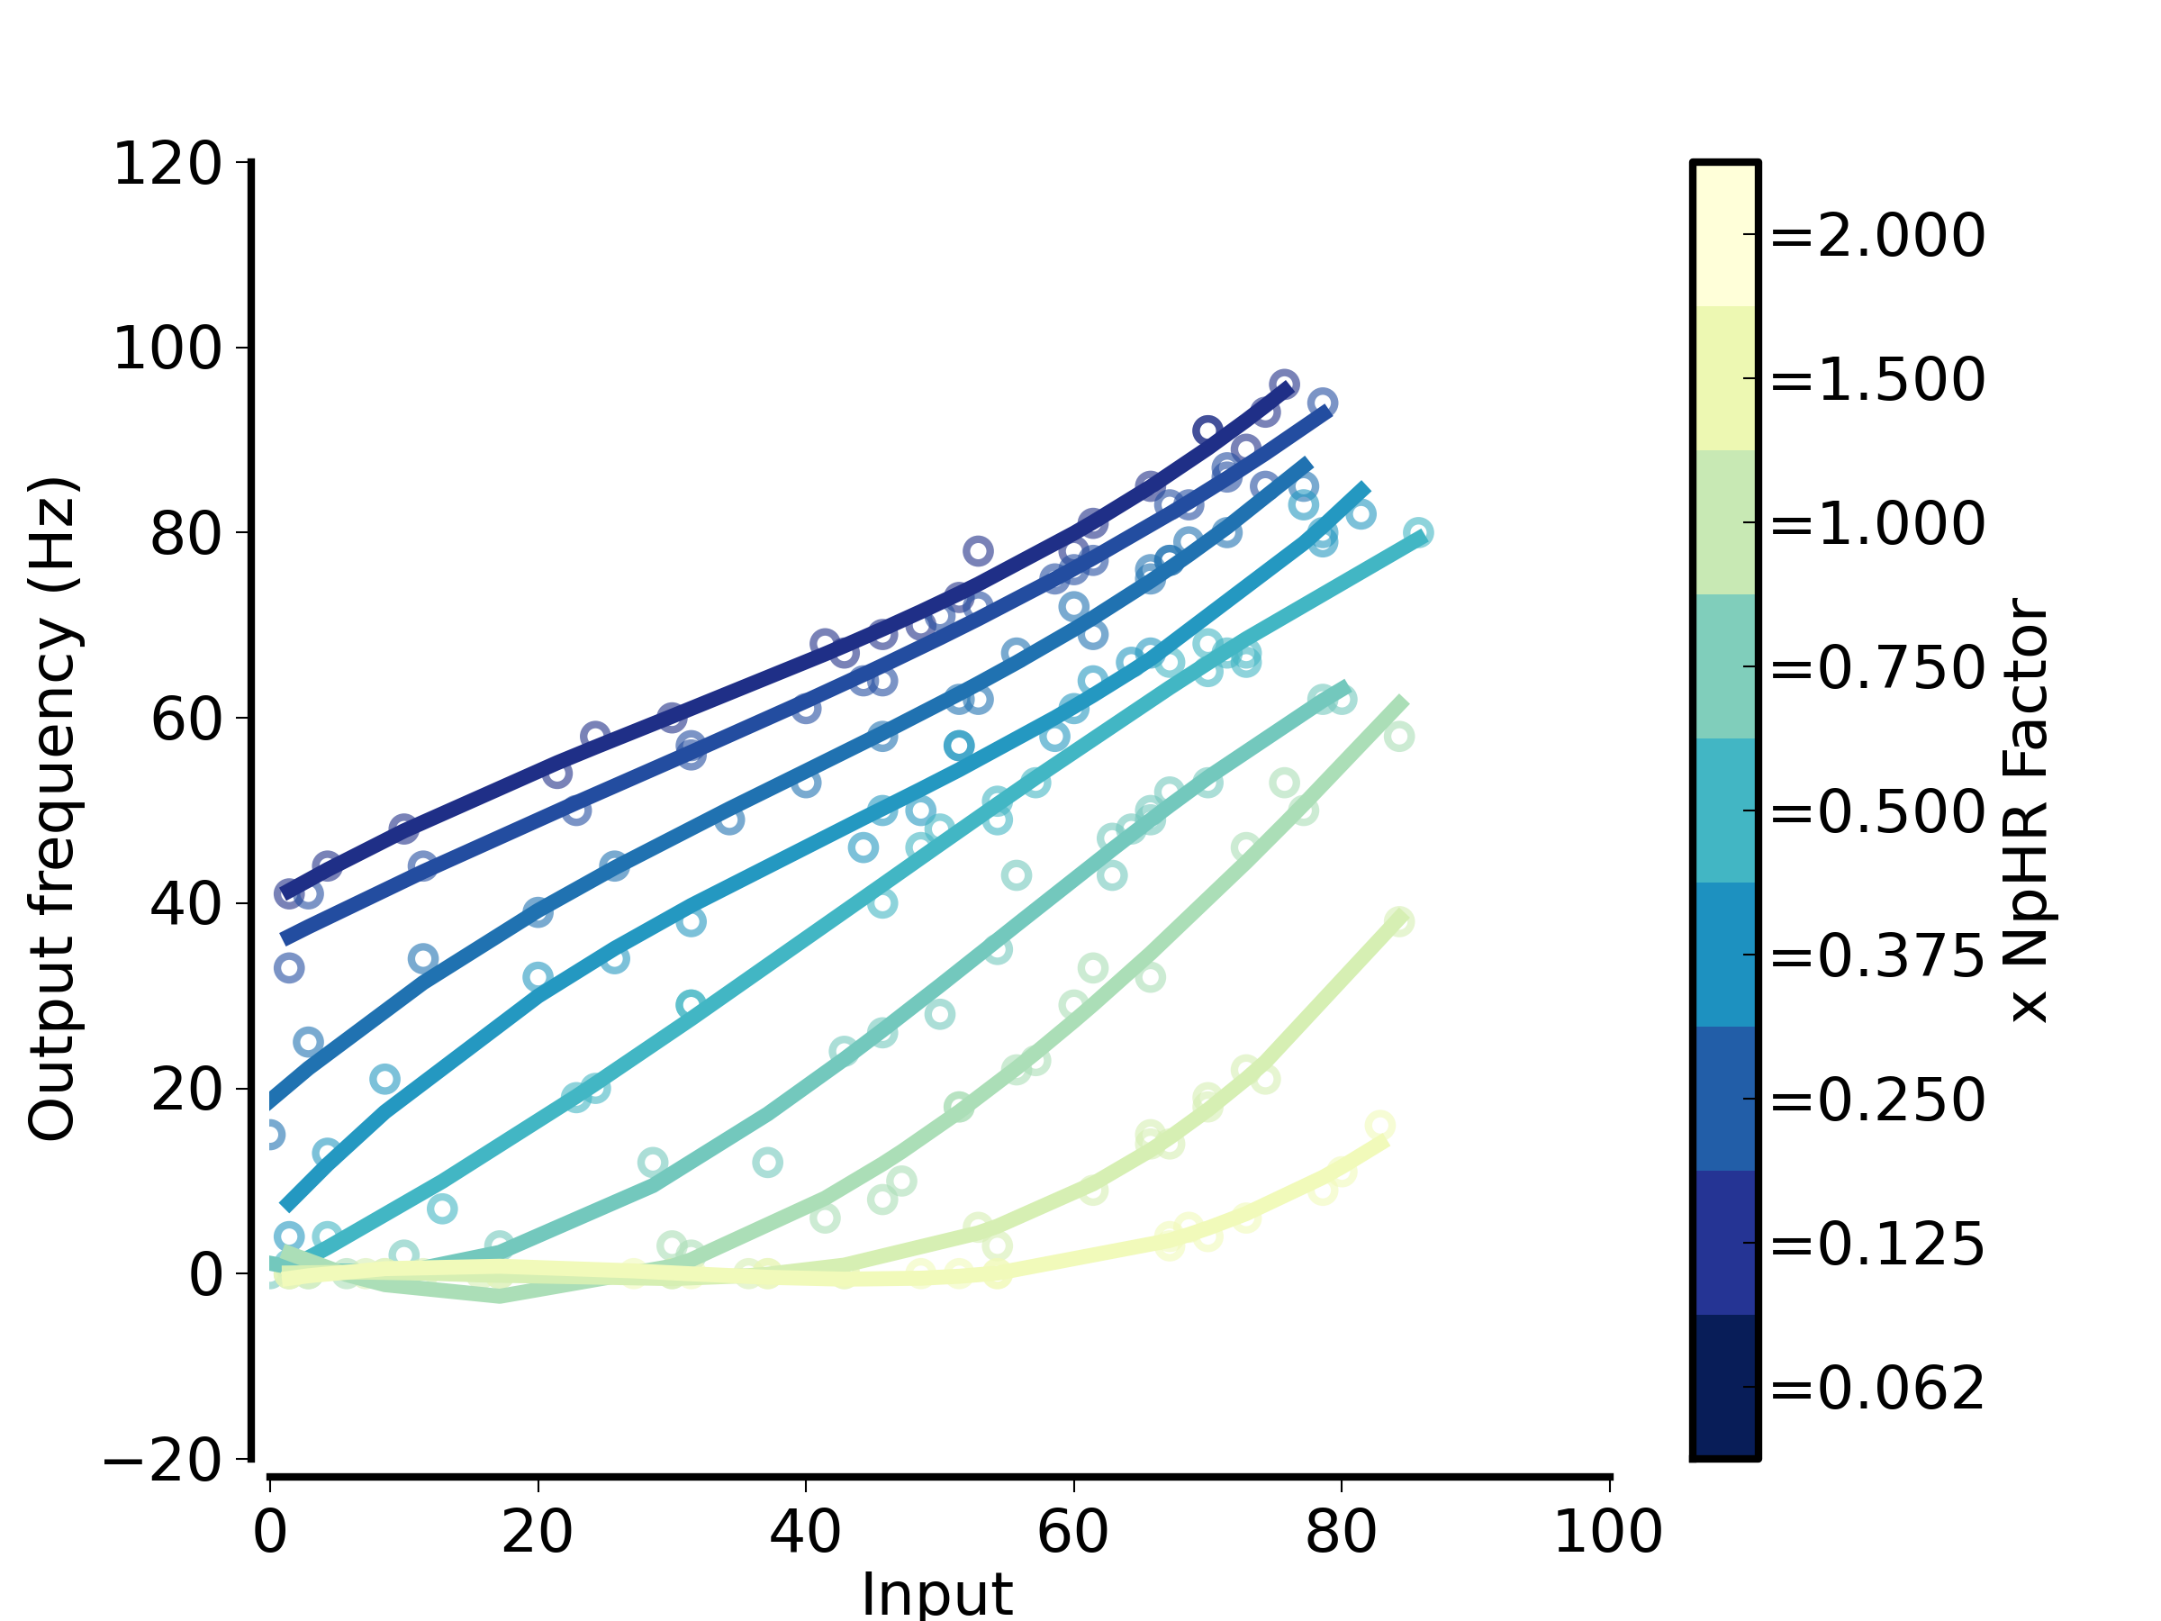
Irradiance on optogenetic activation in Stellate cells:
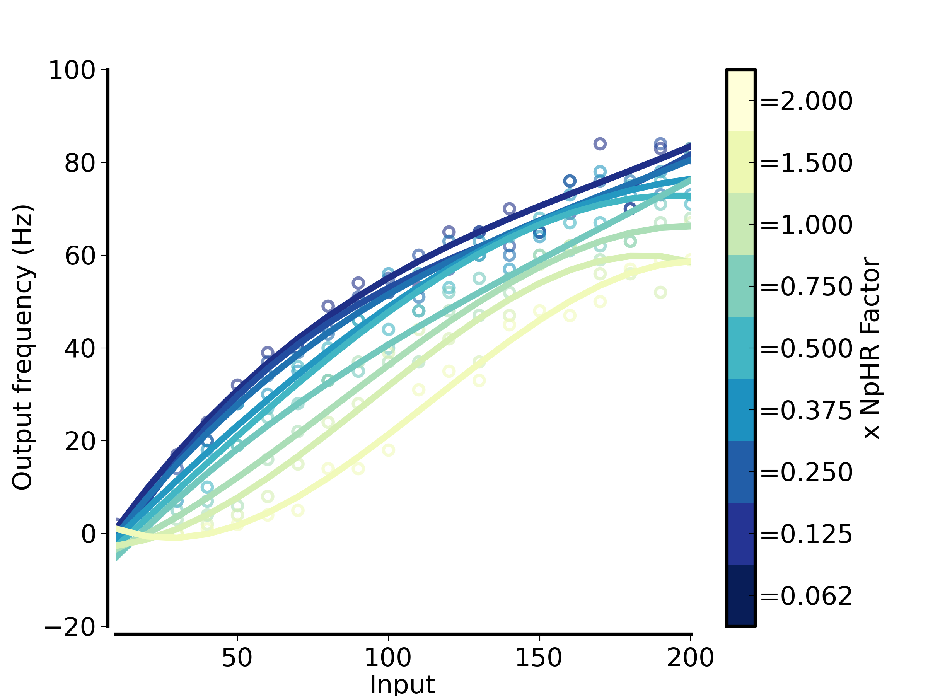
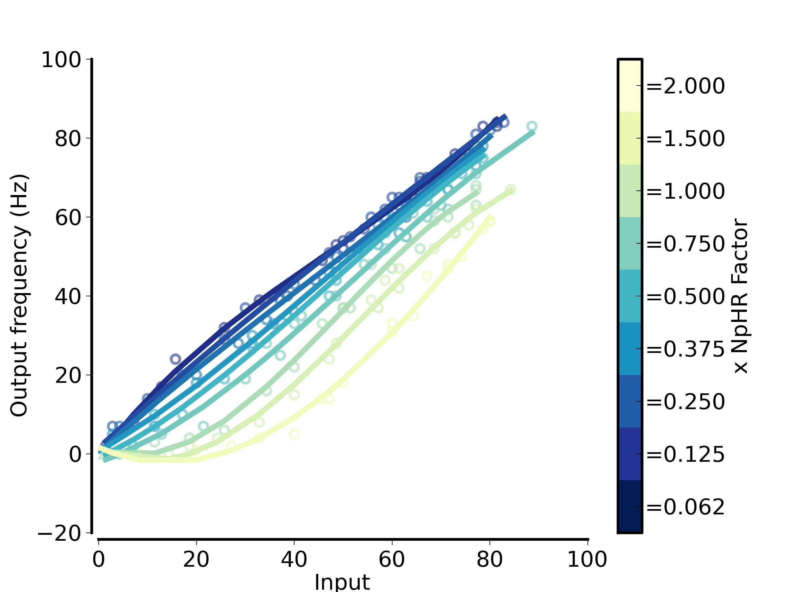
140408_scan_SHstell : different FI gain curves
Irr = 0.003
Irr = 0.007
Irr = 0.012
RH column: same irradiance as LH, but plotted as fn of background firing rate rather than injected current
Injected current
Background firing rate

