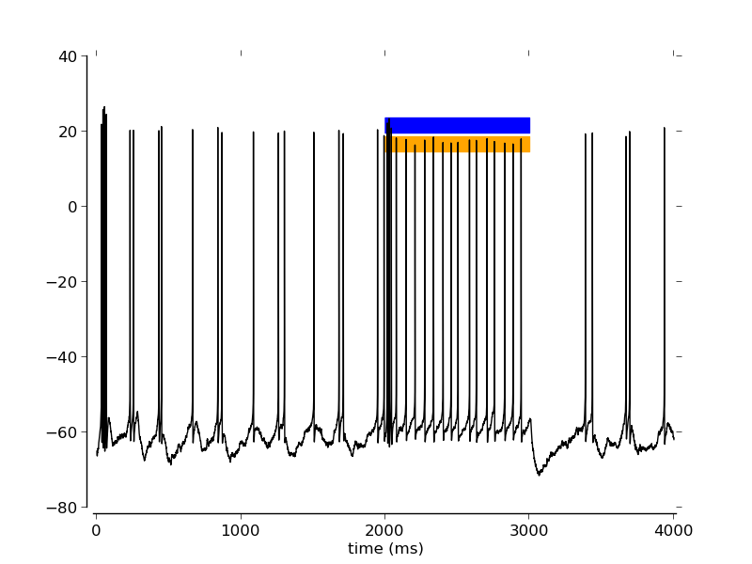
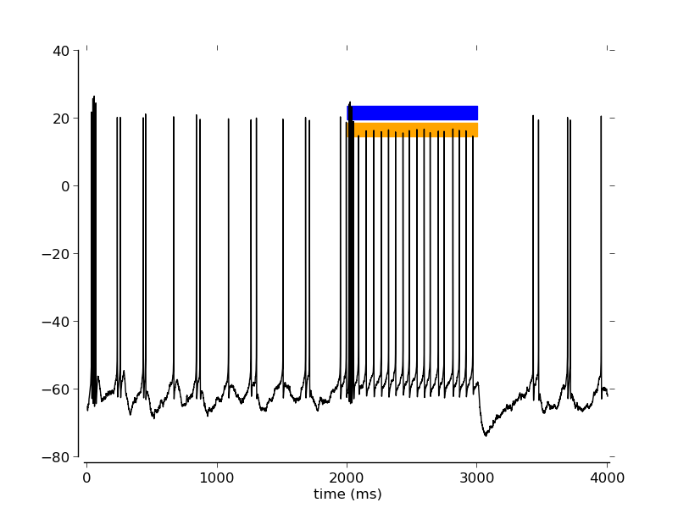
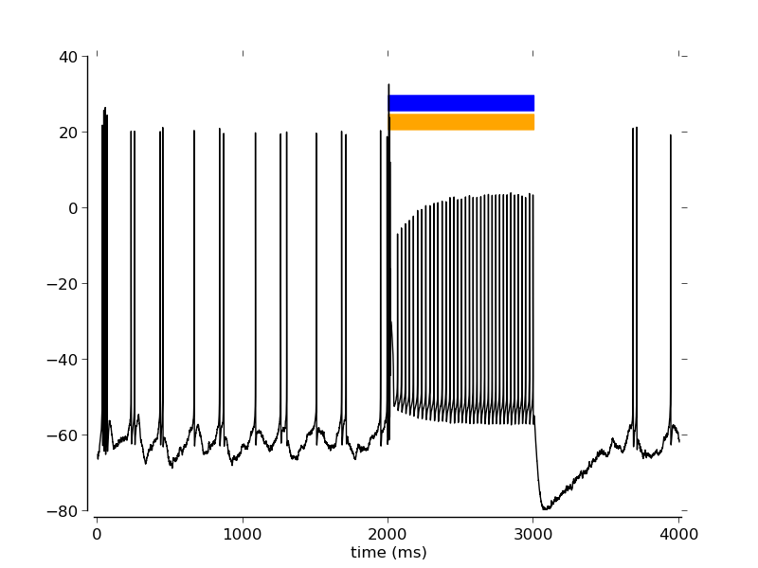
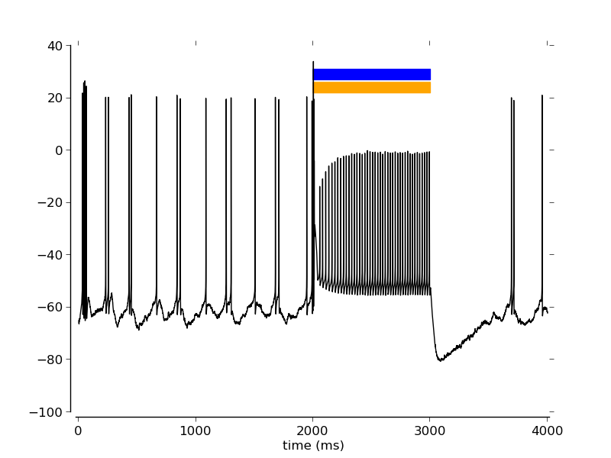
140616_replay_input_apic: for different irradiances.
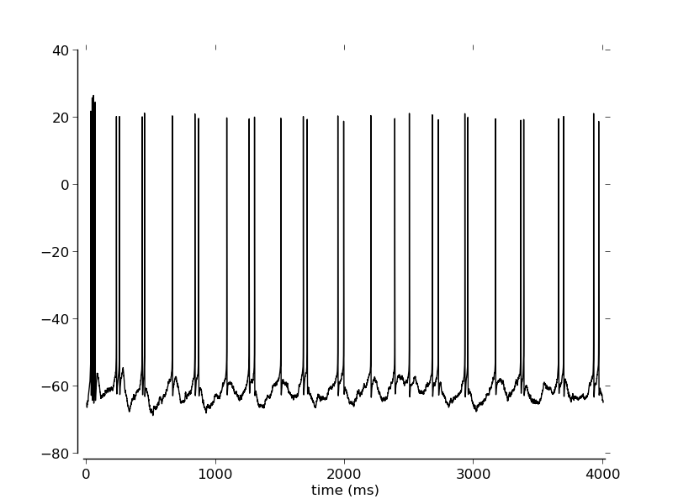
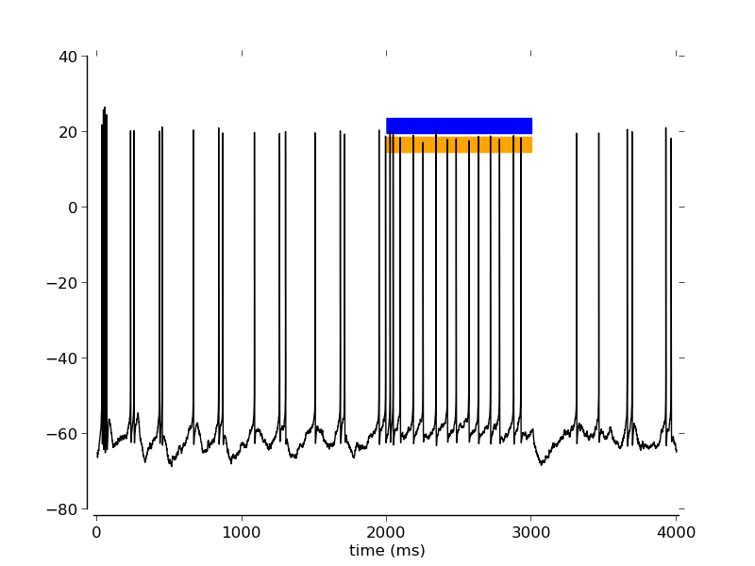
Files: 140616_ replay_input_apicirr%.3f_factor0.00_spikes80_J0.5_cellL5PC_inh-0.05_freqfactor1_shuffle5_NpHR_whole_ChR_whole

