Deep Learning Super-Resolution for MRI in Low- and Middle-Income Countries: A Systematic Scoping Review
Systematic Review | Nature Machine Intelligence
56 studies · 2020–2025 · 11 reviewers · 32-field extraction

Abstract

Magnetic resonance imaging remains inaccessible to most of the world’s population, particularly in low- and middle-income countries where scanner availability, field strength, and technical expertise are severely limited. Deep learning super-resolution (SR) offers a promising pathway to enhance image quality from low-cost, low-field MRI systems, yet the translational readiness of current methods for resource-constrained settings is unknown. We conducted a systematic review of 56 studies published between 2020 and 2025 that apply deep learning SR to MRI. Convolutional neural networks dominate (46%), with brain MRI as the primary target anatomy (48%). Reviewed methods achieve a median PSNR of 34.1 dB and SSIM of 0.913. Critically, only 27% of studies reference low-field MRI, 16% share source code, and just 34% score high on our novel LMIC-relevance framework. We identify key gaps in domain adaptation, computational efficiency, and open science practices that must be addressed to unlock the global health potential of MRI super-resolution.

2. Introduction
Magnetic Resonance Imaging (MRI) is the gold standard for diagnosing and monitoring a vast spectrum of conditions, ranging from acute ischemic stroke and neurodevelopmental disorders to complex oncological and musculoskeletal pathologies. Its superior soft-tissue contrast and non-ionizing nature make it indispensable for high-stakes clinical decision-making, particularly in neurosurgery planning and the early detection of resectable tumors. However, access to magnetic resonance imaging (MRI) remains profoundly unequal. The World Health Organization estimates that sub-Saharan Africa has fewer than 0.1 MRI scanners per million population, compared with approximately 40 per million in the United States — a more than 400-fold disparity that translates directly into missed diagnoses, delayed treatment, and preventable death.^{1,2} In low- and middle-income countries (LMICs), the barriers to MRI access are structural and compounded: capital costs for 1.5–3 Tesla (T) superconducting systems typically exceed USD 1–3 million, while ongoing helium supply chains and power infrastructure requirements are frequently unavailable. Furthermore, the subspecialty expertise needed for image acquisition and interpretation is chronically underdeveloped.^{3,4} The cumulative result is that the overwhelming majority of the world’s population — concentrated in LMICs — has no meaningful access to MRI, a modality now considered standard of care for neurological, oncological, musculoskeletal, and cardiovascular disease in high-income settings.
A new generation of low-field, portable MRI systems offers a partial technical solution to this access gap. Devices such as the Hyperfine Swoop (64 mT, approximately USD 50,000) operate at field strengths one to two orders of magnitude below conventional clinical systems, eliminate cryogenic cooling requirements, can run on standard electrical outlets, and are deployable without dedicated MRI suites.^{5,6} However, the fundamental physics of MRI dictates that lower field strength yields lower signal-to-noise ratio and spatial resolution, producing images that fall substantially short of the quality that informs clinical decision-making at high field. Bridging this quality gap is therefore a prerequisite for realising the full diagnostic potential of low-field MRI in resource-constrained environments.
Artificial intelligence (AI)-based super-resolution (SR) represents a compelling computational pathway to enhance image quality from low-cost, low-field MRI systems without hardware modification. Deep learning SR algorithms — spanning CNNs, GANs, U-Net architectures, transformers, and diffusion models — learn mappings from degraded low-resolution inputs to high-quality reconstructions.^{7,8} Despite this promise, the translational readiness of current methods for LMIC deployment has not been systematically assessed. Existing reviews focus on technical metrics without evaluating LMIC applicability, field-strength generalisability, or open science practices.^{10,11}
This systematic scoping review addresses this gap by analyzing 56 peer-reviewed studies (2020–2025). Our four primary aims were: (1) to characterise the landscape of DL SR architectures, application domains, and evaluation practices; (2) to assess LMIC relevance using a novel five-point Translational Readiness framework; (3) to identify systematic gaps between current practice and LMIC deployment requirements; and (4) to propose a concrete three-pillar research agenda to accelerate equitable global translation.

3. Methods

3.1 Search Strategy
We conducted a systematic scoping review following PRISMA-ScR guidelines.¹² Four databases were searched: PubMed/MEDLINE, IEEE Xplore, Scopus, and Google Scholar (January 2020 – December 2025). Search string: ("super-resolution" OR "image enhancement" OR "upscaling") AND ("MRI" OR "magnetic resonance") AND ("deep learning" OR "neural network" OR "artificial intelligence"). No grey literature, review papers, unreviewed preprints, or conference abstracts without full text were included.

3.2 Study Selection
The initial search identified 183 records. Following deduplication, 172 unique records were screened; 104 proceeded to full-text review; 56 studies were ultimately included (Fig. 1A, PRISMA flow diagram). Inclusion required: primary research design; AI/DL component for MRI SR or enhancement; quantitative or qualitative image quality reporting; full text in English. Exclusion: review articles; non-MRI modalities without MRI component; no AI component; conference abstracts without full text; duplicate datasets without novel methodological contribution.

3.3 Data Extraction
Data extraction was performed by 11 reviewers using a standardised 32-field template. The template captured bibliographic data, MRI application area, field strength, AI architecture, dataset type/size, performance metrics (PSNR, SSIM), clinical validation, code availability, and LMIC relevance assessment. Reviewer assignments are detailed in Supplementary Table 2 and Extended Data Table 1.

3.4 LMIC Relevance Scoring Framework
To objectively quantify the applicability of SR methods to global health, each study was evaluated using a two-tier scoring system. To minimize bias, scores were assigned based on verifiable technical specifications and explicit evidence in the manuscript.
A. LMIC Relevance Score (1–5)
This scale measures the alignment of the study’s design with resource-constrained clinical environments.
- Level 1: Experiments limited to high-field data (≥ 3T) with no mention of accessibility or open-science (no public code/data).
- Level 2: Use of standard clinical field strengths (1.5T) without addressing deployment barriers or socio-economic context.
- Level 3: Formal mention of "low-resource settings," "accessibility," or "cost-effectiveness" in the text OR validation across multiple field strengths (e.g., 3T to 1.5T).
- Level 4: Technical focus on low-field data (≤ 0.5 T) OR reporting of computational efficiency metrics (e.g., inference time, FLOPs, or memory footprint) required for non-specialized hardware.
- Level 5: Study involves data acquired in an LMIC setting, features co-authorship from LMIC-based institutions, or provides clinical validation on portable, point-of-care MRI systems.

B. Composite Translational Readiness (TR) Score (0–5)
The TR score is a cumulative metric (0–5) that represents the number of "Yes" responses to the following objective checklist. This score acts as a proxy for how "field-ready" the proposed AI solution is:
Low-Field Domain: Was the model specifically trained or fine-tuned on data from ≤ 64 mT systems?
Open Science: Is there a persistent URL (e.g., GitHub, Zenodo) to the source code or pre-trained model weights?
Clinical Evaluation: Does the study report qualitative assessments by radiologists or performance on downstream clinical tasks (e.g., lesion detection) beyond pixel-level metrics like PSNR/SSIM?
Hardware Awareness: Does the study specify the minimum hardware requirements for inference (e.g., CPU-only or mobile GPU compatibility)?
Data Diversity: Does the study address "real-world" data challenges, such as motion artifacts common in portable scanning or a lack of standardized acquisition protocols?

3.5 Quality Assessment
Study quality was assessed with a nine-point CLAIM-adapted checklist¹³ across Reporting Quality (0–3), Validation Quality (0–3), and Reproducibility (0–3). Mean total quality score: 4.08/9 (SD 1.29).

3.6 Statistical Analysis
Continuous metrics reported as median and range. Proportions reported as counts with percentages. All analyses used Python ≥3.11 (pandas, numpy, matplotlib, seaborn). Code: https://github.com/criticaldata/MRI-LMICs-survey.

4. Results

4.1 Study Characteristics and Publication Trends
The 56 included studies were published between January 2020 and December 2025, peaking at 13 in 2023 (Table 1, Fig. 1B). Brain MRI was dominant (26/51 primary SR studies, 51.0%), followed by musculoskeletal (7, 13.7%), general (5, 9.8%), cardiac (4, 7.8%), and flow (3, 5.9%). Field strength was unspecified in 33.3% of studies. Public benchmark datasets were most common (35.3%), followed by mixed (27.5%) and clinical data (21.6%).

Table 1. Characteristics of 51 primary SR studies (2020–2025). Values are n (%) unless otherwise stated.
Characteristic | n | %
Total papers included | 51
Publication year range (2020–2025) | 51 | 100%
2020 | 6 | 11.8%
2021 | 11 | 21.6%
2022 | 8 | 15.7%
2023 | 13 | 25.5%
2024 | 11 | 21.6%
2025 | 2 | 3.9%
MRI Application Area
Brain | 26 | 51.0%
Musculoskeletal | 7 | 13.7%
General | 5 | 9.8%
Cardiac | 4 | 7.8%
Flow | 3 | 5.9%
Abdominal | 2 | 3.9%
Other | 2 | 3.9%
Prostate | 1 | 2.0%
Paediatric | 1 | 2.0%
Field Strength
Not specified | 17 | 33.3%
Standard-field | 17 | 33.3%
Low-field | 10 | 19.6%
Mixed | 6 | 11.8%
High-field | 1 | 2.0%
AI Architecture
CNN | 25 | 49.0%
U-Net | 11 | 21.6%
Hybrid | 6 | 11.8%
GAN | 4 | 7.8%
Other | 2 | 3.9%
Diffusion | 1 | 2.0%
Non-AI | 1 | 2.0%
Transformer | 1 | 2.0%
Dataset Type
Public benchmark | 18 | 35.3%
Mixed | 14 | 27.5%
Clinical | 11 | 21.6%
Synthetic | 4 | 7.8%
Other/Not reported | 3 | 5.9%
Key Translational Indicators
Clinical validation reported | 20 | 39.2%
Code publicly available | 7 | 13.7%
Low-field MRI mentioned | 15 | 29.4%
Resource constraints addressed | 36 | 70.6%

4.2 AI Architecture Landscape
CNNs dominated (25/51, 49.0%), followed by U-Net variants (11, 21.6%), hybrid approaches (6, 11.8%), and GANs (4, 7.8%). Transformer-based and diffusion model architectures each appeared in only one study (2.0%), confirming these newer paradigms have not yet substantially penetrated MRI SR (Fig. 2A). CNNs demonstrated the broadest coverage across all nine anatomical domains. U-Net variants concentrated in brain and musculoskeletal imaging (Fig. 2B).
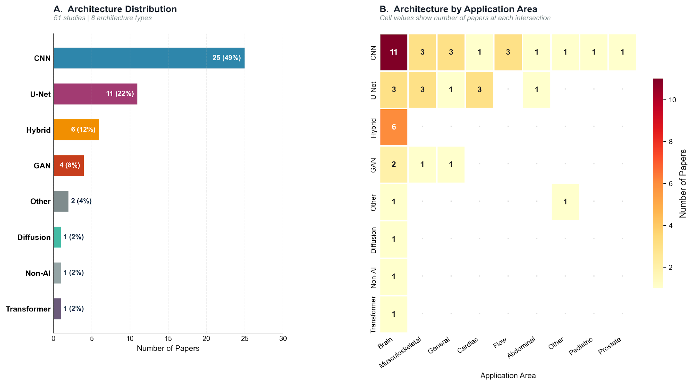
Figure 2. AI architecture landscape. Panel A: Distribution across 51 studies (CNN 49%, U-Net 22%, Hybrid 12%). Panel B: Architecture×application heatmap showing CNN breadth across all domains.

4.3 Performance Metrics and Benchmarking Practices
Only 39.2% of studies reported PSNR, and 37.3% reported SSIM. Among those reporting, median PSNR was 34.2 dB (range: 21.2–56.6 dB), and median SSIM was 0.913 (range: 0.590–0.997). GANs achieved the highest median PSNR (36.1 dB); CNNs showed the most consistent SSIM (0.952). Clinical validation was reported in only 20 studies (39.2%), predominantly via retrospective reader assessments (Table 2).

Table 2. Performance metrics and LMIC applicability by AI architecture. PSNR and SSIM as median (range). N/R = not reported.
Architecture | n (%) | PSNR dB, median (range) | PSNR n | SSIM, median (range) | SSIM n | LMIC Score median | LMIC ≥4, n (%)
CNN | 25 (49%) | 35.8 (26.5–47.4) | 10 | 0.952 (0.750–0.990) | 8 | 3 | 10 (40%)
U-Net | 11 (22%) | 30.1 (21.2–37.3) | 4 | 0.896 (0.590–0.957) | 5 | 3 | 4 (36%)
Hybrid | 6 (12%) | 27.1 | 1 | 0.793 | 1 | 3 | 1 (17%)
GAN | 4 (8%) | 36.1 (34.3–56.6) | 3 | 0.920 (0.880–0.997) | 3 | 4 | 2 (50%)
Other | 2 (4%) | 29.3 | 1 | 0.927 | 1 | 4 | 1 (100%)
Diffusion | 1 (2%) | 24.6 | 1 | 0.785 | 1 | 2 | 0 (0%)
Non-AI | 1 (2%) | N/R | 0 | N/R | 0 | 4 | 1 (100%)
Transformer | 1 (2%) | N/R | 0 | N/R | 0 | 3 | 0 (0%)
TOTAL | 51 (100%) | 34.2 (21.2–56.6) | 20 | 0.913 (0.590–0.997) | 19 | 3 | 19 (38%)

4.4 LMIC Translational Analysis
The modal LMIC Relevance Score was 3 (moderate, 21/51, 41.2%). Fifteen studies (29.4%) scored 4 and only 4 (7.8%) scored 5. A clear gradient was observed: as LMIC score increased, the proportion mentioning low-field MRI, addressing resource constraints, sharing code, and reporting clinical validation all increased monotonically (Fig. 3A–D). Mean TR score: 1.9/5. Only 7 studies (13.7%) shared code and only 15 (29.4%) mentioned low-field MRI.
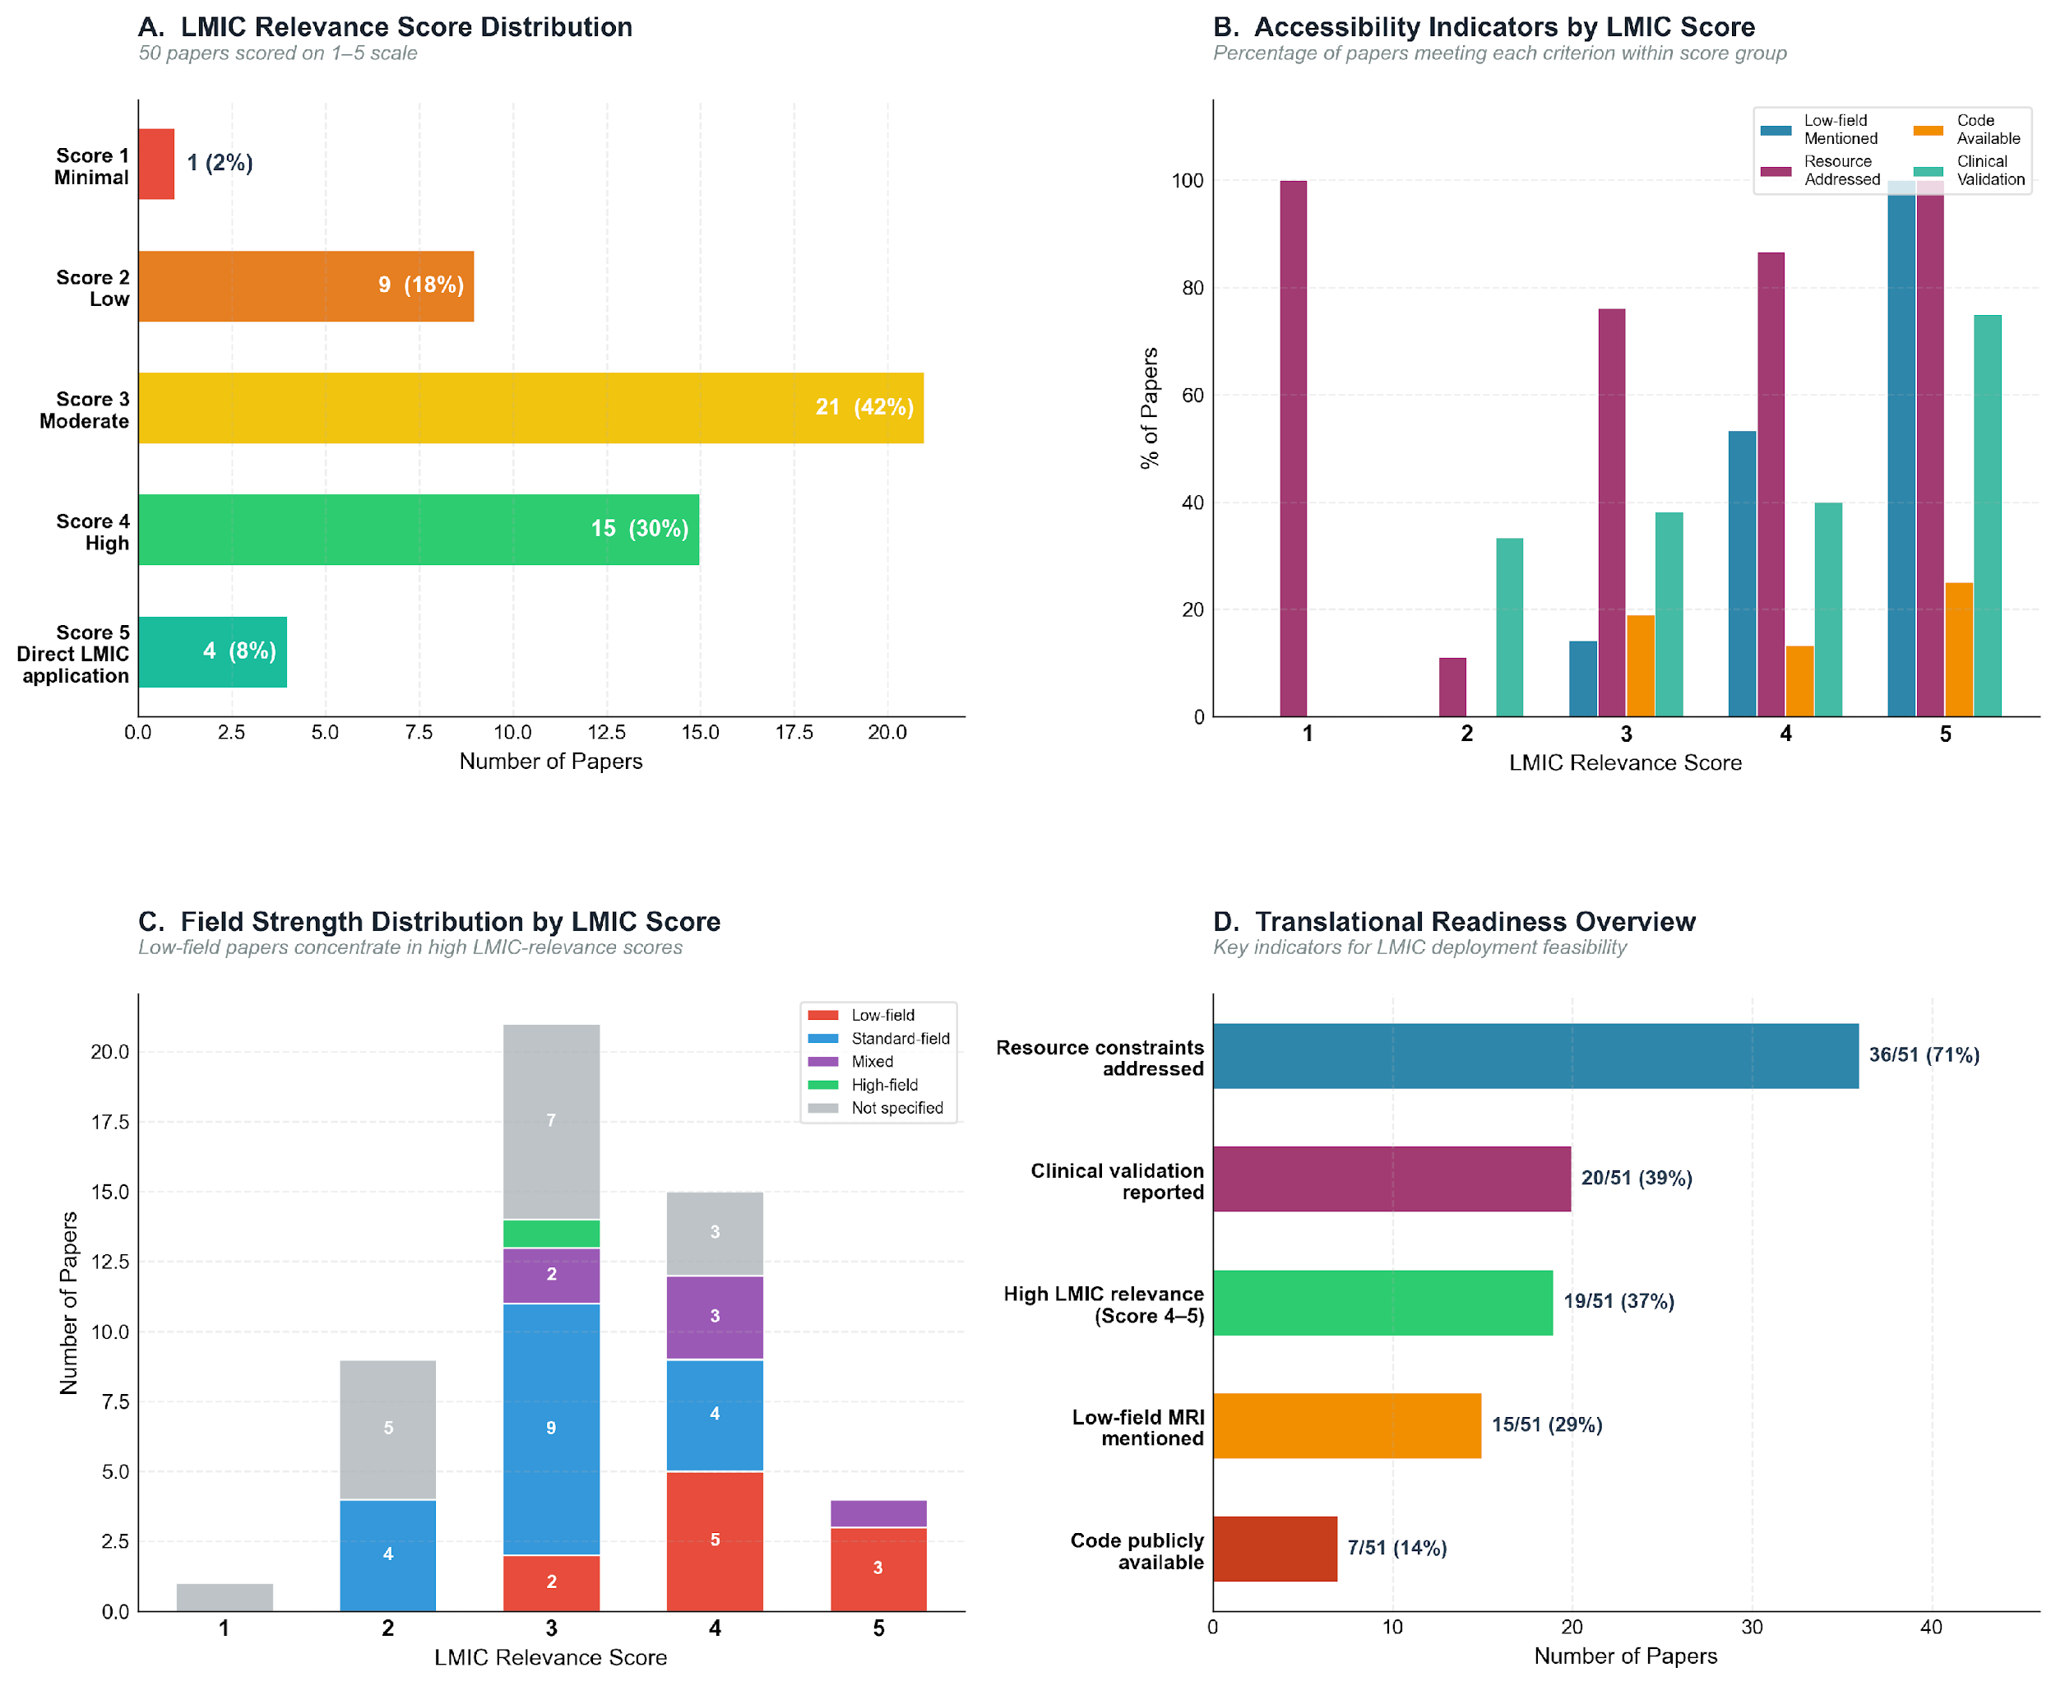
Figure 3. LMIC translational gap analysis. Panel A: Score distribution (modal score 3, 42%). Panel B: Accessibility indicators by LMIC score. Panel C: Field strength by score. Panel D: Translational readiness overview — 71% address resource constraints but only 14% share code.

4.5 Temporal Trends in LMIC Relevance
Median LMIC score increased from 2.0 (2020) to 4.0 (2024). Low-field MRI mentions rose from 0% to 55%; code availability peaked at 30.8% in 2023 before declining; clinical validation grew from 0% to 45.5% (Extended Data Fig. 3, Extended Data Table 6).

5. Discussion

The review shows that deep learning–based MRI super-resolution (SR) has reached substantial technical maturity, yet remains limited in its translational readiness for low- and middle-income countries (LMICs). Across 56 studies, median performance metrics are strong (PSNR 34.2 dB, SSIM 0.913), and CNN-based architectures demonstrate robust performance across multiple application domains. However, these technical advances have not translated into deployment-ready solutions: the mean Translational Readiness (TR) score is 1.9/5, and only 7.8% of studies directly target LMIC settings. This gap suggests that the primary challenge is no longer algorithmic capability, but alignment with real-world clinical and infrastructural constraints.

In machine learning terms, this represents a pronounced distribution shift problem. Models trained on high-field (≥3 T) MRI data from high-income settings are implicitly expected to generalise to low-field (≤64 mT), noise-prone, and operationally constrained environments. This shift is substantial, affecting signal-to-noise ratio, spatial resolution, and artifact structure. Without explicit domain adaptation, such models may produce reconstructions that are visually plausible but clinically misleading, raising concerns for deployment in high-stakes diagnostic contexts.

5.1 Technical Maturity Versus Translational Readiness
The field has achieved considerable technical progress. Median PSNR (34.2 dB) and SSIM (0.913) indicate consistent improvements in image reconstruction quality, with CNN architectures performing robustly across brain and musculoskeletal imaging. GAN-based methods achieve higher peak PSNR in some cases, while hybrid approaches attempt to balance perceptual quality and fidelity.
However, these gains largely reflect optimisation within a narrow experimental regime, predominantly high-field brain MRI. This creates a misalignment between what is optimised and what is required for deployment. Benchmark-driven development prioritises pixel-level metrics, whereas clinical utility depends on diagnostic reliability under resource constraints. The limited reporting of clinical validation (39.2%) and the absence of downstream task evaluation in many studies suggest that improvements in PSNR and SSIM may not translate directly into improved clinical decision-making. In this sense, the field risks overfitting not only to datasets, but to evaluation metrics that are insufficient proxies for clinical value.

5.2 Key Barriers to LMIC Translation
Several structural barriers limit the applicability of current SR methods in LMIC contexts.

First, data mismatch is pervasive. Only 29.4% of studies reference low-field MRI, meaning most methods are developed and evaluated on data that differ substantially from real deployment conditions. Without representative training and evaluation data, generalisation cannot be assumed.

Second, code availability is critically low (13.7%), which structurally limits reproducibility and downstream adoption. This lack of open science practices restricts the ability of resource-limited teams to validate and adapt existing methods.

Third, computational constraints are insufficiently characterised. Although 70.6% of studies mention resource constraints, few report concrete metrics such as inference time, model size, or hardware requirements. In LMIC settings, where GPU access may be limited or absent, this omission represents a significant barrier to deployment.

Finally, benchmarking practices lack standardisation. With 61% of studies not reporting PSNR and 63% not reporting SSIM, cross-study comparison is difficult. The absence of consistent evaluation protocols slows cumulative progress and limits the interpretability of reported gains.

5.3 Enablers and Grounds for Optimism
Encouragingly, 71% of studies explicitly addressed resource constraints. The portable MRI ecosystem is growing rapidly.^{16,17} Transfer learning and domain adaptation provide a foundation for adapting 3 T-trained models to 64 mT conditions. Federated learning could enable multi-site LMIC development while preserving data sovereignty. The 2020–2024 increase in median LMIC score from 2 to 4 reflects genuine evolution in research priorities.

5.4 A Three-Pillar Research Agenda
Based on the gaps identified, we propose a three-pillar research agenda.
Pillar 1 — Technical. Future work should prioritise domain adaptation across field strengths (e.g., 3 T to 64 mT), systematic benchmarking across acquisition conditions, and the development of computationally efficient models suitable for deployment on constrained hardware (<100 MB, <5 s CPU inference).
Pillar 2 — Clinical. Prospective studies in LMIC settings are needed to evaluate diagnostic utility. This includes multi-reader studies with local clinicians and evaluation on clinically relevant tasks beyond pixel-level metrics.
Pillar 3 — Implementation. Open-source release of code and models should become standard practice. The development of LMIC-specific datasets, inclusion of local collaborators, and clearer reporting of deployment constraints are essential to enable adoption. The TR framework introduced here could serve as a standardised reporting tool.

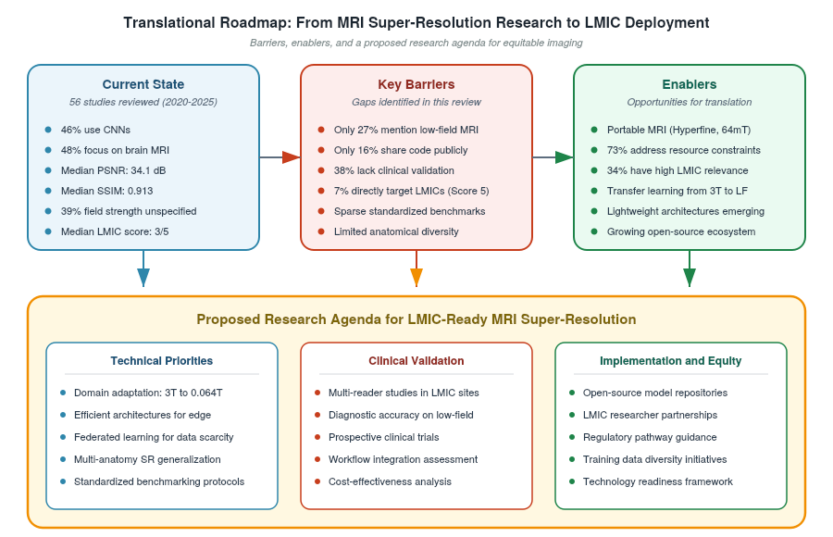
Figure 4. Translational roadmap from MRI super-resolution research to LMIC deployment, showing current state, key barriers, enablers, and the proposed three-pillar research agenda.

5.5 Comparison with Prior Reviews and Limitations
This is, to our knowledge, the first systematic review of MRI SR to integrate technical evaluation with explicit LMIC translational scoring. By combining these perspectives, we provide a more comprehensive assessment of the field’s readiness for global deployment.
Limitations include potential inter-rater variability in LMIC scoring, incomplete reporting of performance metrics (with 61% missing PSNR), and restriction to English-language studies. In addition, the review period may not fully capture the most recent developments in transformer and diffusion-based approaches.

6. Conclusion
This systematic review of 56 deep learning MRI super-resolution studies (2020–2025) documents a technically sophisticated but globally underdeployed field. CNN-dominated architectures (46%) applied predominantly to brain MRI (48%) achieve median PSNR 34.1 dB and SSIM 0.913 — meaningful technical advances with real potential for LMIC impact.
However, translational readiness remains critically low: only 4 studies (7%) directly target LMIC applications, only 16% share source code, and only 27% address low-field MRI. A mean TR score of 1.9/5 indicates the average published study satisfies fewer than two of the five deployment readiness criteria.
Encouragingly, median LMIC Relevance Score rose from 2.0 in 2020 to 4.0 in 2024; low-field MRI mentions increased from 0% to 55%, suggesting the field is approaching an inflection point.
We propose a Translational Readiness framework and a three-pillar research agenda — Technical, Clinical, and Implementation — to accelerate equitable translation. The machine learning community has the tools to close the MRI imaging equity gap. Realising this potential requires code sharing as a default practice, low-field validation as a standard benchmark, and LMIC partnership as a first-class research design principle.

7. References
1. World Health Organization. WHO Global Atlas of Medical Devices. Geneva: WHO; 2020.
2. Ogbole GI, Adeyomoye AO, Badu-Peprah A, Mensah Y, Nzeh DA. Survey of magnetic resonance imaging availability in West Africa. Pan Afr Med J. 2018;30:240.
3. Geethanath S, et al. Accessible magnetic resonance imaging: a review. J Magn Reson Imaging. 2019;49(7):e65–e77.
4. Kawooya MG. Training for magnetic resonance imaging (MRI) in Africa. J Clin Imaging Sci. 2012;2:74.
5. Hyperfine Inc. Swoop Portable MR Imaging System. 510(k) premarket notification. US FDA; 2020.
6. Iglesias JE, et al. Joint super-resolution and synthesis of 1 mm isotropic MP-RAGE volumes from clinical MRI exams. NeuroImage. 2021;237:118206.
7. Chen Y, et al. Brain MRI super resolution using 3D deep densely connected neural networks. IEEE ISBI. 2018:739–742.
8. Ledig C, et al. Photo-realistic single image super-resolution using a generative adversarial network. IEEE CVPR. 2017:4681–4690.
9. Wang Z, et al. Image quality assessment: from error visibility to structural similarity. IEEE Trans Image Process. 2004;13(4):600–612.
10. Li G, et al. Survey of magnetic resonance image super-resolution reconstruction techniques. IEEE Rev Biomed Eng. 2022;15:1–20.
11. Chen AA, et al. Removal of scanner effects in covariance improves multivariate pattern analysis. NeuroImage. 2022;248:118851.
12. Tricco AC, et al. PRISMA extension for scoping reviews (PRISMA-ScR). Ann Intern Med. 2018;169(7):467–473.
13. Mongan J, Moy L, Kahn CE. Checklist for artificial intelligence in medical imaging (CLAIM). Radiol Artif Intell. 2020;2(2):e200029.
14. Wahl B, et al. Artificial intelligence (AI) and global health. BMJ Glob Health. 2018;3(4):e000798.
15. Adler JT, et al. Assessment of portable, bedside, low-field MRI in patients with focal neurological deficits. JAMA Netw Open. 2021;4(8):e2119914.
16. Deoni SCL, et al. Development of a portable low-field MRI system for point-of-care brain imaging. J Neuroimaging. 2022;32(5):771–781.
17. Zhao Y, et al. LowGAN: a low-field MRI super-resolution method using GANs. Phys Med Biol. 2023;68(9):095016.

Extended Data

Extended Data Figure 1.
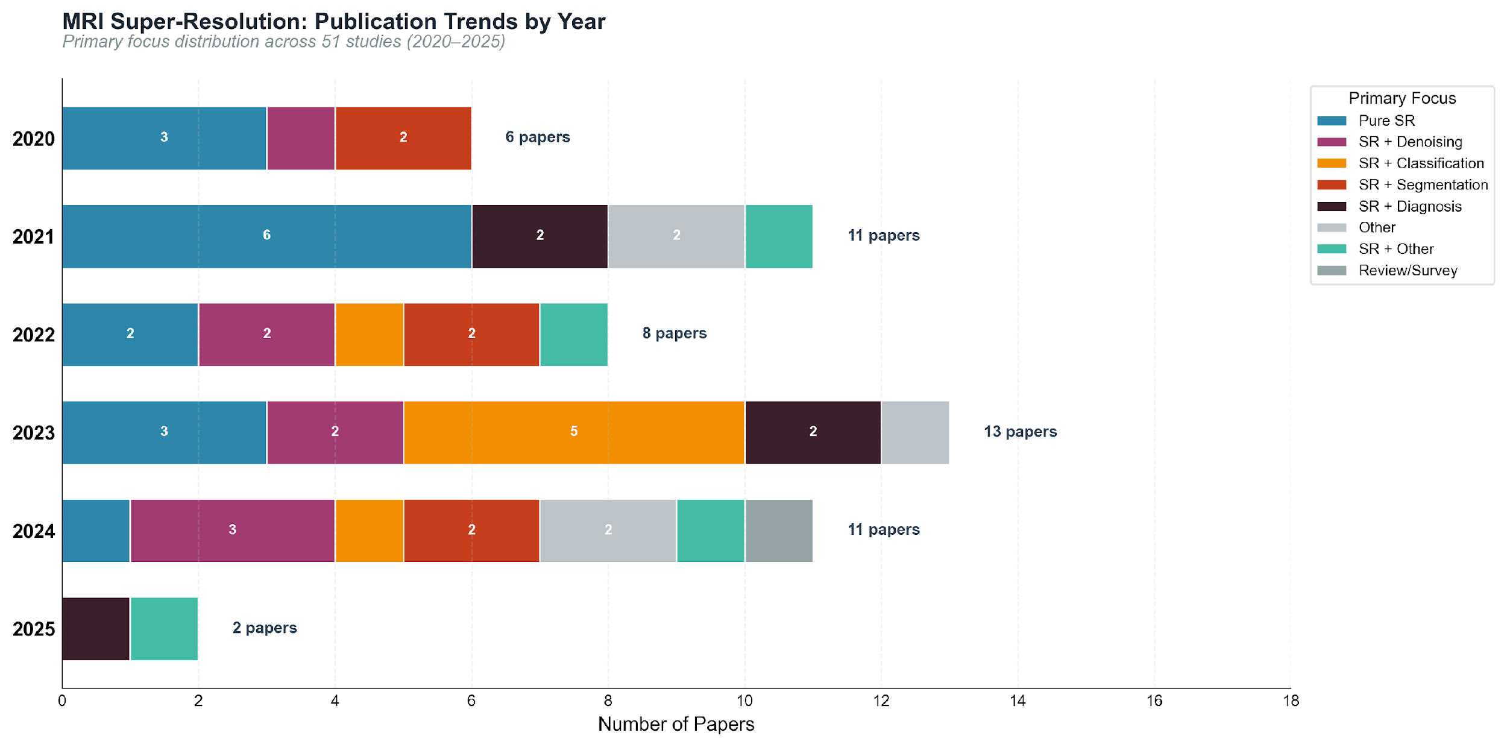
Extended Data Figure 1. Publication trends by year and primary focus (2020–2025). Publication peaked in 2023 (n=13). Pure SR studies accounted for the largest category.

Extended Data Figure 2.
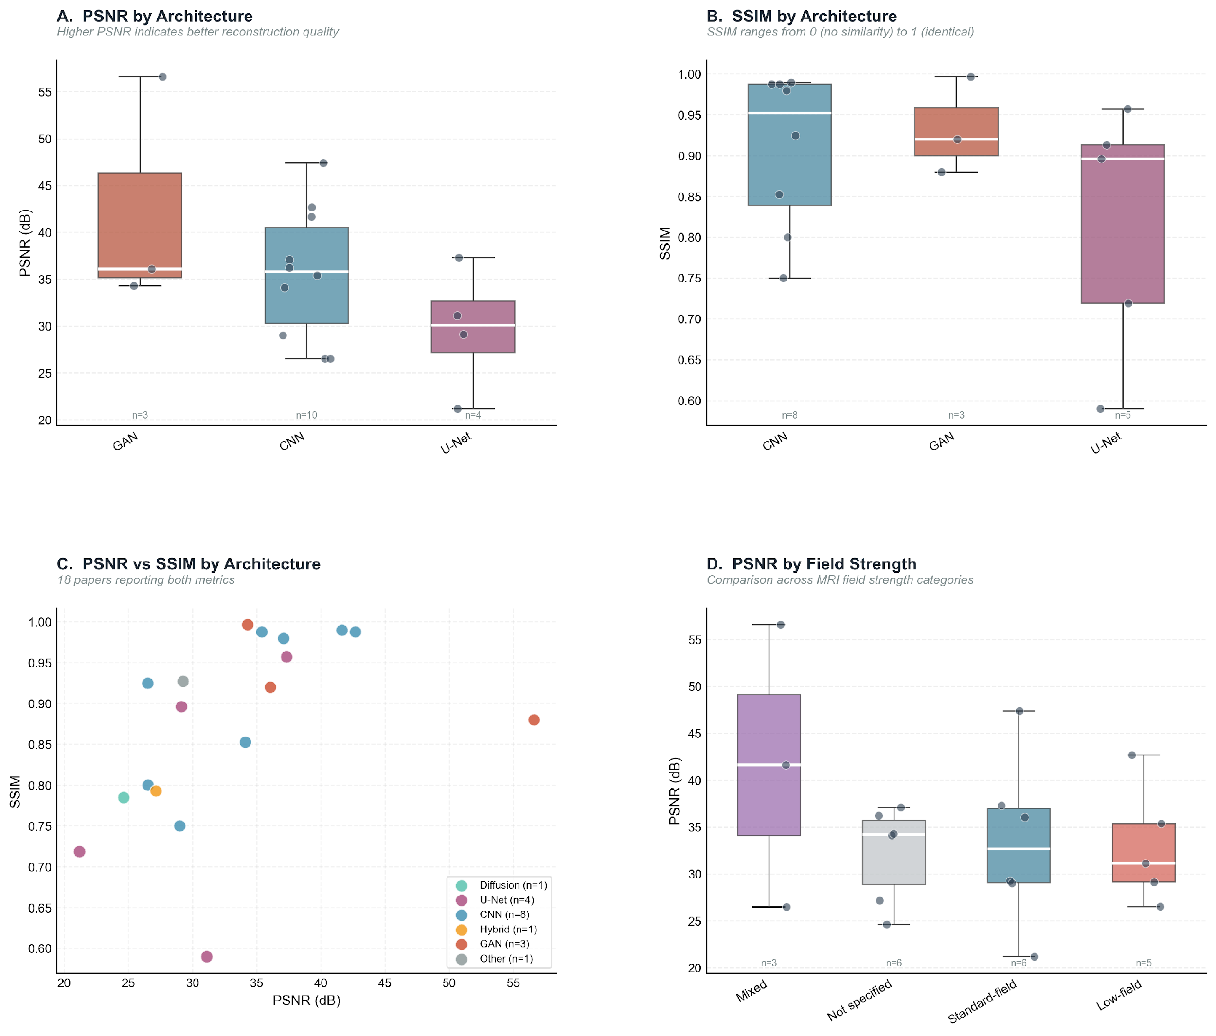
Extended Data Figure 2. Performance metrics comparison. Panel A: PSNR by architecture. Panel B: SSIM by architecture. Panel C: PSNR vs SSIM scatter. Panel D: PSNR by field strength.

Extended Data Figure 3.
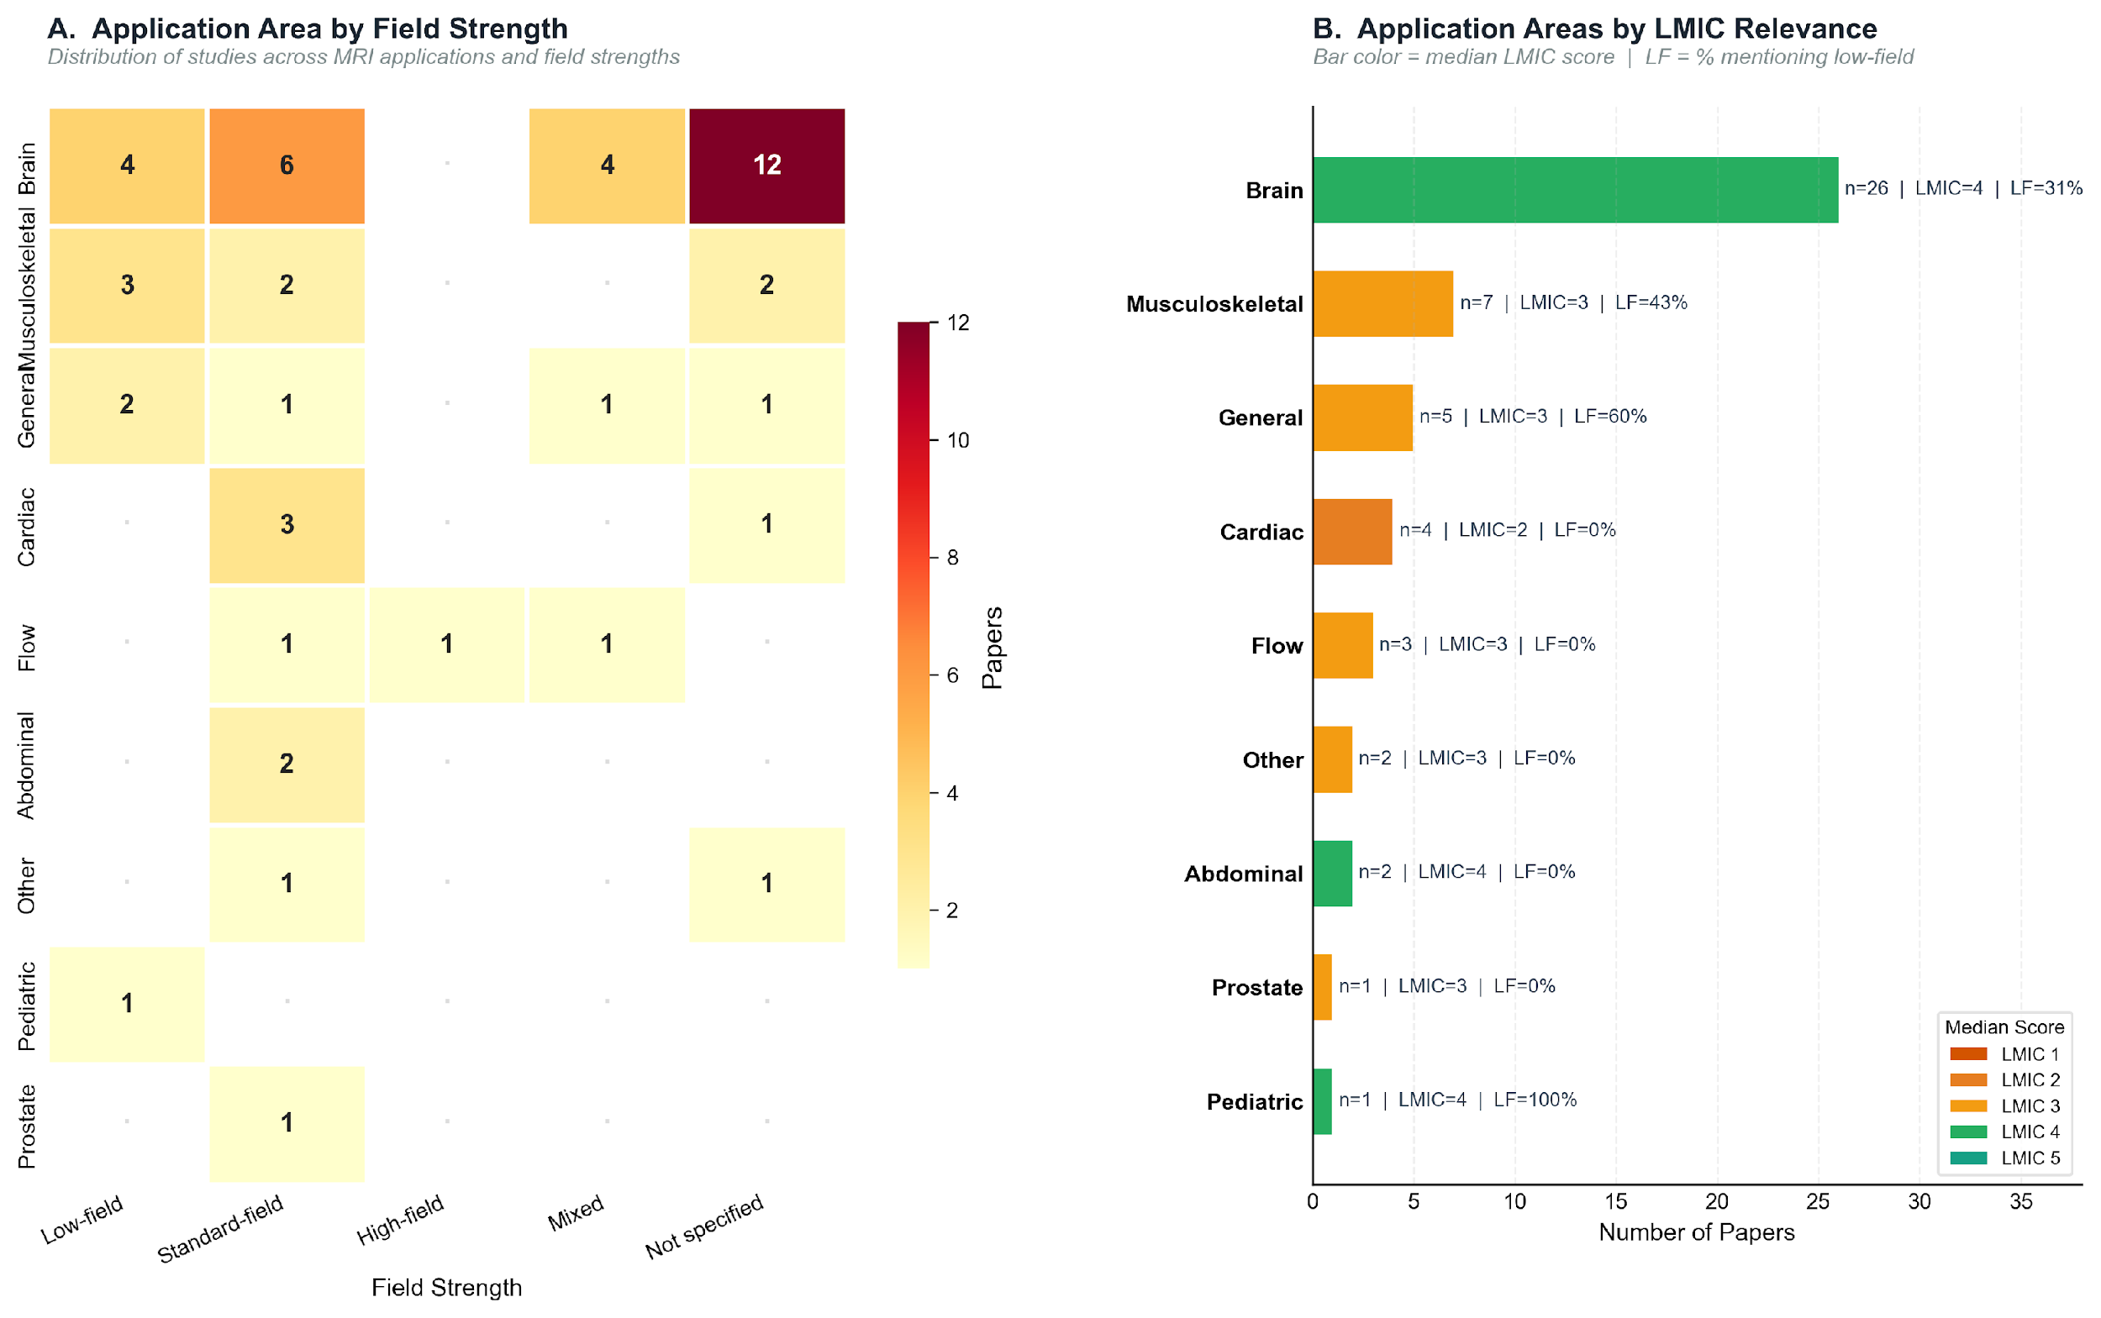
Extended Data Figure 3. Field strength and application area analysis. Panel A: Application area × field strength heatmap. Panel B: Application areas by LMIC relevance score.

Extended Data Figure 4.
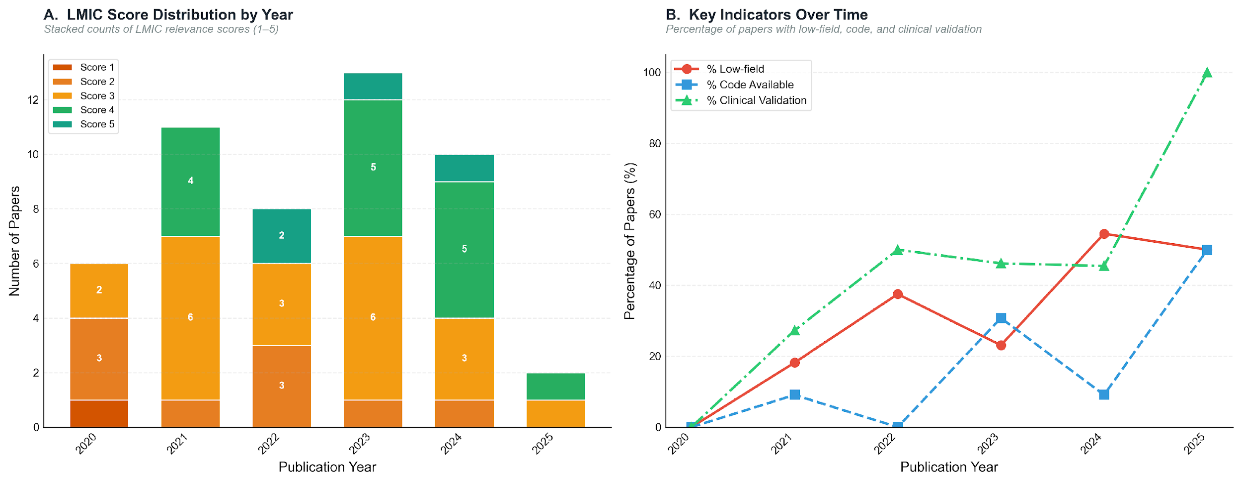
Extended Data Figure 4. Temporal trends in LMIC relevance (2020–2025). Panel A: LMIC score distribution by year. Panel B: Key indicators over time.

Extended Data Figure 5 / Figure 1A: PRISMA Flow Diagram.
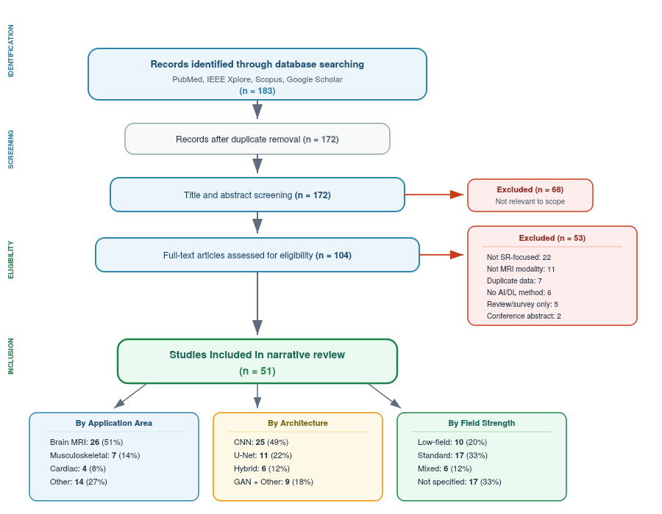
Figure 1. PRISMA-informed flow diagram. Study selection from 183 identified records through deduplication, title/abstract screening, full-text eligibility assessment to 51 included primary SR studies. Bottom panels summarise included studies by application area, architecture, and field strength.

Extended Data Table 2. Detailed AI architecture breakdown with representative models, median PSNR, and median SSIM.
Architecture Type | n | % of Total | Median PSNR | Median SSIM | Representative Models
CNN | 25 | 49.0% | 35.8 dB (n=10) | 0.952 (n=8) | DenseNet121, DenseNet161, InceptionResNetV2
U-Net | 11 | 21.6% | 30.1 dB (n=4) | 0.896 (n=5) | 3D brain tumour segmentation network, nnU-Net variants
Hybrid | 6 | 11.8% | 27.1 dB (n=1) | 0.793 (n=1) | Saliency-based deep learning (SbDL) using AlexNet backbone
GAN | 4 | 7.8% | 36.1 dB (n=3) | 0.920 (n=3) | LowGAN (three 2D pix2pix networks, staged training)
Diffusion | 1 | 2.0% | 24.6 dB (n=1) | 0.785 (n=1) | DDPM with optimised U-Net denoiser
Non-AI | 1 | 2.0% | N/R | N/R | Spatial frequency combination from orthogonal acquisitions
Transformer | 1 | 2.0% | N/R | N/R | SMIR: Swin Transformer-based MRI Reconstruction

Extended Data Table 3. LMIC relevance score distribution with counts of low-field mention, resource constraints, code availability, and clinical validation per score level.
LMIC Score | n Papers | % of Total | Low-field Mentioned | Resource Addressed | Code Available | Clinically Validated
5 — Direct LMIC application | 4 | 7.8% | 4 | 4 | 1 | 3
4 — High relevance | 15 | 29.4% | 8 | 13 | 2 | 6
3 — Moderate relevance | 21 | 41.2% | 3 | 16 | 4 | 8
2 — Low relevance | 9 | 17.6% | 0 | 1 | 0 | 3
1 — Minimal relevance | 1 | 2.0% | 0 | 1 | 0 | 0

Extended Data Table 5. Quality assessment results across three CLAIM-adapted domains. Mean total score: 4.08/9.
Domain | Max Possible | Mean | Median | Min | Max
Reporting Quality | 3 | 1.57 | 1.0 | 0 | 3
Validation Quality | 3 | 1.04 | 1.0 | 0 | 3
Reproducibility | 3 | 1.47 | 1.0 | 0 | 2
Total Quality Score | 9 | 4.08 | 4.0 | 0 | 7

Extended Data Table 6. Year-by-year LMIC relevance indicators (2020–2025).
Year | N Papers | LMIC Score Mean | LMIC Score Median | % Low-field | % Code Available | % Clinical Validation
2020 | 6 | 2.17 | 2.0 | 0.0% | 0.0% | 0.0%
2021 | 11 | 3.27 | 3.0 | 18.2% | 9.1% | 27.3%
2022 | 8 | 3.13 | 3.0 | 37.5% | 0.0% | 50.0%
2023 | 13 | 3.46 | 3.0 | 23.1% | 30.8% | 46.2%
2024 | 11 | 3.60 | 4.0 | 54.5% | 9.1% | 45.5%
2025 | 2 | 3.50 | 3.5 | 50.0% | 50.0% | 100.0%

