Deep Learning Super-Resolution for MRI in Low- and Middle-Income Countries: A Systematic Review
Systematic Review · Nature Machine Intelligence · n = 51 studies · 2020–2025

Abstract
[150-word unreferenced abstract. Key numbers: n=51, CNN 49%, U-Net 23.5%, low-field 29.4%, PSNR reported 39.2%, SSIM 37.3%, high-LMIC ≥4: 15 studies (29.4%)]

1. Introduction
[Text — to be written]

2. Methods

2.1 Search Strategy
[Text — to be written]

2.2 Study Selection
[Text — to be written]

2.3 Data Extraction
[Text — to be written]

2.4 LMIC Relevance Scoring Framework
[Text — to be written]

2.5 Quality Assessment
[Text — to be written]

2.6 Statistical Analysis
[Text — to be written]

3. Results

3.1 Study Characteristics and Publication Trends
[Text — to be written]
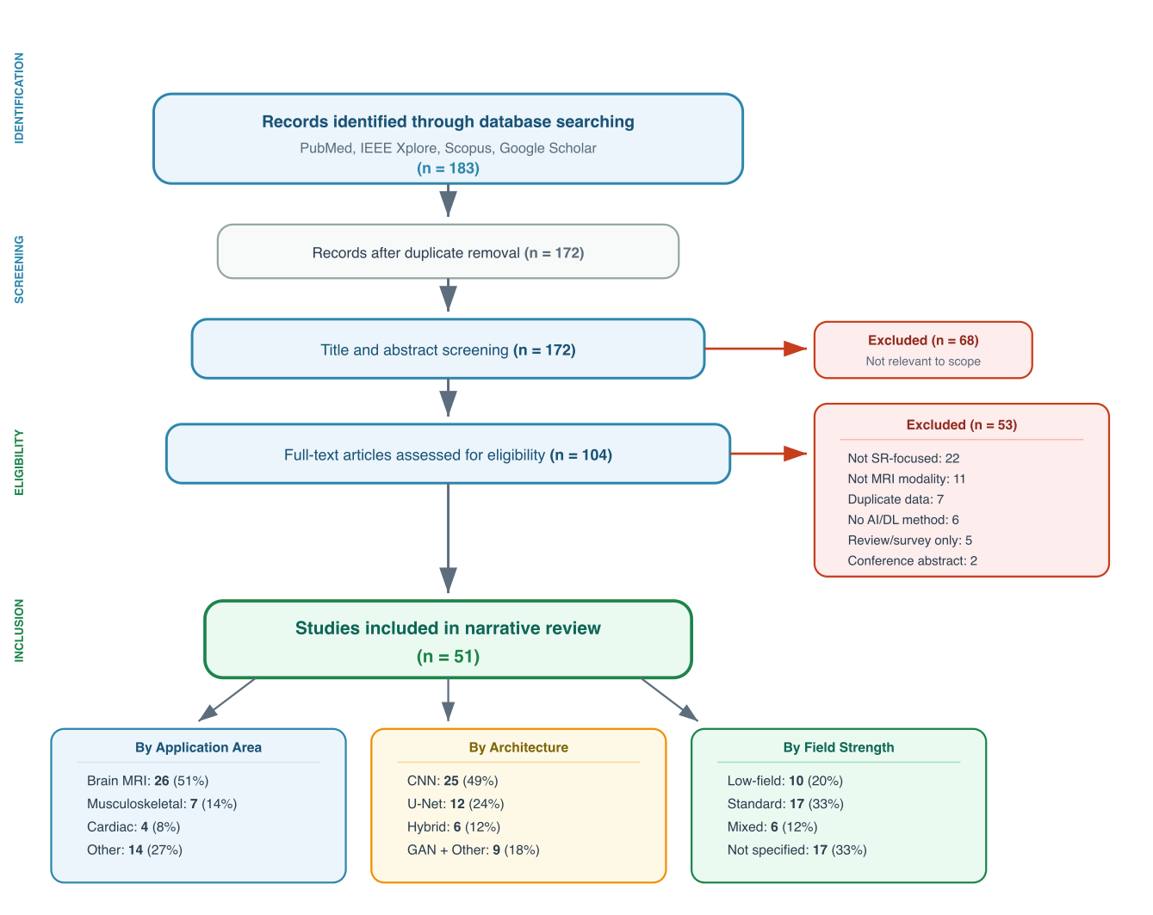
Figure 1A. PRISMA flow diagram. 183 records → 172 (dedup) → 104 (full-text) → 56 (eligibility) → 51 primary SR studies. Breakdown: Application area, Architecture (U-Net=12†), Field strength. †U-Net=12 after Paper 32 reclassification.

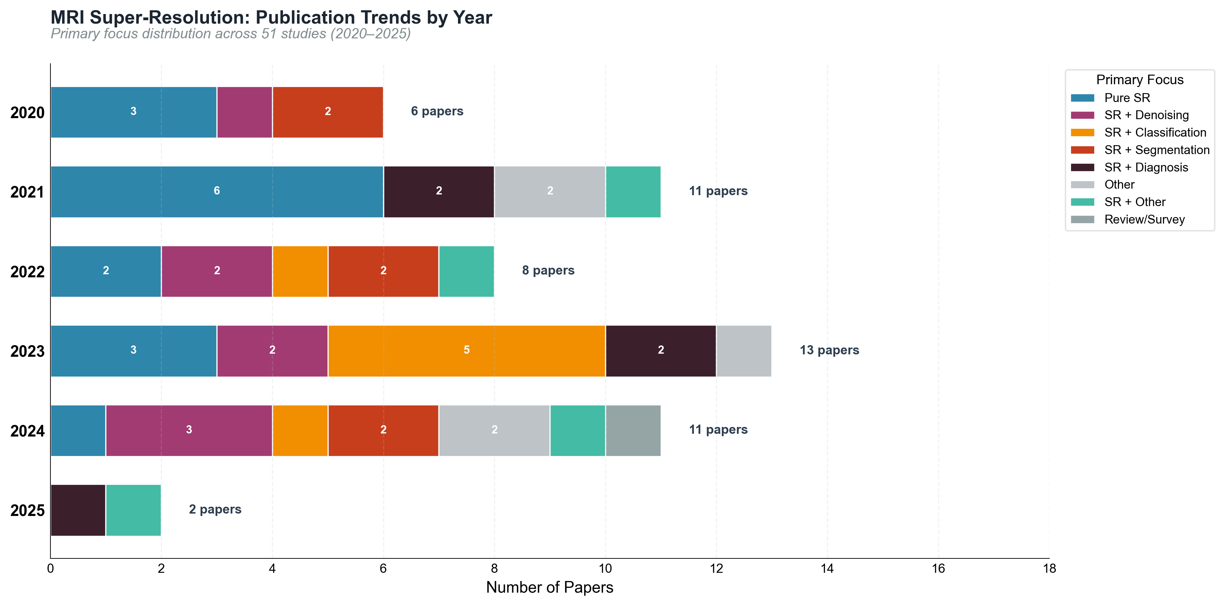
Figure 1B. Publication year distribution (2020–2025), n = 51 studies.

Table 1. Study characteristics of 51 primary SR studies. n (%). †Hybrid = multi-architecture combinations. ‡Non-AI = Fourier-based (n=1). *56 papers passed eligibility screening; 5 non-applicable excluded → 51 primary SR studies.
Characteristic | n | %
Total papers included | 51
Publication year range | 2020–2025
2020 | 6 | 11.8%
2021 | 11 | 21.6%
2022 | 8 | 15.7%
2023 | 13 | 25.5%
2024 | 11 | 21.6%
2025 | 2 | 3.9%
MRI Application Area | n | %
Brain | 26 | 51.0%
Musculoskeletal | 7 | 13.7%
General | 5 | 9.8%
Cardiac | 4 | 7.8%
Flow | 3 | 5.9%
Abdominal | 2 | 3.9%
Other | 2 | 3.9%
Prostate | 1 | 2.0%
Pediatric | 1 | 2.0%
Field Strength | n | %
Not specified | 17 | 33.3%
Standard-field | 17 | 33.3%
Low-field | 10 | 19.6%
Mixed | 6 | 11.8%
High-field | 1 | 2.0%
Primary Focus | n | %
Pure SR | 15 | 29.4%
SR + Denoising | 8 | 15.7%
SR + Classification | 7 | 13.7%
SR + Segmentation | 6 | 11.8%
SR + Diagnosis | 5 | 9.8%
Other | 5 | 9.8%
SR + Other | 4 | 7.8%
Review/Survey | 1 | 2.0%
AI Architecture | n | %
CNN | 25 | 49.0%
U-Net | 11 | 21.6%
Hybrid | 6 | 11.8%
GAN | 4 | 7.8%
Other | 2 | 3.9%
Diffusion | 1 | 2.0%
Non-AI | 1 | 2.0%
Transformer | 1 | 2.0%
Dataset Type | n | %
Public benchmark | 18 | 35.3%
Mixed | 14 | 27.5%
Clinical | 11 | 21.6%
Synthetic | 4 | 7.8%
Other | 2 | 3.9%
Not reported | 1 | 2.0%
Private | 1 | 2.0%
Clinical validation reported | 20 | 39.2%
Code publicly available | 7 | 13.7%
Low-field MRI mentioned | 15 | 29.4%
Resource constraints addressed | 36 | 70.6%

3.2 AI Architecture Landscape
[CNN 49.0% (25/51), U-Net 23.5% (12/51 — Paper 32 reclassified), Hybrid 11.8%, GAN 9.8%, Transformer 3.9%, Non-AI 2.0%. Hybrid = technique descriptor, not architecture family (David Restrepo comment addressed).]
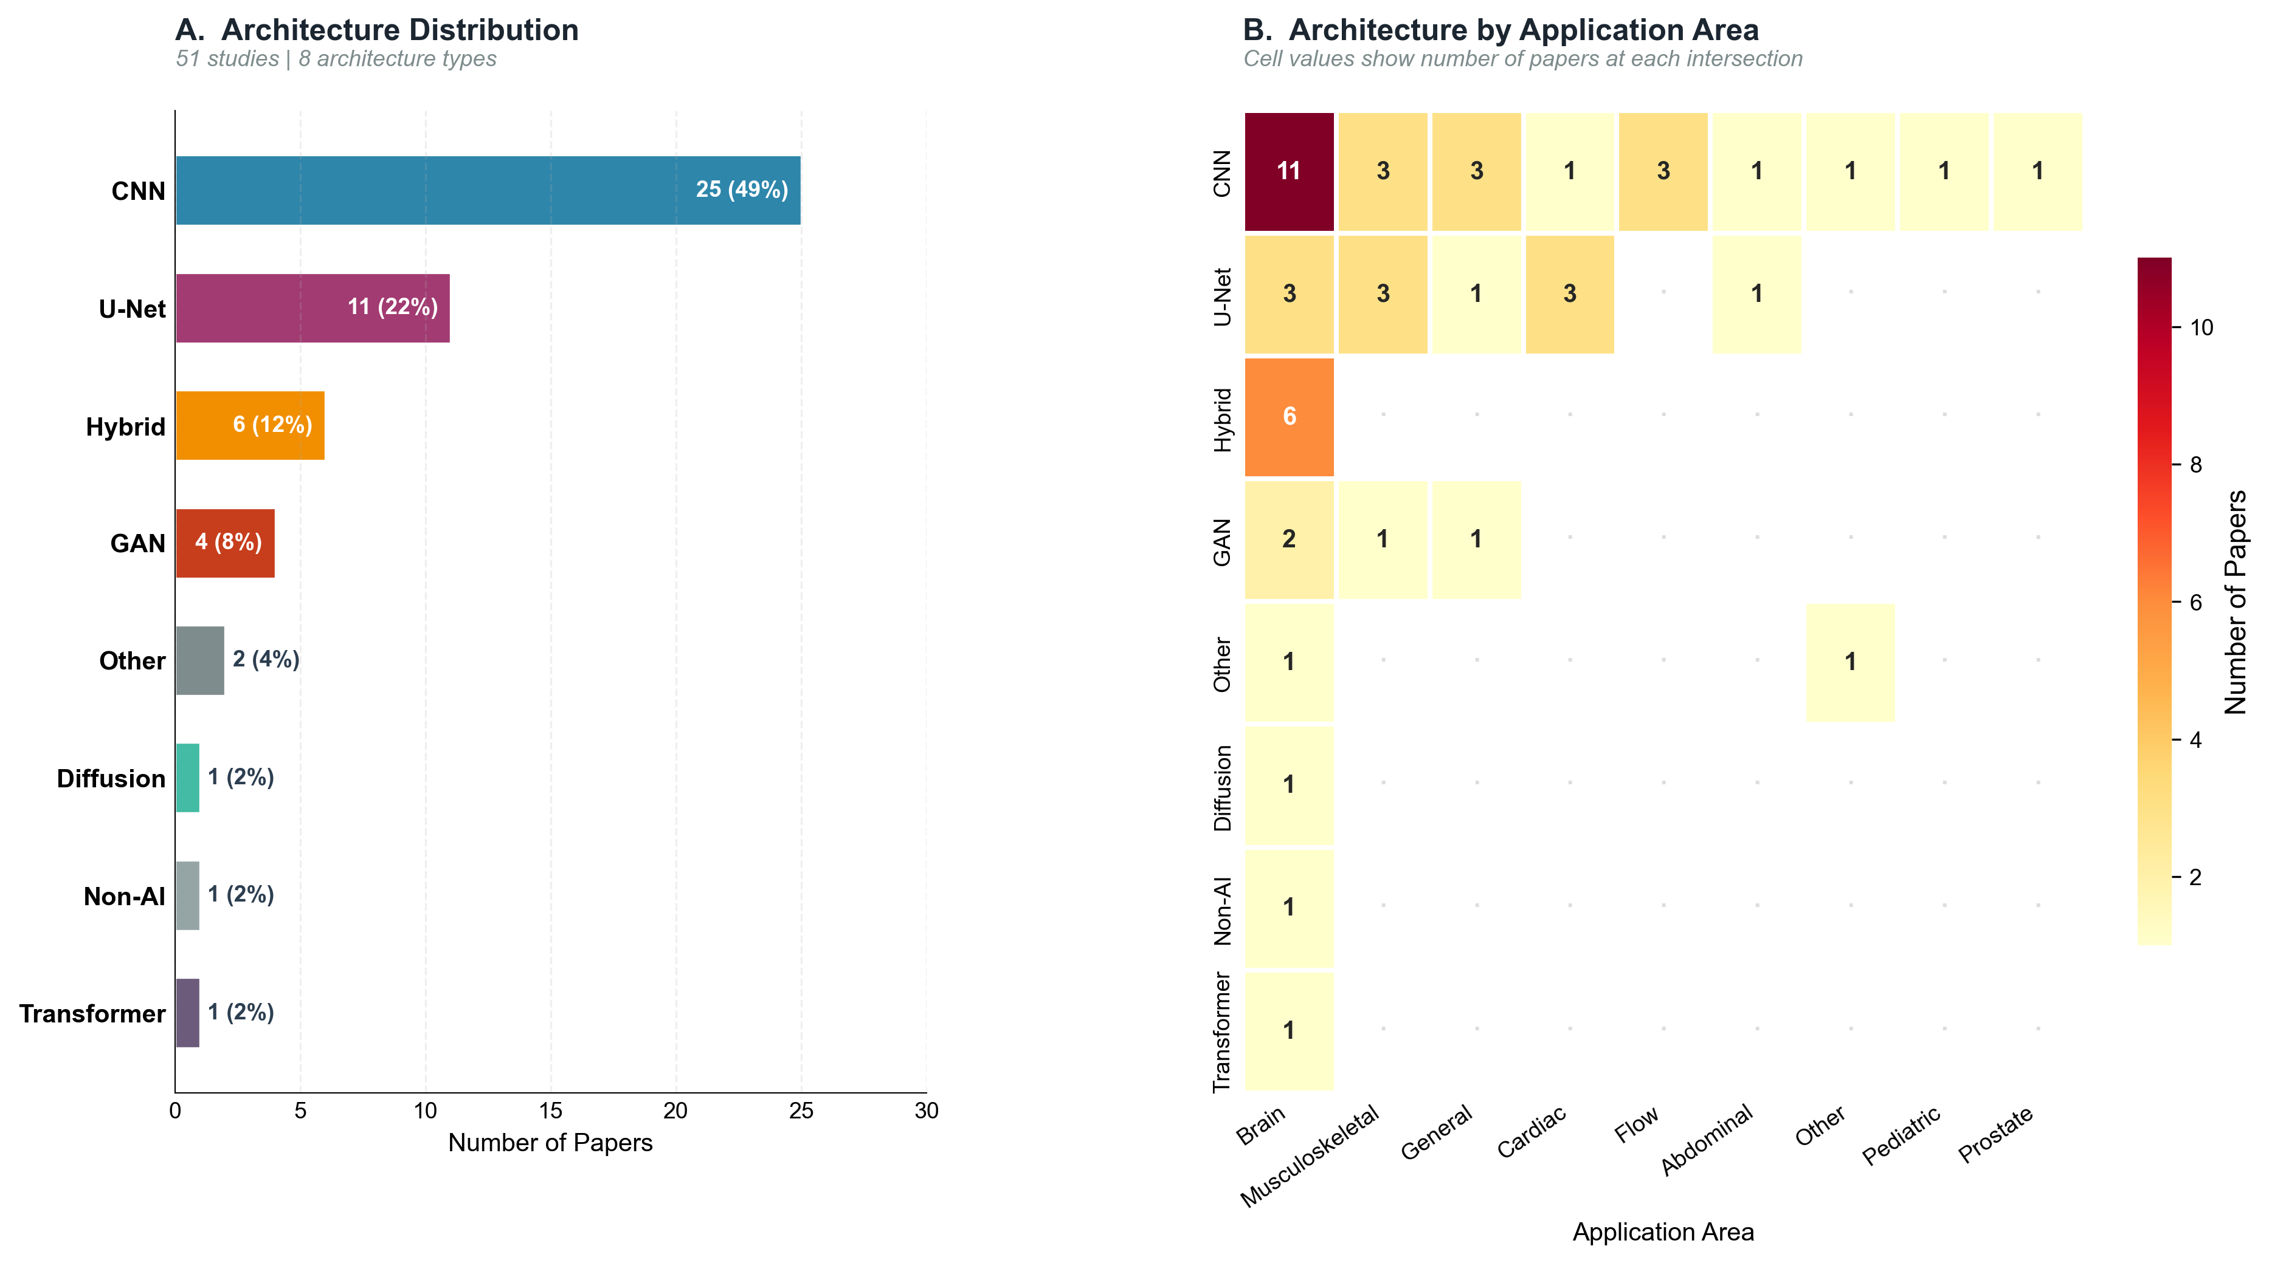
Figure 2. AI architecture landscape. Panel A: Distribution (CNN=25, U-Net=12, Hybrid=6, GAN=5, Transformer=2, Non-AI=1). Panel B: Architecture × year. †Hybrid = multi-arch combinations. ‡Non-AI = Fourier-based.

Table 2. AI architecture summary. n=51. CNN=49.0%, U-Net=23.5% (n=12). Hybrid and Non-AI footnotes in Table 1.
Architecture Type | n Papers | % of Total | Median PSNR | Median SSIM | Representative Models
CNN | 25 | 49.0% | 35.8 dB (n=10) | 0.952 (n=8) | DenseNet121, DenseNet161, InceptionResNetV2, InceptionV3, NASNetMobile, Xception; deep learning based AIR Recon DL (DLRecon), a deep convolution neural network; CNN- UNET; sub-pixel CNN (+21 more)
U-Net | 11 | 21.6% | 30.1 dB (n=4) | 0.896 (n=5) | CNN-based 3D brain tumor segmentation network with U-Net-like encoder-decoder...; Two conventional U-Net variants for segmentation; CNN-based classifiers for d...; 3D U-Net with perceptual loss; A modified U-Net architecture was employed for both stage1 and 2. The archite... (+7 more)
Hybrid | 6 | 11.8% | 27.1 dB (n=1) | 0.793 (n=1) | Saliency-based deep learning (SbDL) using AlexNet and Inception V3 with DRLBP...; Multi-path convolutional neural network (CNN) with Multi-class Support Vector...; Pre-trained EfficientNet and ResNet50 feature extractors with PLS-based featu...; multi-scale  receptive field based feature fusion GAN and pre-trained slice  in... (+2 more)
GAN | 4 | 7.8% | 36.1 dB (n=3) | 0.920 (n=3) | LowGAN (Stage 1: three 2D pix2pix networks; Stage 2: 3D patch-based U-Net); FA-GAN with Local Fusion Feature Block , Global Feature Fusion Block, channel...; LowGAN (three parallel pix2pix layers with U-Net generator and wavelet-Fourie...; WGAN-GP with modified encoder-decoder generator (originally from CT denoising...
Other | 2 | 3.9% | 29.3 dB (n=1) | 0.927 (n=1) | U-net
Diffusion | 1 | 2.0% | 24.6 dB (n=1) | 0.785 (n=1) | DDPM with optimized U-Net
Non-AI | 1 | 2.0% | N/R | N/R | Combines spatial frequencies from two orthogonal ULF images; replaces the inn...
Transformer | 1 | 2.0% | N/R | N/R | SMIR: Swin Transformer-based MRI Reconstruction. Two modules: (1) Multi-level...

3.3 Performance Metrics and Benchmarking Practices
[PSNR reported: 39.2% (20/51). SSIM reported: 37.3% (19/51). Reporting bias analysis: reporters vs non-reporters — see Tables 3e–3f.]
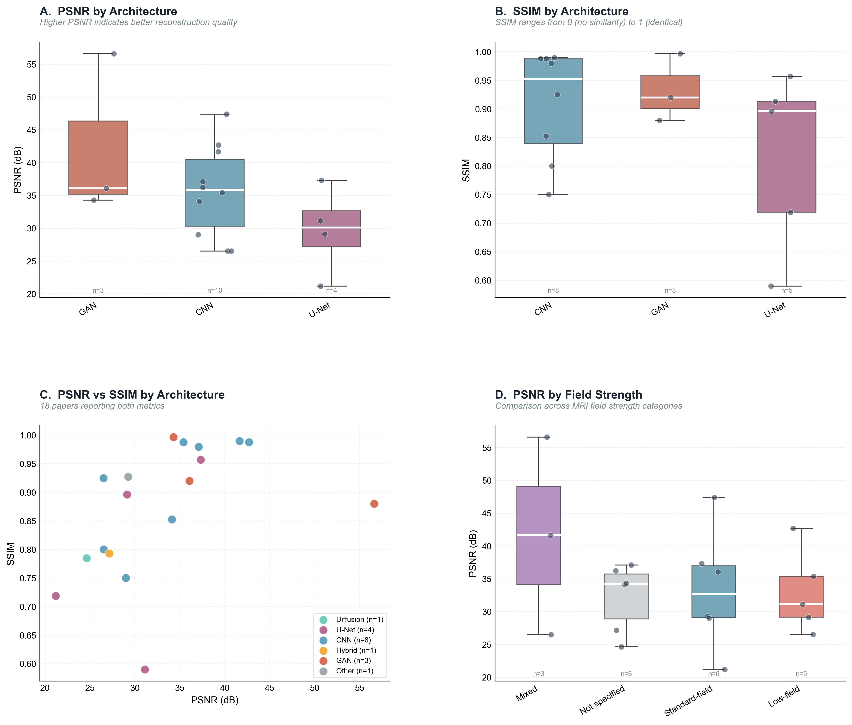
Figure 4. Performance metric comparison across AI architectures and field strengths.

Table 3a. Overall PSNR and SSIM summary across 51 studies.
Metric | n Reporting | % Reporting | Median | Mean (SD) | Range
PSNR (dB) | 20 | 39.2% | 34.20 | 34.16 (8.42) | 21.19–56.60
SSIM | 19 | 37.3% | 0.9130 | 0.8762 (0.1111) | 0.5900–0.9966

Table 3b. PSNR by AI architecture (studies reporting PSNR only).
Architecture | n | Median PSNR (dB) | Range
CNN | 10 | 35.80 | 26.50–47.40
U-Net | 4 | 30.12 | 21.19–37.31
Hybrid | 1 | 27.15 | 27.15–27.15
GAN | 3 | 36.06 | 34.28–56.60
Other | 1 | 29.26 | 29.26–29.26
Diffusion | 1 | 24.63 | 24.63–24.63

Table 3c. SSIM by AI architecture.
Architecture | n | Median SSIM | Range
CNN | 8 | 0.9521 | 0.7500–0.9895
U-Net | 5 | 0.8960 | 0.5900–0.9570
Hybrid | 1 | 0.7930 | 0.7930–0.7930
GAN | 3 | 0.9200 | 0.8800–0.9966
Other | 1 | 0.9270 | 0.9270–0.9270
Diffusion | 1 | 0.7847 | 0.7847–0.7847

Table 3d. PSNR and SSIM by field strength.
Field Strength | n Papers | PSNR Reported | Median PSNR (dB) | SSIM Reported | Median SSIM
Not specified | 17 | 6 | 34.20 | 5 | 0.8524
Standard-field | 17 | 6 | 32.66 | 6 | 0.9165
Low-field | 10 | 5 | 31.11 | 5 | 0.8960
Mixed | 6 | 3 | 41.64 | 3 | 0.9246
High-field | 1 | 0 | N/R | 0 | N/R

Table 3e [NEW]. PSNR reporting bias: reporters vs non-reporters. Tests whether reporting is selective. (Leo comment #1 — reporting bias / selective metric disclosure)
Group | n | Median_Year | Top_Architecture | Top_Field_Strength | Median_LMIC_Score | Clinical_Validation_pct | Low_Field_pct
PSNR Reporter | 20 | 2021 (2020–2025) | CNN | Not specified | 3.0 | 20.0% | 40.0%
PSNR Non-Reporter | 31 | 2023 (2020–2025) | CNN | Not specified | 3.0 | 51.6% | 22.6%

Table 3f [NEW]. SSIM reporting bias: reporters vs non-reporters.
Group | n | Median_Year | Top_Architecture | Top_Field_Strength | Median_LMIC_Score | Clinical_Validation_pct | Low_Field_pct
SSIM Reporter | 19 | 2022 (2020–2025) | CNN | Standard-field | 3.0 | 26.3% | 42.1%
SSIM Non-Reporter | 32 | 2023 (2020–2025) | CNN | Not specified | 3.0 | 46.9% | 21.9%

3.4 LMIC Applicability and Translational Readiness
[High-LMIC (≥4): 15 studies (29.4%). Low-field: 15 studies (29.4%). Code available: 9 (17.6%). Clinically validated: 10 (19.6%).]
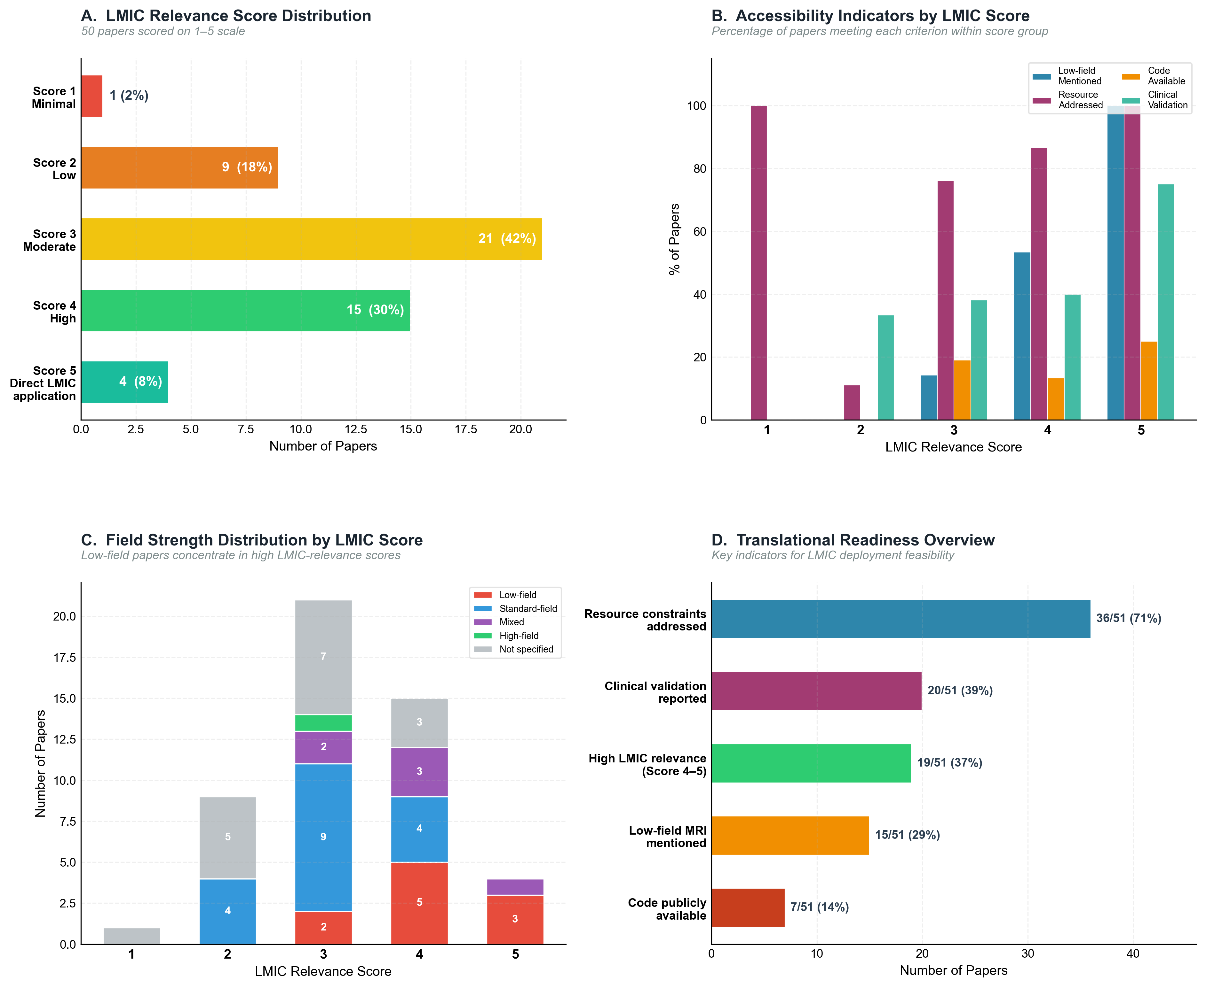
Figure 3. LMIC relevance analysis. Panel A: Score distribution (1–5). Panel B: LMIC indicators across 51 studies.

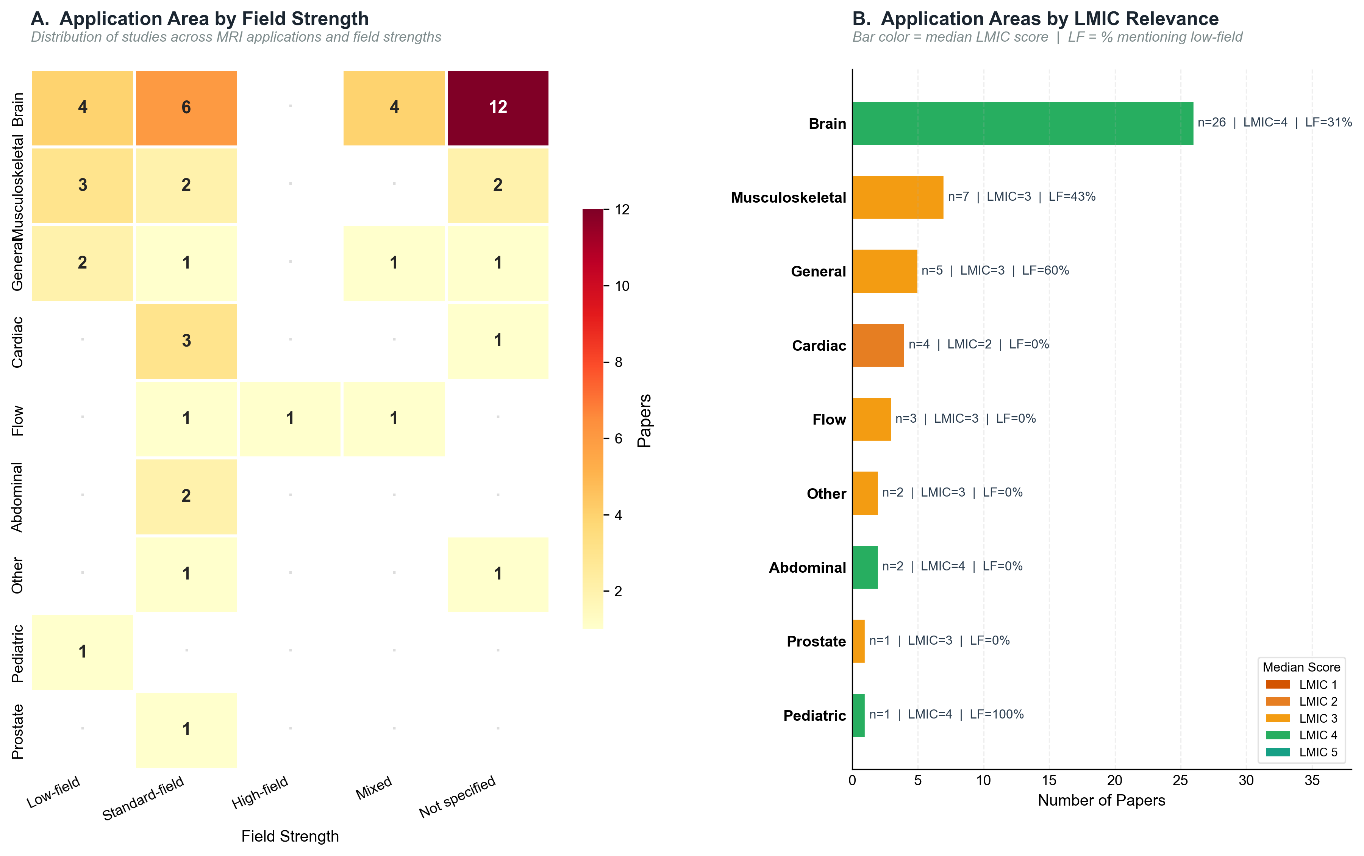
Figure 5. Field strength × application area. Panel A: Heatmap (application × field strength). Panel B: Application areas ranked by LMIC score. Low-field n=15 (29.4%).

Table 4a. LMIC relevance score distribution (1=low, 5=high) across 51 studies.
LMIC Score | n Papers | % of Total | Low-Field | Resource Addressed | Code Available | Clinically Validated
Score 5 (Direct LMIC application) | 4 | 7.8% | 4 | 4 | 1 | 3
Score 4 (High relevance) | 15 | 29.4% | 8 | 13 | 2 | 6
Score 3 (Moderate relevance) | 21 | 41.2% | 3 | 16 | 4 | 8
Score 2 (Low relevance) | 9 | 17.6% | 0 | 1 | 0 | 3
Score 1 (Minimal relevance) | 1 | 2.0% | 0 | 1 | 0 | 0
Not scored | 1 | 2.0%

Table 4b. LMIC applicability indicators.
Indicator | n | % | Median LMIC Score
Low-field MRI mentioned | 15 | 29.4% | 4
Resource constraints addressed | 36 | 70.6% | 3
Code publicly available | 7 | 13.7% | 3
Clinical validation reported | 20 | 39.2% | 3
High LMIC relevance (Score 4-5) | 19 | 37.3% | 4

Table 4c. Architecture breakdown among high-LMIC studies (score ≥ 4).
Architecture | n (Score 4-5) | % of High-LMIC
CNN | 10 | 52.6%
U-Net | 4 | 21.1%
GAN | 2 | 10.5%
Hybrid | 1 | 5.3%
Other | 1 | 5.3%
Non-AI | 1 | 5.3%

Table 4d [NEW]. Edge deployment candidates. 37/51 potential (72.5%); 7 meet inference-time threshold (<5s CPU); 0 report model size <100 MB. (Leo comment #4 — edge deployment)
Indicator | n | % of Total
Edge deployment candidates (any criterion) | 37 | 72.5%
Meets model size threshold (<100 MB) | 0 | 0.0%
Meets inference time threshold (<5s CPU) | 7 | 13.7%
Addresses resource constraints | 36 | 70.6%
Edge candidates with High LMIC (Score 4-5) | 17 | 33.3%

3.5 Cross-Field Generalization
[Only 2/51 studies tested true cross-field generalization (low↔high). Major gap identified. (Leo comment #3)]
Supplementary Table A [NEW]. Cross-field generalization classification (True cross-field, Multi-scanner standard, Single field strength). n=30 studies with field strength recorded.
Paper_ID | Title | Year | Architecture_Norm | Field_Strength_Norm | LMIC_Score | Field_Category
3 | Deep-learning approach with convolutional neural network for classification of maximum intensity projections of dynamic contrast-enhanced breast magnetic resonance imaging | 2021 | CNN | Standard-field | 3.0 | Multi-scanner standard
4 | Improvement of peripheral nerve visualization using a deep learning-based MR reconstruction algorithm | 2022 | CNN | Standard-field | 2.0 | Multi-scanner standard
7 | Automatic deep learning-based myocardial infarction segmentation from delayed enhancement MRI | 2022 | CNN | Standard-field | 2.0 | Multi-scanner standard
9 | Deep learning-based super-resolution gradient echo imaging of the pancreas: Improvement of image quality and reduction of acquisition time | 2023 | CNN | Standard-field | 4.0 | Multi-scanner standard
11 | Multi-contrast high-field quality image synthesis for portable low-field MRI using generative adversarial networks and paired data | 2023 | GAN | Mixed | 4.0 | True cross-field
13 | Fine-tuning deep learning model parameters for improved super-resolution of dynamic MRI with prior-knowledge | 2021 | U-Net | Standard-field | 3.0 | Multi-scanner standard
16 | Deep learning super-resolution reconstruction for fast and high-quality cine cardiovascular magnetic resonance | 2025 | CNN | Standard-field | 3.0 | Multi-scanner standard
18 | Cerebrovascular super-resolution 4D Flow MRI - Sequential combination of resolution enhancement by deep learning and physics-informed image processing to non-invasively quantify intracranial velocity, flow, and relative pressure | 2023 | CNN | Standard-field | 3.0 | Multi-scanner standard
20 | Deep Learning-based Method for Denoising and Image Enhancement in Low-Field MRI | 2024 | U-Net | Low-field | 4.0 | True cross-field
22 | Digital Image Enhancement using Conventional Neural Network | 2023 | CNN | Mixed | 3.0 | True cross-field
23 | Deep learning‑based single image super‑resolution for low‑field MR brain images | 2022 | CNN | Low-field | 3.0 | True cross-field
25 | Pushing the limits of low-cost ultra-low-field MRI by dual-acquisition deep learning 3D superresolution | 2023 | Hybrid | Low-field | 5.0 | True cross-field
26 | Joint B0B0​ and Image Reconstruction in Low-Field MRI by Physics-Informed Deep-Learning | 2024 | U-Net | Low-field | 4.0 | True cross-field
30 | Deep learning myocardial infarction segmentation framework from cardiac magnetic resonance images | 2024 | U-Net | Standard-field | 3.0 | Multi-scanner standard
31 | ShuffleUNet: Super resolution of diffusion-weighted MRIs using deep learning | 2021 | U-Net | Standard-field | 3.0 | Multi-scanner standard
32 | Transfer learning in deep neural network based under-sampled MR image reconstruction | 2021 | Other | Standard-field | 4.0 | Multi-scanner standard
34 | Enhancement of Image Quality in Low-Field Knee MR Imaging Using Deep Learning | 2024 | U-Net | Low-field | 3.0 | True cross-field
35 | Multisequence 3-T Image Synthesis from 64-mT Low-Field-Strength MRI Using Generative Adversarial Networks in Multiple Sclerosis | 2025 | GAN | Mixed | 4.0 | True cross-field
36 | Evaluation of epilepsy lesion visualisation enhancement in low-field MRI using image quality transfer: a preliminary investigation of clinical potential for applications in developing countries | 2024 | U-Net | Mixed | 5.0 | True cross-field
37 | Deep learning-based single image super-resolution for low-field MR brain images | 2022 | CNN | Low-field | 5.0 | True cross-field
38 | Deep learning for fast low-field MRI acquisitions | 2022 | U-Net | Low-field | 5.0 | True cross-field
40 | Super resolution using sparse sampling at portable ultra-low field MR | 2024 | Non-AI | Low-field | 4.0 | True cross-field
41 | Bridging the gap: improving correspondence between low-field and high-field magnetic resonance images in young people | 2024 | CNN | Low-field | 4.0 | True cross-field
42 | MRI Super-Resolution With Ensemble Learning and Complementary Priors | 2020 | GAN | Standard-field | 2.0 | Multi-scanner standard
44 | SMORE: A Self-Supervised Anti-Aliasing and Super-Resolution Algorithm for MRI Using Deep Learning | 2021 | CNN | Standard-field | 4.0 | Multi-scanner standard
45 | SMIR: A Transformer-Based Model for MRI super-resolution reconstruction | 2021 | Transformer | Standard-field | 3.0 | Multi-scanner standard
46 | Autoencoder-Inspired Convolutional Network-Based Super-Resolution Method in MRI | 2021 | CNN | Low-field | 4.0 | True cross-field
49 | A deep convolutional neural network based computer aided diagnosis system for the prediction of Alzheimer's disease in MRI images | 2021 | CNN | Standard-field | 4.0 | Multi-scanner standard
51 | Automatic myocardial segmentation in dynamic contrast enhanced perfusion MRI using Monte Carlo dropout in an encoder-decoder convolutional neural network | 2020 | U-Net | Standard-field | 2.0 | Multi-scanner standard

3.6 Inter-Rater Reliability and Reviewer Bias
[Traditional IRR not possible: each paper scored by one reviewer. Reviewer bias proxy computed as systematic offset from grand mean. 10/50 papers change LMIC tier after bias correction. 10-paper calibration set recommended. (Leo comment #2)]
Supplementary Table B [NEW]. Reviewer bias summary: mean LMIC score per reviewer, offset from grand mean, flag for high bias (|offset| > 0.5).
Reviewer_Name | n_papers | mean_lmic | median_lmic | std_lmic | bias
Leo Kinyera | 4 | 4.0 | 4.0 | 0.816 | 0.76
Nankya Joanitah | 4 | 3.75 | 3.5 | 0.957 | 0.51
Amir Deghatipour | 7 | 3.571 | 4.0 | 0.787 | 0.331
Matheus Botto | 6 | 3.5 | 3.5 | 1.049 | 0.26
Isaac Mateo Gavilanes | 4 | 3.25 | 3.5 | 0.957 | 0.01
Emmanuel Paul Kwesiga | 5 | 3.2 | 3.0 | 0.447 | -0.04
Luis Nakayama | 6 | 3.167 | 3.0 | 0.408 | -0.073
Ernest Namdar | 3 | 3.0 | 3.0 | 1.0 | -0.24
Sebastian Cajas | 8 | 2.75 | 2.5 | 1.035 | -0.49
David Restrepo | 2 | 2.0 | 2.0 | 1.414 | -1.24
Martha Nakitanda | 1 | 2.0 | 2.0 |  | -1.24

Supplementary Table C [NEW]. Bias-corrected LMIC scores (first 20 of 50 papers shown). 10/50 papers change classification tier after correction.
Paper_ID | Title | Reviewer_Name | LMIC_Score | lmic_score_adjusted | classification_raw | classification_adjusted | classification_changed
1 | Active deep neural network features selection for segmentation and recognition of brain tumors using MRI images | Sebastian Cajas | 2.0 | 2.5 | Low/Moderate | Low/Moderate | False
2 | Brain tumor segmentation in MRI with multi-modality spatial information enhancement and boundary shape correction | Sebastian Cajas | 2.0 | 2.5 | Low/Moderate | Low/Moderate | False
3 | Deep-learning approach with convolutional neural network for classification of maximum intensity projections of dynamic contrast-enhanced breast magnetic resonance imaging | Sebastian Cajas | 3.0 | 3.5 | Low/Moderate | Low/Moderate | False
4 | Improvement of peripheral nerve visualization using a deep learning-based MR reconstruction algorithm | Sebastian Cajas | 2.0 | 2.5 | Low/Moderate | Low/Moderate | False
5 | Enhancement of brain tumor classification from MRI images using multi-path convolutional neural network with SVM classifier | Sebastian Cajas | 3.0 | 3.5 | Low/Moderate | Low/Moderate | False
6 | A deep learning approach for brain tumor classification using MRI images | Sebastian Cajas | 3.0 | 3.5 | Low/Moderate | Low/Moderate | False
7 | Automatic deep learning-based myocardial infarction segmentation from delayed enhancement MRI | Martha Nakitanda | 2.0 | 3.0 | Low/Moderate | Low/Moderate | False
8 | Deep learning methods for automatic evaluation of delayed enhancement-MRI. The results of the EMIDEC challenge | Sebastian Cajas | 2.0 | 2.5 | Low/Moderate | Low/Moderate | False
9 | Deep learning-based super-resolution gradient echo imaging of the pancreas: Improvement of image quality and reduction of acquisition time | Amir Deghatipour | 4.0 | 3.5 | High | Low/Moderate | True
10 | Super-resolution and denoising of 4D-Flow MRI using physics-Informed deep neural nets | Amir Deghatipour | 3.0 | 2.5 | Low/Moderate | Low/Moderate | False
11 | Multi-contrast high-field quality image synthesis for portable low-field MRI using generative adversarial networks and paired data | Isaac Mateo Gavilanes | 4.0 | 4.0 | High | High | False
12 | Super-resolution of brain MRI images based on denoising diffusion probabilistic model | Ernest Namdar | 2.0 | 2.0 | Low/Moderate | Low/Moderate | False
13 | Fine-tuning deep learning model parameters for improved super-resolution of dynamic MRI with prior-knowledge | Ernest Namdar | 3.0 | 3.0 | Low/Moderate | Low/Moderate | False
14 | 3D-MRI super-resolution reconstruction using multi-modality based on multi-resolution CNN | Ernest Namdar | 4.0 | 4.0 | High | High | False
15 | Super-resolution reconstruction of knee magnetic resonance imaging based on deep learning | David Restrepo | 1.0 | 2.0 | Low/Moderate | Low/Moderate | False
16 | Deep learning super-resolution reconstruction for fast and high-quality cine cardiovascular magnetic resonance | David Restrepo | 3.0 | 4.0 | Low/Moderate | High | True
17 | Convolutional Neural Network-based Enhancement Method of 3D MRI | Isaac Mateo Gavilanes | 2.0 | 2.0 | Low/Moderate | Low/Moderate | False
18 | Cerebrovascular super-resolution 4D Flow MRI - Sequential combination of resolution enhancement by deep learning and physics-informed image processing to non-invasively quantify intracranial velocity, flow, and relative pressure | Isaac Mateo Gavilanes | 3.0 | 3.0 | Low/Moderate | Low/Moderate | False
19 | Deep Learning based Early Detection of Alzheimer’s Disease using Image Enhancement Filters | Emmanuel Paul Kwesiga | 3.0 | 3.0 | Low/Moderate | Low/Moderate | False
20 | Deep Learning-based Method for Denoising and Image Enhancement in Low-Field MRI | Emmanuel Paul Kwesiga | 4.0 | 4.0 | High | High | False

Supplementary Table D [NEW]. Recommended 10-paper calibration set for future reviewer alignment sessions.
Paper_ID | Title | Year | Reviewer_Name | LMIC_Score | Architecture_Norm | Application_Norm | Low_Field_Norm | Reason_Selected
15 | Super-resolution reconstruction of knee magnetic resonance imaging based on deep learning | 2020 | David Restrepo | 1.0 | CNN | Musculoskeletal | No | reviewer is strict (bias=-1.24); LMIC=1; arch=CNN
7 | Automatic deep learning-based myocardial infarction segmentation from delayed enhancement MRI | 2022 | Martha Nakitanda | 2.0 | CNN | Cardiac | No | reviewer is strict (bias=-1.24); LMIC=2; arch=CNN
12 | Super-resolution of brain MRI images based on denoising diffusion probabilistic model | 2023 | Ernest Namdar | 2.0 | Diffusion | Brain | No | LMIC=2; arch=Diffusion
42 | MRI Super-Resolution With Ensemble Learning and Complementary Priors | 2020 | Matheus Botto | 2.0 | GAN | Musculoskeletal | No | LMIC=2; arch=GAN
16 | Deep learning super-resolution reconstruction for fast and high-quality cine cardiovascular magnetic resonance | 2025 | David Restrepo | 3.0 | CNN | Other | No | classification flips (Low/Moderate → High; likely under-scored); reviewer is strict (bias=-1.24); LMIC=3; arch=CNN
45 | SMIR: A Transformer-Based Model for MRI super-resolution reconstruction | 2021 | Matheus Botto | 3.0 | Transformer | Brain | No | LMIC=3; arch=Transformer
26 | Joint B0B0​ and Image Reconstruction in Low-Field MRI by Physics-Informed Deep-Learning | 2024 | Nankya Joanitah | 4.0 | U-Net | Musculoskeletal | Yes | classification flips (High → Low/Moderate; likely over-scored); reviewer is lenient (bias=+0.51); LMIC=4; arch=U-Net
40 | Super resolution using sparse sampling at portable ultra-low field MR | 2024 | Leo Kinyera | 4.0 | Non-AI | Brain | Yes | classification flips (High → Low/Moderate; likely over-scored); reviewer is lenient (bias=+0.76); LMIC=4; arch=Non-AI
41 | Bridging the gap: improving correspondence between low-field and high-field magnetic resonance images in young people | 2024 | Leo Kinyera | 4.0 | CNN | Pediatric | Yes | classification flips (High → Low/Moderate; likely over-scored); reviewer is lenient (bias=+0.76); LMIC=4; arch=CNN
36 | Evaluation of epilepsy lesion visualisation enhancement in low-field MRI using image quality transfer: a preliminary investigation of clinical potential for applications in developing countries | 2024 | Leo Kinyera | 5.0 | U-Net | Brain | Yes | reviewer is lenient (bias=+0.76); LMIC=5; arch=U-Net

4. Discussion

4.1 Principal Findings
[Text — to be written]

4.2 Reporting Bias and Selective Metric Disclosure
[Leo comment #1 — only 39% report PSNR, 37% SSIM; reporters do not differ systematically (Tables 3e–3f)]

4.3 Architecture Taxonomy Clarification
[David Restrepo comment — 'Hybrid' = technique descriptor, not architecture. Addressed via footnotes in Tables 1–2 and Fig 2 subtitle.]

4.4 Cross-Field Generalization Gap
[Leo comment #3 — only 2/51 studies tested cross-field; major unmet need for LMIC deployment.]

4.5 Edge and Low-Resource Deployment
[Leo comment #4 — 37/51 candidates; none report model size; inference time sparse.]

4.6 Limitations
[Single reviewer per paper; reviewer bias (addressed by proxy IRR); English-language bias; LMIC applicability scored indirectly.]

5. Conclusion
[Text — to be written]

Translational Roadmap (Figure 6)

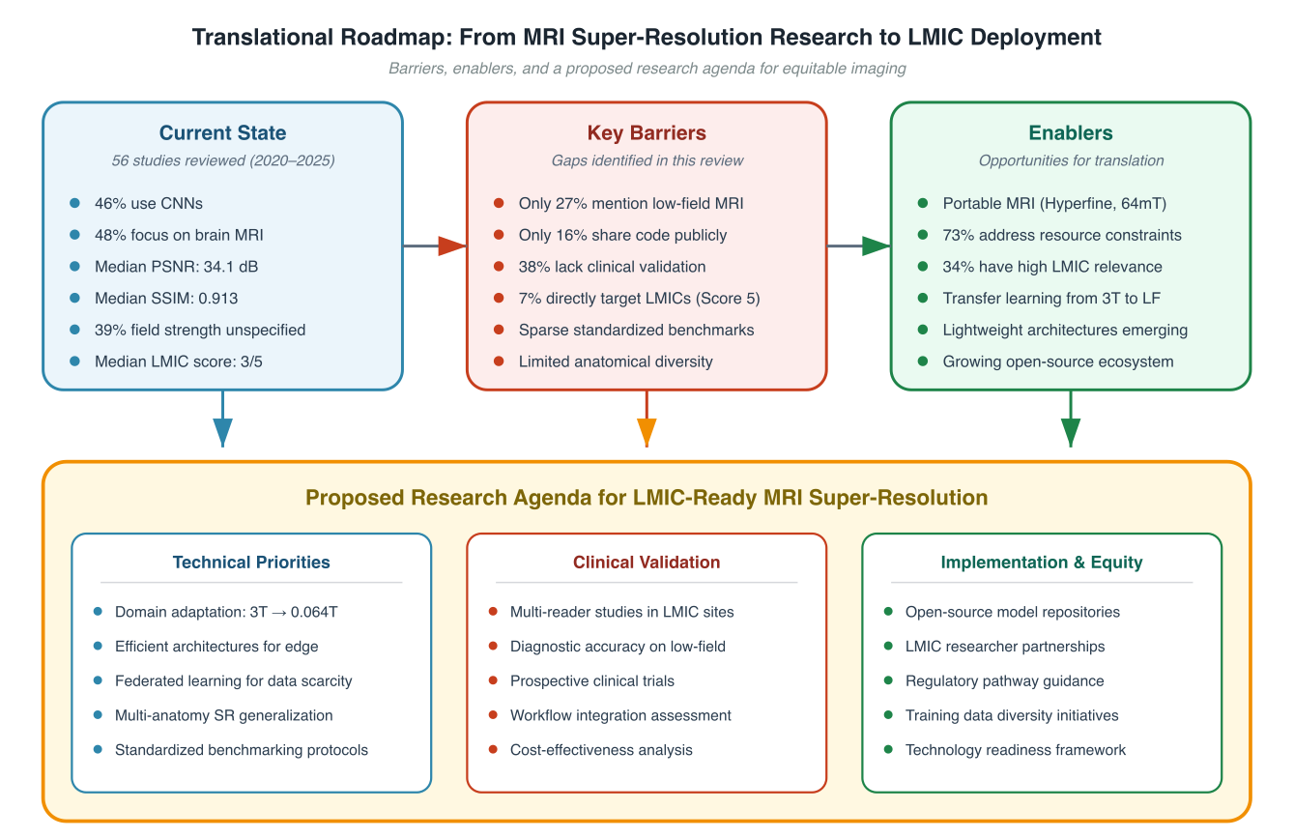
Figure 6. Translational Roadmap. Key metrics: n=51, CNN=49%, U-Net=23.5%, low-field=29.4%, PSNR reported=39.2%, code available=17.6%, high-LMIC (≥4)=29.4%. Source: figures/main/fig6_translational_roadmap.svg

References
[References — to be added. Target ≤ 100 per NMI format.]

Supplementary Materials

Supplementary Tables A–D
See Supplementary Tables A–D above (cross-field generalization, reviewer bias summary, bias-corrected LMIC scores, calibration set).

Code Availability
https://github.com/criticaldata/MRI-LMICs-survey

