Displaying dates on blogposts which are different from the publication date using custom fields

Enable custom fields

1. Edit any blog post
2. Click 3 dots on the top right
3. Go to preferences
4. Go to „panels“
5. Activate „custom fields“

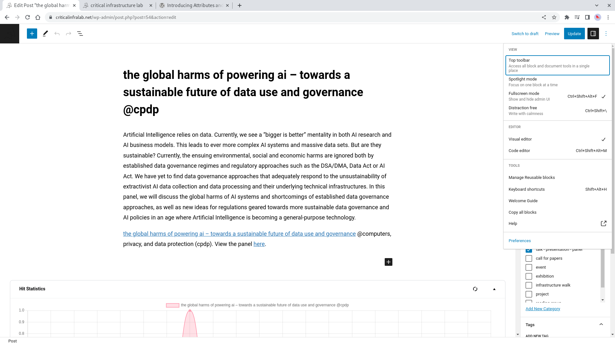

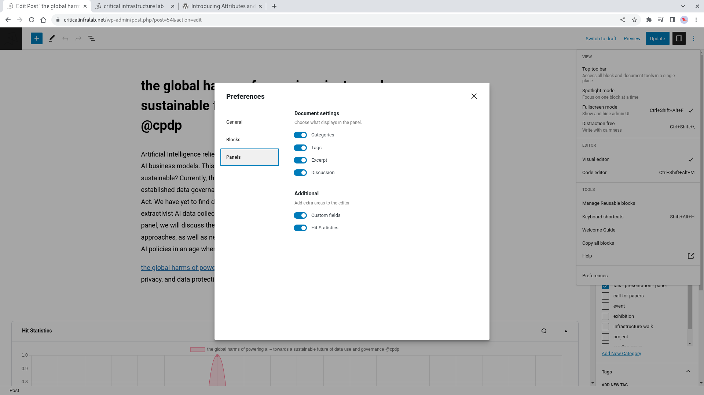

Use custom fields
The fields are displayed on the bottom of each blog post in editing mode.

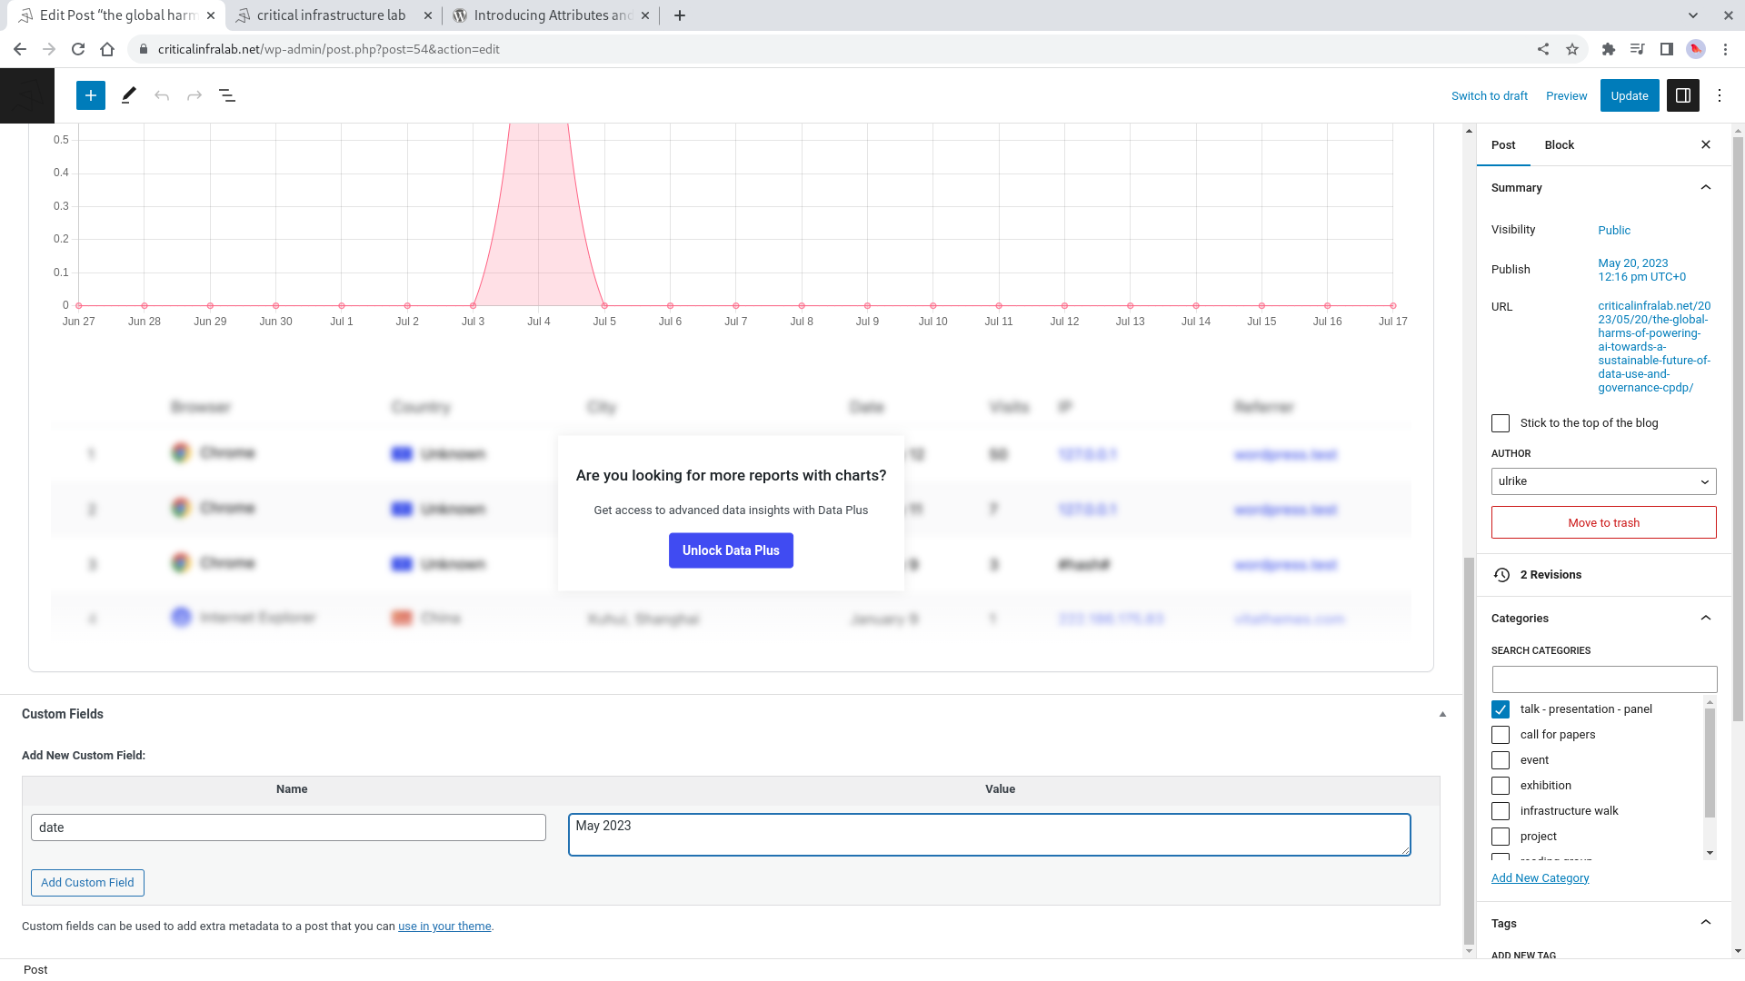
- the name of the field is „date“ (will autofill)
- value can be any type of string, for example „1-10 June 2025“ or „may 23“

If the custom field „date“ is not set for a given post, the publication date will be displayed instead.

Using the correct CSS class for a publication
The CSS class will ensure that the publication has the correct three colored dots displayed when visiting the website.
This can be done manually: add the relevant CSS class per paragraph using the WP block interface
- category-all
- category-environment
- category-geopolitics
- category-standards
- category-standards-geopolitics
- category-environment-geopolitics
- category-environment-standards
But because there is no autocompletion, this is tedious and you can alternatively reuse the „Reusable block“ feature.
When adding a new publication, you’ll press enter and then see a „+“ or you can type „/“ to add a new paragraph. Now, there are reusable blocks named
- publication-all
- publication-environment
- publication-geopolitics
- publication-standards
- etc.
These blocks are defined here: https://www.criticalinfralab.net/wp-admin/edit.php?post_type=wp_block
