Installing Crittercism Unity plugin for Android

Package Contents
Crittercism_Android.zip will unpack the following directories :
Crittercism_Unity_Android
Crittercism_Unity_Android_TestApp

In the notes below (Unity Project) refers to your project, or the test application included with this package.

- Decompress the Crittercism_Android package.
- Inside the Crittercism_Unity_Android folder is a folder called Plugins. Copy this to the (Unity Project)/Assets directory. If you already have a Plugins folder, you will need to copy the follow files to the proper directories in the plugin folder.
  - CrittercismAndroid.jar -> /Plugins/Android/CrittercismAndroid.jar
libs/crittercism_v3_0_8.jar -> /Plugins/Android/libs/crittercism_v3_0_8.jar
res/values/strings.xml -> /Plugins/Android/res/values/strings.xml
Crittercism_Android/ -> /Plugins/Android/Crittercism_Android/
- Open the strings.xml in (Unity Project)/Plugins/Android/res/values/. You will need to change the following lines:
<string name="CrittercismAppID">/*Your Key Here*/</string>
<string name="CrittercismDelaySendingAppLoad">false</string>
<string name="CrittercismShouldCollectLogcat">false</string>
<string name="CrittercismCustomVersionName">/*Your Version Name Here*/</string>
Replace /*Your Key Here*/ with the key from the Crittercism Web Portal.
DelaySendingAppLoad and ShouldCollectLogcat must be either true or false.
CustomVersionName may be any string you so desire.
Note that if you override the launch activity and do not, you must set the appropriate variables in CrittercismInit.cs
- In Unity, in the application launching scene Drag the (Unity Project)/Assets/Plugins/ios/Crittercism_Android/CrittercismInit.cs script onto the Camera or a GameObject. The CrittercismInit.cs will start Crittercism debugging in Unity3d. (See step 5 for Starting Crittercism on app start.) This script will destroy itself in newer versions of Unity3d at runtime. In Versions before Unity 3.4.2 it will stay active in the scene with an Update call.

You can look in the Inspector to confirm the script is associated with the object:

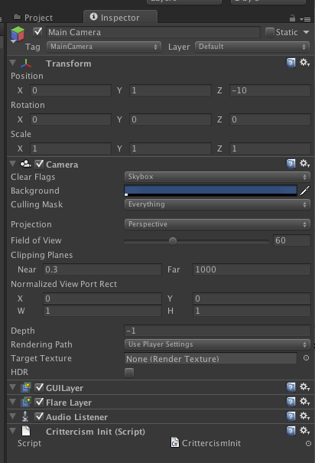
- (Optional) This step will start Unity3d when the application first starts up. This will provide the user with debugging of Unity3d crashes. This will normally require overriding the Unity3d Activity or Application. For convenience a custom Application is provided in the CrittercismAndroid.jar.
  - For users who want to override the activity themselves. Details can be found at:
http://unity3d.com/support/documentation/Manual/Android-Integrating%20Unity%20With%20Eclipse.html
  - A custom AndroidManifiest.xml must be included in the (Unity Project)Plugins/Android directory. The following line must be added to the AndroidManifiest in the <application> tag.
android:name="com.crittercism.unity.ExtendedApplication"
- A custom AndroidManifiest.xml must be added to the (Unity Project)Plugins/Android folder. Inside the file, the following activities must be added.
<!-- Start of Crittercism.com Code-->
<activity android:name="com.crittercism.NewFeedbackSpringboardActivity"
android:theme="@android:style/Theme.Black.NoTitleBar.Fullscreen" android:configChanges="fontScale|keyboard|keyboardHidden|locale|mnc|mcc|navigation|orientation|screenLayout|screenSize|smallestScreenSize|uiMode|touchscreen"/>
<activity android:name="com.crittercism.NewFeedbackIssueListActivity"
android:theme="@android:style/Theme.Black.NoTitleBar.Fullscreen"
android:configChanges="fontScale|keyboard|keyboardHidden|locale|mnc|mcc|navigation|orientation|screenLayout|screenSize|smallestScreenSize|uiMode|touchscreen"/>
<activity android:name="com.crittercism.NewFeedbackQuestionListActivity"
android:theme="@android:style/Theme.Black.NoTitleBar.Fullscreen" android:configChanges="fontScale|keyboard|keyboardHidden|locale|mnc|mcc|navigation|orientation|screenLayout|screenSize|smallestScreenSize|uiMode|touchscreen"/>
<activity android:name="com.crittercism.NewFeedbackItemDetailsActivity"
android:theme="@android:style/Theme.Black.NoTitleBar.Fullscreen" android:configChanges="fontScale|keyboard|keyboardHidden|locale|mnc|mcc|navigation|orientation|screenLayout|screenSize|smallestScreenSize|uiMode|touchscreen"/>
<activity android:name="com.crittercism.NewFeedbackCreateActivity"
android:theme="@android:style/Theme.Black.NoTitleBar.Fullscreen" android:configChanges="fontScale|keyboard|keyboardHidden|locale|mnc|mcc|navigation|orientation|screenLayout|screenSize|smallestScreenSize|uiMode|touchscreen"/>
<activity android:name="com.crittercism.NotificationActivity" android:configChanges="fontScale|keyboard|keyboardHidden|locale|mnc|mcc|navigation|orientation|screenLayout|screenSize|smallestScreenSize|uiMode|touchscreen"/>
<!-- End of Crittercism.com Code -->
The following permissions must also be added.
<uses-permission android:name="android.permission.INTERNET" />
<uses-permission android:name="android.permission.ACCESS_NETWORK_STATE" />
- (Optional) Select Edit->Project Settings->Script Execution Order, and add the CrittercismsInit.cs script to the list with the highest priority . This will prevent any other files from executing before Critercism for Unity is enabled. If crashes occur before Crittercism is started in Unity3d, they will not be captured and sent to the webportal.
- (Optional test harness for Crittercism. If you are using the TestApp, then this step can be skipped.) In Unity, drag Plugins/ios/Crittercism_Android/CrittercismTestGUI.cs file to the camera. This provides a test interface for Unity3d that will throw exceptions.

