Installing Crittercism Unity plugin for IOS

Package Contents
Crittercism_iOS.zip will unpack the following directories :
Crittercism_Unity_iOS
Crittercism_Unity_iOS_TestApp

In the notes below (Unity Project) refers to your project, or the test application included with this package.

- Decompress the Crittercism_iOS package.
- Inside the decompressed folder is a folder called Plugins. Copy the contents of this folder into the (Unity Project)/Assets folder. If you already have a Plugins folder, simply copy the folder Crittercism_iOS and libCrittercismUnity.a file into your existing Plugins/ios/ folder.
- (Optional if Crash detection is not wanted prior to Unity3d's launch). Crashes that occur before Crittercism is started in Unity are not handled. If you would like these to be handled by Crittercism, then perform the following changes. In AppController.mm:
There are several available AppControllers.mm files included in:
Crittercism_Unity_iOS/AppControllers/

The correct AppController file should be selected and copied to the (Unity Project)/Assets/Plugins/ios/ folder , and rename it AppController.mm. Use of the wrong file will result in the application failing to compile.

If a custom AppController.mm is already being used. The Following lines will need to be added to the top of the file, and the AppID, Key and Secret constants set to the values designated for your App in Crittercisms web portal.

{
// If CrittercismIDs.plist exists in the main bundle, ID’s will be pulled from the CrittercismIDs.plist.
// If no CrittercismIDs.plist exists, or ID’s are not found in the file, the values
// Below will be used.
const char* kCrittercism_App_ID = ""; // Your App ID Here

// Crittercism Call into library for init
extern "C" void Crittercism_EnableWithAppID(const char* appID);
}

Add the Following Line to the top of applicationDidFinishLaunching:
{
// Initialize Crittercism so we can see unity startup crashes
Crittercism_EnableWithAppID(kCrittercism_App_ID);
}

- In Unity, in the application launching scene Drag the (Unity Project)/Assets/Plugins/ios/Crittercism_iOS/CrittercismInit.cs script onto the Camera or a GameObject. The CrittercismInit script will destroy the instance of itself when Crittercism is started to save resources.

You can look in the Inspector to confirm the script is associated with the object:

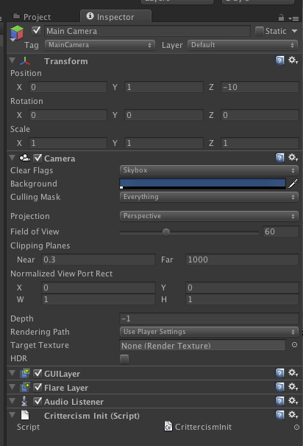

- (Optional) Select Edit->Project Settings->Script Execution Order, and add the CrittercismsInit.cs script with the highest priority to prevent it from being created after other objects. This will prevent any other files from executing before Critercism for Unity is enabled. If crashes occur before Crittercism is started in Unity3d, they will not be captured and send to the webportal.
- (Optional if using AppController.mm, see step 3.) Edit the CrittercismInit.cs file. Replace CrittercismAppID with the ID found in the Crittercism web portal.
- (Optional test harness for Crittercism. If you are using the TestApp, then this step can be skipped.) In Unity, drag Plugins/ios/Crittercism_iOS/CrittercismTestGUI.cs file to the camera. This provides a test interface for Unity3d that will throw exceptions.

The plugin will capture more on iOS and the most detailed exceptions when "Script Call Optimizations" are set to "Slow, but Safe.". Exception handlers are otherwise stripped from the Unity3D engine and have to be handled outside the Mono Environment. In these cases, symbols captured will be relevant to the Unity3d Engine code, not the C# or Jave code. These settings can be found in the IOS Player settings, reachable with the menu from “Edit->Project Settings->Player”, then under the “Other Settings” category.

