1. INTRODUCTION

This project is aimed to give a brief introduction to cyphers. What cyphers are, what they are used for, where and when they were more popular, and what types we can find through History. There is also a section where the user will be able to code and decode any piece of information that they entered in the predefined text area.

For settle down the project and contents, I checked a website (www.practicalcryptography.com) where I found a good introduction about cyphers. It explained the different type of cyphers, their construction and how they work. It also provides some references that might be useful in case of taking the research further.

This website is composed by three webpages: landing page that provides two links to explore each two cyphers:

-The ROT13 Caesar Cypher, one of the classical cyphers.

-The base 64 encoding scheme which was developed in modern times.

1. SOFTWARE DESIGN

After some researching about the topic, I know how much content I must include in the site to create a meaningful and easy to use system for user to have their first contact with cyphers and encoding schemes.

I want to include just enough information for users to have an idea about the site but always keeping it interactive and visually interesting. For that reason, I have included some media content like images and play with the elements design to personalise it.

List of requirements:

-Content. Introduction to the webpage.

-Media display. Images.

-Area to implement the JavaScript encoding and decoding mechanism.

I have organised all this content in one landing page that will lead to two sub-pages.

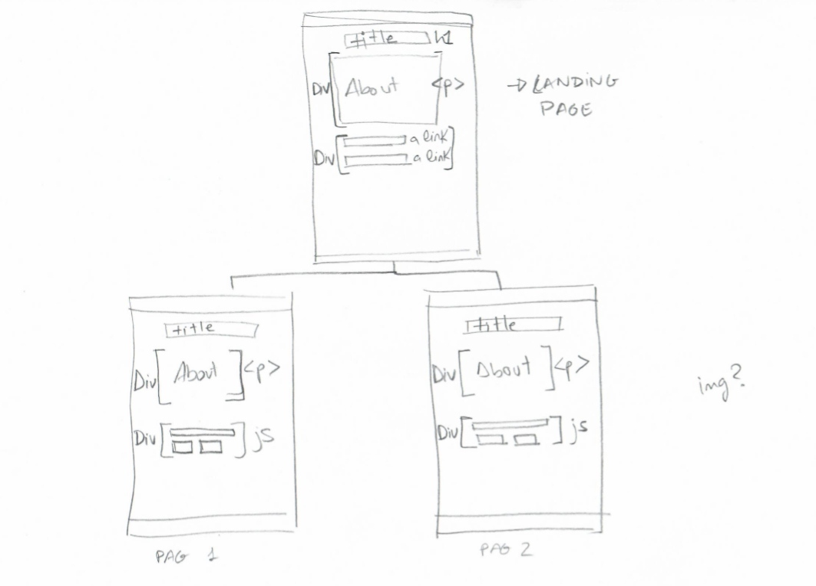

The landing page will display the general information about cyphers and encoding systems. The next section will consist on two links that will connect with the two sub-pages.

The subpages will have the same layout. They both will have a paragraph to display some content about each cypher followed by the “input area” where the user will be able to encrypt their messages.

In terms of the design, I want to create a good-looking site based on light and earthy colours. Since cyphers were used since centuries ago, I chose fonts that remind the classic Greek writing for a more traditional touch, however I will change that scheme on the Base 64 webpage for a more modern design by adding a background related to the digital world.

1. IMPLEMENTATION

1.First, I create the html file of the landing page to configure the basic structure. I will use the same template slightly changed for the two sub-pages too:

<h1>Title of the page

<p>Paragraph to include the content.

<div>This will be a section to add the different elements depending on the webpage. Inside here, I will add more elements to personalise each webpage depending on the requirements and design.

(Landing page-html code)

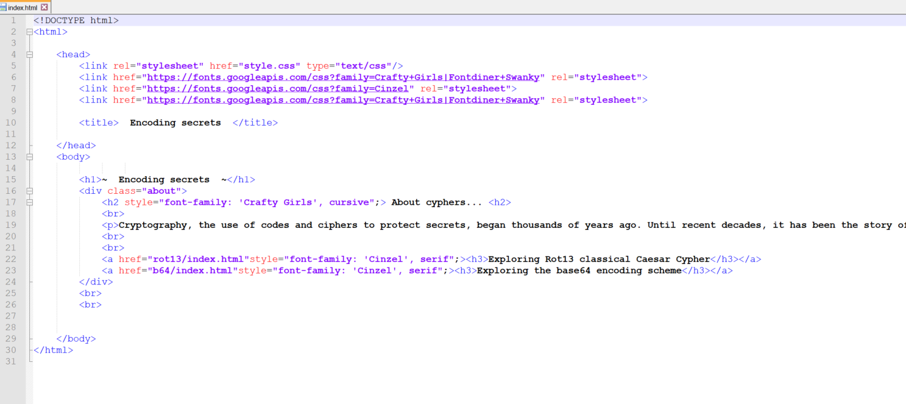

(Landing page-webpage view)

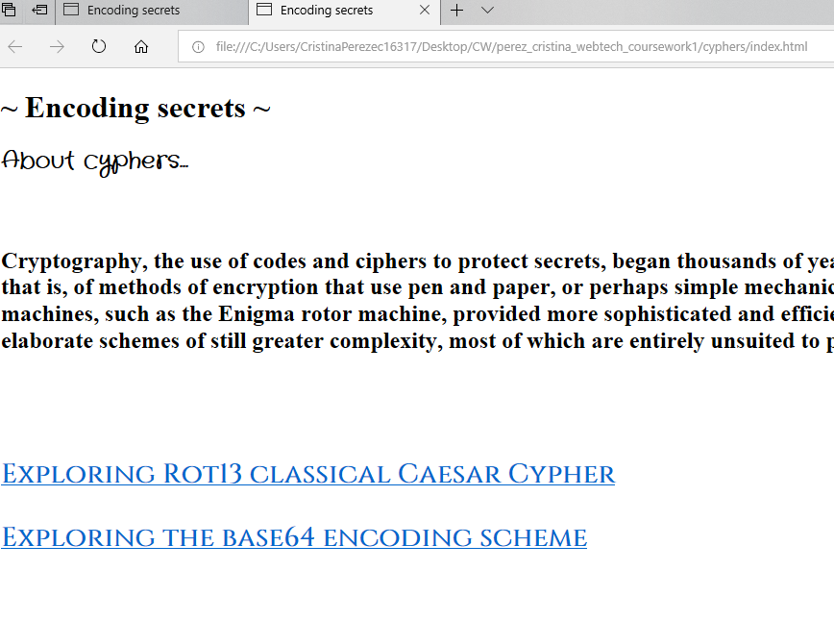

(Rot13 page-html code)

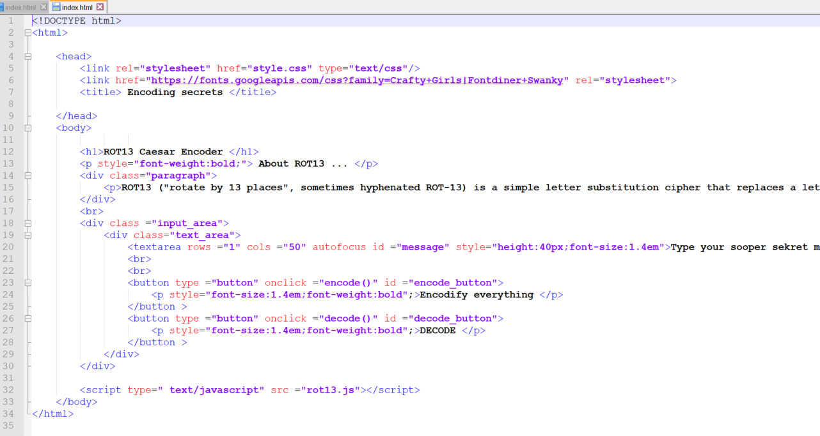

(Rot13 page-html view)

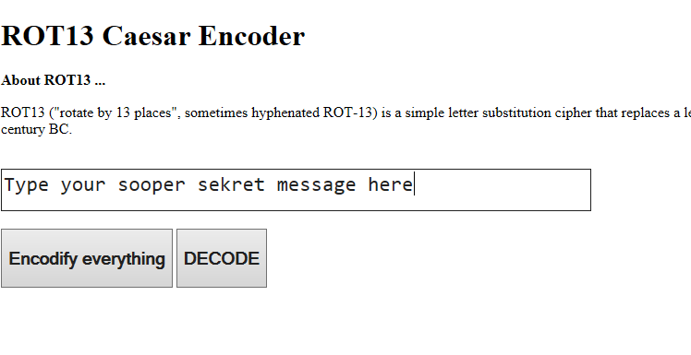

(Base 64 page-html code)

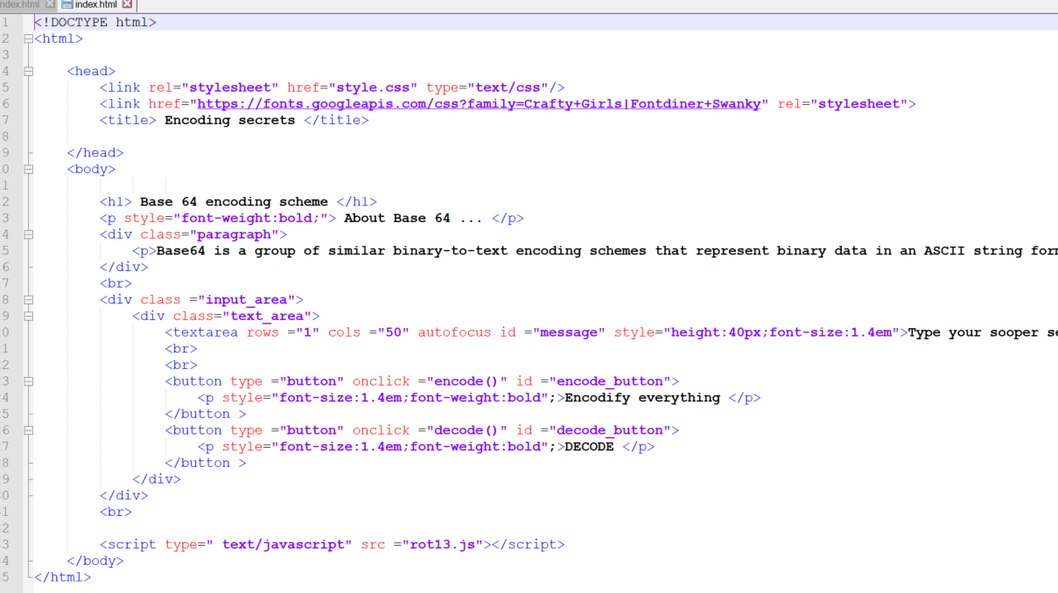

(Base 64-html code)

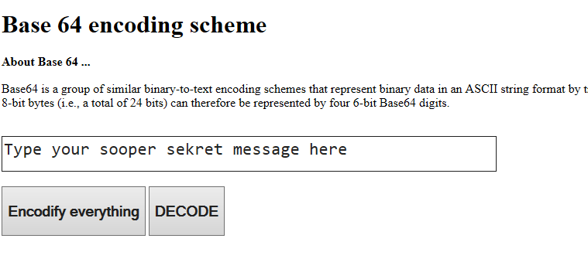

2.Once having the basic structure of the website, I create a CSS file for each page so I can personalise them. I also add a folder containing the two images I am going to use as background for my two sub-pages.

(Langing page-css code)

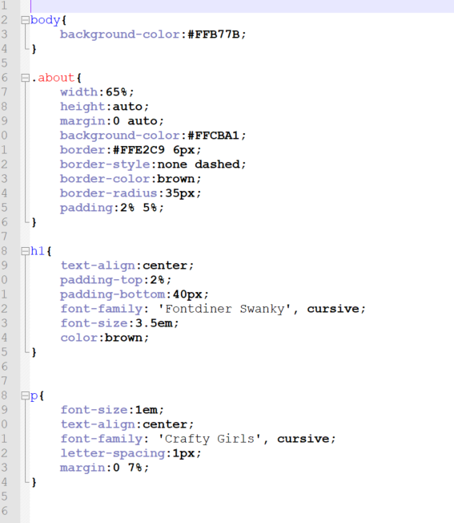

(Landing page-website view)

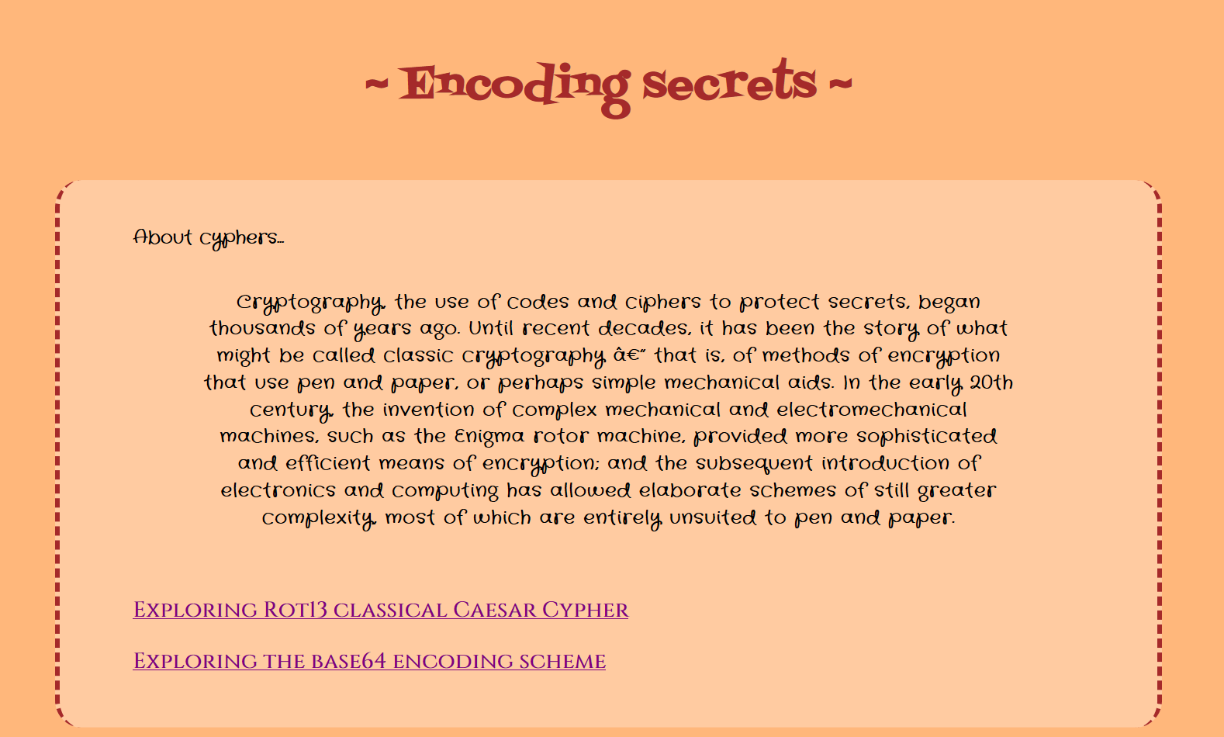

(Rot13 page-css code)

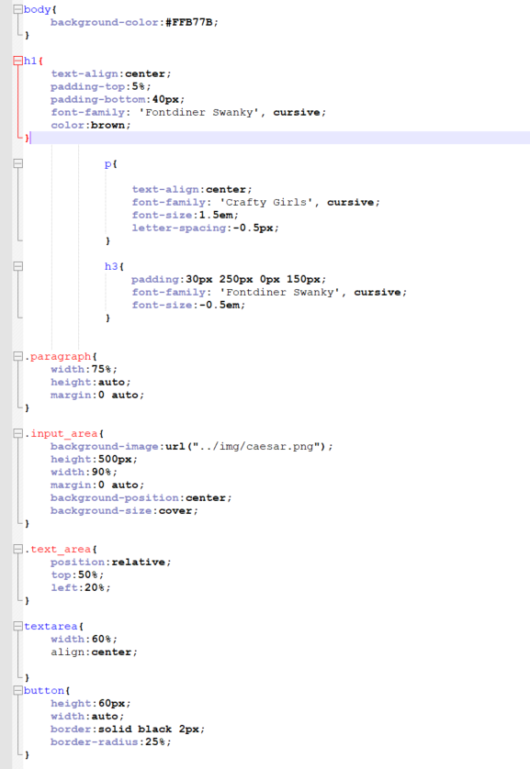

(Rot 13 page- website view)

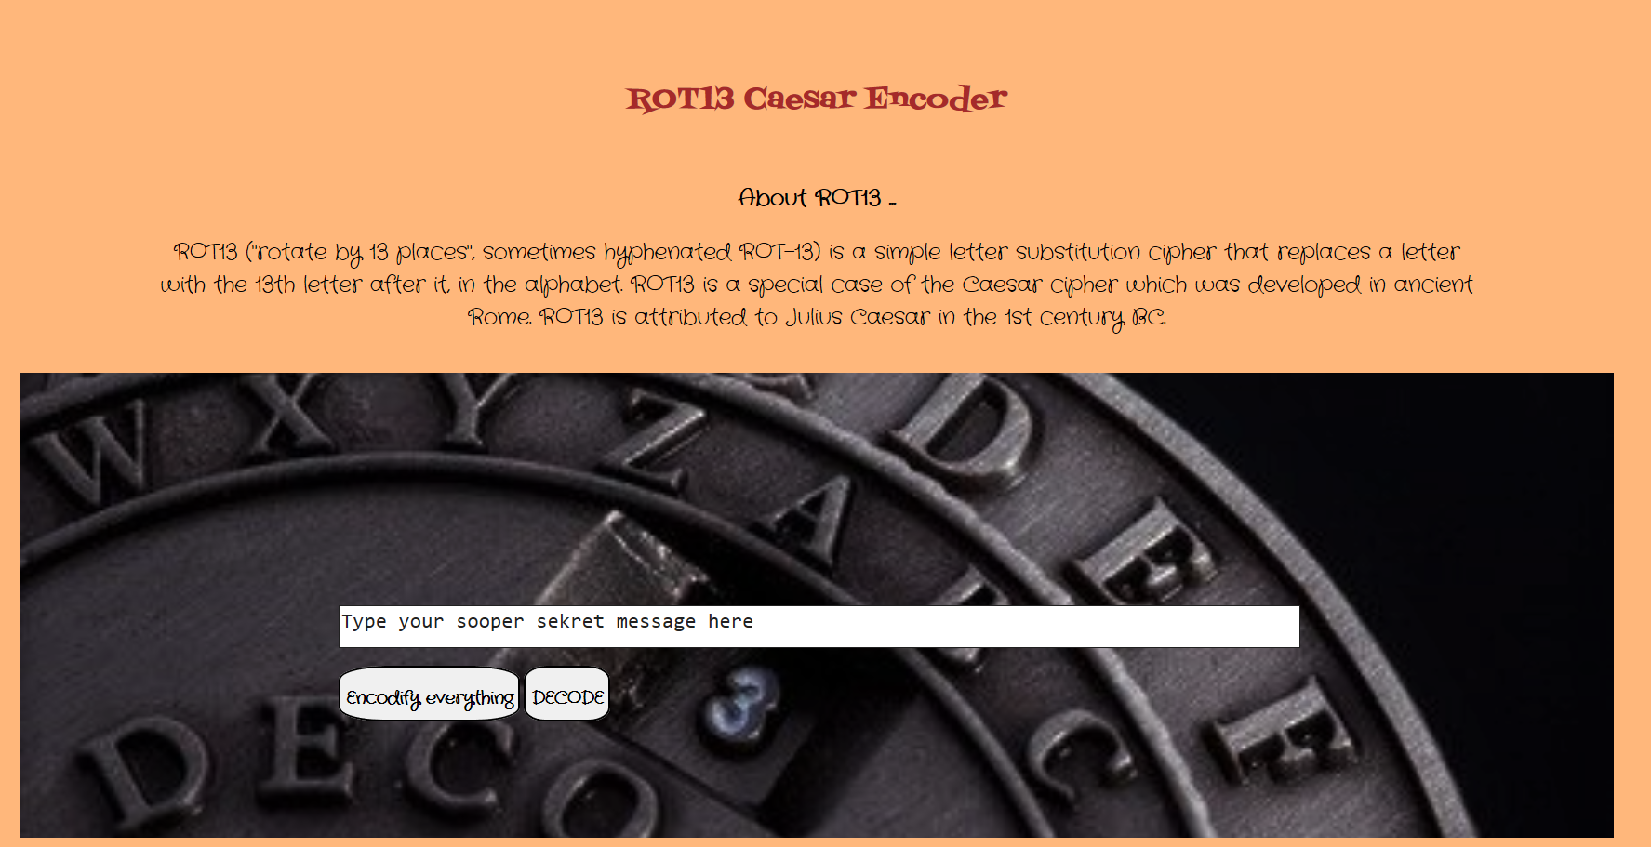

(Base 64 page- css code)

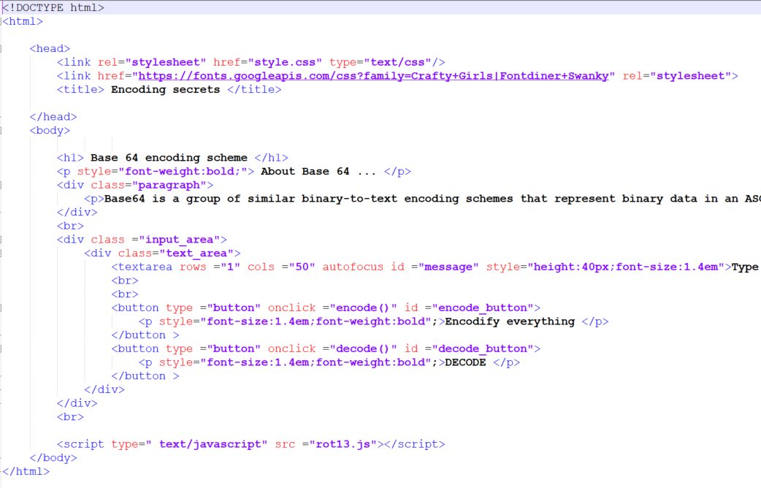

(Base 64- website view)

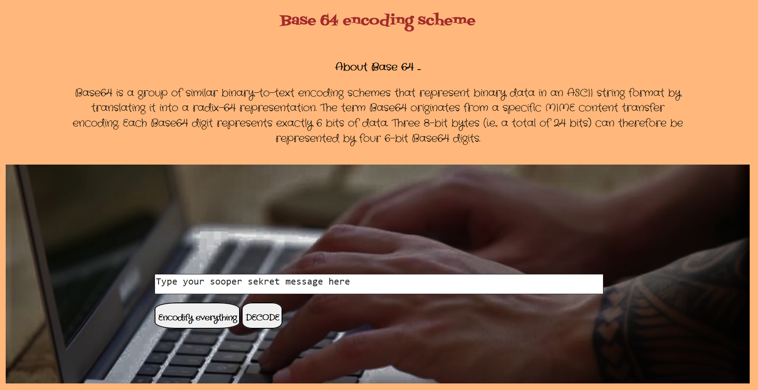

3.Finally, I create the corresponding JavaScript for the sub-pages that will contain the codification and decodification system.

1. CRITICAL EVALUATION OF IMPLEMENTATION

Every requirement set out in the coursework sheet haven been accomplished in this project. This website allows user to choose between two encoding schemes, and to enter any message to get encoded in the text area. There are two buttons that the user can press to get the message encoded and decoded.

These requirements have been implemented on a very basic website that could be as large as we want by adding more cyphers or encoding schemes, webpages, …

Although the website achieves its objective, it could be a lot more interesting if I had added more cyphers to it. This would bring a more diverse view to users about encryption schemes and it would make the whole experience a lot more enjoyable and fulfilling.

In terms of the design, I could have implemented more events to enhance the user experience like colour changing on click’s or size changing on over events. That would bring dynamism and movement to the website.

The overall look of the site is very simple, clean and symmetric to have a good balance. I would add a header and a footer to gather and frame the content of every page. The colours scheme is very limited because I wanted to have a good integration of the images as background and a good consistency.

1. PERSONAL EVALUATION

This project is been very useful as first approach to JavaScript, its syntax and implementation in a website. It made me aware of the scope that JavaScript has to achieve very interesting effects.

The biggest challenge was to learn how html, CSS and JavaScript interact with each other, how to combine their syntax and to decide which implementation way was more convenient depending on the requirements. Small details like “style tag” in in-line html overwrites the“style”css file, or the property “*margin: 0 auto;*” locates an element in the centre of the page width.

I always approach these challenges by making some research. There are many digital communities, platforms and forums whose objective is to put in contact programmers regarding different issues or projects. I think these forums are really good to learn different ways to solve programming problems because every code is made by a different person with a specific background and experience. I also use websites like w3schools.com where I can find the basic steps to start a project.

After this coursework I feel more confident about my self-learning skills and I have widened my resources range. I have more tools that I can count on with for future projects

1. REFERENCES

Online resources

-www.3wschool.com

-github.com

-stackoverflow.com

Images resources

-canva.com

-etsy.com