ABSTRACT
Mallplaza (Plaza S.A.) is the largest shopping center operator in the Andean region: 37 centers and 2.36 million m² of GLA in Chile, Peru and Colombia, with revenue almost as predictable as a bond (81.4% rents, 93% fixed and UF-indexed in Chile) and an 80.5% EBITDA margin. It is a great business, but at CLP 3,555 the market prices it as if its cash flows were nearly risk-free. Weighting our DCF at 80% and peer multiples at 20%, we reach a target price of CLP 2,076 and recommend SELL. Our disagreement with the market is not about cash flows but about the discount rate: the price requires a 7.56% WACC, 285 bp below our 10.41%, and a 6.0% cap rate against the 10.1% implied by our cash flows. Growth does not rescue the price, because each new m² earns a 5.0% real return against a 7.2% real WACC, and neither the bull case (CLP 2,627) nor the appraisers' rate (CLP 2,719) reaches the share price. The main risk to the thesis is a further compression of long-term rates.
Recommendation  SELL | Target price  CLP 2,076 | Price (30-Sep-26)  CLP 3,555 | Upside / downside  −41.6%

BUSINESS DESCRIPTION
FROM ONE MALL IN LA FLORIDA TO 37 URBAN CENTERS ACROSS THE ANDEAN REGION
Figure 1: GLA by country (2Q26) and revenue by source (LTM to Jun-2026)
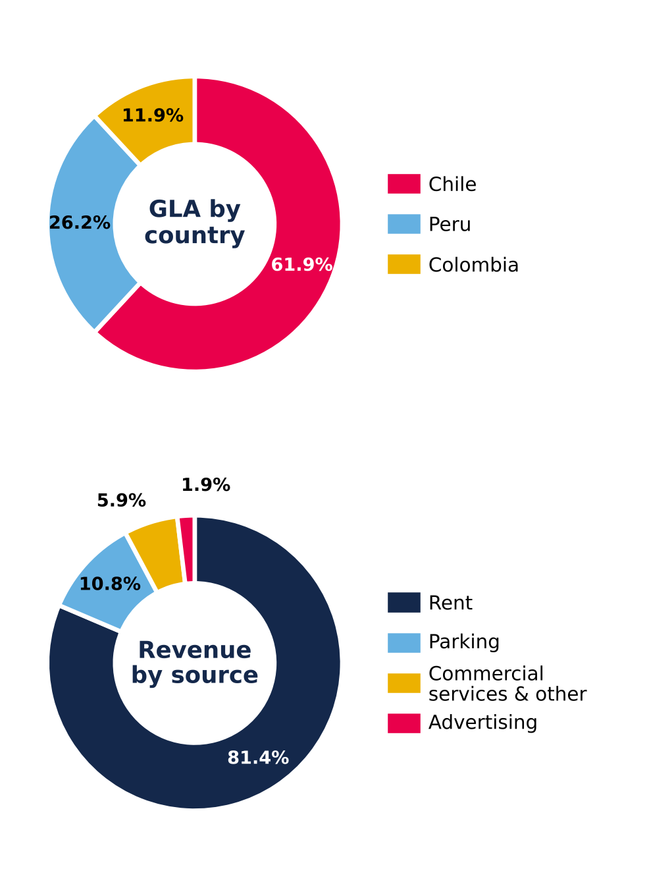
Source: Plaza S.A., Earnings Release 2Q26 (p.19) and Institutional Presentation 2Q26 (p.16).
Mallplaza was founded in 1990 with Mallplaza Vespucio, built from the ground up in La Florida, and 35 years later it is one of the leading retail real estate players in the Andean Region, with 37 urban centers and 2.36 million m² of GLA across Chile, Peru and Colombia (Figure 1). It entered Peru in 2007 with Mallplaza Trujillo, listed on the Santiago Stock Exchange in 2018, and is currently controlled by Falabella S.A., which held a 53.1% stake as of December 2025. Its business, however, remains the same as at inception: leasing m². Rent accounts for 81.4% of last-twelve-months (LTM) revenue, with the remainder coming from parking, commercial services and advertising. Because 93% of that rent is fixed and, in Chile, indexed to the UF, revenue is highly predictable, and the company also manages to grow it in real terms. In Chile, same-store rent (SSR) rose 6.5% LTM versus CPI of 4.3%, without straining its tenants, as rent represents only 9.9% of their sales (occupancy cost), nearly unchanged from a year earlier (9.7%). Nor is this an isolated good year: between 1Q23 and 2Q26, Chile SSR averaged 6.9% against inflation of 4.8%.
A CONSTANTLY REINVENTED TENANT MIX AND HIGH MARGINS BY DESIGN
That pricing power rests on a tenant mix the company has successfully reinvented. Department stores, which occupied 26.7% of GLA in 2020, fell to 19.0% in 2Q26 after Mallplaza converted roughly 146,000 m² of large-format stores since 2019 to brands such as IKEA, H&M and Decathlon (Appendix 2). Today, 32.2% of GLA is devoted to essential retail and daily-traffic services, such as supermarkets, home improvement, public services and healthcare, which drive high-frequency visits, and another 21.5% to specialty retail. No single tenant dominates revenue: the top five tenants account for 18% and related parties for 15.7%. Add to this a lean cost structure, with cost of sales at 6.2% of revenue and administrative expenses at 13.9%, which leaves an LTM EBITDA margin of 80.5%.
VALUE IS CONCENTRATED IN 10 TIER A ASSETS
The growth story is written in its best assets. Ten centers, seven in Chile, two in Colombia and one in Peru, are Tier A, and with 46.4% of GLA they generate more than 60% of EBITDA (Appendix 1). Investment is directed toward them, as the expansions under construction at Trébol, Oeste, Norte, Trujillo and La Serena aim to lift Tier A assets to more than 70% of GLA.
INDUSTRY OVERVIEW AND COMPETITIVE POSITIONING
AN INDUSTRY THAT IS CONCENTRATED IN CHILE AND FRAGMENTED IN PERU AND COLOMBIA
In retail real estate, shopping center operators do not sell products; they lease square meters of gross leasable area (GLA) to their tenants in exchange for income that is mostly fixed and indexed to each country's inflation. At Mallplaza, for example, 93% of rental income is fixed. For this reason, we measure market share by GLA rather than by sales, and on that basis Mallplaza, Cenco Malls and Parque Arauco together manage 3.4 million m² in Chile alone.
Market structure, however, varies from country to country (Figure 2). In Chile, the trio holds 76% of the GLA of the main operators (CR3) and the partial HHI reaches at least 2,126 points, typical of a highly concentrated market, with Mallplaza as leader (33%) followed by Cenco (29%) and Parque Arauco (14%). In Peru and Colombia, by contrast, the trio accounts for only 37% and 13% of GLA, respectively, leadership is held by an outside operator with 29% and 9%, respectively, and Mallplaza ranks second in both markets. Fragmentation is greatest in Colombia, where most shopping centers are strata-titled (multi-owner), which forces professional operators to grow by acquiring single-owner assets, as Mallplaza did with Gran Plaza.
NEW SUPPLY IN CHILE GROWS IN LINE WITH CONSUMPTION, WITH PRESSURE IN 2027-2028
Between 2026 and 2028, the trio will add 219,900 m² of organic GLA in Chile that will compete for consumer spending, equivalent to 6.7% of its current GLA; this figure excludes offices and multifamily, which do not depend on consumption, as well as acquisitions, which merely change ownership. Over the same period, the Central Bank of Chile projects cumulative private consumption growth of 6.4% (Figure 3), so new supply is advancing practically in line with expected demand. The timing, however, is uneven: 2026 adds almost no space (+0.2%), and pressure is concentrated in 2027 and 2028, when supply (+2.9% and +3.5%) outpaces consumption (+2.1% and +2.7%).
Figure 2: Market share by GLA and concentration, 2Q26
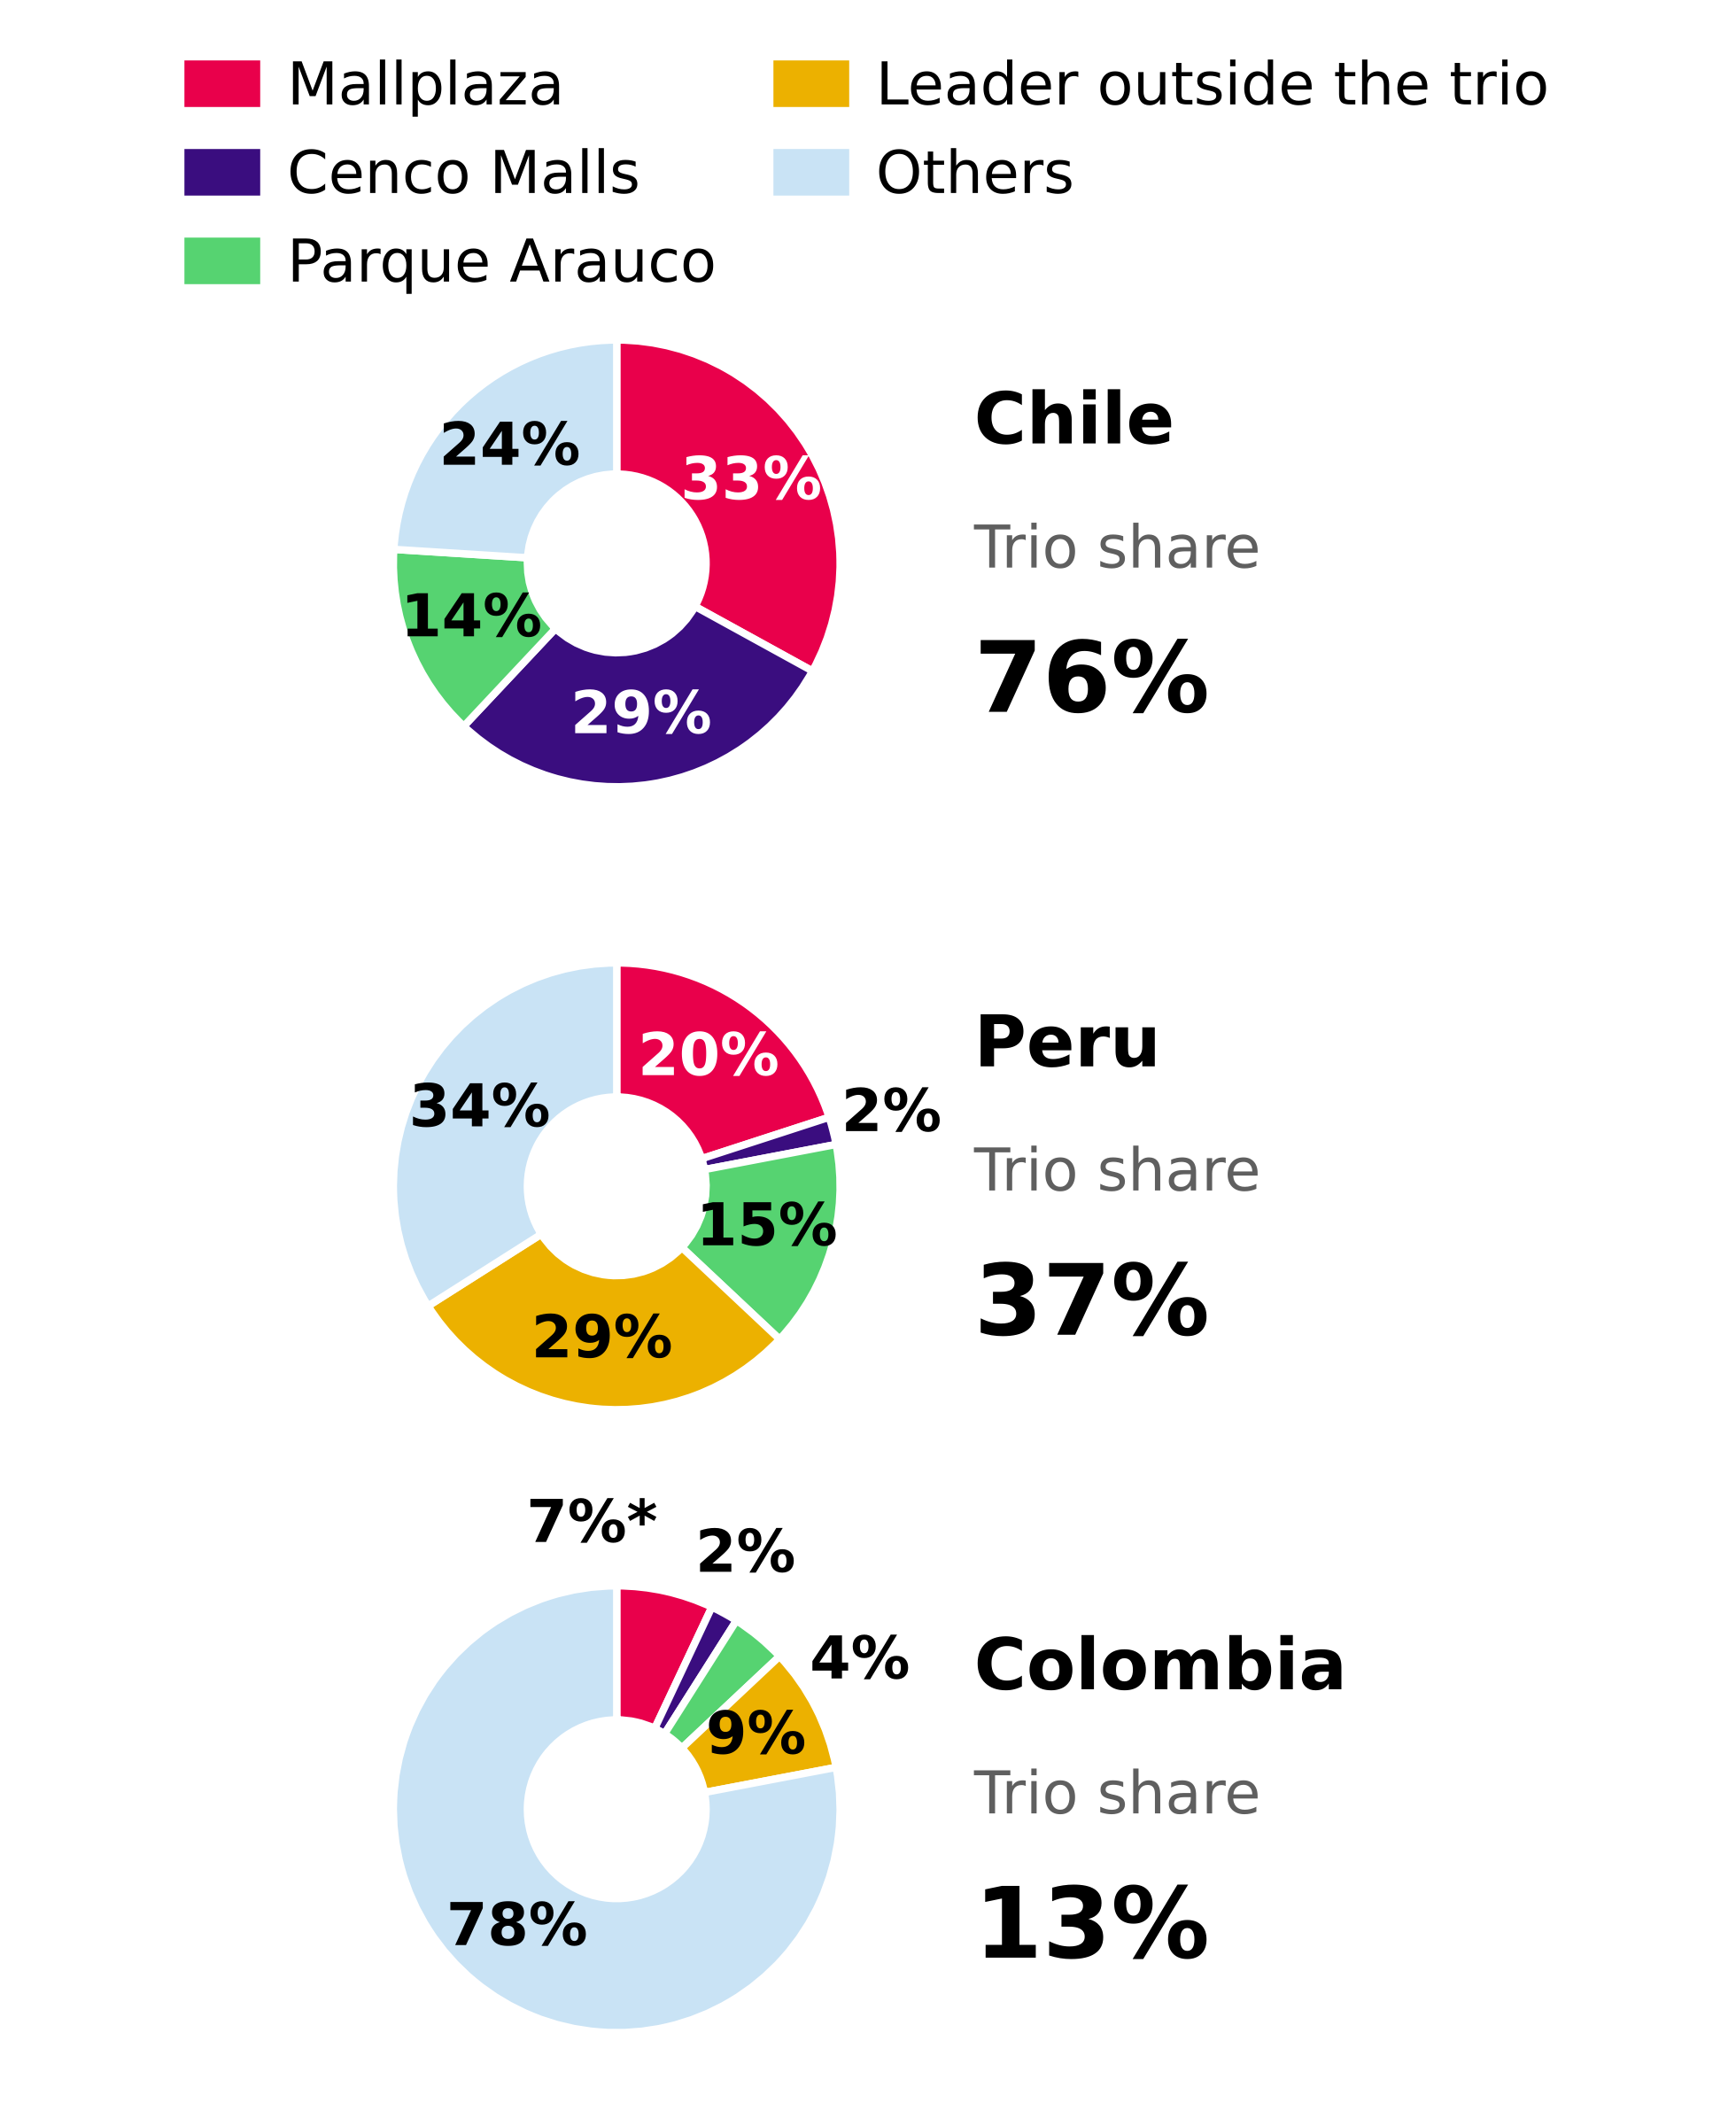
Source: Plaza S.A., Institutional Presentation 2Q26 (slide 7); team analysis. Colombia pro forma, including Gran Plaza.
The starting point is challenging, as in 2Q26 real tenant sales of the trio in Chile fell 2.5% YoY. Mallplaza was the only one to grow in real terms (+1.0%), versus declines at Parque Arauco (−1.7%) and Cenco (−5.9%). Even so, tenants continue to demand space, and consolidated occupancy at the three companies has ranged between 93% and 99% since 2Q22, even through the cycle of high inflation and interest rates (Appendix 4). Outside Chile, the balance is more comfortable: dated new supply is limited to Mallplaza expansions in Peru (55,800 m²), is practically nil in Colombia, and coexists with Mallplaza same-store sales (SSS) that grew 7.0% in Peru and 9.0% in Colombia in local currency.
AN ATTRACTIVE INDUSTRY WHOSE ONLY INTENSE FORCE IS RIVALRY
To assess the industry's attractiveness, we analyze Porter's five forces in each country on a scale of 1 (weak) to 5 (intense) and weight them by Mallplaza's GLA in Chile (62%), Peru (26%) and Colombia (12%) (Figure 4; evidence in Appendix 6). The result describes an attractive industry, consistent with EBITDA margins ranging from 71% to 90% across the three operators, in which the only intense force is rivalry.
Figure 3: New GLA supply in Chile vs expected private consumption, 2026-2028
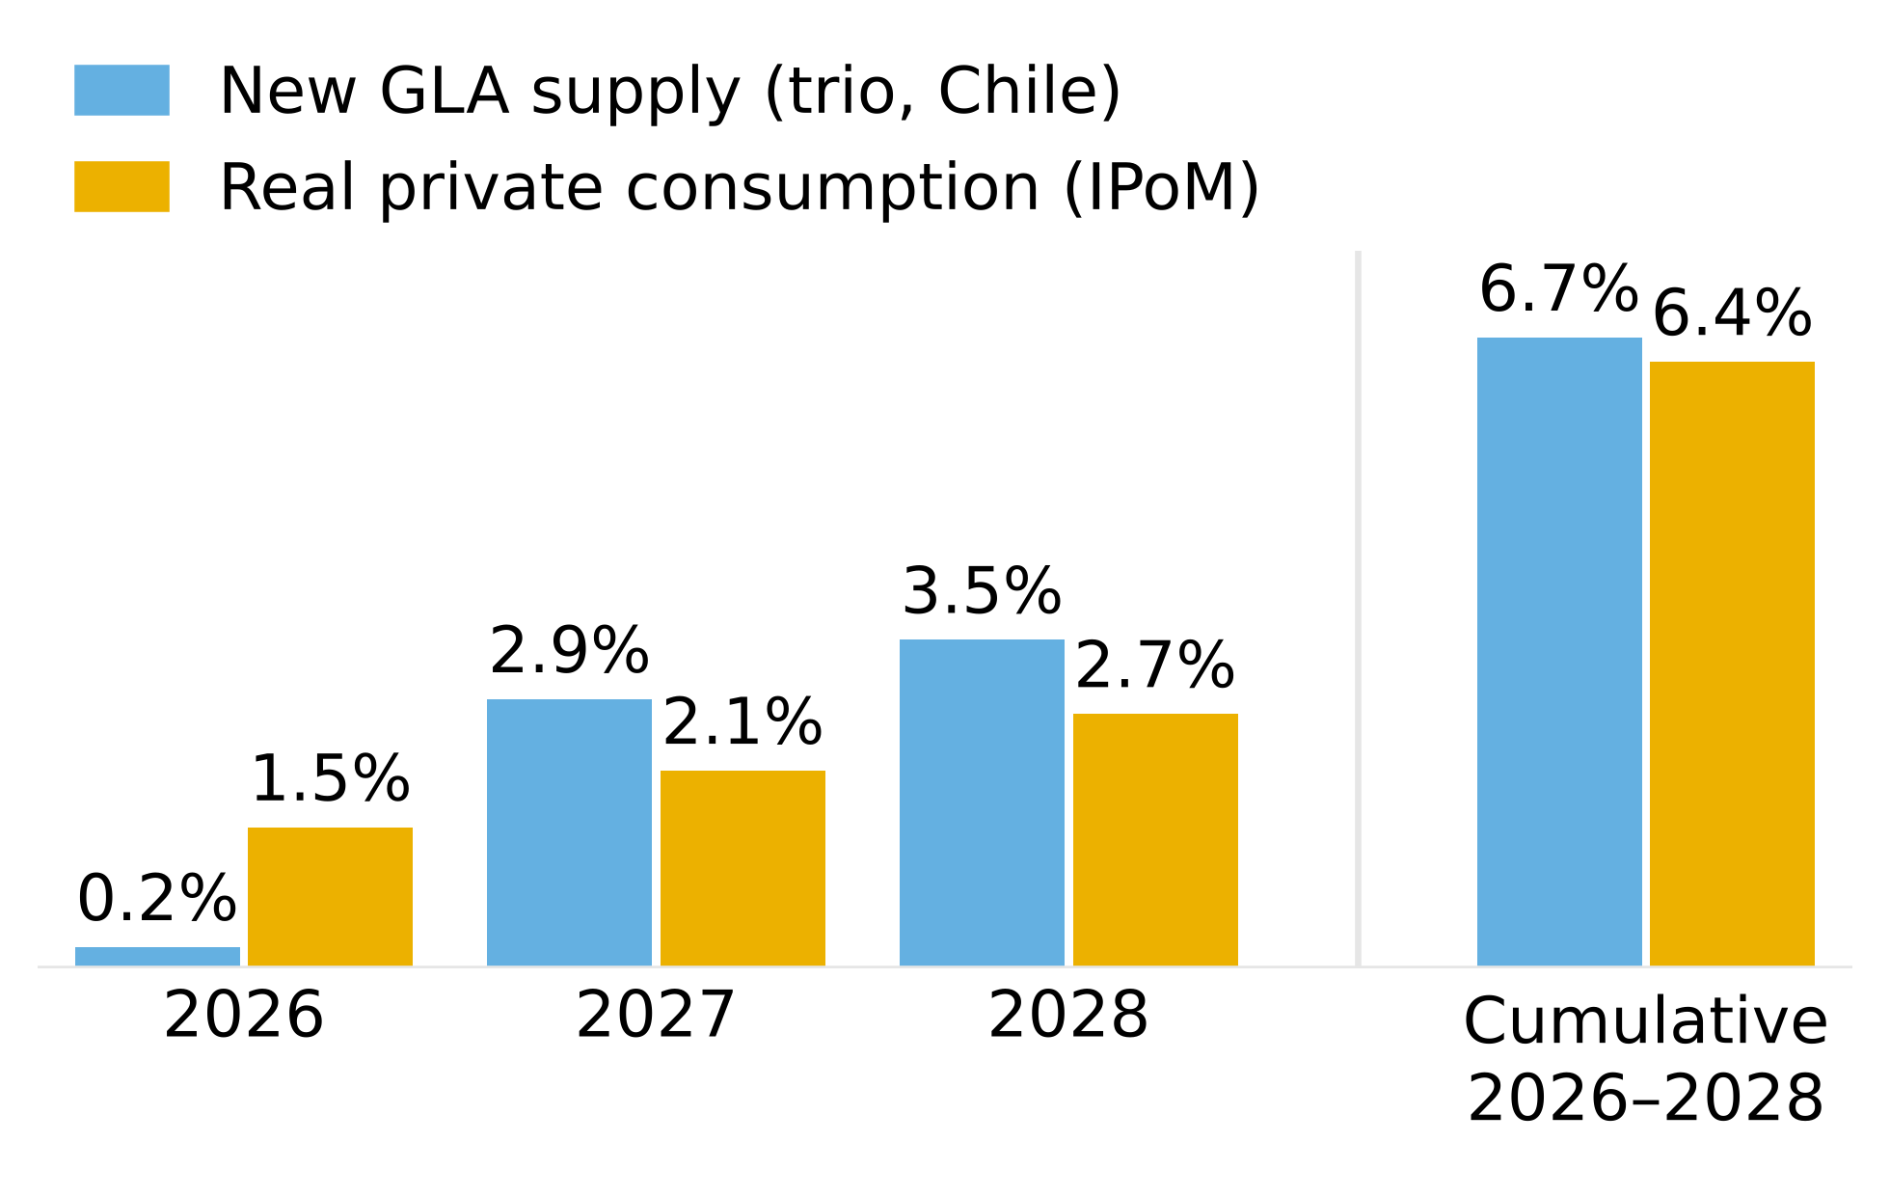
Source: 2Q26 reports of Plaza S.A., Parque Arauco and Cenco Malls; Central Bank of Chile, Monetary Policy Report (IPoM) Sep-2026 (Table II.1); team analysis. Organic consumption-dependent GLA only.
Rivalry (4) is played out not on price but on experience and assets. Mallplaza devotes more than half of its GLA to non-traditional, experience and entertainment formats, Cenco opened QINTO with 30,000 m² of food and dining at Costanera, and Parque Arauco is adding dining floors at Kennedy, while competition to acquire assets is intensifying, with Minka and Plaza Central changing hands in the past year and Parque Arauco announcing the purchase of Quilín and Chicureo. We do not assign the maximum score because the trio's shares in Chile have remained stable since 2Q22 (Appendix 5) and margins show no erosion.
The threat of new entrants (2) is limited, because developing a shopping center is highly capital-intensive (Mallplaza's expansion pipeline totals USD 613 million for 170,200 m²) and much of the scarce urban land is already in the hands of incumbents, with land banks of 618,200 m² at Mallplaza and 640,136 m² at Cenco, although the barrier is lower in Peru and especially in Colombia. The bargaining power of tenants (1) is weak, given that occupancy in Chile reaches 96-99%, leases are long (Figure 6) and tenants are highly fragmented, to the point that the top five account for only 18% of Mallplaza's revenue. Evidence of this is that Mallplaza has raised its rents in Chile above inflation for more than three years (6.9% versus 4.8% on average between 1Q23 and 2Q26) without its tenants' occupancy cost spiking. The exception is department stores, which as anchors negotiate better terms, although their weight has already fallen to 19.0% of GLA. Suppliers (1) carry little weight, because common-area expenses are passed through to tenants and cost of sales represents only 6.2% of Mallplaza's revenue. Finally, substitutes (2) are a low threat: e-commerce takes sales away from tenants, but fixed rent protects the operator and foot traffic keeps growing, as shown by the 4.4% increase at Mallplaza Chile in 2Q26.
MALLPLAZA TURNS ITS SCALE INTO THE MOST PRODUCTIVE M² OF THE TRIO
Figure 4: Porter's five forces, 1-5 scale
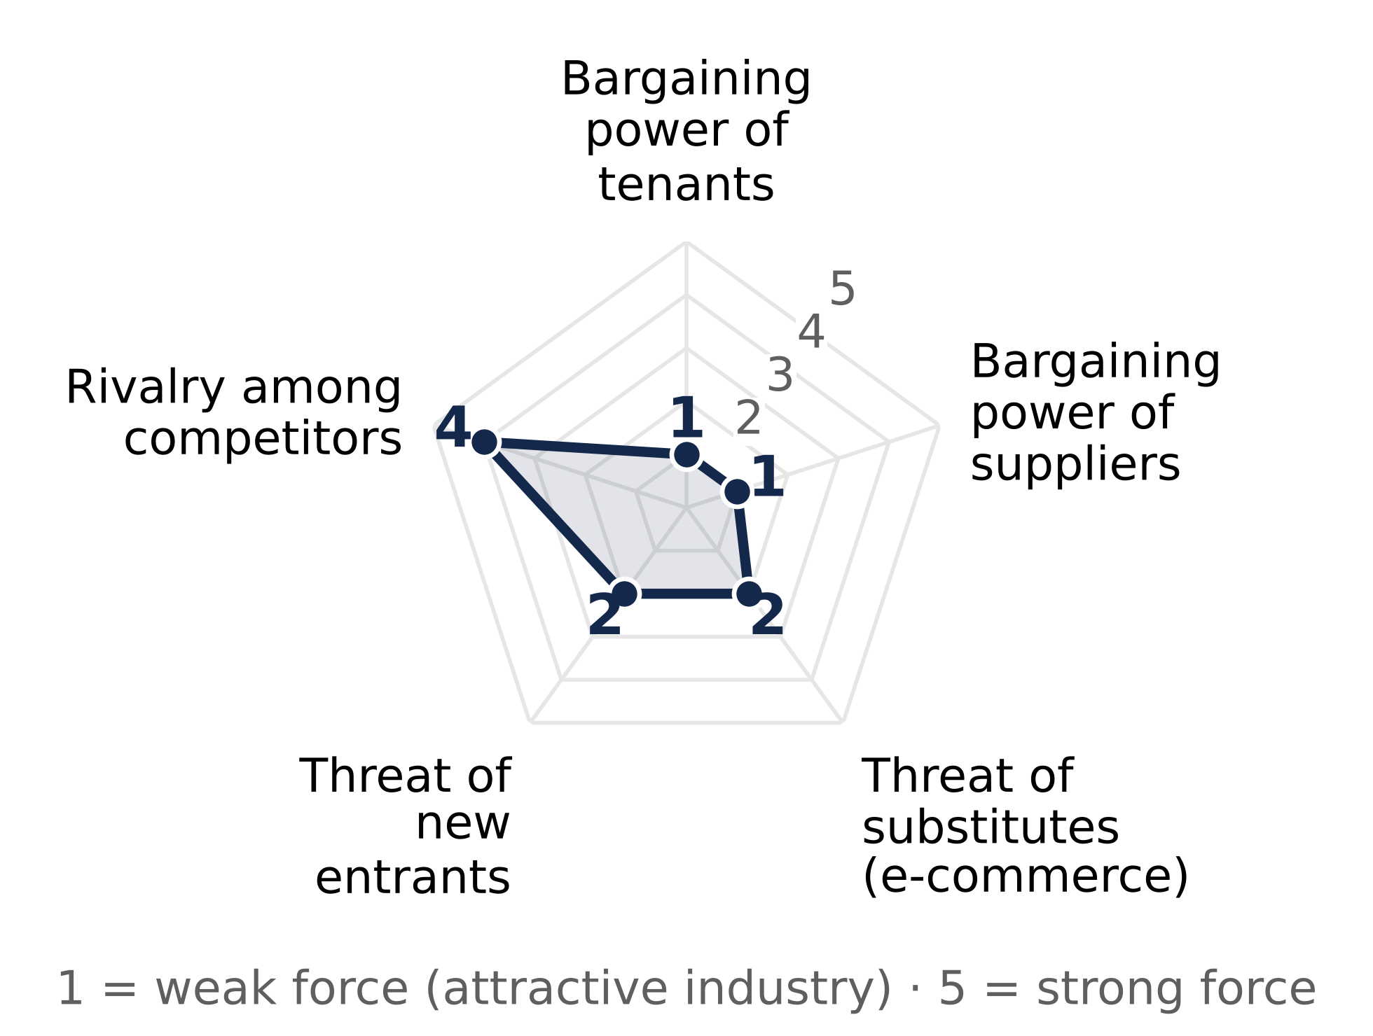
Source: team analysis based on 2Q26 reports (Appendix 6). 1 = weak force; 5 = intense force.
Mallplaza turns its scale into the highest EBITDA per m² of the trio, at CLP 59,451 in 2Q26 versus 58,384 at Cenco and 55,738 at Parque Arauco (Figure 5). That advantage stems from high-traffic urban locations, which in Chile received 52.7 million visits in the quarter versus 32.5 million at Cenco, and from monthly sales per m² of CLP 289,788 in Chile, 5.8% higher than a year earlier. The gap with Cenco is narrow and is partly explained by Cenco having added Plaza Central in June, with just one month of EBITDA in the quarter.
In terms of share, Mallplaza has ceded 1.2 pp within the trio in Chile since 2Q22, mainly because Parque Arauco added Kennedy Oriente (70,000 m²) through an acquisition while Mallplaza grew only through expansions, an organic strategy that its 114,400 m² pipeline in Chile through 2028 allows it to sustain.
LONG LEASES TO DEFEND ITS POSITION
That position is backed by long-duration leases. The weighted average remaining lease term at Mallplaza is 7.1 years and 57% of its GLA expires in more than five years (Figure 6), placing it between Cenco (8.7 years) and Parque Arauco (5.0 years) with a useful balance: it secures enough revenue to weather the supply pressure of 2027-2028 while leaving 15.1% of GLA expiring within two years to reset rents if demand allows.
Figure 6: Lease expiry profile (% of GLA) and weighted average remaining term, 2Q26
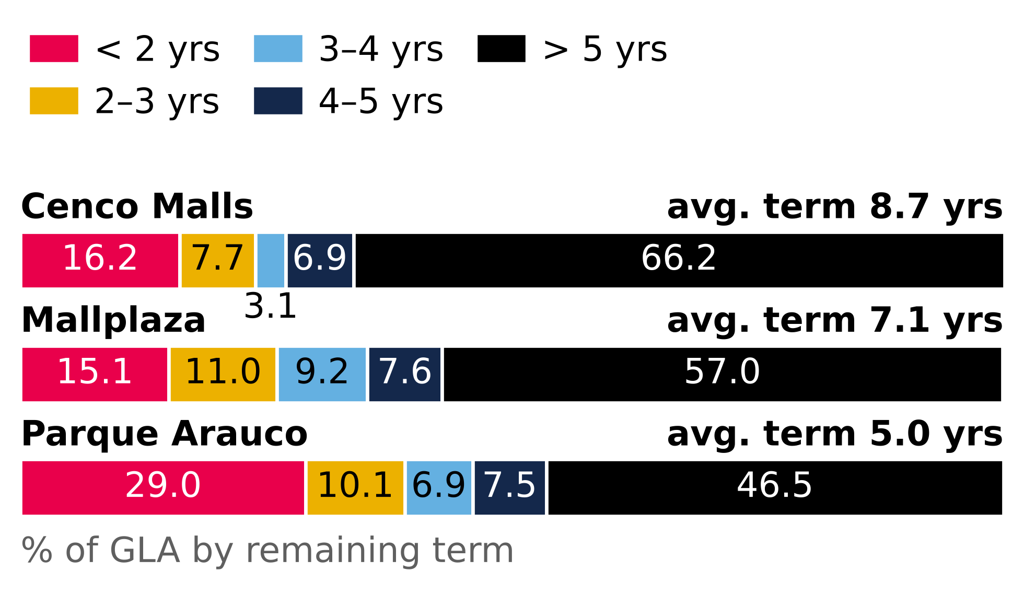
Source: Plaza S.A. Earnings Release 2Q26 (p.7); Cenco Malls Earnings Presentation 2Q26 (p.14); Parque Arauco 2Q26 Report (p.7) and Investor Presentation 2Q26 (slide 17). GLA-weighted; assumption for Mallplaza.
In an attractive industry, but one with high rivalry and supply that will outpace consumption in 2027-2028, the operators with the most productive assets and the most stable leases will gain share and profitability. Mallplaza leads in scale in Chile and in productivity per m², and is the only one of the trio with growing real sales, which leaves it well positioned to defend its profitability. Its main risk is its exposure to Chile, which accounts for 62% of its GLA and where consumption currently looks weaker.
ENVIRONMENTAL, SOCIAL AND GOVERNANCE (ESG)
Plaza's ESG approach cuts across all of its organizational decisions, with the aim of developing its business model in accordance with ESG parameters and thereby contributing to sustainable development, which gives it the opportunity to access financial benefits both from external sources and from its own operations. Regarding compliance with these parameters, Bloomberg rates the company at 3.39 points, below the global industry average (5–6 points) and below its direct competitors in Chile (Figure 7); however, this is offset by the company's “green” profile at the local level, as it ranks among the leading real estate companies in the region. Potential financial benefits: As for operational benefits, the implementation of an ISO 50001-certified energy management system (EnMS) translates into better energy performance and, consequently, lower operating costs. The opportunities to access local external benefits are tied to the company's ESG image: in Chile, under the R&D Law (CORFO), Plaza can obtain up to a 55% reduction in first-category corporate income tax; Peru recognizes the company with 2 out of 4 stars under “Huella de Carbono Perú”, which strengthens the company's image and makes it easier to obtain permits and licenses in the country; and Colombia has Law 2099 of 2021, which allows income tax deductions for investments in environmental control, conservation and improvement.
ENVIRONMENTAL
Plaza's approach is to achieve efficient, sustainable and circular operational management based on continuous improvement in environmental performance. To this end, it has set three strategic focus areas on ESG parameters: energy and water efficiency, carbon footprint, and waste management. Plaza's main objective is to achieve carbon neutrality, targeting Net Zero in direct and indirect emissions by 2035 (65.6% progress in 2025). Sustainability indices: The company is included in the DJSI Chile and DJSI MILA, and is the only real estate company in South America to be part of MSCI ESG, with a “BBB” rating, which gives it exposure to ETFs. In addition, it has received the following recognitions: S&P Global Sustainability Yearbook; Morningstar Sustainalytics assigns it a risk rating of 14.4; and Huella de Carbono Perú (2/4 stars), which supports its ESG image. Energy: Plaza aims to reduce the energy intensity of common-area expenses by 22% by 2035 (35.5% progress in 2025; Figure 8). The electricity efficiency target is for 100% to come from renewable energy by 2026 (89.3% progress). In 2025, the annual ratio was 0.16 MWh/m² (Energy/GLA), of which 0.14 was renewable and 0.014 non-renewable (Figure 9).Water: It set the goal of reducing direct water consumption by 30% by 2025, which was 100.9% achieved, influenced by its LEED and EDGE certifications. In 2025, the annual ratio was 0.77 m³/m² (Water/GLA) and 0.66 m³/m² monthly in December. HCFC: It set the goal of eliminating 100% of HCFC use by 2030 (14.9% progress in 2025), which is vital for GHG emissions management, an area in which Bloomberg recognizes Plaza as a global industry Leader. Waste: Plaza set a target of 60% recovery of waste generated in 2025 (94.8% progress; Figure 9 and Appendix 8, Figure 8.4), and also seeks to divert 75% of solid waste from landfills by 2027. It reports having eliminated 97% of single-use plastics from its operations. Climate management: Plaza adopts the TCFD recommendations to integrate physical and transition risks, together with environmental due diligence on asset acquisitions, under an environmental compliance program aligned with ISO 14001 and monitored by the sustainability committee.
Figure 5: EBITDA per m² of GLA, 2Q26 quarterly (CLP)
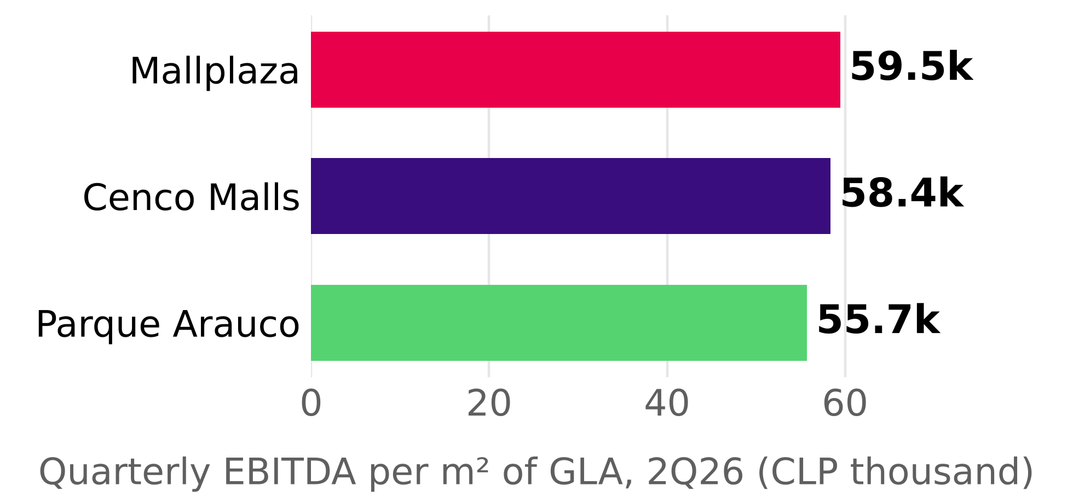
Source: Plaza S.A. Earnings Release 2Q26; Cenco Malls Earnings Presentation 2Q26; Parque Arauco 2Q26 Report; team analysis. 2Q26 EBITDA / consolidated GLA as of June 30, 2026.
Figure 7: Bloomberg ESG score and external ratings.
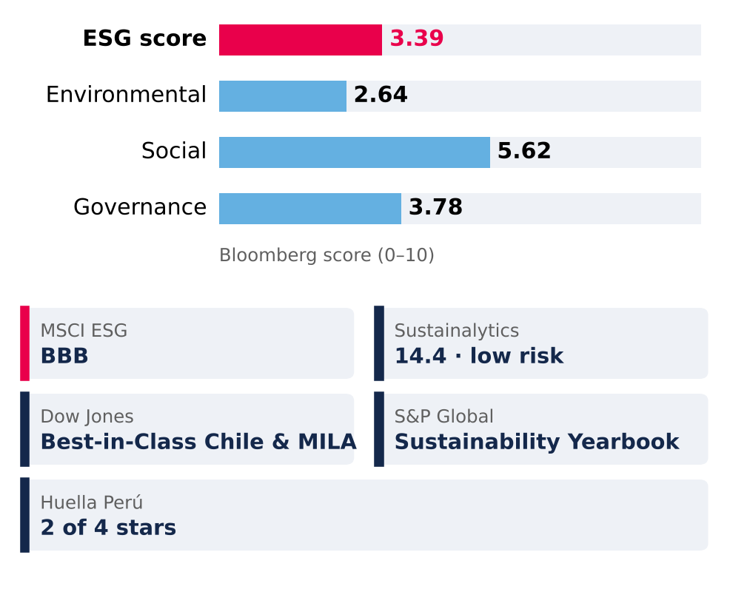
Source: Bloomberg (ESG score); MSCI, Morningstar Sustainalytics, S&P Global, Huella Perú; Mallplaza 2025 Annual Report.
SOCIAL
Figure 8: Environmental targets: progress to 2025.
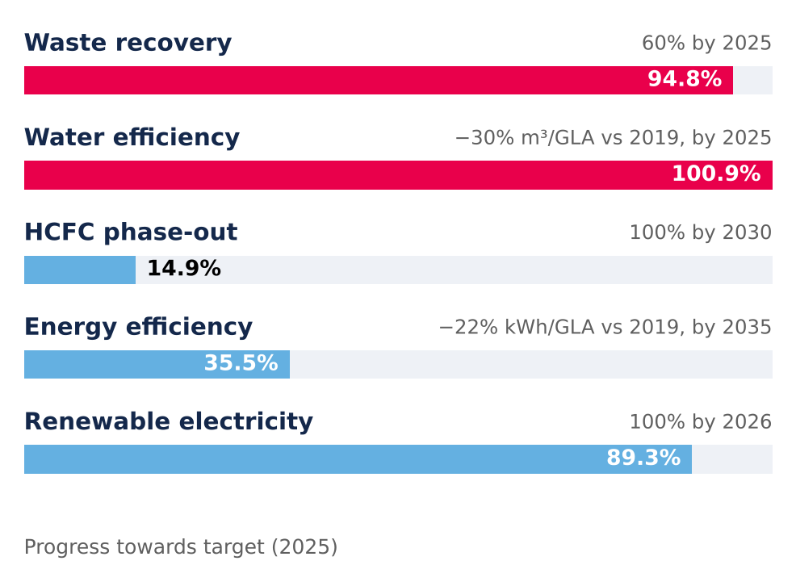
Source: Mallplaza 2025 Annual Report.
The company approaches the social dimension through a model focused on long-term ethical relationships, as a principle of shared value creation that places the people in its stakeholder groups at the center of its strategy, aligned with ISO 45001 and ILO guidelines; in 2025 it incorporated the risk detection and response program of its human rights policy. In this way, Plaza manages its stakeholders by ensuring transparent engagement, using mechanisms such as community dialogues and materiality assessments (Appendix 8, Figure 8.3), and remains alert to any social incident through its integrity hotline. It is also ranked 31st out of 385 by CADEM in “Marcas Ciudadanas” (“Citizen Brands”), winning the “Shopping Centers” category (2026). Regarding employees, they receive training and even have access to specific programs for those nearing retirement (Appendix 8, section 5); in addition, the company evaluates its suppliers using sustainability criteria (55.3% of regional suppliers and 38.4% of foreign suppliers). Plaza manages its relationship with its customers (tenants) through a relationship model focused on value proposition and experience, measuring their satisfaction through NPS, which rose to 13% in 2025 (Figure 10). To manage emergencies, each center has emergency manuals adapted to local geographic contexts and conducts drills to prevent incidents and educate the community (52 drills were conducted in 2025); regarding privacy, Plaza implemented ISO/IEC 27001, ensuring the confidentiality, integrity and availability of information against cyber risks.
In terms of diversity, women represent 53.2% of the total workforce and hold 42% of management positions (Figure 10), and there is an average gender pay gap of 28% at the regional level. The target for 2028 is for 60% of the properties to be certified as inclusive spaces; in addition, Plaza obtained the “Sello Mayor” (“Senior Seal”), a distinction that certifies physical and operational adaptation for older adults.
GOVERNANCE
Figure 9: Renewable energy and waste recovery, 2025.
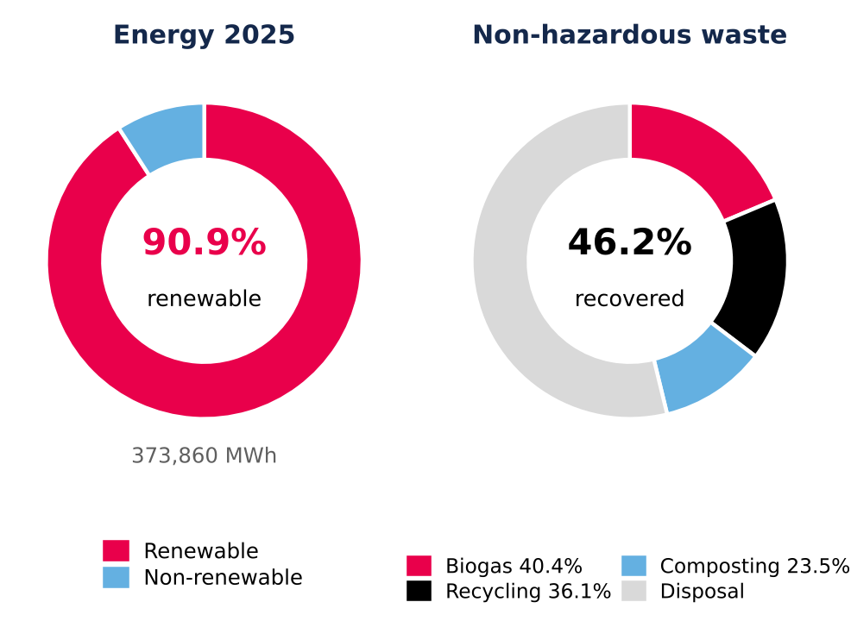
Recovery: percentage of non-hazardous waste; the breakdown adds up to 100% of recovered waste. Source: Mallplaza 2025 Annual Report.
Corporate governance is guided by the G20 and OECD principles, aligned with the CMF's NCG 461; all of this seeks transparent management with risk control and a solid structure to monitor the corporate strategy and ESG commitments. Board and committees: In 2025, the Board, composed of 9 members (only one of whom is classified as independent; Figure 11 and Appendix 8, Figure 8.2), is responsible for defining Plaza's objectives, strategies and policies, while the directors' committee (composed of 3 members) reviews the balance sheets and financial statements, thereby mitigating agency risks. Together, both bodies oversee the risk management led by the executive team committee and the CEO. In the second half of 2025, CEO Fernando de Peña Iver submitted his resignation, effective at year-end, and Pablo Pulido Sierra took over the position in 2026. Shareholders: Plaza has a concentrated control model, as it is controlled by Falabella S.A. through its subsidiary Desarrollos Inmobiliarios SpA (53.05% of the shares; Appendix 8, Figure 8.1). Minority shareholders holding 1% are entitled to propose director candidates, and the shareholders are the highest body, responsible for appointing the Board and external auditors and approving dividend policies. Ethics, audit and control: The ethical framework is supported by the integrity code and the crime prevention model, which together provide a guide for the organization's conduct. In addition, Plaza operates the Autocompliance platform to record meetings with public officials and manage gifts and invitations, along with a confidential integrity hotline for reporting irregularities without risk to the whistleblower. Under the supervision of the directors' committee, a control model is in place, with an internal audit reported monthly to the committee that monitors corrective actions; in parallel, the committee must appoint external auditors and credit rating agencies to analyze the company, as well as have the financial statements audited by independent auditors. Regarding sanctions at the regional level in 2025, Plaza has no antitrust or corruption sanctions, but it has 27 sanctions related to customer/consumer rights, 2 related to workers' rights, 1 from the Superintendency of the Environment and 8 for workplace/sexual harassment (Appendix 8, section 3).
FINANCIAL ANALYSIS
Mallplaza's rental engine grows at roughly 3% in real terms with an 80% EBITDA margin and cash-flow leverage below 2.5x; headline profit, growth and leverage all overstate that engine and must be normalized before forecasting.
Figure 12: Normalized ROE of 8–10% is the real return; reported ROE is appraisal-driven
CLP bn | ’22 A | ’23 A | ’24 A | ’25 A | ’26 E | ’27 E | ’28 E | ’29 E | ’30 E | ’31 E
Revenue | 371 | 420 | 495 | 654 | 704 | 767 | 821 | 870 | 916 | 961
EBITDA margin % | 76.2 | 76.7 | 77.0 | 80.5 | 79.7 | 79.7 | 79.7 | 79.8 | 79.8 | 79.8
FFO margin % | 59.0 | 61.3 | 61.3 | 62.0 | 60.9 | 60.0 | 57.7 | 55.3 | 52.7 | 52.2
Net income, reported | 158 | 350 | 336 | 1,431 | 639 | 592 | 610 | 624 | 627 | 649
Distributable profit | 96 | 198 | 238 | 369 | 380 | 428 | 434 | 437 | 432 | 445
Net margin, normalized % | 25.8 | 47.0 | 48.2 | 56.5 | 54.0 | 55.7 | 52.9 | 50.2 | 47.1 | 46.2
Asset turnover (x) | .086 | .090 | .092 | .097 | .089 | .091 | .092 | .093 | .093 | .094
Assets / equity (x) | 1.94 | 1.91 | 1.86 | 1.77 | 1.69 | 1.71 | 1.74 | 1.79 | 1.84 | 1.89
ROE, reported % | 7.1 | 14.4 | 11.7 | 37.5 | 13.7 | 12.0 | 11.9 | 11.8 | 11.8 | 12.0
ROE, normalized % | 4.3 | 8.1 | 8.3 | 9.7 | 8.1 | 8.6 | 8.4 | 8.3 | 8.1 | 8.2
ROA, normalized % | 2.2 | 4.2 | 4.5 | 5.5 | 4.8 | 5.1 | 4.8 | 4.6 | 4.4 | 4.3
Normalized = distributable profit (2022A team proxy; 2022 UF indexation inflated by ~13% inflation). Average balances; series starts in 2022 (IAS 40 fair value applied retroactively from 1 Jan 2022). 2026E–2031E: valuation base case; balance sheet rolled forward from Dec-25 (equity + reported profit − ordinary and additional distributions; property revalued at 3% inflation, 27% deferred tax; net debt rising to 3.5x EBITDA by 2031E). Source: Plaza S.A. financial statements (CMF), Note 20e; 2Q26 results release (FFO); Team analysis.

Figure 10: Social indicators.
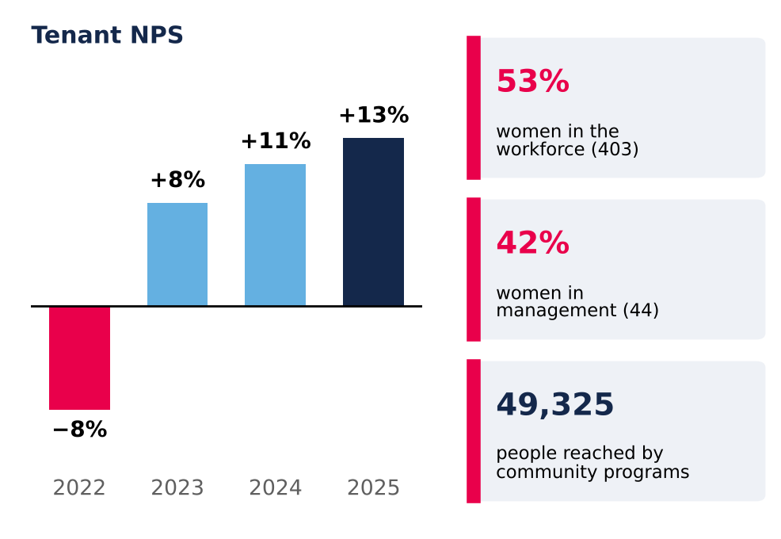
NPS = % of promoters (scores 9–10) minus % of detractors (0–6). Source: Mallplaza 2025 Annual Report.
Reported earnings track the appraiser; FFO tracks the business
Under IAS 40, revaluations of investment property run through the income statement. In 2025 a CLP 1,447bn fair-value gain, 27% of opening property value against about 2% a year at Parque Arauco and Cencosud Shopping, lifted attributable net income to CLP 1,431bn (2.2x revenue) and reported ROE to 37.5% (Figure 12). About two-thirds of Chile's 29% uplift came from a lower appraisal discount rate, not from higher NOI.
Excluding fair-value gains net of deferred tax, audited distributable profit was CLP 369bn and ROE 9.7%, the highest of the three local peers on a comparable basis (Appendix 14). FFO, which we rebuild from the statements to within 0.02% of the reported CLP 405bn (Figure 13), held a 59–62% margin over 2022–2025 while net income swung more than fourfold. FFO excludes the UF indexation of debt (CLP 44bn, 11% of FFO); distributable profit includes it and is our conservative earnings anchor.
Broken down, 2025 normalized ROE (9.7%) is a 56.5% normalized net margin times an asset turnover of only 0.097x and 1.77x accounting leverage. Turnover is low because the balance sheet is at fair value: each revaluation inflates assets and equity without bringing in more cash. We therefore forecast normalized ROE stable at around 8%, rising only with leverage, not with operations.
Figure 11: ESG incentives and Board composition.
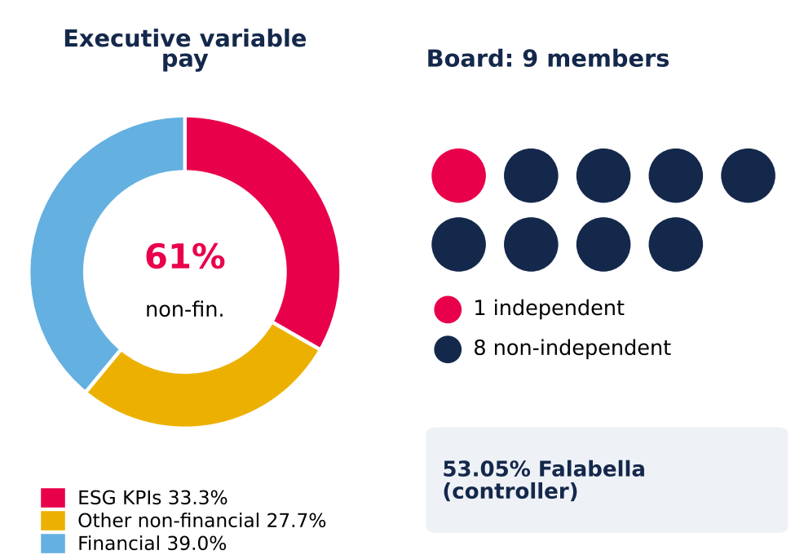
Source: Mallplaza 2025 Annual Report.
Two-thirds of 2025 growth was bought; organic real growth is about 3%
Revenue rose 76% between 2022 and 2025, but 21.8pp of 2025's 32.2% came from perimeter: the Peruvian portfolio bought from Falabella, consolidated from 4 December 2024. Ex-Peru, revenue grew 10.7% in 2025 and 7.1% in 1H26.
Once currency and inflation are removed, 1H26 reported growth of 7.4% falls to about 3.0% real (Figure 14). Chile grew 2.8% after 3.1% UF indexation (5.1% in 2025); Peru 4.5% despite occupancy slipping to 93.8%; Colombia only about 1% once a 7.5% COP appreciation and 6.1% inflation are stripped out. In other words, roughly 60% of 1H26 reported growth came from prices and currency, not from more activity.
Growth is contractual, not sales-driven. Variable rent is 5.1% of revenue and fell 1.1% in 1H26 while tenant sales rose 6.7%, because minimum rents (same-store rent +5.5%) are outpacing tenant sales (same-store sales +3.7%). Revenue is therefore bond-like, but its real growth is converging on the 0.4–0.9% the company assumes for Chile in its own appraisal.
Margin gains came from mix and cost recovery; operating leverage is spent
Figure 13: Removing fair-value gains and non-cash items turns CLP 1,441bn of profit into CLP 408bn of FFO (CLP bn)
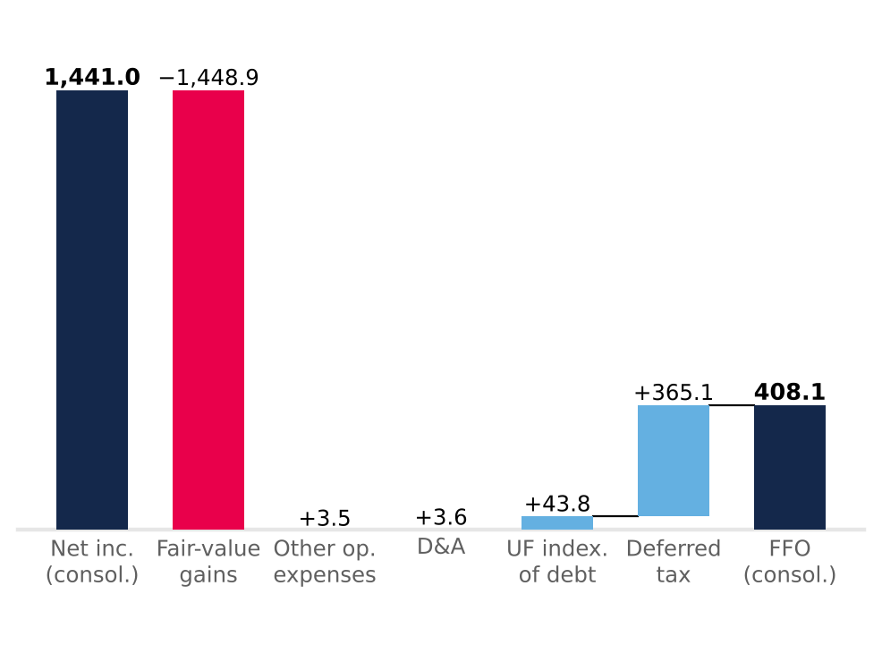
Light blue adds back, red removes, navy = totals. After minorities (CLP 2.8bn), FFO attributable is CLP 405.2bn vs CLP 405.3bn reported. Source: Plaza S.A. financial statements (CMF) FY2025, Notes 13.1 and 23; Team analysis.
EBITDA margin rose from 76.2% in 2022 to 80.5% in 2025 for two reasons. Peru consolidates at an 83% segment margin, against 80% in Chile and 73% in Colombia. Chile's margin gained 2.4pp on a higher recovery of common charges, which are presented net of cost (Note 2.20): real, but dependent on occupancy and tenant negotiations, so not structural.
With cost of sales at 6% of revenue and total operating costs near 20%, little fixed cost is left to dilute; with D&A at 0.7% of revenue, EBIT (CLP 523bn in 2025) tracks EBITDA. In 1H26 EBITDA grew 7.4%, in line with revenue, and margin held at 79.7%. Administrative expense rose 18.1% on payroll (+18.9%: CEO transition and a full year of Peru), a bad-debt charge rebounding from a 2025 base flattered by recoveries (0.64% of revenue, below 1.22% in 2024), and a one-off Colombian wealth tax of CLP 1.7bn. Excluding the last two, 1H26 margin would be 80.4%, up 0.7pp.
Operating costs have already fallen from 23.8% of revenue in 2023 to 20.1% in 2025 (Appendix 11), so there is little left for the margin to gain: from here, EBITDA grows with rents, not with efficiency.
Cash covers the dividend 2.6x; the ceiling is policy, not liquidity
Operating cash flow rose from CLP 301bn in 2024 to CLP 441bn in 2025, converting 98.7% of EBITDA before tax. Cash tax was only 15% of operating profit, sheltered by tax goodwill from Chilean reorganizations and loss carry-forwards (Note 13), and will rise toward the 27% statutory rate. After capex and net interest, free cash flow before debt service was CLP 280bn, covering dividends 2.6x (Figure 15).
The 38.6% jump in 1H26 operating cash flow is not earnings power: 59% of it was December collections unwinding through working capital. Receivable days fell from 66 to 50, with no sign of weaker collection.
The dividend policy pays out 40% of distributable profit with a one-year lag, so retained cash is high: CLP 171.6bn in 2025. In the base case, FFO rises from CLP 428.5bn in 2026E to CLP 501.6bn in 2031E and ordinary dividends from CLP 147.7bn to 172.6bn; the remaining cash, together with new debt, funds capex and the additional distributions (Appendix 13).
Capex is stepping up. Contractual investment commitments rose to CLP 78bn at June 2026 from CLP 18bn in December 2025, and 1H26 property capex was CLP 81bn (+176%). The base case funds USD 445m of remaining pipeline over 2026–2028 and then keeps adding about 27,000 m² of GLA a year, the 2022–2025 organic pace, so capex settles near 16% of revenue rather than the 5.5% maintenance floor (Figure 18).
Figure 14: Two-thirds of 2025 growth was bought; in 1H26 currency and inflation explain more than half
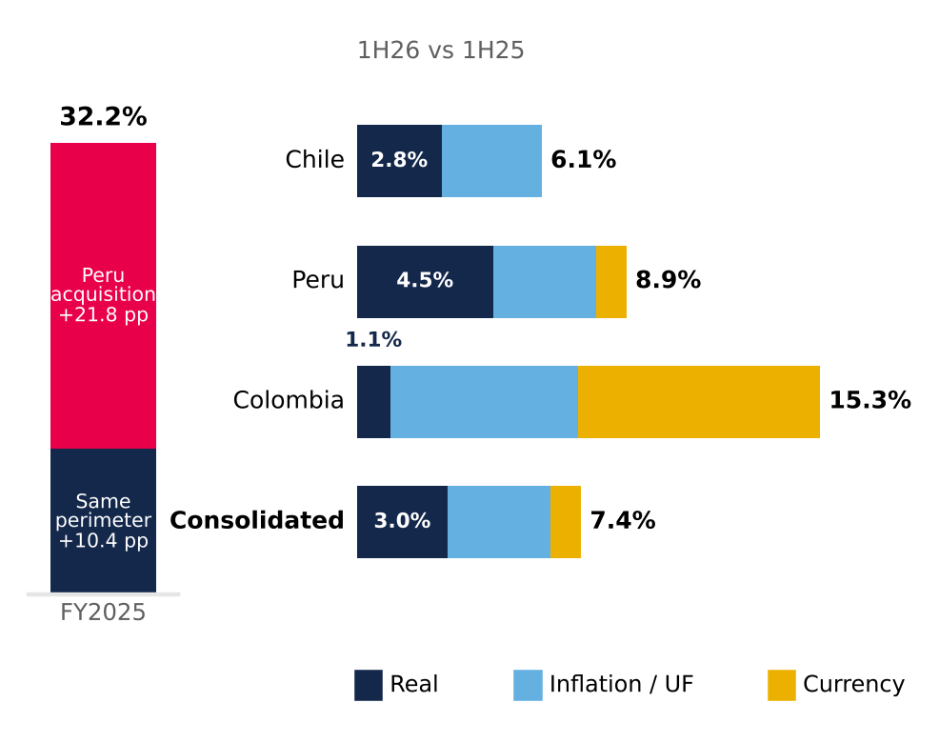
Segments split multiplicatively (real × inflation × FX) from local-currency growth (Chile 6.1%, Peru 7.9%, Colombia 7.3%); consolidated weighted by FY2025 revenue. Source: Plaza S.A. interim financial statements (CMF), Note 24; UF (SII/BCCh); Bloomberg FX; INEI; DANE; Team analysis.
Cash-flow metrics earn the AAA; equity-based ratios flatter it
LTV fell from 26.9% to 18.8% in 2025, but 5.0pp of the 8.0pp drop came from revaluing the denominator; with property at 2024 value plus additions, LTV would have been 23.8% (Figure 16). Cash-flow metrics are the honest lens and support Feller Rate's upgrade to AAA (25 September 2026): net debt/EBITDA fell from 3.78x to 2.36x on June 2026 LTM EBITDA (the 2024 figure includes only one month of Peru), and EBITDA covers financial costs 8.4x.
Gross debt of CLP 1,633bn is 79% UF, 14% PEN and 7% COP, matching revenue currencies; 95% is long term, with a 6.6-year duration. The UF bonds carry a 3.36% real coupon (3.48% effective), but with UF indexation the all-in nominal cost was about 7% in 2025. Maturities cluster in 2029, 2031 and 2033 (Figure 17); refinancing series S (1.32% effective) at the latest issue's 4.33% would add about CLP 4.9bn a year. Liquidity is ample: at June 2026 the current ratio was 2.50x and cash covered current liabilities 1.71x.
Figure 15: Free cash flow covers dividends 1.5–2.6x even as capex rises (FY2025, CLP bn)
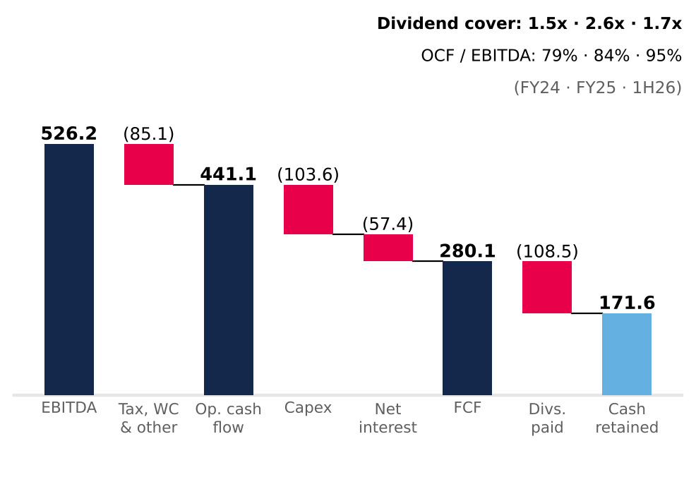
Cash flow statement (direct method; interest paid in financing). FCF before debt repayment. Capex = investment property + intangibles + PP&E (15.8% of revenue in 2025; 24.8% in 1H26). Source: Plaza S.A. financial statements (CMF); Team analysis.
Our base case spends that headroom. Net debt/EBITDA converges linearly from 2.36x to 3.5x by end-2031E, between Cencosud Shopping (2.1x) and Parque Arauco (5.7x), and each extra turn adds 25bp to the real cost of debt. Cash beyond the 40% payout and the capex plan is returned through buybacks or special dividends, CLP 1.8tn cumulatively over 2H26E–2031E (Appendix 13). At 3.5x the new AAA would likely come under pressure.
One liability does not show up in LTV: deferred taxes, CLP 1,313.7bn at June 2026, almost 80% of gross financial debt. They arise almost entirely from property revaluation; they are not debt to be repaid, but they show how much of the CLP 4,820.9bn book equity is appraisal rather than cash (Appendix 10). Against peers the balance sheet is conservative: LTV of 18.8% versus 42.9% at Parque Arauco and 16.3% at Cencosud Shopping, and net debt/EBITDA of 2.49x versus 5.68x and 2.11x (Appendix 14).
The forecast carries forward what history supports, including the pace of expansion
Revenue grows 7.7% in 2026E and 5.0% in 2031E (2026E–2031E CAGR 6.4%), as real same-store growth converges to the appraisal midpoints, 123,700 m² of dated pipeline matures and, from 2029E, about 27,000 m² a year opens at the historical pace (Figure 18); 2026E and 2027E revenue sit within 0.6% of consensus. EBITDA margin stays at 79.7–79.8%, below the 2025 peak. Cash tax normalizes from 16.8% to 27% by 2030E and financial costs rise with leverage, so FFO margin slides from 60.9% to 52.2%. Working capital is held at 15.6% of revenue, the December 2025 level (Appendix 9). New GLA yields 6.9% on cost, a 5.0% real return after tax against a 7.2% real WACC: expansion adds revenue but not value.
Figure 18: After the pipeline, expansion keeps capex near CLP 150bn a year while leverage rebuilds to 3.5x
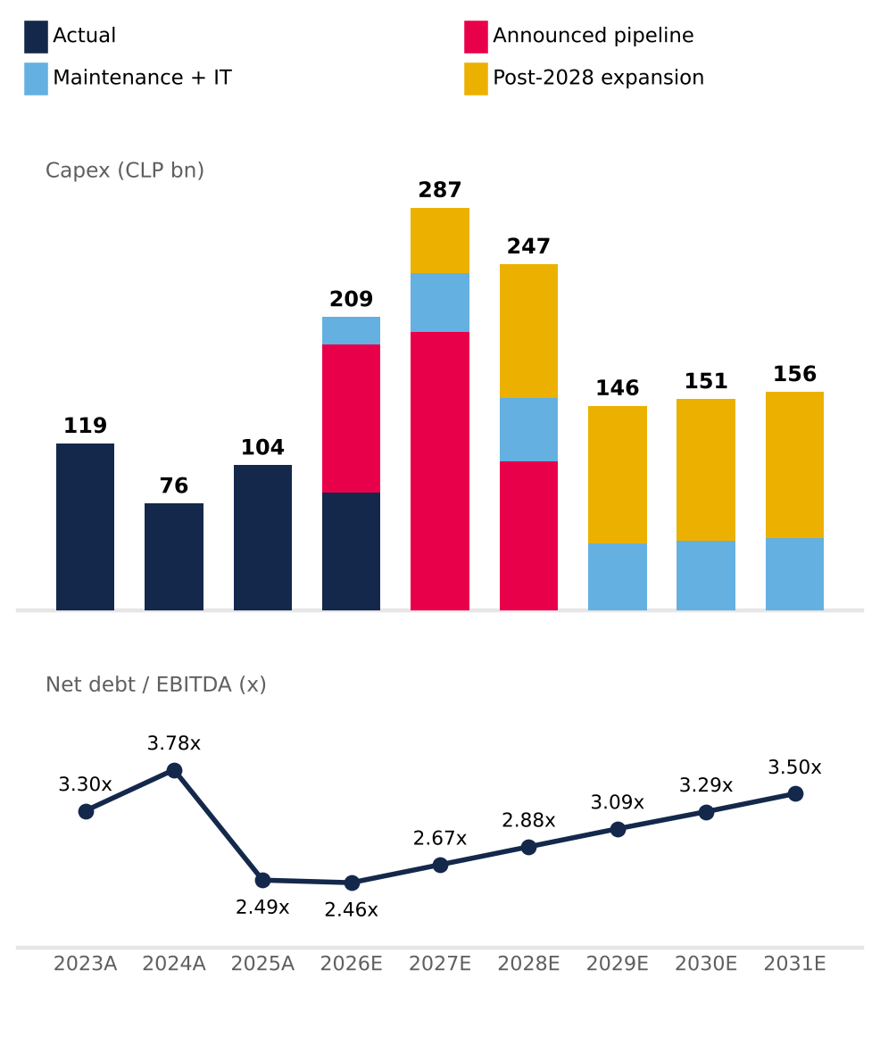
2026E includes CLP 84.2bn spent in 1H26; 2024A leverage includes one month of Peru EBITDA. Source: Plaza S.A. financial statements (CMF); 2Q26 results release (pipeline); valuation base case (Appendices 9 and 13).
What this means for valuation
The analysis leaves three conclusions for the model. First, the right earnings base is cash: we use the company's EBITDA, which removes revaluation once (Appendix 12), and distributable profit as the anchor, not the CLP 1,431bn accounting profit. Second, business quality is not in doubt: Mallplaza earns the highest normalized ROE of its local peers (9.7% against 7.8% at Parque Arauco and 8.0% at Cencosud Shopping) with an LTV of only 18.8% (Appendix 14).
Third, the return on capital at fair value is low. 2025 ROIC, with NOPAT at 27% over invested capital at appraised value, was 7.3% (Appendix 11), below a 10.4% nominal WACC: the properties are worth more on the books than their cash flows justify at our rate. At the current price, 2026E FFO of CLP 428.5bn yields 5.5% on market value (18x FFO) and distributable profit 4.9%: the market is paying for these cash flows as if they were almost risk-free. That is the gap the Valuation section quantifies. In short: a high-quality business, with predictable cash and a comfortable balance sheet, whose price already discounts more than those cash flows can deliver.
VALUATION
Figure 16: Two-thirds of the 2025 fall in LTV is revaluation, not deleveraging
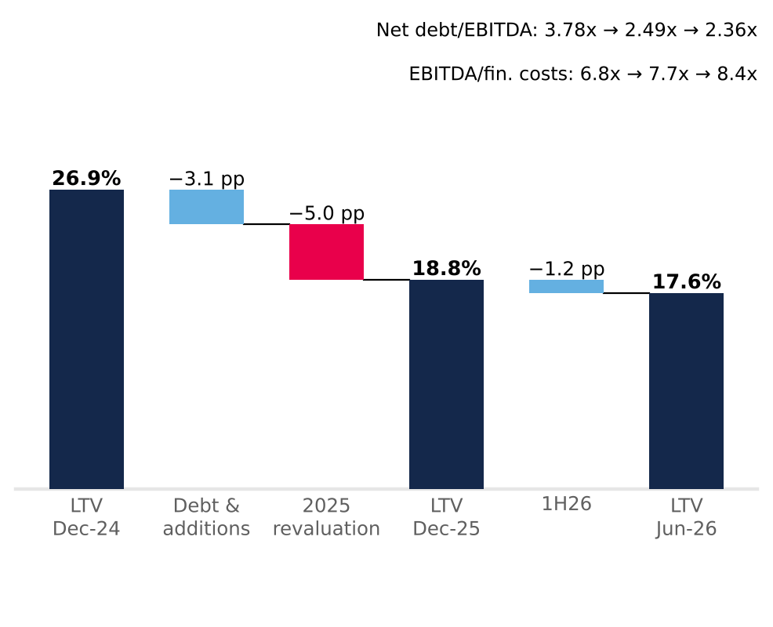
LTV = net financial debt / investment property. Debt & additions = LTV with property at 2024 value plus 2025 additions (23.8%). Jun-26 ratios on LTM EBITDA. Source: Plaza S.A. financial statements (CMF), Notes 11 and 26; MD&A 2025 and 1H26; Team analysis.
We recommend SELL on Mallplaza with a target price of CLP 2,076 per share, 41.6% below the CLP 3,555 close of 30-Sep-26 (−39.7% total return including dividends). Our target sits even below the stock's 52-week low (CLP 2,470).
A PRICE NO METHOD REACHES
In twelve months the stock rose from CLP 2,470 to 4,700 and now trades at CLP 3,555. None of our methods reaches that price: the DCF ranges from CLP 1,379 to 2,329 even with WACC ±100 bp and g between 2.5% and 4.0%, and the most favourable multiples fall short too (Figure 19). We give the DCF an 80% weight because Mallplaza is, at heart, a rent collector: 81.4% of revenue is rent and 93% of that is fixed. The 20% on multiples tests the model against what the market pays today, but with caution: Chile has only two direct peers, and neither captures the company's expansion plan or debt path.
Figure 21: Working capital: an assumption that does not move the price (±1.2%)
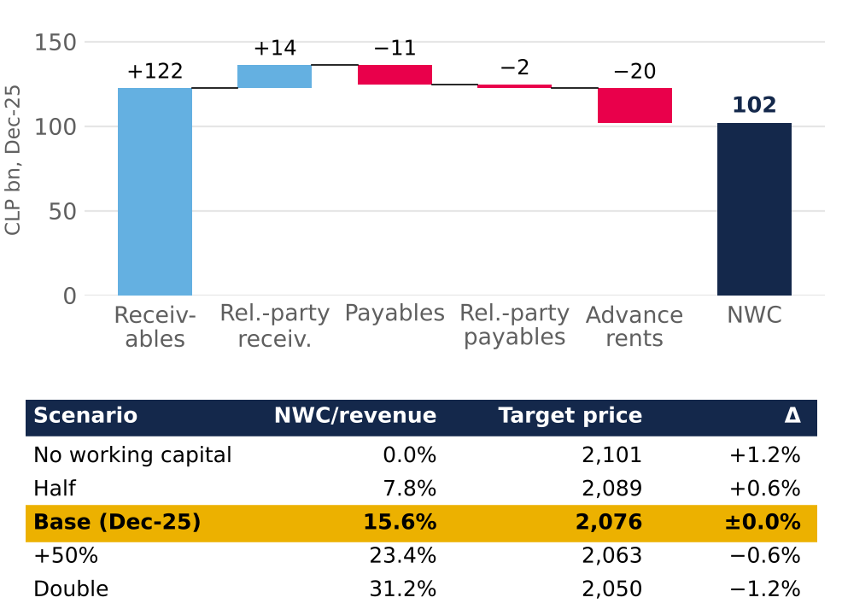
Source: Mallplaza financial statements; Team analysis.
Figure 19 sums up the thesis in one picture. APV, which values the firm unlevered and adds the tax shields separately, gives CLP 1,894, just 2% above the DCF: the result does not depend on how we model financing. Multiples range from CLP 2,152 (common-set median) to 3,294 (Chilean median), and EV/EBITDA NTM and EV/EBIT sit between CLP 2,914 and 3,098. Everything falls to the left of the price; the only thing that reaches it is the stock's own trading range over the past year. Even the Chilean median multiple, the most favourable case for the stock, sits 7% below the price.
THE STORY IS IN THE RATE
We project free cash flow to the firm in nominal CLP from 30-Jun-26, with an explicit horizon to 2031E and a terminal value that accounts for 76% of EV (Appendix 15). The CLP 1,857 per share is CLP 583 of explicit cash flows and CLP 1,884 of terminal value, less CLP 610 of debt and minorities: the result depends, above all, on the discount rate.
That rate moves with the capital structure. Mallplaza uses its debt capacity to grow, as in 2024 after buying Open Plaza Peru (3.78x): we assume net debt/EBITDA rises from 2.36x to 3.5x by 2031, with 25 bp more real cost per turn, and that new debt (CLP 1.40 trillion) funds all capex while operating cash is distributed to shareholders. The nominal WACC thus moves from 10.54% in 2H26E to 10.41% in the terminal period (7.20% real): an 11.93% Ke (Rf 4.98%, relevered beta of 1.14 from a six-peer median of 0.94, ERP 4.14% and a 1.41% revenue-weighted CRP) and a 5.11% after-tax Kd based on the 3.6% real coupon of the latest bond (Appendix 19).
Figure 17: Refinancing risk sits in 2029, 2031 and 2033, not in the near term
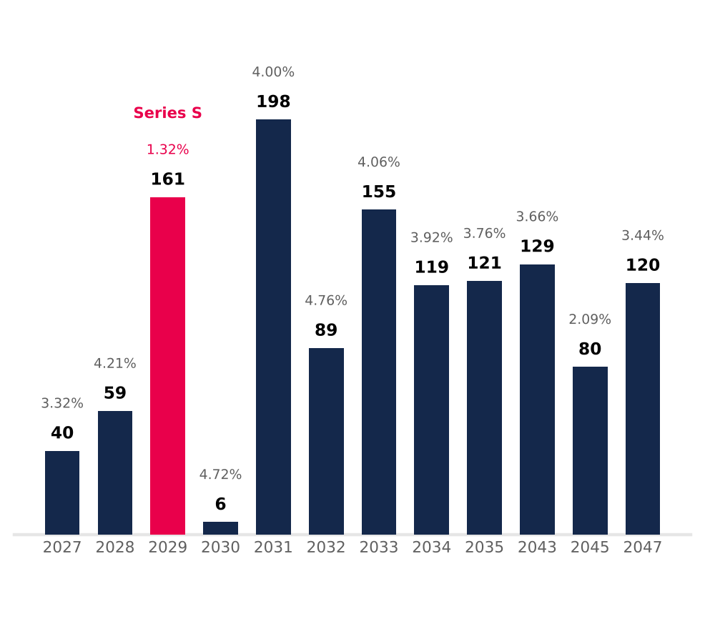
UF bonds, book value Dec-25 (total CLP 1,277.7bn); label = effective real rate (two-series years: book-value-weighted). Excludes CLP 301.6bn of PEN/COP bank debt. Source: Plaza S.A. financial statements Dec-25, Note 14; Team analysis.
We build Ke in dollars because its three inputs are in that currency: the US Treasury Rf, the implied equity risk premium published by Damodaran and country risk, which we weight by revenue (71.8% Chile, 17.7% Peru and 10.5% Colombia). We then convert it to pesos with the gap between expected inflation in Chile (3.0%, the central bank's target) and in the US (2.24%, 10-year breakeven). The beta starts from unlevering six regional peers with Hamada and is relevered each period with Mallplaza's structure, which is why it moves from 1.09 in 2H26E to 1.14 in the terminal period.
Here the first signal appears: at CLP 3,555, equity yields ~4.4% real, just 80 bp above the company's own real cost of debt (Figure 20). The market is pricing the stock almost as if it were a bond.
GROWTH DOES NOT RESCUE THE PRICE
This is not pessimism about operations. We forecast a 79.7% EBITDA margin in 2026E (excluding revaluation, below the 80.5% LTM), a tax rate converging from 16.8% to 27%, the announced pipeline (USD 613 million and 170,200 m²) and, from 2029, 27,075 m² of new GLA a year at the historical pace. The 13-analyst consensus expects NTM EBITDA only ~3% above ours: the disagreement with the market is not about cash flows.
Figure 19: No method justifies the current price (CLP per share)
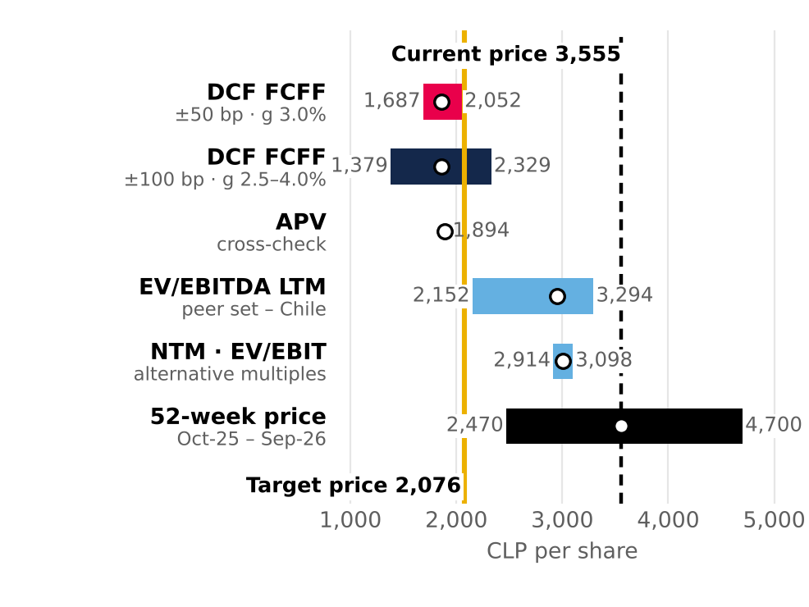
52-week intraday range (1-Oct-25 to 30-Sep-26; low 10-Oct-25, high 27-Apr-26). Source: Team analysis; Bloomberg.
Capex follows the company's plan: the pipeline and maintenance (5.5% of revenue) take base capex to a peak of CLP 240,660 million in 2027, and continuous expansion adds CLP 95,000–104,000 million a year from 2028, at the cost of the identified pipeline (USD 3,603 per m²) with a 35%, 90% and 100% revenue ramp. Working capital, at 15.6% of revenue, requires only CLP 7,100–9,900 million a year and moves the price by ±1.2% (Figure 21). These are assumptions the team can defend line by line (Appendix 16).
Two assumptions deserve explanation. The cash tax rate starts at 16.8% because the company currently uses tax goodwill and loss carry-forwards; we assume those shields run off and the rate reaches 27% by 2030, so as not to overstate value. And working capital is positive because tenant receivables (CLP 122,370 million) exceed rents collected in advance (CLP 20,247 million): it grows with revenue, not with new m².
Figure 20: At CLP 3,555 equity yields almost the same as debt
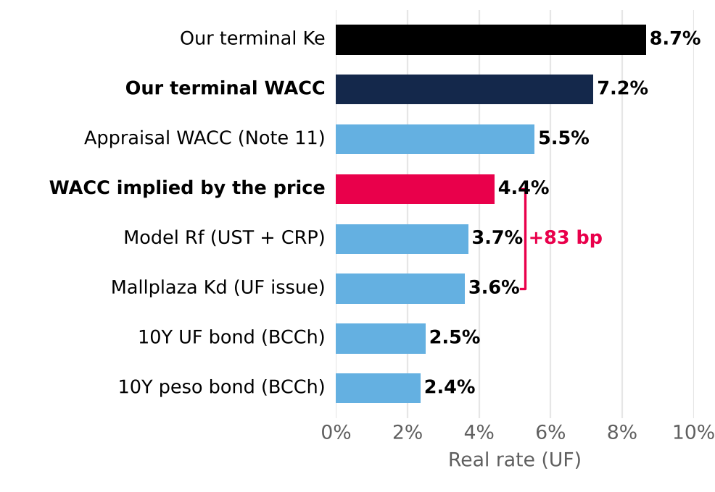
Real rates in UF. Source: Central Bank of Chile (30-Jun-26); Mallplaza; Team analysis.
The problem is the return on growth. Each new m² yields 6.9% on cost, a 5.0% real RONIC after tax, below a 7.2% real WACC. Expansion adds revenue but not value, so terminal value grows only with inflation (g of 3.0% nominal, 0% real) and a higher g lowers value (Figure 22). Assuming more growth would not close the gap with the price; it would widen it.
That is why the explicit horizon includes the capex and ramp-up of projects opening through 2032 (108,301 m² of mature GLA in the terminal year), but from then on the model adds no new malls: terminal capex covers maintenance only (5.5% of revenue). This is not a conservative assumption against the company; at these returns, growing more would reduce its value.
PEERS CONFIRM THE DIRECTION, NOT THE SIZE
Mallplaza trades at 16.8x EV/EBITDA, above the Chilean median (15.7x) and far above Brazilian peers (9.0x). The gap with Brazil is about rates, not quality: with local real bonds at 2.5% in Chile and 8.1% in Brazil (NTN-B), the cap-rate spread over the local rate is similar in both countries, 385 bp in Chile and 302 bp in Brazil (Figure 23). We therefore weight the Chilean median at 70% and the common-set median at 30% (which includes IRSA; we exclude Fibra Danhos for its FIBRA regime): 14.4x, giving CLP 2,951 per share. The weighting matters little: between 0% and 100% Chile, the target price only moves from CLP 1,916 to 2,144 (Appendix 17).
Figure 22: Growing below the WACC destroys value: real g = 0%
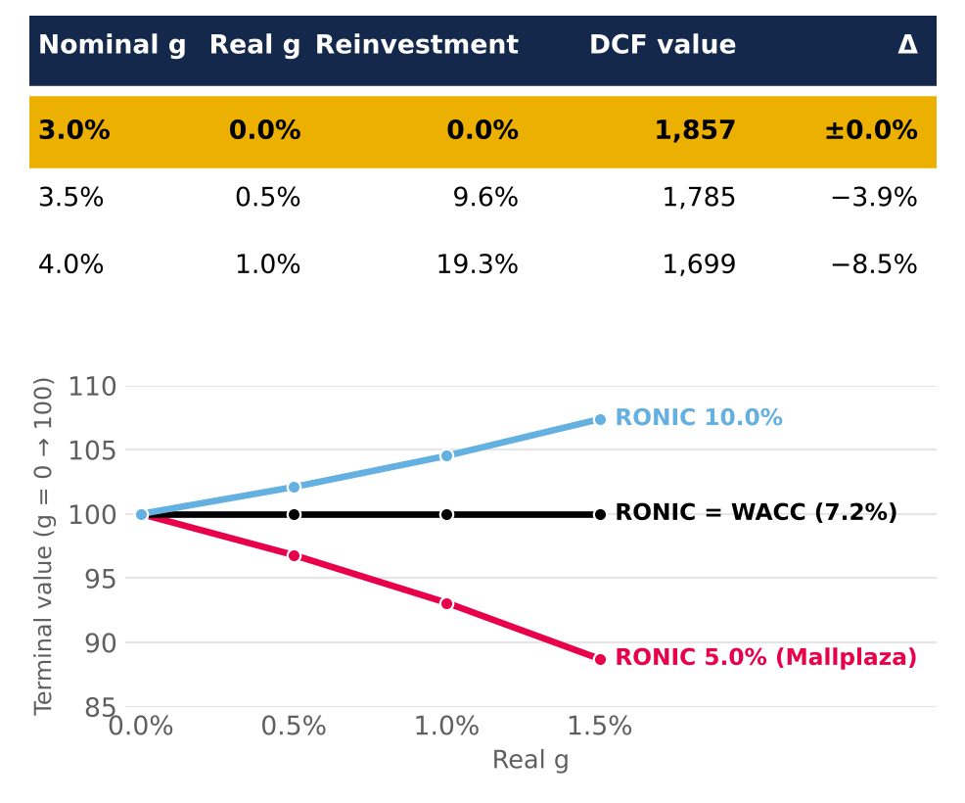
Top: DCF value by g. Bottom: relative terminal value by RONIC. Source: Team analysis.
Macro explains the difference. At 30-Jun-26 Brazil had a 14.25% Selic, a 14.34% nominal 10-year bond and 5.3% expected 2026 inflation, against a 4.5% policy rate, a 5.43% nominal bond and 4.1% inflation in Chile, with similar growth (2.0% and 1.6%). An investor in Brazil demands more from every asset, not just shopping malls; applying that discount to Mallplaza, which earns 71.8% of revenue in Chile, would penalise it for a risk it does not carry. Mallplaza's own spread (346 bp) is in fact tighter than the Chilean median (385 bp): investors already pay it a premium within Chile.
We chose the set on the same basis as the beta. IRSA is kept with caution, since it reports under IAS 29 and its NTM consensus has a single analyst; Fibra Danhos is excluded because, as a FIBRA, it must distribute 95% of its taxable income and has no beta in the WACC. We use EV/EBITDA because it is neutral to leverage and to revaluation (IAS 40), and we measure everyone with Bloomberg net debt (CLP 1,311,569 million for Mallplaza, close to the CLP 1,285,740 million of net financial debt used in the DCF).
Figure 23: Chile and Brazil charge the same premium: multiples differ because of rates
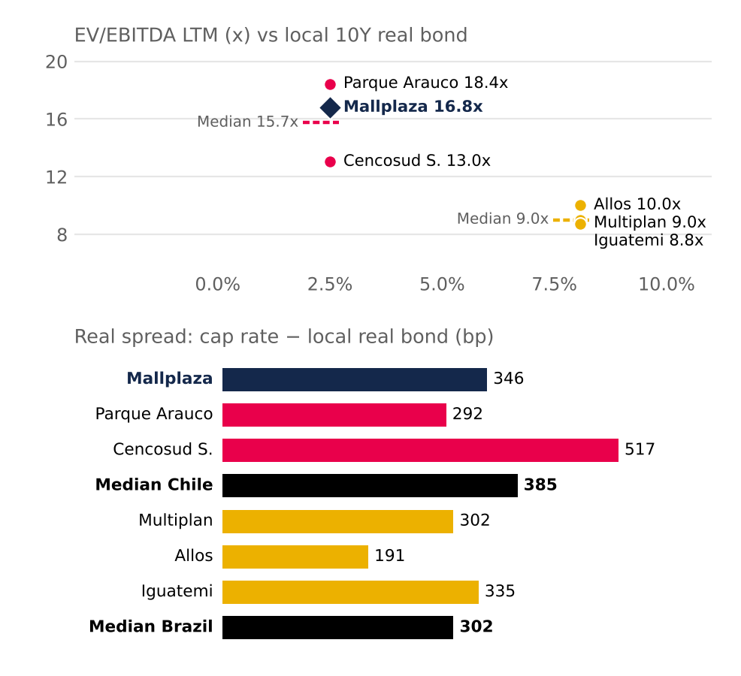
Real bond: 10Y UF (Central Bank of Chile) and NTN-B 2035 (8.08%) at 30-Jun-26. Spread = cap rate (1 / EV/EBITDA) − real bond. IRSA omitted (IAS 29). Source: Bloomberg; Central Bank of Chile; Team analysis.
Nor does quality justify the premium. Mallplaza trades 29% above Cencosud Shopping, yet its EBITDA per m² is only 1.8% higher (see Industry); only at Parque Arauco's multiple (18.4x), with 5.7x leverage, would it be worth more than its price. Every multiple, from EV/EBITDA NTM (CLP 2,914) to P/BV (CLP 3,171), sits below the price (Figure 24): multiples confirm the stock is expensive, and the DCF sets the size of the gap. We exclude P/E (CLP 8,644), distorted by property revaluation.
In price terms: at the Chilean median alone the stock would be worth CLP 3,294 (−7%); at Cencosud's multiple, CLP 2,621; and only at Parque Arauco's, CLP 3,967. Defending CLP 3,555 with multiples requires assuming Mallplaza deserves the valuation of the most leveraged peer in the group. The forward view tells the same story: Mallplaza trades at 14.8x consensus NTM EBITDA against a 12.5x weighted peer multiple. We keep Brazil at 30% rather than zero because the Chilean median rests on only two companies.
WHAT THE MARKET WOULD HAVE TO BELIEVE
The price implies an EV of CLP 9.12 trillion, 69% above ours, and a 6.0% cap rate, against 10.1% in our DCF, 6.4% for Chilean peers and 7.5% at book value (Figure 25). The market pays 1.61x an equity base already at fair value, appraised at a ~5.55% real rate (Note 11): it pays more than the appraisers themselves. To justify CLP 3,555, the WACC would have to be 285 bp lower (Figure 26); even at the appraisers' rate, the DCF would be CLP 2,660.
We pushed the thesis to its extremes. In a bear case (WACC +100 bp and the 75.8% quarterly-low margin) the target falls to CLP 1,713; in a bull case combining WACC −100 bp, g of 2.5%, the 81.3% quarterly-peak margin and the cut in corporate tax to 23%, it rises to CLP 2,627, still 26% below the price. APV (CLP 1,894), a peso-bond Rf (~CLP 2,439) and other debt targets (DCF of CLP 1,819 to 1,894) lead to the same conclusion (Appendix 18).
Figure 24: Value implied by each peer's multiple vs DCF and price (CLP per share)
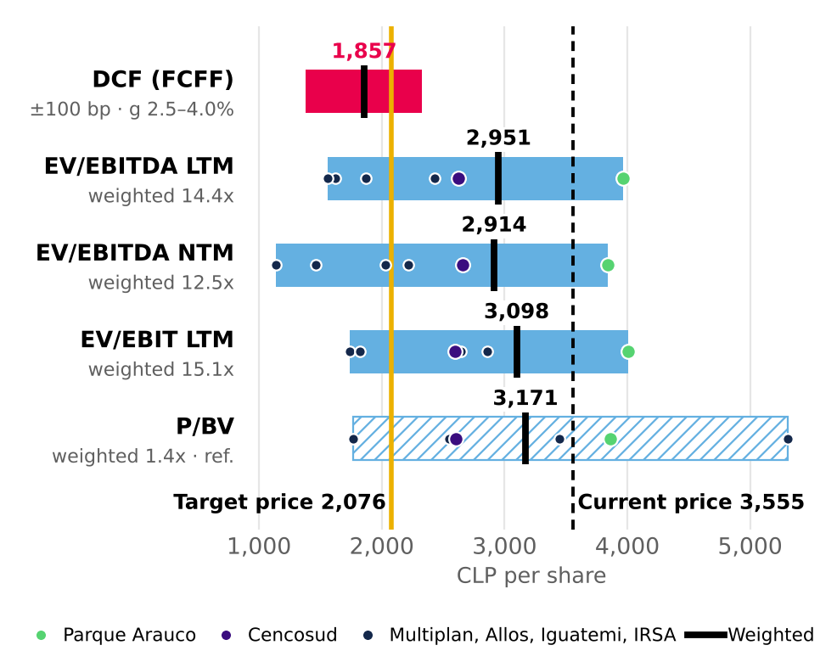
Target = 80% DCF + 20% EV/EBITDA LTM. P/E excluded (includes revaluation). Source: Bloomberg (30-Sep-26); Team analysis.
APV also shows what the debt is really worth. Of its CLP 1,894 per share, CLP 1,632 is the unlevered firm and CLP 261 the tax shields of projected debt: levering up to 3.5x adds value, but even with it the price is far away. And our risk-free choice is the conservative one: using the peso bond (5.43%) and then adding country risk would count Chile risk twice, and even so the target price would only rise to ~CLP 2,439, 31% below the price. In other words, no reasonable choice of inputs rescues the current valuation; the gap is too wide to be a modelling artefact.
Calendar details do not change the outcome either. With an expected dividend of ~CLP 69 per share (2.0%), the expected total return is −39.7%. And since the DCF is dated 30-Jun-26 and the price 30-Sep-26, the comparison slightly favours the market: if the balance of the 2026 dividend (~CLP 27 per share) was already paid before that date, our value would be somewhat overstated, not understated.
That brings us to CLP 2,076 (80% × 1,857 + 20% × 2,951): 10.8x EBITDA, a 9.3% cap rate and 0.94x book value. Rolling the DCF to 30-Sep-26 would lift it to ~CLP 2,118 without changing the call. The catalyst is the same force behind the thesis: with the 10Y UST at 5.22%, its highest since 2002, rates pressure cap rates, and each new appraisal moves them toward our value. We would be wrong if cap rates compress further on institutional demand for defensive assets, or if the market sustains a structural premium for Tier A assets (see Investment Risks).
What we will watch: the Note 11 appraisal at each reporting date (the real discount rate is the bridge between our value and book), the spread of the company's UF bonds over their 3.6% coupon (at the latest issue's 4.33% effective rate, the WACC would rise 12 bp and the target would fall to CLP 2,042), the cut in corporate tax to 23% (+5.1% on the target, not yet included) and the AAA rating, which would likely come under pressure at 3.5x net debt/EBITDA. In short, the operating story is sound; it is the price of that story that no longer adds up.

Figure 25: The market pays 6.0%; our cash flows are worth 10.1%  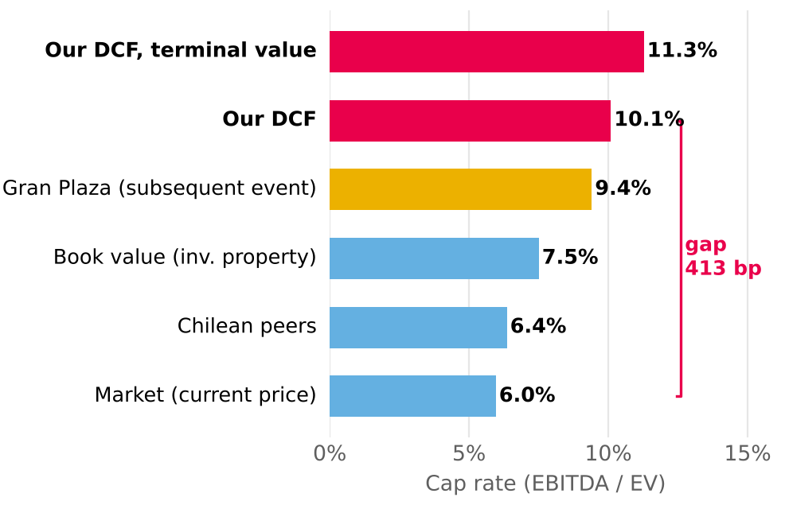  Gran Plaza: subsequent event, not in the model. Source: Mallplaza; Bloomberg; DF; Team analysis. |  | Figure 26: The price requires a WACC 285 bp lower  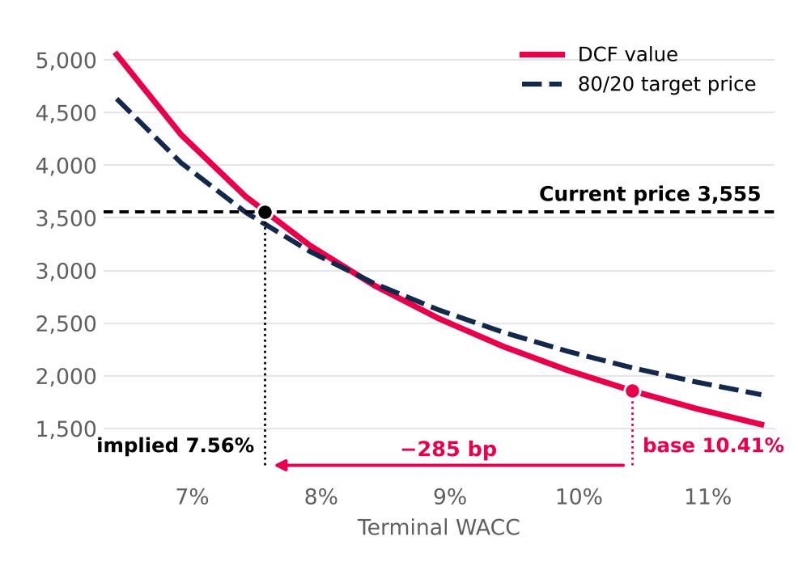  Source: Team analysis.

INVESTMENT RISKS
Mallplaza's risk profile is moderate: its operations are resilient and value depends mainly on market variables. The main risk, with high likelihood, is a rise in long-term rates, which pushes up bond yields and the WACC. Not even the favourable scenarios justify the market price at the report date.
RISK ASSESSMENT  Figure 27 classifies each risk by likelihood and by its impact on value per share (Figures 28 to 26). Risks that could not be quantified are classified according to the team's qualitative analysis of the company.  OPERATIONAL RISKS  OR1: Operating deterioration. EBITDA margin, rents, footfall or occupancy falling to their historical lows. The worst case, a 75.8% margin, cuts DCF value to CLP 1,671 (−10.0%), and the historical floor of same-store rent growth takes it to CLP 1,782 (−4.0%) (Figure 28). (Non‑systematic · Medium likelihood · Medium impact)  Mitigants: stable metrics: EBITDA margin rose from 76.2% (2022) to 80.5% (2025) and occupancy held between 95.5% and 96.6% in 2024-25. After COVID, 1Q22 revenue was already 18% above 1Q19.  OR2: Anchor stores. Anchors, mostly from the Falabella group, drive footfall. Shrinking or losing them would lower visits and rents from smaller stores. The impact ranges from −1.3% to −4.0% (Figure 28). (Non‑systematic · Low likelihood · Low impact)  Mitigants: long-term leases (average remaining term of 7.1 years) and a proven ability to convert anchor space into smaller stores with higher rent per m².  FINANCIAL RISKS  FR1: Interest rates and cost of capital. Higher long-term rates would raise the WACC and the cost of refinancing debt and the pipeline. Likelihood is high: the 10Y UST moved from 4.98% (model Rf) to 5.22% on 8-Oct-26, a 24-year high (since 2002); the Fed hiked in September and the Central Bank of Chile reports rising local long-term rates. With WACC +50 bp and +100 bp, the target price falls 6.5% and 12.3% (Figure 29). (Systematic · High likelihood · High impact)  Mitigants: 79% of debt is fixed-rate in UF, with ~6.7 years of duration, 2.36x net debt/EBITDA and AA+/BBB ratings, which limit the pass-through to the cost of debt; UF-linked rents offset inflation. A higher cost of equity cannot be hedged.  MARKET & MACROECONOMIC RISKS  MR1: Inflation and macro cycle. 79% of debt is in UF: a 3% higher UF takes CLP 38,691 million off accounting earnings (Note 26). On the target price, however, the effect is slightly positive: indexed rents add CLP 40.8 per share and the higher UF debt subtracts 17.7, a net +23.1 (+1.1%) (Figure 30). The risk is that weaker consumption prevents passing the UF through to rents: without that pass-through, UF +3% takes 0.9% off the target price. Weaker consumption also slows the new business lines (Appendix 20). (Systematic · High likelihood · Low impact)  Mitigants: UF-indexed rents, a model based on rent rather than sales, low (if rising) leverage and an active ability to rotate the portfolio.  MR2: E‑commerce. If consumption migrates massively online, malls lose footfall and appeal. E‑commerce in Chile exceeded US$10 billion in 2025, around 12.6% of retail sales. The worst traffic case only takes 1.3% off value (Figure 28). (Systematic · Low likelihood · Medium impact)  Mitigants: the online channel is maturing with no visible effect on the model (visits +16% in 2025). Malls offer entertainment and dining, hard to replicate online.  MR3: Foreign exchange. Around 28% of revenue comes from Peru and Colombia, and the model assumes the sol rises from CLP 268 to 290 between 2026 and 2031. A 10% depreciation of the PEN and COP from 2027E takes 4.3% off DCF value, before hedges and the effect on local-currency debt (team estimate). (Systematic · Medium likelihood · Medium impact)  Mitigants: Mallplaza raises debt in each country's currency and, where not possible, uses hedging derivatives (forwards, swaps and cross currency swaps) (Management Discussion 2Q26, p. 14).  REGULATORY & ESG RISKS  RR1: Interlocking and conflicts of interest. Falabella controls 53.05% and leases space through Falabella, Sodimac and Tottus, which creates receivables with related parties. Fernando de Peña, Mallplaza's CEO for decades, has chaired Falabella since March 2026. Off-market contracts would directly affect rents and value. (Non‑systematic · Low likelihood · High impact)  Mitigants: a three-member directors' committee and review of related-party transactions (Law 18,046). Even so, safeguards are limited: only 1 of 9 directors is independent.  RR2: Regulatory and political. Changes in tax, permitting and economic policy in all three countries. In Chile, the ruling coalition lacks a comfortable majority in the lower house for the rest of its agenda (El Dínamo, 11-Mar-26). In Peru, Fuerza Popular lacks a majority in the new bicameral Congress and the MEF puts the cost of laws passed by the previous Congress at up to S/ 50,000 million (El Comercio). In Colombia, the finance ministry puts the deficit at 7.8% of GDP and proposes spending cuts of at least 1% of GDP (El Tiempo, Jul-26), and the central bank raised its rate to 12.25% (30-Sep-26), which slows consumption. Permit delays push back the pipeline (USD 613 million, 170,200 m² to 2028). (Systematic · Medium likelihood · Low impact)  Mitigants: pro-investment agendas. In Chile, Kast signed the Reconstruction Law (9-Oct-26), which gradually cuts corporate tax from 27% to 23% from 2027 (Emol, 9-Oct-26), S&P affirmed its A stable rating and Law 21,770 (Sep-25) shortens permitting. In Peru, the minimum-wage rise to S/ 1,300 and the doubling of Pensión 65 support consumption (Infobae, 28-Jul-26). Colombia contributes only ~11% of revenue. The model keeps 27%: the Chilean cut would add ~3.9% to the target price. |  | Figure 27: Risk matrix  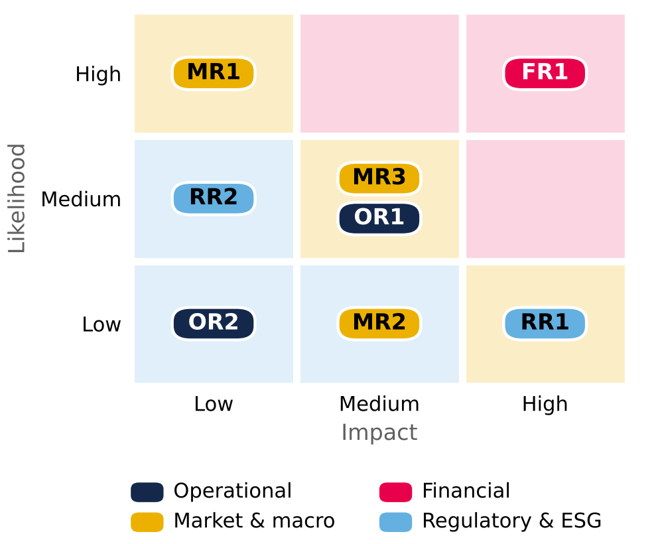  Background colour = severity (likelihood × impact). Source: Team analysis.  Figure 28: Operational risk tornado (CLP per share)  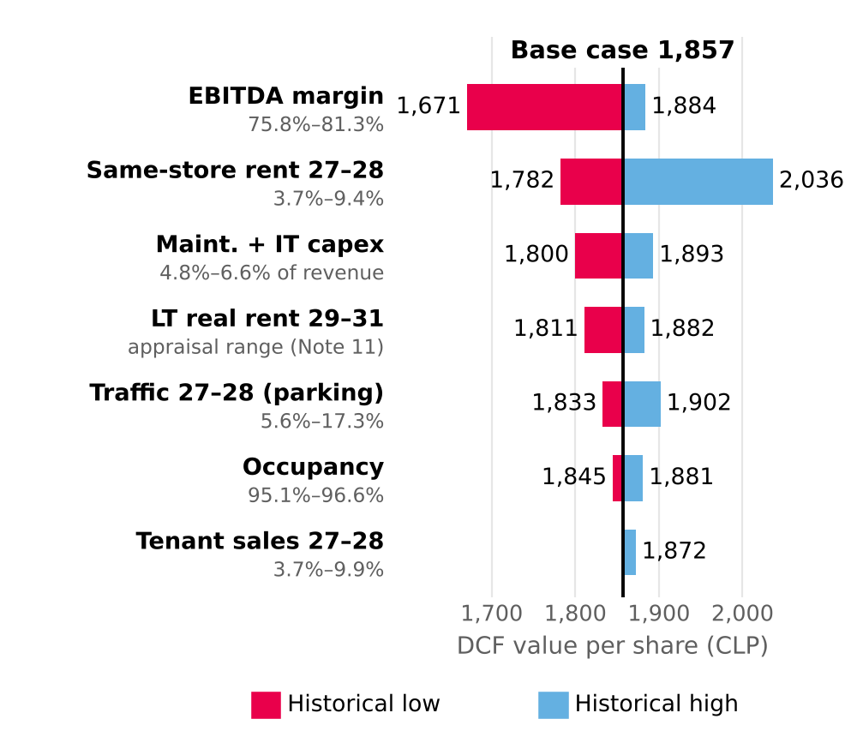  Limits = historical low and high of each driver: Mallplaza earnings releases 4Q23–2Q26 (EBITDA margin, occupancy, same-store rent and sales, visitors) and financial statements (maintenance capex 2024 and LTM 2Q26; appraisal growth range, Note 11). Terminal WACC 10.41% and g 3.0% held constant. Source: Mallplaza; Team analysis.  Figure 29: Target price sensitivity: WACC vs g (CLP)  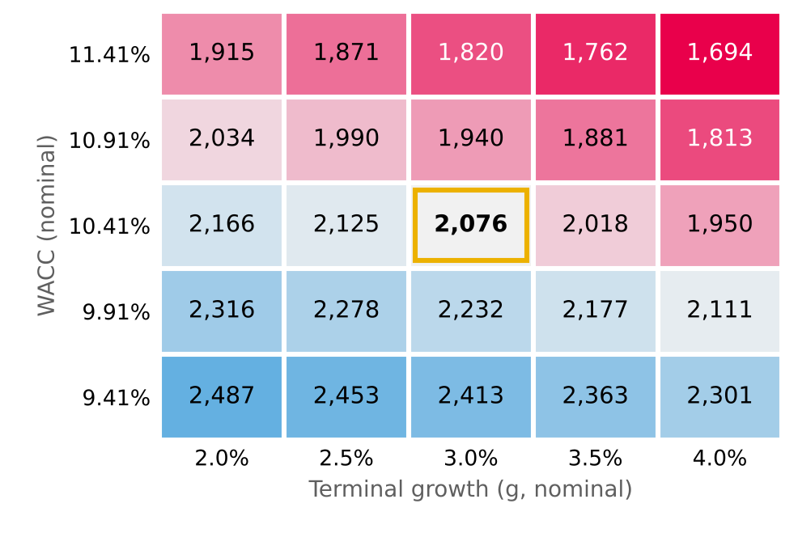  Target price = 80% DCF + 20% EV/EBITDA multiples (CLP 2,951). The g = 2.0% column uses the same formula as the Sensibilidad sheet. Source: Team analysis.  Figure 30: Target price sensitivity to a rise in the UF (CLP per share)  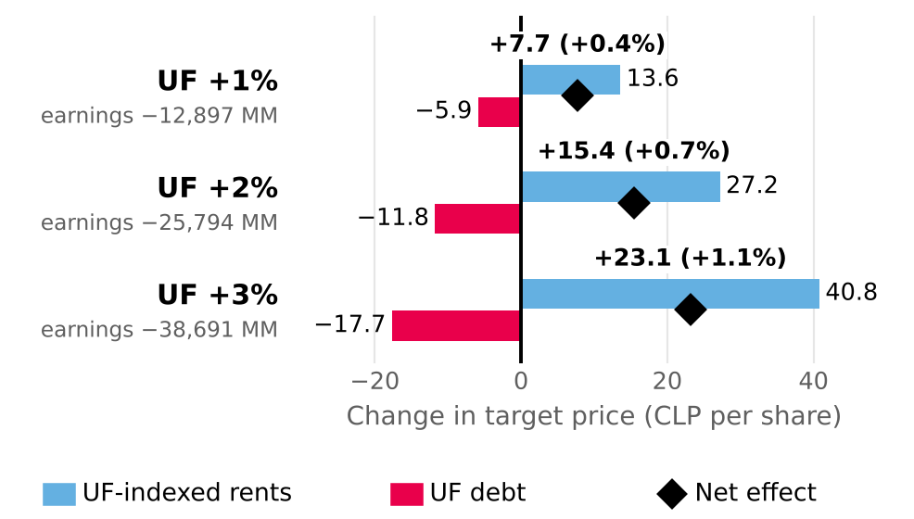  UF level shock from 2027E; WACC and g constant. Debt: net UF exposure from Note 26. Earnings: +3% reported; +1% and +2% extrapolated. Source: financial statements Jun-26, Note 26; Team analysis.

INVESTMENT SUMMARY
TO BE WRITTEN  Recommendation and target price · Investment thesis · Valuation summary · Catalysts · Key risks.  Section to be written by the team; the key data on the right already come from the models. |  | KEY DATA  Source: valuation model v2; Bloomberg (52-week range); Team analysis.
  Recommendation | SELL
  Target price (CLP) | 2,076
  Price 30-Sep-26 (CLP) | 3,555
  Upside / downside | −41.6%
  DCF / multiples value (CLP) | 1,857 / 2,951
  DCF / multiples weight | 80% / 20%
  Ticker | MALLPLAZ CI
  Market cap (CLP bn) | 7,785
  52-week range (CLP) | 2,470 – 4,700
  Expected dividend 2027E (CLP) | 69 (2.0%)
  Net debt / LTM EBITDA 2Q26 | 2.36x

APPENDICES: BUSINESS DESCRIPTION
Appendix 1: Tier A assets by GLA, 2Q26 (thousand m²)  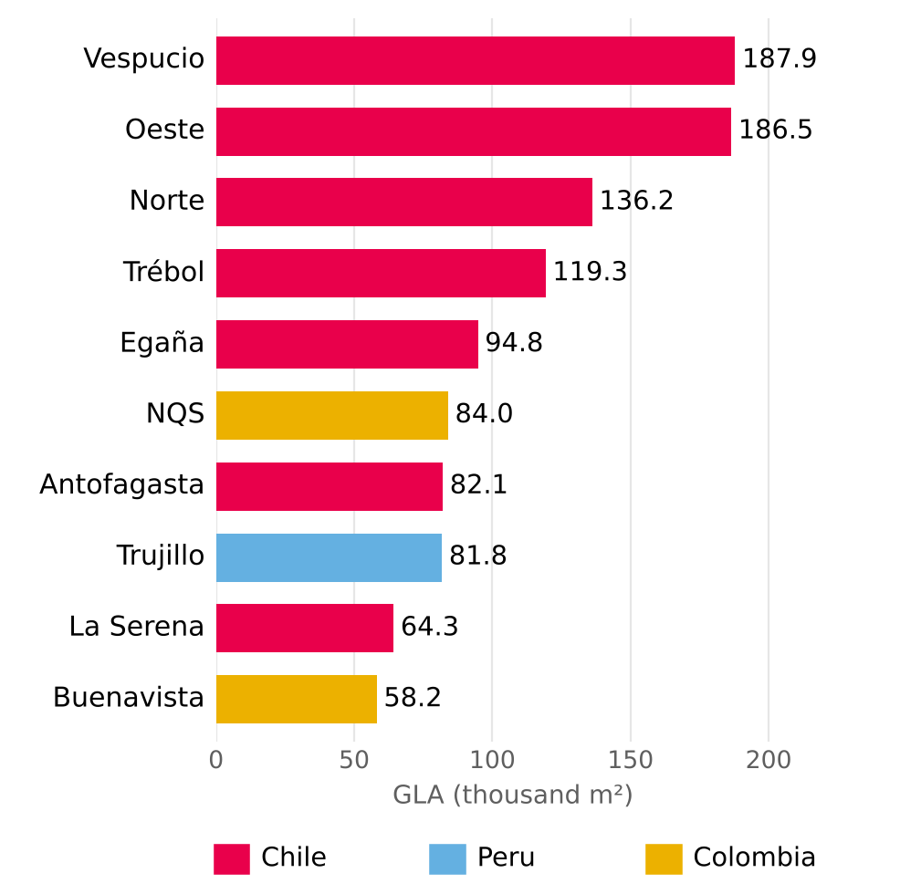  Source: Plaza S.A., Institutional Presentation 2Q26 (p.12). Tier A = 46.4% of total GLA. |  | Appendix 2: Department stores, % of total GLA  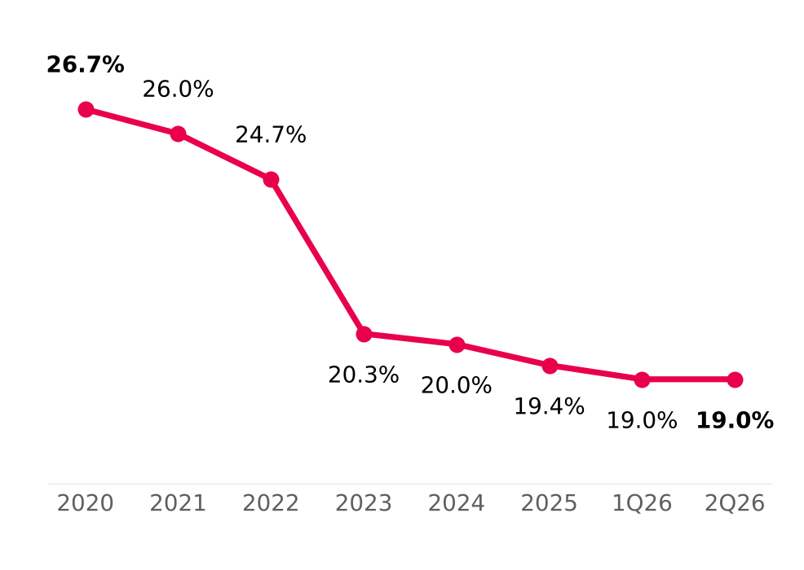  Source: Plaza S.A., Institutional Presentation 2Q26 (p.17).

APPENDICES: INDUSTRY OVERVIEW AND COMPETITIVE POSITIONING
Appendix 3: GLA pipeline 2026-2028: organic vs acquisitions (m²)  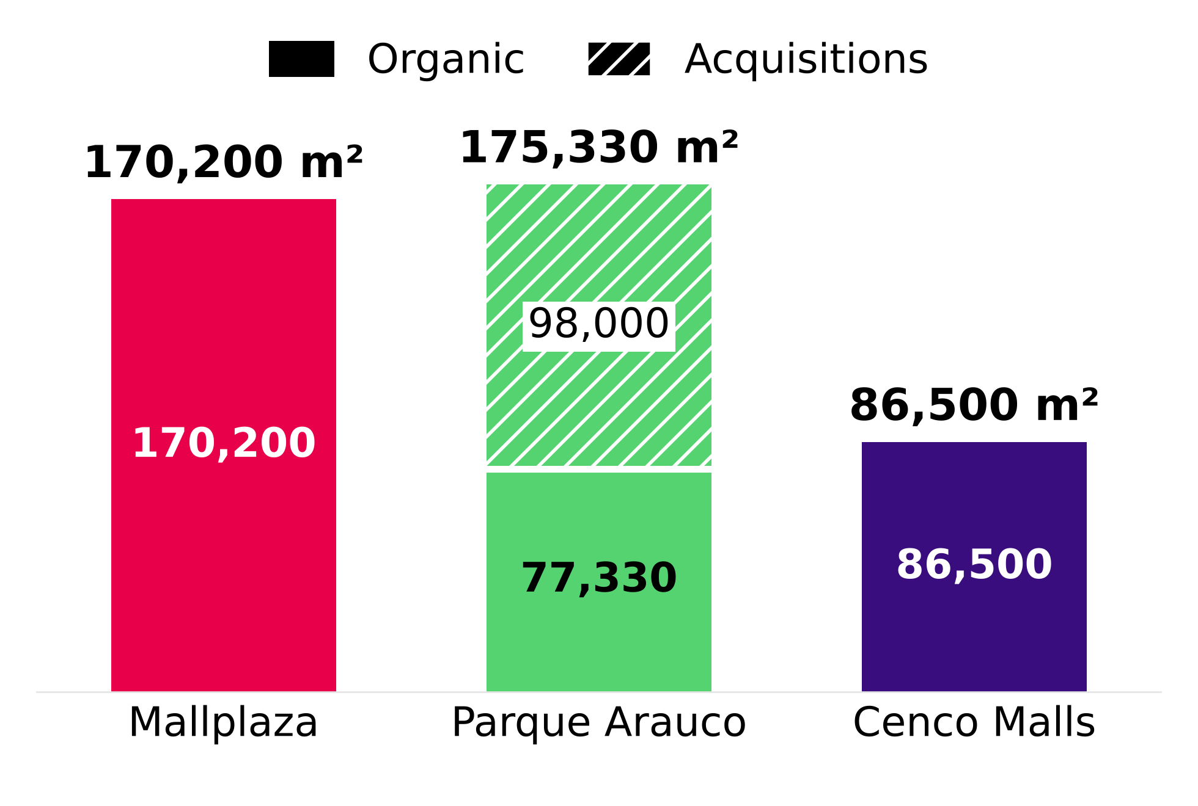  Source: Plaza S.A. 2Q26 reports and 2025 Annual Report; Parque Arauco Investor Presentation 2Q26; Cenco Malls Corporate Presentation 2Q26. Dated projects only.  Appendix 5: Market share within the trio in Chile, 2Q22-2Q26 (% of GLA)  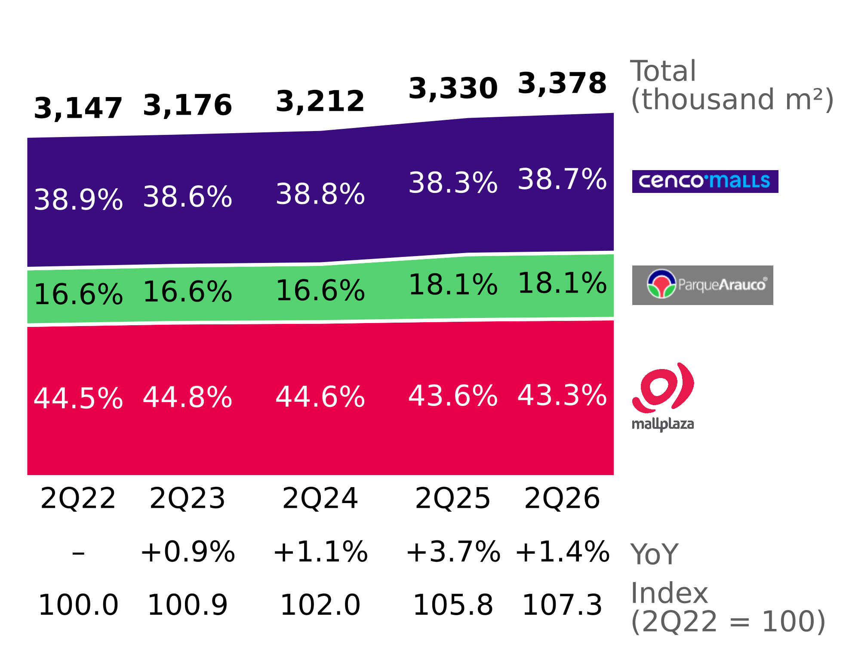  Source: 2Q22-2Q26 earnings reports of the three companies; team analysis. |  | Appendix 4: Consolidated occupancy rate, 2Q22-2Q26  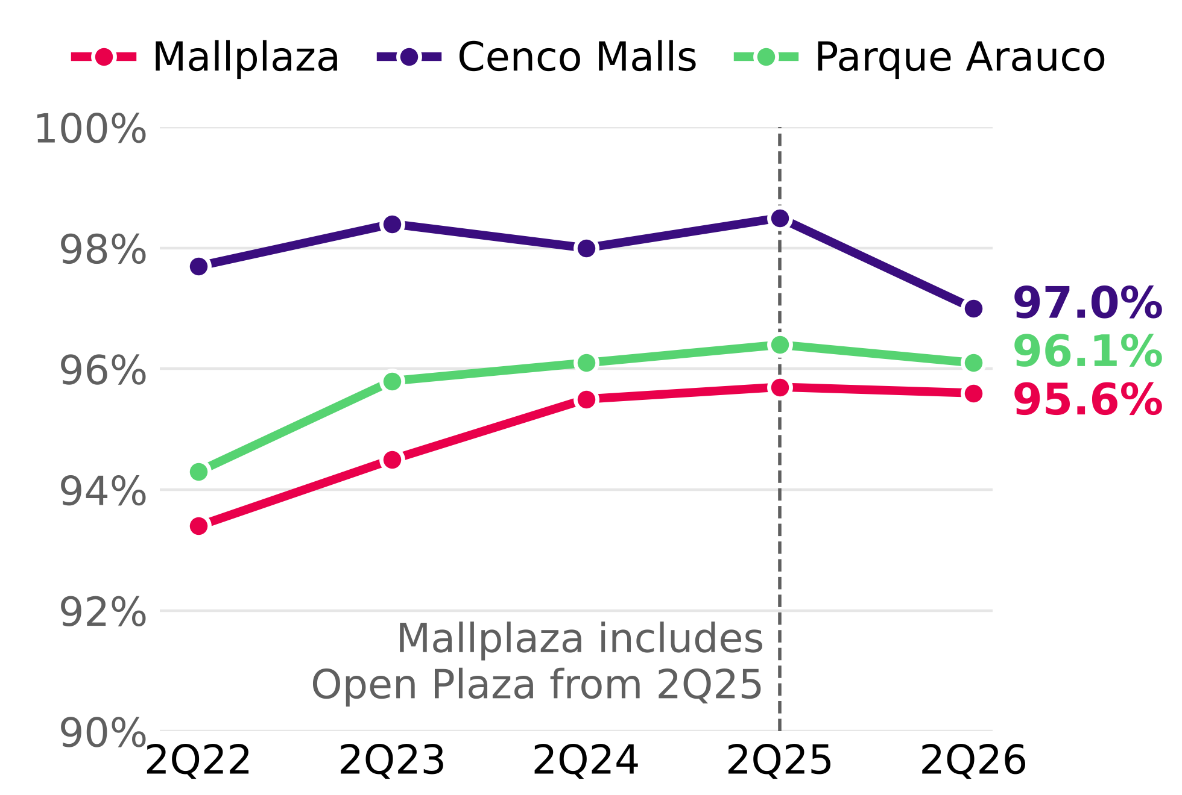  Source: 2Q22-2Q26 earnings reports of the three companies. Each company defines occupancy differently; Mallplaza includes Open Plaza since 2Q25.
Appendix 6: Porter's five forces by country and key evidence
Force | Chile | Peru | Colombia | Final | Key evidence
Rivalry | 4 | 4 | 4 | 4 | CR3 76% / 37% / 13%; race to reinvest in experience; asset acquisitions (Minka, Plaza Central; Quilín and Chicureo announced); supply above consumption in 2027-28. Stable shares and margins of 71-90%.
New entrants | 1 | 2 | 3 | 2 | Capital-intensive (USD 613 million for 170,200 m² at Mallplaza); incumbents' land banks; Peru and Colombia less concentrated; most malls in Colombia are strata-titled (multi-owner).
Bargaining power of tenants | 1 | 2 | 2 | 1 | Chile occupancy 96-99%; average lease terms of 5.0-8.7 years; top 5 = 18% of Mallplaza revenue; Chile SSR above CPI (6.9% vs 4.8%, 1Q23-2Q26); department stores 19.0% of GLA.
Bargaining power of suppliers | 1 | 1 | 1 | 1 | Common-area expenses passed through to tenants (2025 Annual Report, note 2.20); cost of sales 6.2% of Mallplaza revenue.
Substitutes | 2 | 2 | 2 | 2 | 93% of Mallplaza rental income is fixed; 2Q26 visits +4.4% Chile, +1.3% Peru, +2.5% Colombia; shift toward experience. No official e-commerce data by country.
Source: team analysis. 1-5 scale in whole numbers; final score = weighted average by Mallplaza GLA as of 2Q26 (Chile 61.9%, Peru 26.2%, Colombia 11.9%), rounded to the nearest integer. For new entrants, the weighted score sits at the threshold (1.5) and the team sets it at 2 given lower barriers to entry in Peru and Colombia. Detail and sources for each data point in Porter_industria_2Q26.xlsx.
Appendix 7: Key assumptions
Topic | Assumption
Market share | Measured by GLA (not by sales) across the main operators in each country (slide 7, Institutional Presentation 2Q26). Partial HHI: it is a floor.
Pipeline | Only projects with dates in official reports as of 2Q26 and the 2025 Annual Report; for date ranges, the end of the range is used; acquisitions are not new supply for the industry.
Supply vs demand | Chile only and only consumption-dependent m² (excludes offices and multifamily); base GLA excludes Cenco's offices. Private consumption from the Sep-2026 IPoM is used as a demand indicator, not as a sales forecast.
EBITDA per m² | EBITDA as defined by each company (none includes IAS 40 revaluation gains); 2Q26 EBITDA not annualized; consolidated GLA at 100% of controlled assets.
Leases | Profile and term weighted by GLA: explicit for Cenco and in Parque Arauco's profile; assumption for Mallplaza.
Real sales | Chile tenant sales 2Q26 vs 2Q25 deflated by 12-month CPI as of June 2026 (4.3%; INE, release dated July 8, 2026). Cenco 2Q25 calculated from its published change (−1.9%).
Dates | Company data as of June 30, 2026; macro projections from the September 2026 IPoM, as the most recent available.

APPENDIX 8: CORPORATE GOVERNANCE AND SUSTAINABILITY
Supporting information for the ESG section: ownership structure, Board of Directors, compliance, stakeholder engagement model, organisational culture and waste. Main source: Mallplaza Annual Report 2025.
1. OWNERSHIP STRUCTURE (31-DEC-2025)
Figure 8.1: Shareholding by type of shareholder
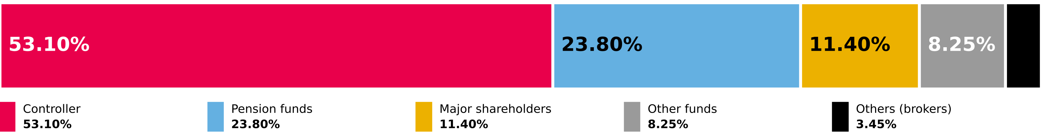
Source: Mallplaza Annual Report 2025 (NCG 461 2.3.3). No ADRs or certificates issued abroad.

Ten largest shareholders | Shares | % of shares
Desarrollos Inmobiliarios SpA (Falabella) | 1,161,849,244 | 53.05%
Inversiones Avenida Borgoño Limitada | 197,439,955 | 9.02%
Banchile Corredores de Bolsa S.A. | 59,447,149 | 2.71%
BCI Corredor de Bolsa S.A. | 53,553,765 | 2.45%
AFP Habitat S.A. Pension Fund C | 50,733,976 | 2.32%
Santiago Stock Exchange | 41,532,310 | 1.90%
AFP Provida S.A. Pension Fund C | 37,746,440 | 1.72%
Banco Santander on behalf of foreign investors | 35,594,345 | 1.63%
AFP Capital S.A. Pension Fund C | 34,539,038 | 1.58%
AFP Habitat S.A. Pension Fund B | 30,039,097 | 1.37%
2. BOARD OF DIRECTORS (ELECTED 22-APR-2025)
Figure 8.2: Board members (red: independent director; blue: chairman)

9 full members, no alternates; one independent director. Each director holds at most four positions in other listed companies. Tomás Müller, Manuela Sánchez and Juan Pablo Montero were directors until 22-Apr-2025. Source: Mallplaza Annual Report 2025.
3. ETHICS AND COMPLIANCE, 2025
Matter | Cases
Breaches of laws and regulations | 0
Corruption | 0
Breaches of customer rights (Consumer Protection Law 19,496) | 27
Breaches of employee rights | 2
Proceedings by the Environment Superintendency | 1
Complaints of workplace, sexual harassment and violence at work | 8
Source: Mallplaza Annual Report 2025.
4. STAKEHOLDER ENGAGEMENT MODEL
Figure 8.3: Implementation process of the engagement model
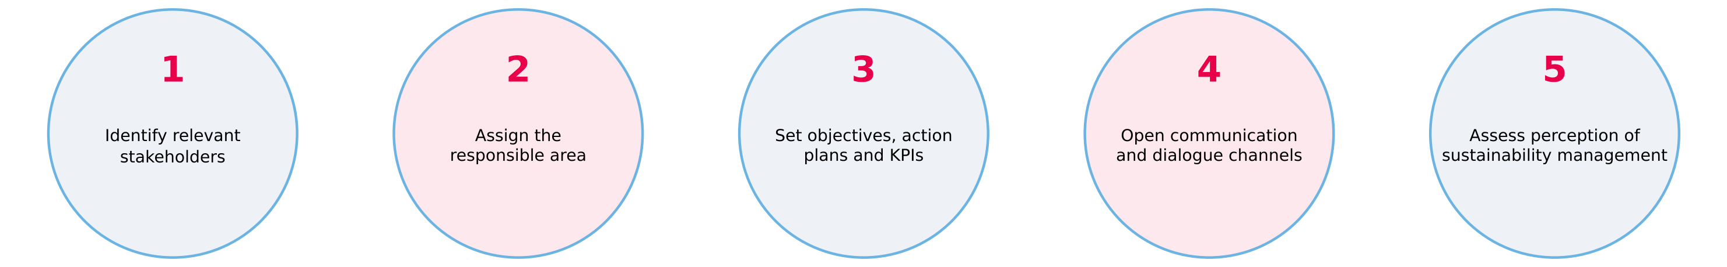
Source: Mallplaza Annual Report 2025.
5. ORGANISATIONAL CULTURE: 2025 CULTURE SURVEY
75%  Engagement  −2 pp vs 2024 · 2025 target: 80% |  | 37  eNPS  −10 vs 2024 |  | 88%  Leadership  +2 pp vs 2024 |  | 93%  Participation  +3 pp vs 2024
Leadership (88%) is the main asset to leverage the strategy. Source: Mallplaza Annual Report 2025.
6. WASTE, 2025
Figure 8.4: Waste generation by country  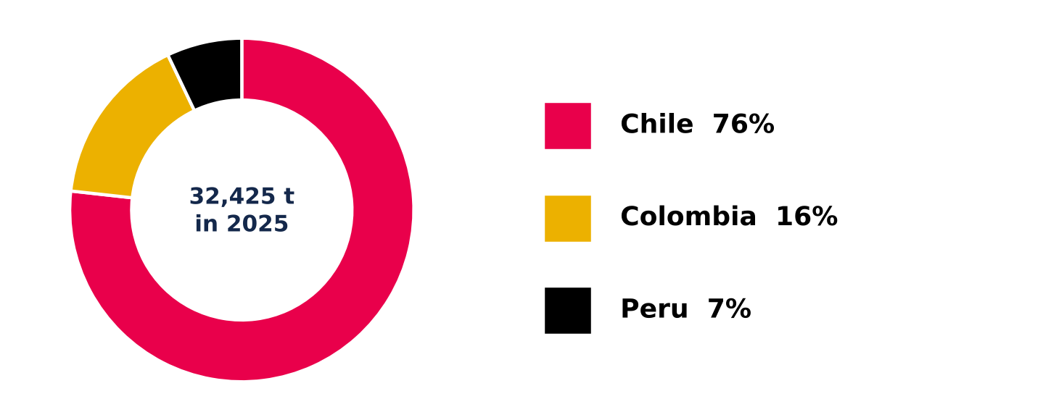  Source: Mallplaza Annual Report 2025. |  | 32,424.86 tonnes of waste across the region: 76% in Chile, 16% in Colombia and 7% in Peru.  46.2% recovered: 14,987.57 t of non-hazardous waste went to energy recovery through biogas (40.4%), recycling (36.1%) and composting (23.5%); the rest went to disposal, mainly sanitary landfills.  Hazardous waste: 9.03 t, a marginal amount given the nature of the business.

APPENDICES: FINANCIAL ANALYSIS
Appendix 9: Forecast assumptions (nominal CLP, 2026E–2031E)  Tags: R reported · C team calculation · S team assumption · P market consensus. Source: Plaza S.A. financial statements (CMF); 2Q26 results release; Bloomberg ECFC; Team analysis. |  | Appendix 10: Summary financial statements (CLP bn)  LTM = FY2025 − 1H25 + 1H26. 2024 as restated in Dec-25; 2022A from restated Dec-23 statements; 2022 financing lines not in the files used. Source: Plaza S.A. financial statements (CMF) Dec-24, Dec-25, Jun-26.
  Driver | Assumption | Basis | Tag
  2026E anchor | 1H26 actual + 2H26E repeating 1H26 local-currency growth (Chile 6.1%, Peru 7.9%, Colombia 7.3%) | Interim FS Jun-26 | R/S
  Inflation | Consensus CPI 2026–28; central-bank targets from 2029 (CL 3%, PE 2%, CO 3%) | Leases indexed to UF/CPI | P/S
  Real same-store growth (ex-parking) | Chile 1.5% → 0.6%; Peru 1.5% → 0.4%; Colombia 2.5% → 2.1% (2027E → 2031E) | Midpoints of company appraisal ranges (Note 11) | S
  Occupancy | Chile 96.1%, Colombia 97.5% flat; Peru 93.8% → 94.6% by 2028E | 2Q26 actual; Peru back to 2025 | R/S
  Parking | 12.1% / 6.4% / 9.0% of 2026 revenue; real growth 9% → 2% | 2Q26 release (LTM +23.7%) | R/S
  Pipeline GLA | 8,900 m² (2026), 72,950 m² (2027), 41,850 m² (2028); ramp 35/90/100% | 2Q26 release, projects | R/S
  Post-2028 expansion | 27,075 m² a year opening from 2029E (55% Chile / 45% Peru); USD 3,603/m² indexed to CPI, spent 50% in t−2 and 50% in t−1; 80.9% EBITDA margin; 6.9% yield on cost | Average organic GLA 2022, 2023, 2025; pipeline cost per m² | C/S
  FX | Consensus year-end 2026–28; purchasing-power parity thereafter | Bloomberg ECFC, 5 Oct 2026 | P/S
  EBITDA margin | Chile 80%, Peru 82%, Colombia 74% (≈ 79.7% consolidated) | 2024–LTM 2Q26; 2025 peak not extrapolated | S
  D&A | 0.70% of revenue | LTM 2Q26 (4.8 / 677.3) | C
  Cash tax rate | 16.8% (2026E) → 19% → 21.5% → 24% → 27% (2030E–31E) | 1H26 current tax; shields run off | C/S
  Project capex | USD 445m remaining at Jun-26, spread to final opening (2026E–28E) | 2Q26 release, pipeline | R/S
  Maintenance + IT capex | 5.5% of revenue | 2024 (4.8%) – LTM 2Q26 (~6.6%) | S
  Working capital | Net operating working capital at 15.6% of revenue (Dec-25); 2026E covers 2H26E only | FS Dec-25, first year-end with full Peru | C/S
  Leverage | Net debt / EBITDA 2.36x (Jun-26) → 3.5x by Dec-31E, linear; cash above the plan returned via buybacks or special dividends | Team assumption; peers 2.1x–5.7x | S
  Cost of debt | Net financial cost 3.08% of opening net debt + 25bp real per turn of leverage above 2.36x; UF indexation on 79% of debt | 1H26 annualized; team assumption | C/S
  Excluded | Greenfield (USD 0.7m LTM vs 55.2m in 2023), Gran Plaza; undated Chile projects replaced by the post-2028 expansion | No date or immaterial | S
  Payout | 40% of distributable profit, one-year lag, plus the additional distributions above | Board policy (Note 20e) | R/S
  Income statement | 2022A | 2023A | 2024A | 2025A | LTM 2Q26
  Revenue | 370.9 | 419.9 | 494.6 | 653.9 | 677.3
  EBITDA (company definition) | 282.7 | 322.2 | 380.6 | 526.2 | 544.9
  D&A | (2.2) | (2.2) | (2.1) | (3.6) | (4.8)
  Fair-value gains & other op. items, net | 83.1 | 193.7 | 157.3 | 1,445.4 | 1,190.4
  Operating income | 363.6 | 513.8 | 535.9 | 1,968.1 | 1,730.6
  Net financial cost | — | (23.8) | (30.9) | (54.0) | (44.9)
  UF indexation of debt | — | (55.3) | (53.2) | (43.8) | (50.4)
  Net income attributable | 157.7 | 349.8 | 335.9 | 1,431.0 | 1,258.1
  FFO attributable (company) | 218.9 | 257.2 | 303.2 | 405.3 | 419.9
  Balance sheet | Dec-23 | Dec-24 | Dec-25 | Jun-26
  Cash and equivalents | 202.0 | 179.2 | 268.3 | 347.6
  Investment property | 4,166.5 | 5,356.5 | 6,961.9 | 7,309.8
  Total assets | 4,796.3 | 5,915.1 | 7,583.6 | 7,985.7
  Gross financial debt | 1,264.0 | 1,617.6 | 1,579.3 | 1,633.4
  Deferred tax liabilities | 656.5 | 892.9 | 1,248.8 | 1,313.7
  Equity attributable to owners | 2,601.1 | 3,157.9 | 4,482.9 | 4,820.9
  Cash flow | 2023A | 2024A | 2025A | 1H26
  Operating cash flow | 295.1 | 300.8 | 441.1 | 258.2
  Capex | (119.1) | (76.3) | (103.6) | (84.2)
  Acquisitions incl. minorities | (164.6) | (400.4) | (0.3) | —
  Equity issued | — | 308.4 | — | —
  Net borrowing / (repayment) | (124.0) | 1.3 | (86.5) | 5.5
  Interest paid | (55.6) | (54.4) | (68.2) | (30.1)
  Dividends paid | (0.0) | (125.8) | (108.5) | (87.6)

Appendix 11: Ratio dashboard  Jun-26 leverage on LTM EBITDA; operating costs = cost of sales + admin (1H26). Dec-24 receivable days n.m. (Peru consolidated one month). Jun-26 returns need the Jun-25 balance sheet. Source: Plaza S.A. financial statements (CMF); MD&A 1H26; Team analysis.  Appendix 12: The EBITDA we use is the company's: fair-value gains are removed once (CLP bn)  Bloomberg's EBITDA field includes fair-value gains and is not used. Source: Plaza S.A. financial statements (CMF), Notes 23.1–23.3; 2Q26 release; Team analysis. |  | Appendix 13: Base-case projection (CLP bn)  2026E = 1H26 actual + 2H26E; capex includes CLP 84.2bn spent in 1H26; Δ working capital and additional distributions cover 2H26E only. FFO = (EBITDA − net financial cost) × (1 − cash tax), before minorities (~1%); distributable profit = FFO − UF indexation. Source: valuation workbook v2 (DCF, Deuda and Expansion sheets); Team analysis.  Appendix 14: Like-for-like, Mallplaza earns the highest normalized ROE of its local peers (FY2025)  Mallplaza normalized on audited distributable profit; peers on net income − fair-value gains × (1 − 27%). Parque Arauco property excludes JVs, overstating its LTV. Source: Plaza S.A. financial statements (CMF); Bloomberg FA as-reported (PARAUCO CI, CENCOMAL CI; export 28 Sep 2026); Team analysis.
   | 2023 | 2024 | 2025 | Jun-26
  ROE, normalized | 8.1% | 8.3% | 9.7% | —
  ROA, normalized | 4.2% | 4.5% | 5.5% | —
  ROIC (NOPAT at 27%, IC at fair value) | 6.5% | 6.6% | 7.3% | —
  Current ratio (x) | 1.78 | 1.18 | 1.54 | 2.50
  Cash / current liabilities (x) | 0.83 | 0.52 | 0.87 | 1.71
  Total liabilities / equity (x) | 0.82 | 0.85 | 0.68 | 0.64
  LTV (net debt / inv. property) | 25.5% | 26.9% | 18.8% | 17.6%
  Net debt / EBITDA (x) | 3.30 | 3.78 | 2.49 | 2.36
  EBITDA / financial costs (x) | 6.9 | 6.8 | 7.7 | 8.4
  Asset turnover (x) | 0.090 | 0.092 | 0.097 | —
  Operating costs / revenue | 23.8% | 23.5% | 20.1% | 21.2%
  Receivable days | 65 | n.m. | 66 | 50
   | 2022A | 2023A | 2024A | 2025A | LTM 2Q26
  Operating income + D&A | 365.8 | 515.9 | 538.0 | 1,971.7 | 1,735.4
  (−) Other op. income (mostly fair value) | (85.4) | (195.6) | (162.5) | (1,448.9) | (1,194.5)
  (+) Other op. expenses (non-recurring) | 2.3 | 1.8 | 5.2 | 3.5 | 4.1
  EBITDA, adjusted | 282.7 | 322.2 | 380.6 | 526.2 | 544.9
  Check vs company EBITDA | 0.0 | 0.0 | 0.0 | 0.0 | 0.0
  CLP bn | 2026E | 2027E | 2028E | 2029E | 2030E | 2031E
  Revenue — Chile | 498.4 | 533.9 | 571.2 | 603.1 | 628.7 | 652.8
  Revenue — Peru | 131.3 | 145.2 | 159.8 | 171.6 | 178.6 | 184.9
  Revenue — Colombia | 75.2 | 88.1 | 89.4 | 92.2 | 96.8 | 101.8
  Eliminations | (1.0) | — | — | — | — | —
  Revenue — post-2028 expansion | — | — | — | 3.1 | 11.7 | 21.8
  Revenue | 704.0 | 767.2 | 820.5 | 870.1 | 915.9 | 961.3
  Growth | 7.7% | 9.0% | 7.0% | 6.0% | 5.3% | 5.0%
  EBITDA | 561.3 | 611.4 | 654.2 | 694.0 | 730.6 | 766.9
  EBITDA margin | 79.7% | 79.7% | 79.7% | 79.8% | 79.8% | 79.8%
  D&A | (5.0) | (5.4) | (5.8) | (6.1) | (6.4) | (6.8)
  EBIT | 556.4 | 606.0 | 648.5 | 687.9 | 724.1 | 760.1
  Cash tax rate | 16.8% | 19.0% | 21.5% | 24.0% | 27.0% | 27.0%
  Capex — pipeline + maintenance | (209.2) | (240.7) | (151.5) | (47.7) | (49.7) | (51.7)
  Capex — post-2028 expansion | — | (46.3) | (95.3) | (98.2) | (101.1) | (104.2)
  Δ working capital | (3.9) | (9.9) | (8.3) | (7.7) | (7.1) | (7.1)
  FFO | 428.5 | 460.4 | 473.1 | 481.5 | 482.3 | 501.6
  Distributable profit | 380.0 | 427.7 | 434.4 | 436.9 | 431.6 | 444.6
  Ordinary dividends (40%) | (147.7) | (152.0) | (171.1) | (173.8) | (174.8) | (172.6)
  Additional distributions | (121.0) | (236.1) | (268.0) | (380.1) | (378.6) | (404.8)
  Net debt / EBITDA (x) | 2.46 | 2.67 | 2.88 | 3.09 | 3.29 | 3.50
   | Mallplaza | Parque Arauco | Cencosud Shopping
  Fair-value gain / opening property | 27.0% | 2.0% | 2.3%
  EBITDA / investment property | 7.3% (Chile) | 7.6% | 7.8%
  ROE, reported | 37.5% | 9.8% | 10.5%
  ROE, normalized | 9.7% | 7.8% | 8.0%
  LTV | 18.8% | 42.9% | 16.3%
  Net debt / EBITDA (x) | 2.49 | 5.68 | 2.11
  Assets / equity attributable, YE (x) | 1.69 | 2.69 | 1.51

APPENDIX 15: DISCOUNTED CASH FLOW
FCFF in nominal CLP from 30-Jun-26, with the mid-period convention and each period's WACC (Appendix 19). Terminal value uses 2032E FCFF with 3.0% nominal g (0% real, no reinvestment because RONIC is below the real WACC) and the 10.41% terminal WACC, and includes 108,301 m² of GLA maturing after 2031. It accounts for 76% of EV.
A. FREE CASH FLOW TO THE FIRM BY PERIOD (CLP MILLION)
 | 2H26E | 2027E | 2028E | 2029E | 2030E | 2031E | Terminal
Total revenue | 364,469 | 767,179 | 820,507 | 870,098 | 915,888 | 961,340 | 1,007,657
EBITDA | 290,741 | 611,360 | 654,236 | 694,005 | 730,578 | 766,858 | 804,002
EBITDA margin | 79.8% | 79.7% | 79.7% | 79.8% | 79.8% | 79.8% | 79.8%
Cash tax rate | 16.8% | 19.0% | 21.5% | 24.0% | 27.0% | 27.0% | 27.0%
NOPAT | 239,763 | 490,829 | 509,043 | 522,791 | 528,617 | 554,868 | 581,746
(+) D&A | 2,565 | 5,398 | 5,773 | 6,122 | 6,445 | 6,764 | 7,090
Base capex (pipeline + maintenance) | −124,994 | −240,660 | −151,495 | −47,682 | −49,731 | −51,674 | −55,421
Expansion capex / terminal reinvestment | 0 | −46,268 | −95,313 | −98,172 | −101,117 | −104,151 | 0
Investment in working capital | −3,908 | −9,859 | −8,321 | −7,738 | −7,145 | −7,093 | −4,580
FCFF | 113,426 | 199,440 | 259,688 | 375,321 | 377,068 | 398,716 | 528,835
Nominal WACC of the period | 10.54% | 10.51% | 10.48% | 10.46% | 10.44% | 10.41% | 10.41%
Discount factor (mid-period) | 0.9753 | 0.9048 | 0.8188 | 0.7412 | 0.6711 | 0.6078
PV of FCFF / of terminal value | 110,620 | 180,452 | 212,644 | 278,200 | 253,058 | 242,325 | 4,125,700
B. FROM ENTERPRISE VALUE TO VALUE PER SHARE |  | C. DCF VALUE SENSITIVITY (CLP/SHARE)
  Item | CLP million | CLP/share
  PV of explicit FCFF (2H26E–2031E) | 1,277,299 | 583
  PV of terminal value | 4,125,700 | 1,884
  Enterprise value (EV) | 5,402,999 | 2,467
  (−) Net financial debt 30-Jun-26 | −1,285,740 | −587
  (−) Minorities (book) | −50,841 | −23
  Equity value / per share | 4,066,418 | 1,857
  Δ WACC \ g | g 2.5% | g 3.0% | g 3.5% | g 4.0%
  −100 bp | 2,329 | 2,278 | 2,216 | 2,139
  −50 bp | 2,109 | 2,052 | 1,983 | 1,900
  0 bp | 1,918 | 1,857 | 1,785 | 1,699
  +50 bp | 1,750 | 1,687 | 1,614 | 1,528
  +100 bp | 1,601 | 1,538 | 1,464 | 1,379
Terminal value at 31-Dec-31: CLP 7,133,037 million (implied cap rate 10.1%; implied LTM EV/EBITDA 9.9x). 2H26E: half year. Source: model v2, DCF and Sensibilidad sheets; 2,190 million shares.
APPENDIX 16: FORECAST ASSUMPTIONS
The base forecast follows the team's operating engine (announced pipeline to 2028); from 2029 a continuous expansion is added at the historical opening pace. 2026E revenue is calendar-year; the 2H26E period deducts actual 1H26 (CLP 339,530 million of revenue).
A. REVENUE, CAPEX AND WORKING CAPITAL FORECAST (CLP MILLION)
 | 2H26E | 2027E | 2028E | 2029E | 2030E | 2031E
Base revenue (calendar year) | 703,999 | 767,179 | 820,507 | 866,952 | 904,203 | 939,524
Total revenue growth | 7.7% | 9.0% | 7.0% | 6.0% | 5.3% | 5.0%
Continuous-expansion revenue | 0 | 0 | 0 | 3,146 | 11,685 | 21,815
Base EBITDA margin | 79.8% | 79.7% | 79.7% | 79.8% | 79.8% | 79.7%
Cash tax rate | 16.8% | 19.0% | 21.5% | 24.0% | 27.0% | 27.0%
Capex on projects under way (USD million) | 113.6 | 215.1 | 116.3 | 0.0 | 0.0 | 0.0
Average USDCLP | 930 | 923 | 915 | 921 | 921 | 921
Capex on projects under way | 105,634 | 198,465 | 106,367 | 0 | 0 | 0
Maintenance + IT capex (5.5% of revenue) | 19,360 | 42,195 | 45,128 | 47,682 | 49,731 | 51,674
Total base capex | 124,994 | 240,660 | 151,495 | 47,682 | 49,731 | 51,674
Continuous-expansion capex | 0 | 46,268 | 95,313 | 98,172 | 101,117 | 104,151
Expansion cost per m² (CLP million, CPI) | 3.32 | 3.42 | 3.52 | 3.63 | 3.73 | 3.85
Investment in working capital | 3,908 | 9,859 | 8,321 | 7,738 | 7,145 | 7,093
B. CONTINUOUS EXPANSION |  | C. OPERATIONS, CAPITAL AND TERMINAL VALUE
  Assumption | Value
  New GLA per year from 2029 | 27,075 m²
  Basis: organic average 2022, 2023 and 2025 | 30,458 / 38,618 / 12,150 m²
  Pipeline under way (2Q26 release) | USD 613.2 million / 170,200 m²
  Cost per m² (= pipeline) | USD 3,603
  Capex disbursement | 50% in t−2 / 50% in t−1
  Revenue ramp (year 1 / 2 / 3+) | 35% / 90% / 100%
  Chile / Peru mix; EBITDA margin | 54.9% / 45.1%; 80% / 82%
  Yield on cost / real after-tax RONIC | 6.9% / 5.0%
  Assumption | Value
  LTM 2Q26 EBITDA margin | 80.5%
  Maintenance + IT capex | 5.5% of revenue
  D&A / revenue | 0.70%
  Cash tax rate | 16.8% → 27% (2030)
  Net working capital / revenue (Dec-25) | 15.6%
  Receivables / advance rents (Dec-25, CLP million) | 122,370 / 20,247
  Nominal (real) terminal g | 3.0% (0.0%)
  Target net debt/EBITDA; real Kd per turn | 3.5x in 2031; +25 bp
  Payout on distributable income | 40%
Source: model v2, Forecast_Base, Expansion, Capital_Trabajo and Supuestos sheets (2Q26 release; Dec-25 financial statements; Exhibits v6).
APPENDIX 17: COMPARABLE MULTIPLES
We use the same peer set as the WACC beta. LTM EV/EBITDA is the main method (neutral to leverage and to IAS 40 revaluation); the multiple weights the Chilean median at 70% and the common-set median at 30%. P/E and P/BV mix fair-value and cost-basis peers: reference only. Price at 30-Sep-26; Bloomberg net debt and FX at 30-Jun-26.
A. PEERS (CLP MILLION; MULTIPLES IN TIMES)
Company | Country | Market cap | EV | LTM EBITDA | EV/EBITDA LTM | EV/EBITDA NTM | EV/EBIT LTM | P/E LTM | P/BV
Mallplaza | Chile | 7,785,450 | 9,147,860 | 544,935 | 16.8x | 14.8x | 16.9x | 6.2x | 1.6x
Parque Arauco | Chile | 3,440,408 | 5,429,487 | 294,411 | 18.4x | 15.8x | 18.8x | 22.3x | 1.8x
Cencosud Shopping | Chile | 3,710,183 | 4,569,181 | 350,561 | 13.0x | 11.7x | 13.1x | 10.5x | 1.2x
Multiplan | Brazil | 2,907,890 | 3,796,907 | 421,296 | 9.0x | 10.1x | 9.6x | 11.7x | 2.4x
Allos | Brazil | 2,656,188 | 3,895,017 | 388,839 | 10.0x | 9.4x | 14.1x | 15.9x | 1.2x
Iguatemi | Brazil | 1,381,190 | 1,763,277 | 201,423 | 8.8x | 7.4x | 9.9x | 12.1x | 1.6x
IRSA | Argentina | 1,140,416 | 1,789,191 | 145,686 | 12.3x | 6.2x | 13.2x | 4.7x | 0.8x
Fibra Danhos (excluded) | Mexico | 2,383,999 | 3,157,944 | 277,625 | 11.4x | 10.1x | 11.4x | 7.9x | 0.7x
Common-set median (6) |  |  |  |  | 11.1x | 9.7x | 13.1x | 11.9x | 1.4x
Chile median (2) |  |  |  |  | 15.7x | 13.8x | 15.9x | 16.4x | 1.5x
Weighted 70/30 |  |  |  |  | 14.4x | 12.5x | 15.1x | 15.0x | 1.4x
B. VALUE BY MULTIPLE |  | C. SENSITIVITY TO THE WEIGHTING
  Multiple | Weighted | Metric (CLP mn) | CLP/share
  EV/EBITDA LTM (main) | 14.4x | 544,935 | 2,951
  EV/EBITDA NTM | 12.5x | 617,130 | 2,914
  EV/EBIT LTM | 15.1x | 540,373 | 3,098
  P/E LTM (ref.) | 15.0x | 1,258,053 | 8,644
  P/BV (ref.) | 1.4x | 4,820,898 | 3,171
  Chile weight | Multiple | Mult. value | Target | Δ
  100% | 15.7x | 3,294 | 2,144 | +3.3%
  70% | 14.4x | 2,951 | 2,076 | 0.0%
  50% | 13.4x | 2,723 | 2,030 | −2.2%
  30% | 12.5x | 2,495 | 1,984 | −4.4%
  0% | 11.1x | 2,152 | 1,916 | −7.7%
Bridge: 14.36x × LTM EBITDA of CLP 544,935 million = EV 7,825,944 − Bloomberg net debt 1,311,569 − minorities 50,841 = CLP 2,951 per share (2,190 million shares). Fibra Danhos is excluded for its FIBRA regime and because it has no beta in the WACC; IRSA reports under IAS 29. Source: Bloomberg; model v2, Comparables and Precio_Objetivo sheets; Figuras_Valuacion, V7.
APPENDIX 18: SCENARIOS AND ROBUSTNESS
No scenario or alternative method reaches the CLP 3,555 price. Scenarios are computed with the DCF v2 replica (which reproduces the base value exactly), and the target keeps the 80% DCF weight and the CLP 2,951 multiples value.
A. SCENARIOS
Scenario | Assumptions | DCF (CLP) | Target price | vs price
Bear | WACC +100 bp in every period; EBITDA margin 75.8% (historical low) instead of 79.7% | 1,403 | 1,713 | −51.8%
Base | Model v2: WACC 10.54% → 10.41%; g 3.0%; margin 79.7% | 1,857 | 2,076 | −41.6%
Bull | WACC −100 bp; g 2.5%; margin 81.3% (historical high); cash tax capped at 23% | 2,546 | 2,627 | −26.1%
Appraisers | Nominal WACC 8.72% (5.55% real, Note 11) in every period | 2,660 | 2,718 | −23.5%
B. ALTERNATIVE METHODS AND INPUTS |  | C. DEBT TARGET VS SPREAD (DCF, CLP)
  Test | DCF (CLP) | Target | vs price
  APV (Ku 11.11%): unlevered value | 1,632
  (+) tax shields of debt | 261
  = APV per share | 1,894 | 2,105 | −40.8%
  Rf peso bond 5.43% (WACC −107 bp) | 2,311 | 2,439 | −31.4%
  DCF VF: constant WACC 10.37% | 1,880 | 2,095 | −41.1%
  WACC implied by the price: 7.56% | 3,555
  ND/EBITDA \ spread | 0 bp | 25 bp | 50 bp
  2.36x (current) | 1,819 | 1,819 | 1,819
  3.0x | 1,849 | 1,841 | 1,834
  3.5x | 1,872 | 1,857 | 1,842
  4.0x | 1,894 | 1,870 | 1,847
Bear and bull: EBITDA margin at the historical low/high (4Q23 and 3Q25 earnings releases) in every year; the bull case does not recompute the WACC tax shield. Source: DCF v2 replica (riesgos/graficos/tornado_operacional.py); model v2, APV, Sensibilidad (table 2, static) and DCF sheets; Figuras_Valuacion, WACC_Construccion and V6.
APPENDIX 19: WACC CONSTRUCTION
The WACC is computed per period: D/E converges linearly from the current structure (20.0%) to the target (28.5%, net debt/EBITDA 3.5x) in 2031. The cost of equity is built in dollars (US Treasury Rf + re-levered beta × ERP + revenue-weighted CRP) and converted to pesos with the inflation differential.
βL = βU × [1 + (1 − t) × D/E] (Hamada)
Ke USD = Rf + βL × ERP + weighted CRP
Ke CLP = (1 + Ke USD) × (1 + π Chile) / (1 + π US) − 1
Kd CLP = (1 + real Kd + spread) × (1 + π Chile) − 1
WACC = E/V × Ke CLP + D/V × Kd CLP × (1 − t)
A. MARKET AND CAPITAL STRUCTURE ASSUMPTIONS
Assumption | Value | Source
Rf: 10Y US Treasury | 4.98% | Tasa_WACC (FFCF)
Equity risk premium (ERP) | 4.14% | Damodaran
Long-term inflation, Chile | 3.00% | Central Bank target
Long-term inflation, US (10Y breakeven) | 2.24% | Bloomberg, Jun-26
Chilean tax rate | 27.00% | Income Tax Law
Real Kd: latest UF bond coupon | 3.60% | Mallplaza
Real Kd increase per turn of net debt/EBITDA | 0.25% | Team assumption
Net debt/EBITDA initial (30-Jun-26) → target | 2.36x → 3.5x | 2Q26 release; team assumption
Gross debt / market cap (current structure, CLP MM) | 1,579 / 7,906 (thousands) | Tasa_WACC (FFCF)
B. BETA: UNLEVERED PEERS
Company | Levered β | Debt (CLP MM) | Market cap (CLP MM) | Tax rate | Unlevered β
Parque Arauco | 1.250 | 1,700,507 | 3,828,031 | 27% | 0.944
Cencosud Shopping | 1.075 | 762,154 | 3,942,858 | 27% | 0.942
Allos | 1.164 | 960,191 | 2,712,166 | 34% | 0.944
Iguatemi | 0.908 | 647,397 | 1,421,560 | 34% | 0.698
IRSA | 0.427 | 625,047 | 1,218,777 | 35% | 0.320
Multiplan | 1.219 | 191,478 | 2,959,845 | 34% | 1.169
Median (6 peers included) |  |  |  |  | 0.9428
Source: Bloomberg (betas), Tasa_WACC. Costa Verde is excluded because it is not in the comparables set.
C. REVENUE-WEIGHTED COUNTRY RISK
Country | Weight (LTM revenue) | CRP (Damodaran) | Contribution
Chile | 71.8% | 1.04% | 0.75%
Peru | 17.7% | 1.55% | 0.27%
Colombia | 10.5% | 3.70% | 0.39%
Weighted CRP | 100.0% |  | 1.41%
D. WACC BY PERIOD
 | 2H26E | 2027E | 2028E | 2029E | 2030E | 2031E | Terminal
Net debt/EBITDA | 2.46x | 2.67x | 2.88x | 3.09x | 3.29x | 3.50x | 3.50x
D/E | 20.8% | 22.3% | 23.9% | 25.4% | 27.0% | 28.5% | 28.5%
D/V | 17.2% | 18.2% | 19.3% | 20.3% | 21.2% | 22.2% | 22.2%
Re-levered beta | 1.086 | 1.096 | 1.107 | 1.118 | 1.128 | 1.139 | 1.139
Ke USD | 10.88% | 10.93% | 10.97% | 11.02% | 11.06% | 11.10% | 11.10%
Nominal Ke CLP | 11.70% | 11.75% | 11.79% | 11.84% | 11.88% | 11.93% | 11.93%
Real Kd (UF) incl. spread | 3.63% | 3.68% | 3.73% | 3.78% | 3.83% | 3.89% | 3.89%
Nominal Kd CLP | 6.73% | 6.79% | 6.84% | 6.89% | 6.95% | 7.00% | 7.00%
After-tax Kd | 4.92% | 4.96% | 4.99% | 5.03% | 5.07% | 5.11% | 5.11%
Nominal WACC CLP | 10.54% | 10.51% | 10.48% | 10.46% | 10.44% | 10.41% | 10.41%
Real WACC | 7.32% | 7.29% | 7.26% | 7.24% | 7.22% | 7.20% | 7.20%
Figure 19.1: Nominal WACC and D/E by period  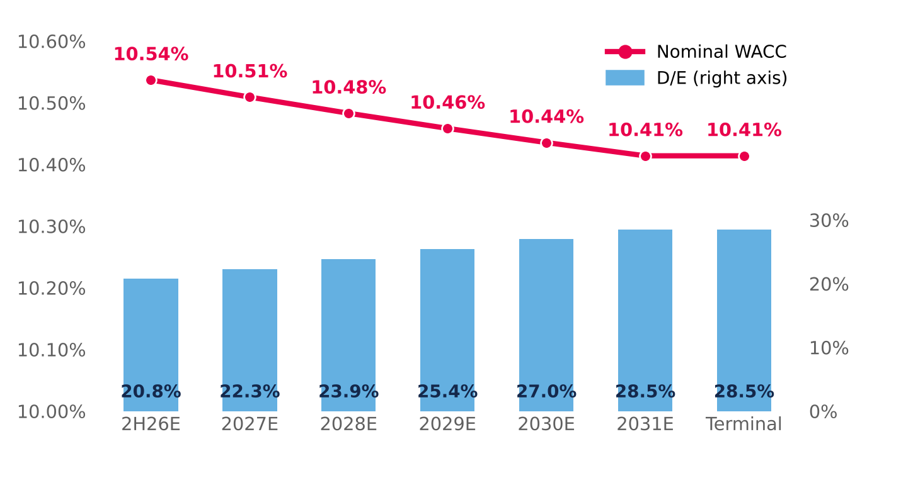  Control: the replica matches the WACC sheet of model v2 (0 bp difference in every period). Source: Damodaran; Bloomberg; Central Bank of Chile; Team analysis. |  | E. CHOICE OF THE RISK-FREE RATE  Why UST + CRP and not the peso bond: the local bond already embeds Chile risk, so adding the CRP would double-count it; also, 28% of revenue comes from Peru and Colombia, whose risk enters through the weighted CRP.  It is the more conservative choice: with the peso bond the target price rises to ~CLP 2,439, still 31% below the CLP 3,555 share price. The recommendation does not change.  Source: Central Bank of Chile, Informativo Diario 2-Jul-26; DCF v2 replica with the WACC shifted in every period.
  Alternative | Value
  Model base: US Rf + Chile CRP, in CLP | 6.80%
  10Y peso bond, Central Bank (30-Jun-26) | 5.43%
  Difference | 137 bp
  Effect on terminal WACC (difference × E/V) | −107 bp
  DCF value using the peso bond (CLP) | 2,311
  80/20 target price in that case (CLP) | 2,439

APPENDIX 20: MACROECONOMIC AND GEOPOLITICAL BACKDROP
Between 2022 and 2026 the world economy absorbed two geopolitical supply shocks and a structural rise in long-term rates. The result is a backdrop of stagflationary pressure and a higher cost of capital that reaches Chile through three channels — inflation, rates and consumption — and that sits behind the two most severe risks in the report (FR1 and MR1). In the charts, the dotted blue line marks the valuation date (30-Jun-2026); later data are shown for context.
USD 114  Brent, Sep-26 average  +61% vs Feb-26, before the conflict |  | 5.22%  10Y UST, 8-Oct-26  24-year high (since 2002) |  | 117 bp  France–Germany spread  30-Sep-26; ~150 bp in early Oct. |  | 3.0% | 4.7%  IMF 2026: GDP | inflation  growth cut; disinflation stalled |  | 0.25–0.75%  Chile 2026 GDP (BCCh)  down from 2–3% expected in Dec-25
1. HOW THE SHOCK REACHES MALLPLAZA
Figure 20.1: Transmission map: from global shocks to Mallplaza's risks
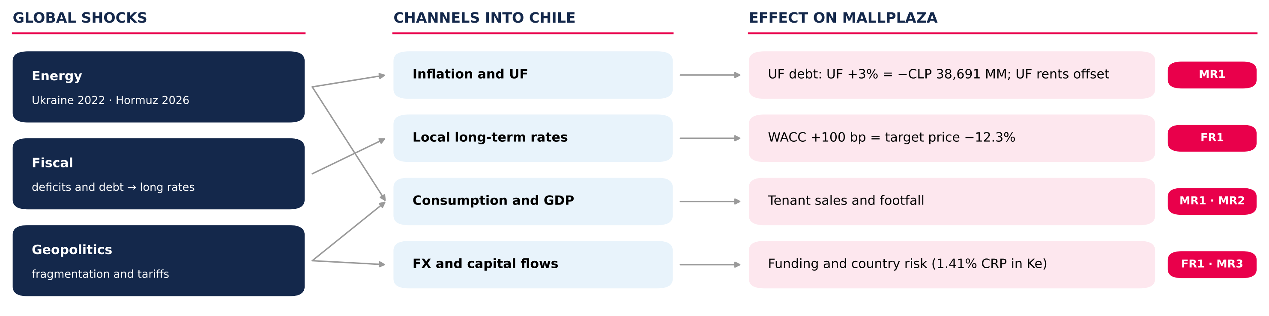
Source: Team analysis; figures from Figures 28–30 of the report (Investment Risks).
2. TWO SUPPLY SHOCKS AND A GLOBAL RISE IN RATES
Figure 20.2: Brent crude oil price, 2022–2026 (USD/barrel)  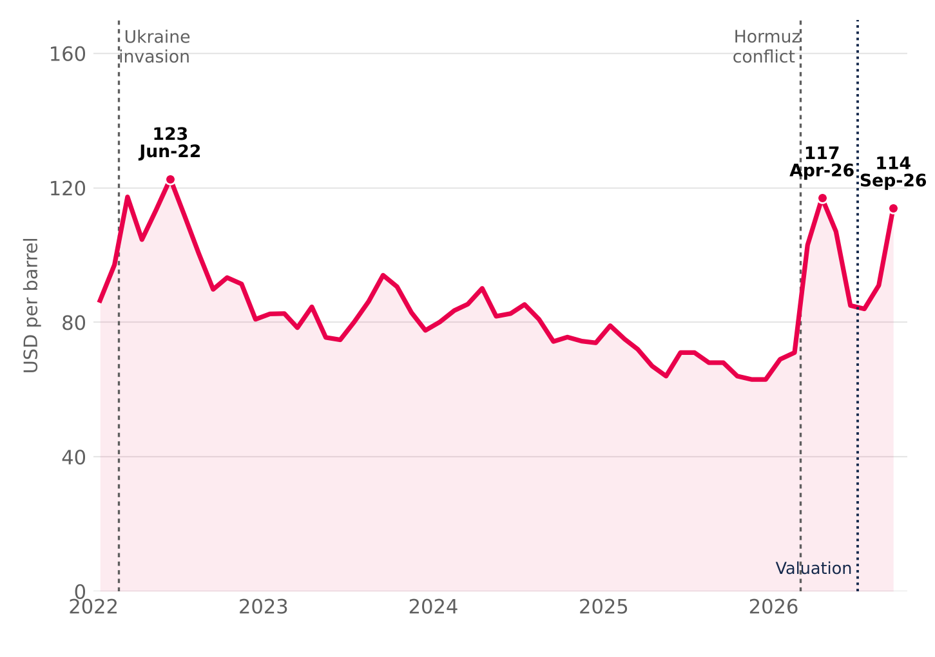  Two supply shocks. Russia's invasion of Ukraine (Feb-22) pushed Brent to USD 123 in June 2022. In 2026, the conflict in the Strait of Hormuz — which carries more than a quarter of seaborne oil — lifted it from USD 71 in February to USD 117 in April; after a truce in June, renewed attacks took it back to USD 114 in September.  Source: EIA (Brent spot, monthly average; STEO Apr-26, Sep-26 and Oct-26); Statista. |  | Figure 20.3: 10-year sovereign yields, 2022–2026 (%)  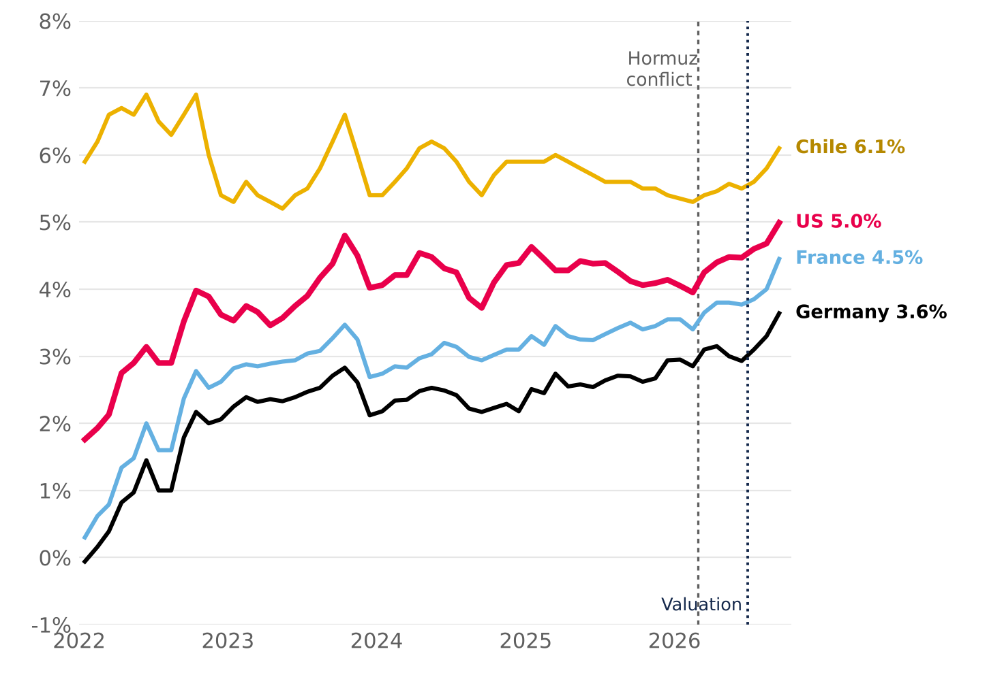  Long-term rates rise together. The 10Y UST moved from 1.8% (Jan-22) to 5.0% (Sep-26) and touched 5.22% on 8 October, a 24-year high; the Bund went from −0.1% to 3.6%. Fiscal deficits push up the risk-free rate, and Chile has followed the move since mid-2026.  Source: FRED (GS10), Bundesbank, Banque de France (via OECD) and BCCh (10Y BCP); monthly averages.

3. FISCAL PREMIUM AND STAGFLATION
Figure 20.4: 10-year spreads: France–Germany and Chile–US (bp)  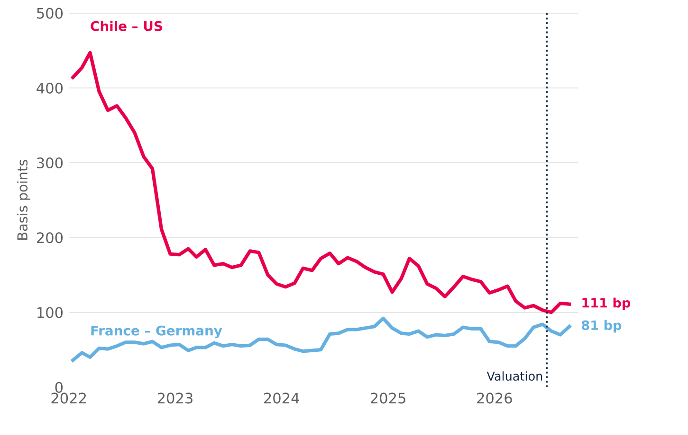  The rise is fiscal and global, not Chile risk. France's spread over Germany rose from ~40 bp in 2022 to an 81 bp average in September 2026 and 117 bp at month-end (~150 bp in early October, the widest since 2011–12). Chile's spread over the US compressed: local rates depend more and more on the global base rate.  Source: Team calculation with Figure 20.3 data (monthly averages); September close: Banque de France / Bundesbank. |  | Figure 20.5: World growth and inflation, 2022–2026P (%)  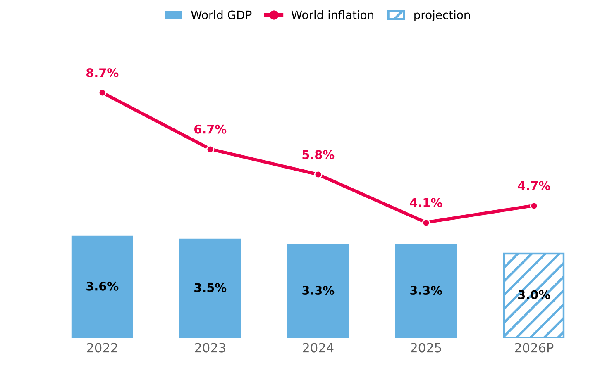  Stagflation. The IMF cut 2026 world growth to 3.0% and raised inflation to 4.7% (from 4.1% in 2025): the disinflation under way since 2024 stalled on higher energy and food prices, in an economy that grows less.  Source: IMF, World Economic Outlook (July 2026 update). 2026P = projection.
4. CHILE: SLOWER GROWTH AND STICKY INFLATION
Figure 20.6: Chile: GDP, inflation and policy rate, 2022–2026P (%)  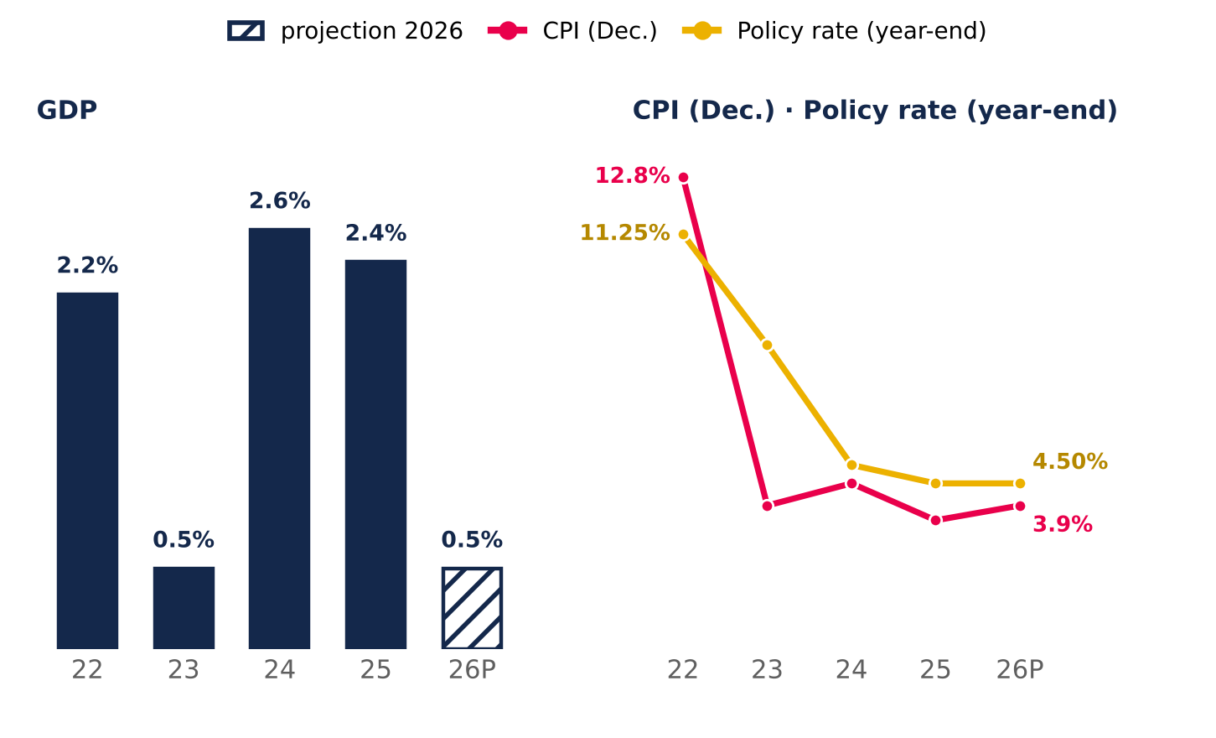  Source: BCCh (Monetary Policy Reports Dec-25, Jun-26 and Sep-26) and INE. 2026 GDP: midpoint of the 0.25–0.75% range. |  | Slower growth. The Central Bank cut 2026 GDP growth to 0.25–0.75%, from 2–3% in December 2025, with a weaker labour market and falling confidence.  Sticky inflation. CPI rises to 3.9%, above the 3% target, and the policy rate stays at 4.5%: there is no room to support consumption, the driver of tenant sales (MR1).  Geopolitical fragmentation. Weaker alliances and unpredictable US trade policy raise hedging costs and reduce flows to emerging markets. For Chile, Peru and Colombia this means more volatile currencies and costlier funding, which the model captures with a 1.41% weighted CRP in the cost of equity.
5. WHAT IT MEANS FOR MALLPLAZA
Channel | 2022–2026 | Effect on Mallplaza | In the model | Risk
Energy and inflation | Brent USD 71 → 114 (Feb–Sep-26); world inflation 4.1% → 4.7% | Indexes UF debt (79% of total); UF-linked rents offset it | UF +3% = −CLP 38,691 MM of earnings (Fig. 30) | MR1
Long-term rates | 10Y UST 4.1% → 5.2%; Bund 2.9% → 3.6% (Dec-25 → Oct-26) | Higher WACC and cost of refinancing the pipeline | Rf 4.98%; WACC +100 bp = target price −12.3% (Fig. 29) | FR1
Consumption and GDP | Chile 2026 GDP: 0.25–0.75%; CPI 3.9% | Lower tenant sales, footfall and demand for new formats | Tornado: traffic −1.3% / +2.4% of value (Fig. 28) | MR1 · MR2
Fragmentation | US tariffs; lower flows to emerging markets | Volatile currencies and costlier funding | 1.41% weighted CRP in Ke; debt in local currency and hedging derivatives (MD&A 2Q26) | FR1 · MR3
6. WHAT TO WATCH
Indicator | Latest | Warning sign | What it means for Mallplaza
10Y UST | 5.22% (8-Oct-26) | Sustained above 5.5% | ≈ WACC +50 bp: target price from CLP 2,076 to ~1,940 (Fig. 29)
Brent | USD 114 (Sep-26) | Above USD 120 or a prolonged Hormuz closure | Higher inflation and UF: larger debt indexation (MR1)
Chile CPI | 3.9% (Jun-26 MPR) | Above 4% for two quarters | No rate cuts; weak consumption and tenant sales
Chile GDP | 0.25–0.75% 2026 (MPR) | Two quarters of contraction | Lower footfall and sales; pressure on occupancy (Fig. 28)
France–Germany spread | 117 bp (30-Sep-26) | Above 150 bp | Fiscal contagion: more pressure on global long-term rates (FR1)
Investor takeaway. The backdrop raises the likelihood of the report's two most severe risks (FR1 and MR1). The model uses a 4.98% Rf and a 10.41% terminal nominal WACC (10.54% in 2H26E); with the 10Y UST above 5.2% in October, the bias on the discount rate is upward, which reinforces the recommendation.

