FINANCIAL ANALYSIS
Mallplaza's rental engine grows at roughly 3% in real terms with an 80% EBITDA margin and cash-flow leverage below 2.5x; headline profit, growth and leverage all overstate that engine and must be normalized before forecasting.
Figure 1: Normalized ROE of 8–10% is the real return; reported ROE is appraisal-driven
CLP bn | ’22 A | ’23 A | ’24 A | ’25 A | ’26 E | ’27 E | ’28 E | ’29 E | ’30 E | ’31 E
Revenue | 371 | 420 | 495 | 654 | 704 | 767 | 821 | 870 | 916 | 961
EBITDA margin % | 76.2 | 76.7 | 77.0 | 80.5 | 79.7 | 79.7 | 79.7 | 79.8 | 79.8 | 79.8
FFO margin % | 59.0 | 61.3 | 61.3 | 62.0 | 60.9 | 60.0 | 57.7 | 55.3 | 52.7 | 52.2
Net income, reported | 158 | 350 | 336 | 1,431 | 639 | 592 | 610 | 624 | 627 | 649
Distributable profit | 96 | 198 | 238 | 369 | 380 | 428 | 434 | 437 | 432 | 445
Net margin, normalized % | 25.8 | 47.0 | 48.2 | 56.5 | 54.0 | 55.7 | 52.9 | 50.2 | 47.1 | 46.2
Asset turnover (x) | .086 | .090 | .092 | .097 | .089 | .091 | .092 | .093 | .093 | .094
Assets / equity (x) | 1.94 | 1.91 | 1.86 | 1.77 | 1.69 | 1.71 | 1.74 | 1.79 | 1.84 | 1.89
ROE, reported % | 7.1 | 14.4 | 11.7 | 37.5 | 13.7 | 12.0 | 11.9 | 11.8 | 11.8 | 12.0
ROE, normalized % | 4.3 | 8.1 | 8.3 | 9.7 | 8.1 | 8.6 | 8.4 | 8.3 | 8.1 | 8.2
ROA, normalized % | 2.2 | 4.2 | 4.5 | 5.5 | 4.8 | 5.1 | 4.8 | 4.6 | 4.4 | 4.3
Normalized = distributable profit (2022A team proxy; 2022 UF indexation inflated by ~13% inflation). Average balances; series starts in 2022 (IAS 40 fair value applied retroactively from 1 Jan 2022). 2026E–2031E: valuation base case; balance sheet rolled forward from Dec-25 (equity + reported profit − ordinary and additional distributions; property revalued at 3% inflation, 27% deferred tax; net debt rising to 3.5x EBITDA by 2031E). Source: Plaza S.A. financial statements (CMF), Note 20e; 2Q26 results release (FFO); Team analysis.

Reported earnings track the appraiser; FFO tracks the business  Under IAS 40, revaluations of investment property run through the income statement. In 2025 a CLP 1,447bn fair-value gain, 27% of opening property value against about 2% a year at Parque Arauco and Cencosud Shopping, lifted attributable net income to CLP 1,431bn (2.2x revenue) and reported ROE to 37.5% (Figure 1). About two-thirds of Chile's 29% uplift came from a lower appraisal discount rate, not from higher NOI.  Excluding fair-value gains net of deferred tax, audited distributable profit was CLP 369bn and ROE 9.7%, the highest of the three local peers on a comparable basis (Appendix 6). FFO, which we rebuild from the statements to within 0.02% of the reported CLP 405bn (Figure 2), held a 59–62% margin over 2022–2025 while net income swung more than fourfold. FFO excludes the UF indexation of debt (CLP 44bn, 11% of FFO); distributable profit includes it and is our conservative earnings anchor.  Broken down, 2025 normalized ROE (9.7%) is a 56.5% normalized net margin times an asset turnover of only 0.097x and 1.77x accounting leverage. Turnover is low because the balance sheet is at fair value: each revaluation inflates assets and equity without bringing in more cash. We therefore forecast normalized ROE stable at around 8%, rising only with leverage, not with operations.  Two-thirds of 2025 growth was bought; organic real growth is about 3%  Revenue rose 76% between 2022 and 2025, but 21.8pp of 2025's 32.2% came from perimeter: the Peruvian portfolio bought from Falabella, consolidated from 4 December 2024. Ex-Peru, revenue grew 10.7% in 2025 and 7.1% in 1H26.  Once currency and inflation are removed, 1H26 reported growth of 7.4% falls to about 3.0% real (Figure 3). Chile grew 2.8% after 3.1% UF indexation (5.1% in 2025); Peru 4.5% despite occupancy slipping to 93.8%; Colombia only about 1% once a 7.5% COP appreciation and 6.1% inflation are stripped out. In other words, roughly 60% of 1H26 reported growth came from prices and currency, not from more activity.  Growth is contractual, not sales-driven. Variable rent is 5.1% of revenue and fell 1.1% in 1H26 while tenant sales rose 6.7%, because minimum rents (same-store rent +5.5%) are outpacing tenant sales (same-store sales +3.7%). Revenue is therefore bond-like, but its real growth is converging on the 0.4–0.9% the company assumes for Chile in its own appraisal.  Margin gains came from mix and cost recovery; operating leverage is spent  EBITDA margin rose from 76.2% in 2022 to 80.5% in 2025 for two reasons. Peru consolidates at an 83% segment margin, against 80% in Chile and 73% in Colombia. Chile's margin gained 2.4pp on a higher recovery of common charges, which are presented net of cost (Note 2.20): real, but dependent on occupancy and tenant negotiations, so not structural.  With cost of sales at 6% of revenue and total operating costs near 20%, little fixed cost is left to dilute; with D&A at 0.7% of revenue, EBIT (CLP 523bn in 2025) tracks EBITDA. In 1H26 EBITDA grew 7.4%, in line with revenue, and margin held at 79.7%. Administrative expense rose 18.1% on payroll (+18.9%: CEO transition and a full year of Peru), a bad-debt charge rebounding from a 2025 base flattered by recoveries (0.64% of revenue, below 1.22% in 2024), and a one-off Colombian wealth tax of CLP 1.7bn. Excluding the last two, 1H26 margin would be 80.4%, up 0.7pp.  Operating costs have already fallen from 23.8% of revenue in 2023 to 20.1% in 2025 (Appendix 3), so there is little left for the margin to gain: from here, EBITDA grows with rents, not with efficiency. |  | Figure 2: Removing fair-value gains and non-cash items turns CLP 1,441bn of profit into CLP 408bn of FFO (CLP bn)  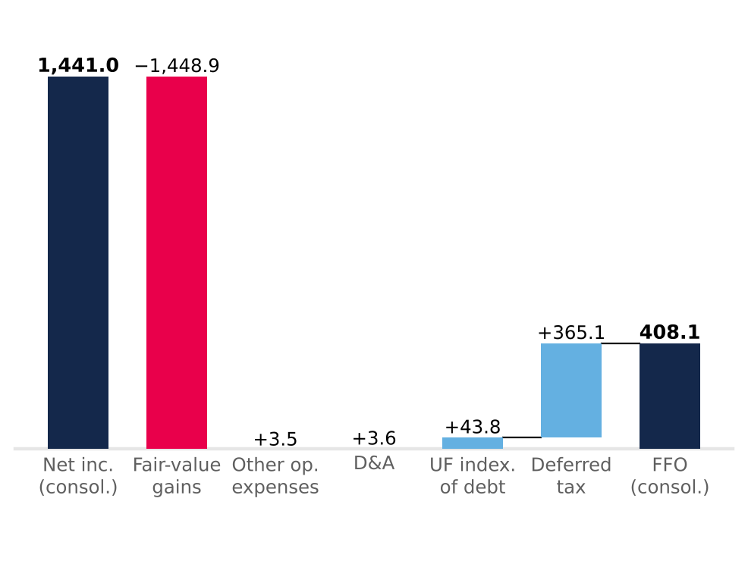  Light blue adds back, red removes, navy = totals. After minorities (CLP 2.8bn), FFO attributable is CLP 405.2bn vs CLP 405.3bn reported. Source: Plaza S.A. financial statements (CMF) FY2025, Notes 13.1 and 23; Team analysis.  Figure 3: Two-thirds of 2025 growth was bought; in 1H26 currency and inflation explain more than half  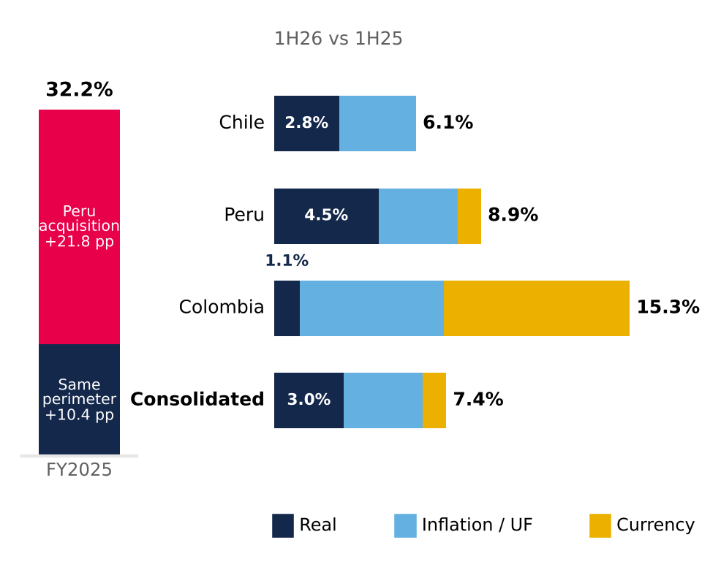  Segments split multiplicatively (real × inflation × FX) from local-currency growth (Chile 6.1%, Peru 7.9%, Colombia 7.3%); consolidated weighted by FY2025 revenue. Source: Plaza S.A. interim financial statements (CMF), Note 24; UF (SII/BCCh); Bloomberg FX; INEI; DANE; Team analysis.  Figure 4: Free cash flow covers dividends 1.5–2.6x even as capex rises (FY2025, CLP bn)  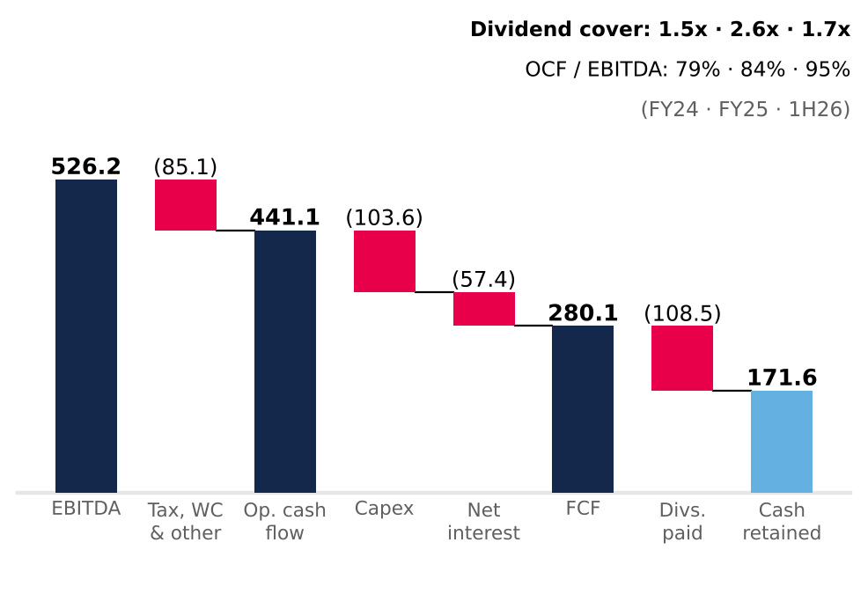  Cash flow statement (direct method; interest paid in financing). FCF before debt repayment. Capex = investment property + intangibles + PP&E (15.8% of revenue in 2025; 24.8% in 1H26). Source: Plaza S.A. financial statements (CMF); Team analysis.

Cash covers the dividend 2.6x; the ceiling is policy, not liquidity  Operating cash flow rose from CLP 301bn in 2024 to CLP 441bn in 2025, converting 98.7% of EBITDA before tax. Cash tax was only 15% of operating profit, sheltered by tax goodwill from Chilean reorganizations and loss carry-forwards (Note 13), and will rise toward the 27% statutory rate. After capex and net interest, free cash flow before debt service was CLP 280bn, covering dividends 2.6x (Figure 4).  The 38.6% jump in 1H26 operating cash flow is not earnings power: 59% of it was December collections unwinding through working capital. Receivable days fell from 66 to 50, with no sign of weaker collection.  The dividend policy pays out 40% of distributable profit with a one-year lag, so retained cash is high: CLP 171.6bn in 2025. In the base case, FFO rises from CLP 428.5bn in 2026E to CLP 501.6bn in 2031E and ordinary dividends from CLP 147.7bn to 172.6bn; the remaining cash, together with new debt, funds capex and the additional distributions (Appendix 5).  Capex is stepping up. Contractual investment commitments rose to CLP 78bn at June 2026 from CLP 18bn in December 2025, and 1H26 property capex was CLP 81bn (+176%). The base case funds USD 445m of remaining pipeline over 2026–2028 and then keeps adding about 27,000 m² of GLA a year, the 2022–2025 organic pace, so capex settles near 16% of revenue rather than the 5.5% maintenance floor (Figure 7).  Cash-flow metrics earn the AAA; equity-based ratios flatter it  LTV fell from 26.9% to 18.8% in 2025, but 5.0pp of the 8.0pp drop came from revaluing the denominator; with property at 2024 value plus additions, LTV would have been 23.8% (Figure 5). Cash-flow metrics are the honest lens and support Feller Rate's upgrade to AAA (25 September 2026): net debt/EBITDA fell from 3.78x to 2.36x on June 2026 LTM EBITDA (the 2024 figure includes only one month of Peru), and EBITDA covers financial costs 8.4x.  Gross debt of CLP 1,633bn is 79% UF, 14% PEN and 7% COP, matching revenue currencies; 95% is long term, with a 6.6-year duration. The UF bonds carry a 3.36% real coupon (3.48% effective), but with UF indexation the all-in nominal cost was about 7% in 2025. Maturities cluster in 2029, 2031 and 2033 (Figure 6); refinancing series S (1.32% effective) at the latest issue's 4.33% would add about CLP 4.9bn a year. Liquidity is ample: at June 2026 the current ratio was 2.50x and cash covered current liabilities 1.71x.  Our base case spends that headroom. Net debt/EBITDA converges linearly from 2.36x to 3.5x by end-2031E, between Cencosud Shopping (2.1x) and Parque Arauco (5.7x), and each extra turn adds 25bp to the real cost of debt. Cash beyond the 40% payout and the capex plan is returned through buybacks or special dividends, CLP 1.8tn cumulatively over 2H26E–2031E (Appendix 5). At 3.5x the new AAA would likely come under pressure.  One liability does not show up in LTV: deferred taxes, CLP 1,313.7bn at June 2026, almost 80% of gross financial debt. They arise almost entirely from property revaluation; they are not debt to be repaid, but they show how much of the CLP 4,820.9bn book equity is appraisal rather than cash (Appendix 2). Against peers the balance sheet is conservative: LTV of 18.8% versus 42.9% at Parque Arauco and 16.3% at Cencosud Shopping, and net debt/EBITDA of 2.49x versus 5.68x and 2.11x (Appendix 6).  The forecast carries forward what history supports, including the pace of expansion  Revenue grows 7.7% in 2026E and 5.0% in 2031E (2026E–2031E CAGR 6.4%), as real same-store growth converges to the appraisal midpoints, 123,700 m² of dated pipeline matures and, from 2029E, about 27,000 m² a year opens at the historical pace (Figure 7); 2026E and 2027E revenue sit within 0.6% of consensus. EBITDA margin stays at 79.7–79.8%, below the 2025 peak. Cash tax normalizes from 16.8% to 27% by 2030E and financial costs rise with leverage, so FFO margin slides from 60.9% to 52.2%. Working capital is held at 15.6% of revenue, the December 2025 level (Appendix 1). New GLA yields 6.9% on cost, a 5.0% real return after tax against a 7.2% real WACC: expansion adds revenue but not value.  What this means for valuation  The analysis leaves three conclusions for the model. First, the right earnings base is cash: we use the company's EBITDA, which removes revaluation once (Appendix 4), and distributable profit as the anchor, not the CLP 1,431bn accounting profit. Second, business quality is not in doubt: Mallplaza earns the highest normalized ROE of its local peers (9.7% against 7.8% at Parque Arauco and 8.0% at Cencosud Shopping) with an LTV of only 18.8% (Appendix 6).  Third, the return on capital at fair value is low. 2025 ROIC, with NOPAT at 27% over invested capital at appraised value, was 7.3% (Appendix 3), below a 10.4% nominal WACC: the properties are worth more on the books than their cash flows justify at our rate. At the current price, 2026E FFO of CLP 428.5bn yields 5.5% on market value (18x FFO) and distributable profit 4.9%: the market is paying for these cash flows as if they were almost risk-free. That is the gap the Valuation section quantifies. In short: a high-quality business, with predictable cash and a comfortable balance sheet, whose price already discounts more than those cash flows can deliver. |  | Figure 5: Two-thirds of the 2025 fall in LTV is revaluation, not deleveraging  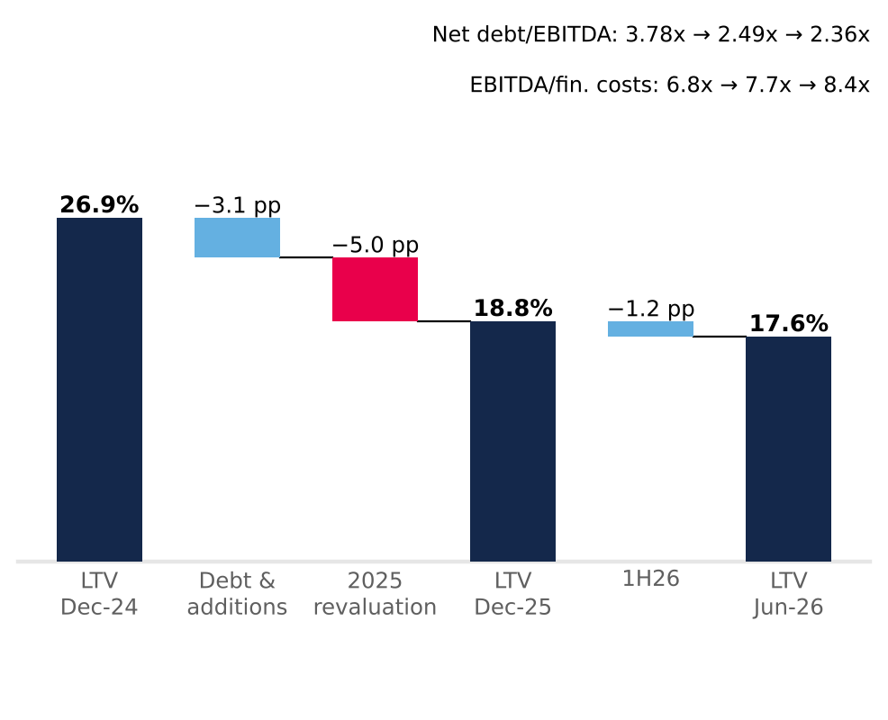  LTV = net financial debt / investment property. Debt & additions = LTV with property at 2024 value plus 2025 additions (23.8%). Jun-26 ratios on LTM EBITDA. Source: Plaza S.A. financial statements (CMF), Notes 11 and 26; MD&A 2025 and 1H26; Team analysis.  Figure 6: Refinancing risk sits in 2029, 2031 and 2033, not in the near term  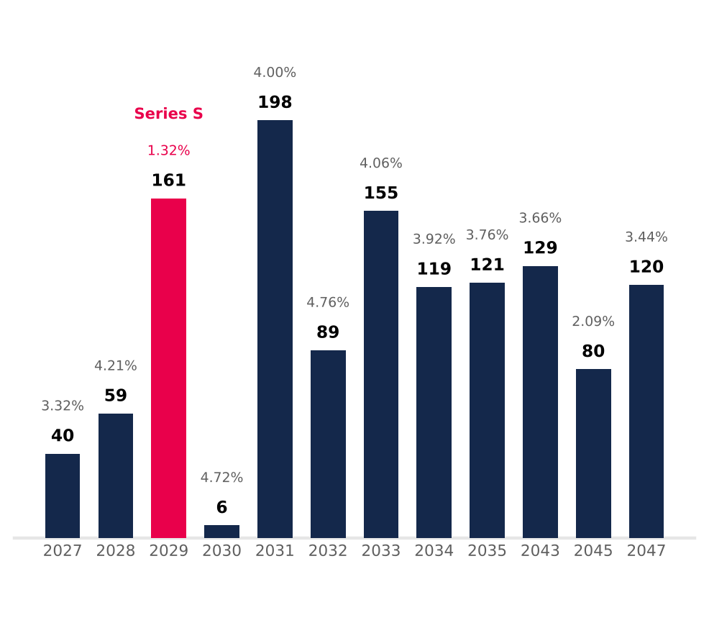  UF bonds, book value Dec-25 (total CLP 1,277.7bn); label = effective real rate (two-series years: book-value-weighted). Excludes CLP 301.6bn of PEN/COP bank debt. Source: Plaza S.A. financial statements Dec-25, Note 14; Team analysis.  Figure 7: After the pipeline, expansion keeps capex near CLP 150bn a year while leverage rebuilds to 3.5x  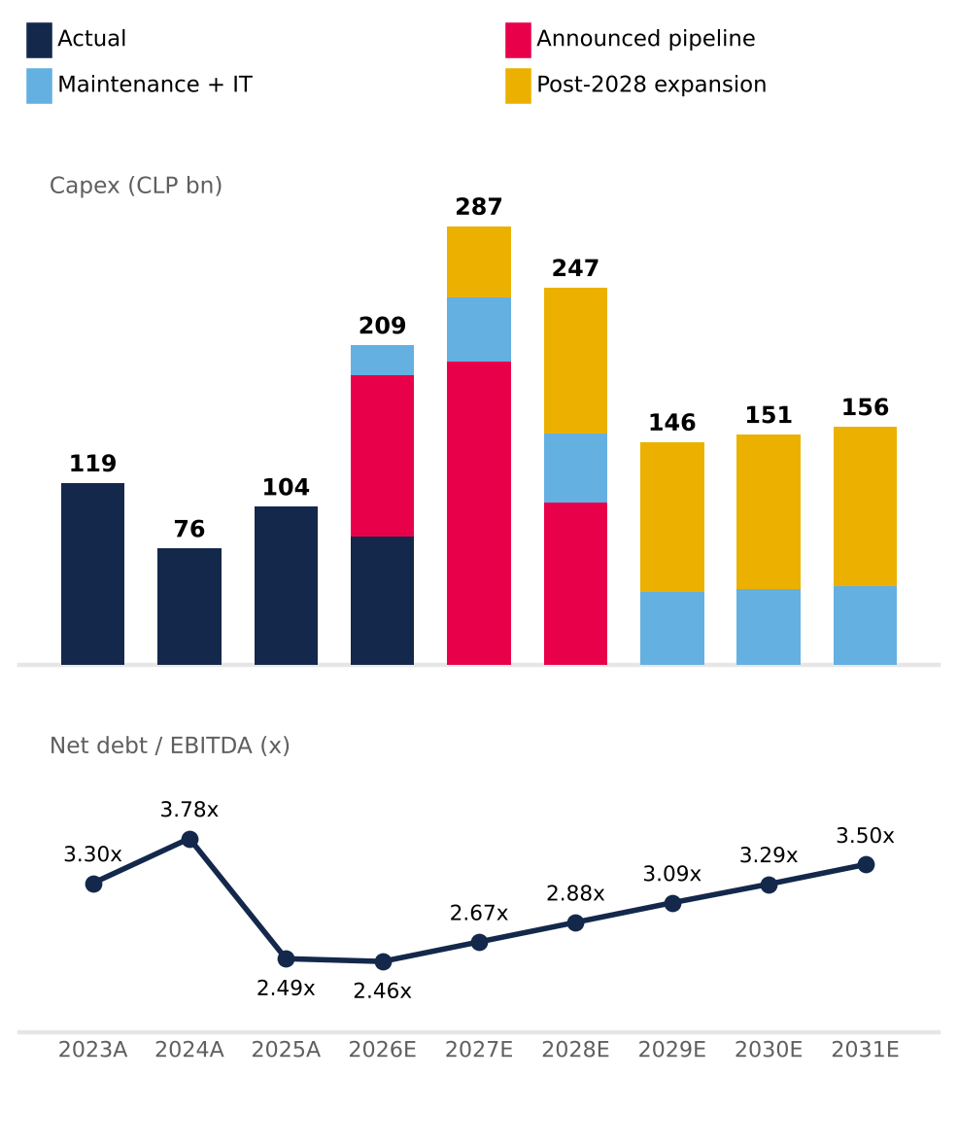  2026E includes CLP 84.2bn spent in 1H26; 2024A leverage includes one month of Peru EBITDA. Source: Plaza S.A. financial statements (CMF); 2Q26 results release (pipeline); valuation base case (Appendices 1 and 5).

