FINANCIAL ANALYSIS
Mallplaza's rental engine grows at roughly 3% in real terms with an 80% EBITDA margin and cash-flow leverage below 2.5x; headline profit, growth and leverage all overstate that engine and must be normalized before forecasting.
Figure 1: Normalized ROE of 8–10% is the real return; reported ROE is appraisal-driven
CLP bn | ’22 A | ’23 A | ’24 A | ’25 A | ’26 E | ’27 E | ’28 E | ’29 E | ’30 E | ’31 E
Revenue | 371 | 420 | 495 | 654 | 704 | 767 | 821 | 870 | 916 | 961
EBITDA margin % | 76.2 | 76.7 | 77.0 | 80.5 | 79.7 | 79.7 | 79.7 | 79.8 | 79.8 | 79.8
FFO margin % | 59.0 | 61.3 | 61.3 | 62.0 | 60.9 | 60.0 | 57.7 | 55.3 | 52.7 | 52.2
Net income, reported | 158 | 350 | 336 | 1,431 | 639 | 592 | 610 | 624 | 627 | 649
Distributable profit | 96 | 198 | 238 | 369 | 380 | 428 | 434 | 437 | 432 | 445
Net margin, normalized % | 25.8 | 47.0 | 48.2 | 56.5 | 54.0 | 55.7 | 52.9 | 50.2 | 47.1 | 46.2
Asset turnover (x) | .086 | .090 | .092 | .097 | .089 | .091 | .092 | .093 | .093 | .094
Assets / equity (x) | 1.94 | 1.91 | 1.86 | 1.77 | 1.69 | 1.71 | 1.74 | 1.79 | 1.84 | 1.89
ROE, reported % | 7.1 | 14.4 | 11.7 | 37.5 | 13.7 | 12.0 | 11.9 | 11.8 | 11.8 | 12.0
ROE, normalized % | 4.3 | 8.1 | 8.3 | 9.7 | 8.1 | 8.6 | 8.4 | 8.3 | 8.1 | 8.2
ROA, normalized % | 2.2 | 4.2 | 4.5 | 5.5 | 4.8 | 5.1 | 4.8 | 4.6 | 4.4 | 4.3
Normalized = distributable profit (2022A team proxy; 2022 UF indexation inflated by ~13% inflation). Average balances; series starts in 2022 (IAS 40 fair value applied retroactively from 1 Jan 2022). 2026E–2031E: valuation base case; balance sheet rolled forward from Dec-25 (equity + reported profit − ordinary and additional distributions; property revalued at 3% inflation, 27% deferred tax; net debt rising to 3.5x EBITDA by 2031E). Source: Plaza S.A. financial statements (CMF), Note 20e; 2Q26 results release (FFO); Team analysis.

Reported earnings track the appraiser; FFO tracks the business  Under IAS 40, revaluations of investment property run through the income statement. In 2025 a CLP 1,447bn fair-value gain, 27% of opening property value against about 2% a year at Parque Arauco and Cencosud Shopping, lifted attributable net income to CLP 1,431bn (2.2x revenue) and reported ROE to 37.5% (Figure 1). About two-thirds of Chile's 29% uplift came from a lower appraisal discount rate, not from higher NOI.  Excluding fair-value gains net of deferred tax, audited distributable profit was CLP 369bn and ROE 9.7%, the highest of the three local peers on a comparable basis (Appendix 6). FFO, which we rebuild from the statements to within 0.02% of the reported CLP 405bn (Figure 2), held a 59–62% margin over 2022–2025 while net income swung more than fourfold. FFO excludes the UF indexation of debt (CLP 44bn, 11% of FFO); distributable profit includes it and is our conservative earnings anchor. |  | Figure 2: Removing fair-value gains and non-cash items turns CLP 1,441bn of profit into CLP 408bn of FFO (CLP bn)  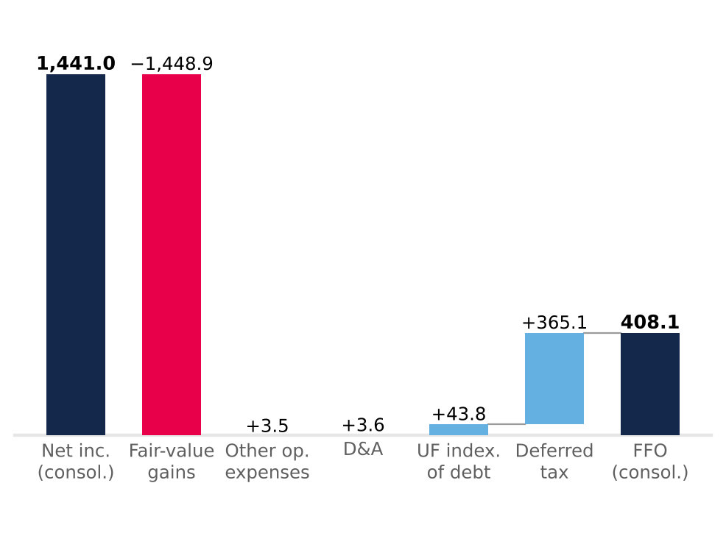  Light blue adds back, red removes, navy = totals. After minorities (CLP 2.8bn), FFO attributable is CLP 405.2bn vs CLP 405.3bn reported. Source: Plaza S.A. financial statements (CMF) FY2025, Notes 13.1 and 23; Team analysis.
Two-thirds of 2025 growth was bought; organic real growth is about 3%  Revenue rose 76% between 2022 and 2025, but 21.8pp of 2025's 32.2% came from perimeter: the Peruvian portfolio bought from Falabella, consolidated from 4 December 2024. Ex-Peru, revenue grew 10.7% in 2025 and 7.1% in 1H26.  Once currency and inflation are removed, 1H26 reported growth of 7.4% falls to about 3.0% real (Figure 3). Chile grew 2.8% after 3.1% UF indexation (5.1% in 2025); Peru 4.5% despite occupancy slipping to 93.8%; Colombia only about 1% once a 7.5% COP appreciation and 6.1% inflation are stripped out.  Growth is contractual, not sales-driven. Variable rent is 5.1% of revenue and fell 1.1% in 1H26 while tenant sales rose 6.7%, because minimum rents (same-store rent +5.5%) are outpacing tenant sales (same-store sales +3.7%). Revenue is therefore bond-like, but its real growth is converging on the 0.4–0.9% the company assumes for Chile in its own appraisal.  Margin gains came from mix and cost recovery; operating leverage is spent  EBITDA margin rose from 76.2% in 2022 to 80.5% in 2025 for two reasons. Peru consolidates at an 83% segment margin, against 80% in Chile and 73% in Colombia. Chile's margin gained 2.4pp on a higher recovery of common charges, which are presented net of cost (Note 2.20): real, but dependent on occupancy and tenant negotiations, so not structural.  With cost of sales at 6% of revenue and total operating costs near 20%, little fixed cost is left to dilute; with D&A at 0.7% of revenue, EBIT (CLP 523bn in 2025) tracks EBITDA. In 1H26 EBITDA grew 7.4%, in line with revenue, and margin held at 79.7%. Administrative expense rose 18.1% on payroll (+18.9%: CEO transition and a full year of Peru), a bad-debt charge rebounding from a 2025 base flattered by recoveries (0.64% of revenue, below 1.22% in 2024), and a one-off Colombian wealth tax of CLP 1.7bn. Excluding the last two, 1H26 margin would be 80.4%, up 1.1pp. |  | Figure 3: Two-thirds of 2025 growth was bought; in 1H26 currency and inflation explain more than half  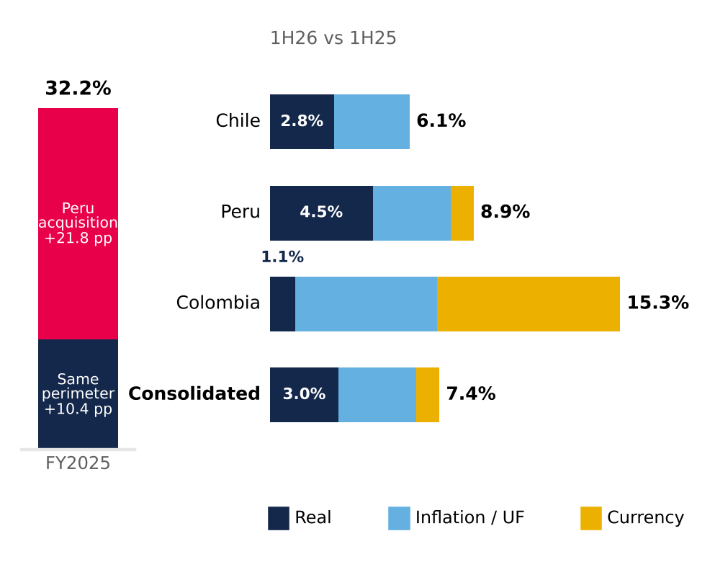  Segments split multiplicatively (real × inflation × FX) from local-currency growth (Chile 6.1%, Peru 7.9%, Colombia 7.3%); consolidated weighted by FY2025 revenue. Source: Plaza S.A. interim financial statements (CMF), Note 24; UF (SII/BCCh); Bloomberg FX; INEI; DANE; Team analysis.

Cash covers the dividend 2.6x; the ceiling is policy, not liquidity  Operating cash flow rose from CLP 301bn in 2024 to CLP 441bn in 2025, converting 98.7% of EBITDA before tax. Cash tax was only 15% of operating profit, sheltered by tax goodwill from Chilean reorganizations and loss carry-forwards (Note 13), and will rise toward the 27% statutory rate. After capex and net interest, free cash flow before debt service was CLP 280bn, covering dividends 2.6x (Figure 4).  The 38.6% jump in 1H26 operating cash flow is not earnings power: 59% of it was December collections unwinding through working capital. Receivable days fell from 66 to 50, with no sign of weaker collection.  Capex is stepping up. Contractual investment commitments rose to CLP 78bn at June 2026 from CLP 18bn in December 2025, and 1H26 property capex was CLP 81bn (+176%). The base case funds USD 445m of remaining pipeline over 2026–2028 and then keeps adding about 27,000 m² of GLA a year, the 2022–2025 organic pace, so capex settles near 16% of revenue rather than the 5.5% maintenance floor (Figure 7). |  | Figure 4: Free cash flow covers dividends 1.5–2.6x even as capex rises (FY2025, CLP bn)  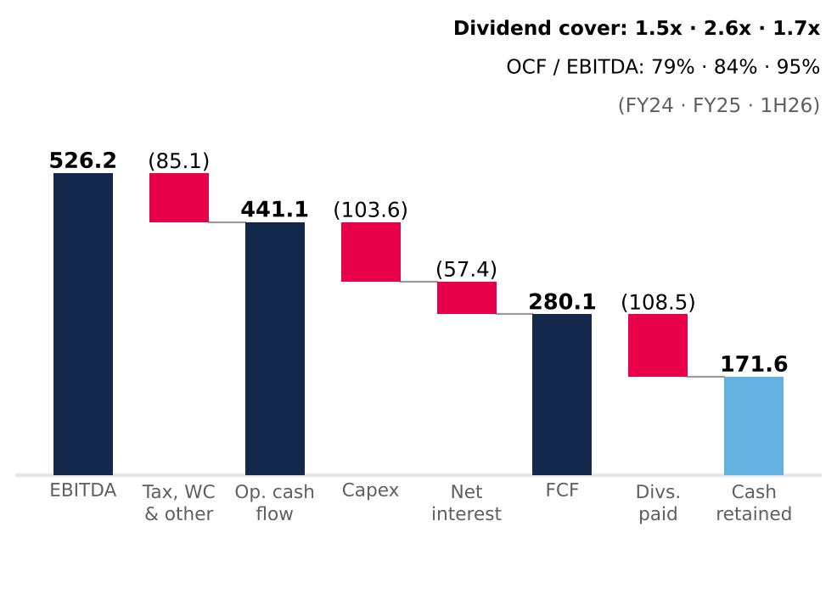  Cash flow statement (direct method; interest paid in financing). FCF before debt repayment. Capex = investment property + intangibles + PP&E (15.8% of revenue in 2025; 24.8% in 1H26). Source: Plaza S.A. financial statements (CMF); Team analysis.
Cash-flow metrics earn the AAA; equity-based ratios flatter it  LTV fell from 26.9% to 18.8% in 2025, but 5.0pp of the 8.0pp drop came from revaluing the denominator; with property at 2024 value plus additions, LTV would have been 23.8% (Figure 5). Cash-flow metrics are the honest lens and support Feller Rate's upgrade to AAA (25 September 2026): net debt/EBITDA fell from 3.78x to 2.36x on June 2026 LTM EBITDA (the 2024 figure includes only one month of Peru), and EBITDA covers financial costs 8.4x.  Gross debt of CLP 1,633bn is 79% UF, 14% PEN and 7% COP, matching revenue currencies; 95% is long term, with a 6.6-year duration. The UF bonds carry a 3.36% real coupon (3.48% effective), but with UF indexation the all-in nominal cost was about 7% in 2025. Maturities cluster in 2029, 2031 and 2033 (Figure 6); refinancing series S (1.32% effective) at the latest issue's 4.33% would add about CLP 4.9bn a year. Liquidity is ample: at June 2026 the current ratio was 2.50x and cash covered current liabilities 1.71x.  Our base case spends that headroom. Net debt/EBITDA converges linearly from 2.36x to 3.5x by end-2031E, between Cencosud Shopping (2.1x) and Parque Arauco (5.7x), and each extra turn adds 25bp to the real cost of debt. Cash beyond the 40% payout and the capex plan is returned through buybacks or special dividends, CLP 1.8tn cumulatively over 2H26E–2031E (Appendix 5). At 3.5x the new AAA would likely come under pressure. |  | Figure 5: Two-thirds of the 2025 fall in LTV is revaluation, not deleveraging  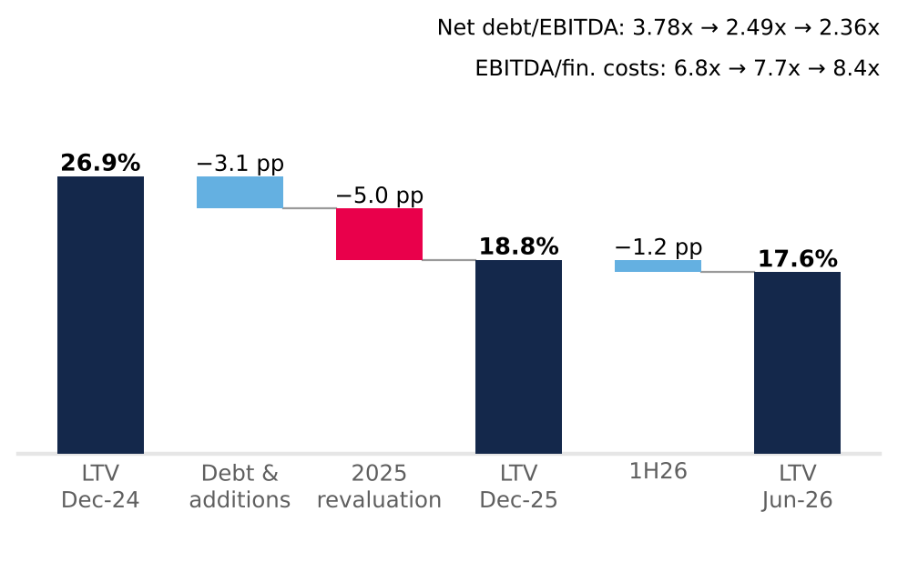  LTV = net financial debt / investment property. Debt & additions = LTV with property at 2024 value plus 2025 additions (23.8%). Jun-26 ratios on LTM EBITDA. Source: Plaza S.A. financial statements (CMF), Notes 11 and 26; MD&A 2025 and 1H26; Team analysis.  Figure 6: Refinancing risk sits in 2029, 2031 and 2033, not in the near term  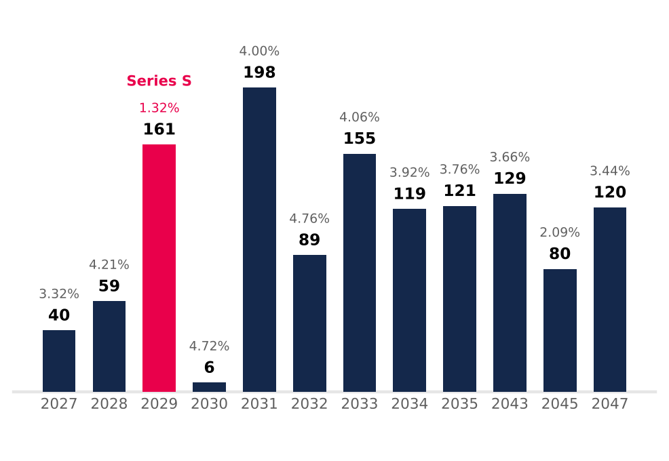  UF bonds, book value Dec-25 (total CLP 1,277.7bn); label = effective real rate (two-series years: book-value-weighted). Excludes CLP 301.6bn of PEN/COP bank debt. Source: Plaza S.A. financial statements Dec-25, Note 14; Team analysis.
The forecast carries forward what history supports, including the pace of expansion  Revenue grows 7.7% in 2026E and 5.0% in 2031E (2026E–2031E CAGR 6.4%), as real same-store growth converges to the appraisal midpoints, 123,700 m² of dated pipeline matures and, from 2029E, about 27,000 m² a year opens at the historical pace (Figure 7); 2026E and 2027E revenue sit within 0.6% of consensus. EBITDA margin stays at 79.7–79.8%, below the 2025 peak. Cash tax normalizes from 16.8% to 27% by 2030E and financial costs rise with leverage, so FFO margin slides from 60.9% to 52.2%. Working capital is held at 15.6% of revenue, the December 2025 level (Appendix 1). New GLA yields 6.9% on cost, a 5.0% real return after tax against a 7.2% real WACC: expansion adds revenue but not value. |  | Figure 7: After the pipeline, expansion keeps capex near CLP 150bn a year while leverage rebuilds to 3.5x  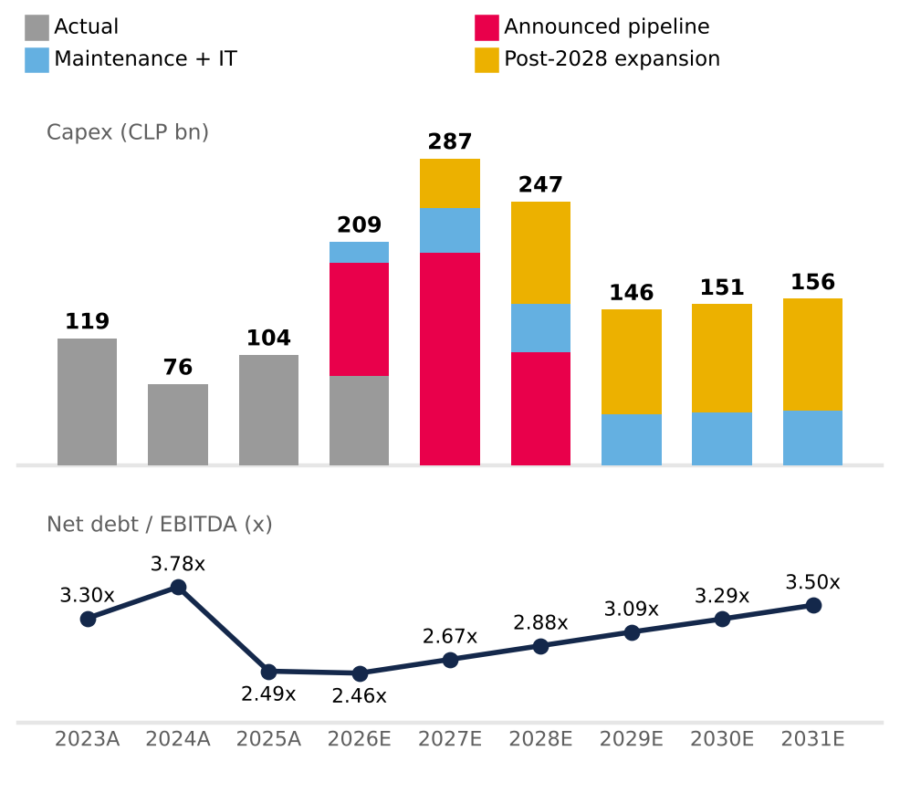  2026E includes CLP 84.2bn spent in 1H26; 2024A leverage includes one month of Peru EBITDA. Source: Plaza S.A. financial statements (CMF); 2Q26 results release (pipeline); valuation base case (Appendices 1 and 5).

APPENDIX: FINANCIAL ANALYSIS
Appendix 1: Forecast assumptions (nominal CLP, 2026E–2031E)  Tags: R reported · C team calculation · S team assumption · P market consensus. Source: Plaza S.A. financial statements (CMF); 2Q26 results release; Bloomberg ECFC; Team analysis. |  | Appendix 2: Summary financial statements (CLP bn)  LTM = FY2025 − 1H25 + 1H26. 2024 as restated in Dec-25; 2022A from restated Dec-23 statements; 2022 financing lines not in the files used. Source: Plaza S.A. financial statements (CMF) Dec-24, Dec-25, Jun-26.
  Driver | Assumption | Basis | Tag
  2026E anchor | 1H26 actual + 2H26E repeating 1H26 local-currency growth (Chile 6.1%, Peru 7.9%, Colombia 7.3%) | Interim FS Jun-26 | R/S
  Inflation | Consensus CPI 2026–28; central-bank targets from 2029 (CL 3%, PE 2%, CO 3%) | Leases indexed to UF/CPI | P/S
  Real same-store growth (ex-parking) | Chile 1.5% → 0.6%; Peru 1.5% → 0.4%; Colombia 2.5% → 2.1% (2027E → 2031E) | Midpoints of company appraisal ranges (Note 11) | S
  Occupancy | Chile 96.1%, Colombia 97.5% flat; Peru 93.8% → 94.6% by 2028E | 2Q26 actual; Peru back to 2025 | R/S
  Parking | 12.1% / 6.4% / 9.0% of 2026 revenue; real growth 9% → 2% | 2Q26 release (LTM +23.7%) | R/S
  Pipeline GLA | 8,900 m² (2026), 72,950 m² (2027), 41,850 m² (2028); ramp 35/90/100% | 2Q26 release, projects | R/S
  Post-2028 expansion | 27,075 m² a year opening from 2029E (55% Chile / 45% Peru); USD 3,603/m² indexed to CPI, spent 50% in t−2 and 50% in t−1; 80.9% EBITDA margin; 6.9% yield on cost | Average organic GLA 2022, 2023, 2025; pipeline cost per m² | C/S
  FX | Consensus year-end 2026–28; purchasing-power parity thereafter | Bloomberg ECFC, 5 Oct 2026 | P/S
  EBITDA margin | Chile 80%, Peru 82%, Colombia 74% (≈ 79.7% consolidated) | 2024–LTM 2Q26; 2025 peak not extrapolated | S
  D&A | 0.70% of revenue | LTM 2Q26 (4.8 / 677.3) | C
  Cash tax rate | 16.8% (2026E) → 19% → 21.5% → 24% → 27% (2030E–31E) | 1H26 current tax; shields run off | C/S
  Project capex | USD 445m remaining at Jun-26, spread to final opening (2026E–28E) | 2Q26 release, pipeline | R/S
  Maintenance + IT capex | 5.5% of revenue | 2024 (4.8%) – LTM 2Q26 (~6.6%) | S
  Working capital | Net operating working capital at 15.6% of revenue (Dec-25); 2026E covers 2H26E only | FS Dec-25, first year-end with full Peru | C/S
  Leverage | Net debt / EBITDA 2.36x (Jun-26) → 3.5x by Dec-31E, linear; cash above the plan returned via buybacks or special dividends | Team assumption; peers 2.1x–5.7x | S
  Cost of debt | Net financial cost 3.08% of opening net debt + 25bp real per turn of leverage above 2.36x; UF indexation on 79% of debt | 1H26 annualized; team assumption | C/S
  Excluded | Greenfield (USD 0.7m LTM vs 55.2m in 2023), Gran Plaza; undated Chile projects replaced by the post-2028 expansion | No date or immaterial | S
  Payout | 40% of distributable profit, one-year lag, plus the additional distributions above | Board policy (Note 20e) | R/S
  Income statement | 2022A | 2023A | 2024A | 2025A | LTM 2Q26
  Revenue | 370.9 | 419.9 | 494.6 | 653.9 | 677.3
  EBITDA (company definition) | 282.7 | 322.2 | 380.6 | 526.2 | 544.9
  D&A | (2.2) | (2.2) | (2.1) | (3.6) | (4.8)
  Fair-value gains & other op. items, net | 83.1 | 193.7 | 157.3 | 1,445.4 | 1,190.4
  Operating income | 363.6 | 513.8 | 535.9 | 1,968.1 | 1,730.6
  Net financial cost | — | (23.8) | (30.9) | (54.0) | (44.9)
  UF indexation of debt | — | (55.3) | (53.2) | (43.8) | (50.4)
  Net income attributable | 157.7 | 349.8 | 335.9 | 1,431.0 | 1,258.1
  FFO attributable (company) | 218.9 | 257.2 | 303.2 | 405.3 | 419.9
  Balance sheet | Dec-23 | Dec-24 | Dec-25 | Jun-26
  Cash and equivalents | 202.0 | 179.2 | 268.3 | 347.6
  Investment property | 4,166.5 | 5,356.5 | 6,961.9 | 7,309.8
  Total assets | 4,796.3 | 5,915.1 | 7,583.6 | 7,985.7
  Gross financial debt | 1,264.0 | 1,617.6 | 1,579.3 | 1,633.4
  Deferred tax liabilities | 656.5 | 892.9 | 1,248.8 | 1,313.7
  Equity attributable to owners | 2,601.1 | 3,157.9 | 4,482.9 | 4,820.9
  Cash flow | 2023A | 2024A | 2025A | 1H26
  Operating cash flow | 295.1 | 300.8 | 441.1 | 258.2
  Capex | (119.1) | (76.3) | (103.6) | (84.2)
  Acquisitions incl. minorities | (164.6) | (400.4) | (0.3) | —
  Equity issued | — | 308.4 | — | —
  Net borrowing / (repayment) | (124.0) | 1.3 | (86.5) | 5.5
  Interest paid | (55.6) | (54.4) | (68.2) | (30.1)
  Dividends paid | (0.0) | (125.8) | (108.5) | (87.6)

Appendix 3: Ratio dashboard  Jun-26 leverage on LTM EBITDA; operating costs = cost of sales + admin (1H26). Dec-24 receivable days n.m. (Peru consolidated one month). Jun-26 returns need the Jun-25 balance sheet. Source: Plaza S.A. financial statements (CMF); MD&A 1H26; Team analysis.  Appendix 4: The EBITDA we use is the company's: fair-value gains are removed once (CLP bn)  Bloomberg's EBITDA field includes fair-value gains and is not used. Source: Plaza S.A. financial statements (CMF), Notes 23.1–23.3; 2Q26 release; Team analysis. |  | Appendix 5: Base-case projection (CLP bn)  2026E = 1H26 actual + 2H26E; capex includes CLP 84.2bn spent in 1H26; Δ working capital and additional distributions cover 2H26E only. FFO = (EBITDA − net financial cost) × (1 − cash tax), before minorities (~1%); distributable profit = FFO − UF indexation. Source: valuation workbook v2 (DCF, Deuda and Expansion sheets); Team analysis.  Appendix 6: Like-for-like, Mallplaza earns the highest normalized ROE of its local peers (FY2025)  Mallplaza normalized on audited distributable profit; peers on net income − fair-value gains × (1 − 27%). Parque Arauco property excludes JVs, overstating its LTV. Source: Plaza S.A. financial statements (CMF); Bloomberg FA as-reported (PARAUCO CI, CENCOMAL CI; export 28 Sep 2026); Team analysis.
   | 2023 | 2024 | 2025 | Jun-26
  ROE, normalized | 8.1% | 8.3% | 9.7% | —
  ROA, normalized | 4.2% | 4.5% | 5.5% | —
  ROIC (NOPAT at 27%, IC at fair value) | 6.5% | 6.6% | 7.3% | —
  Current ratio (x) | 1.78 | 1.18 | 1.54 | 2.50
  Cash / current liabilities (x) | 0.83 | 0.52 | 0.87 | 1.71
  Total liabilities / equity (x) | 0.82 | 0.85 | 0.68 | 0.64
  LTV (net debt / inv. property) | 25.5% | 26.9% | 18.8% | 17.6%
  Net debt / EBITDA (x) | 3.30 | 3.78 | 2.49 | 2.36
  EBITDA / financial costs (x) | 6.9 | 6.8 | 7.7 | 8.4
  Asset turnover (x) | 0.090 | 0.092 | 0.097 | —
  Operating costs / revenue | 23.8% | 23.5% | 20.1% | 21.2%
  Receivable days | 65 | n.m. | 66 | 50
   | 2022A | 2023A | 2024A | 2025A | LTM 2Q26
  Operating income + D&A | 365.8 | 515.9 | 538.0 | 1,971.7 | 1,735.4
  (−) Other op. income (mostly fair value) | (85.4) | (195.6) | (162.5) | (1,448.9) | (1,194.5)
  (+) Other op. expenses (non-recurring) | 2.3 | 1.8 | 5.2 | 3.5 | 4.1
  EBITDA, adjusted | 282.7 | 322.2 | 380.6 | 526.2 | 544.9
  Check vs company EBITDA | 0.0 | 0.0 | 0.0 | 0.0 | 0.0
  CLP bn | 2026E | 2027E | 2028E | 2029E | 2030E | 2031E
  Revenue — Chile | 498.4 | 533.9 | 571.2 | 603.1 | 628.7 | 652.8
  Revenue — Peru | 131.3 | 145.2 | 159.8 | 171.6 | 178.6 | 184.9
  Revenue — Colombia | 75.2 | 88.1 | 89.4 | 92.2 | 96.8 | 101.8
  Eliminations | (1.0) | — | — | — | — | —
  Revenue — post-2028 expansion | — | — | — | 3.1 | 11.7 | 21.8
  Revenue | 704.0 | 767.2 | 820.5 | 870.1 | 915.9 | 961.3
  Growth | 7.7% | 9.0% | 7.0% | 6.0% | 5.3% | 5.0%
  EBITDA | 561.3 | 611.4 | 654.2 | 694.0 | 730.6 | 766.9
  EBITDA margin | 79.7% | 79.7% | 79.7% | 79.8% | 79.8% | 79.8%
  D&A | (5.0) | (5.4) | (5.8) | (6.1) | (6.4) | (6.8)
  EBIT | 556.4 | 606.0 | 648.5 | 687.9 | 724.1 | 760.1
  Cash tax rate | 16.8% | 19.0% | 21.5% | 24.0% | 27.0% | 27.0%
  Capex — pipeline + maintenance | (209.2) | (240.7) | (151.5) | (47.7) | (49.7) | (51.7)
  Capex — post-2028 expansion | — | (46.3) | (95.3) | (98.2) | (101.1) | (104.2)
  Δ working capital | (3.9) | (9.9) | (8.3) | (7.7) | (7.1) | (7.1)
  FFO | 428.5 | 460.4 | 473.1 | 481.5 | 482.3 | 501.6
  Distributable profit | 380.0 | 427.7 | 434.4 | 436.9 | 431.6 | 444.6
  Ordinary dividends (40%) | (147.7) | (152.0) | (171.1) | (173.8) | (174.8) | (172.6)
  Additional distributions | (121.0) | (236.1) | (268.0) | (380.1) | (378.6) | (404.8)
  Net debt / EBITDA (x) | 2.46 | 2.67 | 2.88 | 3.09 | 3.29 | 3.50
   | Mallplaza | Parque Arauco | Cencosud Shopping
  Fair-value gain / opening property | 27.0% | 2.0% | 2.3%
  EBITDA / investment property | 7.3% (Chile) | 7.6% | 7.8%
  ROE, reported | 37.5% | 9.8% | 10.5%
  ROE, normalized | 9.7% | 7.8% | 8.0%
  LTV | 18.8% | 42.9% | 16.3%
  Net debt / EBITDA (x) | 2.49 | 5.68 | 2.11
  Assets / equity attributable, YE (x) | 1.69 | 2.69 | 1.51

