APPENDIX [X]: MACROECONOMIC AND GEOPOLITICAL BACKDROP
Between 2022 and 2026 the world economy absorbed two geopolitical supply shocks and a structural rise in long-term rates. The result is a backdrop of stagflationary pressure and a higher cost of capital that reaches Chile through three channels — inflation, rates and consumption — and that sits behind the two most severe risks in the report (FR1 and MR1). In the charts, the dotted blue line marks the valuation date (30-Jun-2026); later data are shown for context. The figures cover the shock transmission (Figure A1), oil (Figure A2), sovereign yields (Figure A3), spreads (Figure A4), world growth and inflation (Figure A5) and Chile (Figure A6).
USD 114  Brent, Sep-26 average  +61% vs Feb-26, before the conflict |  | 5.22%  10Y UST, 8-Oct-26  24-year high (since 2002) |  | 117 bp  France–Germany spread  30-Sep-26; ~150 bp in early Oct. |  | 3.0% | 4.7%  IMF 2026: GDP | inflation  growth cut; disinflation stalled |  | 0.25–0.75%  Chile 2026 GDP (BCCh)  down from 2–3% expected in Dec-25
1. HOW THE SHOCK REACHES MALLPLAZA
Figure A1: Transmission map: from global shocks to Mallplaza's risks
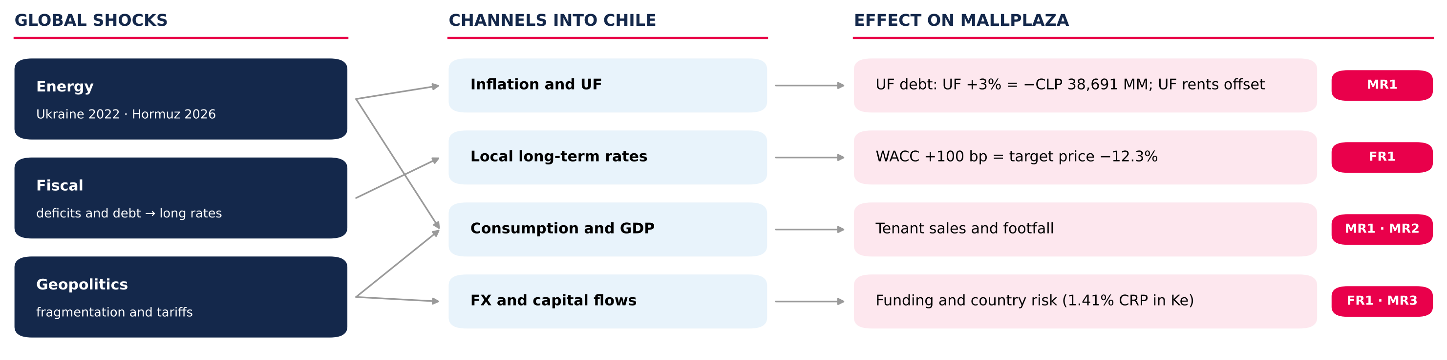
Source: Team analysis; figures from Figures 24–26 of the report (Investment Risks).
2. TWO SUPPLY SHOCKS AND A GLOBAL RISE IN RATES
Figure A2: Brent crude oil price, 2022–2026 (USD/barrel)  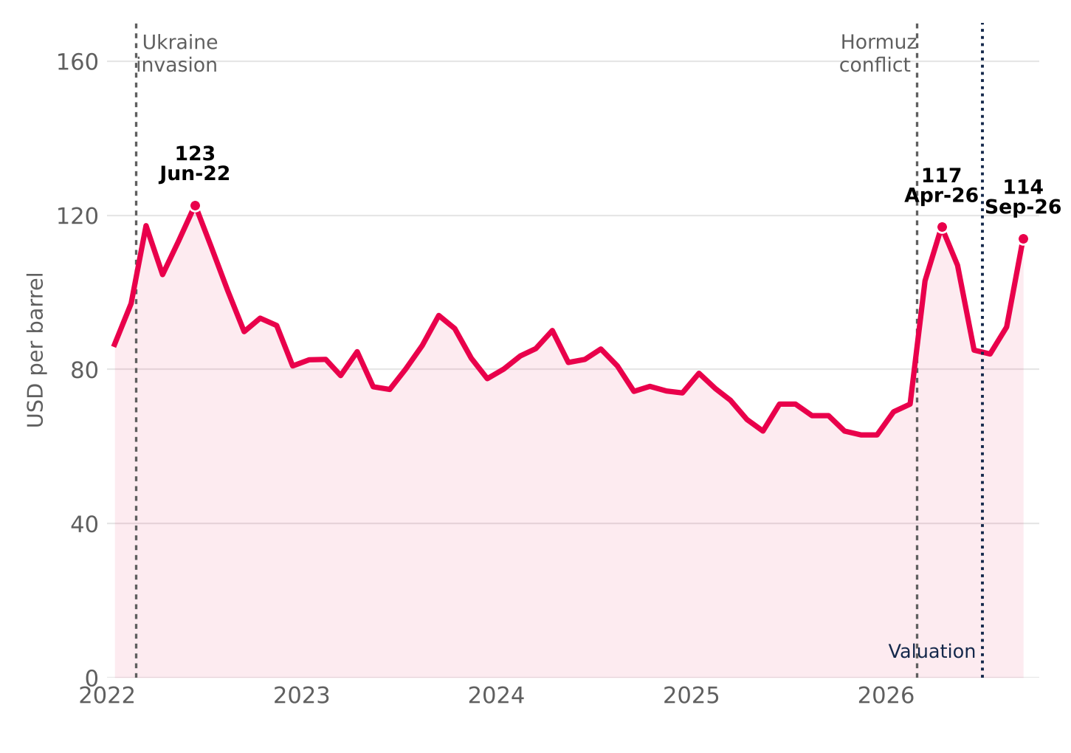  Two supply shocks. Russia's invasion of Ukraine (Feb-22) pushed Brent to USD 123 in June 2022. In 2026, the conflict in the Strait of Hormuz — which carries more than a quarter of seaborne oil — lifted it from USD 71 in February to USD 117 in April; after a truce in June, renewed attacks took it back to USD 114 in September.  Source: EIA (Brent spot, monthly average; STEO Apr-26, Sep-26 and Oct-26); Statista. |  | Figure A3: 10-year sovereign yields, 2022–2026 (%)  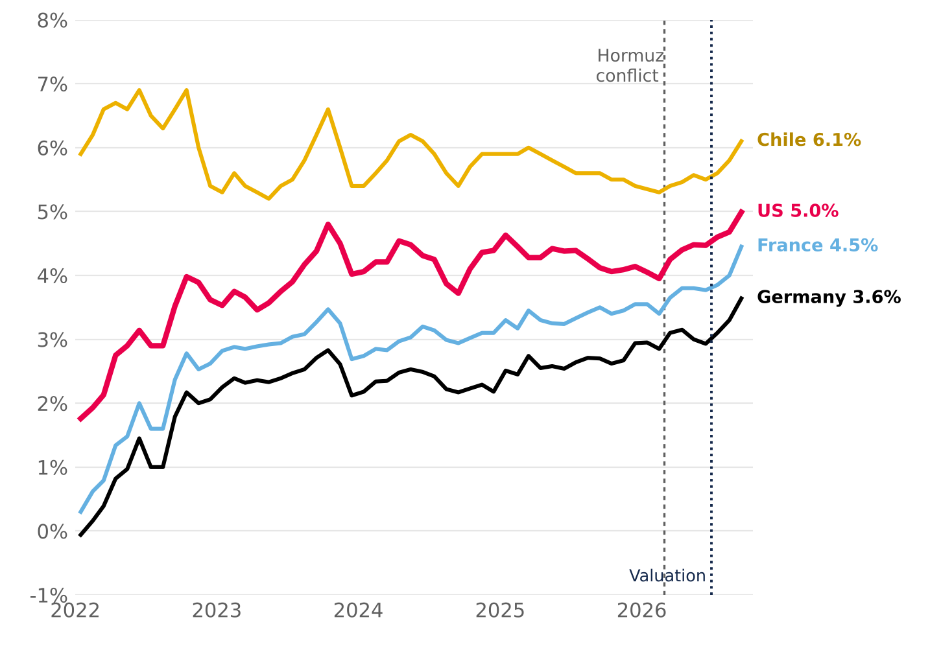  Long-term rates rise together. The 10Y UST moved from 1.8% (Jan-22) to 5.0% (Sep-26) and touched 5.22% on 8 October, a 24-year high; the Bund went from −0.1% to 3.6%. Fiscal deficits push up the risk-free rate, and Chile has followed the move since mid-2026.  Source: FRED (GS10), Bundesbank, Banque de France (via OECD) and BCCh (10Y BCP); monthly averages.

3. FISCAL PREMIUM AND STAGFLATION
Figure A4: 10-year spreads: France–Germany and Chile–US (bp)  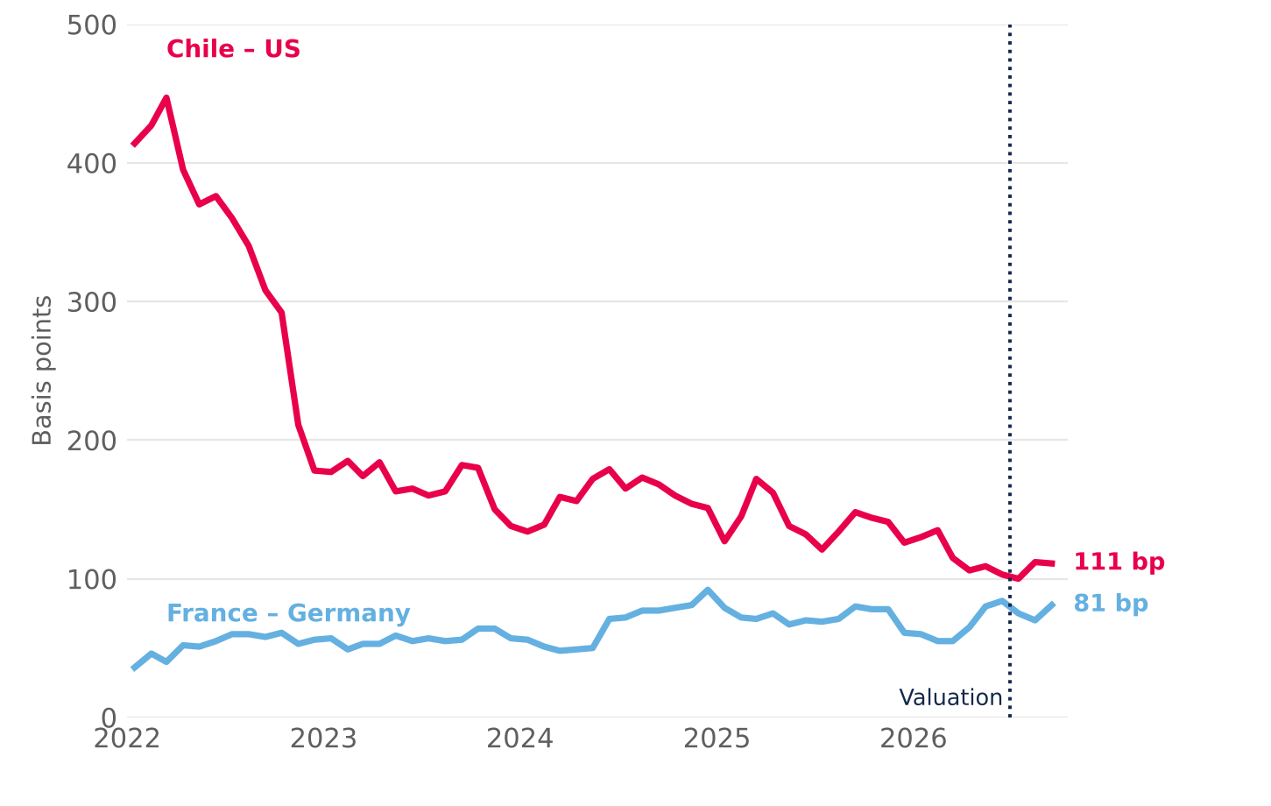  The rise is fiscal and global, not Chile risk. France's spread over Germany rose from ~40 bp in 2022 to an 81 bp average in September 2026 and 117 bp at month-end (~150 bp in early October, the widest since 2011–12). Chile's spread over the US compressed: local rates depend more and more on the global base rate.  Source: Team calculation with Figure A3 data (monthly averages); September close: Banque de France / Bundesbank. |  | Figure A5: World growth and inflation, 2022–2026P (%)  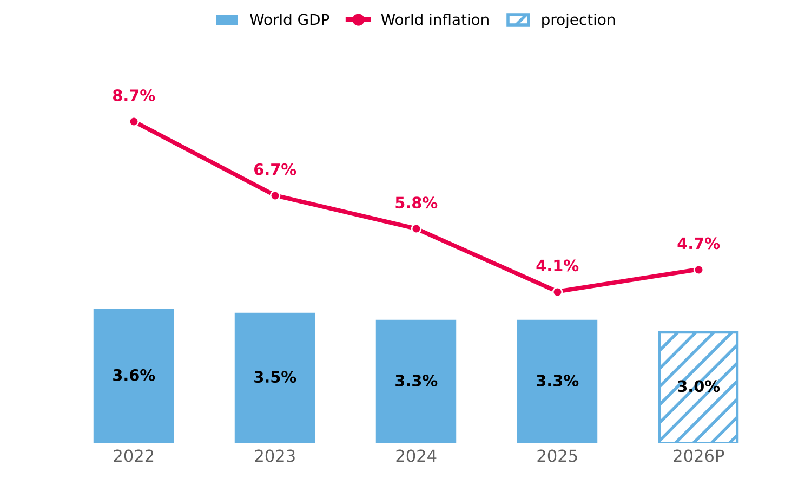  Stagflation. The IMF cut 2026 world growth to 3.0% and raised inflation to 4.7% (from 4.1% in 2025): the disinflation under way since 2024 stalled on higher energy and food prices, in an economy that grows less.  Source: IMF, World Economic Outlook (July 2026 update). 2026P = projection.
4. CHILE: SLOWER GROWTH AND STICKY INFLATION
Figure A6: Chile: GDP, inflation and policy rate, 2022–2026P (%)  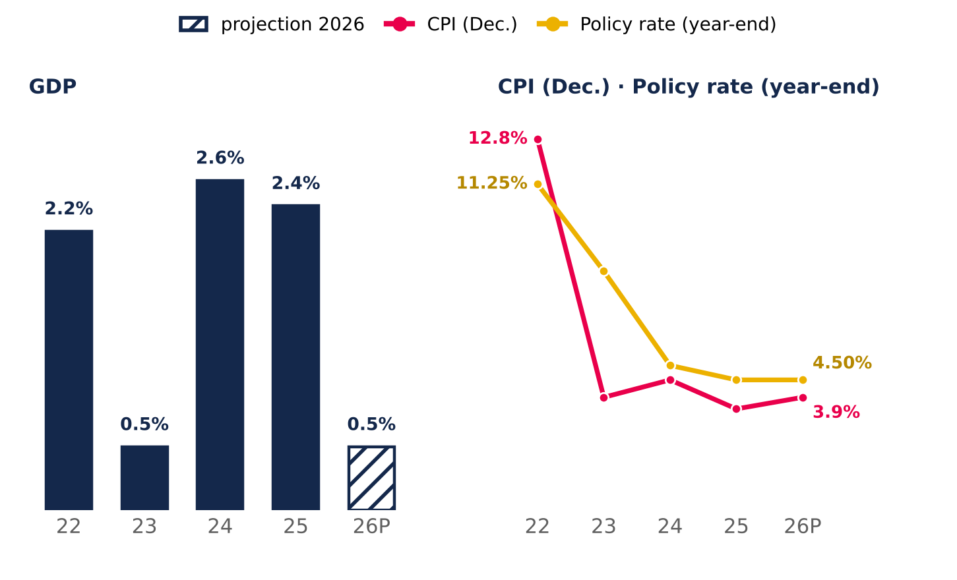  Source: BCCh (Monetary Policy Reports Dec-25, Jun-26 and Sep-26) and INE. 2026 GDP: midpoint of the 0.25–0.75% range. |  | Slower growth. The Central Bank cut 2026 GDP growth to 0.25–0.75%, from 2–3% in December 2025, with a weaker labour market and falling confidence.  Sticky inflation. CPI rises to 3.9%, above the 3% target, and the policy rate stays at 4.5%: there is no room to support consumption, the driver of tenant sales (MR1).  Geopolitical fragmentation. Weaker alliances and unpredictable US trade policy raise hedging costs and reduce flows to emerging markets. For Chile, Peru and Colombia this means more volatile currencies and costlier funding, which the model captures with a 1.41% weighted CRP in the cost of equity.
5. WHAT IT MEANS FOR MALLPLAZA
Channel | 2022–2026 | Effect on Mallplaza | In the model | Risk
Energy and inflation | Brent USD 71 → 114 (Feb–Sep-26); world inflation 4.1% → 4.7% | Indexes UF debt (79% of total); UF-linked rents offset it | UF +3% = −CLP 38,691 MM of earnings (Fig. 26) | MR1
Long-term rates | 10Y UST 4.1% → 5.2%; Bund 2.9% → 3.6% (Dec-25 → Oct-26) | Higher WACC and cost of refinancing the pipeline | Rf 4.98%; WACC +100 bp = target price −12.3% (Fig. 25) | FR1
Consumption and GDP | Chile 2026 GDP: 0.25–0.75%; CPI 3.9% | Lower tenant sales, footfall and demand for new formats | Tornado: traffic −1.3% / +2.4% of value (Fig. 24) | MR1 · MR2
Fragmentation | US tariffs; lower flows to emerging markets | Volatile currencies and costlier funding | 1.41% weighted CRP in Ke; debt in local currency and hedging derivatives (MD&A 2Q26) | FR1 · MR3
6. WHAT TO WATCH
Indicator | Latest | Warning sign | What it means for Mallplaza
10Y UST | 5.22% (8-Oct-26) | Sustained above 5.5% | ≈ WACC +50 bp: target price from CLP 2,077 to ~1,940 (Fig. 25)
Brent | USD 114 (Sep-26) | Above USD 120 or a prolonged Hormuz closure | Higher inflation and UF: larger debt indexation (MR1)
Chile CPI | 3.9% (Jun-26 MPR) | Above 4% for two quarters | No rate cuts; weak consumption and tenant sales
Chile GDP | 0.25–0.75% 2026 (MPR) | Two quarters of contraction | Lower footfall and sales; pressure on occupancy (Fig. 24)
France–Germany spread | 117 bp (30-Sep-26) | Above 150 bp | Fiscal contagion: more pressure on global long-term rates (FR1)
Investor takeaway. The backdrop raises the likelihood of the report's two most severe risks (FR1 and MR1). The model uses a 4.98% Rf and a 10.41% terminal nominal WACC (10.54% in 2H26E); with the 10Y UST above 5.2% in October, the bias on the discount rate is upward, which reinforces the recommendation.

