APPENDICES: BUSINESS DESCRIPTION
Appendix A: Tier A assets by GLA, 2Q26 (thousand m²)  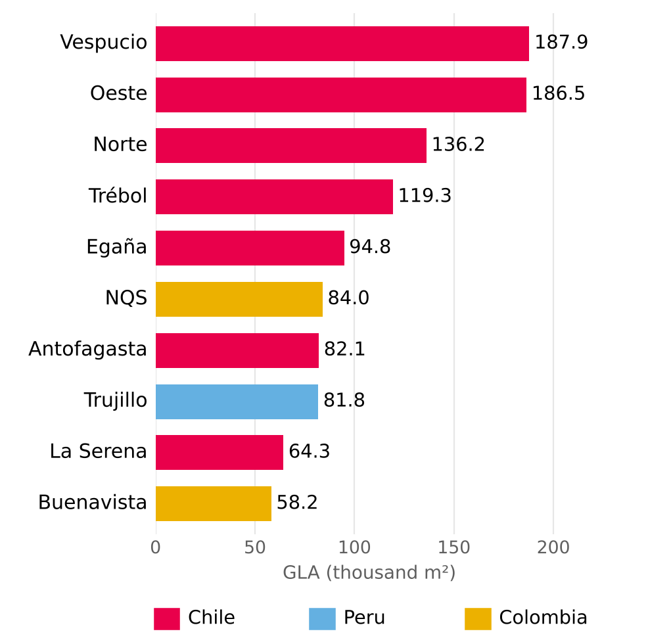  Source: Plaza S.A., Institutional Presentation 2Q26 (p.12). Tier A = 46.4% of total GLA. |  | Appendix B: Department stores, % of total GLA  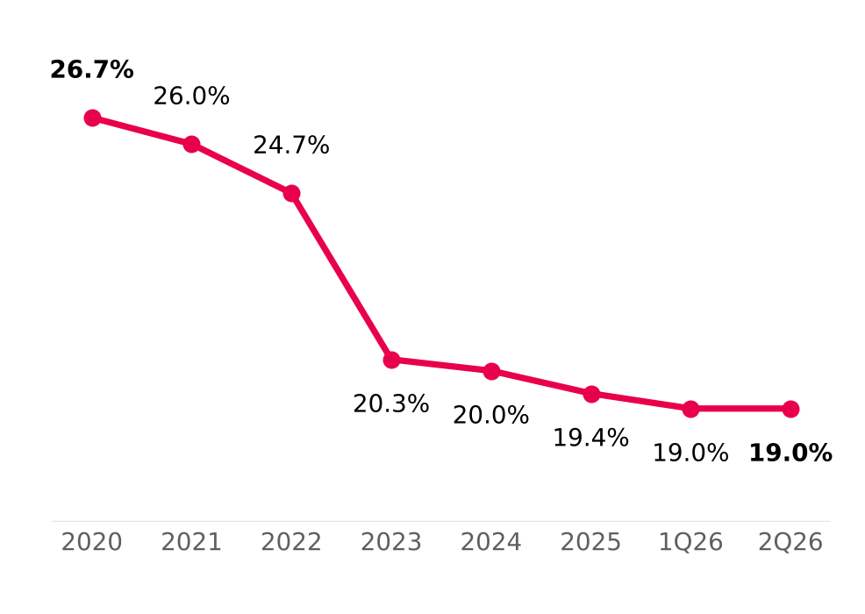  Source: Plaza S.A., Institutional Presentation 2Q26 (p.17).

