INVESTMENT RISKS
Mallplaza's risk profile is moderate: its operations are resilient and value depends mainly on market variables. The main risk, with high likelihood, is a rise in long-term rates, which pushes up bond yields and the WACC. Not even the favourable scenarios justify the market price at the report date.
RISK ASSESSMENT  Figure 23 classifies each risk by likelihood and by its impact on value per share (Figures 24 to 26). Risks that could not be quantified are classified according to the team's qualitative analysis of the company.  OPERATIONAL RISKS  OR1: Operating deterioration. EBITDA margin, rents, footfall or occupancy falling to their historical lows. The worst case, a 75.8% margin, cuts DCF value to CLP 1,669 (−10.2%), and the historical floor of same-store rent growth takes it to CLP 1,783 (−4.1%) (Figure 24). All levers together, with WACC +100 bp, define the bear scenario (target price CLP 1,542, −56.6% against the share price). (Non‑systematic · Medium likelihood · Medium impact)  Mitigants: stable metrics: EBITDA margin rose from 76.2% (2022) to 80.5% (2025) and occupancy held between 95.5% and 96.6% in 2024-25. After COVID, 1Q22 revenue was already 18% above 1Q19.  OR2: Anchor stores. Anchors, mostly from the Falabella group, drive footfall. Shrinking or losing them would lower visits and rents from smaller stores. The impact ranges from −1.3% to −4.1% (Figure 24). (Non‑systematic · Low likelihood · Low impact)  Mitigants: long-term leases (average remaining term of 7.1 years) and a proven ability to convert anchor space into smaller stores with higher rent per m².  FINANCIAL RISKS  FR1: Interest rates and cost of capital. Higher long-term rates would raise the WACC and the cost of refinancing debt and the pipeline. Likelihood is high: the 10Y UST moved from 4.98% (model Rf) to 5.22% on 8-Oct-26, a 24-year high (since 2002); the Fed hiked in September and the Central Bank of Chile reports rising local long-term rates. With nominal WACC +50 bp and +100 bp, the target price falls 6.7% and 12.5% (Figure 25). (Systematic · High likelihood · High impact)  Mitigants: 79% of debt is fixed-rate in UF, with ~6.7 years of duration, 2.36x net debt/EBITDA and AA+/BBB ratings, which limit the pass-through to the cost of debt; UF-linked rents offset inflation. A higher cost of equity cannot be hedged.  MARKET & MACROECONOMIC RISKS  MR1: Inflation and macro cycle. 79% of debt is in UF: a 3% higher UF takes CLP 38,691 million off accounting earnings (Note 26). On the target price, however, the effect is small, because indexed rents rise with inflation: a 100 bp rise in the long nominal rate coming entirely from expected inflation takes off only 0.3%; if it came entirely from the real rate, 12.2% (Figure 26). The risk is that weaker consumption prevents passing inflation through to rents: if only 70% of the cash flow were indexed, the effect of inflation would rise to 1.0%. Weaker consumption also slows the new business lines (Appendix [X]). (Systematic · High likelihood · Low impact)  Mitigants: UF-indexed rents, a model based on rent rather than sales, low (if rising) leverage and an active ability to rotate the portfolio.  MR2: E‑commerce. If consumption migrates massively online, malls lose footfall and appeal. E‑commerce in Chile exceeded US$10 billion in 2025, around 12.6% of retail sales. The worst traffic case only takes 1.3% off value (Figure 24). (Systematic · Low likelihood · Medium impact)  Mitigants: the online channel is maturing with no visible effect on the model (visits +16% in 2025). Malls offer entertainment and dining, hard to replicate online.  MR3: Foreign exchange. Around 28% of revenue comes from Peru and Colombia, and the model assumes the sol rises from CLP 268 to 290 between 2026 and 2031. A 10% depreciation of the PEN and COP from 2027E takes 4.3% off DCF value, before hedges and the effect on local-currency debt (team estimate). (Systematic · Medium likelihood · Medium impact)  Mitigants: Mallplaza raises debt in each country's currency and, where not possible, uses hedging derivatives (forwards, swaps and cross currency swaps) (Management Discussion 2Q26, p. 14).  REGULATORY & ESG RISKS  RR1: Interlocking and conflicts of interest. Falabella controls 53.05% and leases space through Falabella, Sodimac and Tottus, which creates receivables with related parties. Fernando de Peña, Mallplaza's CEO for decades, has chaired Falabella since March 2026. Off-market contracts would directly affect rents and value. There is also a capital-allocation risk: expansion earns less than its cost (real RONIC of 5.3% against a real WACC of 7.2%), so continued growth benefits accounting profit and a controller with other businesses in those malls more than the minority shareholder (to be verified; see Valuation). (Non‑systematic · Low likelihood · High impact)  Mitigants: a three-member directors' committee and review of related-party transactions (Law 18,046). Even so, safeguards are limited: only 1 of 9 directors is independent.  RR2: Regulatory and political. Changes in tax, permitting and economic policy in all three countries. In Chile, the ruling coalition lacks a comfortable majority in the lower house for the rest of its agenda (El Dínamo, 11-Mar-26). In Peru, Fuerza Popular lacks a majority in the new bicameral Congress and the MEF puts the cost of laws passed by the previous Congress at up to S/ 50,000 million (El Comercio). In Colombia, the finance ministry puts the deficit at 7.8% of GDP and proposes spending cuts of at least 1% of GDP (El Tiempo, Jul-26), and the central bank raised its rate to 12.25% (30-Sep-26), which slows consumption. Permit delays push back the pipeline (USD 613 million, 170,200 m² to 2028). (Systematic · Medium likelihood · Low impact)  Mitigants: pro-investment agendas. In Chile, Kast signed the Reconstruction Law (9-Oct-26), which gradually cuts corporate tax from 27% to 23% from 2027 (Emol, 9-Oct-26), S&P affirmed its A stable rating and Law 21,770 (Sep-25) shortens permitting. In Peru, the minimum-wage rise to S/ 1,300 and the doubling of Pensión 65 support consumption (Infobae, 28-Jul-26). Colombia contributes only ~11% of revenue. The model keeps 27%: the Chilean cut would add ~5.2% to the target price. |  | Figure 23: Risk matrix  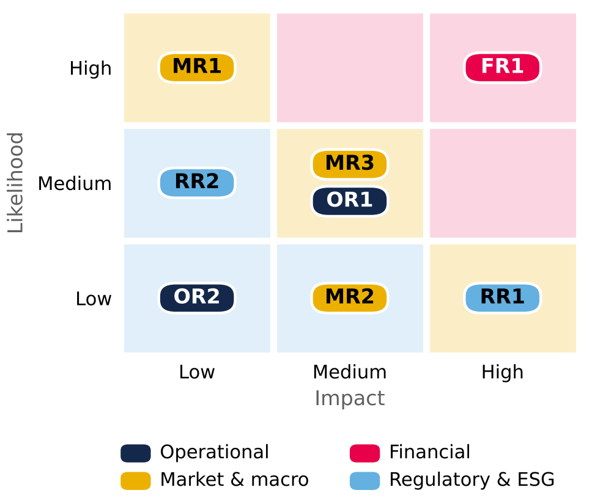  Background colour = severity (likelihood × impact). Source: Team analysis.  Figure 24: Operational risk tornado (CLP per share)  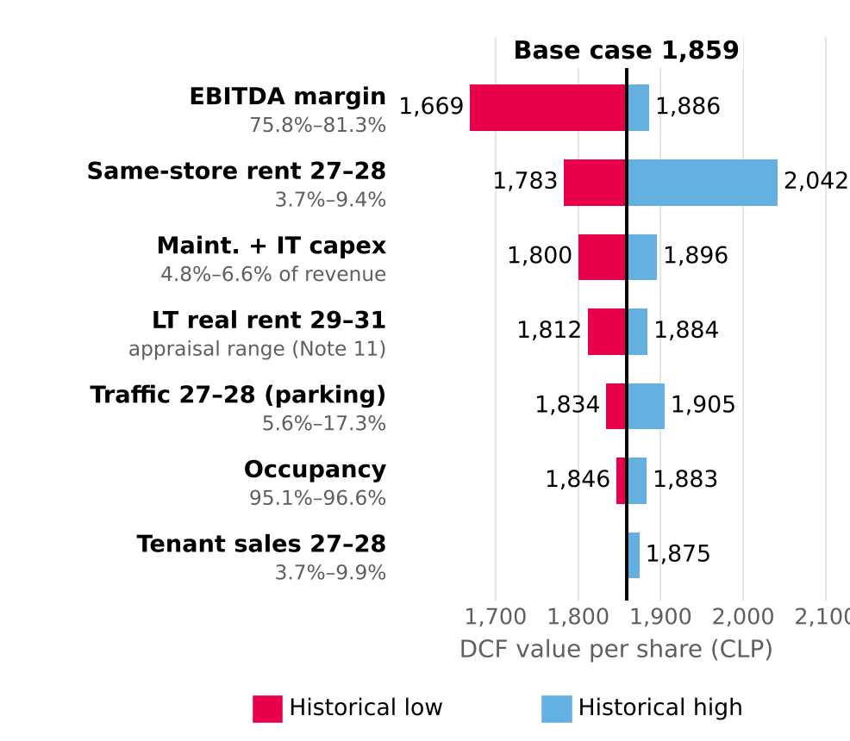  Limits = historical minimum and maximum of each variable (Mallplaza releases 4Q23–2Q26; financial statements for maintenance capex and appraisal, Note 11). WACC 10.41% and g 3.0% constant. Source: Mallplaza; Team analysis.  Figure 25: Target price sensitivity: WACC vs g (CLP)  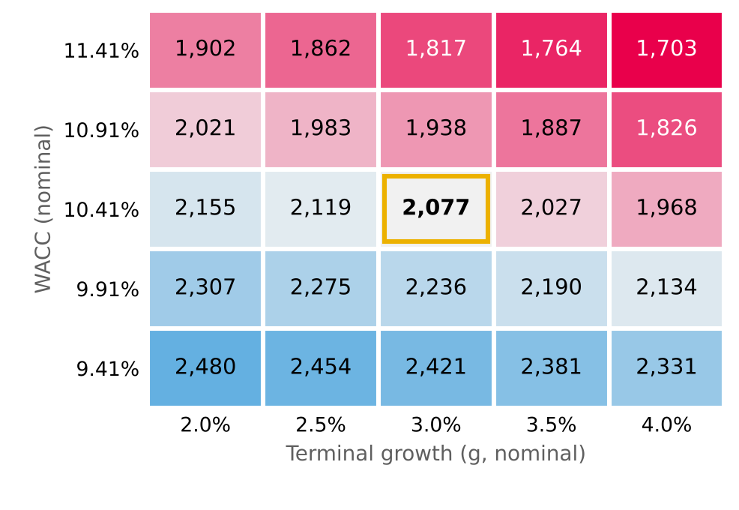  Target price = 80% DCF + 20% EV/EBITDA multiples (CLP 2,951). The g = 2.0% column uses the same formula as the Sensibilidad sheet. Source: Team analysis.  Figure 26: Target price by long nominal rate and the share of its rise that comes from inflation (CLP)  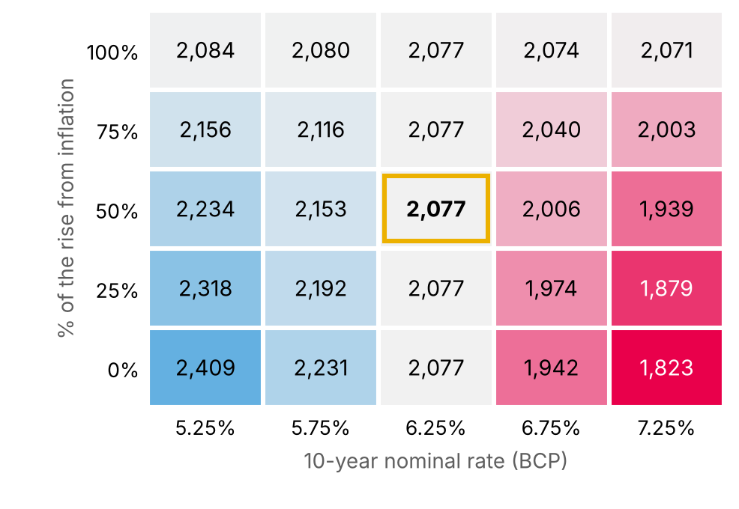  10-year BCP (base 6.25%, 30-Sep-26); the rise is split between real rate and inflation; 85% of cash flow is indexed to inflation (team assumption). Source: Central Bank of Chile; Team analysis.

