INVESTMENT RISKS
Mallplaza's risk profile is moderate: its operations are resilient and value depends mainly on market variables. The main risk is a high-probability rise in interest rates that lifts the WACC, followed by inflation and weaker macro momentum. None of the risks analysed takes the target price above the current share price.
RISK ASSESSMENT  Figure 23 places each risk in a 3x3 matrix by likelihood and impact (low, medium, high); the colour of each label shows its category. Impact is measured as the effect on value per share, using the operational tornado (Figure 24), the WACC and g sensitivity (Figure 25) and the effect of UF indexation (Figure 26). Interest-rate risk (FR1) sits in the most severe cell (high/high), and inflation and the macro cycle (MR1) also fall in the red zone; FX (MR3) sits in the centre.  OPERATIONAL RISKS  OR1: Operating deterioration. EBITDA margin, rents, footfall or occupancy falling to their historical lows. The worst case, a 75.8% margin, cuts DCF value to CLP 1,671 (−10.0%), and the historical floor of same-store rent growth takes it to CLP 1,782 (−4.0%) (Figure 24). (Non‑systematic · Medium likelihood · Low impact)  Mitigants: stable metrics: EBITDA margin rose from 76.2% (2022) to 80.5% (2025) and occupancy held between 95.5% and 96.6% in 2024-25. After COVID, 1Q22 revenue was already 18% above 1Q19.  OR2: Anchor stores. Anchors, mostly from the Falabella group, drive footfall. Shrinking or losing them would lower visits and rents from smaller stores. In 2025 Mallplaza already converted 14,000 m² of large-format space in five malls. The impact is bounded by the traffic and rent bars of the tornado (−1.3% to −4.0%, Figure 24). (Non‑systematic · Low likelihood · Medium impact)  Mitigants: long-term leases (average remaining term of 6.7 years) and a proven ability to convert anchor space into smaller stores with higher rent per m².  FINANCIAL RISKS  FR1: Interest rates and cost of capital. Higher long-term rates would raise the WACC and the cost of refinancing debt and the pipeline. Likelihood is high: the 10Y UST moved from 4.98% (model Rf) to 5.22% on 8-Oct-26, a 24-year high (since 2002); the Fed hiked in September and the Central Bank of Chile reports rising local long-term rates. With WACC +50 bp and +100 bp, the target price falls 6.5% and 12.3% (Figure 25). (Systematic · High likelihood · High impact)  Mitigants: 79% of debt is fixed-rate in UF, with ~6.7 years of duration, 2.36x net debt/EBITDA and AA+/BBB ratings, which limit the pass-through to the cost of debt; UF-linked rents offset inflation. A higher cost of equity cannot be hedged.  MARKET & MACROECONOMIC RISKS  MR1: Inflation and macro cycle. 79% of debt is in UF: a 3% higher UF (base case) takes CLP 38,691 million off earnings (Figure 26). Weaker consumption hurts tenant sales and, without GDP growth, the new business lines Mallplaza has captured do not emerge (Appendix [X]). (Systematic · High likelihood · Medium impact)  Mitigants: UF-indexed rents, a model based on rent rather than sales, low (if rising) leverage and an active ability to rotate the portfolio.  MR2: E‑commerce. If consumption migrates massively online, malls lose footfall and appeal. E‑commerce in Chile exceeded US$10 billion in 2025, around 12.6% of retail sales. The worst traffic case only takes 1.3% off value (Figure 24). (Systematic · Low likelihood · Medium impact)  Mitigants: the online channel is maturing with no visible effect on the model (visits +16% in 2025). Malls offer entertainment and dining, hard to replicate online.  MR3: Foreign exchange. Around 28% of revenue comes from Peru and Colombia, and the model assumes the sol rises from CLP 268 to 290 between 2026 and 2031. A weaker PEN or COP would lower consolidated revenue and EBITDA in pesos. (Systematic · Medium likelihood · Medium impact)  Mitigants: Mallplaza raises debt in each country's currency and, where not possible, uses hedging derivatives (forwards, swaps and cross currency swaps) (Management Discussion 2Q26, p. 14).  REGULATORY & ESG RISKS  RR1: Interlocking and conflicts of interest. Falabella controls 53.05% and leases space through Falabella, Sodimac and Tottus, which creates receivables with related parties. Fernando de Peña, Mallplaza's CEO for decades, has chaired Falabella since March 2026. Off-market contracts would directly affect rents and value. (Non‑systematic · Low likelihood · High impact)  Mitigants: a three-member directors' committee and review of related-party transactions (Law 18,046). Even so, safeguards are limited: only 1 of 9 directors is independent.  RR2: Regulatory and political. Changes to corporate tax and permitting create uncertainty when evaluating pipeline projects (USD 613 million, 170,200 m² to 2028). Permit delays push back revenue, although the value sensitivity is limited. (Systematic · Medium likelihood · Low impact)  Mitigants: pro-market governments in all three countries (Kast, Fujimori, De La Espriella). Law 21,770 shortens permitting times, and the Reconstruction Law cuts corporate tax from 27% to 23% in 2029 (the model uses 27%).  SENSITIVITY ANALYSIS  Value is more sensitive to the discount rate than to operations. The worst operating case, EBITDA margin, takes 10.0% off value (Figure 24), while +100 bp of WACC takes 12.3% off the target price (Figure 25). The current price implies a cap rate close to 6.0%, versus 10.1% in the DCF: the market prices in a low discount rate, which increases the stock's exposure to higher rates. A higher g lowers value because RONIC (5.0%) is below the real WACC (7.2%). Even the best cell in Figure 25 (CLP 2,487) is below the CLP 3,555 share price, so the recommendation stands. |  | Figure 23: Risk matrix  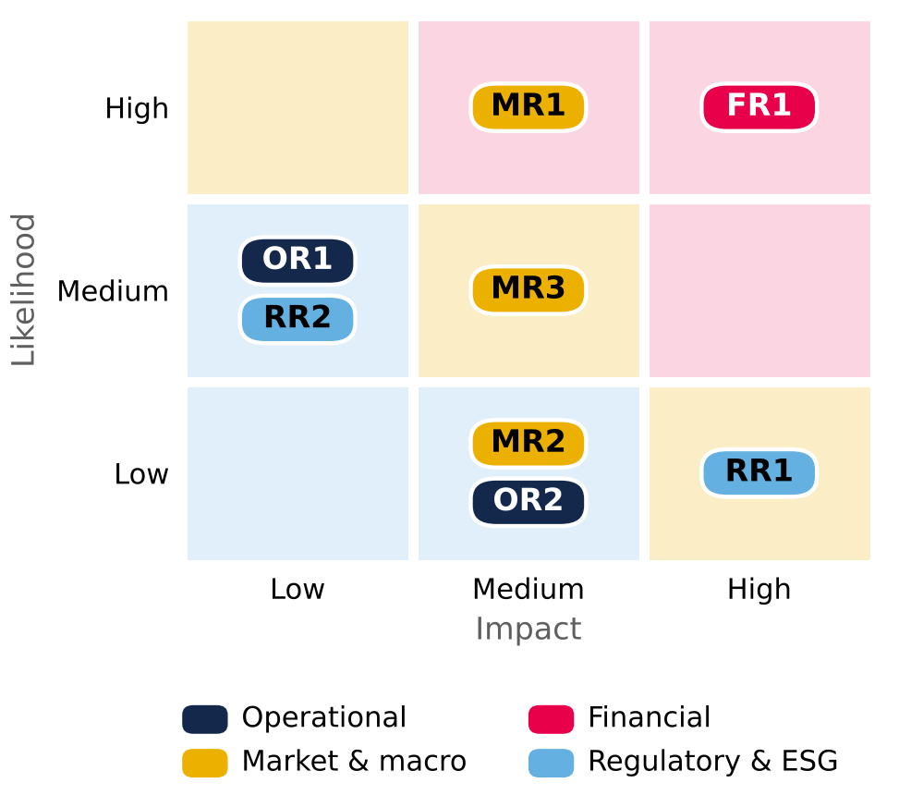  Background colour = severity (likelihood × impact). Source: Team analysis.  Figure 24: Operational risk tornado (CLP per share)  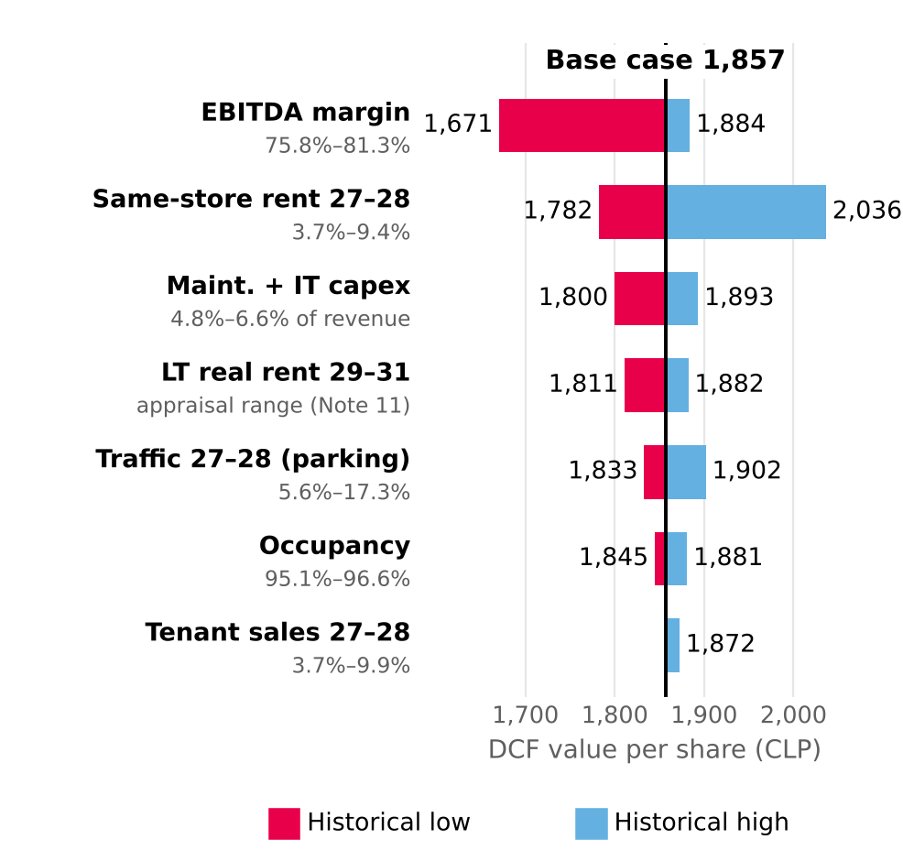  Limits = historical low and high of each driver: Mallplaza earnings releases 4Q23–2Q26 (EBITDA margin, occupancy, same-store rent and sales, visitors) and financial statements (maintenance capex 2024 and LTM 2Q26; appraisal growth range, Note 11). terminal WACC 10.41% and g 3.0% held constant. Source: Mallplaza; Team analysis.  Figure 25: Target price sensitivity: WACC vs g (CLP)  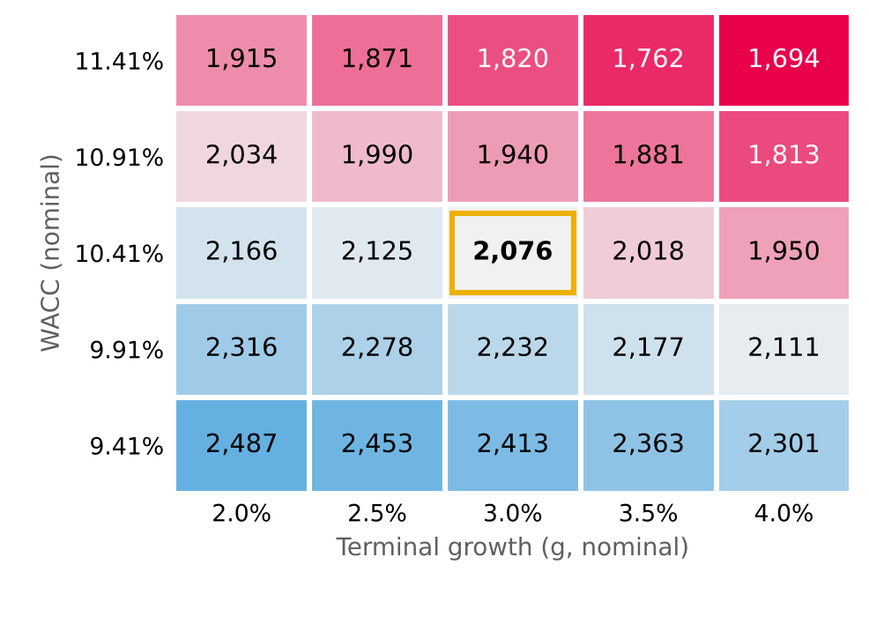  Target price = 80% DCF + 20% EV/EBITDA multiples (CLP 2,951). Source: Team analysis.  Figure 26: Earnings sensitivity to a rise in the UF  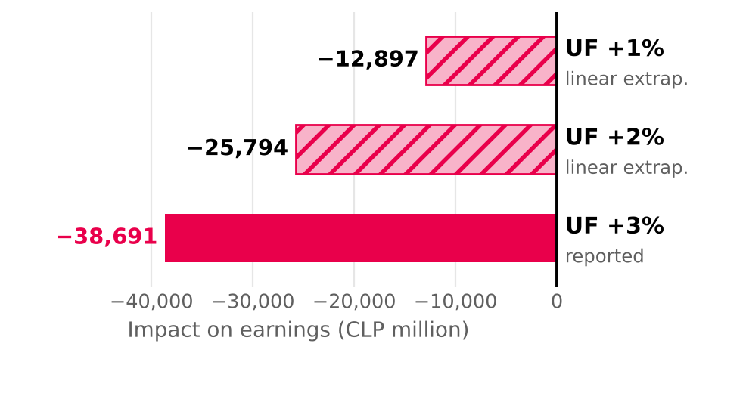  +3% = reported sensitivity; +1% and +2% linear extrapolation. Source: Mallplaza financial statements Jun-26, Note 26.

