VALUATION
We recommend SELL on Mallplaza with a target price of CLP 2,076 per share, 41.6% below the CLP 3,555 close of 30-Sep-26 (−39.7% total return including dividends). Our target sits even below the stock's 52-week low (CLP 2,470).
A PRICE NO METHOD REACHES  NEW In twelve months the stock rose from CLP 2,470 to 4,700 and now trades at CLP 3,555. None of our methods reaches that price: the DCF ranges from CLP 1,379 to 2,329 even with WACC ±100 bp and g between 2.5% and 4.0% (nominal), and the most favourable multiples fall short too (Figure 27). We give the DCF an 80% weight because Mallplaza is, at heart, a rent collector: 81.4% of revenue is rent and 93% of that is fixed. The 20% on multiples tests the model against what the market pays today, but with caution: Chile has only two direct peers, and neither captures the company's expansion plan or debt path.  Figure 27 sums up the thesis in one picture. APV, which values the firm unlevered and adds the tax shields separately, gives CLP 1,894, just 2% above the DCF: the result does not depend on how we model financing. Multiples range from CLP 2,152 (common-set median) to 3,294 (Chilean median), and EV/EBITDA NTM and EV/EBIT sit between CLP 2,914 and 3,098. Everything falls to the left of the price; the only thing that reaches it is the stock's own trading range over the past year. Even the Chilean median multiple, the most favourable case for the stock, sits 7% below the price.  THE STORY IS IN THE RATE  We project free cash flow to the firm in nominal CLP from 30-Jun-26, with an explicit horizon to 2031E and a terminal value that accounts for 76% of EV (Appendix [B]). The CLP 1,857 per share is CLP 583 of explicit cash flows and CLP 1,884 of terminal value, less CLP 610 of debt and minorities: the result depends, above all, on the discount rate.  NEW That rate moves with the capital structure. Mallplaza uses its debt capacity to grow, as in 2024 after buying Open Plaza Peru (3.78x): we assume net debt/EBITDA rises from 2.36x to 3.5x by 2031, with 25 bp more real cost per turn, and that new debt (CLP 1.40 trillion) funds all capex while operating cash is distributed to shareholders. The nominal WACC thus moves from 10.54% in 2H26E to 10.41% in the terminal period (7.20% real): an 11.93% nominal Ke (8.67% real; Rf 4.98%, relevered beta of 1.14 from a six-peer median of 0.94, ERP 4.14% and a 1.41% revenue-weighted CRP) and a 5.11% nominal after-tax Kd based on the 3.6% real (UF) coupon of the latest bond (Appendix [Z]).  NEW We build Ke in dollars because its three inputs are in that currency and are nominal: the US Treasury Rf, the implied equity risk premium published by Damodaran and country risk, which we weight by revenue (71.8% Chile, 17.7% Peru and 10.5% Colombia). We then convert it to pesos with the gap between expected inflation in Chile (3.0%, the central bank's target) and in the US (2.24%, 10-year breakeven). The beta is unlevered with Hamada (six regional peers) and relevered each period (1.09 in 2H26E, 1.14 in the terminal period).  NEW The first signal is the asset IRR, what the business earns for whoever buys it at CLP 3,555 if our cash flows come true: 7.57% nominal (4.44% real in UF), 284 bp below its WACC and just ~80 bp real above its real cost of debt (Figure 28). The market is pricing the business almost as if it were a bond.  NEW Asset (firm) IRR vs its WACC: nominal CLP and real (UF)  Asset IRR: the single rate that equates FCFF and terminal value to the enterprise value paid (price × shares + net debt + minorities). At the DCF value it equals the WACC. Figure 34 shifts the whole WACC curve and gives 7.56% at the market price. Real = (1 + nom.) / (1 + 3.0%) − 1. Source: model v3, TIR_Implicita and TIR_Accionista sheets.  GROWTH DOES NOT RESCUE THE PRICE  This is not pessimism about operations. We forecast a 79.7% EBITDA margin in 2026E (excluding revaluation, below the 80.5% LTM), a tax rate converging from 16.8% to 27%, the announced pipeline (USD 613 million and 170,200 m²) and, from 2029, 27,075 m² of new GLA a year at the historical pace. The 13-analyst consensus expects NTM EBITDA only ~3% above ours: the disagreement with the market is not about cash flows.  NEW Capex follows the company's plan: the pipeline and maintenance (5.5% of revenue) take base capex to a peak of CLP 240,660 million in 2027, and continuous expansion adds CLP 95,000–104,000 million a year from 2028, at the cost of the identified pipeline (USD 3,603 per m²) with a 35%, 90% and 100% revenue ramp. Working capital, at 15.6% of revenue, requires only CLP 7,100–9,900 million a year and moves the price by ±1.2% (Figure 29; Appendix [C]).  NEW Two assumptions deserve explanation. The cash tax rate starts at 16.8% because the company currently uses tax goodwill and loss carry-forwards; we assume those shields run off and the rate reaches 27% by 2030, so as not to overstate value. It is a real cash saving (it lowers current tax), not accounting: CLP 61 per share undiscounted; without it the target falls 2.1% (Figure 29). And working capital is positive because tenant receivables (CLP 122,370 million) exceed rents collected in advance (CLP 20,247 million): it grows with revenue, not with new m².  NEW The problem is the return on growth. Each new m² yields 6.9% real pre-tax on cost, a 5.0% real RONIC after tax, below a 7.2% real WACC. Expansion adds revenue but not value, so terminal value grows only with inflation (g of 3.0% nominal, 0% real) and a higher g lowers value (Figure 30). Assuming more growth would not close the gap with the price; it would widen it.  NEW That is why the explicit horizon includes the capex and ramp-up of projects opening through 2032 (108,301 m² of mature GLA in the terminal year), but from then on the model adds no new malls: terminal capex covers maintenance only (5.5% of revenue). At these returns, growing more would reduce its value. |  | Figure 27: No method justifies the current price (CLP per share)  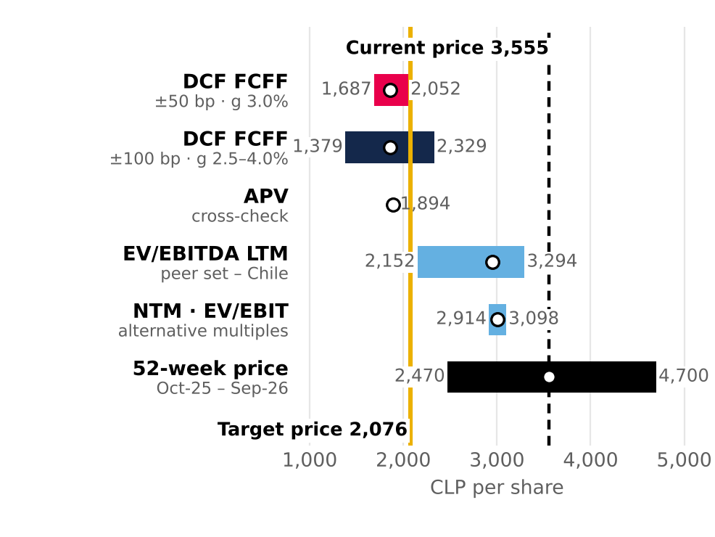  52-week intraday range (1-Oct-25 to 30-Sep-26; low 10-Oct-25, high 27-Apr-26). Source: Team analysis; Bloomberg.  Figure 28: NEW At CLP 3,555 the firm yields almost the same as its debt  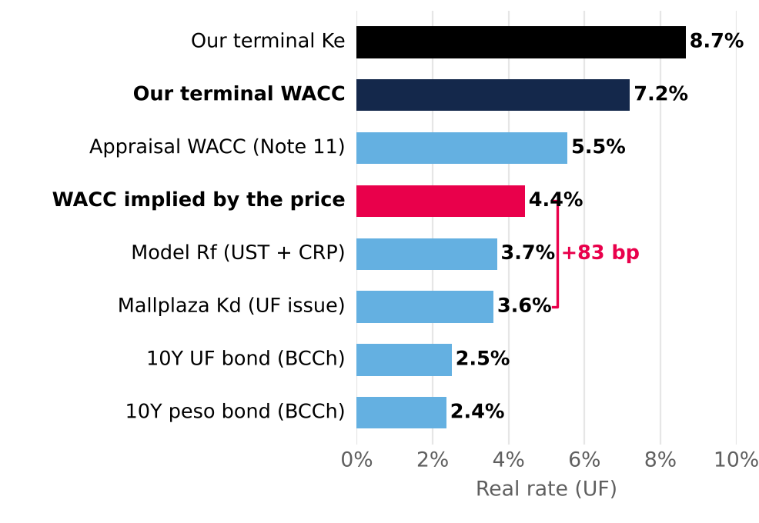  Real rates in UF. Source: Central Bank of Chile (30-Jun-26); Mallplaza; Team analysis.  Figure 29: NEW With every strong assumption in its favor the target reaches CLP 2,928, still 18% below the price  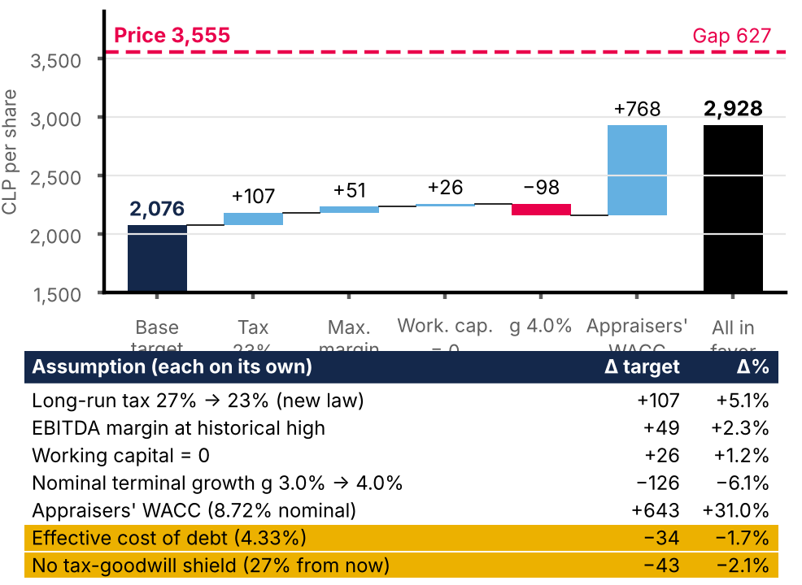  Cumulative waterfall in the order shown; the table gives each assumption on its own. Target price = 80% DCF + 20% multiples. Source: v3 DCF replica; Team analysis.  Figure 30: Growing below the WACC destroys value: real g = 0%  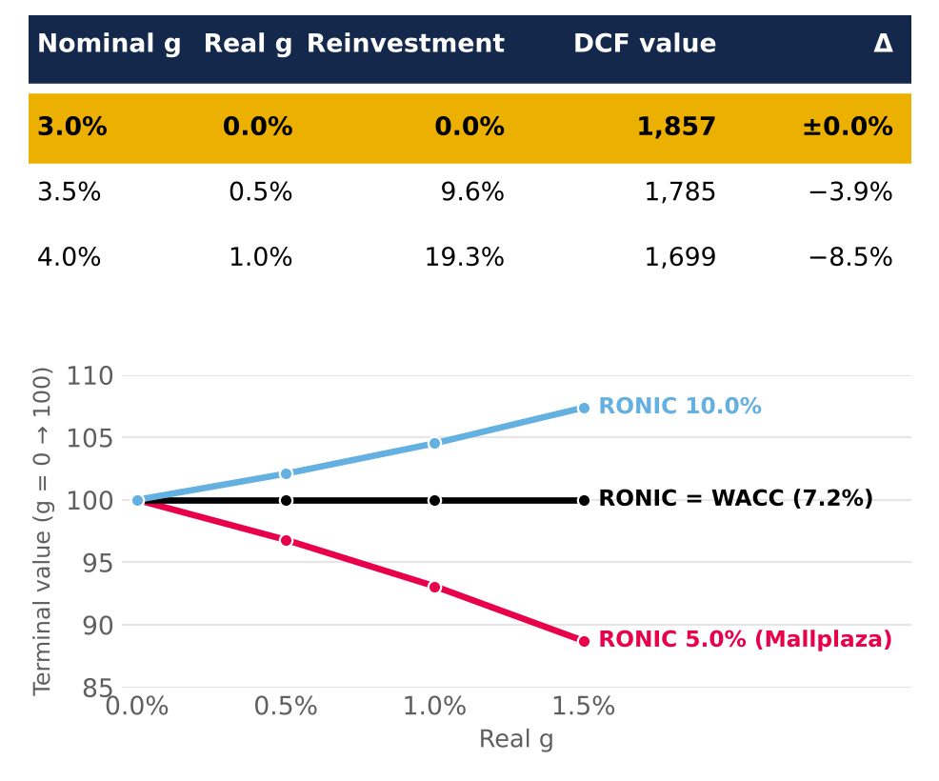  Top: DCF value by g. Bottom: relative terminal value by RONIC. Source: Team analysis.
  Buying at the price of | Nominal | Real | WACC nom./real | Gap nom./real
  Market: CLP 3,555 | 7.57% | 4.44% | WACC 10.41% / 7.20% | −284 / −276 bp
  Our target: CLP 2,076 | 9.87% | 6.67% | WACC 10.41% / 7.20% | −54 / −53 bp
  Our DCF: CLP 1,857 | 10.43% | 7.21% | WACC 10.41% / 7.20% | +2 / +2 bp

PEERS CONFIRM THE DIRECTION, NOT THE SIZE  NEW Mallplaza trades at 16.8x EV/EBITDA, above the Chilean median (15.7x) and far above Brazilian peers (9.0x). The gap with Brazil is about rates, not quality: with local real bonds at 2.5% in Chile and 8.1% in Brazil (NTN-B), the cap-rate spread (EBITDA/EV yield; with UF-indexed rents it is compared with real rates) over the local rate is similar in both countries, 385 bp in Chile and 302 bp in Brazil (Figure 31). We therefore weight the Chilean median at 70% and the common-set median at 30% (which includes IRSA; we exclude Fibra Danhos for its FIBRA regime): 14.4x, giving CLP 2,951 per share. The weighting matters little: between 0% and 100% Chile, the target price only moves from CLP 1,916 to 2,144 (Appendix [E]).  NEW Macro explains the difference. At 30-Jun-26 Brazil had a 14.25% nominal Selic, a 14.34% nominal 10-year bond and 5.3% expected 2026 inflation, against a 4.5% nominal policy rate, a 5.43% nominal bond and 4.1% inflation in Chile, with similar real GDP growth (2.0% and 1.6%). An investor in Brazil demands more from every asset, not just shopping malls; applying that discount to Mallplaza, which earns 71.8% of revenue in Chile, would penalise it for a risk it does not carry. Mallplaza's own spread (346 bp) is in fact tighter than the Chilean median (385 bp): investors already pay it a premium within Chile.  We chose the set on the same basis as the beta. IRSA is kept with caution, since it reports under IAS 29 and its NTM consensus has a single analyst; Fibra Danhos is excluded because, as a FIBRA, it must distribute 95% of its taxable income and has no beta in the WACC. We use EV/EBITDA because it is neutral to leverage and to revaluation (IAS 40), and we measure everyone with Bloomberg net debt (CLP 1,311,569 million for Mallplaza, close to the CLP 1,285,740 million of net financial debt used in the DCF).  Nor does quality justify the premium. Mallplaza trades 29% above Cencosud Shopping, yet its EBITDA per m² is only 1.8% higher (see Industry); only at Parque Arauco's multiple (18.4x), with 5.7x leverage, would it be worth more than its price. Every multiple, from EV/EBITDA NTM (CLP 2,914) to P/BV (CLP 3,171), sits below the price (Figure 32): multiples confirm the stock is expensive, and the DCF sets the size of the gap. We exclude P/E (CLP 8,644), distorted by property revaluation.  In price terms: at the Chilean median alone the stock would be worth CLP 3,294 (−7%); at Cencosud's multiple, CLP 2,621; and only at Parque Arauco's, CLP 3,967. Defending CLP 3,555 with multiples requires assuming Mallplaza deserves the valuation of the most leveraged peer in the group. The forward view tells the same story: Mallplaza trades at 14.8x consensus NTM EBITDA against a 12.5x weighted peer multiple. We keep Brazil at 30% rather than zero because the Chilean median rests on only two companies.  WHAT THE MARKET WOULD HAVE TO BELIEVE  NEW The price implies an EV of CLP 9.12 trillion, 69% above ours, and a real 6.0% cap rate, against 10.1% in our DCF, 6.4% for Chilean peers and 7.5% at book value (Figure 33). The market pays 1.61x an equity base already at fair value, appraised at a real discount rate of ~5.55% (Note 11); the real IRR the price leaves, 4.4%, is below that rate: it pays more than the appraisers themselves. To justify CLP 3,555, the nominal WACC would have to be 285 bp lower (7.56%; Figure 34); even at the appraisers' rate (5.55% real, 8.72% nominal), the DCF would be CLP 2,660.  NEW We pushed the thesis to its extremes. In a bear case (nominal WACC +100 bp and the 75.8% quarterly-low margin) the target falls to CLP 1,713; in a bull case combining nominal WACC −100 bp, nominal g of 2.5%, the 81.3% quarterly-peak margin and the cut in corporate tax to 23%, it rises to CLP 2,627, still 26% below the price. APV (CLP 1,894), a peso-bond Rf (~CLP 2,439) and other debt targets (DCF of CLP 1,819 to 1,894) lead to the same conclusion (Appendix [F]). The firm's IRR at the market price barely moves across scenarios (7.3%, 7.6% and 7.9% nominal in bear, base and bull; 4.2%, 4.4% and 4.7% real) and always stays below each one's WACC (409, 284 and 152 bp nominal): even the bull case leaves no margin of safety.  NEW APV also shows what the debt is really worth. Of its CLP 1,894 per share, CLP 1,632 is the unlevered firm and CLP 261 the tax shields of projected debt: levering up to 3.5x adds value, but even with it the price is far away. And our risk-free choice is the conservative one: using the nominal peso bond (5.43%) and then adding country risk would count Chile risk twice, and even so the target price would only rise to ~CLP 2,439, 31% below the price. In other words, no reasonable choice of inputs rescues the current valuation; the gap is too wide to be a modelling artefact.  Calendar details do not change the outcome either. With an expected dividend of ~CLP 69 per share (2.0%), the expected total return is −39.7%. And since the DCF is dated 30-Jun-26 and the price 30-Sep-26, the comparison slightly favours the market: if the balance of the 2026 dividend (~CLP 27 per share) was already paid before that date, our value would be somewhat overstated, not understated.  NEW That brings us to CLP 2,076 (80% × 1,857 + 20% × 2,951): 10.8x EBITDA, a real 9.3% cap rate and 0.94x book value. Rolling the DCF to 30-Sep-26 would lift it to ~CLP 2,118 without changing the call. The catalyst is the same force behind the thesis: with the nominal 10Y UST at 5.22%, its highest since 2002, rates pressure cap rates, and each new appraisal moves them toward our value. We would be wrong if cap rates compress further on institutional demand for defensive assets, or if the market sustains a structural premium for Tier A assets (see Investment Risks).  NEW What we will watch: the Note 11 appraisal at each reporting date (the real discount rate is the bridge between our value and book), the spread of the company's UF bonds over their 3.6% real coupon (at the latest issue's 4.33% real effective rate, the nominal WACC would rise 12 bp and the target would fall to CLP 2,042), the cut in corporate tax to 23% (+5.1% on the target, not yet included) and the AAA rating, which would likely come under pressure at 3.5x net debt/EBITDA. In short, the operating story is sound; it is the price of that story that no longer adds up. |  | Figure 31: Chile and Brazil charge the same premium: multiples differ because of rates  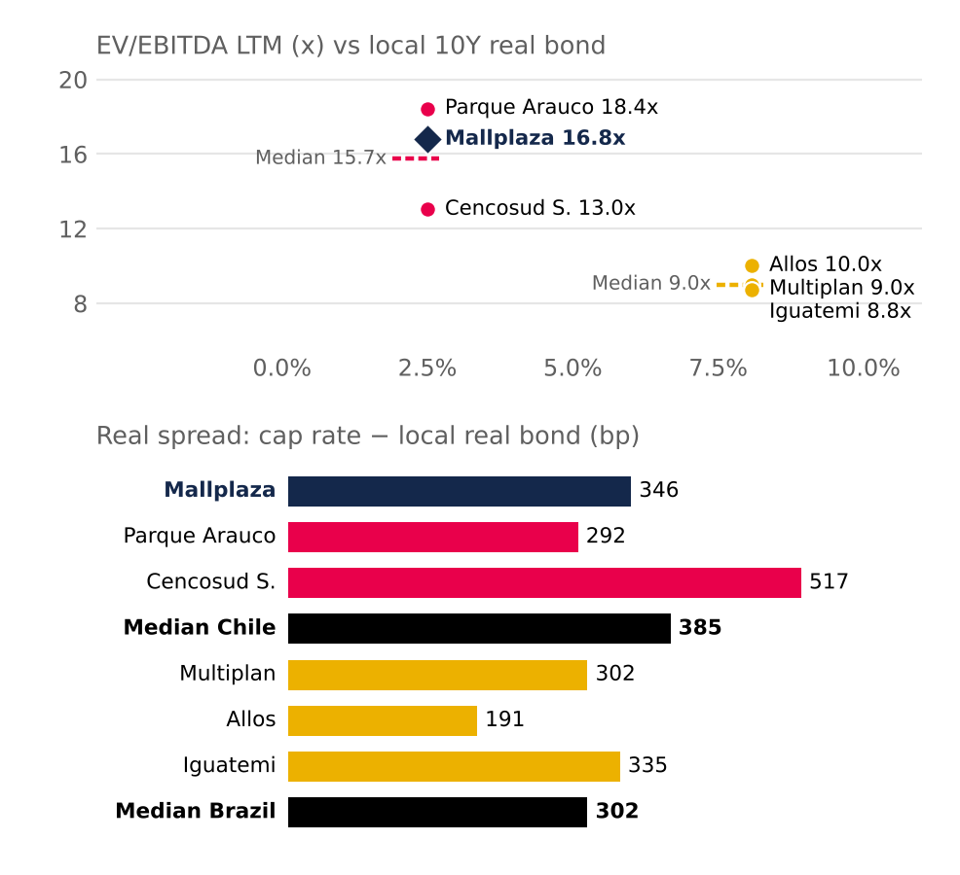  Real bond: 10Y UF (Central Bank of Chile) and NTN-B 2035 (8.08%) at 30-Jun-26. Spread = cap rate (1 / EV/EBITDA) − real bond. IRSA omitted (IAS 29). Source: Bloomberg; Central Bank of Chile; Team analysis.  Figure 32: Value implied by each peer's multiple vs DCF and price (CLP per share)  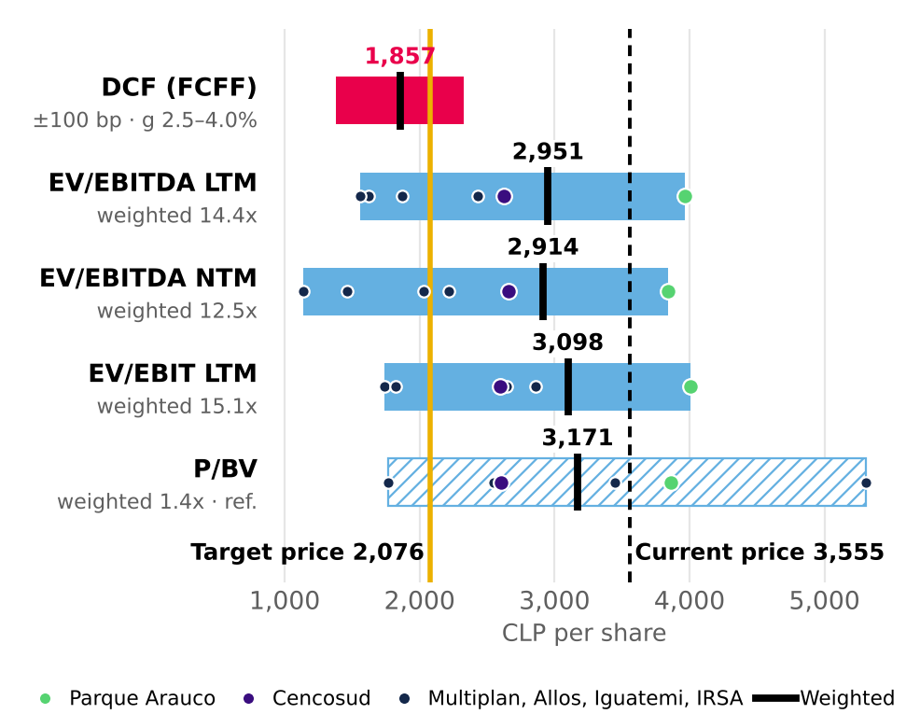  Target = 80% DCF + 20% EV/EBITDA LTM. P/E excluded (includes revaluation). Source: Bloomberg (30-Sep-26); Team analysis.  Figure 33: The market pays 6.0%; our cash flows are worth 10.1%  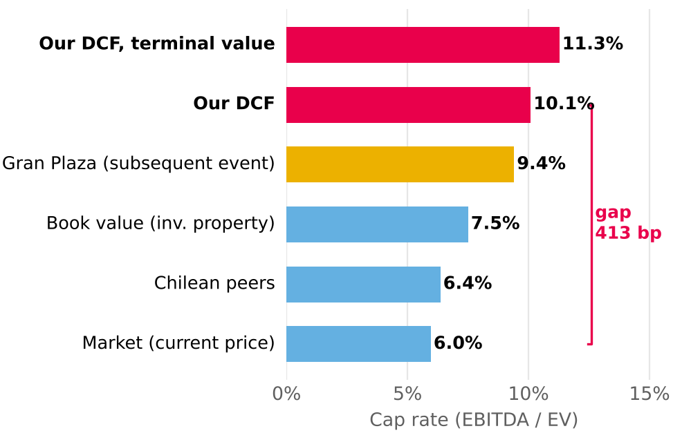  Gran Plaza: subsequent event, not in the model. Source: Mallplaza; Bloomberg; DF; Team analysis.  Figure 34: NEW The price requires a nominal WACC 285 bp lower  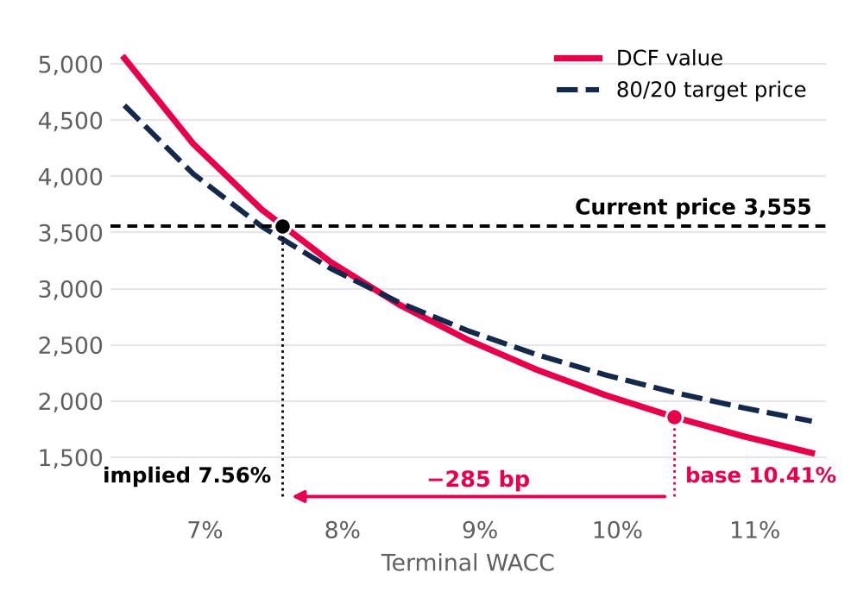  Source: Team analysis.

