BUSINESS DESCRIPTION
WHO WE ARE AND WHAT WE DO  [Write here: company overview, history and listing.]  BUSINESS MODEL  [Write here: fixed and variable rents, parking and services.]  GEOGRAPHIC FOOTPRINT AND ASSET MIX  [Write here: portfolio by country, GLA and asset type.]  KEY GROWTH DRIVERS  [Write here: pipeline, expansions and acquisitions.]  CORPORATE STRUCTURE AND GOVERNANCE  [Write here: controlling shareholder and corporate structure.] |  | Figure 1: [Figure title, e.g. GLA and revenue by country]  Source: [Company filings / Team analysis]
  [Insert chart or table]

INDUSTRY OVERVIEW AND COMPETITIVE POSITIONING
INDUSTRY OVERVIEW (RETAIL AND SHOPPING MALLS)  [Write here: structure of the retail and mall industry in Chile, Peru and Colombia.]  MARKET SIZE AND GROWTH  [Write here: market size, growth and penetration.] |  | Figure 2: [Figure title, e.g. Retail sales growth by country]  Source: [Company filings / Team analysis]
  [Insert chart or table]

Figure 3: [Figure title, e.g. Porter's five forces]  Source: [Company filings / Team analysis]  Figure 4: [Figure title, e.g. Peer comparison: occupancy and rent]  Source: [Company filings / Team analysis]  Figure 5: [Figure title, e.g. Market share by operator]  Source: [Company filings / Team analysis] |  | COMPETITIVE DYNAMICS  [Write here: main competitors and recent moves.]  PORTER'S FIVE FORCES  [Write here: assessment of each force and its intensity.]  MALLPLAZA'S COMPETITIVE POSITION  [Write here: advantages versus peers (location, scale, mix).]
  [Insert chart or table]
  [Insert chart or table]
  [Insert chart or table]

BARRIERS TO ENTRY AND BARGAINING POWER  [Write here: land, permits, capital, and tenant and supplier power.]  INDUSTRY OUTLOOK AND KEY TRENDS  [Write here: e-commerce, mixed-use projects and consumption trends.] |  | Figure 6: [Figure title, e.g. Industry outlook]  Source: [Company filings / Team analysis]
  [Insert chart or table]

ESG
ENVIRONMENTAL MANAGEMENT  [Write here: energy, emissions, water and certifications.]  SOCIAL IMPACT AND COMMUNITY RELATIONS  [Write here: employees, tenants, visitors and communities.] |  | Figure 7: [Figure title, e.g. Energy and emissions intensity]  Source: [Company filings / Team analysis]
  [Insert chart or table]

Figure 8: [Figure title, e.g. ESG scorecard]  Source: [Company filings / Team analysis]  Figure 9: [Figure title, e.g. Board composition]  Source: [Company filings / Team analysis]  Figure 10: [Figure title, e.g. Materiality matrix]  Source: [Company filings / Team analysis] |  | CORPORATE GOVERNANCE  [Write here: board, independence, related parties and incentives.]  REGULATORY COMPLIANCE AND STANDARDS  [Write here: regulation and reporting standards that apply.]  ESG RISKS AND OPPORTUNITIES  [Write here: material ESG issues and their link to value.]
  [Insert chart or table]
  [Insert chart or table]
  [Insert chart or table]

FINANCIAL ANALYSIS
HISTORICAL RESULTS AND TRENDS  [Write here: revenue, EBITDA and FFO over time and what drove them.]  MARGIN AND PROFITABILITY ANALYSIS  [Write here: EBITDA margin by country and profitability trends.]  CASH FLOW  [Write here: operating cash flow, capex and dividends.] |  | Figure 11: [Figure title, e.g. Revenue and EBITDA 2021–2025]  Source: [Company filings / Team analysis]  Figure 12: [Figure title, e.g. EBITDA margin by country]  Source: [Company filings / Team analysis]  Figure 13: [Figure title, e.g. FFO bridge]  Source: [Company filings / Team analysis]
  [Insert chart or table]
  [Insert chart or table]
  [Insert chart or table]

Figure 14: [Figure title, e.g. Debt maturity profile]  Source: [Company filings / Team analysis]  Figure 15: [Figure title, e.g. Net debt/EBITDA and LTV]  Source: [Company filings / Team analysis]  Figure 16: [Figure title, e.g. DuPont ROE decomposition]  Source: [Company filings / Team analysis] |  | CAPITAL STRUCTURE AND LIQUIDITY  [Write here: net debt, maturities, UF exposure and liquidity.]  KEY RATIOS (ROIC, ROE, LEVERAGE)  [Write here: ratio analysis and comparison with peers.]
  [Insert chart or table]
  [Insert chart or table]
  [Insert chart or table]

VALUATION
VALUATION METHODOLOGY (DCF + COMPS)  [Write here: methods used and their weighting.]  KEY ASSUMPTIONS  [Write here: growth, margins, capex and terminal value.]  CASH FLOW PROJECTIONS  [Write here: FCFF forecast 2026E–2031E.] |  | Figure 17: [Figure title, e.g. Valuation summary (football field)]  Source: [Company filings / Team analysis]  Figure 18: [Figure title, e.g. Key assumptions]  Source: [Company filings / Team analysis]  Figure 19: [Figure title, e.g. FCFF 2026E–2031E]  Source: [Company filings / Team analysis]
  [Insert chart or table]
  [Insert chart or table]
  [Insert chart or table]

Figure 20: [Figure title, e.g. WACC build-up]  Source: [Company filings / Team analysis]  Figure 21: [Figure title, e.g. Scenario analysis]  Source: [Company filings / Team analysis]  Figure 22: [Figure title, e.g. Target price vs. current price]  Source: [Company filings / Team analysis] |  | COST OF CAPITAL (WACC, KE)  [Write here: risk-free rate, beta, ERP, country risk and cost of debt.]  SENSITIVITY AND SCENARIO ANALYSIS  [Write here: bear, base and bull cases and their drivers.]  VALUE PER SHARE AND UPSIDE  [Write here: value per share versus the current price.]
  [Insert chart or table]
  [Insert chart or table]
  [Insert chart or table]

INVESTMENT RISKS
[Summary: overall risk view for Mallplaza and the main risks to the recommendation and target price.]
RISK ASSESSMENT  [Explain how likelihood and impact were scored (1–5) in Figure 23 and which risks fall in the high-risk zone.]  OPERATIONAL RISKS  OR1: [Risk title, e.g. EBITDA margin compression.] [Describe the risk: what could happen, how likely it is, and its impact on revenue, EBITDA or value per share; reference Figures 23–26 where relevant.]  Mitigants: [How the company or the thesis offsets this risk.]  OR2: [Risk title, e.g. slowdown in same-store rent growth.] [Describe the risk: what could happen, how likely it is, and its impact on revenue, EBITDA or value per share; reference Figures 23–26 where relevant.]  Mitigants: [How the company or the thesis offsets this risk.]  OR3: [Risk title, e.g. higher maintenance capex.] [Describe the risk: what could happen, how likely it is, and its impact on revenue, EBITDA or value per share; reference Figures 23–26 where relevant.]  Mitigants: [How the company or the thesis offsets this risk.]  FINANCIAL RISKS  FR1: [Risk title, e.g. revaluation of UF-indexed debt.] [Describe the risk: what could happen, how likely it is, and its impact on revenue, EBITDA or value per share; reference Figures 23–26 where relevant.]  Mitigants: [How the company or the thesis offsets this risk.]  FR2: [Risk title, e.g. higher cost of capital.] [Describe the risk: what could happen, how likely it is, and its impact on revenue, EBITDA or value per share; reference Figures 23–26 where relevant.]  Mitigants: [How the company or the thesis offsets this risk.]  MARKET & MACROECONOMIC RISKS  MR1: [Risk title, e.g. FX exposure in Peru and Colombia.] [Describe the risk: what could happen, how likely it is, and its impact on revenue, EBITDA or value per share; reference Figures 23–26 where relevant.]  Mitigants: [How the company or the thesis offsets this risk.]  REGULATORY & ESG RISKS  RR1: [Risk title, e.g. related-party transactions.] [Describe the risk: what could happen, how likely it is, and its impact on revenue, EBITDA or value per share; reference Figures 23–26 where relevant.]  Mitigants: [How the company or the thesis offsets this risk.]  SENSITIVITY ANALYSIS  [Comment on Figures 24–26: which drivers move the value per share most, the downside versus the base case, and whether the recommendation holds.] |  | Figure 23: Risk matrix  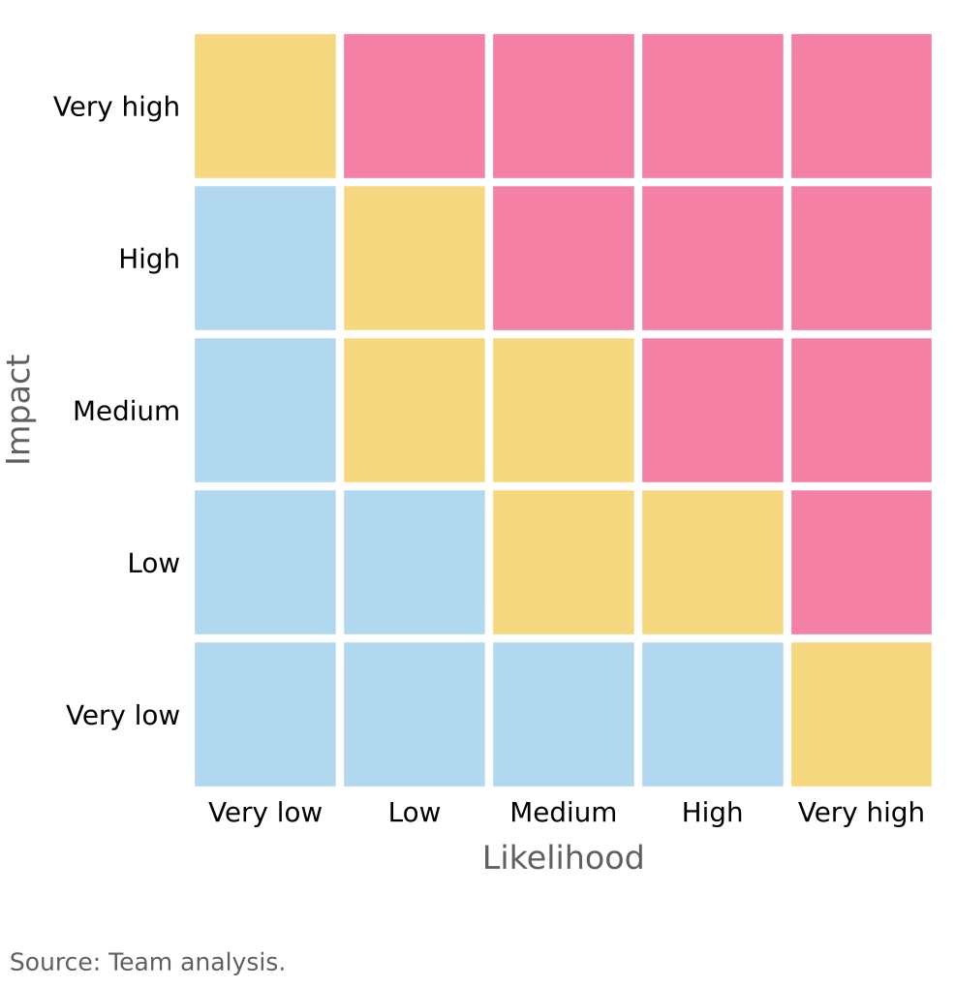  Figure 24: Operational risk tornado (CLP per share)  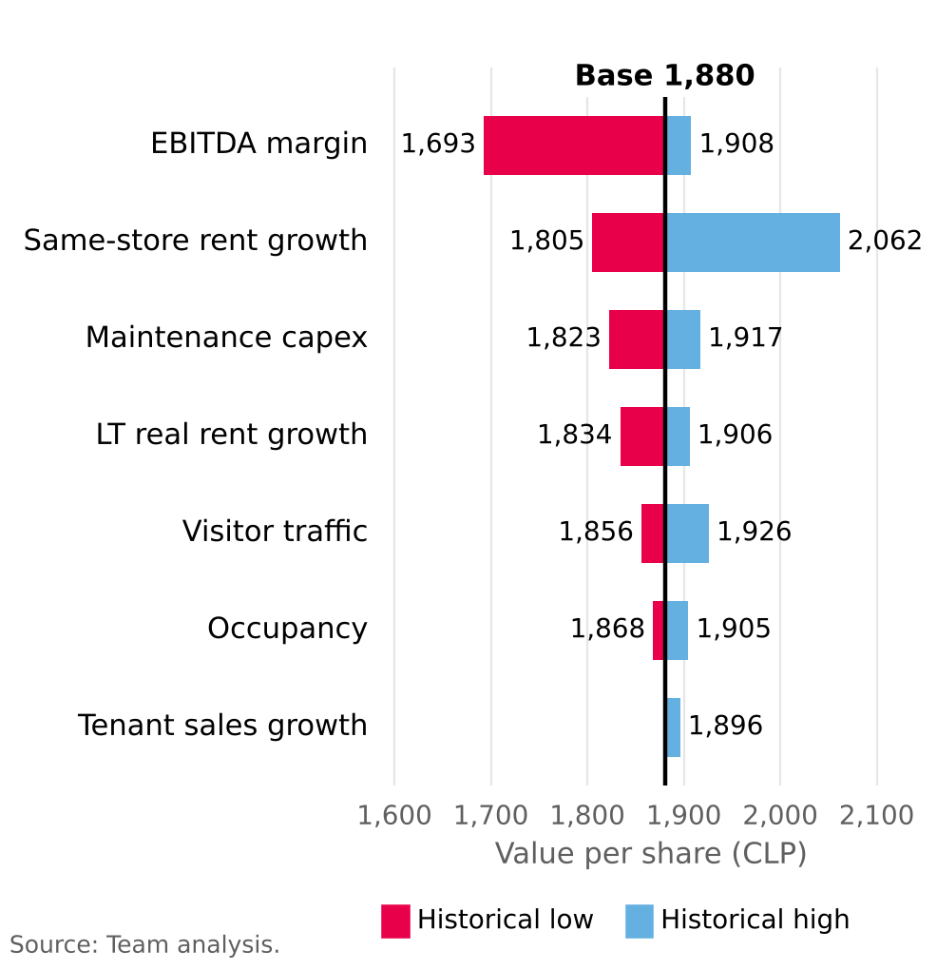  Figure 25: Value per share sensitivity: WACC vs g  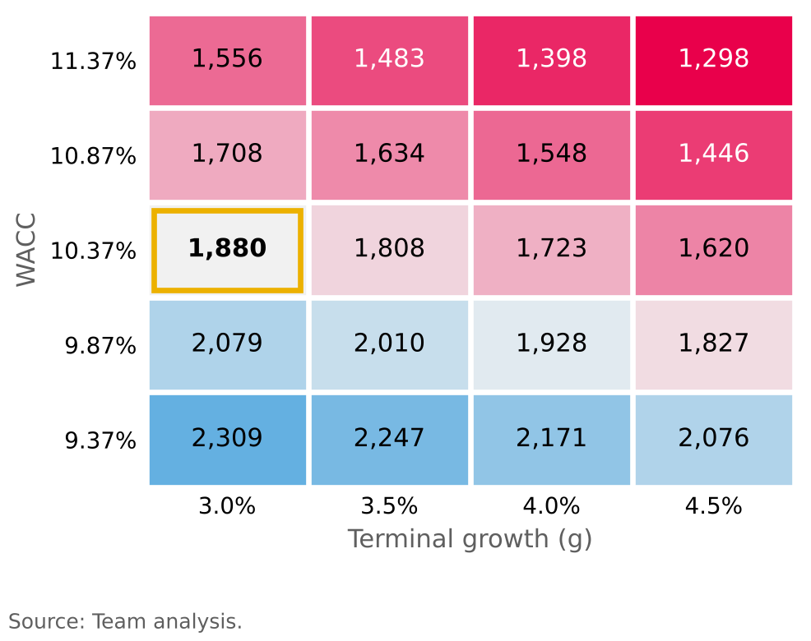  Figure 26: Earnings sensitivity to a rise in the UF  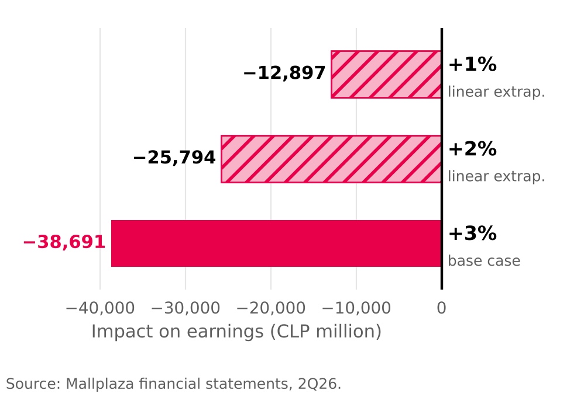

INVESTMENT SUMMARY
KEY DATA  Figure 27: [Figure title, e.g. Share price vs. IPSA]  Source: [Company filings / Team analysis]  Figure 28: [Figure title, e.g. Valuation summary]  Source: [Company filings / Team analysis] |  | RECOMMENDATION AND TARGET PRICE  [Write here: BUY / HOLD / SELL, target price, upside and time horizon.]  INVESTMENT THESIS  [Write here: the two or three main reasons behind the recommendation.]  VALUATION SUMMARY  [Write here: DCF and multiples result and how they support the target price.]  CATALYSTS AND DRIVERS  [Write here: events or trends that could unlock value and their timing.]  KEY RISKS  [Write here: the risks that could change the recommendation (see Investment Risks).]
  Recommendation | [ ]
  Target price (CLP) | [ ]
  Current price (CLP) | [ ]
  Upside / downside | [ ]
  Ticker | [ ]
  Market cap (CLP bn) | [ ]
  52-week range (CLP) | [ ]
  Dividend yield | [ ]
  [Insert chart or table]
  [Insert chart or table]

APPENDIX 1: [Title, e.g. Income statement 2022A–2031E]
[Insert table or exhibit]
Source: [Company filings / Team analysis]

APPENDIX 2: [Title, e.g. Balance sheet]
[Insert table or exhibit]
Source: [Company filings / Team analysis]

APPENDIX 3: [Title, e.g. Cash flow statement]
[Insert table or exhibit]
Source: [Company filings / Team analysis]

APPENDIX 4: [Title, e.g. Forecast assumptions]
[Insert table or exhibit]
Source: [Company filings / Team analysis]

APPENDIX 5: [Title, e.g. DCF valuation detail]
[Insert table or exhibit]
Source: [Company filings / Team analysis]

APPENDIX 6: [Title, e.g. WACC calculation]
[Insert table or exhibit]
Source: [Company filings / Team analysis]

APPENDIX 7: [Title, e.g. Comparable companies]
[Insert table or exhibit]
Source: [Company filings / Team analysis]

APPENDIX 8: [Title, e.g. DuPont and key ratios]
[Insert table or exhibit]
Source: [Company filings / Team analysis]

APPENDIX 9: [Title, e.g. Sensitivity and scenario analysis]
[Insert table or exhibit]
Source: [Company filings / Team analysis]

APPENDIX 10: [Title, e.g. ESG scorecard and risk detail]
[Insert table or exhibit]
Source: [Company filings / Team analysis]

