VALUATION
SUMMARY AND METHOD  DCF: DISCOUNT RATE  DCF: TERMINAL GROWTH |  | Figure 27: No method justifies the current price (CLP per share)  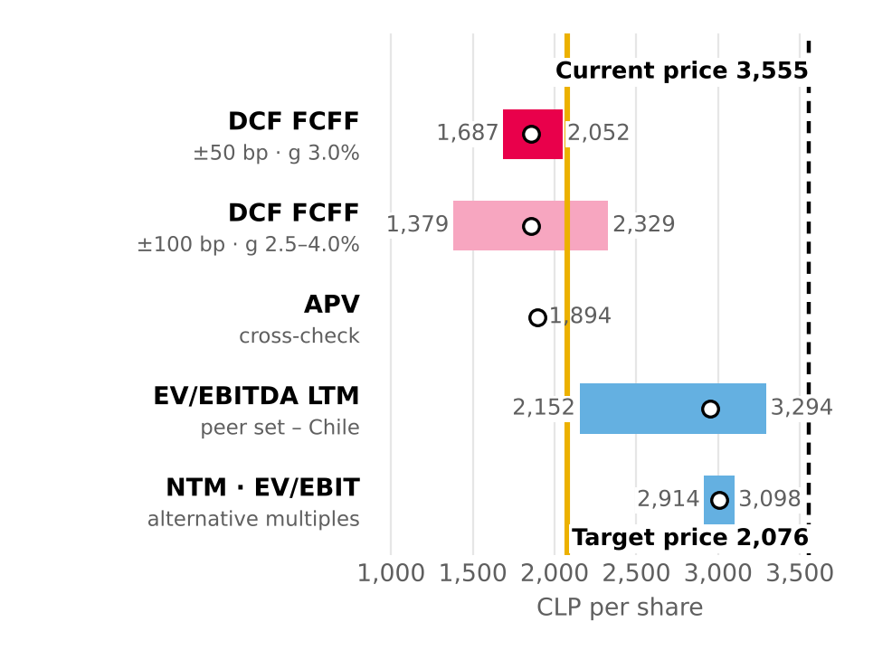  52-week range pending (Bloomberg). Source: Team analysis; Bloomberg.  Figure 28: At CLP 3,555 equity yields almost the same as debt  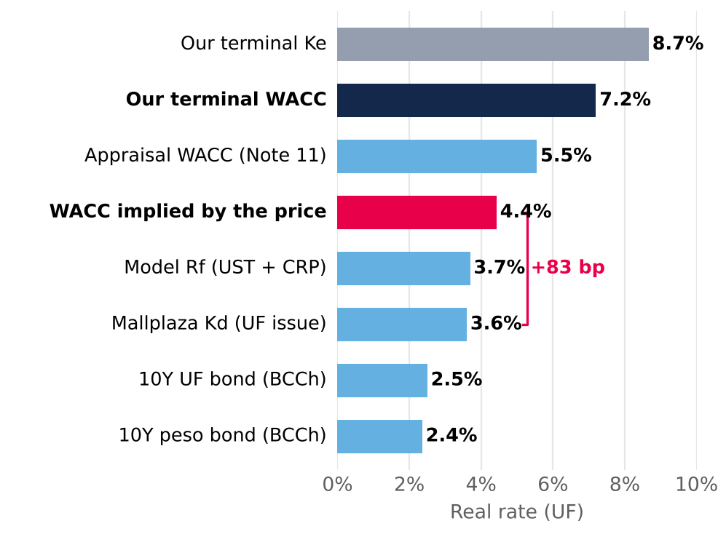  Real rates in UF. Source: Central Bank of Chile (30-Jun-26); Mallplaza; Team analysis.  Figure 29: Growing below the WACC destroys value: real g = 0%  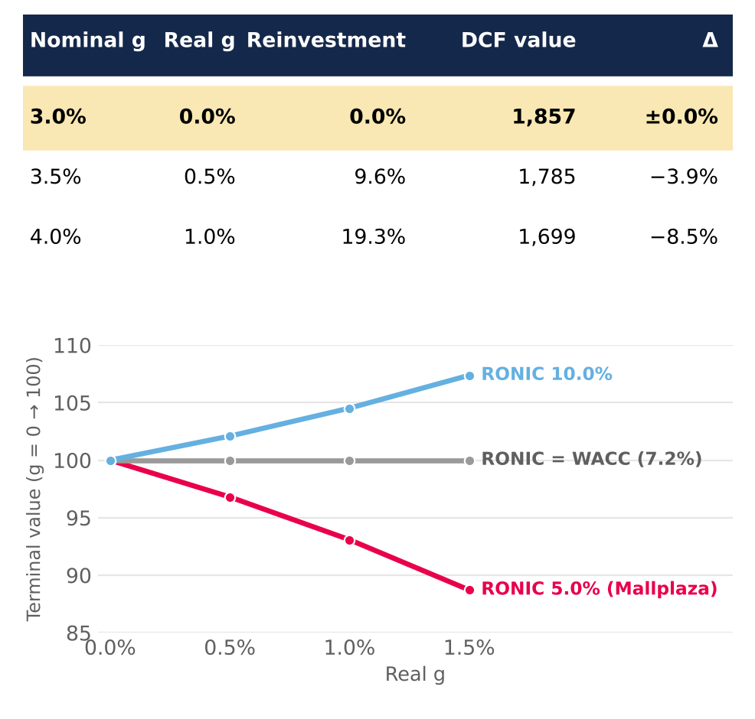  Top: DCF value by g. Bottom: relative terminal value by RONIC. Source: Team analysis.

DCF: WORKING CAPITAL  DCF VALIDATION  COMPARABLE MULTIPLES (20%)  VALUATION SENSITIVITY AND RISK |  | Figure 30: Working capital: an assumption that does not move the price (±1.2%)  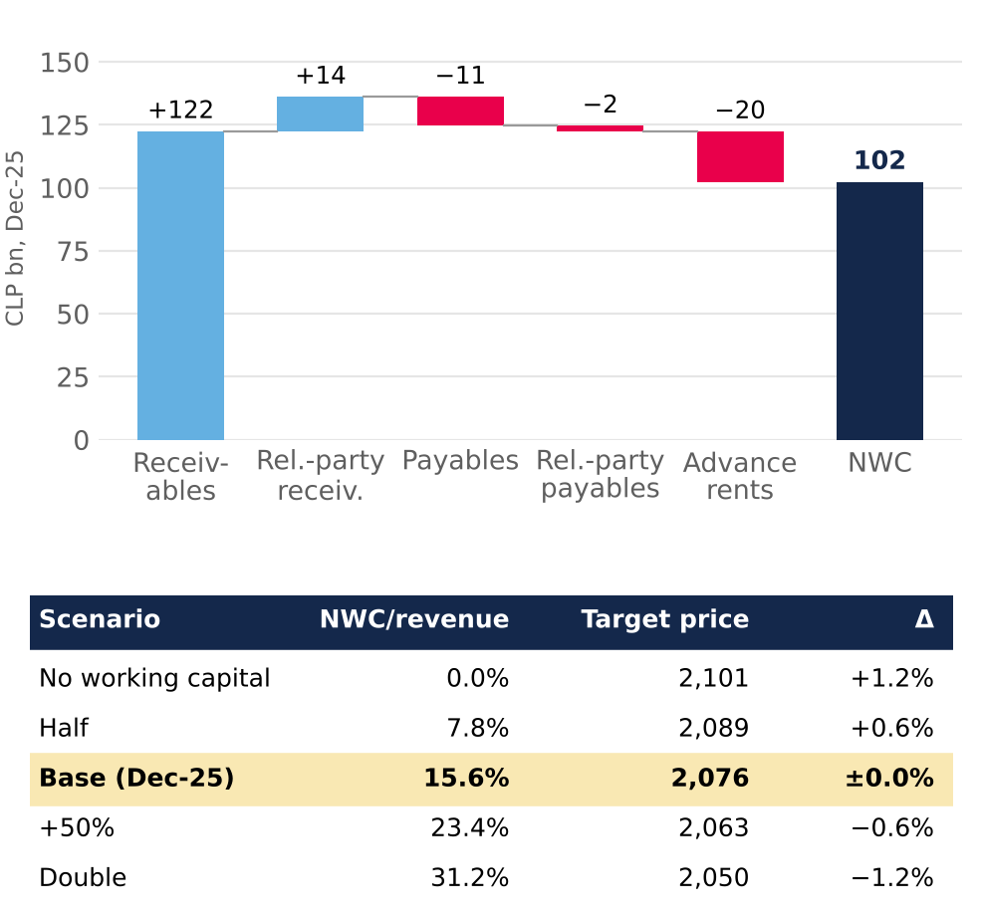  Source: Mallplaza financial statements; Team analysis.  Figure 31: The market pays 6.0%; our cash flows are worth 10.1%  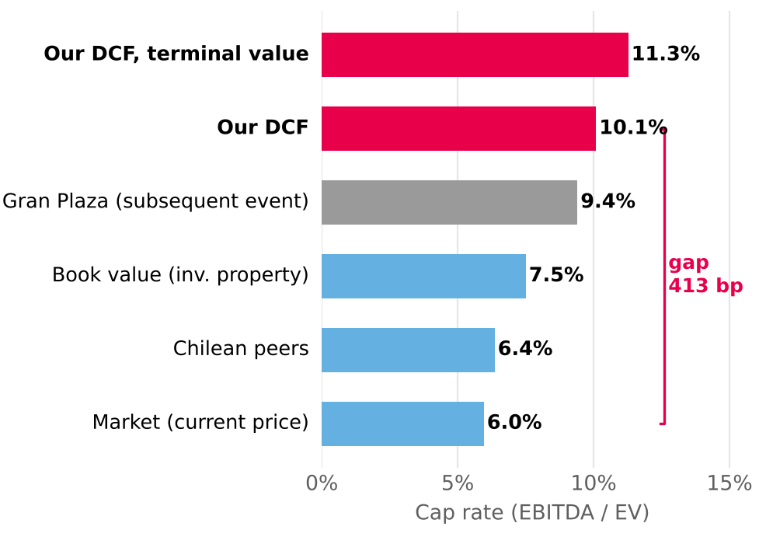  Gran Plaza: subsequent event, not in the model. Source: Mallplaza; Bloomberg; DF; Team analysis.  Figure 32: The price requires a WACC 285 bp lower  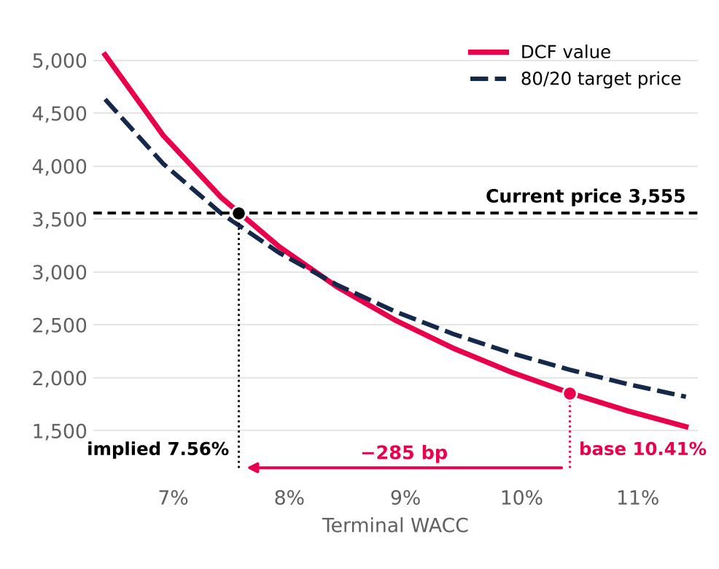  Source: Team analysis.

APPENDIX [Z]: WACC CONSTRUCTION
The WACC is computed per period: D/E converges linearly from the current structure (20.0%) to the target (28.5%, net debt/EBITDA 3.5x) in 2031. The cost of equity is built in dollars (US Treasury Rf + re-levered beta × ERP + revenue-weighted CRP) and converted to pesos with the inflation differential.
βL = βU × [1 + (1 − t) × D/E] (Hamada)
Ke USD = Rf + βL × ERP + weighted CRP
Ke CLP = (1 + Ke USD) × (1 + π Chile) / (1 + π US) − 1
Kd CLP = (1 + real Kd + spread) × (1 + π Chile) − 1
WACC = E/V × Ke CLP + D/V × Kd CLP × (1 − t)
A. MARKET AND CAPITAL STRUCTURE ASSUMPTIONS
Assumption | Value | Source
Rf: 10Y US Treasury | 4.98% | Tasa_WACC (FFCF)
Equity risk premium (ERP) | 4.14% | Damodaran
Long-term inflation, Chile | 3.00% | Central Bank target
Long-term inflation, US (10Y breakeven) | 2.24% | Bloomberg, Jun-26
Chilean tax rate | 27.00% | Income Tax Law
Real Kd: latest UF bond coupon | 3.60% | Mallplaza
Real Kd increase per turn of net debt/EBITDA | 0.25% | Team assumption
Net debt/EBITDA initial (30-Jun-26) → target | 2.36x → 3.5x | 2Q26 release; team assumption
Gross debt / market cap (current structure, CLP MM) | 1,579 / 7,906 (thousands) | Tasa_WACC (FFCF)
B. BETA: UNLEVERED PEERS
Company | Levered β | Debt (CLP MM) | Market cap (CLP MM) | Tax rate | Unlevered β
Parque Arauco | 1.250 | 1,700,507 | 3,828,031 | 27% | 0.944
Cencosud Shopping | 1.075 | 762,154 | 3,942,858 | 27% | 0.942
Allos | 1.164 | 960,191 | 2,712,166 | 34% | 0.944
Iguatemi | 0.908 | 647,397 | 1,421,560 | 34% | 0.698
IRSA | 0.427 | 625,047 | 1,218,777 | 35% | 0.320
Multiplan | 1.219 | 191,478 | 2,959,845 | 34% | 1.169
Median (6 peers included) |  |  |  |  | 0.9428
Source: Bloomberg (betas), Tasa_WACC. Costa Verde is excluded because it is not in the comparables set.
C. REVENUE-WEIGHTED COUNTRY RISK
Country | Weight (LTM revenue) | CRP (Damodaran) | Contribution
Chile | 71.8% | 1.04% | 0.75%
Peru | 17.7% | 1.55% | 0.27%
Colombia | 10.5% | 3.70% | 0.39%
Weighted CRP | 100.0% |  | 1.41%
D. WACC BY PERIOD
 | 2H26E | 2027E | 2028E | 2029E | 2030E | 2031E | Terminal
Net debt/EBITDA | 2.46x | 2.67x | 2.88x | 3.09x | 3.29x | 3.50x | 3.50x
D/E | 20.8% | 22.3% | 23.9% | 25.4% | 27.0% | 28.5% | 28.5%
D/V | 17.2% | 18.2% | 19.3% | 20.3% | 21.2% | 22.2% | 22.2%
Re-levered beta | 1.086 | 1.096 | 1.107 | 1.118 | 1.128 | 1.139 | 1.139
Ke USD | 10.88% | 10.93% | 10.97% | 11.02% | 11.06% | 11.10% | 11.10%
Nominal Ke CLP | 11.70% | 11.75% | 11.79% | 11.84% | 11.88% | 11.93% | 11.93%
Real Kd (UF) incl. spread | 3.63% | 3.68% | 3.73% | 3.78% | 3.83% | 3.89% | 3.89%
Nominal Kd CLP | 6.73% | 6.79% | 6.84% | 6.89% | 6.95% | 7.00% | 7.00%
After-tax Kd | 4.92% | 4.96% | 4.99% | 5.03% | 5.07% | 5.11% | 5.11%
Nominal WACC CLP | 10.54% | 10.51% | 10.48% | 10.46% | 10.44% | 10.41% | 10.41%
Real WACC | 7.32% | 7.29% | 7.26% | 7.24% | 7.22% | 7.20% | 7.20%
Figure Z1: Nominal WACC and D/E by period  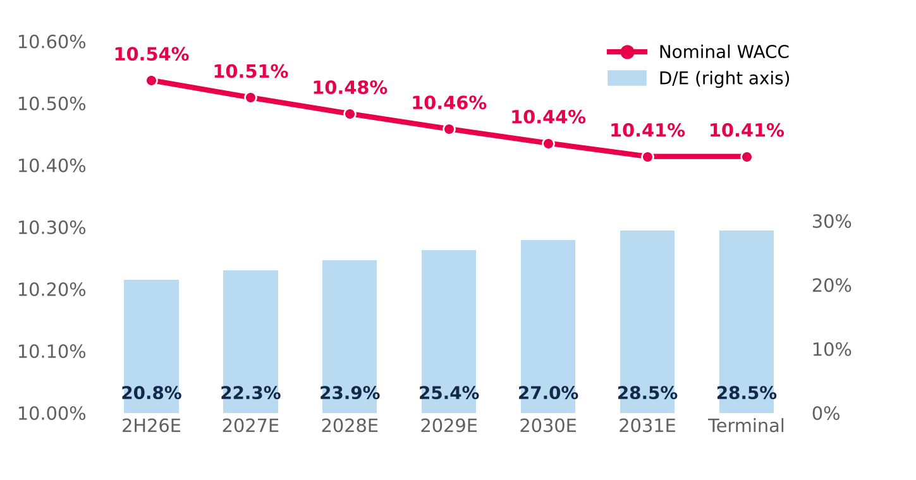  Control: the replica matches the WACC sheet of model v2 (0 bp difference in every period). Source: Damodaran; Bloomberg; Central Bank of Chile; Team analysis. |  | E. CHOICE OF THE RISK-FREE RATE  Why UST + CRP and not the peso bond: the local bond already embeds Chile risk, so adding the CRP would double-count it; also, 28% of revenue comes from Peru and Colombia, whose risk enters through the weighted CRP.  It is the more conservative choice: with the peso bond the target price rises to ~CLP 2,439, still 31% below the CLP 3,555 share price. The recommendation does not change.  Source: Central Bank of Chile, Informativo Diario 2-Jul-26; DCF v2 replica with the WACC shifted in every period.
  Alternative | Value
  Model base: US Rf + Chile CRP, in CLP | 6.80%
  10Y peso bond, Central Bank (30-Jun-26) | 5.43%
  Difference | 137 bp
  Effect on terminal WACC (difference × E/V) | −107 bp
  DCF value using the peso bond (CLP) | 2,311
  80/20 target price in that case (CLP) | 2,439

