BUSINESS DESCRIPTION
FROM ONE MALL IN LA FLORIDA TO 37 URBAN CENTERS ACROSS THE ANDEAN REGION  Mallplaza was founded in 1990 with Mallplaza Vespucio, built from the ground up in La Florida, and 35 years later it is one of the leading retail real estate players in the Andean Region, with 37 urban centers and 2.36 million m² of GLA across Chile, Peru and Colombia (Figure 1). It entered Peru in 2007 with Mallplaza Trujillo, listed on the Santiago Stock Exchange in 2018, and is currently controlled by Falabella S.A., which held a 53.1% stake as of December 2025. Its business, however, remains the same as at inception: leasing m². Rent accounts for 81.4% of last-twelve-months (LTM) revenue, with the remainder coming from parking, commercial services and advertising. Because 93% of that rent is fixed and, in Chile, indexed to the UF, revenue is highly predictable, and the company also manages to grow it in real terms. In Chile, same-store rent (SSR) rose 6.5% LTM versus CPI of 4.3%, without straining its tenants, as rent represents only 9.9% of their sales (occupancy cost), nearly unchanged from a year earlier (9.7%). Nor is this an isolated good year: between 1Q23 and 2Q26, Chile SSR averaged 6.9% against inflation of 4.8%.  A CONSTANTLY REINVENTED TENANT MIX AND HIGH MARGINS BY DESIGN  That pricing power rests on a tenant mix the company has successfully reinvented. Department stores, which occupied 26.7% of GLA in 2020, fell to 19.0% in 2Q26 after Mallplaza converted roughly 146,000 m² of large-format stores since 2019 to brands such as IKEA, H&M and Decathlon (Appendix B). Today, 32.2% of GLA is devoted to essential retail and daily-traffic services, such as supermarkets, home improvement, public services and healthcare, which drive high-frequency visits, and another 21.5% to specialty retail. No single tenant dominates revenue: the top five tenants account for 18% and related parties for 15.7%. Add to this a lean cost structure, with cost of sales at 6.2% of revenue and administrative expenses at 13.9%, which leaves an LTM EBITDA margin of 80.5%.  VALUE IS CONCENTRATED IN 10 TIER A ASSETS  The growth story is written in its best assets. Ten centers, seven in Chile, two in Colombia and one in Peru, are Tier A, and with 46.4% of GLA they generate more than 60% of EBITDA (Appendix A). Investment is directed toward them, as the expansions under construction at Trébol, Oeste, Norte, Trujillo and La Serena aim to lift Tier A assets to more than 70% of GLA. |  | Figure 1: GLA by country (2Q26) and revenue by source (LTM to Jun-2026)  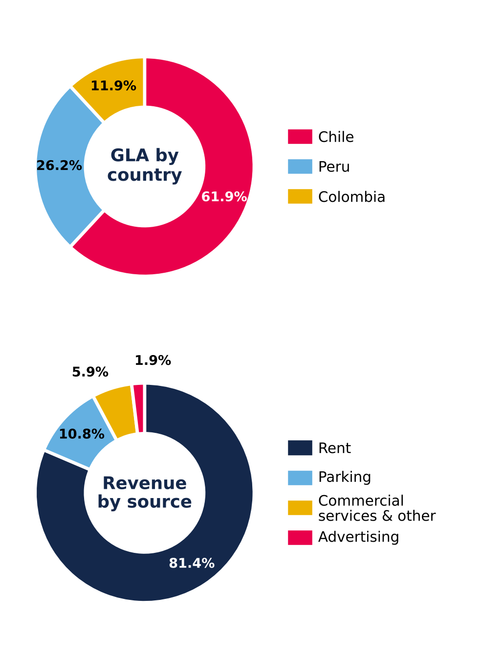  Source: Plaza S.A., Earnings Release 2Q26 (p.19) and Institutional Presentation 2Q26 (p.16).

