ENVIRONMENTAL, SOCIAL AND GOVERNANCE (ESG)
Plaza's ESG approach cuts across all of its decisions: it seeks to grow its business model within ESG parameters and contribute to sustainable development, which also opens up external financial benefits and savings in its own operations. Bloomberg rates the company at 3.39 points (Figure E1), below the global industry average (5–6 points) and its direct competitors in Chile; this contrasts with its local “green” profile, where it ranks among the region's leading real estate management (REM) companies.
Potential financial benefits: its ISO 50001-certified energy management system improves energy performance and lowers operating costs. External benefits depend on its ESG standing: in Chile, the R&D Law (CORFO) allows 35% of R&D spending to be credited against first-category income tax (up to 52.55% in total including the expense deduction); in Peru, the “Huella Perú” recognition (2 of 4 stars) eases permits and licences; and in Colombia, Law 2099 of 2021 allows investments in environmental control, conservation and improvement to be deducted from income tax.  ENVIRONMENTAL  Plaza aims for efficient, sustainable and circular operations, with three strategic focus areas: energy and water efficiency, carbon footprint and waste management. Its main goal is carbon neutrality, with a target of Net Zero direct and indirect emissions by 2035 (65.6% progress in 2025).  Sustainability indices: the company is included in the DJSI Chile and DJSI MILA, and is the only South American real estate management (REM) company in the MSCI ESG indices, rated “BBB”, which gives it ETF exposure. It is also part of the S&P Global Sustainability Yearbook, and Morningstar Sustainalytics assigns it an ESG risk score of 14.4 (low) (Figure E1).  Energy: the targets are a 22% cut in common-area energy intensity by 2035 (35.5% progress) and 100% renewable electricity by 2026 (89.3% progress) (Figure E2). In 2025 renewables supplied 90.9% of total consumption of 373,860 MWh (Figure E3), an intensity of 0.16 MWh/m² of GLA (0.14 renewable and 0.014 non-renewable).  Water: the target of a 30% cut in direct water consumption by 2025 was met at 100.9%, supported by LEED and EDGE certifications. In 2025 intensity was 0.77 m³/m² of GLA.  HCFC: it plans to phase out 100% of HCFC use by 2030 (14.9% progress), key to managing greenhouse gas emissions, an area where Bloomberg recognises Plaza as a global industry leader.  Waste: the target of recovering 60% of waste by 2025 shows 94.8% progress; it also aims to divert 75% of solid waste from landfill by 2027 and has already eliminated 97% of single-use plastics from its operations. In 2025 it recovered 46.2% of its non-hazardous waste (Figure E3).  Climate management: Plaza follows the TCFD recommendations to integrate physical and transition risks, performs environmental due diligence on asset acquisitions and runs an environmental compliance programme aligned with ISO 14001, overseen by the sustainability committee.  SOCIAL  The company approaches social matters through a model of long-term ethical relationships based on shared value creation, placing its stakeholders at the centre of its strategy, in line with ISO 45001 and ILO guidelines. In 2025 it added a programme to detect and respond to risks under its human rights policy. It engages stakeholders through community dialogues and materiality assessments (Appendix [Y]) and handles any social incident through its integrity channel. Cadem ranked it 31st of 365 “Citizen Brands” and winner of the Shopping Centres category (2026). In 2025 its programmes and projects positively reached 49,325 people (Figure E4).  Employees and suppliers: it trains its staff, offers programmes for employees nearing retirement and assesses suppliers on sustainability criteria (55.3% of local suppliers and 38.4% of foreign ones).  Tenants: it manages tenant relationships through an engagement model focused on value proposition and experience; tenant NPS rose from −8% in 2022 to 13% in 2025 (Figure E4).  Safety and privacy: every centre has emergency manuals adapted to its local context, and 52 community drills were held in 2025. It implemented ISO/IEC 27001 to protect the confidentiality, integrity and availability of information against cyber risks.  Diversity: women make up 53% of the workforce (403 people) and 42% of management positions (44), with an average gender pay gap of 28% across the region. The 2028 target is for 60% of centres to be certified as inclusive spaces, and Plaza earned the “Sello Mayor” seal, which certifies its physical and operational adaptation for older people. |  | Figure E1: Bloomberg ESG score and external ratings  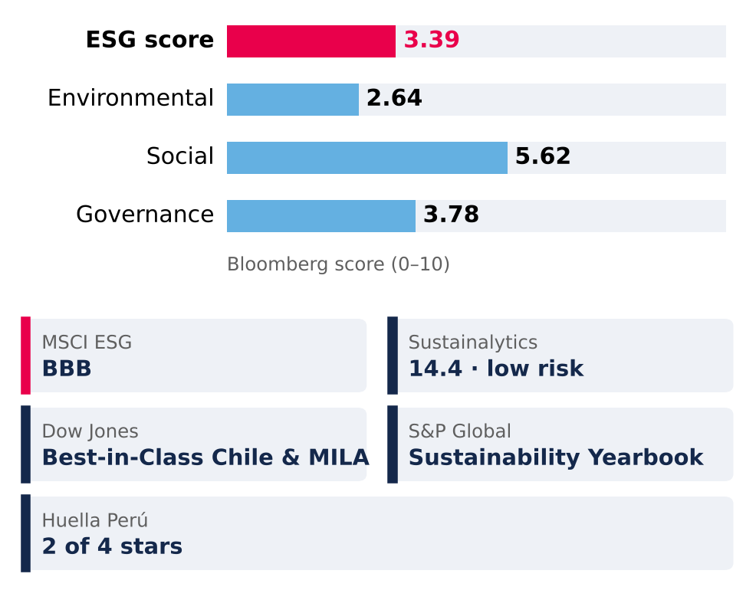  Source: Bloomberg (ESG score); MSCI, Morningstar Sustainalytics, S&P Global, Huella Perú; Mallplaza Annual Report 2025.  Figure E2: Environmental targets: progress to 2025  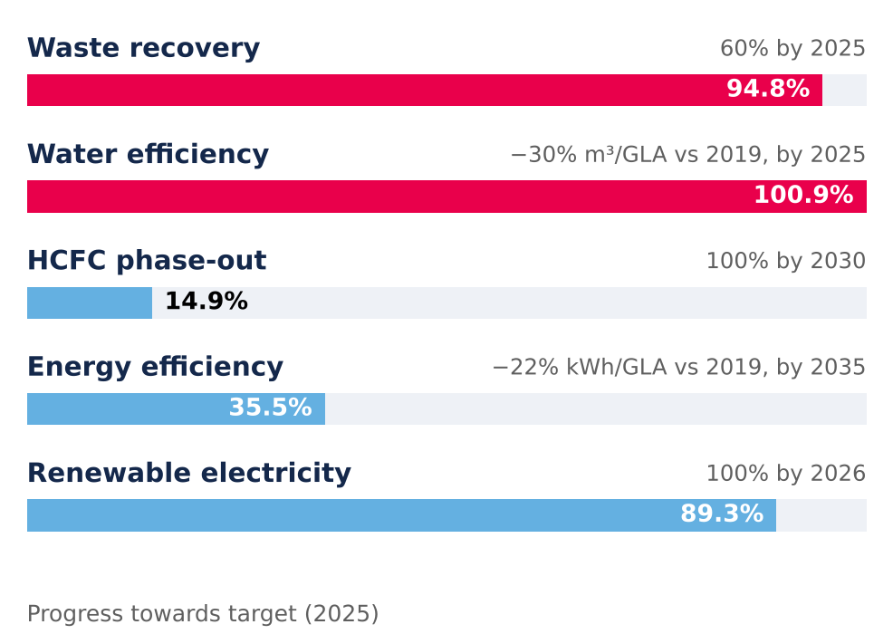  Source: Mallplaza Annual Report 2025.  Figure E3: Renewable energy and waste recovery, 2025  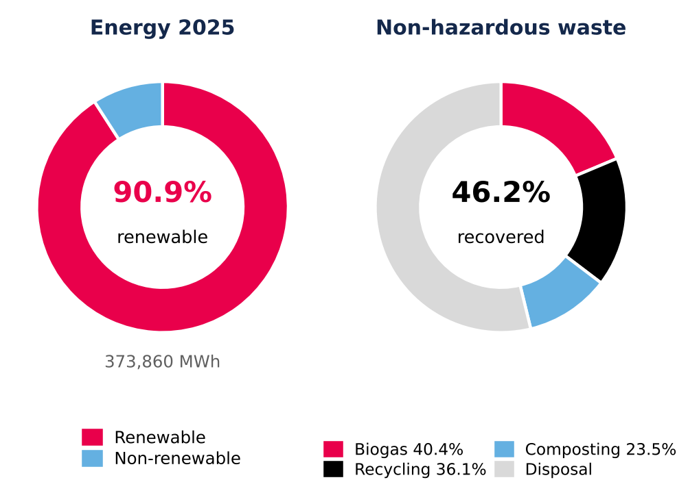  Recovery: share of non-hazardous waste; the breakdown adds up to 100% of recovered waste. Source: Mallplaza Annual Report 2025.  Figure E4: Social indicators  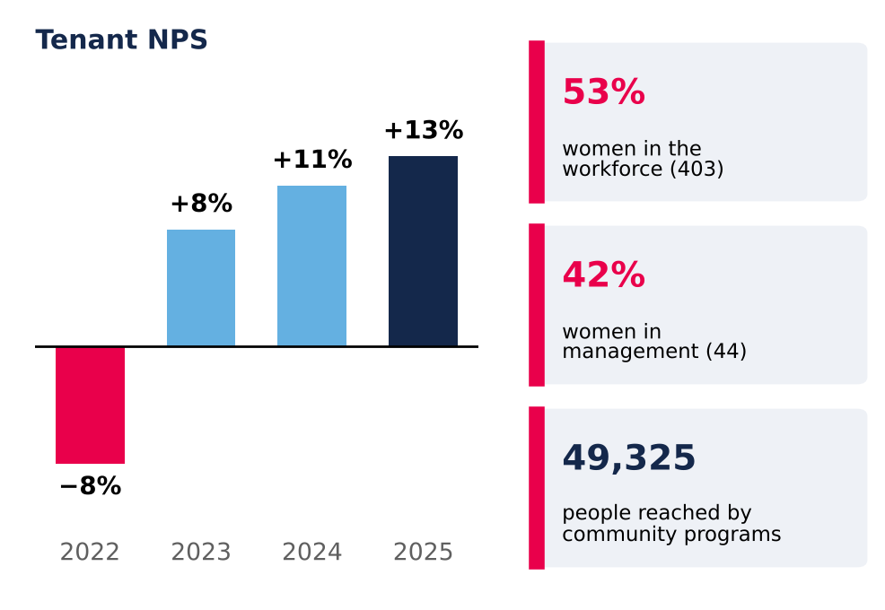  NPS = % promoters (scores 9–10) minus % detractors (0–6). Source: Mallplaza Annual Report 2025.

GOVERNANCE  Corporate governance follows the G20/OECD principles and the CMF's General Rule 461, to ensure transparent management, risk control and a solid structure to monitor the strategy and ESG commitments.  Board and committees: the 9-member Board sets Plaza's objectives, strategies and policies, but only one director is independent (Figure E5). The three-member directors' committee, chaired by the independent director, reviews related-party transactions (Law 18,046). Falabella controls 53.05% of the shares and pension funds hold 23.8% (Appendix [Y]). Low board independence is the main governance weakness (RR1, Investment Risks).  ESG incentives: ESG KPIs are measured annually and are part of the variable pay of the CEO, managers and deputy managers. Non-financial indicators weigh 61% (33.3% linked directly to ESG matters and 27.7% to other topics) and financial indicators 39% (Figure E5).  Ethics and compliance: in 2025 there were no breaches of laws and regulations and no corruption cases. There were 27 breaches of consumer rights (Law 19,496), 2 of labour rights, 1 proceeding by the Environment Superintendency and 8 complaints of workplace harassment or violence (Appendix [Y]). |  | Figure E5: ESG incentives and board composition  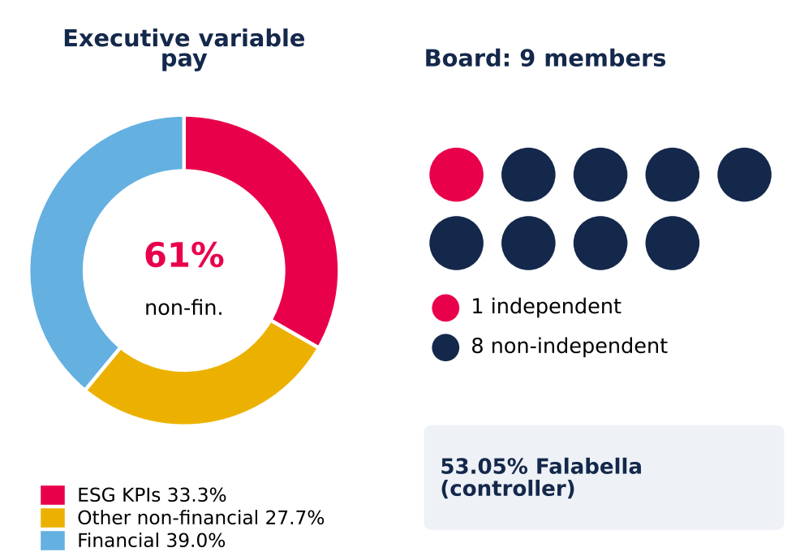  Source: Mallplaza Annual Report 2025.

APPENDIX [Y]: CORPORATE GOVERNANCE AND SUSTAINABILITY
Supporting information for the ESG section: ownership structure, Board of Directors, compliance, stakeholder engagement model, organisational culture and waste. Main source: Mallplaza Annual Report 2025.
1. OWNERSHIP STRUCTURE (31-DEC-2025)
Figure S1: Shareholding by type of shareholder
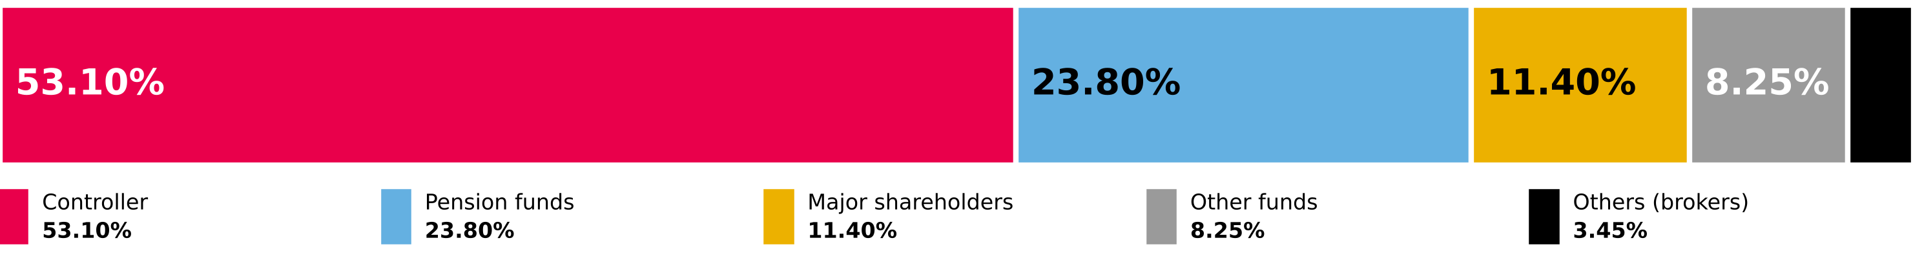
Source: Mallplaza Annual Report 2025 (NCG 461 2.3.3). No ADRs or certificates issued abroad.

Ten largest shareholders | Shares | % of shares
Desarrollos Inmobiliarios SpA (Falabella) | 1,161,849,244 | 53.05%
Inversiones Avenida Borgoño Limitada | 197,439,955 | 9.02%
Banchile Corredores de Bolsa S.A. | 59,447,149 | 2.71%
BCI Corredor de Bolsa S.A. | 53,553,765 | 2.45%
AFP Habitat S.A. Pension Fund C | 50,733,976 | 2.32%
Santiago Stock Exchange | 41,532,310 | 1.90%
AFP Provida S.A. Pension Fund C | 37,746,440 | 1.72%
Banco Santander on behalf of foreign investors | 35,594,345 | 1.63%
AFP Capital S.A. Pension Fund C | 34,539,038 | 1.58%
AFP Habitat S.A. Pension Fund B | 30,039,097 | 1.37%
2. BOARD OF DIRECTORS (ELECTED 22-APR-2025)
Figure S2: Board members (red: independent director; blue: chairman)

9 full members, no alternates; one independent director. Each director holds at most four positions in other listed companies. Tomás Müller, Manuela Sánchez and Juan Pablo Montero were directors until 22-Apr-2025. Source: Mallplaza Annual Report 2025.
3. ETHICS AND COMPLIANCE, 2025
Matter | Cases
Breaches of laws and regulations | 0
Corruption | 0
Breaches of customer rights (Consumer Protection Law 19,496) | 27
Breaches of employee rights | 2
Proceedings by the Environment Superintendency | 1
Complaints of workplace, sexual harassment and violence at work | 8
Source: Mallplaza Annual Report 2025.
4. STAKEHOLDER ENGAGEMENT MODEL
Figure S3: Implementation process of the engagement model
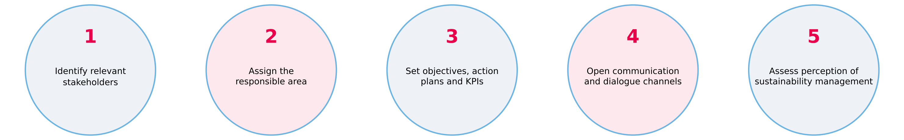
Source: Mallplaza Annual Report 2025.
5. ORGANISATIONAL CULTURE: 2025 CULTURE SURVEY
75%  Engagement  −2 pp vs 2024 · 2025 target: 80% |  | 37  eNPS  −10 vs 2024 |  | 88%  Leadership  +2 pp vs 2024 |  | 93%  Participation  +3 pp vs 2024
Leadership (88%) is the main asset to leverage the strategy. Source: Mallplaza Annual Report 2025.
6. WASTE, 2025
Figure S4: Waste generation by country  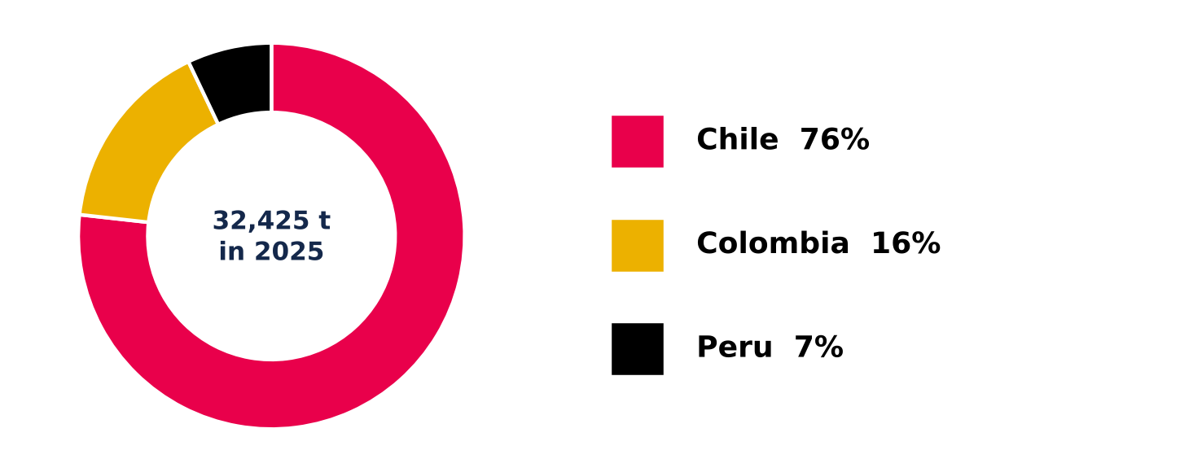  Source: Mallplaza Annual Report 2025. |  | 32,424.86 tonnes of waste across the region: 76% in Chile, 16% in Colombia and 7% in Peru.  46.2% recovered: 14,987.57 t of non-hazardous waste went to energy recovery through biogas (40.4%), recycling (36.1%) and composting (23.5%); the rest went to disposal, mainly sanitary landfills.  Hazardous waste: 9.03 t, a marginal amount given the nature of the business.

