INVESTMENT RISKS
[Summary: overall risk view for Mallplaza and the main risks to the recommendation and target price.]
RISK ASSESSMENT  [Explain how likelihood and impact were scored (1–5) in Figure 1 and which risks fall in the high-risk zone.]  OPERATIONAL RISKS  OR1: [Risk title, e.g. EBITDA margin compression.] [Describe the risk: what could happen, how likely it is, and its impact on revenue, EBITDA or value per share; reference Figures 1–4 where relevant.]  Mitigants: [How the company or the thesis offsets this risk.]  OR2: [Risk title, e.g. slowdown in same-store rent growth.] [Describe the risk: what could happen, how likely it is, and its impact on revenue, EBITDA or value per share; reference Figures 1–4 where relevant.]  Mitigants: [How the company or the thesis offsets this risk.]  OR3: [Risk title, e.g. higher maintenance capex.] [Describe the risk: what could happen, how likely it is, and its impact on revenue, EBITDA or value per share; reference Figures 1–4 where relevant.]  Mitigants: [How the company or the thesis offsets this risk.]  FINANCIAL RISKS  FR1: [Risk title, e.g. revaluation of UF-indexed debt.] [Describe the risk: what could happen, how likely it is, and its impact on revenue, EBITDA or value per share; reference Figures 1–4 where relevant.]  Mitigants: [How the company or the thesis offsets this risk.]  FR2: [Risk title, e.g. higher cost of capital.] [Describe the risk: what could happen, how likely it is, and its impact on revenue, EBITDA or value per share; reference Figures 1–4 where relevant.]  Mitigants: [How the company or the thesis offsets this risk.]  MARKET & MACROECONOMIC RISKS  MR1: [Risk title, e.g. FX exposure in Peru and Colombia.] [Describe the risk: what could happen, how likely it is, and its impact on revenue, EBITDA or value per share; reference Figures 1–4 where relevant.]  Mitigants: [How the company or the thesis offsets this risk.]  REGULATORY & ESG RISKS  RR1: [Risk title, e.g. related-party transactions.] [Describe the risk: what could happen, how likely it is, and its impact on revenue, EBITDA or value per share; reference Figures 1–4 where relevant.]  Mitigants: [How the company or the thesis offsets this risk.]  SENSITIVITY ANALYSIS  [Comment on Figures 2–4: which drivers move the value per share most, the downside versus the base case, and whether the recommendation holds.] |  | Figure 1: Risk matrix  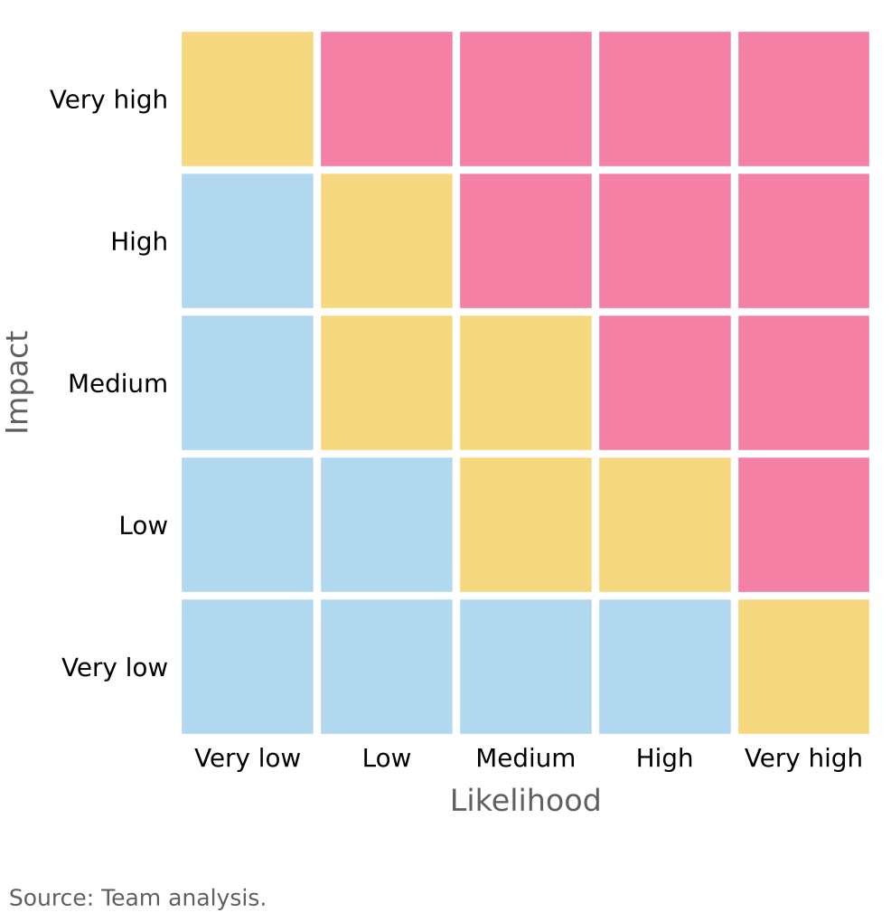  Figure 2: Operational risk tornado (CLP per share)  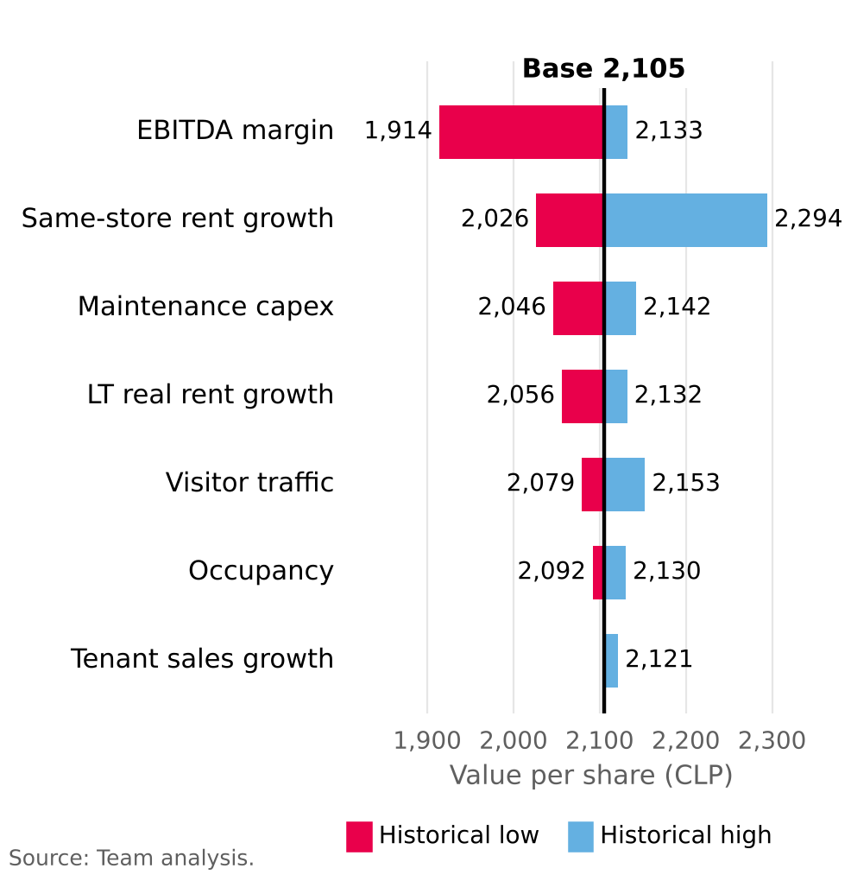  Figure 3: Value per share sensitivity: WACC vs g  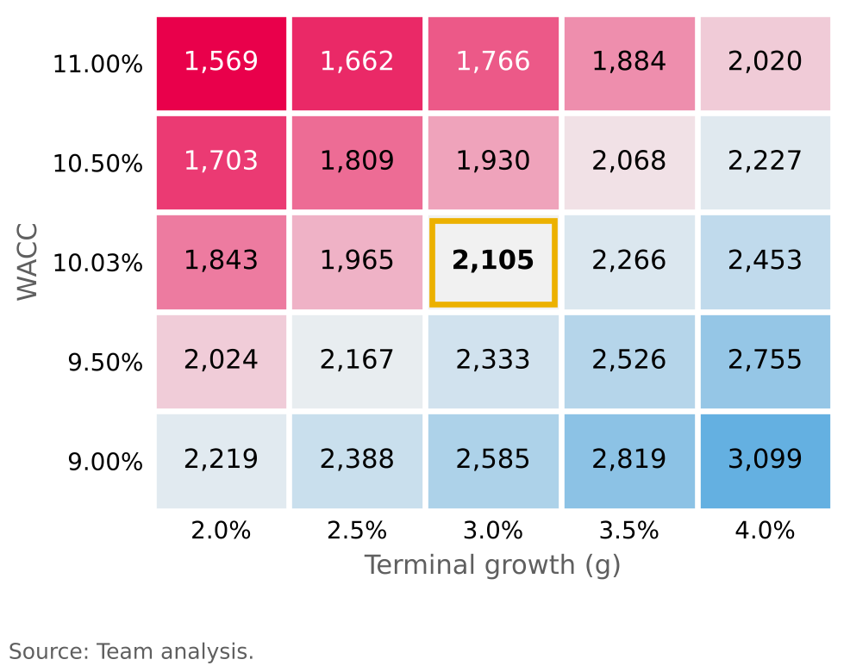  Figure 4: Earnings sensitivity to a rise in the UF  