ABSTRACT
Mallplaza (Plaza S.A.) is the largest shopping-center operator in the Andean region: 37 centers and 2.36 million m² of GLA in Chile, Peru and Colombia. 81.4% of its revenue is rent and 93% of that is fixed and UF-indexed in Chile; the last-twelve-months (LTM) EBITDA margin is 80.5%. It is a great business, but at CLP 3,555 (30-Sep-26) the market prices it as if its cash flows were nearly risk-free. Weighting a DCF (CLP 1,859) at 80% and peer multiples (CLP 2,951) at 20%, the target price is CLP 2,077 (−41.6% versus the price) and we recommend SELL. Our disagreement with the market is not about cash flows but about the discount rate: the price requires a nominal WACC of 7.60% (4.5% real), 281 bp below our nominal WACC of 10.41% (7.2% real), and a real cap rate (LTM EBITDA over enterprise value) of 6.0% against the 10.1% implied by our cash flows. Growth does not rescue the price: the real after-tax return on the cost of a new m² (RONIC) is 5.3%, below the real WACC of 7.2%. Neither the bull case, in which everything goes right (CLP 2,915), nor the appraisers' rate (CLP 2,734) reaches the share price. The main risk to the thesis is a further compression of long-term rates.
Recommendation  SELL | Target price  CLP 2,077 | Price (30-Sep-26)  CLP 3,555 | Upside / downside  −41.6%

BUSINESS DESCRIPTION
FROM ONE MALL IN LA FLORIDA TO 37 URBAN CENTERS ACROSS THE ANDEAN REGION
Figure 1: GLA by country (2Q26) and revenue by source (LTM to Jun-2026)
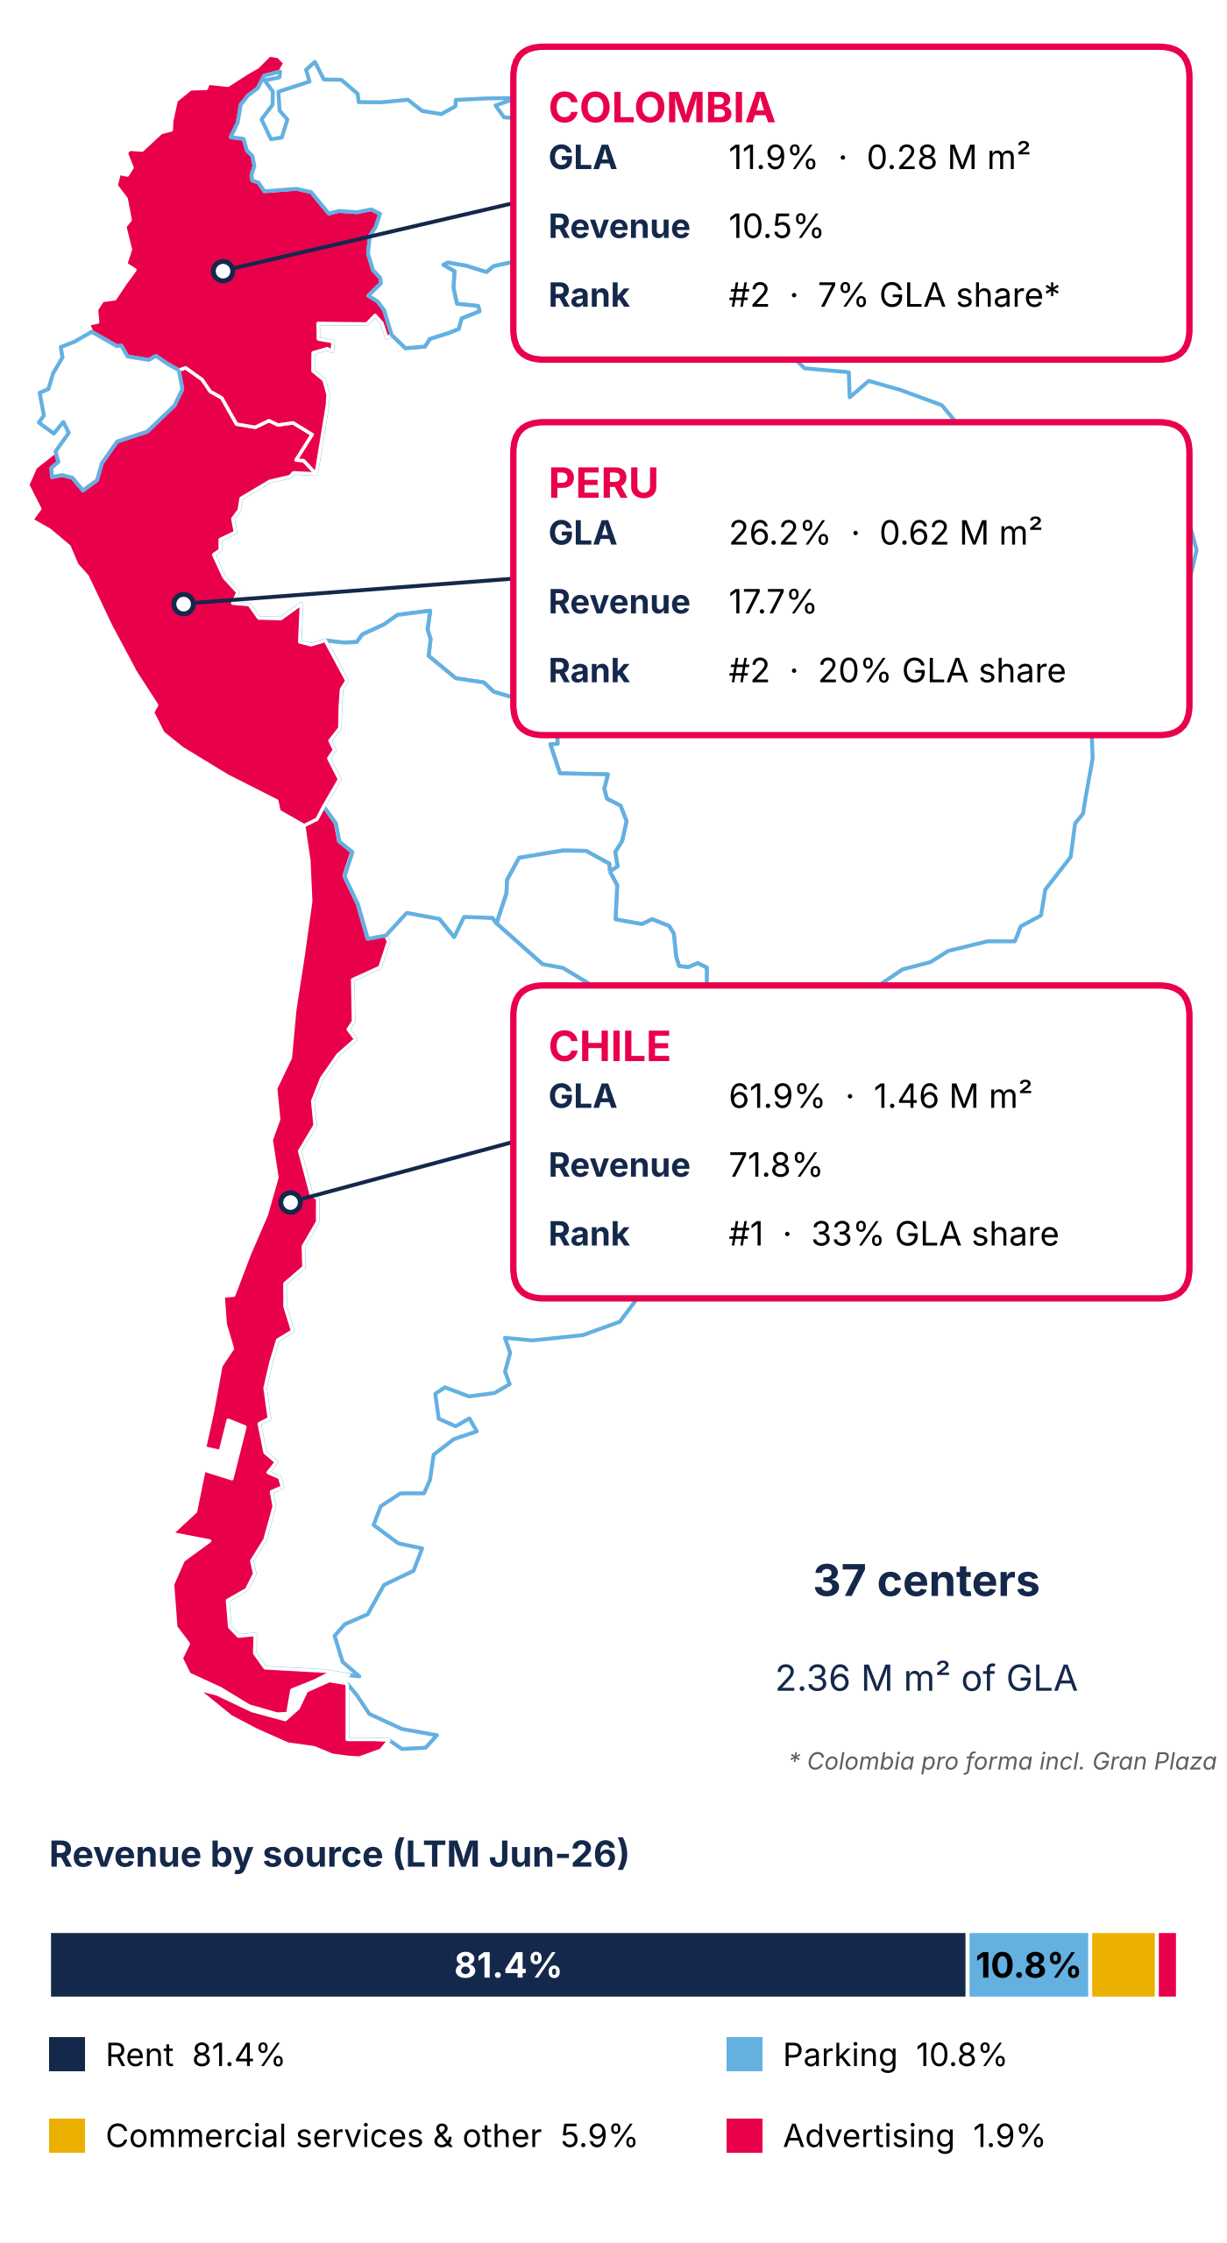
Source: Plaza S.A., Earnings Release 2Q26 (p.19) and Institutional Presentation 2Q26 (p.16).
Mallplaza was founded in 1990 with Mallplaza Vespucio, built from the ground up in La Florida, and 35 years later it is one of the leading retail real estate players in the Andean Region, with 37 urban centers and 2.36 million m² of GLA across Chile, Peru and Colombia (Figure 1). It entered Peru in 2007 with Mallplaza Trujillo, listed on the Santiago Stock Exchange in 2018, and is currently controlled by Falabella S.A., which held a 53.1% stake as of December 2025. Its business, however, remains the same as at inception: leasing m². Rent accounts for 81.4% of last-twelve-months (LTM) revenue, with the remainder coming from parking, commercial services and advertising. Because 93% of that rent is fixed and, in Chile, indexed to the UF, revenue is highly predictable, and the company also manages to grow it in real terms. In Chile, same-store rent (SSR) rose 6.5% LTM versus CPI of 4.3%, without straining its tenants, as rent represents only 9.9% of their sales (occupancy cost), nearly unchanged from a year earlier (9.7%). Nor is this an isolated good year: between 1Q23 and 2Q26, Chile SSR averaged 6.9% against inflation of 4.8%.
A CONSTANTLY REINVENTED TENANT MIX AND HIGH MARGINS BY DESIGN
That pricing power rests on a tenant mix the company has successfully reinvented. Department stores, which occupied 26.7% of GLA in 2020, fell to 19.0% in 2Q26 after Mallplaza converted roughly 146,000 m² of large-format stores since 2019 to brands such as IKEA, H&M and Decathlon (Appendix 2). Today, 32.2% of GLA is devoted to essential retail and daily-traffic services, such as supermarkets, home improvement, public services and healthcare, which drive high-frequency visits, and another 21.5% to specialty retail. No single tenant dominates revenue: the top five tenants account for 18% and related parties for 15.7%. Add to this a lean cost structure, with cost of sales at 6.2% of revenue and administrative expenses at 13.9%, which leaves an LTM EBITDA margin of 80.5%.
VALUE IS CONCENTRATED IN 10 TIER A ASSETS
The growth story is written in its best assets. Ten centers, seven in Chile, two in Colombia and one in Peru, are Tier A, and with 46.4% of GLA they generate more than 60% of EBITDA (Appendix 1). Investment is directed toward them, as the expansions under construction at Trébol, Oeste, Norte, Trujillo and La Serena aim to lift Tier A assets to more than 70% of GLA.
INDUSTRY OVERVIEW AND COMPETITIVE POSITIONING
AN INDUSTRY THAT IS CONCENTRATED IN CHILE AND FRAGMENTED IN PERU AND COLOMBIA
In retail real estate, shopping center operators do not sell products; they lease square meters of gross leasable area (GLA) to their tenants in exchange for income that is mostly fixed and indexed to each country's inflation. At Mallplaza, for example, 93% of rental income is fixed. For this reason, we measure market share by GLA rather than by sales, and on that basis Mallplaza, Cenco Malls and Parque Arauco together manage 3.4 million m² in Chile alone.
Figure 2: Market share by GLA and concentration, 2Q26
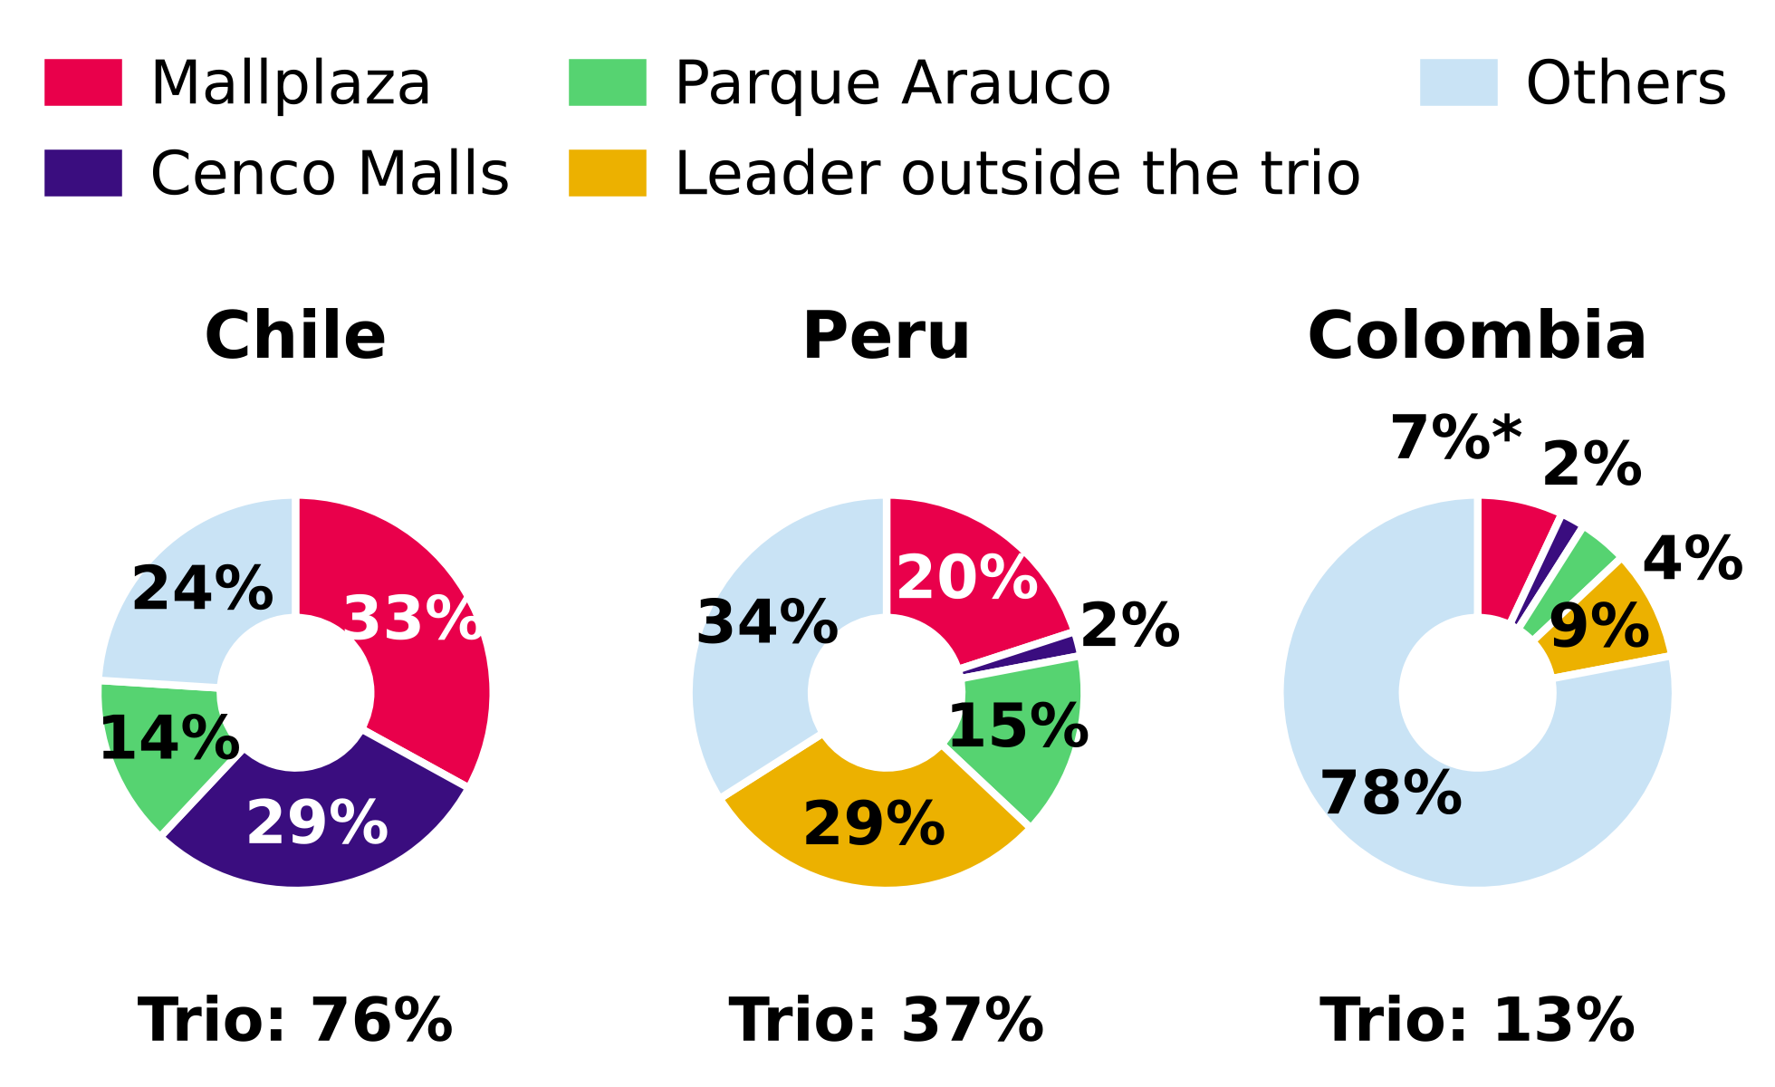
Source: Plaza S.A., Institutional Presentation 2Q26 (slide 7); team analysis. Colombia pro forma, including Gran Plaza.
Market structure, however, varies from country to country (Figure 2). In Chile, the trio holds 76% of the GLA of the main operators (CR3) and the partial HHI index reaches at least 2,126 points, typical of a highly concentrated market, with Mallplaza as leader (33%) followed by Cenco (29%) and Parque Arauco (14%). In Peru and Colombia, by contrast, the trio accounts for only 37% and 13% of GLA, respectively, leadership is held by an outside operator with 29% and 9%, respectively, and Mallplaza ranks second in both markets. In Peru that leader is Real Plaza (InRetail), with 888,000 m² and 95.5% occupancy, versus Mallplaza's 618,093 m² and 93.8%; even so, Mallplaza generates more EBITDA per m² (S/ 159 versus S/ 148 in 2Q26). Fragmentation is greatest in Colombia, where most shopping centers are strata-titled (multi-owner), which forces professional operators to grow by acquiring single-owner assets, as Mallplaza will do with Gran Plaza (179,667 m², announced acquisition).
NEW SUPPLY IN CHILE GROWS BELOW CONSUMPTION, WITH PRESSURE CONCENTRATED IN 2027
Between 2026 and 2028, the trio will add 219,900 m² of organic GLA in Chile that will compete for consumer spending, equivalent to 5.1% of the industry's GLA in Chile. We estimate that GLA (≈4.3 million m²) by dividing the trio's GLA excluding offices (3.29 million m²) by its 76% share of the main operators' GLA (assumptions in Appendix 7); measuring supply against the trio's own GLA (6.7%) would overstate the pressure, because it leaves out the other operators. The figure excludes offices and multifamily, which do not depend on consumption, as well as acquisitions, which merely change ownership (detail in Appendix 3). Over the same period, the Central Bank of Chile projects cumulative private consumption growth of 6.4% (Figure 3), so new supply is advancing below expected demand. The timing, however, is uneven: 2026 adds almost no space (+0.2%), and pressure is concentrated in 2027, when supply (+2.2%) barely exceeds consumption (+2.1%); in 2028 it falls below it again (+2.6% versus +2.7%). We only measure the trio's supply, whose pipeline is public: if other operators open additional m², the pressure would be greater.
The starting point is challenging, as in 2Q26 real tenant sales of the trio in Chile fell 2.5% YoY. Mallplaza was the only one to grow in real terms (+1.0%), versus declines at Parque Arauco (−1.7%) and Cenco (−5.9%). Even so, tenants continue to demand space, and consolidated occupancy at the three companies has ranged between 93% and 99% since 2Q22, even through the cycle of high inflation and interest rates (Appendix 4). Outside Chile, the balance is more comfortable: dated new supply is limited to Mallplaza expansions in Peru (55,800 m²), is practically nil in Colombia, and coexists with Mallplaza same-store sales (SSS) that grew 7.0% in Peru and 9.0% in Colombia in local currency.
Figure 3: New GLA supply in Chile vs expected private consumption, 2026-2028
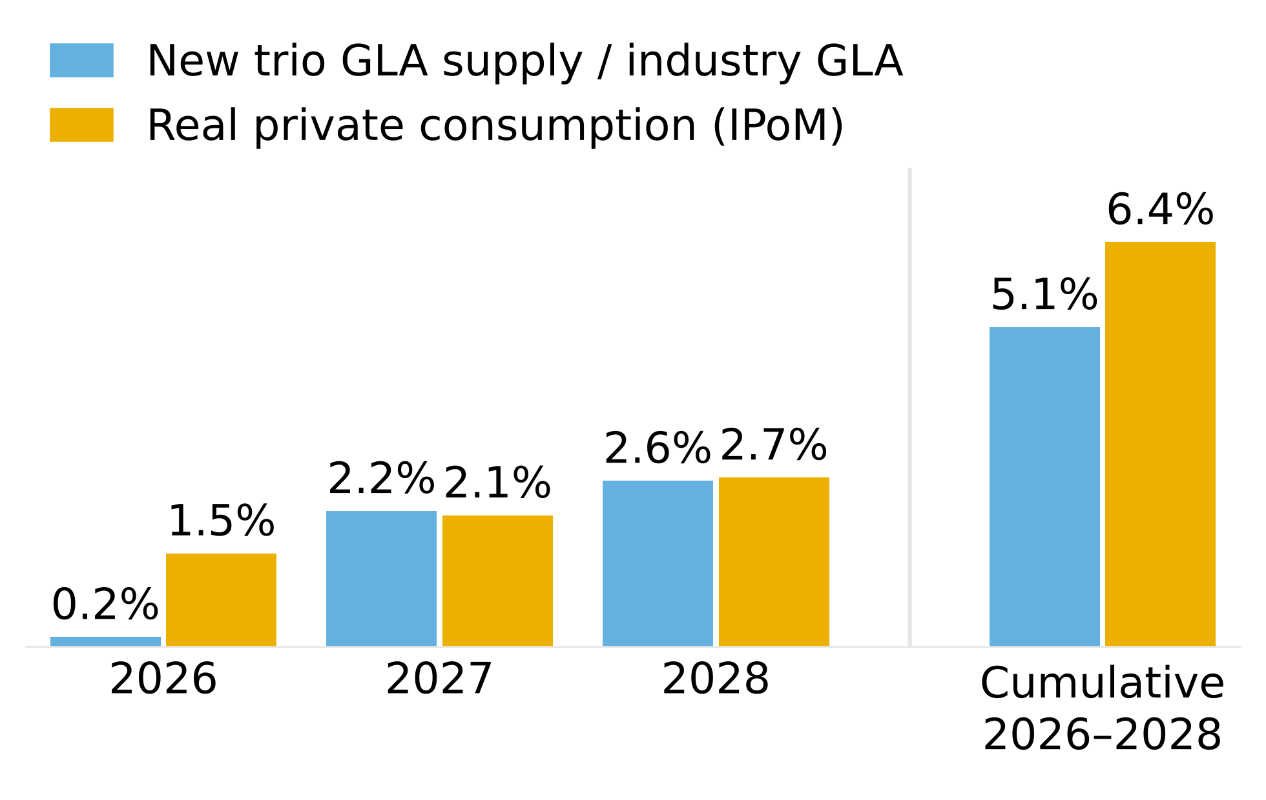
Source: 2Q26 reports of Plaza S.A., Parque Arauco and Cenco Malls; Central Bank of Chile, Monetary Policy Report (IPoM) Sep-2026 (Table II.1); team analysis. Organic consumption-dependent GLA only.
AN ATTRACTIVE INDUSTRY WHOSE ONLY INTENSE FORCE IS RIVALRY
To assess the industry's attractiveness, we analyze Porter's five forces in each country on a scale of 1 (weak) to 5 (intense) and weight them by Mallplaza's GLA in Chile (62%), Peru (26%) and Colombia (12%) (Figure 4; evidence in Appendix 6). The result describes an attractive industry, consistent with EBITDA margins ranging from 71% to 90% across the three operators, in which the only intense force is rivalry.
Rivalry (4) is played out not on price but on experience and assets. There are no signs of a price war: in 2Q26 all three operators raised same-store rents in Chile (Mallplaza +5.4%, Parque Arauco +3.8% and Cenco +0.8%, the latter hit by lower sales-linked variable rent), with 96-99% occupancy that leaves no vacant space to fill with discounts (Appendix 6, table 6.2). Mallplaza devotes more than half of its GLA to non-traditional, experience and entertainment formats, Cenco opened QINTO with 30,000 m² of food and dining at Costanera, and Parque Arauco is adding dining floors at Kennedy, while competition to acquire assets is intensifying, with Minka and Plaza Central changing hands in the past year and Parque Arauco announcing the purchase of Quilín and Chicureo. We do not assign the maximum score because the trio's shares in Chile have remained stable since 2Q22 (Appendix 5) and margins show no erosion.
Figure 4: Porter's five forces, 1-5 scale
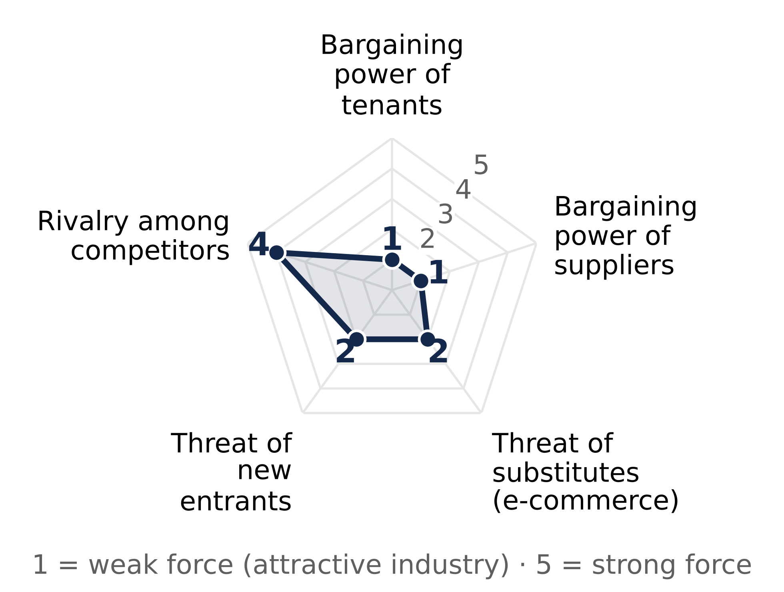
Source: team analysis based on 2Q26 reports (Appendix 6). 1 = weak force; 5 = intense force.
The threat of new entrants (2) is limited, because developing a shopping center is highly capital-intensive (Mallplaza's expansion pipeline totals USD 613 million for 170,200 m²) and much of the scarce urban land is already in the hands of incumbents, with land banks of 618,200 m² at Mallplaza and 640,136 m² at Cenco, although the barrier is lower in Peru and especially in Colombia. The bargaining power of tenants (1) is weak, given that occupancy in Chile reaches 96-99%, leases are long (Figure 6) and tenants are highly fragmented, to the point that the top five account for only 18% of Mallplaza's revenue. Evidence of this is that Mallplaza has raised its rents in Chile above inflation for more than three years (6.9% versus 4.8% on average between 1Q23 and 2Q26) without its tenants' occupancy cost spiking. The exception is department stores, which as anchors negotiate better terms, although their weight has already fallen to 19.0% of GLA. Suppliers (1) carry little weight, because common-area expenses are passed through to tenants and cost of sales represents only 6.2% of Mallplaza's revenue. Finally, substitutes (2) are a low threat: e-commerce takes sales away from tenants, but fixed rent protects the operator and foot traffic keeps growing, as shown by the 4.4% increase at Mallplaza Chile in 2Q26.
MALLPLAZA TURNS ITS SCALE INTO THE MOST PRODUCTIVE M² OF THE TRIO
Mallplaza turns its scale into the highest EBITDA per m² of the trio, at CLP 59,451 in 2Q26 versus 58,384 at Cenco and 55,363 at Parque Arauco (Figure 5). That advantage stems from high-traffic urban locations, which in Chile received 52.7 million visits in the quarter versus 32.5 million at Cenco, and from monthly sales per m² of CLP 289,788 in Chile, 5.8% higher than a year earlier. The gap with Cenco is narrow and is partly explained by Cenco having added Plaza Central in June, with just one month of EBITDA in the quarter.
Figure 6: Lease expiry profile (% of GLA) and weighted average remaining term, 2Q26
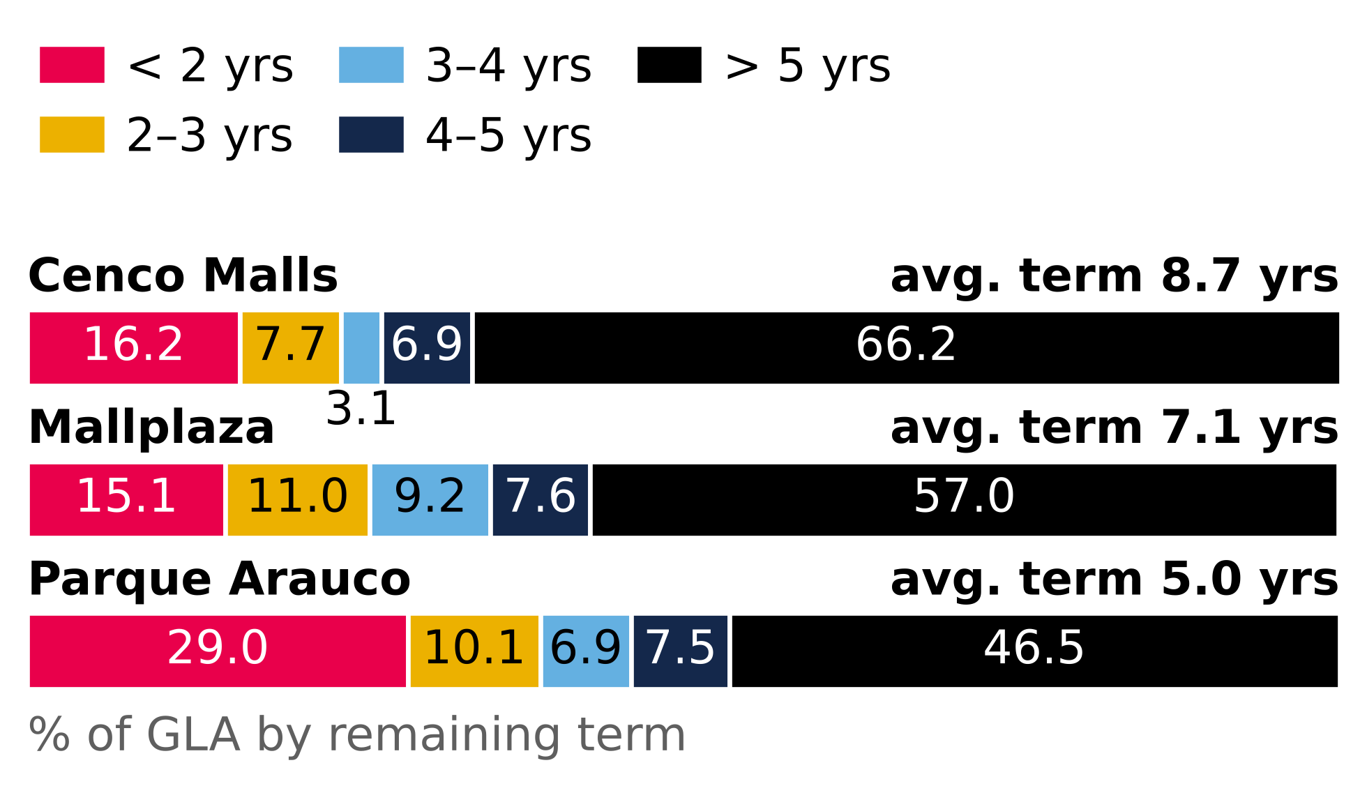
Source: Plaza S.A. Earnings Release 2Q26 (p.7); Cenco Malls Earnings Presentation 2Q26 (p.14); Parque Arauco 2Q26 Report (p.7) and Investor Presentation 2Q26 (slide 17). GLA-weighted; assumption for Mallplaza.
In terms of share, Mallplaza has ceded 1.2 pp within the trio in Chile since 2Q22, mainly because Parque Arauco added Kennedy Oriente (70,000 m²) through an acquisition while Mallplaza grew only through expansions, an organic strategy that its 114,400 m² pipeline in Chile through 2028 allows it to sustain.
LONG LEASES TO DEFEND ITS POSITION
That position is backed by long-duration leases. The weighted average remaining lease term at Mallplaza is 7.1 years and 57% of its GLA expires in more than five years (Figure 6), placing it between Cenco (8.7 years) and Parque Arauco (5.0 years) with a useful balance: it secures enough revenue to weather the supply pressure of 2027-2028 while leaving 15.1% of GLA expiring within two years to reset rents if demand allows.
In an attractive industry, but one with high rivalry and supply that will catch up with consumption in 2027, the operators with the most productive assets and the most stable leases will gain share and profitability. Mallplaza leads in scale in Chile and in productivity per m², and is the only one of the trio with growing real sales, which leaves it well positioned to defend its profitability. Its main risk is its exposure to Chile, which accounts for 62% of its GLA and where consumption currently looks weaker.
ENVIRONMENTAL, SOCIAL AND GOVERNANCE (ESG)
Figure 5: EBITDA per m² of GLA, 2Q26 quarterly (CLP)
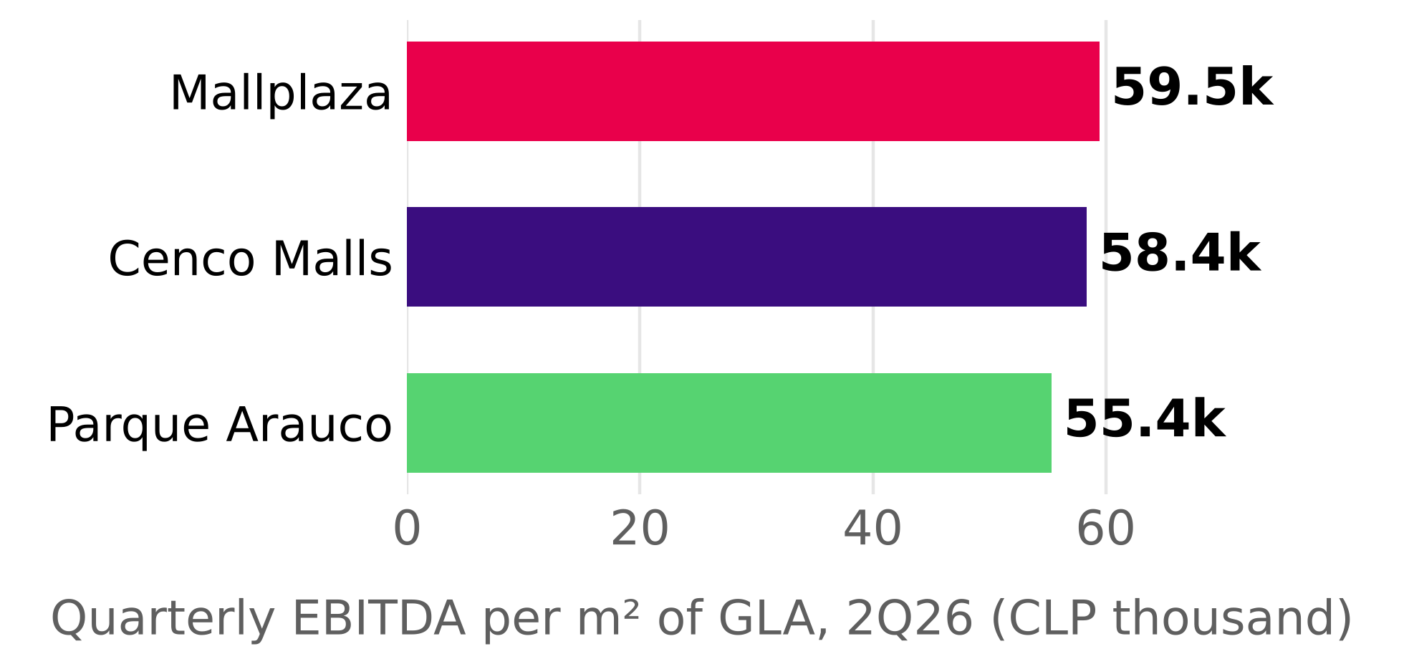
Source: Plaza S.A. Earnings Release 2Q26; Cenco Malls Earnings Presentation 2Q26; Parque Arauco 2Q26 Report; team analysis. 2Q26 EBITDA / consolidated GLA as of June 30, 2026.
PLAZA's ESG approach cuts across all of its organizational decisions, with the aim of developing its business model in accordance with ESG parameters and thereby contributing to sustainable development, which gives it the opportunity to access financial benefits both from external sources and from its own operations. Regarding compliance with these parameters, Bloomberg rates the company at 3.39 points, below the global industry average (5–6 points) and below its direct competition in Chile (Figure 7), but this is offset by the company's “green” profile at the local level, since it ranks among the leading REM (real estate) companies in the region. Potential financial benefits: As for the benefits of its own operations, the implementation of an energy management system (EnMS) certified under ISO 50001 translates into better energy performance and therefore lower operating costs. The opportunities to access local external benefits are tied to the company's ESG image: in Chile, under the R&D Law (CORFO), PLAZA can obtain up to a 55% reduction in first-category tax; Peru recognizes the company with 2 out of 4 stars in “Huella de Carbono Perú”, which strengthens its image and makes it easier to obtain permits and licenses in the country; and Colombia has Law 2099 of 2021, which allows income-tax deductions for investments in environmental control, conservation and improvement. In addition, the company holds certifications and recognitions that support its ESG image and has joined indices such as DJSI MILA (Figure 7). Figure 12 estimates (as a scenario, not as data) that operating ESG savings add about CLP 2 per share and that a 25 bp cut in the cost of debt and equity would add CLP 72, against the CLP 1,478 that separate the target price from the share price.
ENVIRONMENTAL
PLAZA's approach is to achieve efficient, sustainable and circular operational management based on continuous improvement in environmental performance, which translates into cost savings in its operations. To this end, it has set three strategic focus areas on ESG parameters: energy and water efficiency, carbon footprint, and waste management. PLAZA's main objective is to achieve carbon neutrality, targeting Net Zero in direct and indirect emissions by 2035 (65.6% success rate in 2025). Energy: PLAZA aims to reduce the energy intensity of common-area expenses by 22% by 2035 (35.5% success rate in 2025; Figure 8). The electricity efficiency target is for 100% to come from renewable energy by 2026 (89.3% success rate). In 2025, the annual ratio was 0.16 MWh/m² (Energy/GLA), of which 0.14 was renewable and 0.014 non-renewable (Figure 9). Water: It set the goal of reducing direct water consumption by 30% by 2025, which was 100.9% achieved, influenced by its LEED and EDGE certifications. In 2025, the annual ratio (average) was 0.77 m³/m² (Water/GLA) and 0.66 m³/m² monthly in December. HCFC: It set the goal of eliminating 100% of HCFC use by 2030 (14.9% success rate in 2025), which is vital for GHG emissions management, an area in which Bloomberg recognizes PLAZA as a global industry leader. Waste: PLAZA set a target of 60% recovery of the waste generated in 2025 (94.8% success rate; Figure 9 and Appendix 8, Figure 8.4), and also seeks to divert 75% of solid waste from landfills by 2027. It reports having eliminated 97% of single-use plastics from its operations. Climate management: PLAZA adopts the TCFD recommendations to integrate physical and transition risks, together with an environmental due diligence on asset acquisitions, under an environmental compliance program aligned with ISO 14001 and monitored by the sustainability committee.
Figure 7: Bloomberg ESG score and external ratings.
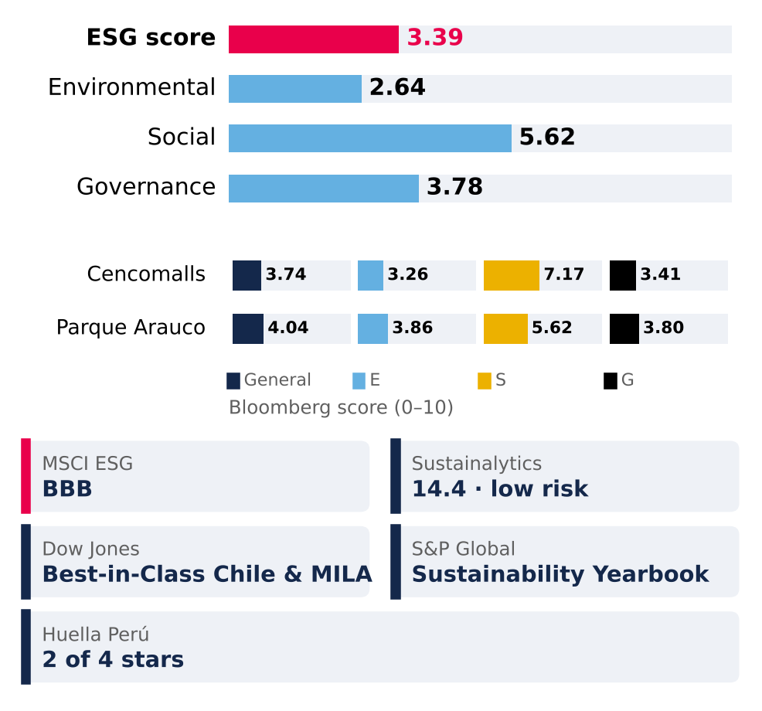
Source: Bloomberg (ESG score); MSCI, Morningstar Sustainalytics, S&P Global, Huella Perú; Mallplaza 2025 Annual Report.
SOCIAL
Figure 12: ESG savings and lower cost of capital versus the share price (scenario).
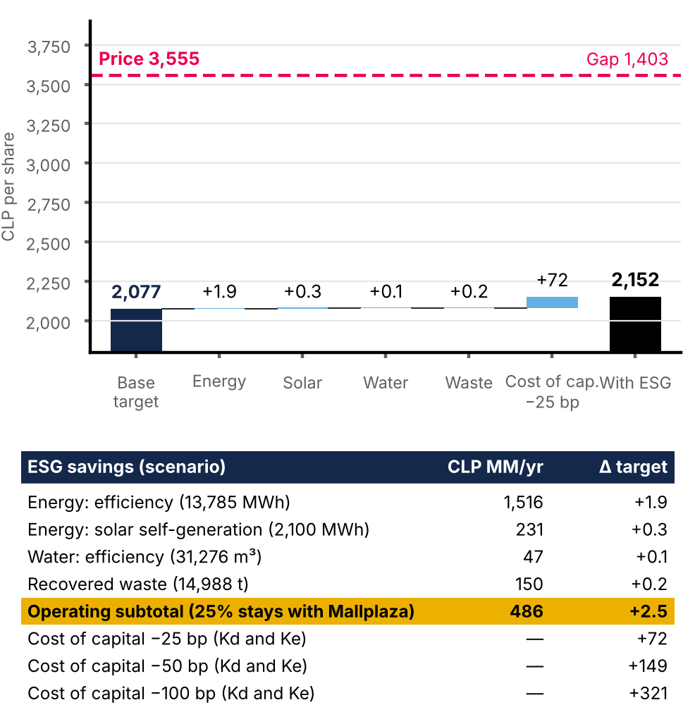
Scenario: unit prices (energy CLP 110/kWh, water CLP 1,500/m³, waste CLP 10,000/t), the 25% of savings retained by Mallplaza and the 25 bp cut in Kd and Ke are team assumptions, not data from the sources. Volumes: Mallplaza 2025 Annual Report. Source: model v3, ESG_Ahorros sheet; Team analysis.
The company approaches the social dimension through a model focused on long-term ethical relationships (Appendix 8, Figure 8.3), as a principle of shared value creation that places the people in its stakeholder groups at the center of its strategy, aligned with ISO 45001 and ILO guidelines; in 2025 it incorporated the risk detection and response program of its human rights policy. In this way, PLAZA manages its stakeholders by ensuring transparent engagement, using mechanisms such as community dialogues, materiality assessments and organizational culture surveys (Appendix 8, section 5), and remains alert to any social incident through its integrity hotline. It is also recognized by CADEM at 31st out of 385 in “Marcas Ciudadanas” (“Citizen Brands”), winning the “Shopping Centers” category (2026). Regarding employees, they receive training and even have access to specific programs for those nearing retirement; in addition, the company evaluates its suppliers using sustainability criteria (55.3% of regional suppliers and 38.4% of foreign suppliers). PLAZA manages its relationship with its customers (tenants) through a relationship model focused on value proposition and experience, measuring their satisfaction through NPS, which rose to 13% in 2025 (Figure 10). To manage emergencies, each center has emergency manuals adapted to local geographic contexts and conducts drills to prevent incidents and educate the community (52 drills were conducted in 2025); regarding privacy, PLAZA implemented ISO/IEC 27001, ensuring the confidentiality, integrity and availability of information against cyber risks.
In terms of diversity, women represent 53.2% of the total workforce and hold 42% of management positions (Figure 10), a point in the company's favor in terms of workforce balance, but there is a gender pay gap averaging 28% at the regional level, which undermines that balance; in addition, there is only one woman on the Board, out of 9 directors. The target for 2028 is for 60% of the properties to be certified as inclusive spaces, and PLAZA obtained the “Sello Mayor” (“Senior Seal”) at one of its urban centers, the first in Chile to obtain it, a distinction that certifies physical and operational adaptation for older adults. These certifications matter to the community, and as PLAZA expands it is important that it builds to the parameters the certification requires, avoiding additional costs of retrofitting those facilities in the future, and begins the transition of its existing centers to these conditions.
GOVERNANCE
Figure 8: Environmental targets: progress to 2025.
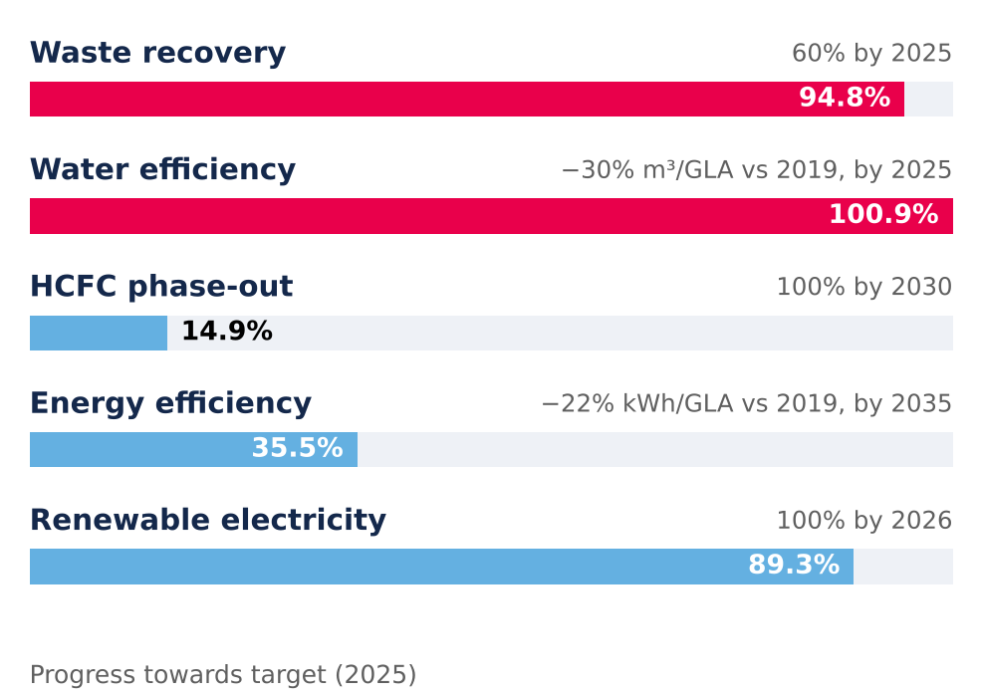
Source: Mallplaza 2025 Annual Report.
Corporate governance is guided by the G20 and OECD principles, aligned with the CMF's NCG 461; all of this seeks transparent management with risk control and a solid structure to monitor the corporate strategy and ESG commitments. Structure of the board of directors and committees: The Board is composed of 9 members, only one of whom is classified as independent, below 50%, which creates agency risks (Figure 11 and Appendix 8, Figure 8.2) and is the only unfavorable factor in the ESG risk matrix (Appendix 8, Figure 8.5). This body is responsible for defining PLAZA's objectives, strategies and policies, while the directors' committee (composed of 3 members) reviews the balance sheets and financial statements, seeking to mitigate agency risks. Together, both bodies oversee the risk management led by the executive team committee and the CEO. In the second half of 2025, CEO Fernando de Peña Iver submitted his resignation, effective at year-end, and Pablo Pulido Sierra took over the position in 2026. Executive compensation: 33.3% of executives' variable pay depends on ESG KPIs, and in total 61% is tied to non-financial metrics (Figure 11), which aligns management's incentives with PLAZA's ESG goals. Shareholders: PLAZA has a concentrated control model, as it is controlled by Falabella S.A. through its subsidiary Desarrollos Inmobiliarios SpA (53.10% of the shares; Appendix 8, Figure 8.1); minority shareholders holding 1% are entitled to propose director candidates, and the shareholders are the highest body, responsible for appointing the Board and external auditors and approving dividend policies. Ethics, audits and controls: The ethical framework is supported by the integrity code and the crime prevention model, which together provide a guide for the organization's conduct. In addition, PLAZA operates the Autocompliance platform to record meetings with public officials and manage gifts and invitations, along with a confidential integrity hotline for reporting irregularities without risk to the whistleblower; in 2025 the company reported regional non-compliance cases and complaints related to workers and customers, but none concerning corruption or conduct that undermines market development (Appendix 8, section 3). Under the supervision of the directors' committee a control model is in place, with an internal audit reported monthly to the committee that monitors corrective actions; in parallel, the committee must appoint external auditors and credit rating agencies to analyze the company, as well as have the financial statements audited by independent auditors.
FINANCIAL ANALYSIS
Mallplaza's rental engine grows at roughly 3% in real terms with an 80% EBITDA margin and cash-flow leverage below 2.5x; headline profit, growth and leverage all overstate that engine and must be normalized before forecasting.
Figure 13: ROE on distributable profit of 8–10% (not the shareholder's return); reported ROE follows the appraisal
CLP bn | ’22 A | ’23 A | ’24 A | ’25 A | ’26 E | ’27 E | ’28 E | ’29 E | ’30 E | ’31 E
Revenue | 371 | 420 | 495 | 654 | 704 | 767 | 827 | 887 | 936 | 982
EBITDA margin % | 76.2 | 76.7 | 77.0 | 80.5 | 79.7 | 79.7 | 79.7 | 79.8 | 79.8 | 79.8
FFO margin % | 59.0 | 61.3 | 61.3 | 62.0 | 60.9 | 60.0 | 57.7 | 55.4 | 52.7 | 52.2
Net income, reported | 158 | 350 | 336 | 1,431 | 639 | 591 | 614 | 634 | 637 | 660
Distributable profit | 96 | 198 | 238 | 369 | 380 | 428 | 438 | 446 | 441 | 454
Net margin, normalized % | 25.8 | 47.0 | 48.2 | 56.5 | 54.0 | 55.7 | 53.0 | 50.3 | 47.2 | 46.3
Asset turnover (x) | .086 | .090 | .092 | .097 | .089 | .090 | .091 | .093 | .094 | .095
Assets / equity (x) | 1.94 | 1.91 | 1.86 | 1.77 | 1.69 | 1.70 | 1.73 | 1.78 | 1.84 | 1.89
ROE, reported % | 7.1 | 14.4 | 11.7 | 37.5 | 13.7 | 11.8 | 11.7 | 11.8 | 11.8 | 12.0
ROE, normalized % | 4.3 | 8.1 | 8.3 | 9.7 | 8.1 | 8.5 | 8.4 | 8.3 | 8.1 | 8.3
ROA, normalized % | 2.2 | 4.2 | 4.5 | 5.5 | 4.8 | 5.0 | 4.8 | 4.7 | 4.4 | 4.4
Normalized = distributable profit (2022A team proxy; 2022 UF indexation inflated by ~13% inflation). Average balances; series starts in 2022 (IAS 40 fair value applied retroactively from 1 Jan 2022). 2026E–2031E: valuation base case; balance sheet rolled forward from Dec-25 (equity + reported profit − ordinary and additional distributions; property revalued at 3% inflation, 27% deferred tax; net debt rising to 3.5x EBITDA by 2031E). Source: Plaza S.A. financial statements (CMF), Note 20e; 2Q26 results release (FFO); Team analysis.

Reported earnings track the appraiser; FFO tracks the business
Under IAS 40, revaluations of investment property run through the income statement. In 2025 a CLP 1,447bn fair-value gain, 27% of opening property value against about 2% a year at Parque Arauco and Cencosud Shopping, lifted attributable net income to CLP 1,431bn (2.2x revenue) and reported ROE to 37.5% (Figure 13). About two-thirds of Chile's 29% uplift came from a lower appraisal discount rate (6.62% to 5.64% real, Note 11), not from higher NOI (Appendix 11C).
Excluding fair-value gains net of deferred tax, audited distributable profit was CLP 369bn and ROE 9.7%; with the same adjustment we apply to peers it would be 10.0%, the highest of the three (Appendix 14). FFO, which we rebuild from the statements to within 0.02% of the reported CLP 405bn (Figure 14), held a 59–62% margin over 2022–2025 while net income swung more than fourfold. FFO excludes the UF indexation of debt (CLP 44bn, 11% of FFO); distributable profit includes it and is our conservative earnings anchor.
Figure 9: Renewable energy and waste recovery, 2025.
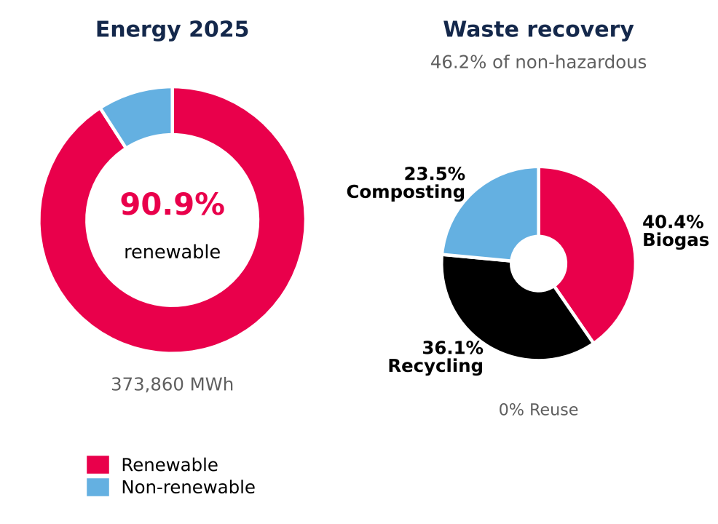
Recovery: percentage of non-hazardous waste; the breakdown adds up to 100% of recovered waste. Source: Mallplaza 2025 Annual Report.
Broken down, 2025 normalized ROE (9.7%) is a 56.5% normalized net margin times an asset turnover of 0.097x and 1.77x accounting leverage. It is not the shareholder's return: the denominator is equity at appraised value, and each revaluation raises its book value without generating cash flow, because it is a non-cash fair-value change that does not enter FFO or dividends. We therefore forecast normalized ROE of 8–9%, rising only with leverage.
Two-thirds of 2025 growth was bought; organic real growth is about 3%
Revenue rose 76% between 2022 and 2025, but 21.8pp of 2025's 32.2% came from perimeter: the Peruvian portfolio bought from Falabella, consolidated from 4 December 2024 (Appendix 11C). Ex-Peru, revenue grew 10.7% in 2025 and 7.1% in 1H26.
Once currency and inflation are removed, the 7.4% growth of 1H26 falls to ~3.0% real (Figure 15): Chile 2.8% (UF +3.1%), Peru 4.5% (occupancy 93.8%) and Colombia ~1% net of the 7.5% COP appreciation and 6.1% inflation.
Figure 10: Social indicators.
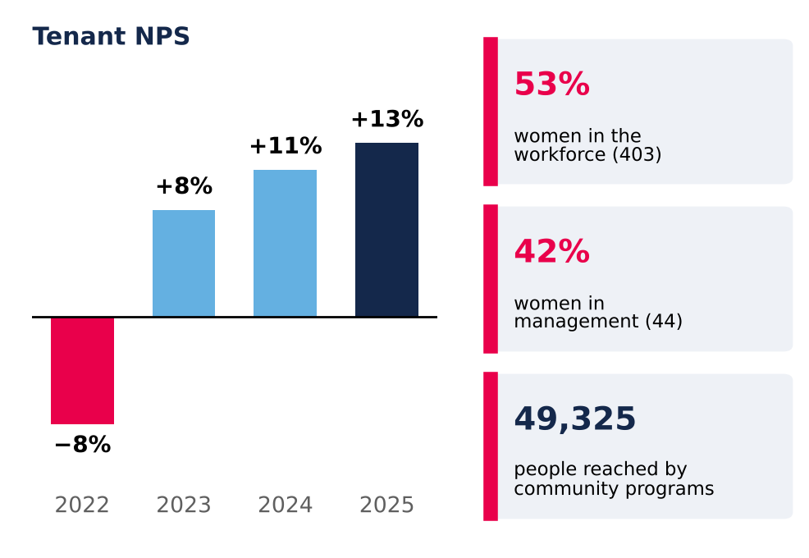
NPS = % of promoters (scores 9–10) minus % of detractors (0–6). Source: Mallplaza 2025 Annual Report.
In our reading, growth depends more on contracts than on sales: variable rent is 5.1% of 1H26 revenue and fell 1.1% while tenant sales rose 6.7%, because minimum rents (+5.5%) are outpacing sales (+3.7%). It is not a bond: 15.1% of GLA expires within two years and tenant solvency matters, and real growth converges on the 0.4–0.9% of the appraisal.
Margin gains came from mix and cost recovery; further room looks limited
EBITDA margin rose from 76.2% in 2022 to 80.5% in 2025 for two reasons. Peru consolidates at an 83% segment margin, against 80% in Chile and 73% in Colombia. And Chile's margin gained 2.4pp on a higher recovery of common charges, presented net of cost (Note 2.20): real, but dependent on occupancy and tenant negotiations, so we do not extrapolate it.
Operating costs (cost of sales plus administration) were 20.1% of revenue in 2025 and include D&A (0.55%): 20.1% − 0.55% = 19.5% = 1 − EBITDA margin (Appendix 11). If they were fixed, a 1% fall in revenue would cut EBITDA by 1.24% (1.1% if half were variable). In 1H26 EBITDA grew 7.4%, in line with revenue, and margin held at 79.7%. Administrative expense rose 18.1% on payroll (+18.9%: CEO transition and a full year of Peru), bad debts normalizing from a 2025 base flattered by recoveries, and a one-off Colombian wealth tax of CLP 1.7bn. Excluding the last two, 1H26 margin would be 80.4%.
Cash covers the dividend 2.6x before debt and 1.8x after repaying it
Operating cash flow rose from CLP 301bn in 2024 to CLP 441bn in 2025. Cash tax was only 15% of operating profit, sheltered by tax goodwill and loss carry-forwards (Note 13), and will rise toward the 27% statutory rate. After capex and net interest, free cash flow before debt was CLP 280bn, covering dividends 2.6x (Figure 16); 1.8x after repaying net debt (Appendix 10D).
Figure 11: ESG incentives and Board composition.
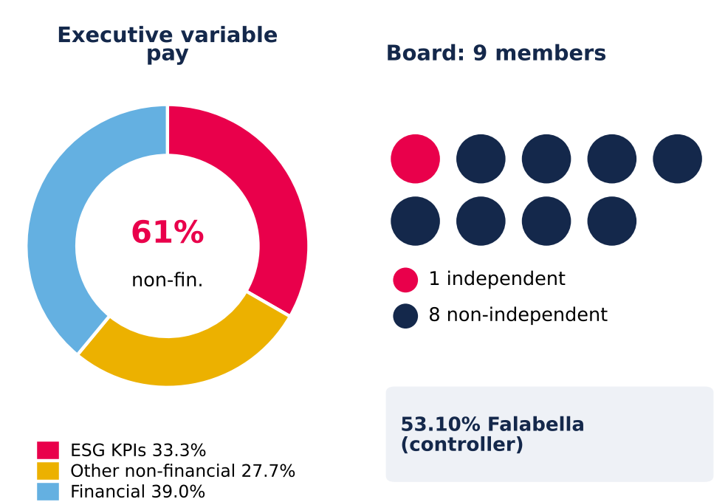
Source: Mallplaza 2025 Annual Report.
The CLP 71.9bn (+38.6%) rise in 1H26 operating cash flow comes 78% from higher collections (partly December balances: receivable days from 66 to 50) and 15% from lower taxes paid; we do not extrapolate it.
The dividend policy pays out 40% of distributable profit with a one-year lag and the covenant (net debt/equity ≤ 2.0x; 0.26x at June) does not constrain it: retained cash was CLP 171.6bn in 2025. In the base case, FFO rises from CLP 428.5bn in 2026E to 512.6bn in 2031E and ordinary dividends from CLP 147.7bn to 176.5bn; the remaining cash, together with new debt, funds capex and the additional distributions (Appendix 13).
Capex is stepping up. Contractual investment commitments rose to CLP 78bn at June 2026 from CLP 18bn in December 2025, and 1H26 property capex was CLP 81bn (+176%). The base case funds the USD 579m of remaining dated pipeline over 2026–2028 (including USD 134m of other projects in Chile) and then keeps adding about 27,000 m² a year, the 2022–2025 organic pace: total capex settles near 16% of revenue, 5.5% maintenance and ~11% incremental (Figure 19).
Cash-flow metrics earn the AAA; equity-based ratios flatter it
Figure 14: Removing fair-value gains and non-cash items turns CLP 1,441bn of profit into CLP 408bn of FFO (CLP bn)
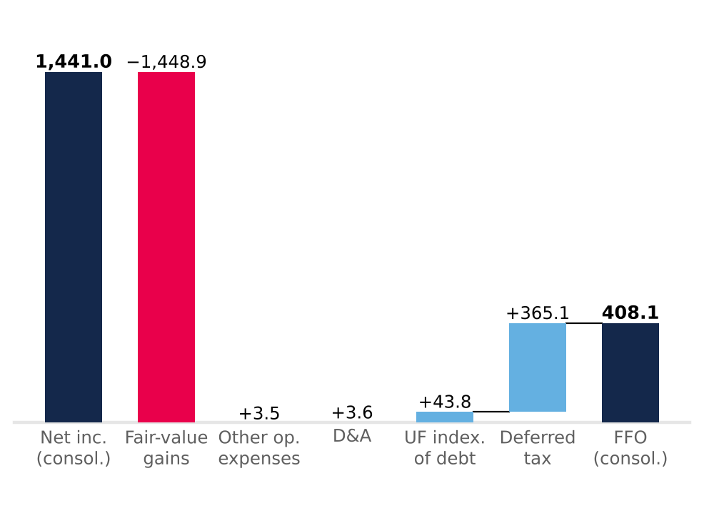
Light blue adds back, red removes, navy = totals. After minorities (CLP 2.8bn), FFO attributable is CLP 405.2bn vs CLP 405.3bn reported. Source: Plaza S.A. financial statements (CMF) FY2025, Notes 13.1 and 23; Team analysis.
LTV fell from 26.9% to 18.8% in 2025, but 5.0pp of the 8.0pp drop came from revaluing the denominator; with property at 2024 value plus additions, LTV would have been 23.8% (Figure 17). Cash-flow metrics support Feller Rate's upgrade to AAA (25 September 2026), but of the fall in net debt/EBITDA from 3.78x to 2.36x, 0.75x is perimeter (Peru consolidated one month in 2024; pro forma ≥ 3.0x), 0.39x EBITDA growth and only 0.28x lower debt (Appendix 11B). EBITDA covers financial costs 8.4x.
Gross debt of CLP 1,633bn is 79% UF, 14% PEN and 7% COP, matching revenue currencies; 95% is long term, with a 6.6-year duration. The UF bonds carry a 3.36% real coupon (3.48% effective); with UF indexation the all-in nominal cost was about 7% in 2025. Maturities cluster in 2029, 2031 and 2033 (Figure 18); refinancing series S (1.32% effective) at the latest issue's 4.33% would add about CLP 4.9bn a year. At June 2026 the current ratio was 2.50x and cash covered current liabilities 1.71x.
One liability does not show up in LTV: deferred taxes, CLP 1,313.7bn at June 2026, almost 80% of gross financial debt. They arise almost entirely from property revaluation; they are not debt to be repaid, but they show how much of the CLP 4,820.9bn book equity is appraisal rather than cash (Appendix 10). Against peers the balance sheet is conservative: LTV of 18.8% versus 42.9% at Parque Arauco and 16.3% at Cencosud Shopping, and net debt/EBITDA of 2.49x versus 5.68x and 2.11x (Appendix 14).
Our base case spends that headroom. Net debt/EBITDA converges linearly from 2.36x to 3.5x by end-2031E, between Cencosud Shopping (2.1x) and Parque Arauco (5.7x), and each extra turn adds 25bp to the real cost of debt. Cash beyond the 40% payout and the capex plan is returned through buybacks or special dividends, CLP 1.7tn cumulatively over 2H26E–2031E (Appendix 13). At 3.5x the new AAA would likely come under pressure.
Figure 18: Refinancing risk sits in 2029, 2031 and 2033, not in the near term
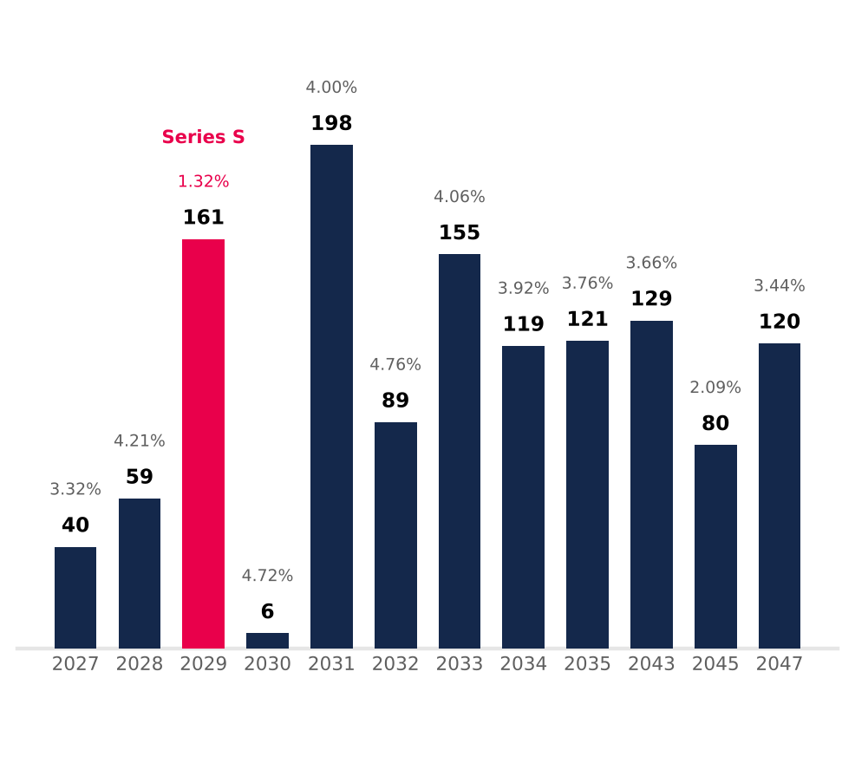
UF bonds, book value Dec-25 (total CLP 1,277.7bn); label = effective real rate (two-series years: book-value-weighted). Excludes CLP 301.6bn of PEN/COP bank debt. Source: Plaza S.A. financial statements Dec-25, Note 14; Team analysis.
The forecast carries forward what history supports, including the pace of expansion
Revenue grows 7.7% in 2026E and 5.0% in 2031E (2026E–2031E CAGR 6.9%), as real same-store growth converges to the appraisal midpoints, 170,200 m² of dated pipeline matures (including 46,500 m² of other projects in Chile opening in 2028) and, from 2029E, about 27,000 m² a year opens at the historical pace (Figure 19); 2026E revenue sits 0.3% above the BEst consensus of 13 analysts (Appendix 11C). EBITDA margin stays at 79.7–79.8%, below the 2025 peak. Cash tax (Chile's rate) normalizes from 16.8% to 27% by 2030E and financial costs rise with leverage, so FFO margin slides from 60.9% to 52.2%. Working capital is held at 15.6% of revenue, the December 2025 level (Appendix 9). New GLA yields 7.3% on cost, a 5.3% real return after tax against a 7.2% real WACC: expansion adds revenue but not value.
What this means for valuation
The analysis leaves three conclusions for the model. First, the right earnings base is cash: we use the company's EBITDA, which removes revaluation once (Appendix 12), and distributable profit as the anchor, not the CLP 1,431bn accounting profit. Second, business quality is not in doubt: with the same adjustment for all three, Mallplaza earns the highest normalized ROE of its local peers (10.0% against 7.8% at Parque Arauco and 8.0% at Cencosud Shopping) with an LTV of 18.8% (Appendix 14).
Figure 15: Two-thirds of 2025 growth was bought; in 1H26 currency and inflation explain more than half
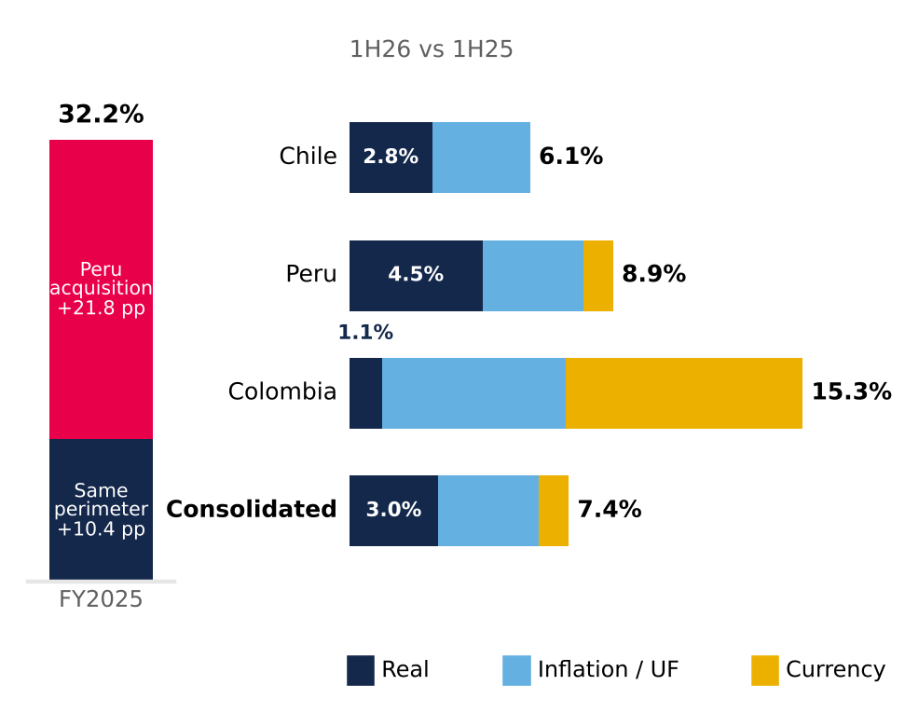
Segments split multiplicatively (real × inflation × FX) from local-currency growth (Chile 6.1%, Peru 7.9%, Colombia 7.3%); consolidated weighted by FY2025 revenue. Source: Plaza S.A. interim financial statements (CMF), Note 24; UF (SII/BCCh); Bloomberg FX; INEI; DANE; Team analysis.
Third, existing capital barely earns its cost. 2025 ROIC, with NOPAT at 27% over capital at appraised value, was 7.3%, in line with our 7.2% real WACC; the comparison is with the real rate because that ROIC excludes revaluation (Appendix 11). New capital, by contrast, earns less than its cost (RONIC of 5.3%). At the current price, 2026E FFO of CLP 428.5bn yields 5.5% on market value (18x FFO) and distributable profit 4.9%: the market is paying for these cash flows as if they were almost risk-free. That is the gap the Valuation section quantifies. In short: a high-quality business, with predictable cash and a comfortable balance sheet, whose price already discounts more than those cash flows can deliver.
VALUATION
We recommend SELL on Mallplaza with a target price of CLP 2,077 per share, 41.6% below the CLP 3,555 close of 30-Sep-26 (−39.6% total return including dividends). Our target sits even below the stock's 52-week low (CLP 2,470).
A PRICE NO METHOD REACHES
Figure 16: Free cash flow covers dividends 1.5–2.6x even as capex rises (FY2025, CLP bn)
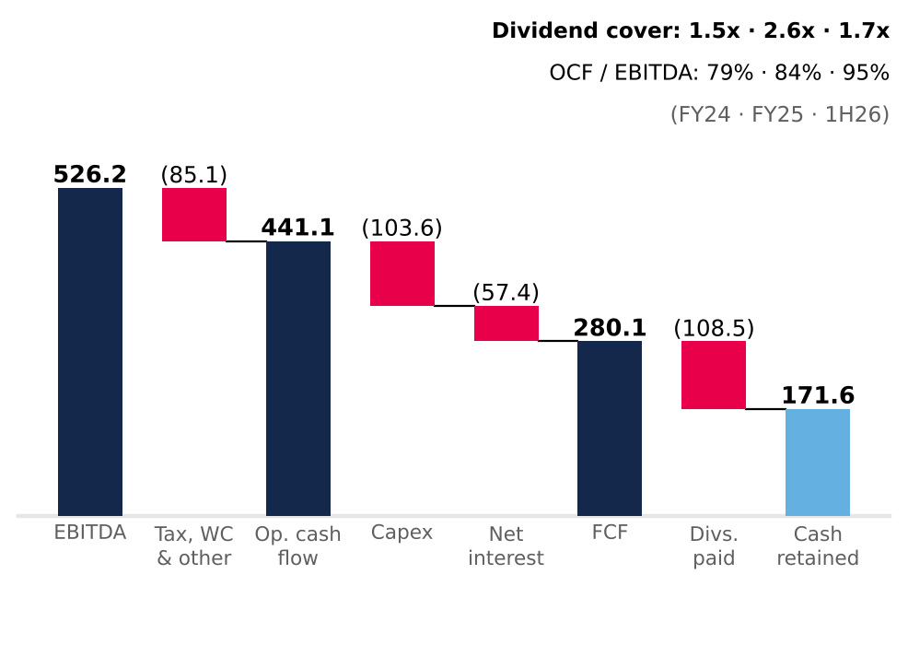
Cash flow statement (direct method; interest paid in financing). FCF before debt repayment. Capex = investment property + intangibles + PP&E (15.8% of revenue in 2025; 24.8% in 1H26). Source: Plaza S.A. financial statements (CMF); Team analysis.
In twelve months the stock rose from CLP 2,470 to 4,700 and now trades at CLP 3,555. None of our methods reaches that price: the DCF ranges from CLP 1,391 to 2,329 even with nominal WACC ±100 bp and nominal g between 2.5% and 4.0%, and the most favourable multiples fall short too (Figure 20). We give the DCF an 80% weight because Mallplaza is, at heart, a rent collector: 81.4% of revenue is rent and 93% of that is fixed. The 20% on multiples tests the model against what the market pays today, but with caution: Chile has only two direct peers, and neither captures the company's expansion plan or debt path.
Figure 20 sums up the thesis in one image. The APV, which values the firm without debt and adds the tax shields separately, gives CLP 1,895, only 2% above the DCF: the result does not depend on how we model financing. Multiples range from CLP 2,152 (common-set median) to 3,294 (Chilean median), and NTM EV/EBITDA and EV/EBIT fall between CLP 2,914 and 3,098. Everything lands to the left of the price; only the stock's own one-year trading range reaches it. Even the Chilean median multiple, the most favourable case for the stock, sits 7% below the price.
THE STORY IS IN THE DISCOUNT RATE
We project the firm's free cash flow (FCFF) in nominal CLP from 30-Jun-26, with an explicit horizon to 2031E and a terminal value that explains 78% of EV (Appendix 15). The CLP 1,859 per share is CLP 543 of explicit cash flows and CLP 1,926 of terminal value, less CLP 610 of net debt and minorities: the result depends, above all, on the discount rate.
That rate moves with the capital structure. Mallplaza uses its debt capacity to grow, as in 2024 after buying Open Plaza Peru (3.78x): we assume net debt/EBITDA rises from 2.36x to 3.5x by 2031, with 25 bp more real cost per turn, and that the new debt (CLP 1.46 trillion) funds all capex while operating cash is distributed to shareholders. Nominal WACC thus moves from 10.54% in 2H26E to 10.41% at the terminal (7.32% and 7.20% real): a nominal Ke of 11.93% (8.67% real; USD Rf of 4.98%, re-levered beta of 1.14 from a six-peer median of 0.00, ERP 4.14% and a revenue-weighted CRP of 1.41%) and a nominal after-tax Kd of 5.11%, based on the 3.6% real (UF) coupon of the latest issue (Appendix 19).
We build Ke in dollars because its three inputs are in that currency and nominal: the US Treasury Rf, the implied market risk premium published by Damodaran and country risk, which we weight by revenue. We then convert it to pesos with the differential between expected inflation in Chile (3.0%, the central bank target) and in the US (2.24%, 10-year breakeven). Beta is unlevered with Hamada (six regional peers) and re-levered each period (NaN in 2H26E, 1.14 at the terminal).
The first signal is the asset (firm) IRR: the single rate that equates FCFF and terminal value to the enterprise value the market pays at CLP 3,555 (EV of CLP 9.12 trillion). It is 7.61% nominal (4.48% real in UF), 280 bp below the nominal WACC (272 bp in real terms) and only ~88 real bp above the real cost of its debt (Figure 21).
Asset (firm) and new-project IRR vs WACC: nominal CLP and real (UF)
Buying at the price of | Nominal | Real | WACC nom./real | Gap nom./real
Market: CLP 3,555 | 7.61% | 4.48% | 10.41% / 7.20% | −280 / −272 bp
Our target: CLP 2,077 | 9.88% | 6.68% | 10.41% / 7.20% | −53 / −51 bp
Our DCF: CLP 1,859 | 10.43% | 7.21% | 10.41% / 7.20% | +2 / +2 bp
New project: 1 m² (cohort) | 7.98% | 4.84% | 10.41% / 7.20% | −243 / −236 bp
Asset IRR: the single rate that equates FCFF and terminal value to the enterprise value paid; at the DCF value it equals the WACC. New project: cash flow of 1 m² with the expansion cost, ramp and margin, maintenance and working capital. Real = (1 + nom.) / (1 + 3.0%) − 1. The implied WACC in Figure 27 (7.60%) shifts the whole WACC curve and the single-rate IRR is 7.61%: two readings of the same idea. Source: model v4, TIR_Implicita and TIR_Proyecto sheets.
Figure 19: After the pipeline, incremental capex for continuous expansion keeps total capex near CLP 150bn a year; net debt/EBITDA rises to 3.5x
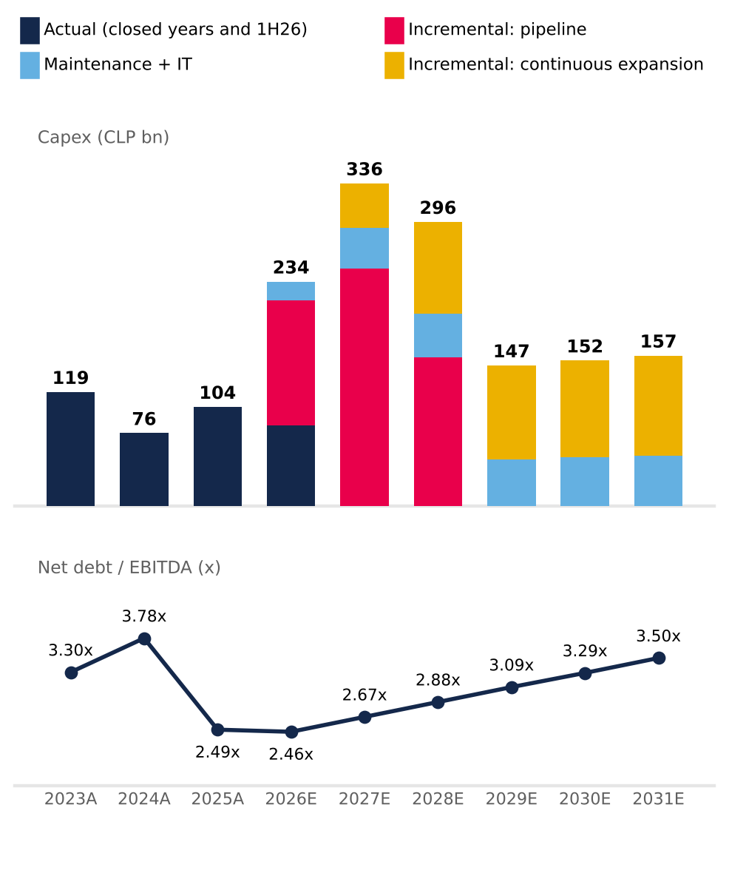
2026E includes CLP 84.2bn of 1H26 (no breakdown by type). Maintenance + IT = 5.5% of revenue; incremental = pipeline under way + continuous expansion. 2024A: one month of Peru EBITDA. Source: Plaza S.A. financial statements (CMF); 2Q26 results release; model v4 (Appendix 15).
GROWTH DOES NOT RESCUE THE PRICE
We are not pessimistic about operations. We project a 79.7% EBITDA margin in 2026E (excluding revaluations, below the 80.5% LTM), a cash tax rate converging from 16.8% to 27% by 2030, the company's full dated pipeline (170,200 m² and USD 613 MM, including 46,500 m² of “other projects” in Chile opening in 2028) and, from 2029, 27,075 new m² per year, the historical organic pace. The consensus of 13 analysts expects 12-month EBITDA only ~3% above ours: the disagreement with the market is not in the cash flows.
Capex follows the company's plan and is split into maintenance and IT (5.5% of revenue, CLP 42–53 bn per year) and incremental capex: the pipeline under way (CLP 534 bn in 2H26E–2028E) and continuous expansion (CLP 95–104 bn per year from 2028, at USD 3,603 per m² and a revenue ramp of 35%, 90% and 100%). Total capex peaks at CLP 336 bn in 2027E and settles near 16% of revenue from 2029E (Figure 19). Working capital (15.6% of revenue) requires CLP 7.3–9.9 bn per year and, if it were zero, the target would rise only 1.3% (Figure 22; Appendix 16).
Two assumptions deserve an explanation. The cash tax rate starts at 16.8% because the company currently uses tax goodwill and accumulated losses; we assume those shields run out and the rate reaches 27% in 2030. It is real cash savings (lower current tax), not accounting: CLP 62 per share undiscounted; without it the target falls 2.1% (Figure 22). And working capital grows with revenue, not with new m².
Price and sales. For a rental operator the price is rent per m², and tenants' sales reach revenue only through variable rent (5.7% of revenue). So 1 pp more nominal same-store rent growth in 2027–28 adds CLP 45 to the DCF value per share, 18 times what 1 pp more tenant-sales growth adds (CLP 2.6); 1 pp more real rent growth in 2029–31 adds CLP 57. Better prices can translate into higher sales and variable rent when occupancy and traffic sustain them, so in the bull case we move both levers at once (rent +9.4%, sales +9.9%): even so, the target stays 18% below the price.
The problem is the return on growth. Each new m² yields 7.3% real before tax on its cost (expansion mix: 67% Chile, 33% Peru), a real after-tax RONIC of 5.3%, below a real WACC of 7.2%. The IRR of a new m², with capex, ramp, maintenance and working capital, is 4.84% real (7.98% nominal): 236 bp below the real WACC and 243 bp below the nominal one; to match it, revenue per m² would have to be 1.54 times the model's. Expansion adds revenue but not value: that is why terminal value grows only with inflation (nominal g of 3.0%, 0% real) and a higher g reduces value (Figure 23). Assuming more growth would not close the gap with the price; it would widen it. The explicit horizon therefore includes the capex and maturation of projects opening through 2032 (108,301 m² mature in the terminal year), but from there terminal incremental capex is zero and only maintenance remains.
Figure 17: Two-thirds of the 2025 fall in LTV is revaluation, not deleveraging
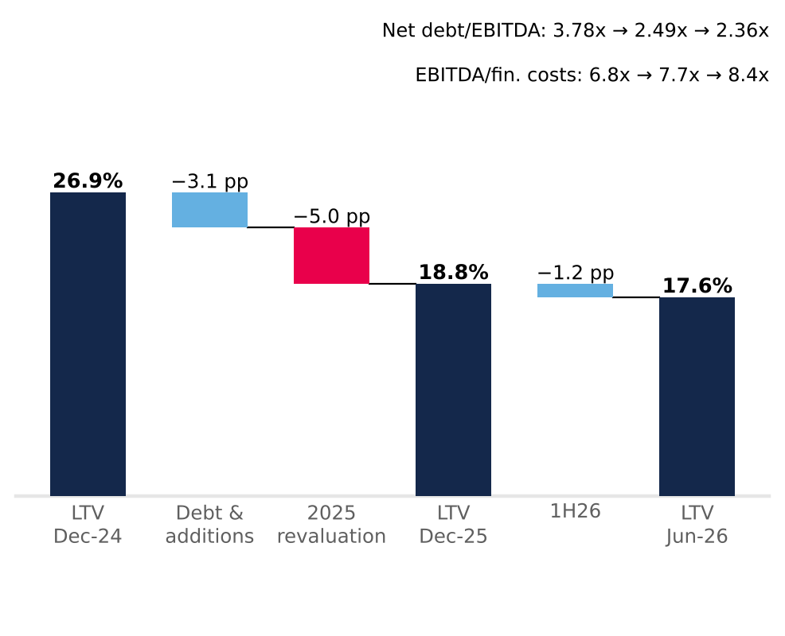
LTV = net financial debt / investment property. Debt & additions = LTV with property at 2024 value plus 2025 additions (23.8%). Jun-26 ratios on LTM EBITDA. Source: Plaza S.A. financial statements (CMF), Notes 11 and 26; MD&A 2025 and 1H26; Team analysis.
WHY EXPAND IF IT DOES NOT CREATE VALUE?
Figure 20: No method justifies the current price (CLP per share)
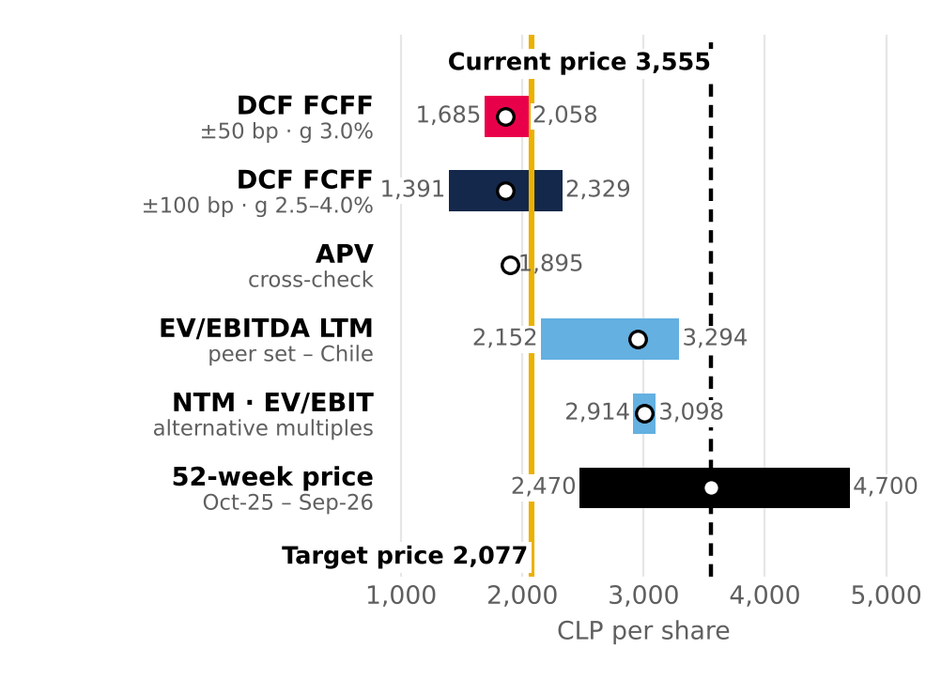
Intraday 52-week range (01-10-25 to 30-09-26; low 10-10-25, high 27-04-26). Source: Team analysis; Bloomberg.
If growth earns less than the cost of capital, what pushes management to keep going? We put forward four hypotheses, to be verified against the annual report and financial statements. First, accounting versus economics: debt is 100% UF-denominated at ~3.6% real, below what a new asset yields, so every debt-financed project improves FFO, EBITDA and profit even if it does not cover the return required on total capital. Second, revaluation: under IAS 40 appraisals use real rates of 5.5–6.4%, below the WACC, and each new asset is appraised above its cost and generates accounting profit. Third, the controlling shareholder: if the group (Falabella, to be confirmed) has anchor stores or other businesses in those malls, a new m² serves the group even if it earns little for Plaza, an agency conflict with minority shareholders (to be verified in the related-party notes). Fourth, compensation: if bonuses depend on GLA or EBITDA rather than ROIC, expanding is rational for management (to be verified). There are defensible strategic reasons (scarce land, network advantages); it is a capital-allocation risk, not a contradiction with a good business. The break-even for expansion is a real WACC of 5.3% (8.5% nominal); the WACC implied by the price (7.60% nominal, 4.5% real) is below that level: if the market were right, expanding would create value.
PEERS CONFIRM THE DIRECTION, NOT THE MAGNITUDE
Mallplaza trades at 16.8x EV/EBITDA, above the Chilean median (15.7x) and far above Brazilian peers (9.0x). The gap with Brazil is not about quality but about rates: with local real bonds of 2.5% in Chile and 8.1% in Brazil (NTN-B), the cap-rate spread (EBITDA/EV yield; with UF-indexed rents it is compared with real rates) over the local rate is similar in both countries, 385 bp in Chile and 302 bp in Brazil (Figure 24). That is why we weight the Chilean median 70% and the common-set median 30% (which includes IRSA; we exclude Fibra Danhos because of its FIBRA regime): 14.4x, which leads to CLP 2,951 per share. The weighting matters little: from 0% to 100% Chile, the target price only moves from CLP 1,916 to 2,144 (Appendix 17).
We chose the set with the beta criterion: IRSA with caution (IAS 29 reporter; one analyst on NTM) and without Fibra Danhos (FIBRA: distributes 95% of taxable income; no beta in the WACC). We use EV/EBITDA, neutral to leverage and revaluation (IAS 40), with Bloomberg net debt (CLP 1,311,569 MM for Mallplaza; the gap to the CLP 1,285,740 MM in the DCF is CLP 25,828 MM of IFRS 16 leases).
Figure 21: At CLP 3,555 the firm earns almost the same as its debt (real rates, UF)
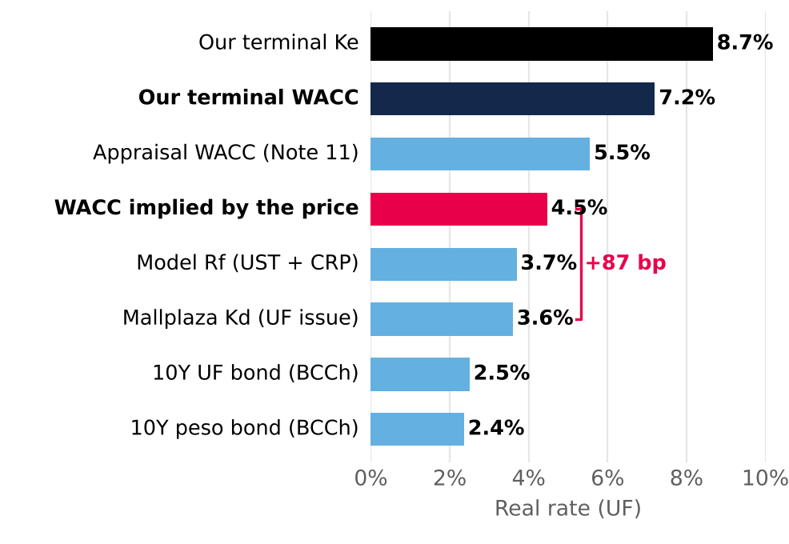
Real rates in UF. Source: Central Bank of Chile (30-06-26); Mallplaza; Team analysis.
Quality does not justify the premium either. Mallplaza trades 29% above Cencosud Shopping, yet its EBITDA per m² is only 1.9% higher (see Industry); only at Parque Arauco's multiple (18.4x), which runs 5.7x leverage, would it be worth more than its price. Every multiple, from NTM EV/EBITDA (CLP 2,914) to P/BV (CLP 3,171), sits below the price (Figure 25): they confirm the stock is expensive, and the DCF gives the magnitude. We exclude P/E (CLP 8,644), distorted by property revaluation. In prices: Chilean median CLP 3,294 (−7%), Cencosud CLP 2,621 and only Parque Arauco CLP 3,967. Defending CLP 3,555 with multiples requires assuming Mallplaza deserves the valuation of the most leveraged peer in the group.
WHAT THE MARKET WOULD HAVE TO BELIEVE
Figure 22: With every strong assumption in our favor the target reaches CLP 2,977, still 16% below the price
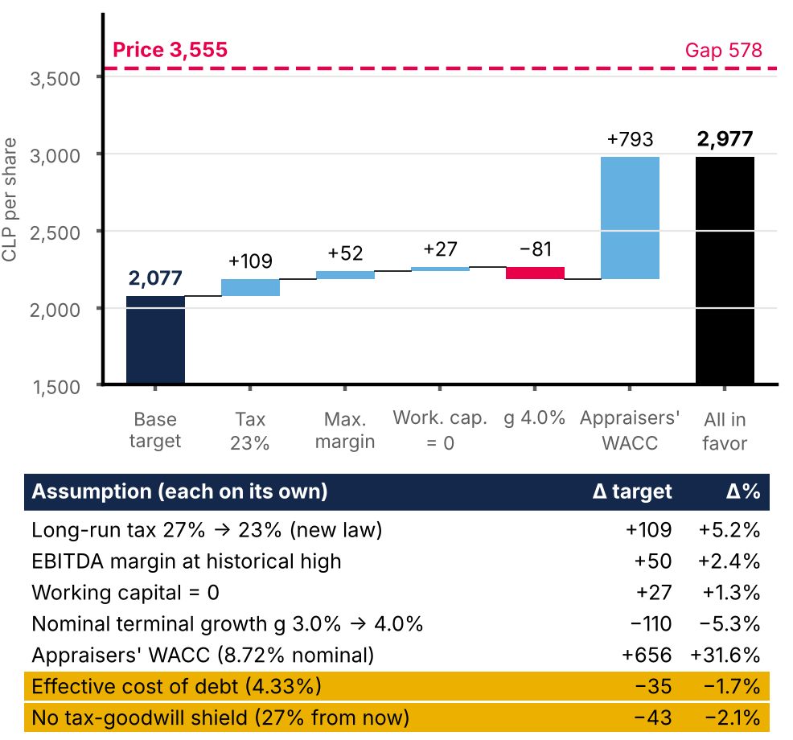
Cumulative waterfall in the order shown; the table gives each assumption's effect alone. Target price = 80% DCF + 20% multiples. Source: DCF v4 replica; Team analysis.
The price implies an EV of CLP 9.12 trillion, 69% above ours, and a real cap rate of 6.0% (LTM EBITDA / EV, comparable with real rates because rents are UF-indexed), against 10.1% in our DCF, 6.4% for Chilean peers and 7.5% at book value (Figure 26). The market pays 1.61 times an equity that is already at fair value, appraised with a real discount rate of ~5.55% (Note 11); the real IRR the price leaves, 4.5%, is below that rate: it pays more than the appraisers themselves. To justify CLP 3,555, nominal WACC would have to be 281 bp lower (7.60%, 4.5% real; Figure 27); even with the appraisers' rate (5.55% real, 8.72% nominal), the DCF would be CLP 2,679. (The implied WACC shifts the whole WACC curve; the single-rate IRR, 7.61%, is the same idea and also gives CLP 3,555.)
WHY THE MARKET PAYS CLP 3,555
In twelve months the stock went from a low of CLP 2,470 (10-Oct-25) to a high of CLP 4,700 (27-Apr-26), a ~90% rise the business does not explain: EBITDA grew 5–10% a year. The push came from outside. The Chilean market rose 56% in 2025, with a change of government and expectations of lower taxes, and malls returned ~48% (LarrainVial) and re-rated together. MSCI EM Mid Cap inclusion (25-Nov-25) forced passive funds to buy ~USD 110 MM, some 15 times daily volume (Morgan Stanley). And analysts extrapolated growth: JPMorgan projects FFO growing ~11% a year to 2028, double our ~6% (2026E–2028E). The fall to CLP 3,555 (−24% from the high) coincides with weaker-than-expected results (EBITDA +5.2% in 1Q26), JPMorgan's target cut and the 10-year UST rising to 5.22%. It is a partial correction: at that price the stock trades 91% above the DCF, 33% above the value at the appraisers' rate (CLP 2,679) and at 1.61x book value. Figures attributed to analysts come from their own notes and intermediate prices are approximate (Figure 32).
OUR VALUE VERSUS THE CONSENSUS
Figure 23: Growing below the WACC destroys value: real g = 0%
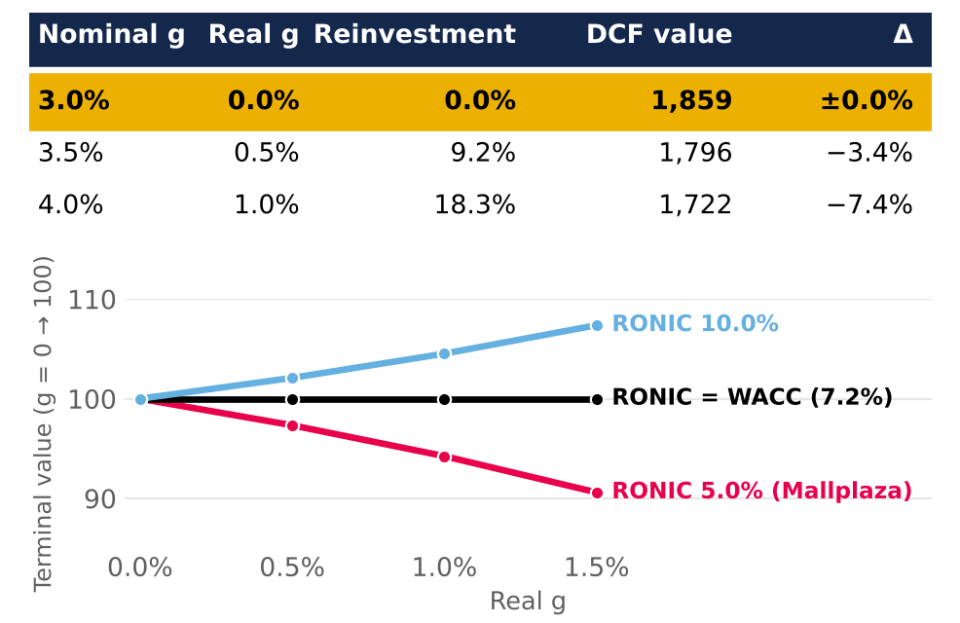
Top: DCF value by nominal g. Bottom: relative terminal value by RONIC. Source: Team analysis.
Bloomberg shows 14 sources with an average recommendation of 2.85 (1 buy, 10 hold, 2 sell) and a 12-month target price of CLP 4,111, 49.5% above ours; the lowest is Goldman Sachs (sell, CLP 3,377) and the range runs from 3,377 to 4,600. Four reasons explain the gap (Figure 34). The discount rate is the main one: the price requires a nominal WACC of 7.60%, 281 bp below our 10.41%, and since terminal value is 78% of EV, each point of rate weighs heavily. Multiples do not get there either: the 20% on multiples gives CLP 2,951, 17% below the price, so it is not all WACC. The horizon also counts: targets are 12-month and ours is as of 30-Jun-26; at our nominal Ke of 11.93%, CLP 4,111 is worth ~CLP 3,673 today, so the gap narrows but does not close. And growth: if growth earns less than the WACC, our model penalises it, while the market probably values it at a return close to the cap rate. Targets followed the price (the stock rose 39% in 12 months) and we do not know their assumptions, only their targets.
SCENARIOS: WHAT WOULD HAVE TO HAPPEN
We push the thesis to its extremes with three scenarios defined with the same levers as the Risks tornado (Figure 29), instead of moving only the discount rate. Bear is everything going wrong at once: nominal WACC +100 bp and every operating lever at its historical minimum. Bull is everything going right: nominal WACC −100 bp, every lever at its historical maximum and a 23% tax rate (Reconstruction Law). Base is the model's central estimate. Same-store rent (price) and tenants' sales move together; nominal g stays at 3.0% in all three. The weights come from the risk matrix on the Risks page: the bear combines FR1 (rates, high likelihood) and OR1 (operating deterioration, medium) and, because they happen together, carries the weight of the less likely one (medium, 30%); the bull combines their opposites (low and medium) and carries 10%; the base is the remainder, 60%. With low = 10%, medium = 30% and high = 50% over 12 months (team assumption), the weighted target price is CLP 2,001 (−43.7%).
Scenarios: bear (everything goes wrong), base (central) and bull (everything goes right)
Assumption (all at once) | Bear | Base | Bull
Terminal nominal WACC (all periods) | +100 bp (11.41%; 8.17% real) | 10.41% (7.20% real) | −100 bp (9.41%; 6.23% real)
EBITDA margin (historical quarterly min / max) | 75.8% | 79.7% (2026E) | 81.3%
Consolidated occupancy | 95.1% | 95.6% | 96.6%
Same-store rent 2027–28 (price, nominal) | 3.7% | 5.4% | 9.4%
Tenant sales 2027–28 (variable rent, 5.7% of revenue) | 3.7% | 3.7% | 9.9%
Real rent growth 2029–31 | Note 11 floor | model | Note 11 ceiling
Maintenance + IT capex (% of revenue) | 6.6% | 5.5% | 4.8%
Long-run tax rate | 27% | 16.8% → 27% | 23%
DCF value / 80/20 target price (CLP) | 1,190 / 1,542 | 1,859 / 2,077 | 2,906 / 2,915
Target price vs CLP 3,555 | −56.6% | −41.6% | −18.0%
Firm IRR at the price (nom.) / gap vs WACC | 6.95% / −446 bp | 7.61% / −280 bp | 8.51% / −90 bp
Probability (from the risk matrix) | 30% | 60% | 10%
Operating levers are the historical extremes of the Risks tornado; nominal WACC and g; rent (price) and sales move together. Terminal nominal g 3.0% in all three. Weighted 30/60/10%: DCF CLP 1,763, target price CLP 2,001 (−43.7%). Source: DCF v4 replica (Appendix 18); Team analysis.
Figure 25: Implied value per peer multiple vs DCF and price (CLP per share)
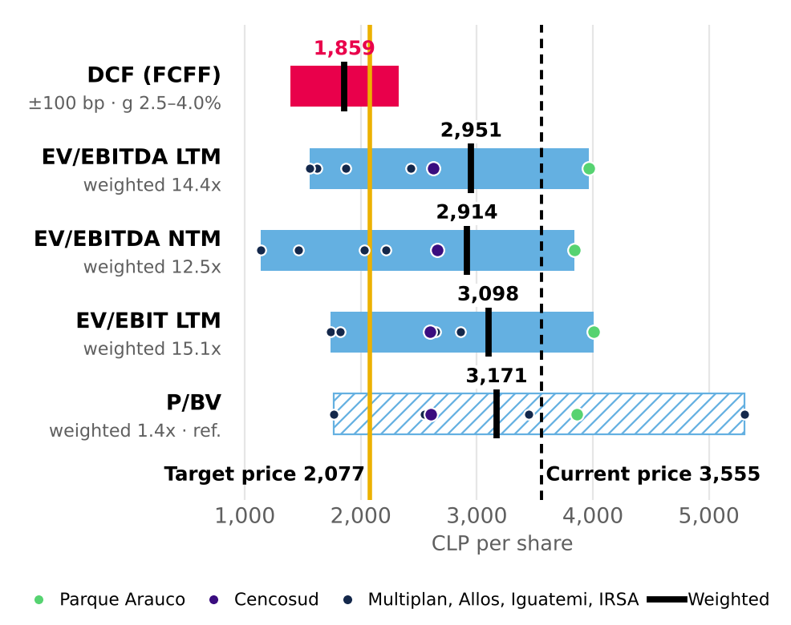
Target price = 80% DCF + 20% LTM EV/EBITDA. P/E excluded (includes revaluation). Source: Bloomberg (30-09-26); Team analysis.
The result is robust: even with everything in its favour the target price (CLP 2,915) does not reach the quote. The firm's IRR at the market price barely changes across scenarios (table) and always sits below each one's WACC (446, 280 and 90 nominal bp): not even the bull leaves a margin of safety. The APV (CLP 1,895), an Rf based on the peso bond (~CLP 2,449) and other debt targets (DCF of CLP 1,820 to 1,897) lead to the same conclusion (Appendix 18).
The APV also says how much the debt is really worth. Of its CLP 1,895 per share, CLP 1,630 is the unlevered firm and CLP 265 the tax shields of the projected debt: levering up to 3.5x adds value, but even adding it does not approach the price. Our risk-free choice is the conservative one: using the nominal peso bond (5.43%) and also adding country risk would count Chile risk twice, and even so the target price would only rise to ~CLP 2,449, 31% below the price. With an expected dividend of ~CLP 69 per share (2.0%), the expected total return is −39.6%.
That is how we get to CLP 2,077 (80% × 1,859 + 20% × 2,951): 10.8x EBITDA, a real cap rate of 6.1% and 0.94x book value. Rolling the DCF forward to 30-Sep-26 would lift it to ~CLP 2,119, without changing the recommendation. The catalyst is the one that holds the thesis together: with the nominal 10Y UST at 5.22%, the highest since 2002, rates pressure cap rates, and each new appraisal moves them toward our value. We would be wrong if cap rates compress further on institutional demand for defensive assets, or if the market sustains a structural premium for Tier A assets (see Investment Risks). We will watch the Note 11 appraisal at each close, the spread on the company's UF bond versus its 3.6% real coupon (at the 4.33% real effective rate of the latest issue, nominal WACC would rise 12 bp and the target price would fall to CLP 2,042), the cut in corporate tax to 23% (+5.2% to the target price, not yet included) and the AAA rating, which would probably come under pressure at 3.5x net debt/EBITDA.

Figure 24: Chile and Brazil charge the same premium: multiples differ because of rates  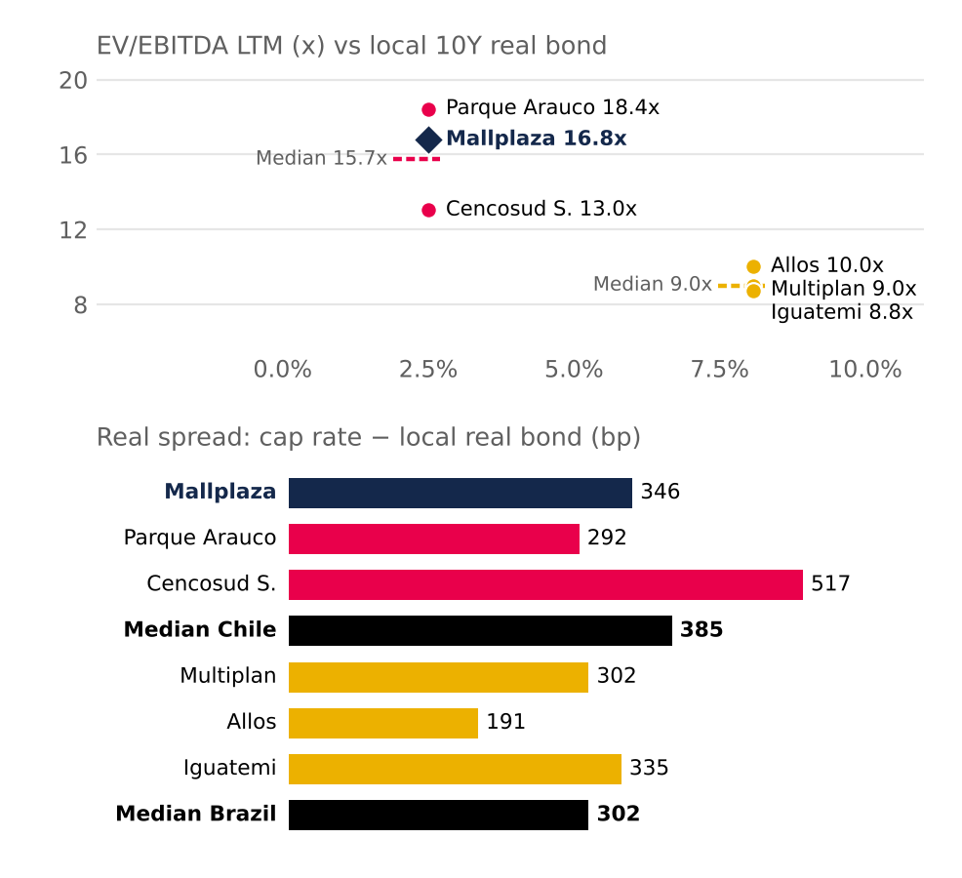  Real bond: 10-year UF (BCCh) and NTN-B 2035 (8.08%) at 30-06-26. Spread = cap rate (1 / EV/EBITDA) − real bond. IRSA omitted (IAS 29). Source: Bloomberg; BCCh; Team analysis. |  | Figure 26: The market pays 6.0%; our cash flows are worth 10.1% (real cap rate)  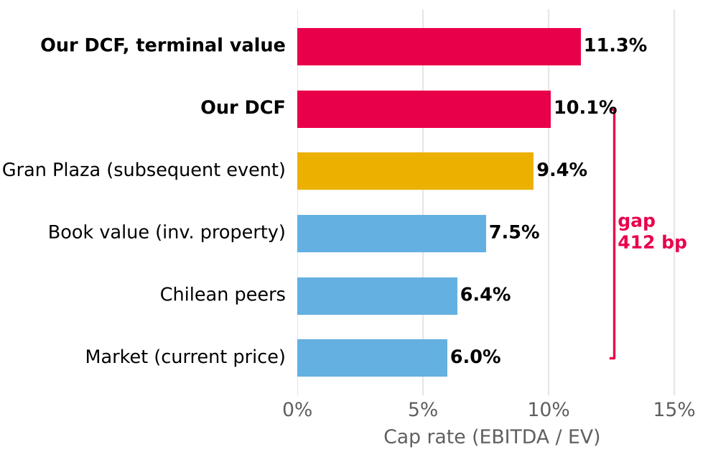  Cap rate = LTM EBITDA / EV, comparable with real rates (UF rents). Gran Plaza: subsequent event, not in the model. Source: Mallplaza; Bloomberg; DF; Team analysis.
Figure 27: The price requires a nominal WACC 281 bp lower
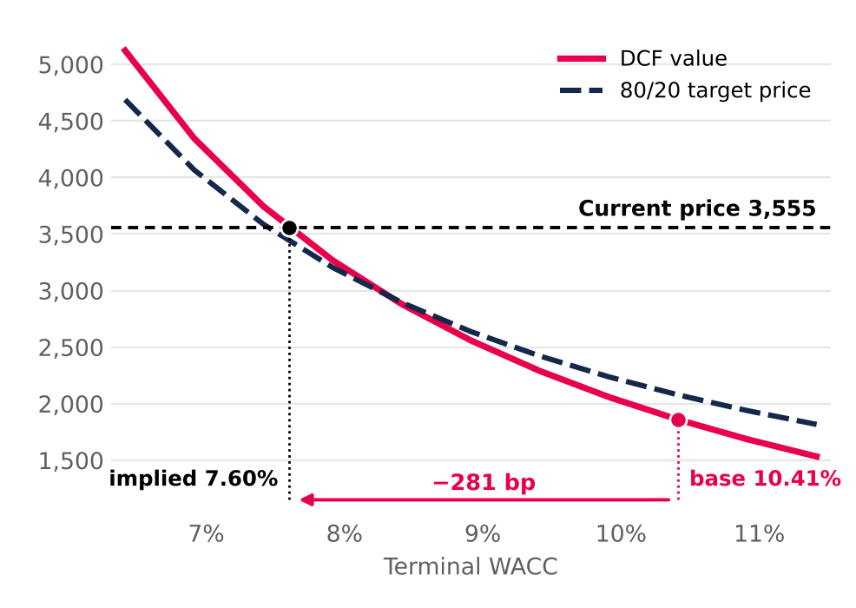
Terminal nominal WACC; all periods shift in parallel. Source: Team analysis.

INVESTMENT RISKS
Mallplaza's risk profile is moderate: its operations are resilient and value depends mainly on market variables. The main risk, with high likelihood, is a rise in long-term rates, which pushes up bond yields and the WACC. Not even the favourable scenarios justify the market price at the report date.
RISK ASSESSMENT  Figure 28 classifies each risk by likelihood and by its impact on value per share (Figures 29 to 26). Risks that could not be quantified are classified according to the team's qualitative analysis of the company. This matrix sets the scenario weights in Valuation: the bear combines FR1 (high likelihood) and OR1 (medium), and the bull their opposites.  OPERATIONAL RISKS  OR1: Operating deterioration. EBITDA margin, rents, footfall or occupancy falling to their historical lows. The worst case, a 75.8% margin, cuts DCF value to CLP 1,669 (−10.2%), and the historical floor of same-store rent growth takes it to CLP 1,783 (−4.1%) (Figure 29). All levers together, with WACC +100 bp, define the bear scenario (target price CLP 1,542, −56.6% against the share price). (Non‑systematic · Medium likelihood · Medium impact)  Mitigants: stable metrics: EBITDA margin rose from 76.2% (2022) to 80.5% (2025) and occupancy held between 95.5% and 96.6% in 2024-25. After COVID, 1Q22 revenue was already 18% above 1Q19.  OR2: Anchor stores. Anchors, mostly from the Falabella group, drive footfall. Shrinking or losing them would lower visits and rents from smaller stores. The impact ranges from −1.3% to −4.1% (Figure 29). (Non‑systematic · Low likelihood · Low impact)  Mitigants: long-term leases (average remaining term of 7.1 years) and a proven ability to convert anchor space into smaller stores with higher rent per m².  FINANCIAL RISKS  FR1: Interest rates and cost of capital. Higher long-term rates would raise the WACC and the cost of refinancing debt and the pipeline. Likelihood is high: the 10Y UST moved from 4.98% (model Rf) to 5.22% on 8-Oct-26, a 24-year high (since 2002); the Fed hiked in September and the Central Bank of Chile reports rising local long-term rates. With nominal WACC +50 bp and +100 bp, the target price falls 6.7% and 12.5% (Figure 30). (Systematic · High likelihood · High impact)  Mitigants: 79% of debt is fixed-rate in UF, with ~6.7 years of duration, 2.36x net debt/EBITDA and AA+/BBB ratings, which limit the pass-through to the cost of debt; UF-linked rents offset inflation. A higher cost of equity cannot be hedged.  MARKET & MACROECONOMIC RISKS  MR1: Inflation and macro cycle. 79% of debt is in UF: a 3% higher UF takes CLP 38,691 million off accounting earnings (Note 26). On the target price, however, the effect is small, because indexed rents rise with inflation: a 100 bp rise in the long nominal rate coming entirely from expected inflation takes off only 0.3%; if it came entirely from the real rate, 12.2% (Figure 31). The risk is that weaker consumption prevents passing inflation through to rents: if only 70% of the cash flow were indexed, the effect of inflation would rise to 1.0%. Weaker consumption also slows the new business lines (Appendix 20). (Systematic · High likelihood · Low impact)  Mitigants: UF-indexed rents, a model based on rent rather than sales, low (if rising) leverage and an active ability to rotate the portfolio.  MR2: E‑commerce. If consumption migrates massively online, malls lose footfall and appeal. E‑commerce in Chile exceeded US$10 billion in 2025, around 12.6% of retail sales. The worst traffic case only takes 1.3% off value (Figure 29). (Systematic · Low likelihood · Medium impact)  Mitigants: the online channel is maturing with no visible effect on the model (visits +16% in 2025). Malls offer entertainment and dining, hard to replicate online.  MR3: Foreign exchange. Around 28% of revenue comes from Peru and Colombia, and the model assumes the sol rises from CLP 268 to 290 between 2026 and 2031. A 10% depreciation of the PEN and COP from 2027E takes 4.3% off DCF value, before hedges and the effect on local-currency debt (team estimate). (Systematic · Medium likelihood · Medium impact)  Mitigants: Mallplaza raises debt in each country's currency and, where not possible, uses hedging derivatives (forwards, swaps and cross currency swaps) (Management Discussion 2Q26, p. 14).  REGULATORY & ESG RISKS  RR1: Interlocking and conflicts of interest. Falabella controls 53.05% and leases space through Falabella, Sodimac and Tottus, which creates receivables with related parties. Fernando de Peña, Mallplaza's CEO for decades, has chaired Falabella since March 2026. Off-market contracts would directly affect rents and value. There is also a capital-allocation risk: expansion earns less than its cost (real RONIC of 5.3% against a real WACC of 7.2%), so continued growth benefits accounting profit and a controller with other businesses in those malls more than the minority shareholder (to be verified; see Valuation). (Non‑systematic · Low likelihood · High impact)  Mitigants: a three-member directors' committee and review of related-party transactions (Law 18,046). Even so, safeguards are limited: only 1 of 9 directors is independent.  RR2: Regulatory and political. Changes in tax, permitting and economic policy in all three countries. In Chile, the ruling coalition lacks a comfortable majority in the lower house for the rest of its agenda (El Dínamo, 11-Mar-26). In Peru, Fuerza Popular lacks a majority in the new bicameral Congress and the MEF puts the cost of laws passed by the previous Congress at up to S/ 50,000 million (El Comercio). In Colombia, the finance ministry puts the deficit at 7.8% of GDP and proposes spending cuts of at least 1% of GDP (El Tiempo, Jul-26), and the central bank raised its rate to 12.25% (30-Sep-26), which slows consumption. Permit delays push back the pipeline (USD 613 million, 170,200 m² to 2028). (Systematic · Medium likelihood · Low impact)  Mitigants: pro-investment agendas. In Chile, Kast signed the Reconstruction Law (9-Oct-26), which gradually cuts corporate tax from 27% to 23% from 2027 (Emol, 9-Oct-26), S&P affirmed its A stable rating and Law 21,770 (Sep-25) shortens permitting. In Peru, the minimum-wage rise to S/ 1,300 and the doubling of Pensión 65 support consumption (Infobae, 28-Jul-26). Colombia contributes only ~11% of revenue. The model keeps 27%: the Chilean cut would add ~5.2% to the target price. |  | Figure 28: Risk matrix  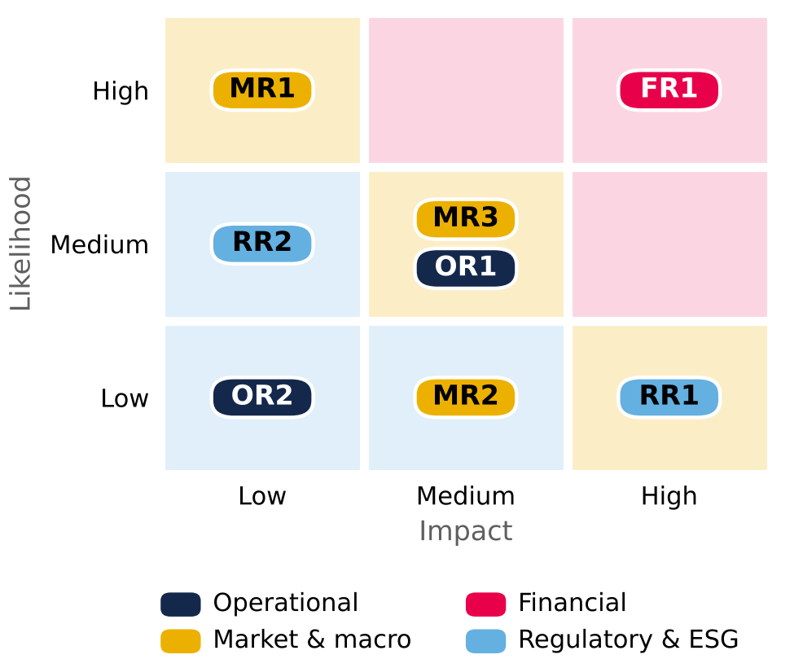  Background colour = severity (likelihood × impact). Source: Team analysis.  Figure 29: Operational risk tornado (CLP per share)  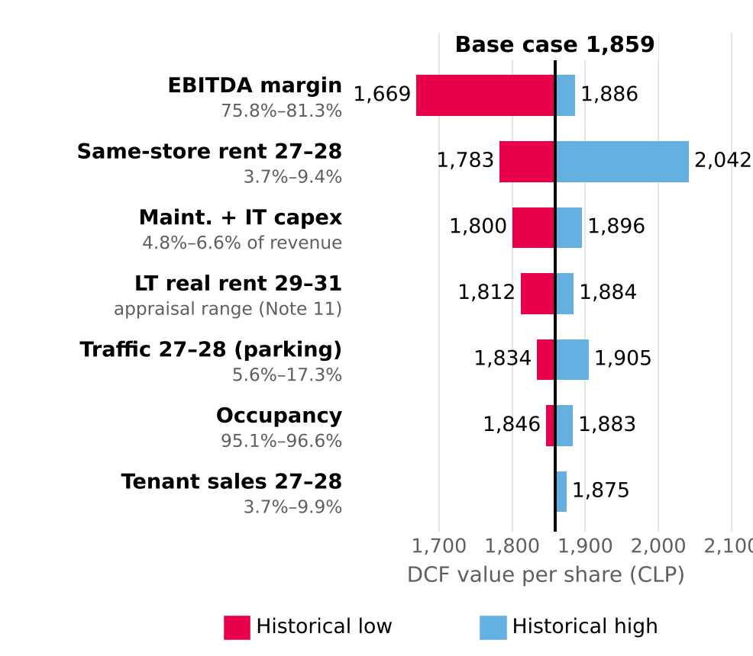  Limits = historical minimum and maximum of each variable (Mallplaza releases 4Q23–2Q26; financial statements for maintenance capex and appraisal, Note 11). WACC 10.41% and g 3.0% constant. Source: Mallplaza; Team analysis.  Figure 30: Target price sensitivity: WACC vs g (CLP)  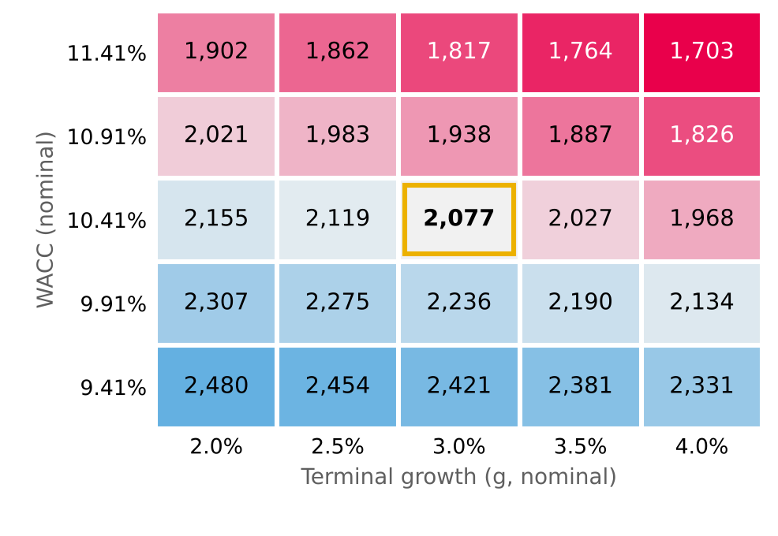  Target price = 80% DCF + 20% EV/EBITDA multiples (CLP 2,951). The g = 2.0% column uses the same formula as the Sensibilidad sheet. Source: Team analysis.  Figure 31: Target price by long nominal rate and the share of its rise that comes from inflation (CLP)  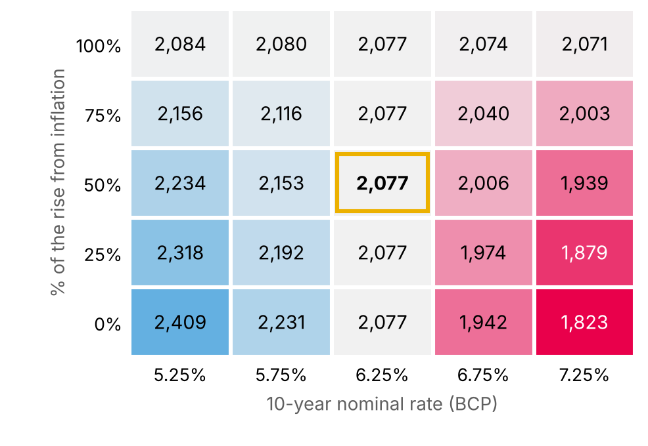  10-year BCP (base 6.25%, 30-Sep-26); the rise is split between real rate and inflation; 85% of cash flow is indexed to inflation (team assumption). Source: Central Bank of Chile; Team analysis.
INVESTMENT SUMMARY
SELL · target price CLP 2,077 per share, 41.6% below the CLP 3,555 close (30-Sep-26): an excellent rental business that the market prices as if its cash flows were nearly risk-free.
KEY DATA
Recommendation | SELL | Bear / base / bull (CLP) | 1,542 / 2,077 / 2,915
Target price (CLP) | 2,077 | Market cap (CLP bn) | 7,785
Price 30-Sep-26 (CLP) | 3,555 | 52-week range (CLP) | 2,470 – 4,700
Upside / downside | −41.6% | Expected dividend 2027E (CLP) | 69 (2.0%)
DCF / multiples value (CLP) | 1,859 / 2,951 | Nominal / real WACC | 10.41% / 7.20%
DCF / multiples weight | 80% / 20% | Net debt / LTM EBITDA 2Q26 | 2.36x

RECOMMENDATION AND TARGET PRICE
We recommend SELL on Mallplaza (MALLPLAZ CI) with a target price of CLP 2,077 per share, 41.6% below the 30-Sep-26 close (−39.6% total return with an expected dividend of CLP 69, 2.0%). The target price weights the DCF value 80% (CLP 1,859, at 30-Jun-26) and the peer LTM EV/EBITDA multiple value 20% (CLP 2,951; 14.4x). It sits even below the 52-week low (CLP 2,470).
INVESTMENT THESIS
Mallplaza is an excellent business: rents almost as stable as a bond (81.4% of revenue; 93% fixed), an 80% EBITDA margin, 95.6% occupancy, 2.36x net debt/EBITDA and a local AAA rating. But the price pays more than those cash flows can deliver, for three reasons. First, the discount rate: the price requires a nominal WACC of 7.60% (4.5% real), 281 bp below ours; the asset IRR at the price is 7.61% nominal (4.48% real), 280 bp below the nominal WACC. Second, growth does not create value: each new m² yields 7.3% real before tax on its cost, a 5.3% real RONIC, and its IRR is 4.84% real (7.98% nominal), 236 bp below the real WACC; even the full pipeline (170,200 m², USD 613 MM) adds revenue, not value. Third, cash flows are not the problem: we project a 79.7% EBITDA margin and the consensus expects 12-month EBITDA only ~3% above ours.
WHY IT IS EXPENSIVE
The stock rose ~90% from the low of CLP 2,470 (10-Oct-25) to the high of CLP 4,700 (27-Apr-26) without the business changing (EBITDA +5% to +10% a year): the push came from the Chilean market (+56% in 2025), the joint re-rating of malls, passive buying from the MSCI EM Mid Cap inclusion (~USD 110 MM, ~15 times daily volume, per Morgan Stanley) and analysts extrapolating growth (JPMorgan projects ~11% annual FFO growth). The subsequent fall to CLP 3,555 is a partial correction: the stock trades 91% above the DCF and at 1.61x its fair-value book value (Figure 32).
SCENARIOS
We define three scenarios with the same levers as the Risks tornado. Bear is everything going wrong at once (nominal WACC +100 bp and every operating lever at its historical minimum): CLP 1,542 (−56.6%). Base is the model's central estimate: CLP 2,077 (−41.6%). Bull is everything going right (nominal WACC −100 bp, every lever at its historical maximum, 23% tax): CLP 2,915 (−18.0%). Weights from the risk matrix (bear 30%: FR1 high and OR1 medium, together; bull 10%: their opposites; base 60%; low 10%, medium 30%, high 50%, team assumptions): CLP 2,001. No scenario reaches the price (Figure 33; Appendix 18).
Scenarios: bear (everything goes wrong), base (central) and bull (everything goes right)
Assumption (all at once) | Bear | Base | Bull
Terminal nominal WACC (all periods) | +100 bp (11.41%; 8.17% real) | 10.41% (7.20% real) | −100 bp (9.41%; 6.23% real)
EBITDA margin (historical quarterly min / max) | 75.8% | 79.7% (2026E) | 81.3%
Consolidated occupancy | 95.1% | 95.6% | 96.6%
DCF value / 80/20 target price (CLP) | 1,190 / 1,542 | 1,859 / 2,077 | 2,906 / 2,915
Target price vs CLP 3,555 | −56.6% | −41.6% | −18.0%
Probability (from the risk matrix) | 30% | 60% | 10%
Full assumptions in Appendix 18 and in the Valuation table. Source: DCF v4 replica; Team analysis.
SENSITIVITIES
No lever alone explains the price: the largest, cutting nominal WACC by 100 bp, adds CLP 430 (23%) and the gap to the price is CLP 1,696.
Sensitivity of DCF value per share (base CLP 1,859)
Lever (change) | Δ value (CLP) | Δ value (% of DCF)
Nominal WACC −100 bp / +100 bp | +430 / −326 | 23% / −18%
Same-store rent 2027–28 (nominal) +1 pp | +45 | 2.4%
Real rent growth 2029–31 +1 pp | +57 | 3.1%
EBITDA margin +1 pp | +39 | 2.1%
Occupancy +1 pp | +25 | 1.3%
Tenant sales 2027–28 +1 pp (variable rent) | +2.6 | 0.14%
Each row moves one lever with the others at base. The gap between the price and the DCF is CLP 1,696: no single lever closes it. Source: DCF v4 replica; Team analysis.
Figure 32: The stock rose ~90% in six months with no change in the business, then gave back 24%
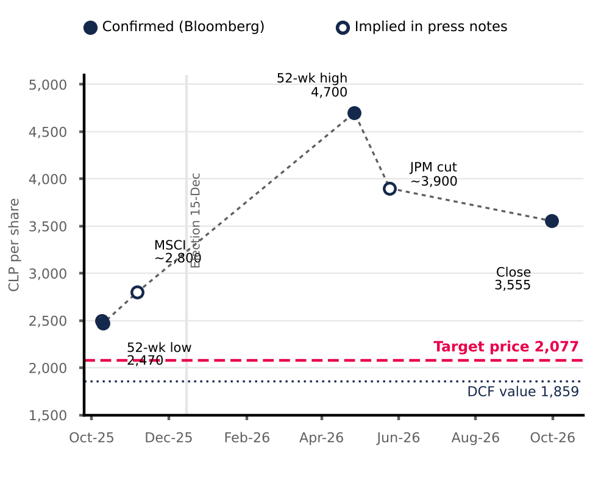
Bloomberg low, high and close; prices marked “~” are implied in notes by LarrainVial (9-Oct-25), Morgan Stanley (6-Nov-25) and Diario Financiero (25-May-26). The line only joins milestones: it is not the daily series. Source: Bloomberg; DF; Team analysis.
VERSUS THE CONSENSUS
The Bloomberg consensus (14 sources; 1 buy, 10 hold, 2 sell) sets a 12-month target of CLP 4,111, 49.5% above ours. It is the discount rate: at the appraisers' WACC (8.72% nominal) the DCF rises to CLP 2,679, and at the implied WACC (7.60%) it equals the price. The rest is horizon (CLP 4,111 is worth ~CLP 3,673 today at our Ke) and growth that the market values at the cap rate (Figure 34).
BASE-CASE ASSUMPTIONS
Valuation at 30-Jun-26 and price at 30-Sep-26. FCFF in nominal CLP, mid-period convention; inflation 3.0% (UF). Nominal WACC 10.54% in 2H26E and 10.41% terminal (7.20% real): Rf 4.98% (10Y UST), market risk premium 4.14%, weighted country risk 1.41%, re-levered beta 1.14, Ke 11.93%, after-tax Kd 5.11% (real coupon 3.6% + spread) and net debt/EBITDA from 2.36x to 3.5x in 2031. Terminal g 3.0% nominal (0% real). EBITDA margin 79.7% in 2026E; cash tax rate of 16.8% converging to 27% by 2030; maintenance + IT capex 5.5% of revenue; working capital 15.6% of revenue. Dated pipeline of 170,200 m² (USD 613 MM) and continuous expansion of 27,075 m² a year from 2029, with a revenue ramp of 35%, 90% and 100%.
CATALYSTS AND RISKS
Figure 33: Scenarios: even with everything in our favor the target price stays 18% below the price (CLP per share)
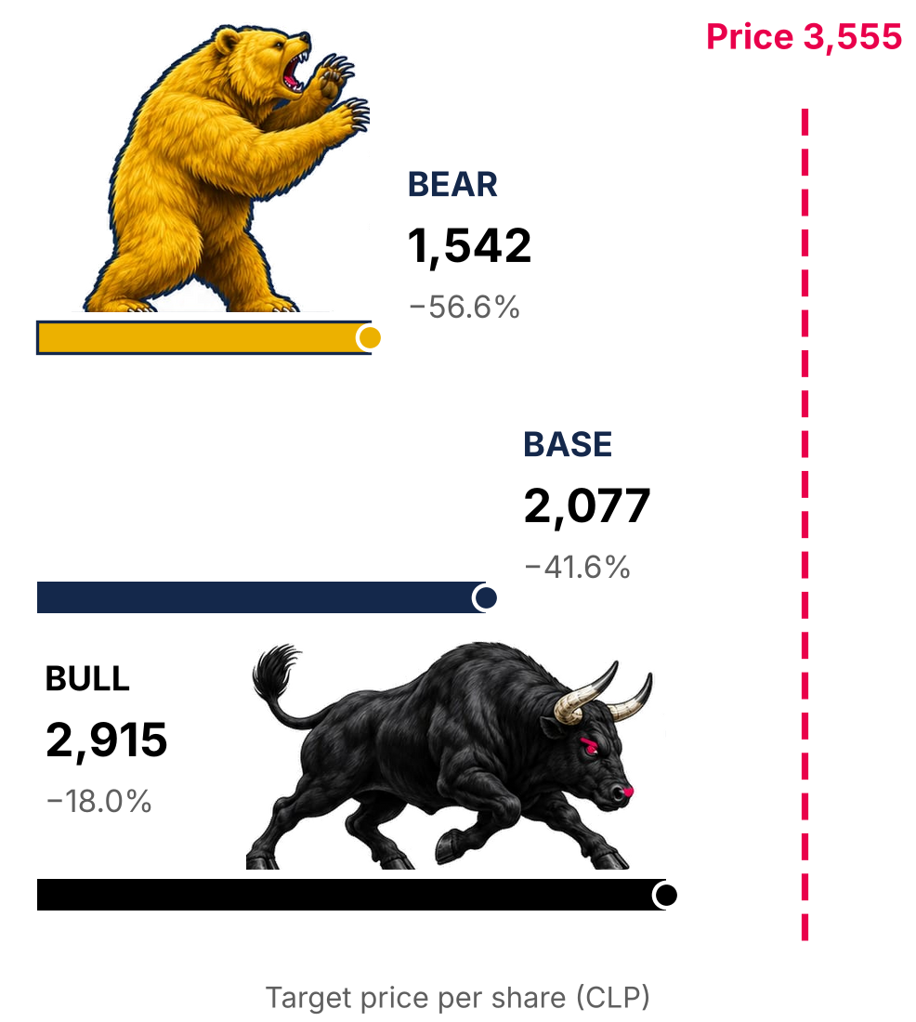
Bear: everything goes wrong; base: central estimate; bull: everything goes right (definitions in Appendix 18). Team illustrations. Source: DCF v4 replica; Team analysis.
Figure 34: From our DCF to the price and the consensus: the gap is the discount rate (CLP per share)
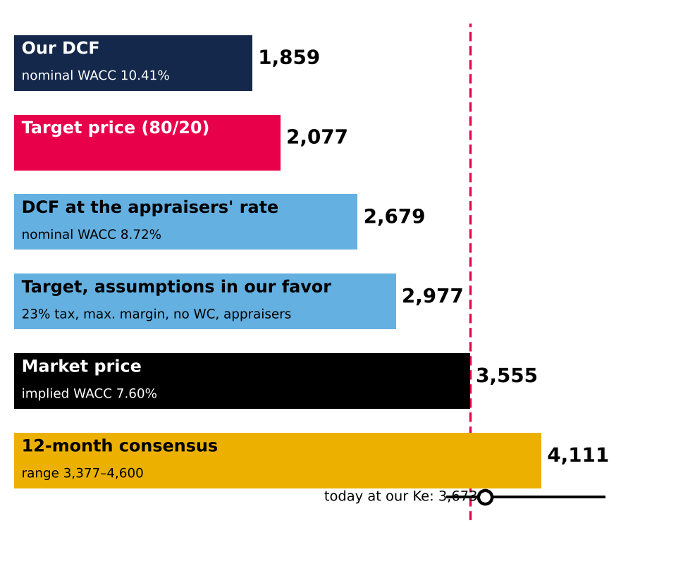
Consensus: Bloomberg 12-month target (14 sources). “Today at our Ke” = target / (1 + terminal nominal Ke). Source: Bloomberg; Team analysis.
Catalysts: high long-term rates (nominal 10Y UST at 5.22%), each new appraisal (Note 11) that moves the cap rate toward our value, and the normalization of cash tax from 16.8% to 27%. Risks to the thesis: a further compression of long-term rates; a structural premium for Tier A assets; the cut in corporate tax to 23% (+5.2% to the target price, not yet included); and corporate governance (Falabella controls 53.1% and only 1 of 9 directors is independent; expansion earns less than its cost of capital, with incentives still to be verified). ESG savings (~CLP 2 per share) do not change the conclusion.

APPENDICES: BUSINESS DESCRIPTION
Appendix 1: Tier A assets by GLA, 2Q26 (thousand m²)  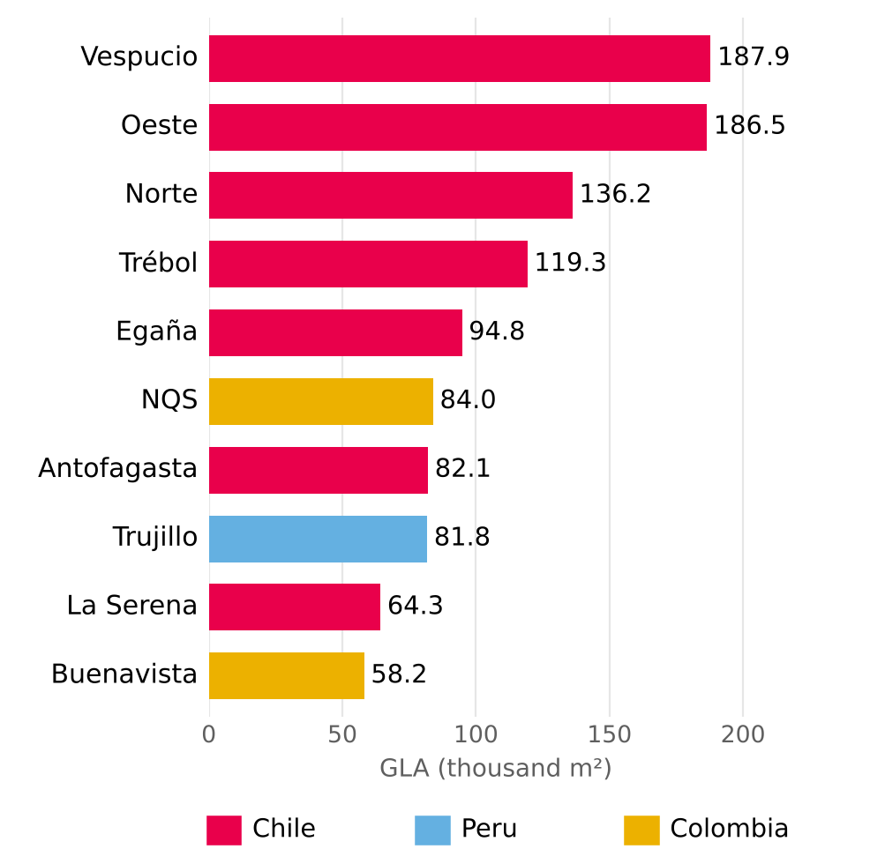  Source: Plaza S.A., Institutional Presentation 2Q26 (p.12). Tier A = 46.4% of total GLA. |  | Appendix 2: Department stores, % of total GLA  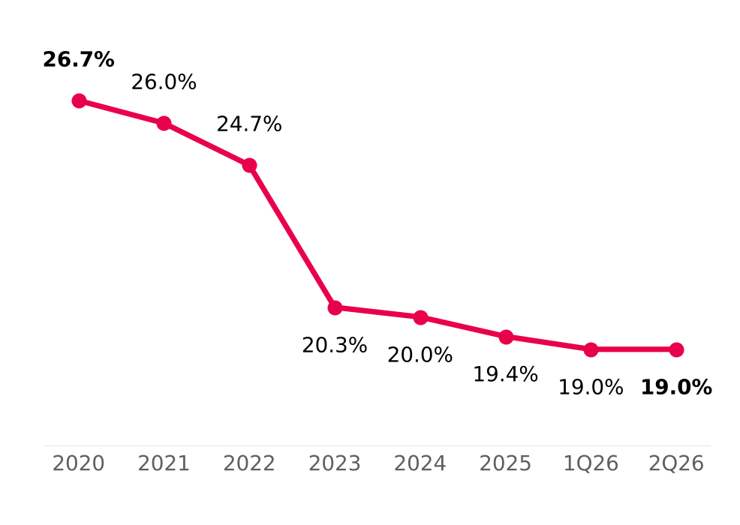  Source: Plaza S.A., Institutional Presentation 2Q26 (p.17).

APPENDICES: INDUSTRY AND COMPETITIVE POSITIONING
APPENDIX 3: NEW GLA SUPPLY, 2026-2028
The trio will add 432,030 m² between 2026 and 2028, of which 334,030 m² are organic (6.4% of their current total GLA; in Chile, 219,900 m², equivalent to 5.1% of the industry's GLA in Chile and 6.7% of the trio's own GLA). Acquisitions (98,000 m², all by Parque Arauco) change owner but add no supply to the industry; the supply-versus-demand analysis for Chile (Figure 3) therefore uses organic GLA only.
A. PIPELINE BY COMPANY (m²)  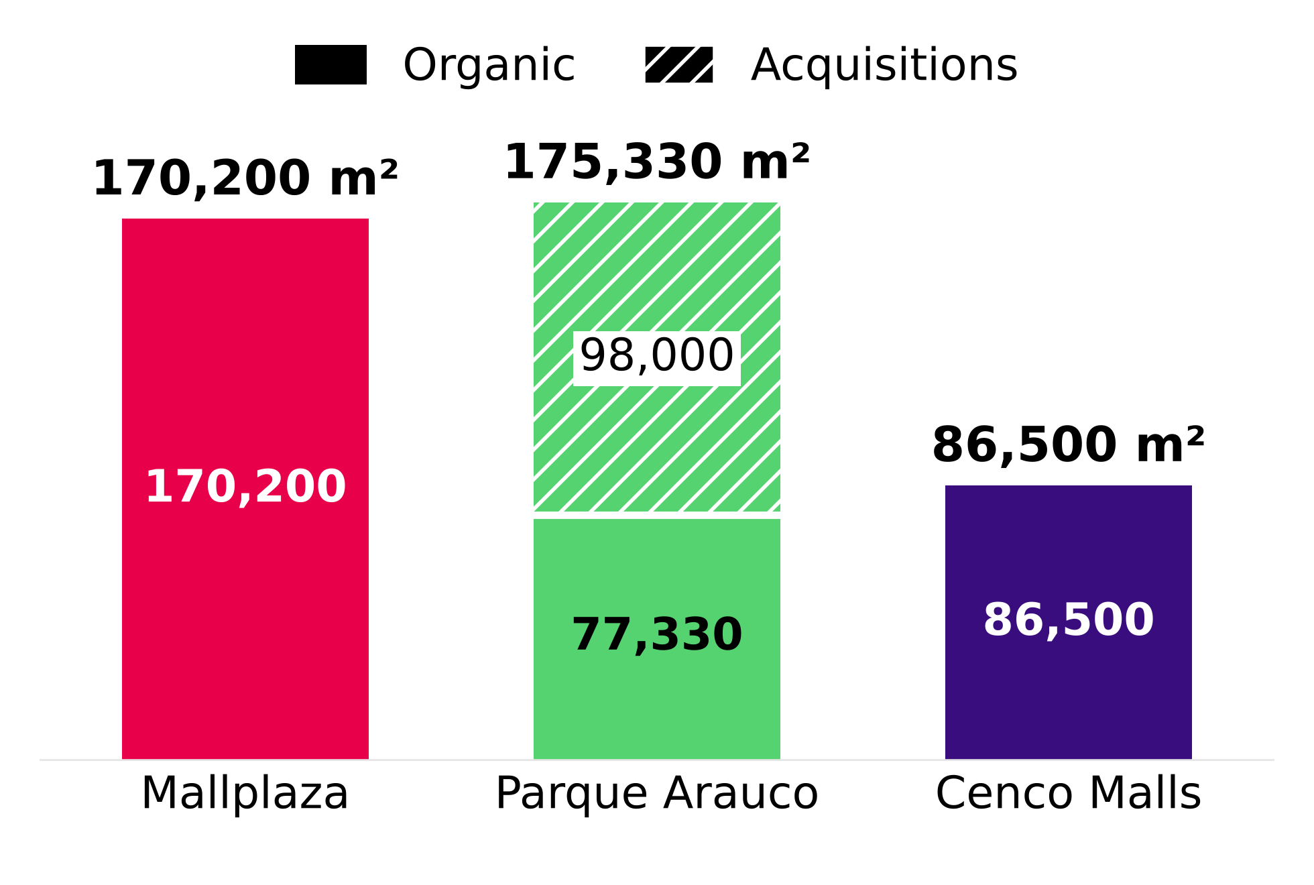 |  | B. GLA BY OPENING YEAR (m²)  Org./GLA = organic GLA 2026-2028 over consolidated GLA at 2Q26. Mallplaza: 2028 includes 46,500 m² of “Other projects Chile”, dated 2028 by the 2025 Annual Report (p.45). Parque Arauco: 2026 = 2H26 (acquisitions). Cenco: deliveries given as a range are placed at the end of the range. In Chile, the trio's organic supply (219,900 m²) equals 5.1% of the estimated industry GLA (≈4.3 million m²: 3.29 million of the trio excluding offices ÷ 76%, its share of the main operators).
  Company | 2026 | 2027 | 2028 | Organic | Acquis. | Total | Org./GLA
  Mallplaza | 8,900 | 72,950 | 88,350 | 170,200 | – | 170,200 | 7.2%
  Parque Arauco | 87,000 | 46,000 | 42,330 | 77,330 | 98,000 | 175,330 | 5.8%
  Cenco Malls | – | 34,000 | 52,500 | 86,500 | – | 86,500 | 5.6%
  Trío | 95,900 | 152,950 | 183,180 | 334,030 | 98,000 | 432,030 | 6.4%
Source: Plaza S.A., 2Q26 Release (p.13) and 2025 Annual Report (p.45); Parque Arauco, 2Q26 Investor Presentation (slide 23); Cenco Malls, 2Q26 Corporate Presentation (slides 15-17). Dated projects only.
APPENDIX 4: OCCUPANCY  The consolidated occupancy of the three operators has stayed between 93% and 99% since 2Q22, even through the inflation and high-rate cycle. Each company defines occupancy differently, so trends are compared rather than levels.  A. CONSOLIDATED OCCUPANCY RATE, 2Q22-2Q26  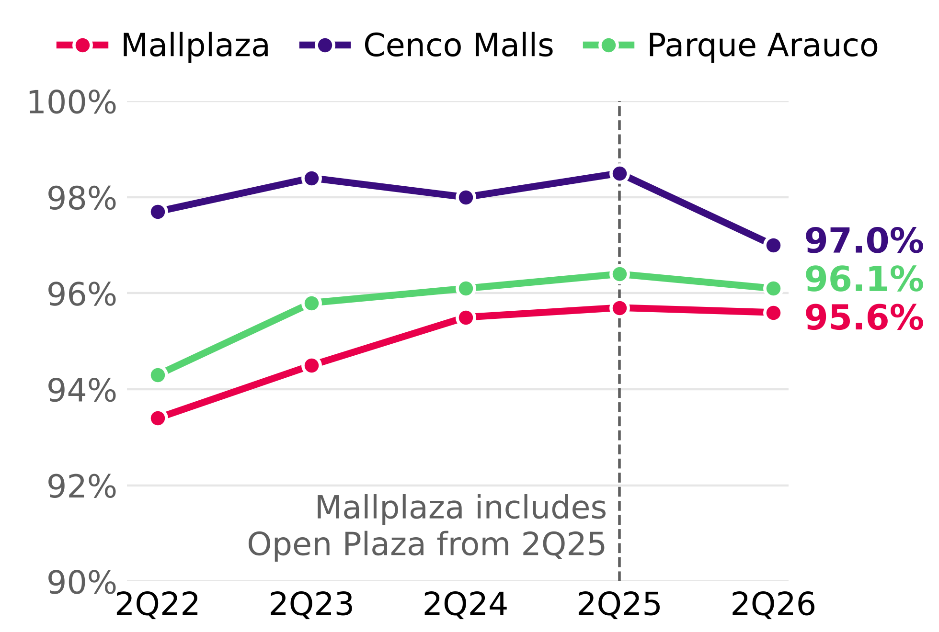  Source: 2Q22-2Q26 earnings reports of the three companies. Mallplaza includes Open Plaza since 2Q25. |  | APPENDIX 5: MARKET SHARE IN CHILE  The trio's GLA in Chile grew 7.3% since 2Q22. Mallplaza gave up 1.2 pp of share because it grew only through expansions, while Parque Arauco added Kennedy Oriente (70,000 m²) by purchase.  A. SHARE WITHIN THE TRIO, 2Q22-2Q26 (% OF GLA)  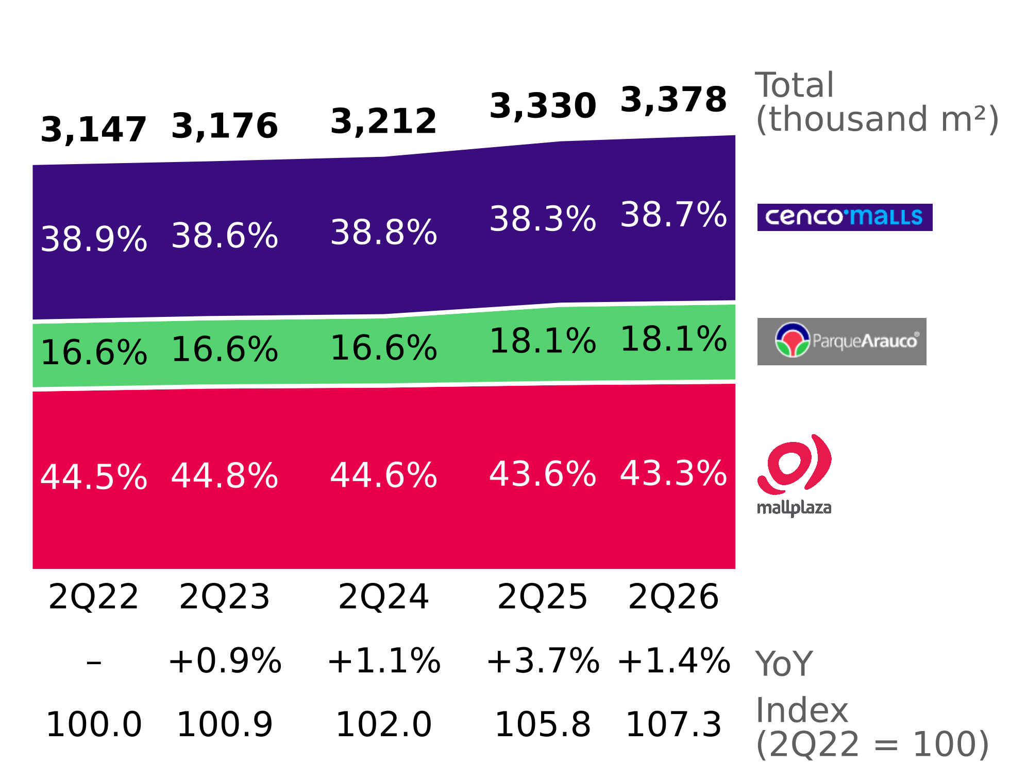  Source: 2Q22-2Q26 earnings reports of the three companies; Team analysis.
APPENDIX 6: PORTER'S FIVE FORCES
Attractive industry: with whole-number scores by country weighted by Mallplaza's GLA, the only intense force is rivalry (4), which plays out in experience and assets rather than price, since in 2Q26 same-store rents rose in Chile at all three operators (table B).
A. SCORES BY COUNTRY AND MAIN EVIDENCE (1 = WEAK FORCE; 5 = INTENSE FORCE)
Force | Chile | Peru | Colombia | Final | Main evidence
Rivalry | 4 | 4 | 4 | 4 | CR3 76% / 37% / 13%; reinvestment race in experience; asset purchases (Minka, Plaza Central; Quilín and Chicureo announced); supply catching up with consumption in 2027. Stable shares and margins of 71-90%. No price war: positive SSR/SAR in Chile (table B).
New entrants | 1 | 2 | 3 | 2 | Capital intensive (USD 613 million for 170,200 m² at Mallplaza); incumbents' land banks; Peru and Colombia less concentrated; Colombia with most malls under horizontal ownership.
Tenant bargaining power | 1 | 2 | 2 | 1 | Chile occupancy 96-99%; contracts averaging 5.0-8.7 years; top 5 = 18% of Mallplaza's revenue; Chile SSR above CPI (6.9% vs 4.8%, 1Q23-2Q26); department stores 19.0% of GLA.
Supplier bargaining power | 1 | 1 | 1 | 1 | Common expenses passed through to tenants (2025 Annual Report, note 2.20); cost of sales 6.2% of Mallplaza's revenue.
Substitutes | 2 | 2 | 2 | 2 | 93% of Mallplaza's rental income is fixed; 2Q26 visits +4.4% Chile, +1.3% Peru, +2.5% Colombia; shift to experience. No official e-commerce data by country.
Source: Team analysis. Final score = average weighted by Mallplaza's GLA at 2Q26 (Chile 61.9%, Peru 26.2%, Colombia 11.9%), rounded to the nearest integer. For new entrants the weighted score sits at the threshold (1.5) and the team sets it at 2 because of lower entry barriers in Peru and Colombia.
B. PRICE INDICATORS BY OPERATOR, 2Q26
Indicator | Country | Mallplaza | Cenco Malls | Parque Arauco
Same-store or same-area rent (YoY change) | Chile | SSR +5.4% | SSR +0.8% | SAR +3.8%
 | Peru | SSR +4.7% | SSR +11.0% | SAR +3.0%
 | Colombia | SSR +7.5% | SSR −9.9% | SAR +13.0%
Monthly revenue per m² (YoY change) | Chile | CLP 28,618 (+6.6%) | Not published | CLP 31,571 (+9.6%)
 | Peru | PEN 66 (+10.0%) | Not published | PEN 68 (−0.1%)
 | Colombia | COP 84,790 (+8.0%) | Not published | COP 125,932 (+10.3%)
Occupancy cost (2Q25) | Chile | 10.3% (10.2%) | 9.1% (8.8%) | 11.9% (11.1%)*
 | Peru | 7.3% (7.4%) | 8.8% (8.8%) | 8.1% (8.4%)*
 | Colombia | 10.5% (10.4%) | 6.5% (7.5%) | 11.7% (11.5%)*
Source: Plaza S.A., 2Q26 Release (p.18); Cenco Malls, 2Q26 Earnings Presentation (p.17); Parque Arauco, 2Q26 Earnings Report (p.5, p.6 and p.21). Each indicator follows each company's definition: Mallplaza's SSR considers fixed rent in Chile and the change in the UF; Cenco's includes variable rent (Cenco 1Q26: “SSR Chile reflects the effect of lower sales”); Parque Arauco's SAR measures rent collected in areas leased in both periods. *Includes common expenses and promotion fund: its level is not comparable, its change is. Mallplaza's revenue per m² change in Colombia (+8.0%) is a team calculation: 84,790 / 78,545 − 1. Everything else is published data.
APPENDIX 7: MAIN ASSUMPTIONS
Criteria used so that figures are comparable across operators and consistent with the official 2Q26 reports.
Topic | Assumption
Market share | Measured by GLA (not by sales) over each country's main operators (slide 7, 2Q26 Institutional Presentation). Partial HHI: considers only the operators identified on slide 7, so it is a floor (the real HHI is equal or higher); classified with the 2023 DOJ/FTC Merger Guidelines thresholds (above 1,800 = highly concentrated). Colombia pro forma: includes Gran Plaza (announced acquisition of 179,667 m²; 2Q26 Release); without it, Mallplaza's share would be 4.3%.
Pipeline | Only dated projects in official reports at 2Q26 and the 2025 Annual Report; dates given as a range are placed at the end of the range; acquisitions are not new supply for the industry.
Supply vs demand | Chile only and only m² that depend on consumption (excludes offices and multifamily); base GLA excludes Cenco's offices. Private consumption from the September 2026 IPoM is used as a demand indicator, not as a sales projection. Industry GLA in Chile ≈ trio GLA excluding offices ÷ 76% (the trio's share of the main operators, slide 7); the trio's supply is a lower bound of the industry's supply.
EBITDA per m² | EBITDA per each company's definition (none includes the IAS 40 revaluation); 2Q26 EBITDA not annualized; GLA consolidated at 100% of controlled assets. Parque Arauco: multifamily NOI (CLP 503 million) is subtracted, since its size is reported in units and not in m²; effect −0.7%, does not change the ranking.
Contracts | Profile and duration weighted by GLA. Cenco states it explicitly; Parque Arauco presents its maturity profile as % of GLA but does not state the basis of its average duration; Mallplaza does not publish the basis. In both cases GLA is assumed.
Real sales | Tenant sales in Chile 2Q26 vs 2Q25 deflated with the 12-month CPI of June 2026 (4.3%; INE, release of 08-07-2026). Cenco 2Q25 calculated from its published change (−1.9%).
Real Plaza (Peru) | InRetail 2Q26 adjusted EBITDA, Shopping Malls segment (S/ 131 million; excludes investment property revaluation) ÷ total GLA of 888,000 m² (InRetail, 2Q26 Corporate Presentation, p.26 and p.29). Mallplaza Peru: published monthly EBITDA per m² (S/ 53) × 3 (2Q26 Release, p.18). Margins are not compared: InRetail calculates its own on net rent.
Dates | Company data as of 30-Jun-2026; macro projections from the September 2026 IPoM as the most recent available.

APPENDIX 8: CORPORATE GOVERNANCE AND SUSTAINABILITY
Supporting information for the ESG section: ownership structure, Board of Directors, compliance, stakeholder engagement model, organisational culture and waste. Main source: Mallplaza Annual Report 2025.
1. OWNERSHIP STRUCTURE (31-DEC-2025)
Figure 8.1: Shareholding by type of shareholder
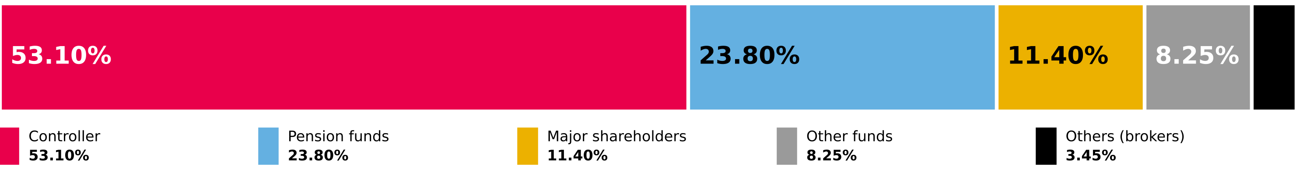
Source: Mallplaza Annual Report 2025 (NCG 461 2.3.3). No ADRs or certificates issued abroad.

Ten largest shareholders | Shares | % of shares
Desarrollos Inmobiliarios SpA (Falabella) | 1,161,849,244 | 53.10%
Inversiones Avenida Borgoño Limitada | 197,439,955 | 9.02%
Banchile Corredores de Bolsa S.A. | 59,447,149 | 2.71%
BCI Corredor de Bolsa S.A. | 53,553,765 | 2.45%
AFP Habitat S.A. Pension Fund C | 50,733,976 | 2.32%
Santiago Stock Exchange | 41,532,310 | 1.90%
AFP Provida S.A. Pension Fund C | 37,746,440 | 1.72%
Banco Santander on behalf of foreign investors | 35,594,345 | 1.63%
AFP Capital S.A. Pension Fund C | 34,539,038 | 1.58%
AFP Habitat S.A. Pension Fund B | 30,039,097 | 1.37%
2. BOARD OF DIRECTORS (ELECTED 22-APR-2025)
Figure 8.2: Board members (red: independent director; blue: chairman)

9 full members, no alternates; one independent director. Each director holds at most four positions in other listed companies. Tomás Müller, Manuela Sánchez and Juan Pablo Montero were directors until 22-Apr-2025. Source: Mallplaza Annual Report 2025.
3. ETHICS AND COMPLIANCE, 2025
Matter | Cases
Corruption | 0
Breaches of customer rights (Consumer Protection Law 19,496) | 27
Breaches of employee rights | 2
Proceedings by the Environment Superintendency | 1
Complaints of workplace, sexual harassment and violence at work | 8
Source: Mallplaza Annual Report 2025.
4. STAKEHOLDER ENGAGEMENT MODEL
Figure 8.3: Implementation process of the engagement model
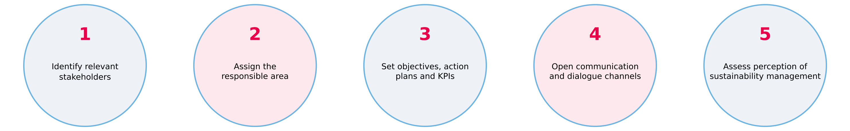
Source: Mallplaza Annual Report 2025.
5. ORGANISATIONAL CULTURE: 2025 CULTURE SURVEY
75%  Engagement  −2 pp vs 2024 · 2025 target: 80% |  | 37  eNPS  −10 vs 2024 |  | 88%  Leadership  +2 pp vs 2024 |  | 93%  Participation  +3 pp vs 2024
Leadership (88%) is the main asset to leverage the strategy. Source: Mallplaza Annual Report 2025.
6. WASTE, 2025
Figure 8.4: Waste generation by country  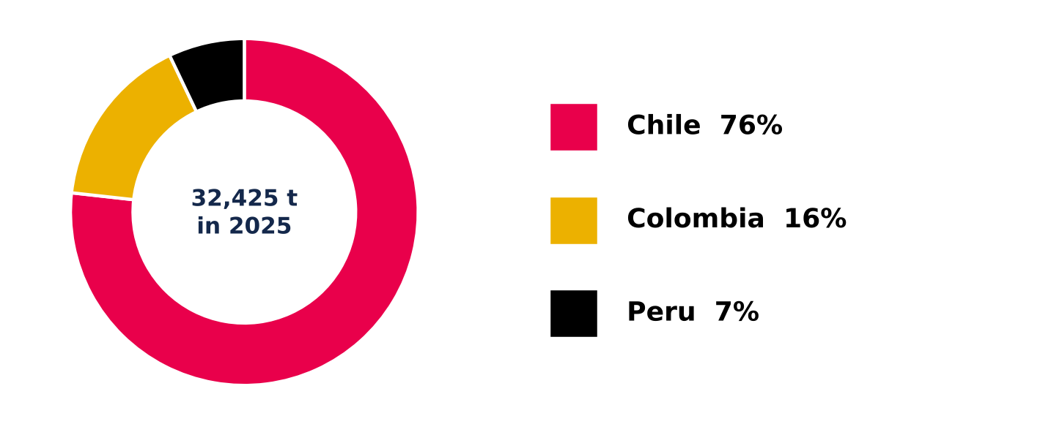  Source: Mallplaza Annual Report 2025. |  | 32,424.86 tonnes of waste across the region: 76% in Chile, 16% in Colombia and 7% in Peru.  46.2% recovered: 14,987.57 t of non-hazardous waste went to energy recovery through biogas (40.4%), recycling (36.1%) and composting (23.5%); the rest went to disposal, mainly sanitary landfills.  Hazardous waste: 9.03 t, a marginal amount given the nature of the business.
7. ESG RISK MATRIX
Figure 8.5: ESG factor matrix and its effect on the investment case
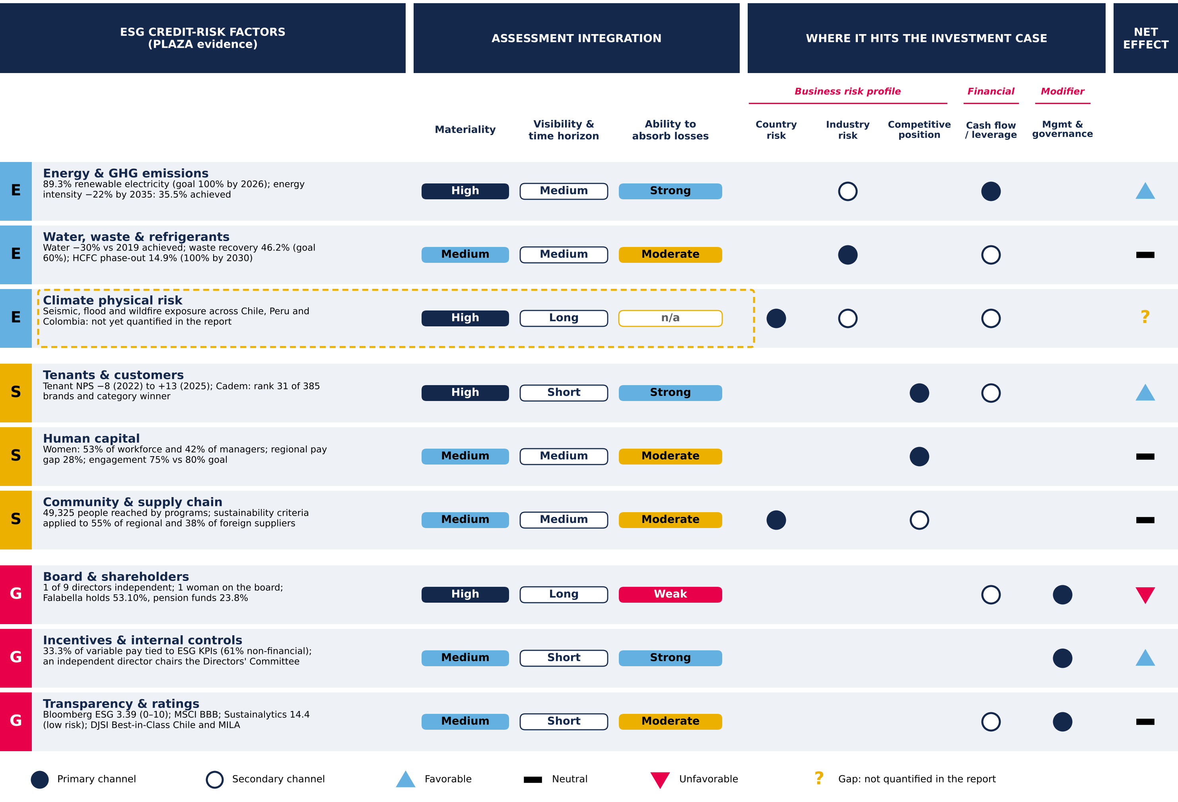
Materiality, time horizon, ability to absorb losses and net effect are team assessments. Framework adapted from S&P Global Ratings' approach to ESG credit factors. Source: Mallplaza Annual Report 2025, Bloomberg, MSCI, Sustainalytics, S&P Global; Team analysis.
8. EXECUTIVE TEAM TRACK RECORD
Name | Role at PLAZA | Tenure | Previous experience | Profile and responsibilities
Pablo Pulido Sierra | CEO (since 2026) | 10 years | Grupo Casino, Grupo Éxito | Commercial profile; experience in regional integrations.
Fernando de Peña Iver | CEO (until 2025) | 35 years | Career at Mallplaza | Led the company until 2025; extensive career in Latin American retail.
Derek Schweitzer Tang | Chief Administration and Finance Officer (CFO) | Since 2023 | BRMalls | International experience; his area leads the financial structure and the entry into global indices (MSCI).
Carlos Honorato C. | CTO, Chief Technology Officer | 2 years | Ripley.com, Neoris, Alto Movup, ProChile | Responsible for modernizing omnichannel sales and corporate cybersecurity.
María Sol de Cabo | Chief People and Culture Officer | Since 2025 | Betterfly | Over 20 years of international experience in talent management.
Oscar Munizaga Delfín | Chief Development and Business Officer | 34 years | Career at Mallplaza | Responsible for growth through M&A and greenfield developments.
Luis Hernán Silva | Chief Legal, Risk and Compliance Officer | 27 years | Career at Mallplaza | Responsible for corporate legal affairs and risk and compliance management.
Source: company public information; Team notes (track record).

APPENDICES: FINANCIAL ANALYSIS
Appendix 9: Forecast assumptions (nominal CLP, 2026E–2031E)  Tags: R reported · C team calculation · S team assumption · P market consensus. Source: Plaza S.A. financial statements (CMF); 2Q26 release; Bloomberg ECFC; PwC Tax Summaries (Jul-26); Team analysis. |  | Appendix 10: Summary financial statements (CLP bn)  LTM = 2025 − 1H25 + 1H26. 2024 restated in the Dec-25 financials; 2022A from the restated Dec-23 financials. Vertical analysis: % of total assets at Jun-26; the balance sheet is 92% investment property at fair value and deferred taxes (CLP 1,314bn) equal 80% of gross debt. Source: Plaza S.A. financial statements (CMF) Dec-24, Dec-25, Jun-26.  Appendix 10D: Sources and uses of cash and change in operating cash flow (CLP bn)  The 1H26 rise comes from collections (partly December balances: receivable days from 66 to 50) and lower taxes paid; it is not extrapolated. FCF = operating cash flow − capex − net interest. Source: Dec-25 and Jun-26 financials, direct cash-flow statement; Notes 11 and 25.
  Variable | Assumption | Basis | Tag
  2026E anchor | 1H26 actual + 2H26E repeating the 1H26 local-currency growth (Chile 6.1%, Peru 7.9%, Colombia 7.3%) | Interim financials Jun-26 | R/S
  Inflation | Consensus CPI 2026–28; central-bank targets from 2029 (CL 3%, PE 2%, CO 3%) | Rents indexed to UF/CPI | P/S
  Real same-store growth (ex parking) | Chile 1.5% → 0.6%; Peru 1.5% → 0.4%; Colombia 2.5% → 2.1% (2027E → 2031E) | Appraisal midpoints (Note 11) | S
  Occupancy | Chile 96.1% and Colombia 97.5% constant; Peru 93.8% → 94.6% by 2028E | 2Q26 actual; Peru returns to 2025 | R/S
  Parking | 12.1% / 6.4% / 9.0% of 2026 revenue; real growth 9% → 2% | 2Q26 release (LTM +23.7%) | R/S
  Pipeline GLA | 8,900 m² (2026), 72,950 m² (2027), 88,350 m² (2028, incl. 46,500 m² of other projects in Chile); 35/90/100% ramp; 170,200 m² in total | 2Q26 release; 2025 Annual Report (p. 45) | R/S
  Continuous expansion | 27,075 m²/yr opening from 2029E (67% Chile / 33% Peru); USD 3,603/m² indexed to CPI; capex 50% in t−2 and 50% in t−1 (from 2027E); 80.7% margin; yield on cost 7.3% | Organic GLA avg 2022, 2023, 2025; pipeline cost/m² | C/S
  FX | Year-end consensus 2026–28; purchasing-power parity afterwards | Bloomberg ECFC, 5-Oct-26 | P/S
  EBITDA margin | Chile 80%, Peru 82%, Colombia 74% (≈ 79.7% consolidated) | 2024–LTM 2Q26; 2025 peak not extrapolated | S
  D&A | 0.704% of revenue from 2H26E; 2026E = 1H26 actual (2,993) + 2H26E (2,565) | LTM 2Q26 (4,766 / 677,333) | C
  Cash tax | 16.8% (2026E) → 19% → 21.5% → 24% → 27% (2030E–31E), Chile's rate on all EBIT | 1H26 current tax; Peru/Colombia in Appendix 18 | C/S
  Maintenance + IT capex | 5.5% of revenue (2H26E: half year) | 2024 (4.8%) – LTM 2Q26 (~6.6%) | S
  Incremental capex: pipeline | USD 579m remaining at Jun-26 (USD 445m dated projects + USD 134m other projects in Chile), spread until opening (2H26E–28E) | 2Q26 release, pipeline; Exhibits v7 | R/S
  Incremental capex: expansion | Continuous expansion (above); terminal incremental capex = 0 (real g 0%) | RONIC 5.3% < real WACC 7.2% | C/S
  Working capital | Net operating working capital at 15.6% of revenue (Dec-25); 2026E covers 2H26E only | Dec-25 financials, first close with full Peru | C/S
  Leverage | Net debt/EBITDA 2.36x (Jun-26) → 3.5x by Dec-31E, linear; cash above plan returned via buybacks or special dividends | Team assumption; peers 2.1x–5.7x | S
  Cost of debt | Net financial cost 3.08% of opening net debt + 25bp real per turn above 2.36x; UF indexation on 79% of debt | 1H26 annualized; team assumption | C/S
  Excluded: greenfield (Mallplaza Cali) | USD 0.7m LTM Jun-26 vs USD 55.2m in 2023 | Immaterial | S
  Excluded: Gran Plaza | Subsequent event: 31-Jul-26 contract subject to the SIC (Note 30); USD 376m at a 9.4% cap rate (LTM NOI); ~−CLP 11/share at our cap rate (Appendix 18) | After the valuation date (30-Jun-26) | S
  Payout | 40% of distributable profit with a one-year lag, plus the additional distributions | Board policy (Note 20e) | R/S
  Income statement | 2022A | 2023A | 2024A | 2025A | LTM 2Q26
  Revenue | 370.9 | 419.9 | 494.6 | 653.9 | 677.3
  EBITDA (company definition) | 282.7 | 322.2 | 380.6 | 526.2 | 544.9
  D&A | (2.2) | (2.2) | (2.1) | (3.6) | (4.8)
  Revaluation and other op. items, net | 83.1 | 193.7 | 157.3 | 1,445.4 | 1,190.4
  Operating profit | 363.6 | 513.8 | 535.9 | 1,968.1 | 1,730.6
  Net financial cost | — | (23.8) | (30.9) | (54.0) | (44.9)
  UF indexation of debt | — | (55.3) | (53.2) | (43.8) | (50.4)
  Attributable profit | 157.7 | 349.8 | 335.9 | 1,431.0 | 1,258.1
  Attributable FFO (company) | 218.9 | 257.2 | 303.2 | 405.3 | 419.9
  Balance sheet | Dec-23 | Dec-24 | Dec-25 | Jun-26 | % assets
  Current assets | — | 405.0 | 472.1 | 507.1 | 6.4%
  Cash and equivalents | 202.0 | 179.2 | 268.3 | 347.6 | 4.4%
  Non-current assets | — | 5,510.1 | 7,111.5 | 7,478.6 | 93.6%
  Investment property | 4,166.5 | 5,356.5 | 6,961.9 | 7,309.8 | 91.5%
  Total assets | 4,796.3 | 5,915.1 | 7,583.6 | 7,985.7 | 100%
  Current liabilities | — | 344.5 | 307.1 | 203.2 | 2.5%
  Non-current liabilities | — | 2,379.5 | 2,752.0 | 2,910.8 | 36.5%
  Gross financial debt (ST + LT) | 1,264.0 | 1,617.6 | 1,579.3 | 1,633.4 | 20.5%
  Deferred tax liabilities | 656.5 | 892.9 | 1,248.8 | 1,313.7 | 16.5%
  Total equity | — | 3,191.0 | 4,524.6 | 4,871.7 | 61.0%
  Attributable equity | 2,601.1 | 3,157.9 | 4,482.9 | 4,820.9 | 60.4%
  Cash flow | 2023A | 2024A | 2025A | 1H26
  Operating cash flow | 295.1 | 300.8 | 441.1 | 258.2
  Capex | (119.1) | (76.3) | (103.6) | (84.2)
  Acquisitions (incl. minorities) | (164.6) | (400.4) | (0.3) | —
  Share issuance | — | 308.4 | — | —
  Net borrowing / (repayment) | (124.0) | 1.3 | (86.5) | 5.5
  Interest paid | (55.6) | (54.4) | (68.2) | (30.1)
  Dividends paid | (0.0) | (125.8) | (108.5) | (87.6)
   | 2025 | 1H26
  Operating cash flow | 441.1 | 258.2
  New debt (bonds + loans) | 245.7 | 57.9
  Interest received and other | 17.6 | 12.5
  Total sources | 704.5 | 328.7
  Capex (IP + intangibles + PP&E) | 103.6 | 84.2
  Debt repayment | 332.2 | 52.4
  Interest paid | 68.2 | 30.1
  Dividends paid | 108.5 | 87.6
  Minorities and other | 2.9 | 1.4
  Cash increase (before FX) | 89.0 | 72.9
  Total uses | 704.5 | 328.7
  Dividend cover: FCF before debt | 2.6x | 1.7x
  Cover after net debt repayment | 1.8x | 1.8x
  Contractual capex commitments (Note 11) | 18.1 | 78.0
  Covenant net debt / equity (≤ 2.0x; Note 25) | 0.29x | 0.26x
  Δ operating cash flow | 1H25 | 1H26 | Δ | %Δ
  Collections from sales and services | 402.1 | 458.3 | +56.1 | 78%
  Payments to suppliers | (92.3) | (84.4) | +7.9 | 11%
  Payments to employees | (25.9) | (33.5) | −7.6 | −11%
  Other operating payments | (49.6) | (45.1) | +4.6 | 6%
  Taxes paid | (48.5) | (37.5) | +11.0 | 15%
  Other inflows | 0.5 | 0.4 | −0.1 | 0%
  Operating cash flow | 186.3 | 258.2 | +71.9 | 100%

Appendix 11: Ratio dashboard  ROIC is a cash return on capital at fair value (excluding property revaluation): it is compared with the real WACC, not the nominal one. Operating costs include D&A; without it they are exactly 1 − EBITDA margin. Jun-26 leverage on LTM EBITDA; Dec-24 collection days n.m. (Peru consolidates one month). Source: Financial statements (CMF); MD&A 1H26; 2Q26 Release (p. 8; m²); Team analysis.  Appendix 11B: Net debt/EBITDA bridge Dec-24 → Jun-26 (CLP bn)  Peru = revenue − cost of sales − segment G&A (Dec-24 Note 31; Dec-25 Note 25; Jun-26 Note 24). Using LTM Jun-26 as a proxy for the full year makes 3.03x a lower bound of the 2024 pro forma.  Appendix 11C: Figures in the text: calculation and source |  | Appendix 12: The EBITDA we use is the company's: revaluation is removed once (CLP bn)  Bloomberg's EBITDA field includes revaluation and is not used. Source: Financial statements (CMF), Notes 23.1–23.3; 2Q26 release; Team analysis.  Appendix 13: Base-case projection (CLP bn)  2026E = 1H26 actual + 2H26E: D&A 3.0 + 2.6; 1H26 capex (84.2) has no breakdown by type in the release; Δ working capital and additional distributions cover 2H26E only. FFO = (EBITDA − net financial cost) × (1 − cash tax), before minorities (~1%); distributable profit = FFO − UF indexation. Source: model v4 (Forecast_Base, DCF, Deuda and Expansion sheets).  Appendix 14: With the same adjustment, Mallplaza has the highest normalized ROE among its local peers (2025)  Normalized = attributable profit − revaluation × (1 − 27%) × % attributable to the parent; revaluation = operating profit − (EBITDA − D&A) at Mallplaza and Parque Arauco, and −net other operating income at Cencosud Shopping. Limits: uniform 27% (Peru 29.5%, Colombia 35%); Cencosud EBITDA = revenue × Bloomberg adjusted margin; all three operate in Chile, Peru and Colombia, with different weights. Parque Arauco's investment in associates: CLP 209.2bn (Dec-25). Source: Financial statements (CMF); Bloomberg FA (PARAUCO CI, CENCOMAL CI; 28-Sep-26); Team analysis.
   | 2023 | 2024 | 2025 | Jun-26
  ROE, normalized (distributable profit) | 8.1% | 8.3% | 9.7% | —
  ROA, normalized | 4.2% | 4.5% | 5.5% | —
  ROIC (NOPAT at 27%, capital at fair value) | 6.5% | 6.6% | 7.3% | —
  ROIC − real WACC (7.2%), pp | −0.7 | −0.6 | +0.1 | —
  Current ratio (x) | 1.78 | 1.18 | 1.54 | 2.50
  Cash / current liabilities (x) | 0.83 | 0.52 | 0.87 | 1.71
  Total liabilities / equity (x) | 0.82 | 0.85 | 0.68 | 0.64
  LTV (net debt / investment property) | 25.5% | 26.9% | 18.8% | 17.6%
  Net debt / EBITDA (x) | 3.30 | 3.78 | 2.49 | 2.36
  EBITDA / financial costs (x) | 6.9 | 6.8 | 7.7 | 8.4
  Asset turnover (x) | 0.090 | 0.092 | 0.097 | —
  Net operating working capital / revenue | 12.8% | 16.3% | 15.6% | —
  Collection days | 65 | n.m. | 66 | 50
  Margin bridge (point 2) | 2023 | 2024 | 2025 | 1H26
  Operating costs (cost of sales + G&A) / revenue | 23.8% | 23.5% | 20.1% | 21.2%
  (−) D&A included in those costs / revenue | (0.5%) | (0.4%) | (0.6%) | (0.9%)
  = 1 − EBITDA margin | 23.3% | 23.0% | 19.5% | 20.3%
  Monthly revenue / EBITDA per m² (CLP, LTM Jun-26) | 24.006 / 19.241
   | DFN | EBITDA | x | Δ
  Dec-24 reported (Peru consolidates one month) | 1,438.4 | 380.6 | 3.78x | —
  Perimeter: Peru 12 months instead of 1 (LTM Jun-26: 104.3 − 9.5) | 1,438.4 | 475.5 | 3.03x | −0.75x
  EBITDA growth of the rest (to Jun-26) | 1,438.4 | 544.9 | 2.64x | −0.39x
  Lower net debt = Jun-26 reported | 1,285.7 | 544.9 | 2.36x | −0.28x
  Figure | Value | Source
  Rise in Chile investment property from fair value (1,141.2 / Chile IP Dec-24 3,933.0) | 29.0% | Dec-25 financials, Note 25
  Rate effect: (6.62% − 0.5%) / (5.64% − 0.5%) − 1, perpetuity | 19.1% | Note 11: Dec-24 / Dec-25 midpoints
  Rate share of the rise (“two-thirds”) | 66% | Calculation
  2025 growth from perimeter: (121.3 − 13.6) / 494.6 | 21,8 pp | Dec-25 financials, Note 25
  2025 growth ex-Peru: 532.6 / 481.0 − 1 | 10.7% | Dec-25 financials, Note 25
  2026E revenue (704.0) vs BEst consensus (701.7; 13 analysts) | +0.3% | Bloomberg EE/ANR, 17-Oct-26
  2026E EBITDA (561.3) vs BEst consensus (569.1) | −1.4% | Bloomberg EE, 17-Oct-26
  2025 ROE with the same method as peers | 10.0% | Appendix 14
   | 2022A | 2023A | 2024A | 2025A | LTM 2Q26
  Operating profit + D&A | 365.8 | 515.9 | 538.0 | 1,971.7 | 1,735.4
  (−) Other op. income (mainly fair value) | (85.4) | (195.6) | (162.5) | (1,448.9) | (1,194.5)
  (+) Other op. expenses (non-recurring) | 2.3 | 1.8 | 5.2 | 3.5 | 4.1
  Adjusted EBITDA | 282.7 | 322.2 | 380.6 | 526.2 | 544.9
  Check vs company EBITDA | 0.0 | 0.0 | 0.0 | 0.0 | 0.0
  CLP bn | 2026E | 2027E | 2028E | 2029E | 2030E | 2031E
  Revenue — Chile | 498.4 | 533.9 | 577.4 | 619.6 | 647.9 | 672.6
  Revenue — Peru | 131.3 | 145.2 | 159.8 | 171.6 | 178.6 | 184.9
  Revenue — Colombia | 75.2 | 88.1 | 89.4 | 92.2 | 96.8 | 101.8
  Eliminations | (1.0) | — | — | — | — | —
  Revenue — continuous expansion | — | — | — | 3.3 | 12.3 | 23.0
  Revenue | 704.0 | 767.2 | 826.7 | 886.8 | 935.6 | 982.3
  Growth | 7.7% | 9.0% | 7.8% | 7.3% | 5.5% | 5.0%
  EBITDA | 561.3 | 611.4 | 659.2 | 707.4 | 746.3 | 783.6
  EBITDA margin | 79.7% | 79.7% | 79.7% | 79.8% | 79.8% | 79.8%
  D&A | (5.6) | (5.4) | (5.8) | (6.2) | (6.6) | (6.9)
  EBIT | 555.8 | 606.0 | 653.3 | 701.1 | 739.8 | 776.7
  Cash tax rate | 16.8% | 19.0% | 21.5% | 24.0% | 27.0% | 27.0%
  Capex 1H26 actual (no breakdown) | (84.2) | — | — | — | — | —
  Capex — maintenance + IT | (19.4) | (42.2) | (45.5) | (48.6) | (50.8) | (52.8)
  Incremental capex — pipeline | (130.5) | (247.9) | (155.4) | — | — | —
  Incremental capex — continuous expansion | — | (46.3) | (95.3) | (98.2) | (101.1) | (104.2)
  Total capex | (234.1) | (336.4) | (296.2) | (146.8) | (151.9) | (156.9)
  Δ working capital | (3.9) | (9.9) | (9.3) | (9.4) | (7.6) | (7.3)
  FFO | 428.5 | 460.4 | 477.0 | 491.3 | 492.9 | 512.6
  Distributable profit | 380.0 | 427.7 | 438.3 | 446.4 | 441.1 | 454.4
  Ordinary dividends (40%) | (147.7) | (152.0) | (171.1) | (175.3) | (178.5) | (176.5)
  Additional distributions | (96.1) | (186.7) | (235.7) | (412.6) | (393.9) | (416.5)
  Net debt / EBITDA (x) | 2.46 | 2.67 | 2.88 | 3.09 | 3.29 | 3.50
   | Mallplaza | Parque Arauco | Cencosud Shopping
  Revaluation / opening property | 27.0% | 2.0% | 2.3%
  EBITDA / investment property (consolidated) | 7.6% | 7.5% | 7.7%
  ROE, reported | 37.5% | 9.8% | 10.5%
  ROE normalized — same method for all three | 10.0% | 7.8% | 8.0%
  ROE normalized — Mallplaza on distributable profit | 9.7% | — | —
  LTV (net debt / IP) | 18.8% | 42.9% | 16.3%
  LTV with JV/associate investments in the denominator | 18.8% | 40.6% | 16.3%
  Net debt / EBITDA (x) | 2.49 | 5.68 | 2.11
  Assets / attributable equity, closing (x) | 1.69 | 2.69 | 1.51

APPENDIX 15: DISCOUNTED CASH FLOW
FCFF in nominal CLP from 30-Jun-26, mid-period convention and each period's WACC (Appendix 19). Capex is split into maintenance and IT (5.5% of revenue) and incremental capex (pipeline under way and continuous expansion). Terminal value uses 2032E FCFF with nominal g of 3.0% (0% real: terminal incremental capex is zero because RONIC is below the real WACC) and a terminal WACC of 10.41%, and includes 108,301 m² of GLA maturing after 2031. It explains 78% of EV. Sections D and E break down each line and prove it ties to the DCF.
A. FIRM FREE CASH FLOW BY PERIOD (CLP MM)
 | 2H26E | 2027E | 2028E | 2029E | 2030E | 2031E | Terminal
Total revenue | 364,469 | 767,179 | 826,662 | 886,792 | 935,616 | 982,334 | 1,030,197
EBITDA | 290,741 | 611,360 | 659,160 | 707,354 | 746,336 | 783,607 | 821,950
EBITDA margin | 79.8% | 79.7% | 79.7% | 79.8% | 79.8% | 79.8% | 79.8%
Cash tax rate | 16.8% | 19.0% | 21.5% | 24.0% | 27.0% | 27.0% | 27.0%
NOPAT | 239,763 | 490,829 | 512,875 | 532,847 | 540,019 | 566,987 | 594,732
(+) D&A | 2,565 | 5,398 | 5,817 | 6,240 | 6,583 | 6,912 | 7,249
Maintenance + IT capex | (19,360) | (42,195) | (45,466) | (48,592) | (50,783) | (52,766) | (56,661)
Incremental capex: pipeline | (130,546) | (247,924) | (155,398) | −0 | −0 | −0 | 0
Incremental capex: continuous expansion | 0 | (46,268) | (95,313) | (98,172) | (101,117) | (104,151) | 0
Working capital investment | (3,908) | (9,859) | (9,282) | (9,383) | (7,619) | (7,290) | (4,682)
FCFF | 88,514 | 149,981 | 213,233 | 382,940 | 387,084 | 409,693 | 540,638
Nominal WACC of the period | 10.54% | 10.51% | 10.48% | 10.46% | 10.44% | 10.41% | 10.41%
Discount factor (mid-period) | 0.9753 | 0.9048 | 0.8188 | 0.7412 | 0.6711 | 0.6078
PV of FCFF / terminal value | 86,325 | 135,701 | 174,604 | 283,847 | 259,780 | 248,997 | 4,217,777
B. FROM ENTERPRISE VALUE TO VALUE PER SHARE |  | C. DCF VALUE SENSITIVITY (CLP/SHARE)
  Item | CLP MM | CLP/share
  PV of explicit FCFF (2H26E–2031E) | 1,189,255 | 543
  PV of terminal value | 4,217,777 | 1,926
  Enterprise value (EV) | 5,407,032 | 2,469
  (−) Net financial debt 30-Jun-26 | (1,285,740) | (587)
  (−) Minorities (book) | (50,841) | (23)
  Equity value / per share | 4,070,451 | 1,859
  Δ WACC \ g | g 2.5% | g 3.0% | g 3.5% | g 4.0%
  −100 bp | 2,329 | 2,288 | 2,238 | 2,176
  −50 bp | 2,106 | 2,058 | 2,000 | 1,930
  −0 bp | 1,912 | 1,859 | 1,796 | 1,722
  +50 bp | 1,741 | 1,685 | 1,620 | 1,544
  +100 bp | 1,590 | 1,533 | 1,467 | 1,391
Terminal value at 31-Dec-31: CLP 7,292,232 MM (implied terminal cap rate 11.3%; implied LTM EV/EBITDA of EV 9.9x). Bloomberg net debt (CLP 1,311,569 MM, used in multiples) differs from net financial debt by IFRS 16 lease liabilities (CLP 25,828 MM at Jun-26). Source: model v4, DCF and Sensibilidad sheets; 2,190 MM shares.
D. BREAKDOWN OF THE DCF LINES (CLP MM UNLESS STATED)
 | 2H26E | 2027E | 2028E | 2029E | 2030E | 2031E | Terminal
Revenue: base + expansion (D1)
Base revenue (operating engine) | 364,469 | 767,179 | 826,662 | 883,482 | 923,322 | 959,374
(+) Continuous expansion (cohorts from 2029) | 0 | 0 | 0 | 3,309 | 12,294 | 22,960
Chile / Peru / Colombia, calendar year (CLP bn) | 498.4 / 131.3 / 75.2 | 533.9 / 145.2 / 88.1 | 577.4 / 159.8 / 89.4 | 619.6 / 171.6 / 92.2 | 647.9 / 178.6 / 96.8 | 672.6 / 184.9 / 101.8
Bridge to terminal: + maturation of 108,301 m²; × (1 + 3.0%) |  |  |  |  |  | 40,818 | 30,006
EBITDA and D&A (D2–D3)
Base EBITDA | 290,741 | 611,360 | 659,160 | 704,685 | 736,420 | 765,088
(+) Expansion EBITDA (margin 80.7%) | 0 | 0 | 0 | 2,669 | 9,916 | 18,519
EBITDA Chile / Peru / Colombia, calendar year (80/82/74%) | 398.7 / 107.7 / 55.7 | 427.1 / 119.0 / 65.2 | 461.9 / 131.1 / 66.2 | 495.7 / 140.7 / 68.2 | 518.3 / 146.5 / 71.7 | 538.1 / 151.6 / 75.4
D&A = 0.704% × total revenue | 2,565 | 5,398 | 5,817 | 6,240 | 6,583 | 6,912 | 7,249
Tax, capex and working capital (D4–D6)
EBIT | 288,177 | 605,962 | 653,344 | 701,114 | 739,752 | 776,695 | 814,701
(−) Tax = EBIT × rate | −48,414 | −115,133 | −140,469 | −168,267 | −199,733 | −209,708 | −219,969
Incremental capex (a): pipeline, USD MM × USDCLP | 140.4 × 930 | 268.7 × 923 | 169.9 × 915
New GLA opening in the year (m²; pipeline and expansion) | 8,900 | 72,950 | 88,350 | 27,075 | 27,075 | 27,075
Total capex / revenue | 41.1% | 43.8% | 35.8% | 16.5% | 16.2% | 16.0% | 5.5%
Incremental capex / revenue | 35.8% | 38.3% | 30.3% | 11.1% | 10.8% | 10.6% | 0.0%
Δ revenue for working capital (× 15.6%) | 25,044 | 63,180 | 59,482 | 60,130 | 48,824 | 46,718 | 30,006
Country revenue from Appendix 13 (calendar year; 0.1 bn precision). 1H26 capex has no breakdown by type: the release only gives the LTM breakdown (USD 132.5m: maintenance 40.0; IT and other 10.2; brownfield 52.5; reconversion 29.1; greenfield 0.7). Yield on cost 7.3%; real RONIC 5.3% vs real WACC 7.2%.
E. TIE-OUT CHECK (CLP MM) |  | READING  Maximum absolute difference across all lines and periods: 0. The breakdown only reorders the DCF: EV CLP 5,407,032 MM, DCF value CLP 1,859 and target price CLP 2,077. Incremental capex (pipeline + expansion) weighs 38%–36% of revenue in 2H26E–2027E and ~11% from 2029E; maintenance, 5.5%. The terminal only funds maintenance: growing at a real RONIC of 5.3% under a real WACC of 7.2% would subtract value (Figure 23).  Terminal value starts from 2031E revenue (982,334), adds the maturation of the expansion already funded (+40,818) and indexes for inflation (+30,006) to 1,030,197; 2032E FCFF = NOPAT 594,732 + D&A 7,249 − maintenance 56,661 − working capital 4,682 = 540,638.
  Line: breakdown − DCF | Max. |diff.| 2H26E–Terminal
  Total revenue | 0
  Total EBITDA | 0
  D&A | 0
  Operating tax | 0
  NOPAT | 0
  Total capex (maintenance + incremental) | 0
  Working capital investment | 0
  FCFF | 0
  PV of FCFF | 0
  Terminal value / PV of TV / EV | 0
  Value per share (CLP) | 0
APPENDIX 16: PROJECTION ASSUMPTIONS
The base forecast follows the team's operating engine with the full dated pipeline (170,200 m², announced pipeline through 2028, including 46,500 m² of other projects in Chile); from 2029 a continuous expansion at the historical opening pace is added. 2026E revenue is calendar-year; the 2H26E period nets out the 1H26 actual (CLP 339,530 MM of revenue).
A. REVENUE, CAPEX AND WORKING CAPITAL PROJECTION (CLP MM)
 | 2H26E | 2027E | 2028E | 2029E | 2030E | 2031E
Base revenue (calendar year) | 703,999 | 767,179 | 826,662 | 883,482 | 923,322 | 959,374
Total revenue growth | 7.7% | 9.0% | 7.8% | 7.3% | 5.5% | 5.0%
Continuous expansion revenue | 0 | 0 | 0 | 3,309 | 12,294 | 22,960
Base EBITDA margin | 79.8% | 79.7% | 79.7% | 79.8% | 79.8% | 79.7%
Cash tax rate | 16.8% | 19.0% | 21.5% | 24.0% | 27.0% | 27.0%
Maintenance + IT capex (5.5% of revenue) | 19,360 | 42,195 | 45,466 | 48,592 | 50,783 | 52,766
Incremental capex: projects under way (USD MM) | 140.4 | 268.7 | 169.9 | 0.0 | 0.0 | 0.0
Average USDCLP | 930 | 923 | 915 | 921 | 921 | 921
Incremental capex: projects under way | 130,546 | 247,924 | 155,398 | 0 | 0 | 0
Incremental capex: continuous expansion | 0 | 46,268 | 95,313 | 98,172 | 101,117 | 104,151
Total incremental capex | 130,546 | 201,656 | 60,085 | −98,172 | −101,117 | −104,151
Total capex | 149,906 | 336,388 | 296,177 | 146,764 | 151,900 | 156,916
New GLA opening in the year (m²) | 8,900 | 72,950 | 88,350 | 27,075 | 27,075 | 27,075
Expansion cost per m² (CLP MM, CPI) | 3.32 | 3.42 | 3.52 | 3.63 | 3.73 | 3.85
Working capital investment | 3,908 | 9,859 | 9,282 | 9,383 | 7,619 | 7,290
B. CONTINUOUS EXPANSION |  | C. OPERATIONS, CAPITAL AND TERMINAL VALUE
  Assumption | Value
  New GLA per year from 2029 | 27,075 m²
  Base: organic average 2022, 2023 and 2025 | 30,458 / 38,618 / 12,150 m²
  Pipeline under way (2Q26 Release; 2025 Annual Report) | USD 613.2 MM / 170,200 m²
  Cost per m² (= pipeline) | USD 3,603
  Capex disbursement (from 2027E) | 50% in t−2 / 50% en t−1
  Revenue ramp (year 1 / 2 / 3+) | 35% / 90% / 100%
  Chile / Peru mix; EBITDA margin | 67.2% / 32.8%; 80% / 82%
  Yield on cost / real after-tax RONIC | 7.3% / 5.3%
  Assumption | Value
  LTM 2Q26 EBITDA margin | 80.5%
  Maintenance + IT capex | 5.5% of revenue
  Terminal incremental capex | 0 (real g 0%)
  D&A / revenue (LTM 2Q26) | 0.704%
  Cash tax | 16.8% → 27% (2030)
  Net working capital / revenue (Dec-25) | 15.6%
  Receivables / prepaid rents (Dec-25, CLP MM) | 122,370 / 20,247
  Terminal nominal g (real) | 3.0% (0.0%)
  Target net debt/EBITDA; real Kd per turn | 3.5x in 2031; +25 bp
  Payout on distributable profit | 40%
D. DEBT SCHEDULE (CLP MM; DEUDA SHEET)
 | 2H26E | 2027E | 2028E | 2029E | 2030E | 2031E
Opening net debt | 1,285,740 | 1,382,590 | 1,632,638 | 1,896,981 | 2,182,363 | 2,457,403
(−) FCFF | 88,514 | 149,981 | 213,233 | 382,940 | 387,084 | 409,693
(+) Net financial cost, after tax | 16,474 | 34,783 | 40,471 | 46,273 | 51,959 | 59,437
(+) UF indexation, after tax | 12,676 | 26,542 | 30,374 | 34,168 | 37,757 | 42,516
(+) Ordinary dividends | 60,108 | 152,016 | 171,061 | 175,311 | 178,543 | 176,458
(+) Additional distribution (buyback / special dividend) | 96,106 | 186,689 | 235,670 | 412,570 | 393,865 | 416,502
Closing net debt | 1,382,590 | 1,632,638 | 1,896,981 | 2,182,363 | 2,457,403 | 2,742,623
Closing net debt / EBITDA (x) | 2.46x | 2.67x | 2.88x | 3.09x | 3.29x | 3.50x
Closing gross debt (constant cash 347,621) | 1,730,211 | 1,980,259 | 2,244,602 | 2,529,984 | 2,805,024 | 3,090,244
Net debt(t) = net debt(t−1) − FCFF + financial cost and UF indexation after tax + ordinary dividends + additional distribution, which takes net debt to the target path (2.36x → 3.5x). Financial cost: 3.08% of net debt + 25 bp per turn above 2.36x; UF indexation on 79% of debt at 3.0%. Bond maturities: Figure 18. Source: model v4 (2Q26 Release; Dec-25 financials; Exhibits v7).
APPENDIX 17: COMPARABLE MULTIPLES
We use the same peer set as the WACC beta. LTM EV/EBITDA is the main method (neutral to leverage and to IAS 40 revaluation); the multiple weights the Chilean median 70% and the common-set median 30%. P/E and P/BV mix fair-value and cost-based peers: reference only. Price at 30-Sep-26; Bloomberg net debt and FX at 30-Jun-26.
A. PEERS (CLP MM; MULTIPLES IN TIMES)
Company | Country | Market cap | EV | LTM EBITDA | LTM EV/EBITDA | NTM EV/EBITDA | LTM EV/EBIT | LTM P/E | P/BV
Mallplaza | Chile | 7,785,450 | 9,147,860 | 544,935 | 16.8x | 14.8x | 16.9x | 6.2x | 1.6x
Parque Arauco | Chile | 3,440,408 | 5,429,487 | 294,411 | 18.4x | 15.8x | 18.8x | 22.3x | 1.8x
Cencosud Shopping | Chile | 3,710,183 | 4,569,181 | 350,561 | 13.0x | 11.7x | 13.1x | 10.5x | 1.2x
Multiplan | Brazil | 2,907,890 | 3,796,907 | 421,296 | 9.0x | 10.1x | 9.6x | 11.7x | 2.4x
Allos | Brazil | 2,656,188 | 3,895,017 | 388,839 | 10.0x | 9.4x | 14.1x | 15.9x | 1.2x
Iguatemi | Brazil | 1,381,190 | 1,763,277 | 201,423 | 8.8x | 7.4x | 9.9x | 12.1x | 1.6x
IRSA | Argentina | 1,140,416 | 1,789,191 | 145,686 | 12.3x | 6.2x | 13.2x | 4.7x | 0.8x
Fibra Danhos (excluded) | Mexico | 2,383,999 | 3,157,944 | 277,625 | 11.4x | 10.1x | 11.4x | 7.9x | 0.7x
Common-set median (6) |  |  |  |  | 11.1x | 9.7x | 13.1x | 11.9x | 1.4x
Chile median (2) |  |  |  |  | 15.7x | 13.8x | 15.9x | 16.4x | 1.5x
Weighted 70/30 |  |  |  |  | 14.4x | 12.5x | 15.1x | 15.0x | 1.4x
B. VALUE BY MULTIPLE |  | C. SENSITIVITY TO THE WEIGHTING
  Multiple | Weighted | Metric CLP MM | CLP/share
  LTM EV/EBITDA (main) | 14.4x | 544,935 | 2,951
  NTM EV/EBITDA | 12.5x | 617,130 | 2,914
  LTM EV/EBIT | 15.1x | 540,373 | 3,098
  LTM P/E (ref.) | 15.0x | 1,258,053 | 8,644
  P/BV (ref.) | 1.4x | 4,820,898 | 3,171
  Chile weight | Multiple | Mult. value | Target price | Δ
  100% | 15.7x | 3,294 | 2,146 | +3.3%
  70% | 14.4x | 2,951 | 2,077 | 0.0%
  50% | 13.4x | 2,723 | 2,032 | −2.2%
  30% | 12.5x | 2,495 | 1,986 | −4.4%
  0% | 11.1x | 2,152 | 1,917 | −7.7%
Bridge: 14.36x × LTM EBITDA CLP 544,935 MM = EV 7,825,944 − Bloomberg net debt 1,311,569 − minorities 50,841 = CLP 2,951 per share (2,190 MM shares). Fibra Danhos is excluded because of its FIBRA regime and because it has no beta in the WACC; IRSA reports under IAS 29. Source: Bloomberg; model v4, Comparables and Precio_Objetivo sheets; Figuras_Valuacion, V7.
APPENDIX 18: SCENARIOS AND ROBUSTNESS
No scenario or alternative method reaches the CLP 3,555 price. Scenarios are computed with the DCF replica (it reproduces the base value exactly) and the target price keeps the 80% DCF weight and the multiples value of CLP 2,951. Bear is everything going wrong at once; bull, everything going right; both use the same levers as the Risks tornado. Probability weighting is a cross-check: the target price remains the base-case one.
A. SCENARIOS
Scenario | Assumptions (all at once) | Prob. | DCF (CLP) | Target price | vs price
Bear | Everything goes wrong: nominal WACC +100 bp in all periods; EBITDA margin 75.8%, occupancy 95.1%, same-store rent 2027–28 3.7%, tenant sales 3.7%, 2029–31 real growth at the Note 11 floor, visitors 5.6%, maintenance capex 6.6% | 30% | 1,190 | 1,542 | −56.6%
Base | Central: model v4; nominal WACC 10.54% → 10.41%; g 3.0%; margin 79.7% | 60% | 1,859 | 2,077 | −41.6%
Bull | Everything goes right: nominal WACC −100 bp; margin 81.3%, occupancy 96.6%, same-store rent 9.4%, tenant sales 9.9%, real growth at the Note 11 ceiling, visitors 17.3%, maintenance capex 4.8%; cash tax capped at 23% | 10% | 2,906 | 2,915 | −18.0%
Weighted | 30% / 60% / 10% (risk matrix: FR1 high, OR1 medium; low 10%, medium 30%, high 50%) | 100% | 1,763 | 2,001 | −43.7%
Appraisers | Nominal WACC 8.72% (5.55% real, Note 11) in all periods |  | 2,679 | 2,734 | −23.1%
Weights (team assumptions): the risk matrix gives FR1 (rates) high likelihood and OR1 (operating deterioration) medium; they translate to low 10%, medium 30% and high 50% over 12 months. Bear = FR1 and OR1 happening together (perfect correlation), with the probability of the less likely one: 30%. Bull = their opposites (high ↔ low, medium ↔ medium): 10%. Base = the remainder: 60%. Source: Risks page (matrix); matriz_datos.py.
B. ALTERNATIVE METHODS AND ASSUMPTIONS  C. DEBT TARGET VS SPREAD (DCF, CLP) |  | EFFECT OF EACH LEVER ALONE ON THE DCF (CLP/SHARE)  D. SENSITIVITIES REQUESTED BY THE REVIEW (OUTSIDE THE BASE CASE)
  Test | DCF (CLP) | Target price | vs price
  APV (Ku 11.11%): unlevered value | 1,630
  (+) tax shields of debt | 265
  = APV per share | 1,895 | 2,106 | −40.8%
  Peso-bond Rf 5.43% (WACC −107 bp) | 2,323 | 2,449 | −31.1%
  DCF VF: constant WACC 10.37% | 1,883 | 2,096 | −41.0%
  WACC implied by the price: 7.60% | 3,555
  Net debt/EBITDA \ spread | 0 bp | 25 bp | 50 bp
  2.36x (current) | 1,820 | 1,820 | 1,820
  3.0x | 1,851 | 1,843 | 1,835
  3.5x | 1,874 | 1,859 | 1,844
  4.0x | 1,897 | 1,872 | 1,849
  Lever (tornado extremes) | Bear | Bull
  EBITDA margin | −190 | +28
  Occupancy | −12 | +25
  Same-store rent 2027–28 (price) | −76 | +183
  Real rent growth 2029–31 | −47 | +26
  Maintenance + IT capex | −58 | +37
  Visitor traffic 2027–28 (parking) | −25 | +46
  Tenant sales 2027–28 (variable rent) | 0 | +16
  Nominal WACC ±100 bp | −326 | +430
  23% tax (bull only) | 0 | +136
  Sensitivity | DCF | Δ DCF | Target price | vs price
  Tax by jurisdiction: Peru 29.5%, Colombia 35% (weighted 28.3% vs 27%) | 1,807 | −52 | 2,036 | −42.7%
  D&A at the 1H26 run-rate (0.88% vs 0.704% of revenue) | 1,861 | +2 | 2,079 | −41.5%
  Gran Plaza included: USD 376m at a 9.4% cap rate (order of magnitude) | 1,848 | −11 | 2,069 | −41.8%
Bear and bull: every lever at the historical minimum/maximum of the Risks tornado (4Q23 and 3Q25 earnings releases for margin; Note 11 for long-run real growth) in all years; the bull does not recompute the WACC tax shield. Section D: each year's rate scaled by the EBITDA mix by country (Chile ~70%, Peru ~20%, Colombia ~10%; PwC Tax Summaries, Peru reviewed 13-Jul-26, Colombia 21-Jul-26); Gran Plaza at our implied cap rate (10.1%) − price paid, applying an EBITDA cap rate to an NOI. None changes the recommendation. Source: DCF v4 replica (escenarios_dcf.py); model v4, APV, Sensibilidad (table 2, static) and DCF sheets; Figuras_Valuacion, WACC_Construccion and V6.
APPENDIX 19: WACC CONSTRUCTION
The WACC is computed per period: D/E converges linearly from the current structure (20.0%) to the target (28.5%, net debt/EBITDA 3.5x) in 2031. The cost of equity is built in dollars (US Treasury Rf + re-levered beta × ERP + revenue-weighted CRP) and converted to pesos with the inflation differential.
βL = βU × [1 + (1 − t) × D/E] (Hamada)
Ke USD = Rf + βL × ERP + weighted CRP
Ke CLP = (1 + Ke USD) × (1 + π Chile) / (1 + π US) − 1
Kd CLP = (1 + real Kd + spread) × (1 + π Chile) − 1
WACC = E/V × Ke CLP + D/V × Kd CLP × (1 − t)
A. MARKET AND CAPITAL STRUCTURE ASSUMPTIONS
Assumption | Value | Source
Rf: 10Y US Treasury | 4.98% | Tasa_WACC (FFCF)
Equity risk premium (ERP) | 4.14% | Damodaran
Long-term inflation, Chile | 3.00% | Central Bank target
Long-term inflation, US (10Y breakeven) | 2.24% | Bloomberg, Jun-26
Chilean tax rate | 27.00% | Income Tax Law
Real Kd: latest UF bond coupon | 3.60% | Mallplaza
Real Kd increase per turn of net debt/EBITDA | 0.25% | Team assumption
Net debt/EBITDA initial (30-Jun-26) → target | 2.36x → 3.5x | 2Q26 release; team assumption
Gross debt / market cap (current structure, CLP MM) | 1,579 / 7,906 (thousands) | Tasa_WACC (FFCF)
B. BETA: UNLEVERED PEERS
Company | Levered β | Debt (CLP MM) | Market cap (CLP MM) | Tax rate | Unlevered β
Parque Arauco | 1.250 | 1,700,507 | 3,828,031 | 27% | 0.944
Cencosud Shopping | 1.075 | 762,154 | 3,942,858 | 27% | 0.942
Allos | 1.164 | 960,191 | 2,712,166 | 34% | 0.944
Iguatemi | 0.908 | 647,397 | 1,421,560 | 34% | 0.698
IRSA | 0.427 | 625,047 | 1,218,777 | 35% | 0.320
Multiplan | 1.219 | 191,478 | 2,959,845 | 34% | 1.169
Median (6 peers included) |  |  |  |  | 0.9428
Source: Bloomberg (betas), Tasa_WACC. Costa Verde is excluded because it is not in the comparables set.
C. REVENUE-WEIGHTED COUNTRY RISK
Country | Weight (LTM revenue) | CRP (Damodaran) | Contribution
Chile | 71.8% | 1.04% | 0.75%
Peru | 17.7% | 1.55% | 0.27%
Colombia | 10.5% | 3.70% | 0.39%
Weighted CRP | 100.0% |  | 1.41%
D. WACC BY PERIOD (Figure 19.1)
 | 2H26E | 2027E | 2028E | 2029E | 2030E | 2031E | Terminal
Net debt/EBITDA | 2.46x | 2.67x | 2.88x | 3.09x | 3.29x | 3.50x | 3.50x
D/E | 20.8% | 22.3% | 23.9% | 25.4% | 27.0% | 28.5% | 28.5%
D/V | 17.2% | 18.2% | 19.3% | 20.3% | 21.2% | 22.2% | 22.2%
Re-levered beta | 1.086 | 1.096 | 1.107 | 1.118 | 1.128 | 1.139 | 1.139
Ke USD | 10.88% | 10.93% | 10.97% | 11.02% | 11.06% | 11.10% | 11.10%
Nominal Ke CLP | 11.70% | 11.75% | 11.79% | 11.84% | 11.88% | 11.93% | 11.93%
Real Kd (UF) incl. spread | 3.63% | 3.68% | 3.73% | 3.78% | 3.83% | 3.89% | 3.89%
Nominal Kd CLP | 6.73% | 6.79% | 6.84% | 6.89% | 6.95% | 7.00% | 7.00%
After-tax Kd | 4.92% | 4.96% | 4.99% | 5.03% | 5.07% | 5.11% | 5.11%
Nominal WACC CLP | 10.54% | 10.51% | 10.48% | 10.46% | 10.44% | 10.41% | 10.41%
Real WACC | 7.32% | 7.29% | 7.26% | 7.24% | 7.22% | 7.20% | 7.20%
Figure 19.1: Nominal WACC and D/E by period  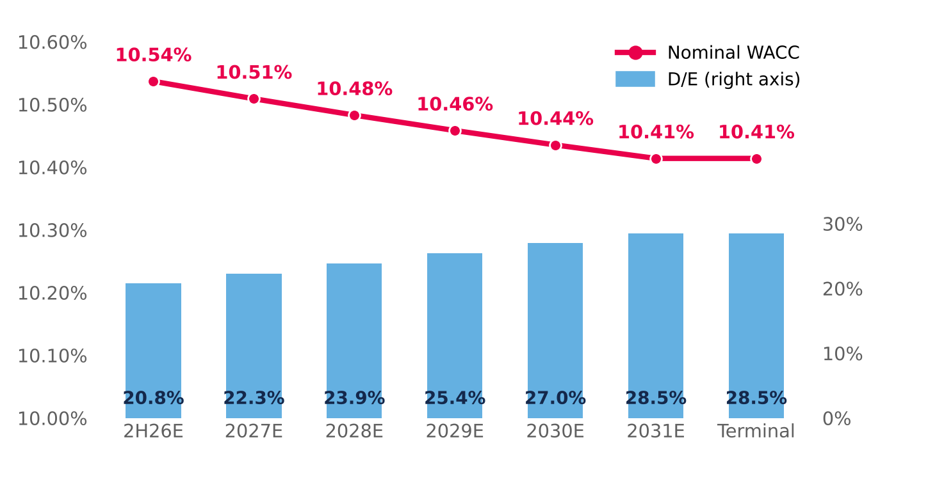  Control: the replica matches the WACC sheet of model v4 (0 bp difference in every period). Source: Damodaran; Bloomberg; Central Bank of Chile; Team analysis. |  | E. CHOICE OF THE RISK-FREE RATE  Why UST + CRP and not the peso bond: the local bond already embeds Chile risk, so adding the CRP would double-count it; also, 28% of revenue comes from Peru and Colombia, whose risk enters through the weighted CRP.  It is the more conservative choice: with the peso bond the target price rises to ~CLP 2,449, still 31% below the CLP 3,555 share price. The recommendation does not change.  Source: Central Bank of Chile, Informativo Diario 2-Jul-26; DCF v4 replica with the WACC shifted in every period.
  Alternative | Value
  Model base: US Rf + Chile CRP, in CLP | 6.80%
  10Y peso bond, Central Bank (30-Jun-26) | 5.43%
  Difference | 137 bp
  Effect on terminal WACC (difference × E/V) | −107 bp
  DCF value using the peso bond (CLP) | 2,323
  80/20 target price in that case (CLP) | 2,449

APPENDIX 20: MACROECONOMIC AND GEOPOLITICAL BACKDROP
Between 2022 and 2026 the world economy absorbed two geopolitical supply shocks and a structural rise in long-term rates. The result is a backdrop of stagflationary pressure and a higher cost of capital that reaches Chile through three channels — inflation, rates and consumption — and that sits behind the two most severe risks in the report (FR1 and MR1). In the charts, the dotted blue line marks the valuation date (30-Jun-2026); later data are shown for context. The figures cover the shock transmission (Figure 20.1), oil (Figure 20.2), sovereign yields (Figure 20.3), spreads (Figure 20.4), world growth and inflation (Figure 20.5) and Chile (Figure 20.6).
USD 114  Brent, Sep-26 average  +61% vs Feb-26, before the conflict |  | 5.22%  10Y UST, 8-Oct-26  24-year high (since 2002) |  | 117 bp  France–Germany spread  30-Sep-26; ~150 bp in early Oct. |  | 3.0% | 4.7%  IMF 2026: GDP | inflation  growth cut; disinflation stalled |  | 0.25–0.75%  Chile 2026 GDP (BCCh)  down from 2–3% expected in Dec-25
1. HOW THE SHOCK REACHES MALLPLAZA
Figure 20.1: Transmission map: from global shocks to Mallplaza's risks
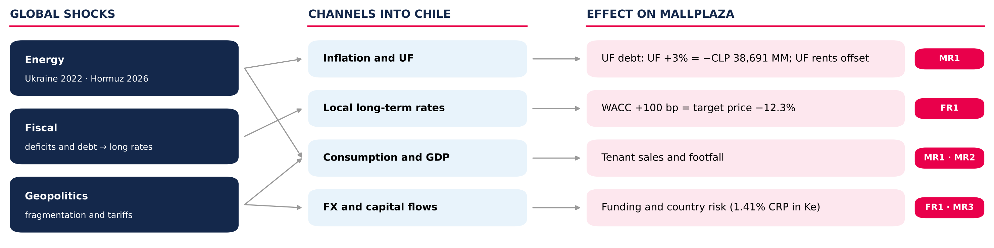
Source: Team analysis; figures from Figures 29–31 of the report (Investment Risks).
2. TWO SUPPLY SHOCKS AND A GLOBAL RISE IN RATES
Figure 20.2: Brent crude oil price, 2022–2026 (USD/barrel)  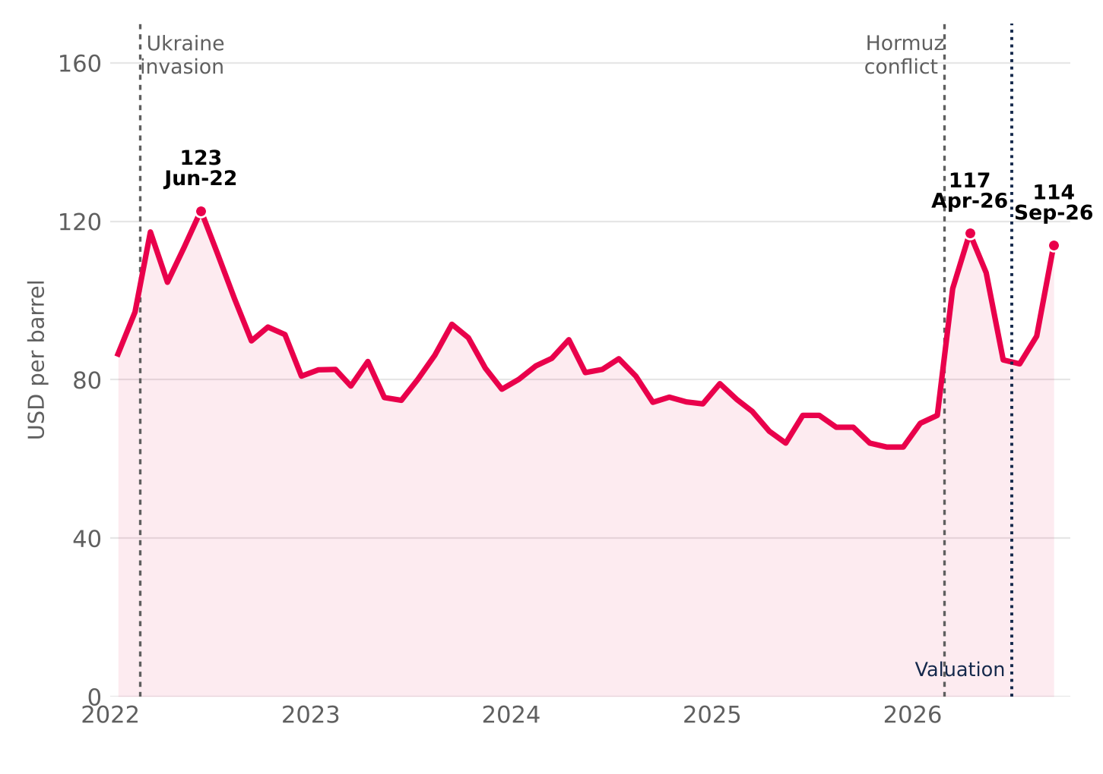  Two supply shocks. Russia's invasion of Ukraine (Feb-22) pushed Brent to USD 123 in June 2022. In 2026, the conflict in the Strait of Hormuz — which carries more than a quarter of seaborne oil — lifted it from USD 71 in February to USD 117 in April; after a truce in June, renewed attacks took it back to USD 114 in September.  Source: EIA (Brent spot, monthly average; STEO Apr-26, Sep-26 and Oct-26); Statista. |  | Figure 20.3: 10-year sovereign yields, 2022–2026 (%)  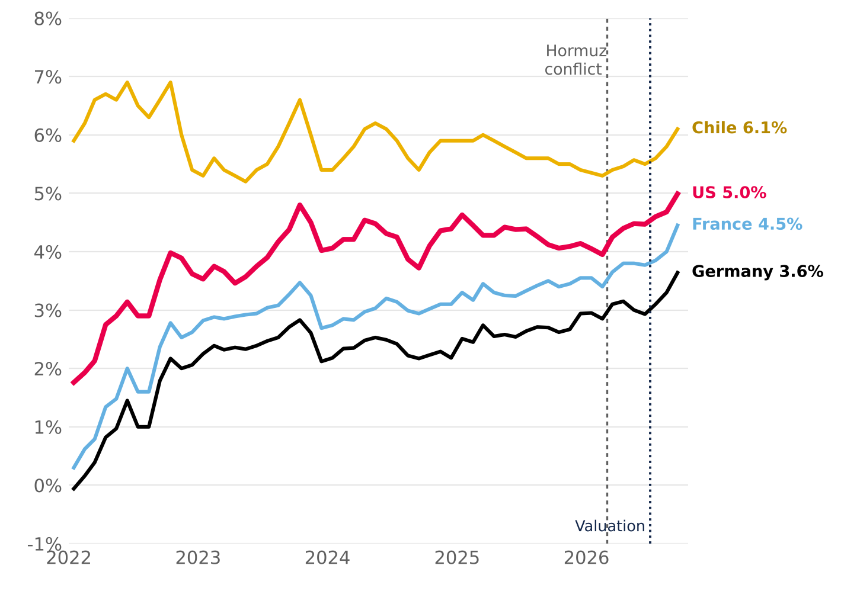  Long-term rates rise together. The 10Y UST moved from 1.8% (Jan-22) to 5.0% (Sep-26) and touched 5.22% on 8 October, a 24-year high; the Bund went from −0.1% to 3.6%. Fiscal deficits push up the risk-free rate, and Chile has followed the move since mid-2026.  Source: FRED (GS10), Bundesbank, Banque de France (via OECD) and BCCh (10Y BCP); monthly averages.

3. FISCAL PREMIUM AND STAGFLATION
Figure 20.4: 10-year spreads: France–Germany and Chile–US (bp)  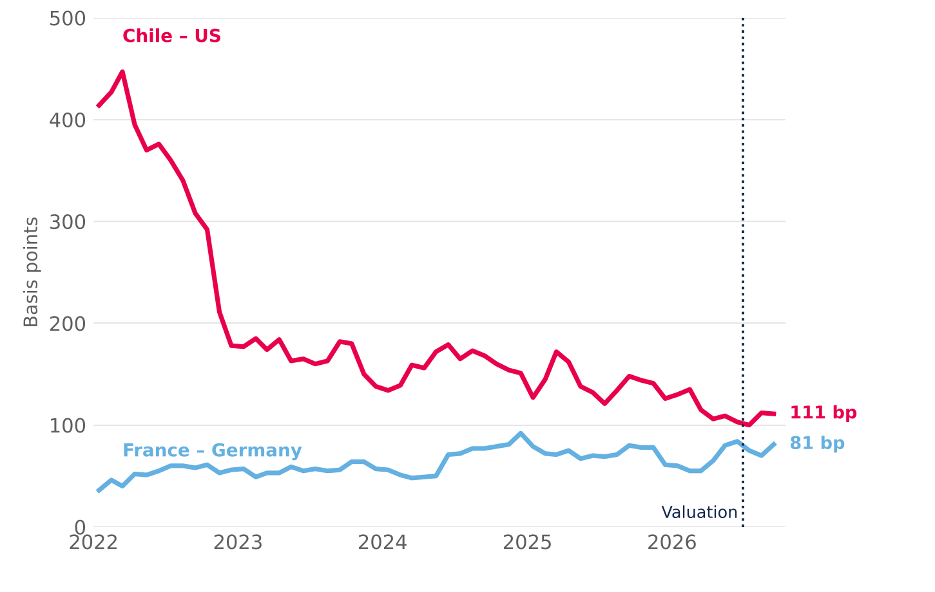  The rise is fiscal and global, not Chile risk. France's spread over Germany rose from ~40 bp in 2022 to an 81 bp average in September 2026 and 117 bp at month-end (~150 bp in early October, the widest since 2011–12). Chile's spread over the US compressed: local rates depend more and more on the global base rate.  Source: Team calculation with Figure 20.3 data (monthly averages); September close: Banque de France / Bundesbank. |  | Figure 20.5: World growth and inflation, 2022–2026P (%)  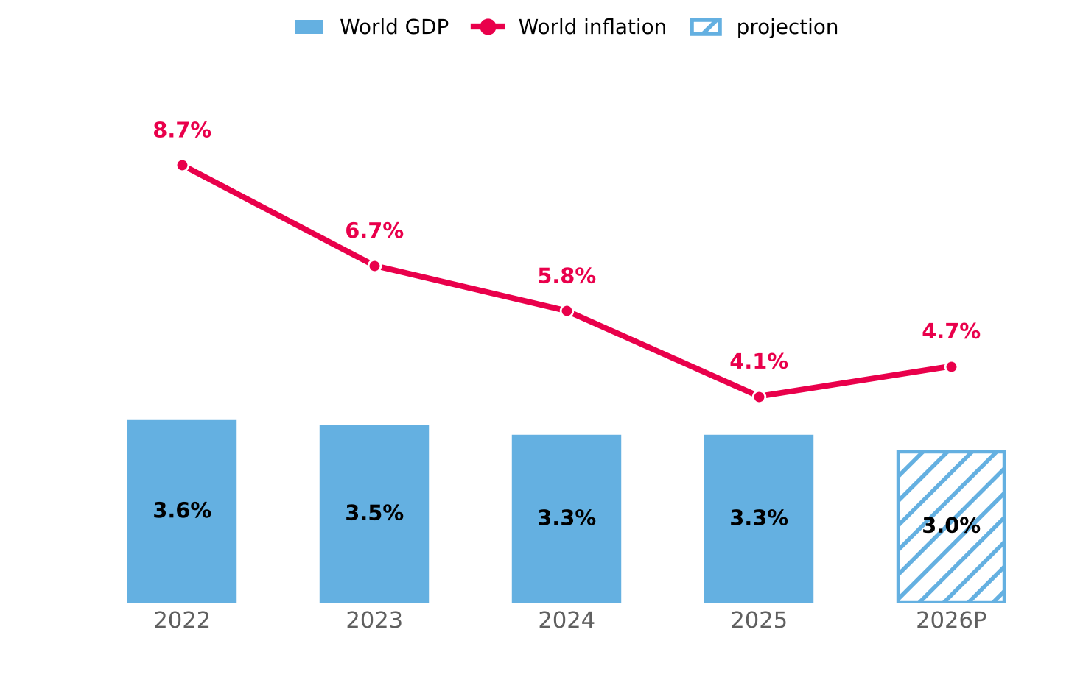  Stagflation. The IMF cut 2026 world growth to 3.0% and raised inflation to 4.7% (from 4.1% in 2025): the disinflation under way since 2024 stalled on higher energy and food prices, in an economy that grows less.  Source: IMF, World Economic Outlook (July 2026 update). 2026P = projection.
4. CHILE: SLOWER GROWTH AND STICKY INFLATION
Figure 20.6: Chile: GDP, inflation and policy rate, 2022–2026P (%)  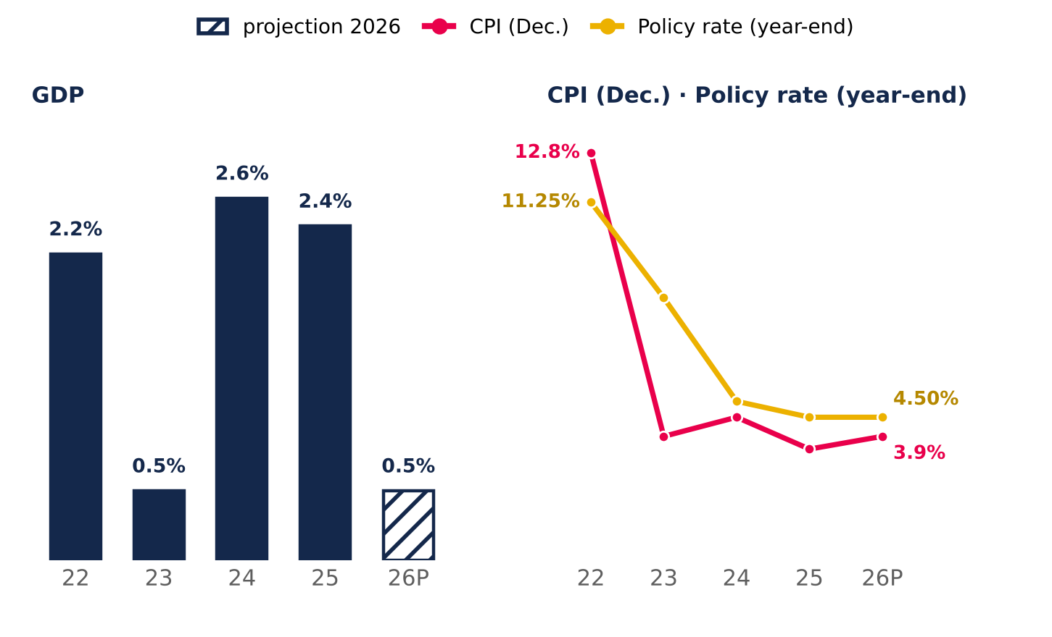  Source: BCCh (Monetary Policy Reports Dec-25, Jun-26 and Sep-26) and INE. 2026 GDP: midpoint of the 0.25–0.75% range. |  | Slower growth. The Central Bank cut 2026 GDP growth to 0.25–0.75%, from 2–3% in December 2025, with a weaker labour market and falling confidence.  Sticky inflation. CPI rises to 3.9%, above the 3% target, and the policy rate stays at 4.5%: there is no room to support consumption, the driver of tenant sales (MR1).  Geopolitical fragmentation. Weaker alliances and unpredictable US trade policy raise hedging costs and reduce flows to emerging markets. For Chile, Peru and Colombia this means more volatile currencies and costlier funding, which the model captures with a 1.41% weighted CRP in the cost of equity.
5. WHAT IT MEANS FOR MALLPLAZA
Channel | 2022–2026 | Effect on Mallplaza | In the model | Risk
Energy and inflation | Brent USD 71 → 114 (Feb–Sep-26); world inflation 4.1% → 4.7% | Indexes UF debt (79% of total); UF-linked rents offset it | UF +3% = −CLP 38,691 MM of earnings (Fig. 31) | MR1
Long-term rates | 10Y UST 4.1% → 5.2%; Bund 2.9% → 3.6% (Dec-25 → Oct-26) | Higher WACC and cost of refinancing the pipeline | Rf 4.98%; WACC +100 bp = target price −12.3% (Fig. 30) | FR1
Consumption and GDP | Chile 2026 GDP: 0.25–0.75%; CPI 3.9% | Lower tenant sales, footfall and demand for new formats | Tornado: traffic −1.3% / +2.4% of value (Fig. 29) | MR1 · MR2
Fragmentation | US tariffs; lower flows to emerging markets | Volatile currencies and costlier funding | 1.41% weighted CRP in Ke; debt in local currency and hedging derivatives (MD&A 2Q26) | FR1 · MR3
6. WHAT TO WATCH
Indicator | Latest | Warning sign | What it means for Mallplaza
10Y UST | 5.22% (8-Oct-26) | Sustained above 5.5% | ≈ WACC +50 bp: target price from CLP 2,077 to ~1,940 (Fig. 30)
Brent | USD 114 (Sep-26) | Above USD 120 or a prolonged Hormuz closure | Higher inflation and UF: larger debt indexation (MR1)
Chile CPI | 3.9% (Jun-26 MPR) | Above 4% for two quarters | No rate cuts; weak consumption and tenant sales
Chile GDP | 0.25–0.75% 2026 (MPR) | Two quarters of contraction | Lower footfall and sales; pressure on occupancy (Fig. 29)
France–Germany spread | 117 bp (30-Sep-26) | Above 150 bp | Fiscal contagion: more pressure on global long-term rates (FR1)
Investor takeaway. The backdrop raises the likelihood of the report's two most severe risks (FR1 and MR1). The model uses a 4.98% Rf and a 10.41% terminal nominal WACC (10.54% in 2H26E); with the 10Y UST above 5.2% in October, the bias on the discount rate is upward, which reinforces the recommendation.

