APPENDICES: INDUSTRY AND COMPETITIVE POSITIONING
APPENDIX 3: NEW GLA SUPPLY, 2026-2028
The trio will add 432,030 m² between 2026 and 2028, of which 334,030 m² are organic (6.4% of their current total GLA; in Chile, 219,900 m², equivalent to 6.7% of their GLA in that country). Acquisitions (98,000 m², all by Parque Arauco) change owner but add no supply to the industry; the supply-versus-demand analysis for Chile (Figure 3) therefore uses organic GLA only.
A. PIPELINE BY COMPANY (m²)  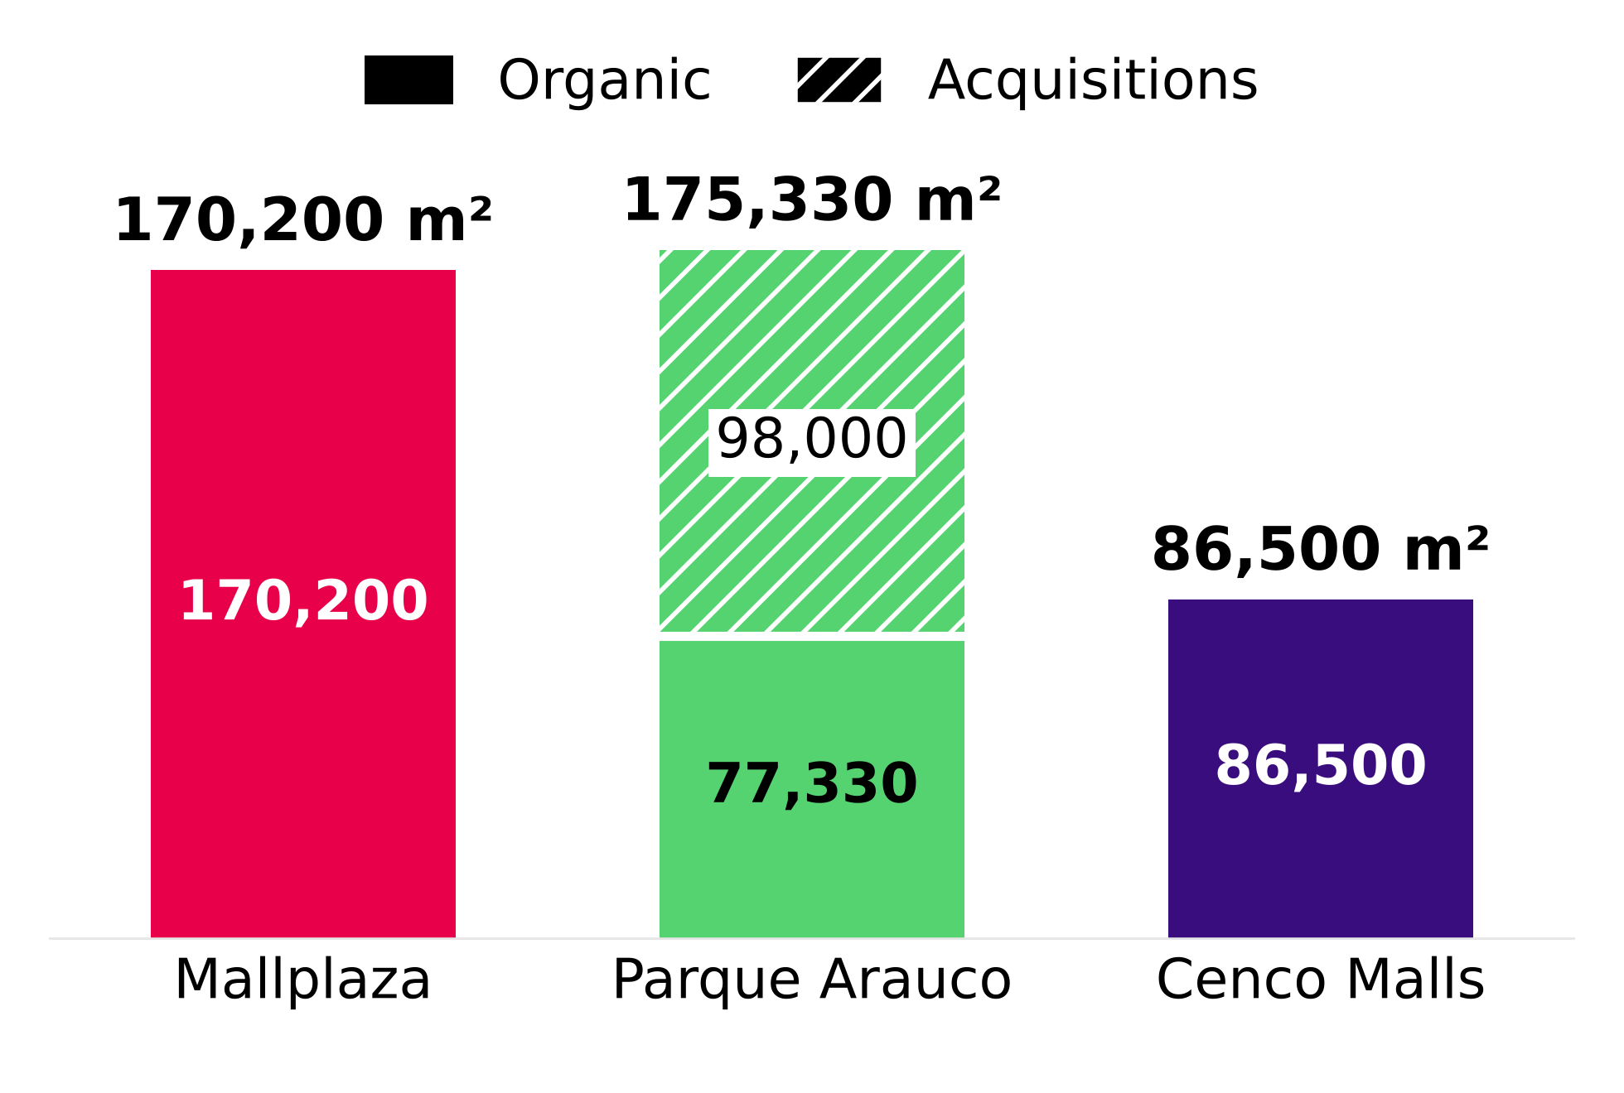 |  | B. GLA BY OPENING YEAR (m²)  Org./GLA = organic GLA 2026-2028 over consolidated GLA at 2Q26. Mallplaza: 2028 includes 46,500 m² of “Other projects Chile”, dated 2028 by the 2025 Annual Report (p.45). Parque Arauco: 2026 = 2H26 (acquisitions). Cenco: deliveries given as a range are placed at the end of the range.
  Company | 2026 | 2027 | 2028 | Organic | Acquis. | Total | Org./GLA
  Mallplaza | 8,900 | 72,950 | 88,350 | 170,200 | – | 170,200 | 7.2%
  Parque Arauco | 87,000 | 46,000 | 42,330 | 77,330 | 98,000 | 175,330 | 5.8%
  Cenco Malls | – | 34,000 | 52,500 | 86,500 | – | 86,500 | 5.6%
  Trío | 95,900 | 152,950 | 183,180 | 334,030 | 98,000 | 432,030 | 6.4%
Source: Plaza S.A., 2Q26 Release (p.13) and 2025 Annual Report (p.45); Parque Arauco, 2Q26 Investor Presentation (slide 23); Cenco Malls, 2Q26 Corporate Presentation (slides 15-17). Dated projects only.
APPENDIX 4: OCCUPANCY  The consolidated occupancy of the three operators has stayed between 93% and 99% since 2Q22, even through the inflation and high-rate cycle. Each company defines occupancy differently, so trends are compared rather than levels.  A. CONSOLIDATED OCCUPANCY RATE, 2Q22-2Q26  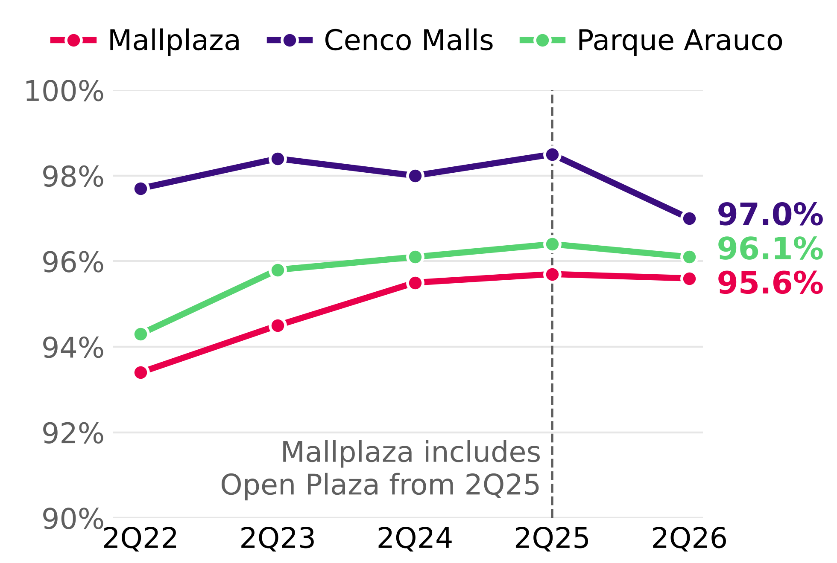  Source: 2Q22-2Q26 earnings reports of the three companies. Mallplaza includes Open Plaza since 2Q25. |  | APPENDIX 5: MARKET SHARE IN CHILE  The trio's GLA in Chile grew 7.3% since 2Q22. Mallplaza gave up 1.2 pp of share because it grew only through expansions, while Parque Arauco added Kennedy Oriente (70,000 m²) by purchase.  A. SHARE WITHIN THE TRIO, 2Q22-2Q26 (% OF GLA)  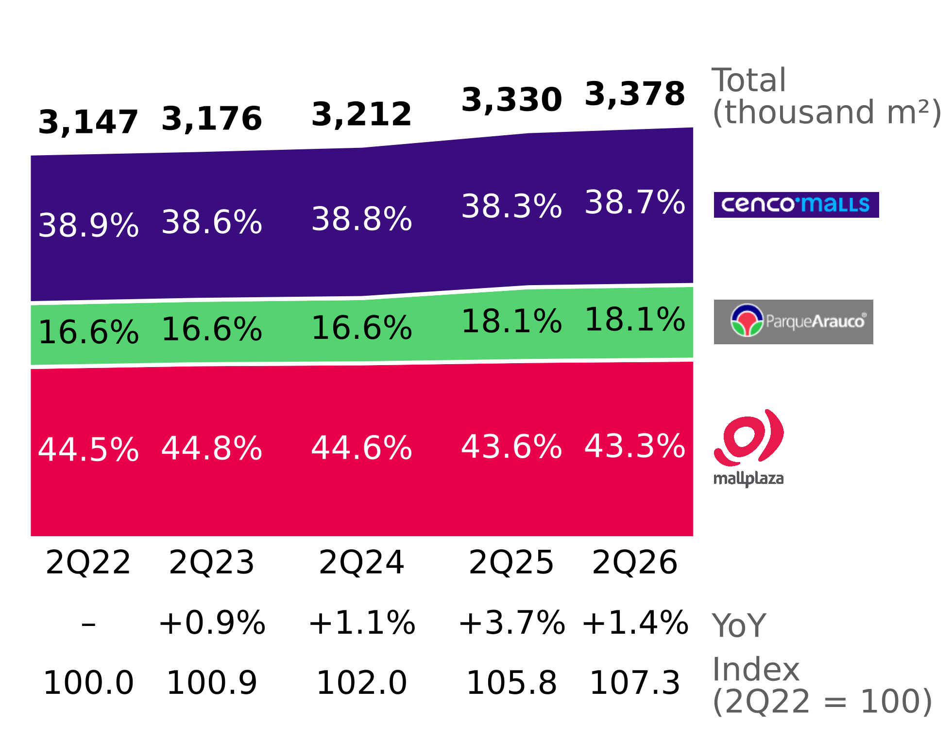  Source: 2Q22-2Q26 earnings reports of the three companies; Team analysis.
APPENDIX 6: PORTER'S FIVE FORCES
Attractive industry: with whole-number scores by country weighted by Mallplaza's GLA, the only intense force is rivalry (4), which plays out in experience and assets rather than price, since in 2Q26 same-store rents rose in Chile at all three operators (table B).
A. SCORES BY COUNTRY AND MAIN EVIDENCE (1 = WEAK FORCE; 5 = INTENSE FORCE)
Force | Chile | Peru | Colombia | Final | Main evidence
Rivalry | 4 | 4 | 4 | 4 | CR3 76% / 37% / 13%; reinvestment race in experience; asset purchases (Minka, Plaza Central; Quilín and Chicureo announced); supply above consumption in 2027-28. Stable shares and margins of 71-90%. No price war: positive SSR/SAR in Chile (table B).
New entrants | 1 | 2 | 3 | 2 | Capital intensive (USD 613 million for 170,200 m² at Mallplaza); incumbents' land banks; Peru and Colombia less concentrated; Colombia with most malls under horizontal ownership.
Tenant bargaining power | 1 | 2 | 2 | 1 | Chile occupancy 96-99%; contracts averaging 5.0-8.7 years; top 5 = 18% of Mallplaza's revenue; Chile SSR above CPI (6.9% vs 4.8%, 1Q23-2Q26); department stores 19.0% of GLA.
Supplier bargaining power | 1 | 1 | 1 | 1 | Common expenses passed through to tenants (2025 Annual Report, note 2.20); cost of sales 6.2% of Mallplaza's revenue.
Substitutes | 2 | 2 | 2 | 2 | 93% of Mallplaza's rental income is fixed; 2Q26 visits +4.4% Chile, +1.3% Peru, +2.5% Colombia; shift to experience. No official e-commerce data by country.
Source: Team analysis. Final score = average weighted by Mallplaza's GLA at 2Q26 (Chile 61.9%, Peru 26.2%, Colombia 11.9%), rounded to the nearest integer. For new entrants the weighted score sits at the threshold (1.5) and the team sets it at 2 because of lower entry barriers in Peru and Colombia.
B. PRICE INDICATORS BY OPERATOR, 2Q26
Indicator | Country | Mallplaza | Cenco Malls | Parque Arauco
Same-store or same-area rent (YoY change) | Chile | SSR +5.4% | SSR +0.8% | SAR +3.8%
 | Peru | SSR +4.7% | SSR +11.0% | SAR +3.0%
 | Colombia | SSR +7.5% | SSR −9.9% | SAR +13.0%
Monthly revenue per m² (YoY change) | Chile | CLP 28,618 (+6.6%) | Not published | CLP 31,571 (+9.6%)
 | Peru | PEN 66 (+10.0%) | Not published | PEN 68 (−0.1%)
 | Colombia | COP 84,790 (+8.0%) | Not published | COP 125,932 (+10.3%)
Occupancy cost (2Q25) | Chile | 10.3% (10.2%) | 9.1% (8.8%) | 11.9% (11.1%)*
 | Peru | 7.3% (7.4%) | 8.8% (8.8%) | 8.1% (8.4%)*
 | Colombia | 10.5% (10.4%) | 6.5% (7.5%) | 11.7% (11.5%)*
Source: Plaza S.A., 2Q26 Release (p.18); Cenco Malls, 2Q26 Earnings Presentation (p.17); Parque Arauco, 2Q26 Earnings Report (p.5, p.6 and p.21). Each indicator follows each company's definition: Mallplaza's SSR considers fixed rent in Chile and the change in the UF; Cenco's includes variable rent (Cenco 1Q26: “SSR Chile reflects the effect of lower sales”); Parque Arauco's SAR measures rent collected in areas leased in both periods. *Includes common expenses and promotion fund: its level is not comparable, its change is. Mallplaza's revenue per m² change in Colombia (+8.0%) is a team calculation: 84,790 / 78,545 − 1. Everything else is published data.
APPENDIX 7: MAIN ASSUMPTIONS
Criteria used so that figures are comparable across operators and consistent with the official 2Q26 reports.
Topic | Assumption
Market share | Measured by GLA (not by sales) over each country's main operators (slide 7, 2Q26 Institutional Presentation). Partial HHI: considers only the operators identified on slide 7, so it is a floor (the real HHI is equal or higher); classified with the 2023 DOJ/FTC Merger Guidelines thresholds (above 1,800 = highly concentrated). Colombia pro forma: includes Gran Plaza (announced acquisition of 179,667 m²; 2Q26 Release); without it, Mallplaza's share would be 4.3%.
Pipeline | Only dated projects in official reports at 2Q26 and the 2025 Annual Report; dates given as a range are placed at the end of the range; acquisitions are not new supply for the industry.
Supply vs demand | Chile only and only m² that depend on consumption (excludes offices and multifamily); base GLA excludes Cenco's offices. Private consumption from the September 2026 IPoM is used as a demand indicator, not as a sales projection.
EBITDA per m² | EBITDA per each company's definition (none includes the IAS 40 revaluation); 2Q26 EBITDA not annualized; GLA consolidated at 100% of controlled assets. Parque Arauco: multifamily NOI (CLP 503 million) is subtracted, since its size is reported in units and not in m²; effect −0.7%, does not change the ranking.
Contracts | Profile and duration weighted by GLA. Cenco states it explicitly; Parque Arauco presents its maturity profile as % of GLA but does not state the basis of its average duration; Mallplaza does not publish the basis. In both cases GLA is assumed.
Real sales | Tenant sales in Chile 2Q26 vs 2Q25 deflated with the 12-month CPI of June 2026 (4.3%; INE, release of 08-07-2026). Cenco 2Q25 calculated from its published change (−1.9%).
Real Plaza (Peru) | InRetail 2Q26 adjusted EBITDA, Shopping Malls segment (S/ 131 million; excludes investment property revaluation) ÷ total GLA of 888,000 m² (InRetail, 2Q26 Corporate Presentation, p.26 and p.29). Mallplaza Peru: published monthly EBITDA per m² (S/ 53) × 3 (2Q26 Release, p.18). Margins are not compared: InRetail calculates its own on net rent.
Dates | Company data as of 30-Jun-2026; macro projections from the September 2026 IPoM as the most recent available.

