APPENDIX [Y]: CORPORATE GOVERNANCE AND SUSTAINABILITY
Supporting information for the ESG section: ownership structure, Board of Directors, compliance, stakeholder engagement model, organisational culture and waste. Main source: Mallplaza Annual Report 2025.
1. OWNERSHIP STRUCTURE (31-DEC-2025)
Figure S1: Shareholding by type of shareholder
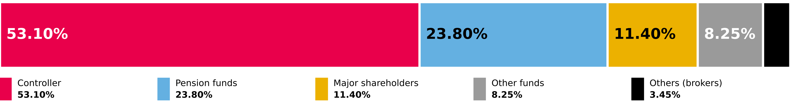
Source: Mallplaza Annual Report 2025 (NCG 461 2.3.3). No ADRs or certificates issued abroad.

Ten largest shareholders | Shares | % of shares
Desarrollos Inmobiliarios SpA (Falabella) | 1,161,849,244 | 53.10%
Inversiones Avenida Borgoño Limitada | 197,439,955 | 9.02%
Banchile Corredores de Bolsa S.A. | 59,447,149 | 2.71%
BCI Corredor de Bolsa S.A. | 53,553,765 | 2.45%
AFP Habitat S.A. Pension Fund C | 50,733,976 | 2.32%
Santiago Stock Exchange | 41,532,310 | 1.90%
AFP Provida S.A. Pension Fund C | 37,746,440 | 1.72%
Banco Santander on behalf of foreign investors | 35,594,345 | 1.63%
AFP Capital S.A. Pension Fund C | 34,539,038 | 1.58%
AFP Habitat S.A. Pension Fund B | 30,039,097 | 1.37%
2. BOARD OF DIRECTORS (ELECTED 22-APR-2025)
Figure S2: Board members (red: independent director; blue: chairman)

9 full members, no alternates; one independent director. Each director holds at most four positions in other listed companies. Tomás Müller, Manuela Sánchez and Juan Pablo Montero were directors until 22-Apr-2025. Source: Mallplaza Annual Report 2025.
3. ETHICS AND COMPLIANCE, 2025
Matter | Cases
Corruption | 0
Breaches of customer rights (Consumer Protection Law 19,496) | 27
Breaches of employee rights | 2
Proceedings by the Environment Superintendency | 1
Complaints of workplace, sexual harassment and violence at work | 8
Source: Mallplaza Annual Report 2025.
4. STAKEHOLDER ENGAGEMENT MODEL
Figure S3: Implementation process of the engagement model
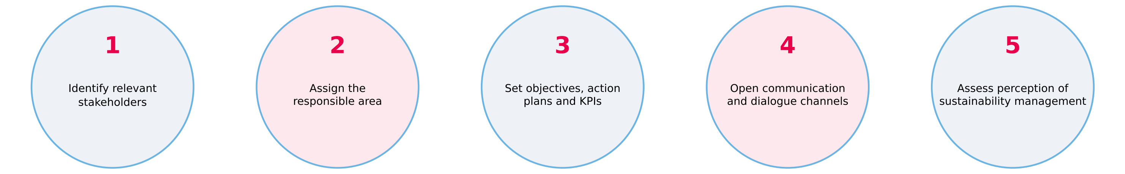
Source: Mallplaza Annual Report 2025.
5. ORGANISATIONAL CULTURE: 2025 CULTURE SURVEY
75%  Engagement  −2 pp vs 2024 · 2025 target: 80% |  | 37  eNPS  −10 vs 2024 |  | 88%  Leadership  +2 pp vs 2024 |  | 93%  Participation  +3 pp vs 2024
Leadership (88%) is the main asset to leverage the strategy. Source: Mallplaza Annual Report 2025.
6. WASTE, 2025
Figure S4: Waste generation by country  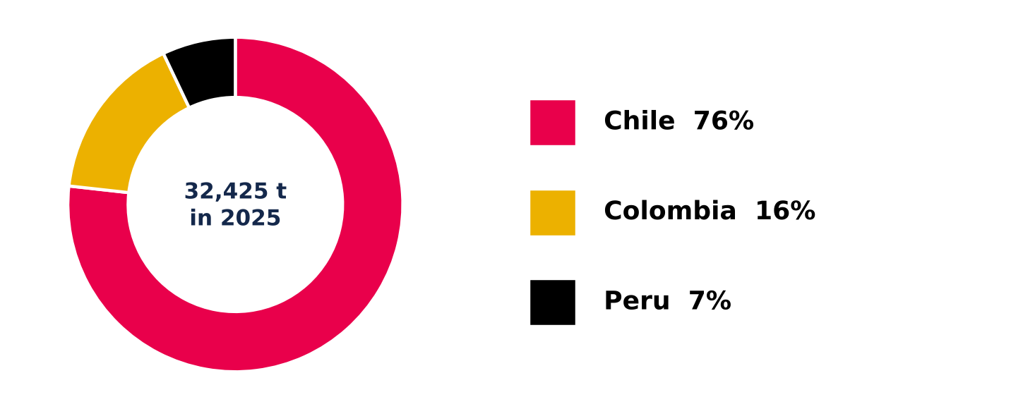  Source: Mallplaza Annual Report 2025. |  | 32,424.86 tonnes of waste across the region: 76% in Chile, 16% in Colombia and 7% in Peru.  46.2% recovered: 14,987.57 t of non-hazardous waste went to energy recovery through biogas (40.4%), recycling (36.1%) and composting (23.5%); the rest went to disposal, mainly sanitary landfills.  Hazardous waste: 9.03 t, a marginal amount given the nature of the business.
7. ESG RISK MATRIX
Figure S5: ESG factor matrix and its effect on the investment case
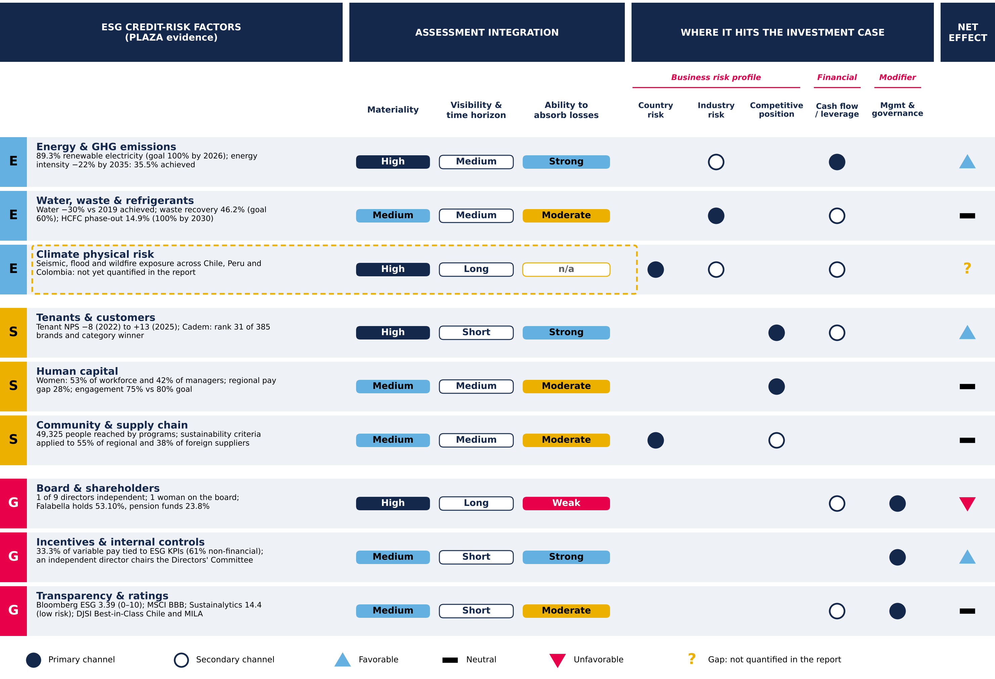
Materiality, time horizon, ability to absorb losses and net effect are team assessments. Framework adapted from S&P Global Ratings' approach to ESG credit factors. Source: Mallplaza Annual Report 2025, Bloomberg, MSCI, Sustainalytics, S&P Global; Team analysis.
8. EXECUTIVE TEAM TRACK RECORD
Name | Role at PLAZA | Tenure | Previous experience | Profile and responsibilities
Pablo Pulido Sierra | CEO (since 2026) | 10 years | Grupo Casino, Grupo Éxito | Commercial profile; experience in regional integrations.
Fernando de Peña Iver | CEO (until 2025) | 35 years | Career at Mallplaza | Led the company until 2025; extensive career in Latin American retail.
Derek Schweitzer Tang | Chief Administration and Finance Officer (CFO) | Since 2023 | BRMalls | International experience; his area leads the financial structure and the entry into global indices (MSCI).
Carlos Honorato C. | CTO, Chief Technology Officer | 2 years | Ripley.com, Neoris, Alto Movup, ProChile | Responsible for modernizing omnichannel sales and corporate cybersecurity.
María Sol de Cabo | Chief People and Culture Officer | Since 2025 | Betterfly | Over 20 years of international experience in talent management.
Oscar Munizaga Delfín | Chief Development and Business Officer | 34 years | Career at Mallplaza | Responsible for growth through M&A and greenfield developments.
Luis Hernán Silva | Chief Legal, Risk and Compliance Officer | 27 years | Career at Mallplaza | Responsible for corporate legal affairs and risk and compliance management.
Source: company public information; Team notes (track record).

