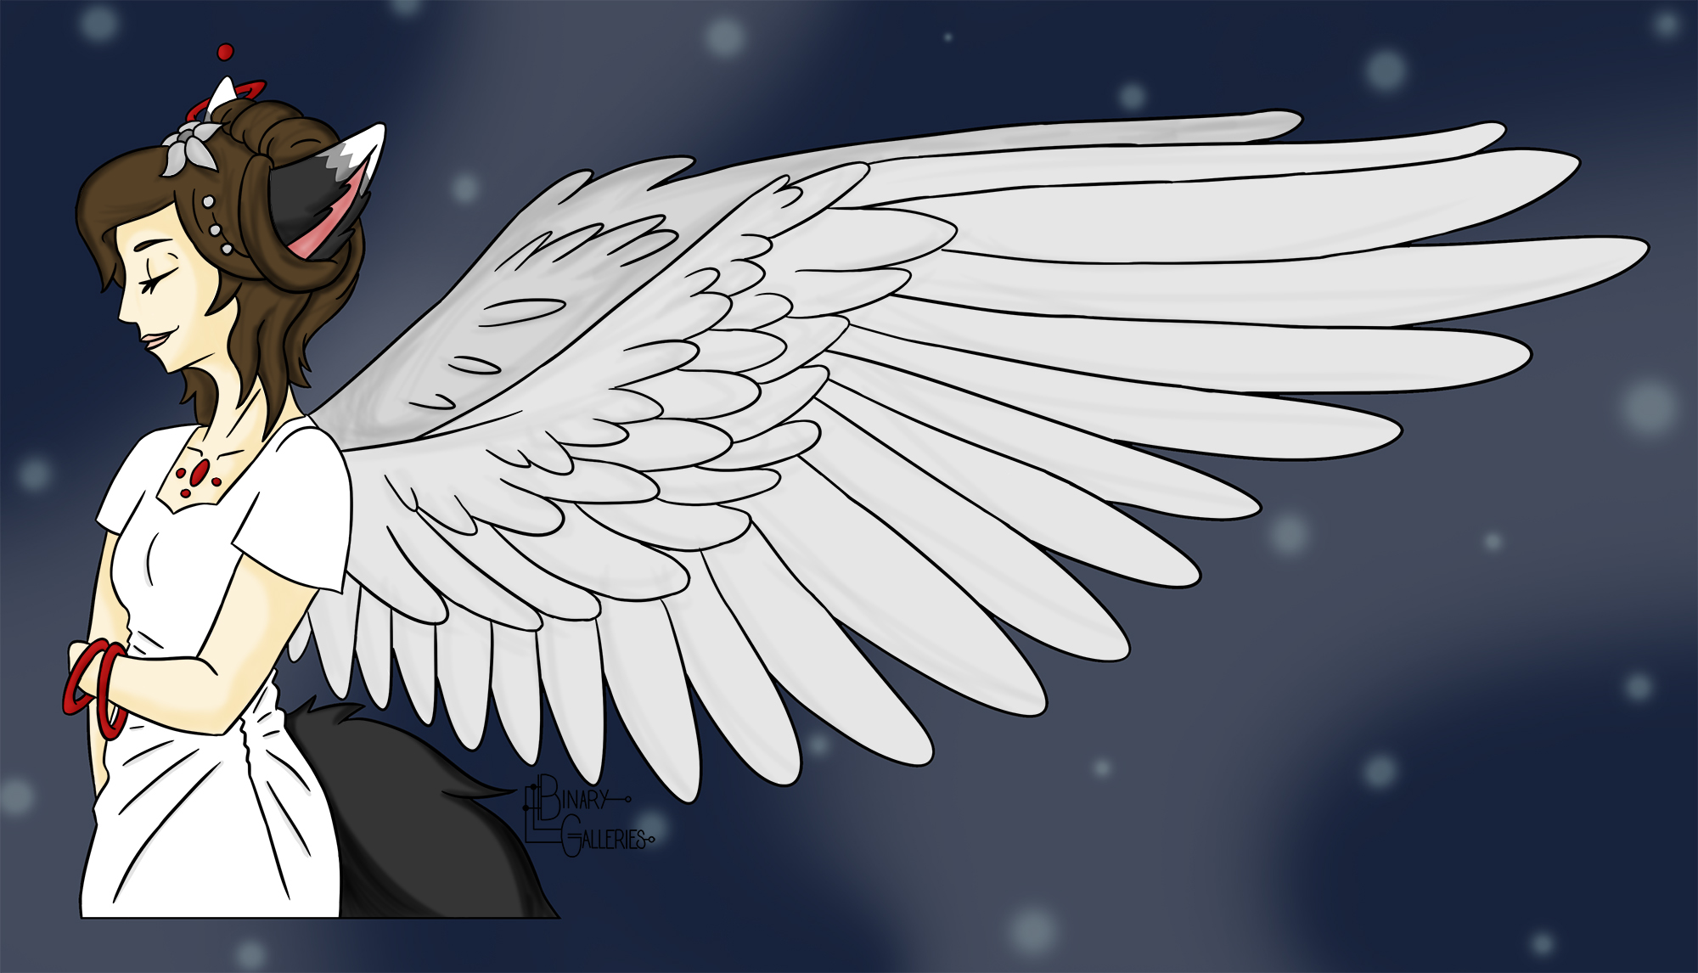

**Binary Galleries Portfolio**

Site Plan

Carly Kjelstrom

crkjelstrom@gmail.com

**Binary Galleries Style Guide**

**Overview**

**Site Purpose**

The purpose of this website will be sharing my best art work in digital illustration and graphic design. I want to give a clean experience that clearly shows what I am offering to clients. I also want to give a shop for people to purchase prints of my art or order a design.

**Target Audience**

My target audience will be potential employers as well as the casual viewer wanting to see examples. I will need to keep this professional but inviting. I think the age range will be 27-45. This will include my peers as well as people who are interested in hiring me. It will be for both males and females.

## Branding

### Website Logo



### Color Palette

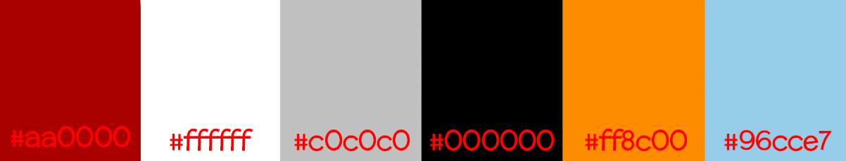

|  |  |  |  |  |  |
| --- | --- | --- | --- | --- | --- |
| Background | Header & Footer 1 | Header & Footer 2 | Buttons to site links | Words | Social Links |
| #ffffff | #aa0000 | #ff8c00 | #c0c0c0 | #000000 | #96cce7 |

## Typography

### Heading Font

#### ABCDEFGHIJKLMNOPQRSTUVWXYZ abcdefghijklmnopqrstuvwxyz 1234567890!@#$%^&*()_+

#### Sample Heading

I chose McLaren Bold for the headings and subheadings of the site. This is the same font I am using in my logo, so this provides repetition throughout the site.

### Body Copy Font

ABCDEFGHIJKLMNOPQRSTUVWXYZ  
abcdefghijklmnopqrstuvwxyz  
1234567890!@#$%^&*()_+

This paragraph will show how your paragraph text will look.

I chose Source Sans Pro for the body font and most identifying information. It has a good contrast to the flair of McLaren but not too much stiffness.

### Other Font

ABCDEFGHIJKLMNOPQRSTUVWXYZ  
abcdefghijklmnopqrstuvwxyz  
1234567890!@#$%^&*()_+

This paragraph will show how your additional text will look.

In case I need a third font for things like numbers or something else, I will use Libre Baskerville. It is a serif font and works great for numbers, and has a balancing contrast with the other two fonts.

## Navigation

### Main Navigation

The main color for the navigation bar will be a white background (#ffffff) with black words (#000000), and a bar of a maroon underneath the whole thing (#808080). The hover color will be orange (#ff8c00). The current page will be underlined and light blue (#96cce7). Visited links will be red (#ff0000).

|  |  |  |  |
| --- | --- | --- | --- |
| Home | About Me | Portfolio | Contact Me |
|  |  |  |  |

### Links

Link:normal : #000000

Link:hover : #ff8c00

Link:current : #96cce7

Link:visited: #ff0000

## Layout

### Site Map

|  |  |  |  |  |
| --- | --- | --- | --- | --- |
| Home | About | Portfolio | Contact | Shop |
|  |  | Illustration |  | Prints |
|  |  | Concept Art |  | Commission |
|  |  | Graphic Design |  | T.O.S. |
|  |  | Other |  |  |

### Wireframes