**Problem on Source partitioning**

There are some very helpful programs available on the web from Don Phillips at the EPA for source partitioning by both statistical and quantitative methods. There is also an R package “simmr” that does the same thing.

You can find the simple spreadsheet “Isoerror” that you can use – we will put this on the course web site. For Problem 2a you will need to use one of the two programs below that give probability distributions when you have multiple sources.

Please download one of these and for answering the following questions:

Isosource <http://www.epa.gov/wed/pages/models/stableIsotopes/isotopes.htm>

Simmr <https://cran.r-project.org/web/packages/simmr/vignettes/simmr.html>

If using the Simmr, you will need R (also recommended Rstudio), and

**a)** You are trying to detect the contribution of heterotrophic decomposition to total ecosystem respiration fluxes, and have measured the respiration 14CO2 value to be +118‰ (SD±10, n=4). From your lab incubations of soil and plant respiration at your site, you found the 14CO2 values to be +145‰ (SD±20, n=2), and +75‰ (SD±5, n=6) respectively. Please calculate the proportional contribution of heterotrophic respiration using IsoError. What would happen to your estimate if you had more replicates of your measurements? What happens if the inherent variability of your observations was larger, or smaller?

(for this you can use the Isoerror spreadsheet, on the web site).

DO PARTS B and C only if you have the on-line Isoerror or simmr….

**b)** Now you want to understand how the surface and deep soil each contribute individually to the total ecosystem respiration value, so you make measurements in another site and find the respiration 14CO2 value to be +31‰ (SD±8, n=4). From your lab incubations of surface soil, deep soil, and plant respiration at your site, you found the 14CO2 values to be +98‰ (SD±15, n=3), –13‰ (SD±15, n=3), and +65‰ (SD±5, n=4) respectively. Please calculate the statistical proportional contribution of the three components to total ecosystem respiration using IsoSource or simmr (you can assume 13C of all observations was -25 per mil).

**c)** Because you are left with an unsatisfied craving after your statistical partitioning, you decide to reanalyze your data by including 13CO2 data that you also collected from your sites. Your measurement of ecosystem respiration 13CO2 was –24.6‰ (SD±0.2, n=3). From your lab incubations of surface soil, deep soil, and plant respiration at your site, you found the 13CO2 values to be –26.2‰ (SD±0.3, n=3), –23.7‰ (SD±0.2, n=3), and –23.5‰ (SD±0.4, n=3) respectively. Please combine these measurements with those of 2b and calculate the contribution of the three components to ecosystem respiration using IsoError or simmr.

Problem on Fossil fuel emissions

On the web site you will find an excel file with data taken at Caltech in the Los Angeles basin. This basin has a strong night-time air inversion that traps air, so concentrations of CO2 rise at night. Using either the mixing approach or the Keeling plot approach (see below), estimate how much fossil fuels contribute to night-time CO2 increase in the LA basin on the nights given.

Isotope mixing – linear superposition of two sources

(otherwise known as the “Keeling plot”)

Cm = Cbg + Cff  mass balance for sum of isotopes where C = concentration in mixture (m), and sources bg (background atmosphere) and ff (fossil fuel)

13Cm = 13Cbg + 13Cff mass balance for isotope (13C or 14C)

mCm = bgCbg + ffCff ≈ mass balance for isotope (13C or 14C)

with some algebra (see the papers referenced below for the derivation)

m = (bgCbg - ffCbg)*(1/Cm) + ff

slope intercept

Keeling plot assumptions:

1. CA, dA and dB are unchanging
2. mixing is mass-independent (turbulent, no diffusion)
3. no chemical or equilibrium reactions
4. only 2 sources A and B mix

(above are usually met for respiration at night)

1. OR if there is a third source (C) then the relative proportions of B and C do not change, so their combined isotope ratio is the same

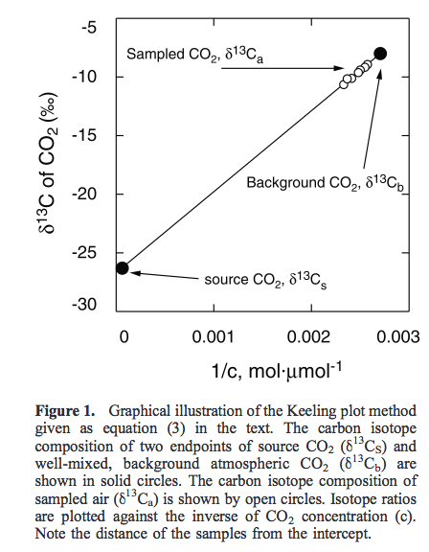

Keeling, C.D. The concentration and isotopic abundances of atmospheric carbon dioxide in rural areas.Geochimca et Cosmochimica Acta 13:  322-334, 1958.

Pataki, D. E.; Ehleringer, J. R.; Flanagan, L. B.; Yakir, D.; Bowling, D. R.; Still, C.

J.; Buchmann, N.; Kaplan, J. O.; Berry, J. A. The application and interpretation of

Keeling plots in terrestrial carbon cycle research Global Biogeochem. Cycles Vol.

17 No. 1 doi 10.1029/2001GB001850