access control custom API documentation

Version and revision records
Version | describe | date
V1.0 | create | 2019-06-06 _ _ _ _
V1.1 | Modify Wiegand interface mode | 2019-06-25 _ _ _ _ _
V1.2 | Add Wiegand input interface | 2019-08-09
V1.3 | Add three-color lighting control | 2019-09-24
V1.5 | The three-color light interface is compatible with multiple platforms  Wiegand input adds active stop interface | 2019-12-26

Table of contents
1. Version and revision records 1
2. Table of contents 2
3. How to use SMDT API in Android Studio 4
4. SDK interface functions 5
4.1. public int smdtSendCard(String idCard , int transformat) 5
Description: Wiegand interface operation, the parameter is ID card number . 5
4.2. public int smdtSendCard(String HID_value, String PID_value, int transformat) 5
Description: Wiegand interface operation, the parameter is the public code hidden code . 5
4.3. public String smdtReadWiegandData ( ) 6
Description: Get Wiegand input, this is a blocking method, use the following parameters. 6
4.4. public int smdtReleaseWiegandRead() 7
Description: Actively exit the blocking method smdtReadWiegandData(), which can only be used after version 1.5. 7
4.5. public String[] smdtGetCameraVidPid(int cameraId) 7
Description: Read camera VID, PID interface 7
4.6. public int setLedLighted(String ledColor, boolean lighted) 8
Description: Fill light operation (new API) -- white light, red light, green light . Only available after version 1.5 8
4.7. public int s etControl(int type, int values) 8
Description: Fill light operation -- white light . (It is recommended to use setLedLighted for versions after 2019-12-26) 8
4.8. public int smdtSetUsbPower(int type, int num, int values) 9
Description: Fill light operation -- red light . (It is recommended to use setLedLighted for versions after 2019-12-26) 9
4.9. public int smdtSetGpioDirection(int gpioNumber, int direction, int value) 9
Description: Fill light operation -- green light . (It is recommended to use setLedLighted for versions after 2019-12-26) 9
4.10. public int setRelayIoMode(int mode, int delay); 10
Description: Relay mode and delay settings . 10
4.11. public int setRelayIoValue(int value); 11
Description: Turns the relay on or off . 11
4.12. public int getRelayIoMode(); 12
Description: In non-automatic mode, get the state of the relay 12
5. For other general functions, please refer to the API documentation of the Seetech system_20180205.docx 错误!未定义书签。

How to use SMDT API in Android Studio
- Copy SmdtAccessControl_1_1.jar to [Project Directory\app\libs\];
2. Right-click the jar file in the libs folder and select add as Library...
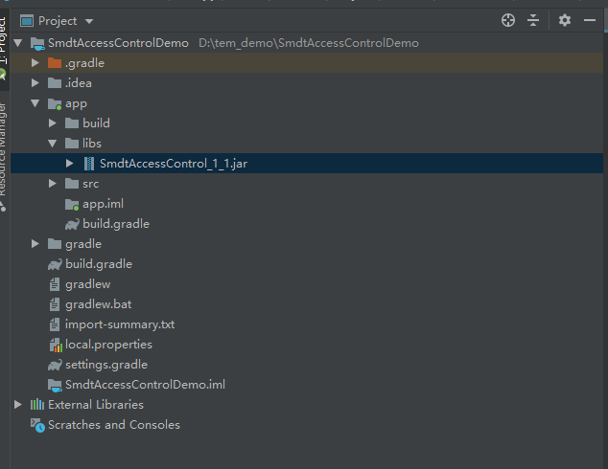 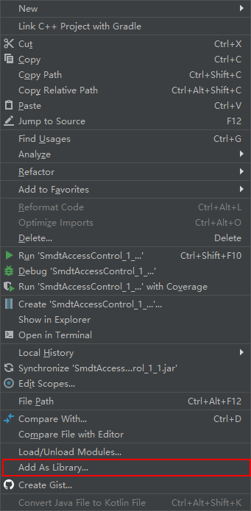
Note: All api calls
SmdtManager smdt = SmdtManager.create(this);

started with the SMDT API
First declare the SmdtManager object, and then you can start using the API. For example:
//declare the SmdtManager object
private SmdtManager smdt ;
smdt = SmdtManager.create ( this ) ;

//
use API smdt.setRelayIoValue ( 0 ) ;

SDK interface functions

public int smdtSendCard(String idCard , int transformat)

Description: Wiegand interface operation, the parameter is ID card number .
API version implementing this interface : V1.1
parameter name / return value | type | illustrate | Example
idCard | String | card number | 2147584137
transformat | int | Format: Wiegand 26=1, Wiegand 34=2; | 1
return value | int | success : 0, failure: -1
example:
SmdtManager smdt = SmdtManager.create ( this ) ;
smdt .smdtSendCard( "2147584137" , 1 ) ;

public int smdtSendCard(String HID_value, String PID_value, int transformat)

Description: Wiegand interface operation, the parameter is the public code hidden code .
API version implementing this interface : V1.0
parameter name / return value | type | illustrate | Example
HID_value | String | cryptic code | 001
PID_value | String | public code | 34953
transformat | int | Format: Wiegand 26=1, Wiegand 34=2; | 1
return value | int | success : 0, failure: -1
example:
SmdtManager smdt = SmdtManager.create ( this ) ;
smdt .smdtSendCard( "001" , "34953" , 1 ) ;

public String smdtReadWiegandData ( )

Description: Get Wiegand input, this is a blocking method, use the following parameters.
API version implementing this interface : V1.0
parameter name / return value | type | illustrate | Example
return value | String | Return Wiegand Card Number | Such as: 4017669612
Note: Blocking method, swiping the card once will trigger once, it is recommended to open a thread in the Service to monitor all the time
example:
private class ReadThread extends Thread {
@Override
public void run() {
while (!isInterrupted()) {
String result = smdt.smdtReadWiegandData();
if (result == null || result.equals("")|| result.equals("0")) {
Log.i(TAG, "result ==== null............");
continue;
}
Log.i(TAG, "result =======" + result);
}
}
}
when using it:
mReadThread = new ReadThread() ;
mReadThread .start () ;
end :
@Override
protected void on Stop () {
super .onPause() ;
if ( mReadThread != null ) {
mReadThread .interrupt() ;
//Version 1.5 and later can use the following code to exit the blocking function in time smdtReadWiegandData ()
smdt.smdtReleaseWiegandRead () ;
}
}

public int smdtReleaseWiegandRead()

Description: Actively exit the blocking method smdtReadWiegandData(), which can only be used after version 1.5.
API version implementing this interface : V1. 5
parameter name / return value | type | illustrate | Example
return value | int | success: 0  fail: -1 | Such as: 4017669612

public String[] smdtGetCameraVidPid(int cameraId)

Description: Read camera VID, PID interface
API version implementing this interface : V1.0
parameter name / return value | type | illustrate | Example
cameraId | int | Camera ID value | 0
return value | String [] | string[0] means vid, string[1] means pid
be careful:
example:
SmdtManager smdt = SmdtManager.create ( this ) ;
String[] results = smdt .smdtGetCameraVidPid( 0 ) ;

Result: results[0]=34b3 ,results[1]=53a9

public int setLedLighted(String ledColor, boolean lighted)

Description: Fill light operation (new API) -- white light, red light, green light . Only available after version 1.5
API version implementing this interface : V1. 5

parameter name / return value | type | illustrate | Example
ledColor | String | SmdtManager.LED_WHITE white light  SmdtManager.LED_RED red light  SmdtManager.LED_GREEN green light
lighted | boolean | true: turn on the lights  false: turn off the lights | 1
return value | int | success : 0,  Failed: -1
example:
SmdtManager smdt = SmdtManager.create ( this ) ;
smdt.setLedLighted ( SmdtManager.LED_WHITE , true ) ;

public int s etControl(int type, int values)

Description: Fill light operation -- white light . (It is recommended to use setLedLighted for versions after 2019-12-26)
API version implementing this interface : V1.0
parameter name / return value | type | illustrate | Example
type | int | fixed at 3
values | int | 0: off, 1: on | 1
return value | int | success : 0, failure: -1
example:
SmdtManager smdt = SmdtManager.create ( this ) ;
smdt.setControl ( 3 , _ _ 0 ) ;

public int smdtSetUsbPower(int type, int num, int values)

Description: Fill light operation -- red light . (It is recommended to use setLedLighted for versions after 2019-12-26)
API version implementing this interface : V1.0
parameter name / return value | type | illustrate | Example
type | int | fixed at 1
num | int | Firmware is 3
values | int | 0: off, 1: on | 1
return value | int | success : 0, failure: -1
example:
SmdtManager smdt = SmdtManager.create ( this ) ;
smdt .smdtSetUsbPower( 1 , 3 , 1 ) ;

public int smdtSetGpioDirection(int gpioNumber, int direction, int value)

Description: Fill light operation -- green light . (It is recommended to use setLedLighted for versions after 2019-12-26)
API version implementing this interface : V1.0
parameter name / return value | type | illustrate | Example
gpioNumber | int | fixed at 4
direction | int | fixed at 1
values | int | 0: off, 1: on | 1
return value | int | success : 0, failure: -1
example:
SmdtManager smdt = SmdtManager.create ( this ) ;
smdt .smdtSetGpioDirection( 4 , 1 , 1 ) ;

public int setRelayIoMode(int mode, int delay);

Description: Relay mode and delay settings .
API version implementing this interface : V1.1
parameter name / return value | type | illustrate | Example
mode | int | model:  0: Indicates no automatic closing mode, that is, it will not automatically close after opening the relay  1: Indicates automatic closing mode (high effective - default low level, then high level for X seconds, and finally low level), that is, after opening the relay, it will automatically close after a delay of X seconds  2: Indicates automatic closing mode (low effective - default low level, then high level for X seconds, and finally low level), that is, after opening the relay, it will automatically close after a delay of X seconds
delay | int | The delay of automatic closing mode, the unit is s, the maximum is 63s | 5
return value | int | success : 0, failure: -1

example:
SmdtManager smdt = SmdtManager.create ( this ) ;
smdt .setRelayIoMode (1,5) ; //Auto mode, automatically close in five seconds
smdt .setRelayIoValue (1) ; //In automatic mode, both 0 and 1 can open the relay

public int setRelayIoValue(int value);

Description: Turns the relay on or off .
API version implementing this interface : V1.1
parameter name / return value | type | illustrate | Example
value | int | Non-electric closing mode, 0 means close the relay, 1 means open the relay.  In auto-close mode, calling this method will open the relay.
delay | int | The delay of automatic closing mode, the unit is s, the maximum is 63s | 5
return value | int | success : 0, failure: -1
example:
SmdtManager smdt = SmdtManager.create ( this ) ;
smdt .setRelayIoMode (0,5) ; //Non-automatic mode, the delay parameter is invalid
smdt .setRelayIoValue (1) ; //Open the relay
smdt .setRelayIoValue (0) ; //Close the relay

public int getRelayIoMode();

Description: In non-automatic mode, get the state of the relay
API version implementing this interface : V1.0
parameter name / return value | type | illustrate | Example
return value | int | 0 means off state, 1 means on state
example:
SmdtManager smdt = SmdtManager.create ( this ) ;
int status = smdt . getRelayIoMode (); //Get the status of the relay

