Wiegand test documentation

Document modification history
Version | describe | date | author
V1.0 _ | create | 2019-7.4 _ _ _ _ _ | Zhu Weijun

Wiegand Test Instructions Document 1
1. Use the specified Wiegand WG26/34 to USB 3
2. Hardware connection Wiegand 3
3. Install the driver and use the serial debugging assistant 3
3.1. Install the computer USB serial port driver 3
3.2. Using serial port debugging assistant 3
4. Debug Wiegand and compare data 6
4.1. The APP sends Wiegand data, and the computer serial port obtains hexadecimal data 6
4.2. Whether the hexadecimal conversion 2 binary comparison result is correct 9

Use specified Wiegand WG26/34 to USB
the virtual serial port in the following Taobao link https://item.taobao.com/item.htm?spm=a1z10.5-c.w4002-8509857316.20.6f3d4c1dvCZKNE&id=522603482132 Hexadecimal bytes, if you want to use other devices, please explore the test method by yourself. Because the current device outputs the result in hexadecimal, it needs to be converted into binary. You can also buy 10-digit output, directly get the card number comparison, the test results are more obvious.

Hardware connection Wiegand
Hardware connection Wiegand three lines, D0, D1, GND, the power line can not be connected, plug into the computer USB. 3288 access control connection

The hardware corresponding connectors are as follows.
4Pin plug
1: VCC
2: GND
3:2 Wiegand D1 (EXTIO-3)
4:2 Wiegand D0 (EXTIO-2)

Install the driver and use the serial debugging assistant

Install the computer USB serial port driver
Operate on the computer, right click on my computer--select properties--device manager--other devices--right-click to update the driver, this Wiegand to USB module can update the driver from the network. No driver is shown in Figure 3-1.
After the driver is updated, it will be as shown in Figure 3-2, remember the product you drive, for example, mine is COM15, which will be used in the next step.

Using the Serial Debug Assistant
Open the serial port debugging assistant.exe, select the serial port number seen in the previous step for the serial port number, and you can see it when the driver is installed successfully. The baud rate is 9600, open the serial port, and check the HEX display (hexadecimal), other options default to Can. As shown in Figure 3-3.

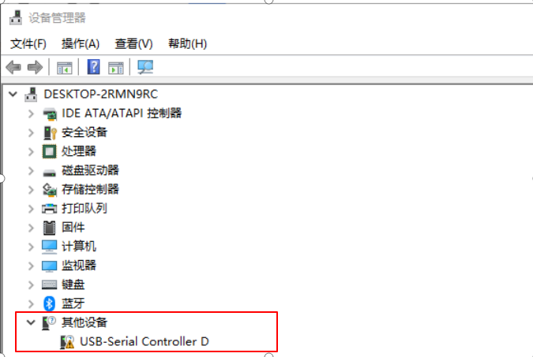
Figure 3_ 1

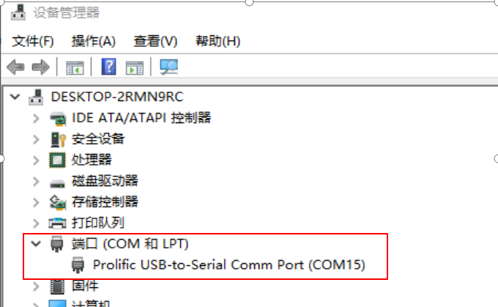
Figure 3_ 2

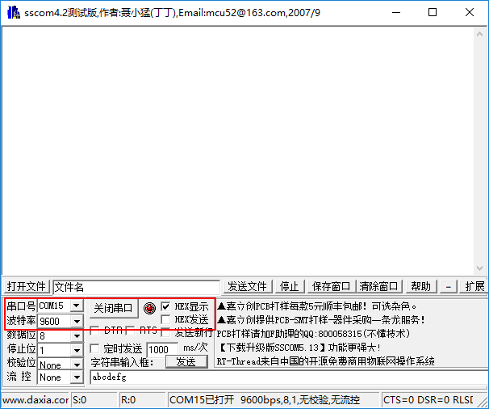
Figure 3- 3

Debug Wiegand and compare data

The APP sends Wiegand data, and the computer serial port obtains hexadecimal data
Open the "Access Control Demo" APP, test the Wiegand card number sending method, and the Wiegand PID, HID test mode.
We estimated two interfaces for Wiegand, one is to issue the card number directly, the other is to issue the PID, HID form, both of which can achieve the same output effect.
Reference link: https://www.cnblogs.com/icedog/p/3281074.html , find a Wiegand card number, or find a legal Wiegand card test yourself. The red APP input and the result obtained by the computer serial port.

Data output order:
Example: The content of an ID card is:
HID: 32769 PID: 34953 ( Print on the card: 2147584137 001, 34953 )
The corresponding binary is:
HID: 1000 0000 0000 0001 (only output the lower 8 bits)
PID: 1000 1000 1000 1001
Wiegand 26: The output is as follows:
1 2 9 10 25 26
0 0 0 0 0 0 0 0 1 1 0 0 0 1 0 0 0 1 0 0 0 1 0 0 1 1
| HID_L | PID |
The Wiegand 34 output is as follows:
1 2 17 18 33 34
0 1 0 0 0 0 0 0 0 0 0 0 0 0 0 0 1 1 0 0 0 1 0 0 0 1 0 0 0 1 0 0 1 0
| HID_L | PID |

The card number found above is "2147584137"; the PID and HID are "34953" and "32769" respectively, and fill in the test on the APP.
Test the card number method, Wiegand 26, fill in the card number "2147584137" in the APP, select "1, Wiegand 26" for Wiegand mode, click the "Wiegand send, card number" button, the serial port tool receives hexadecimal "01 88" 89”, as shown in Figure 4-1.

Test card number method, Wiegand 32, fill in the card number "2147584137" in the APP, select "2, Wiegand 32" for Wiegand mode, click the "Wiegand send, card number" button, the serial port tool receives hexadecimal "80 01" 88 89".

Test PID, HID mode, Wiegand 26, fill in HID "32769", PID "34953" in APP respectively, select Wiegand mode "1, Wiegand 26", click the "Wiegand send, PID, HID method" button, Hexadecimal "01 88 89" is received in the serial port tool.

Test PID, HID mode, Wiegand 32, fill in HID "32769", PID "34953" in APP respectively, select Wiegand mode "2, Wiegand 32", click "Wiegand send, PID, HID mode" button, Hexadecimal "80 01 88 89" is received in the serial port tool.

Output test: demo.apk--Wiegand test-->The converter only connects to the device Wiegand OUT-->DMEO select Wiegand output: 1, Wiegand 26/2, Wiegand 34-->Input card number (2147584137 ) Send --> PC-side serial port debugging has a corresponding binary output indicating that the test is OK (PID, HID input value in the corresponding place)
Input test: demo.apk--Wiegand test-->The converter only connects to the device Wiegand IN-->PC side input data (80 01 88 89), send--> board-side serial port debugging has the corresponding dodecabinary The output indicates that the test is OK
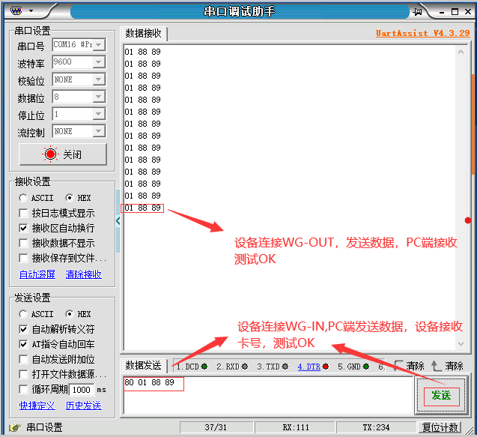

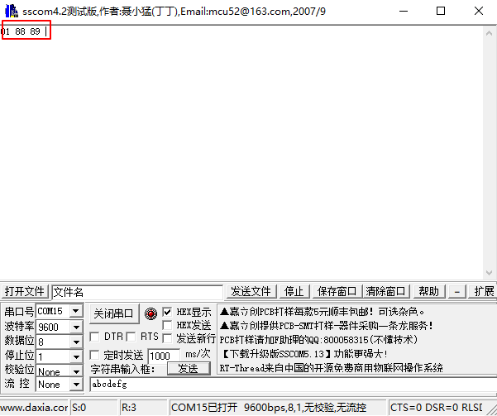
Figure 4_ 1

Is the hexadecimal conversion 2 binary comparison result correct?
Open Windows 10 Calculator and select Programmer's Calculator. Or any hexadecimal to binary calculator;
Find 4.1 to convert to binary the result "01 88 89" for Wiegand 26 and the result "80 01 88 89" for Wiegand 32 .
Wiegand 26, " 01 88 89 " is converted to binary "1 1000 1000 1000 1001", compare the results on the website " 0 0 0 0 0 0 0 0 1 1 0 0 0 1 0 0 0 1 0 0 0 1 0 0 1 1 "bits 2-25, the missing digits are filled with 0, the result is the same, and the verification is passed. As shown in Figure 4-2.
Wiegand 34, " 80 01 88 89 " is converted to binary "1000 0000 0000 0001 1000 1000 1000 1001", compare the results on the website " 0 1 0 0 0 0 0 0 0 0 0 0 0 0 0 0 1 1 0 0 0 1 0 0 0 1 0 0 0 1 0 0 1 0 "bits 2-33, the result is the same, the verification is passed. As shown in Figure 4-3.

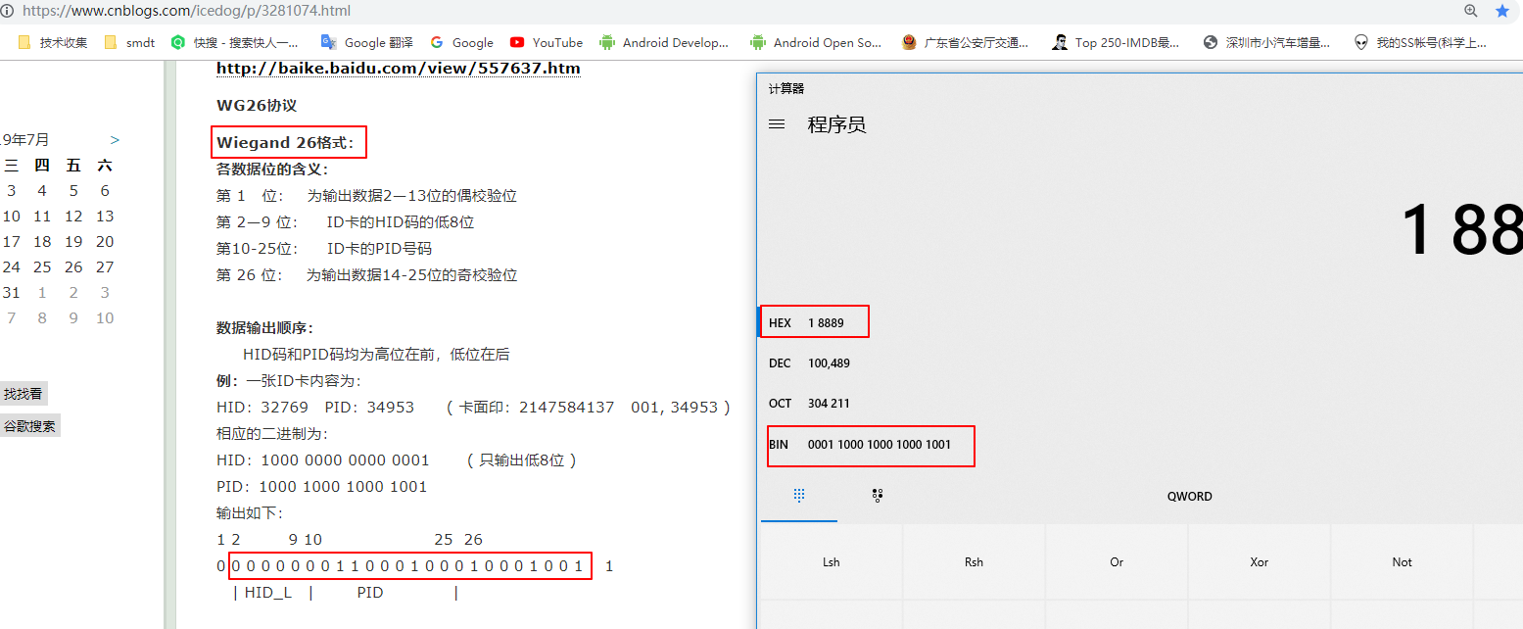
Figure 4_ 2
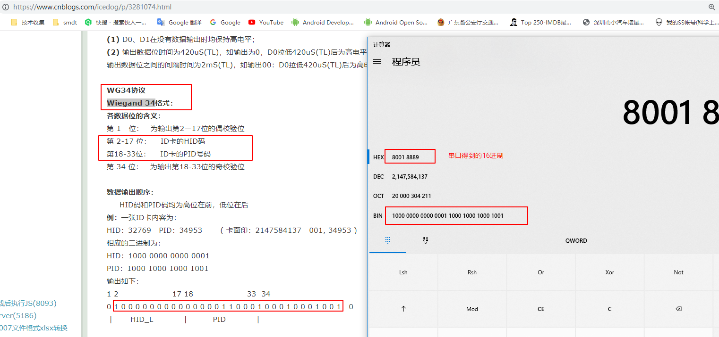
Figure 4_ 3

